Cybersecurity Policy Development for FinSecure Ltd

Abstract
This report outlines the development of a comprehensive cybersecurity policy framework for FinSecure Ltd (FSL), a medium-sized UK financial services firm. It summarizes key threats – both internal (e.g. negligent or malicious insiders) and external (e.g. phishing, ransomware, malware, DDoS) – and shows how policies aligned to standards (ISO/IEC 27001, NIST CSF) and regulations (GDPR/UK Data Protection Act) can manage those risks. Recommended mitigation measures include technical controls (encryption, multi-factor authentication, network defences), as well as organizational steps like incident response planning and monitoring. Staff training and awareness are emphasized as critical to reinforce policy compliance.

Introduction
FinSecure Ltd (FSL) handles sensitive customer finances and personal data, so regulatory compliance and robust security governance are essential. For example, UK GDPR requires that “personal data [be processed] securely by means of ‘appropriate technical and organisational measures’” [1]. International standards provide frameworks: ISO/IEC 27001 requires establishing an Information Security Management System (ISMS) with documented policies and continual risk management [2], while the NIST Cybersecurity Framework (CSF) helps organizations improve their cybersecurity risk management [3]. In simple terms, FSL must define clear security policies and processes (e.g. acceptable use, access control, incident handling) that align with these guidelines, while meeting GDPR/data-protection obligations (data minimization, breach notification, encryption, etc.). This report first identifies major cyber threats to FSL (both outside attackers and inside risks), then proposes specific policies and controls (aligned to ISO 27001, NIST CSF and GDPR principles) to mitigate them. It also covers how to monitor and respond to incidents (with an incident response flowchart) and highlights the importance of ongoing staff training.

Identification of Threats
FSL faces both external cyber threats and internal risks. Externally, financial firms are high-value targets: one study reported that banks and insurers faced “300 times more” cyberattacks than other industries [4]. Common external threats include:
- Phishing and Social Engineering: Attackers send deceptive emails or calls to trick staff into revealing credentials or opening malware attachments. (Financial services are the most impersonated sector in phishing attacks [6].)

- Ransomware and Malware: Malware (including ransomware) encrypts or corrupts data. Ransomware has hit the financial sector heavily; in one period it accounted for about 22% of all ransomware attacks globally. [6]

- Hacking and Exploits: Cybercriminals (or sometimes nation-state actors) exploit system vulnerabilities, use brute-force attacks, or deploy malware to steal funds or data.

- Distributed Denial of Service (DDoS): Overloading network resources to disrupt online services (e.g. online banking portals).
Internally, threats come from within the organisation. These include:
- Negligent insiders: Employees may inadvertently cause breaches (e.g. by clicking phishing links, losing devices, or misconfiguring systems). Even a simple mistake (like sending a spreadsheet to the wrong email) can expose data.

- Malicious insiders: Disgruntled or rogue employees with legitimate access might steal or sabotage data. In fact, industry studies find that roughly 30% of data breaches in financial services are caused by insiders [5]. For example, departing staff might copy customer lists or trade secrets, despite NDAs [5].

- Third-party/supply-chain risks: Contractors or service providers (e.g. IT vendors) might introduce vulnerabilities or be attacked as a backdoor into FSL’s systems.
Overall, both human and technical factors play a role. FSL’s policy must therefore consider insider dangers (e.g. by controlling privileges and monitoring internal systems) as well as hardening against external cyberattacks.

Security Policies (ISO 27001, NIST, GDPR)
A robust policy framework ensures that security controls are standardized, documented, and enforced. Key policies for FSL should include:
- Information Security Policy: The top-level directive defining FSL’s overall security objectives, risk approach, roles (e.g. management’s commitment) and scope. ISO 27001 explicitly requires a formally documented information security policy as part of its ISMS foundation [2].

- Data Protection Policy: To comply with GDPR/UK-GDPR, FSL needs a data protection policy outlining how personal data is processed lawfully, how consent is managed, data subject rights, and how breaches are reported. UK GDPR guidance reminds that organizations must implement appropriate “technical and organisational measures” (e.g. policies, training, encryption) to protect personal data [1].

- Access Control Policy: Rules for authentication, authorization, user account management (e.g. password rules, role-based access, privileged account controls). For example, ISO Annex A (control family) expects organisations to define who can access which systems and data [2].

- Acceptable Use Policy (AUP): Guidelines for employees on permitted use of company IT (e.g. email, internet, devices). This helps prevent unapproved software install, phishing vulnerability, or unsafe uploads.

- Incident Response Policy: Defines how FSL will detect, report, and respond to security incidents. It should specify response team roles, escalation paths, communication plans, and legal/PR considerations.

- Business Continuity/Disaster Recovery Policy: Although separate from cybersecurity policies, an overlap is crucial – ensuring FSL can continue operating or quickly restore services after an incident (e.g. data backups, alternate sites).

- Acceptable Encryption Policy: Under GDPR, FSL should use encryption and pseudonymisation where appropriate to protect data [1]. A policy can specify data at-rest and in-transit encryption standards (e.g. AES for databases, TLS for web).

- Vendor/Supply-Chain Security Policy: Requirements for third parties (e.g. banks, cloud providers) such as contractual security clauses, regular audits, and compliance with FSL’s standards.
These policies should be aligned with recognized frameworks: ISO 27001 guides the overall ISMS structure; NIST CSF’s Protect category includes establishing policies and controls (e.g. identity management, data security) to reduce risks; and GDPR mandates governance (e.g. appointing a Data Protection Officer, documenting processing activities). For instance, NIST CSF’s Protect function explicitly calls for formal policies and procedures to limit impact of events [2]. In practice, FSL’s security committee would draft and review these policies, ensuring they meet legal (GDPR/FCA) requirements and map to ISO/NIST best practices.
Important points from authoritative sources: the ICO says that organisations “have an information security policy (or equivalent) and take steps to make sure the policy is implemented”, and that these policies must be regularly reviewed and updated [1]. In other words, it’s not enough to write a policy; FSL must enforce it (via oversight and audit) and refine it over time as threats or business needs change.

Mitigation Measures
Policy documents set the rules; mitigation measures put them into practice. Controls and safeguards fall into technical, administrative, and physical categories:
- Technical Controls:
  - Firewalls and Network Security: A properly configured firewall and intrusion detection/prevention system (IDS/IPS) at network perimeters.
  - Encryption: Use strong encryption (AES, TLS) for data at rest and in transit. As the ICO notes, organisations should use encryption and pseudonymisation “where appropriate” to protect data [1]. For example, customer databases and backups should be encrypted.
  - Multi-Factor Authentication (MFA): Require MFA for all privileged and remote logins (admins, VPN access, cloud consoles) to reduce credential theft risk.
  - Endpoint Protection and Patch Management: Install up-to-date anti-malware/EDR on all endpoints (PCs, servers) and ensure timely OS/software patching to close vulnerabilities.
  - Network Segmentation: Separate critical systems (e.g. payment processing) from general user networks to contain breaches.
  - Logging and SIEM: Implement central logging (e.g. Security Information and Event Management) to monitor unusual activity (multiple failed logins, spikes in traffic) as an early warning system.
- Administrative Controls:
  - Risk Assessment: Conduct regular risk assessments (as required by ISO 27001) to identify assets (customer records, systems) and rate risks. This drives which controls to implement and how strict they should be.
  - User Access Reviews: Periodically review user permissions to ensure employees have only the access needed for their role (principle of least privilege).
  - Policies & Enforcement: Enforce the policies listed above. For example, audits to confirm devices comply with the AUP, or that sensitive data is classified and handled according to the policy.
  - Incident Drills & Testing: Regularly test incident response procedures (see next section) through tabletop exercises or phishing simulations.
  - Data Backups: Maintain frequent, tested backups of critical data to enable recovery from ransomware or system failures.
- Physical Controls:
  - Secure Premises: Control physical access to offices and data centres (badges, locks, cameras) so that outsiders and unauthorised insiders cannot easily steal hardware or servers.
  - Hardware Security: Lock workstation consoles in public spaces; secure portable devices (laptops, USB drives) with cable locks or storage.
These measures aim to ensure the CIA triad (Confidentiality, Integrity, Availability) of FSL’s systems. The ICO stresses that security measures must achieve “confidentiality, integrity and availability” of data, and enable timely restoration of data if incidents occur [1]. In summary, FSL should adopt a layered (“defence in depth”) approach: technical controls enforced by policy, backed by management processes and employee practices.

Monitoring and Response
Active monitoring and a planned response are critical. Continuous monitoring (e.g. log review, IDS alerts) helps detect breaches early, and a clear response plan limits damage. FSL should establish a Cyber Incident Response Plan (CIRP) that outlines steps and roles when an incident occurs.

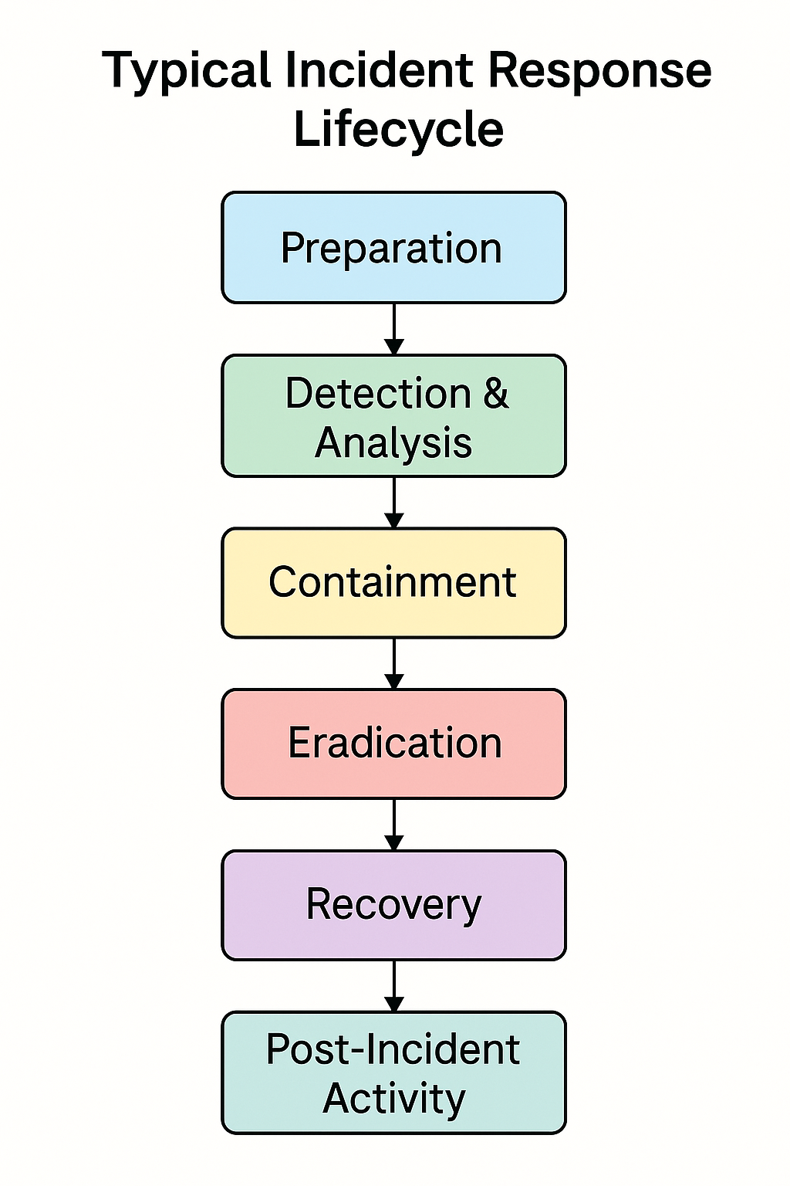
Preparation, Detection & Analysis, Containment, Eradication & Recovery, and Post-Incident Review [3]. In Preparation, FSL sets up an incident team, defines communication paths (hotlines, escalation), and ensures tools are ready (forensics kits, alternate sites). Detection & Analysis involves identifying a suspicious event (e.g. unusual login), triaging alerts, and confirming a security incident. During Containment, Eradication & Recovery, the team isolates affected systems (containing malware), removes the threat (eradicating malware or closing a breached account), and restores systems (from backups or clean images). Finally, Post-Incident Activity focuses on reporting the incident, documenting lessons learned, and updating policies and defences to prevent recurrence [3].
Key points in this process include timely communication and evidence preservation. For instance, ISO 27035 (UK standard on incident response) requires that incidents be reported to management and (if data was involved) to the Information Commissioner’s Office within 72 hours (for GDPR breaches). FSL should also have a flowchart or checklist (as sketched above) that staff can follow during an incident, as recommended by the NCSC. The flowchart illustrates these steps and helps ensure the incident team doesn’t skip any critical action.
For monitoring specifically, FSL should implement real-time log monitoring and anomaly detection. Automated alerts can flag, say, multiple failed login attempts or large data transfers. These alerts should feed into the incident response procedure (e.g. triggering the Detection/Analysis phase). Throughout all stages, documentation is vital: each incident report should record who discovered it, what actions were taken, and when. This aligns with best practices in NIST SP 800-61 (Incident Handling Guide) for post-incident analysis and lessons learned [3].
Finally, flowcharts and diagrams should be tested in drills. Many organizations find that having a clear, visual plan (like the flowchart above) greatly improves coordination during the stress of a real incident.

Training and Awareness
Even the best policies and tools can fail if staff aren’t aware of them. FSL must invest in security awareness training so that all employees) understand threats and their role in defence. This training should cover:
- Regular Phishing Simulations: Send mock phishing emails to employees to test and reinforce correct handling. Follow up immediately with guidance if someone clicks a simulated attack.
- Induction Training: Every new hire should receive baseline security training (password hygiene, identifying phishing, device usage rules).
- Periodic Refreshers: Annual or semi-annual modules on topics like data protection rules (GDPR basics), remote-work security, and updates on new scam trends.
- Role-Based Training: IT and security staff need deeper technical training (incident handling drills, secure coding, etc.), while management should understand their accountability (e.g. confirming compliance).
- Clear Communication: FSL should publish succinct policy summaries (posters, intranet notices) and report metrics (e.g. “X staff attended training, Y suspicious emails reported”) to keep security top-of-mind.
By making training engaging and relevant (for instance, real-world banking scams, password managers, or even short awareness videos), FSL can empower employees to be part of the security team. The NCSC and ICO both emphasize that an “organisational measure” like staff training is as crucial as any firewall [1]. Ultimately, well-informed staff will follow policies more consistently and can act quickly to report incidents (feeding into the incident response process above).

Conclusion
FinSecure Ltd operates in a high-risk space and must therefore adopt a structured approach to cybersecurity. This report has identified the main threats (cyberattacks from outside and misuse/accidents from inside) and proposed a layered set of policies and controls to address them. By aligning FSL’s policies with international standards (ISO 27001) and frameworks (NIST CSF) and by meeting UK/EU legal requirements (GDPR), the company ensures it covers technical, organizational, and legal bases. Preventive measures (firewalls, encryption, access controls) are supplemented by prepared incident response (with a clear flowchart) and continual user education. Finally, as both the ICO and NIST guidance stress, these policies and measures must be regularly reviewed and updated to remain effective. In short, a combination of well-defined policies, solid technical safeguards, proactive monitoring, and an informed workforce will give FinSecure a robust cyber-defence posture.

References
[1] Information Commissioner’s Office, “A guide to data security,” UK GDPR guidance (May 2023).
[2] Sean Craig, “A Comparison of Leading Security Frameworks: NIST, ISO 27001, and Zero Trust,” Quick and Dirty Tips (2023).
[3] National Institute of Standards and Technology, Cybersecurity Framework, NIST CSF 2.0 (2024).
[4] N. Eide, “Cyberattacks hit financial services 300 times more than other sectors,” CIO Dive, 21 June 2019.
[5] CYFOR, “Insider Threats within the Finance Industry,” 2021.
[6] P. Cichonski et al., Computer Security Incident Handling Guide, NIST SP 800-61r2 (U.S. Dept. of Commerce, Aug. 2012).

Appendix

Powerpoint:

https://uowtsd-my.sharepoint.com/:p:/g/personal/2406098_student_uwtsd_ac_uk/EeP4FEk4IAFOrIogbz7jjfoBtKmAmsWeG9JHLlJGmA39dQ?e=Ramwvd

