

MODULE CODE: Digital Skills for Personal Development and Business Growth BMSW4008

ASSESSMENT COMPONENT: PORTFOLIO

STUDENT NAME:Shannon O’Connell

STUDENT NUMBER:2429748

LECTURER: Philipa fitzgerald

DATE:
Contents
Task 1 3
Assessment of Digital Skills 3
References 3
Task 2 4
LinkedIn Learning Certificates for Office365 4
Task 3 5
Essay on Relevance of Excel in professional and personal life. 5
References 5
Task 4 6
7 Minute Reflective Presentation 6
References 6

AI Acknowledgement
Examples of statements If you have not used AI
I confirm that I have not presented any AI generated materials as my own work.
I confirm that I have copies of my drafts, notes, and other resources I used, which I may be asked to provide in evidence.
Examples of AI statements if you have used AI
Example 1:
I acknowledge the use of Grammarly (https://www.grammarly.com/) on Date to check my work using the prompt(s):
1. Please check the following text for readability, grammar and syntax.
I confirm that I have not presented any AI generated text as my own work. I confirm that I have copies of my drafts, notes, and other resources I used before, and after the use of AI tools which I may be asked to provide in evidence.
Example 2:
I acknowledge the use of SciSpace (https://typeset.io/) on 7 March 2024 to support my research using the prompt(s):
1. Please provide me with materials on the biology of the liver.
2. Please provide me with materials on liver cells.
I confirm that I have not presented any AI generated text as my own work. I confirm that I have copies of my drafts, notes, and other resources I used before, and after the use of AI tools which I may be asked to provide in evidence.
Example 3:
I acknowledge the use of ChatGPT (https://chatgpt.com/) on 13 April 2024 to write my notes into submission format using the prompt(s):
1. Please write up these bullet points as an essay paragraph at university level.
I confirm that I have not presented any AI generated text as my own work. I confirm that I have copies of my drafts, notes, and other resources I used before, and after the use of AI tools which I may be asked to provide in evidence.
Example 4 - acknowledgement of the use of multiple AI tools:
I acknowledge the use of SciSpace (https://typeset.io/) on 28 June 2024 to support my research using the prompt(s):
1. Please provide me with materials on the American Civil War.
2. Please provide me with materials on the reception of Gone with the Wind.
I confirm that I have not presented any AI generated text as my own work. I confirm that I have copies of my drafts, notes, and other resources I used before, and after the use of AI tools which I may be asked to provide in evidence.
I acknowledge the use of Adobe Express (https://www.adobe.com/express/) on 24 June 2024 to edit photographic material:
1. Remove background from Figure 1.
I confirm that I have not presented any AI generated materials as my own work. I confirm that I have copies of my drafts, notes, and other resources I used before and after the use of AI tools which I may be asked to provide in evidence.

Task 1

Assessment of Digital Skills

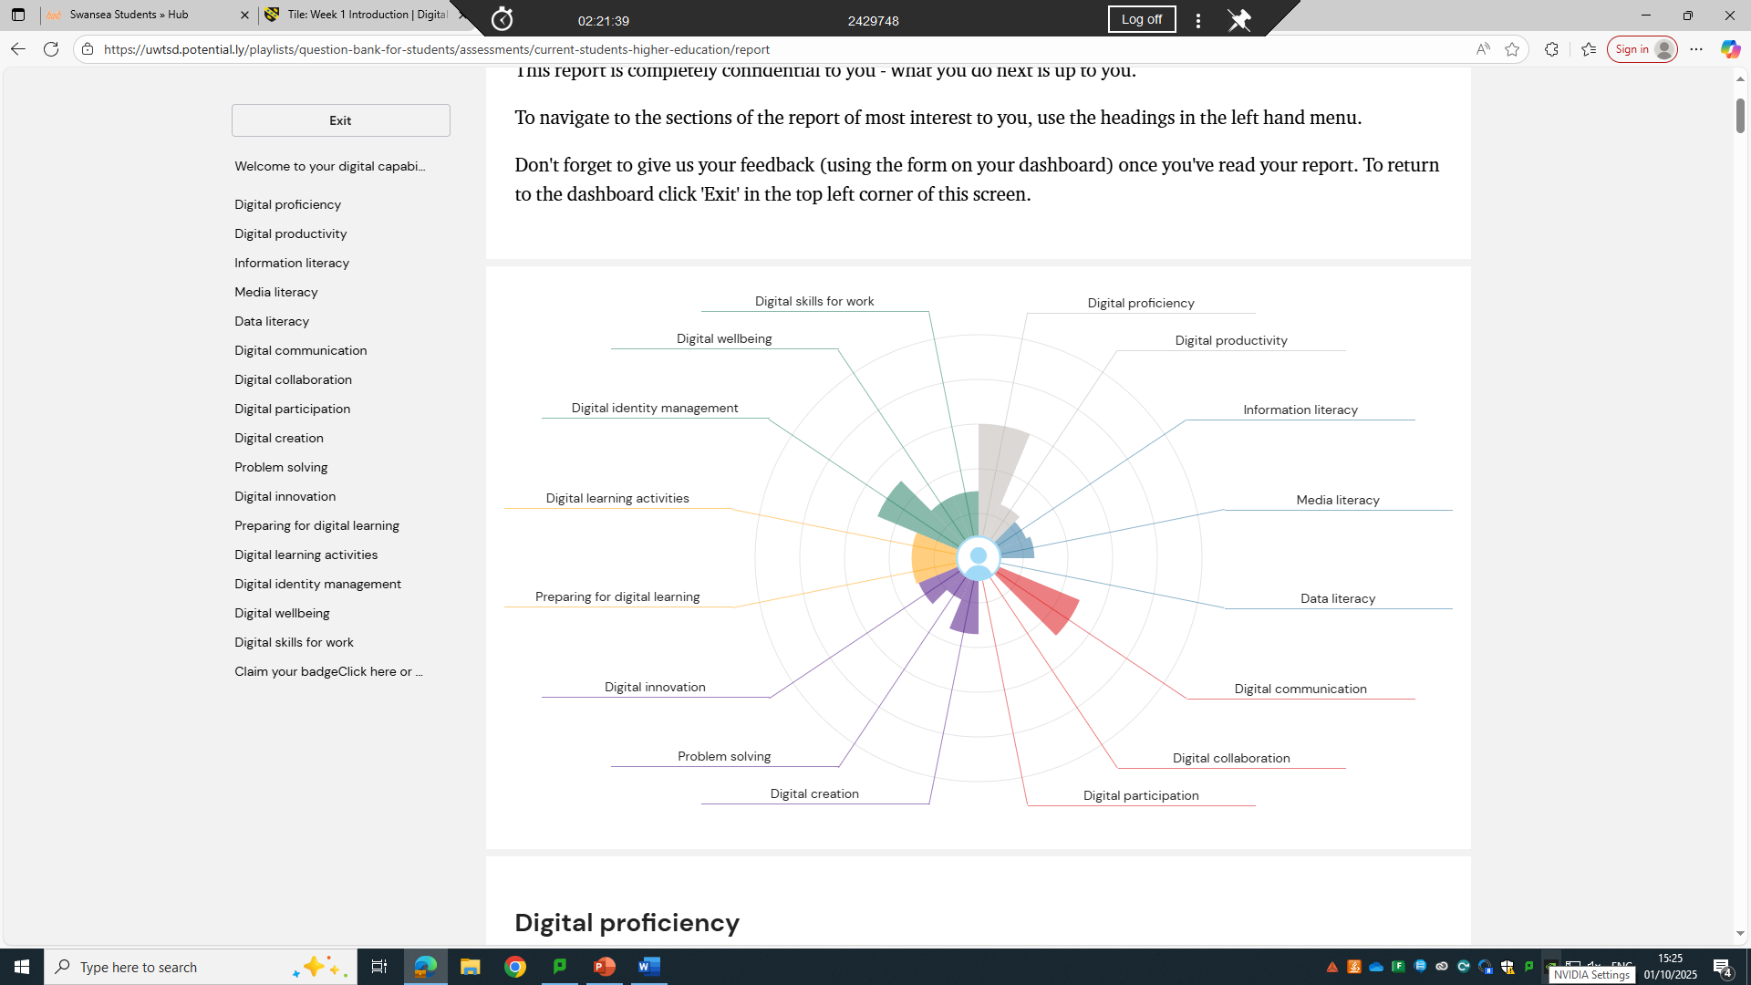

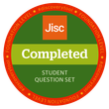
Introduction
Digital skills have become essential in modern education and employment, influencing how individuals communicate, collaborate, learn, and solve problems. The JISC Digital Capability Tool provides a structured method for analysing one’s competencies across key digital areas. Understanding digital strengths and weaknesses enables targeted development and supports academic success and professional readiness. This reflection evaluates my JISC results, highlighting my strongest and weakest areas, and presents a SMART-based action plan to address priority gaps. Developing these skills is crucial not only for improving my efficiency as a student but also for preparing for a technology-driven workplace where digital literacy is increasingly expected.

Summary of JISC Results
My JISC Digital Capability profile highlighted a range of strengths and weaknesses across the six core areas. I scored highest in Digital Communication and Collaboration, showing confidence in tools such as Microsoft Teams, email, and virtual learning environments (Jisc, 2023). I also performed strongly in Information, Data, and Media Literacy, which reflects good critical evaluation and research abilities important for academic work (Cottrell, 2021). However, the assessment identified weaker performance in Digital Creation, Problem-Solving, and Digital Well-being, especially around producing advanced digital content and managing digital overload. These results suggest that I need to develop stronger technical and self-management skills to become a more balanced digital learner (Beetham, 2019).
Two strengths
- Digital Communication and Collaboration
One of my key strengths was digital communication and collaboration. I am confident using communication tools such as Microsoft Teams, Zoom, and other cloud-based platforms, which supports my ability to participate in discussions, group work, and virtual learning (Jisc, 2023). These skills are essential, as modern academic and professional environments depend heavily on digital communication and teamwork (Microsoft, 2024). Having strong collaboration skills improves my ability to contribute effectively to shared tasks, submit work online, and stay connected with tutors.
- Information, Data, and Media Literacy
A second strength identified in my JISC profile was information, data, and media literacy. I can locate credible academic sources, interpret research, and evaluate information critically, which is essential for producing accurate and evidence-based academic work (Cottrell, 2021). In a digital world where misinformation is common, having strong information literacy skills helps ensure that my work is reliable and well-supported (Redecker, 2017). This strength also prepares me for careers that require data interpretation, decision-making, and report writing.
Two weaknesses
- Digital Creation and Content Production
One of my main weaknesses was digital creation, especially around designing advanced presentations, visual content, and interactive materials. Although I can complete basic tasks in Microsoft Office applications, I lack confidence using more complex design tools or creating professional-level content (Jisc, 2023). Improving these skills is important for producing high-quality academic presentations and workplace-standard documents.
- Digital Well-Being and Self-Management
Another weakness was digital well-being, particularly managing digital distractions, screen time, and organisation. Research highlights that poor digital well-being can reduce productivity and increase cognitive overload (Beetham, 2019). I often find myself switching between apps, which disrupts focus and efficiency. Improving my organisation and adopting healthier digital habits will support both my academic work and personal wellbeing.
SMART Action plan
Goal 1: Improve digital content creation skills.
Specific: Learn Canva, advanced PowerPoint tools, and Office365 design features.
Measurable: Produce three digital artefacts such as an infographic, poster, and advanced PowerPoint presentation.
Achievable: Use free tutorials and LinkedIn Learning resources recommended by Jisc (2023).
Relevant: Improved content creation supports my academic presentations and helps with Task 4 (Redecker, 2017).
Time-bound: Complete this within eight weeks.
Goal 2:Enhance digital well-being and organisation.
Specific: Reduce digital distractions, improve file organisation, and establish healthy screen-time habits.
Measurable: Track habits for two weeks using a wellbeing log.
Achievable: Use tools such as Focus Mode, OneDrive folders, and notification settings (Beetham, 2019).
Relevant: Better digital organisation and well-being improves academic performance and productivity.
Time-bound: Implement improvements by the end of the semester.
Conclusion
The JISC assessment has helped me understand my digital strengths and areas that require further development. By focusing on improving digital creation skills and strengthening digital well-being, I can develop a more effective digital profile. These improvements will help me produce high-quality academic presentations, remain better organised, and work more productively. Strengthening my digital skills not only supports my academic work but will also prepare me for future employment in an increasingly digital workplace (Microsoft, 2024).
Reference list
Beetham, H. (2019) Developing digital capability: A toolkit for learners. Jisc.

Cottrell, S. (2021) Skills for Success: Personal Development and Employability. 4th edn. London: Macmillan.

Jisc (2023) Digital Capability Framework. Available at: https://digitalcapability.jisc.ac.uk/ (Accessed: 7 December 2025).

Microsoft (2024) Digital skills for the modern workplace. Available at: https://learn.microsoft.com/ (Accessed: 7 December 2025).

Redecker, C. (2017) European Framework for the Digital Competence of Educators (DigCompEdu). Luxembourg: Publications Office of the European Union.

Task 2

LinkedIn Learning Certificates for Office365
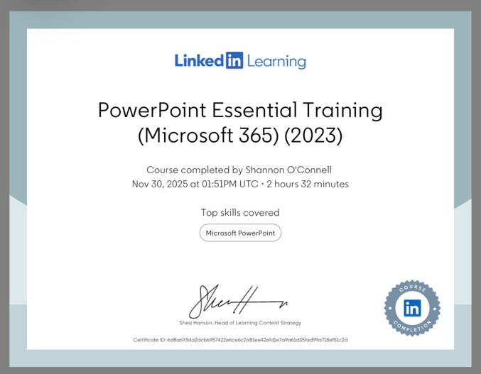
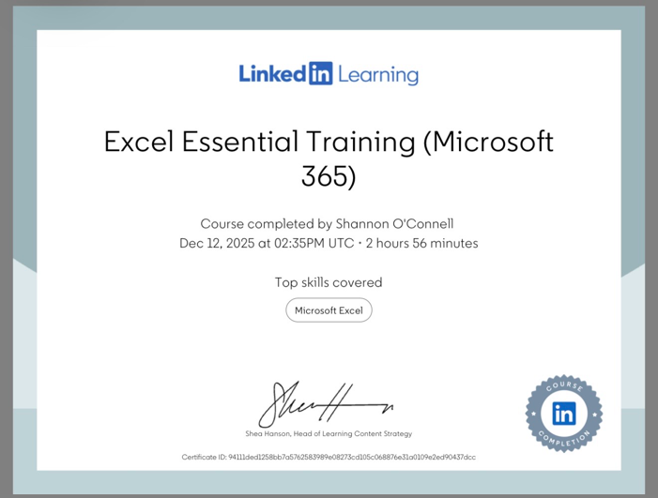
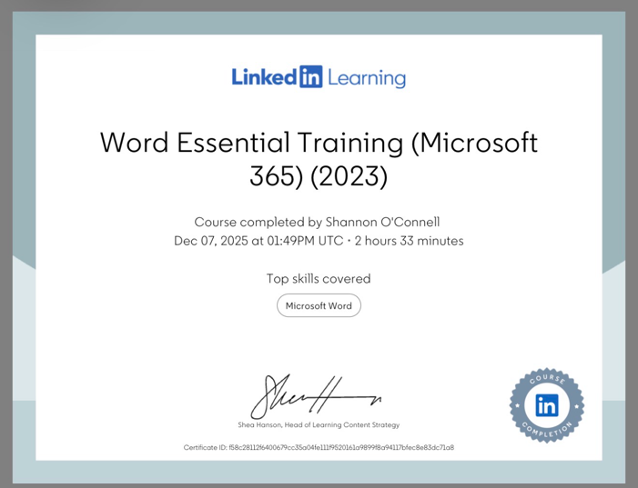

Task 3

The Relevance of Excel

Microsoft Excel is one of the most widely used computer programs in the world, and it continues to play an important role in everyday life. Even though it might look complicated at first, Excel is designed to make tasks easier, faster, and more organised. People use it at home, in school, and at work because it helps them keep track of information, understand data, and make good decisions. When looked at closely, Excel becomes more than just a spreadsheet—it becomes a tool that helps people manage life more smoothly (Walkenbach, 2015).
One of the main reasons Excel is so relevant is because it helps people stay organised. Life can get busy, and trying to remember everything mentally or on paper can become stressful. Excel provides a clear space where information can be stored in rows and columns, also known as spreadsheets. These spreadsheets can hold almost anything: budgets, plans, lists, or goals. Instead of keeping random notes everywhere, a person can bring all their important information together in one place. This helps reduce mistakes and makes it easy to find information later (Frye, 2018). For many people, having their life organised in a spreadsheet brings a sense of control and calmness.
Another reason Excel remains important is because it handles maths automatically. Not everyone enjoys working with numbers, and even people who are confident in maths can make mistakes when rushed. Excel helps by doing calculations instantly. It can add, subtract, divide, work out percentages, and show averages. This saves time and gives reliable results. For example, someone trying to manage their spending can enter their income and expenses into Excel and quickly see how much money they have left each month. Instead of worrying about errors, they can trust the program to get the maths right (Jones, 2020). This makes budgeting and planning a lot easier.
Excel is also valuable because it turns numbers into clear visuals. Long lists of data can be hard to understand, but Excel can turn them into charts and graphs. These visuals help people see patterns and trends right away. Whether it is a bar chart showing monthly spending or a line graph showing progress over time, charts make information easier to understand. They also help when presenting information to others at school or work (Winston, 2014). This makes Excel a strong communication tool.
Another important point is that Excel teaches people to think more logically. When someone works with spreadsheets, they learn how information connects and changes. This encourages clearer thinking and better problem-solving. It helps people notice patterns, solve issues, and predict what might happen next. Learning to handle data builds confidence and supports smarter decision-making in everyday life (Sullivan, 2016). Many people find themselves using the same style of thinking in other tasks, like planning trips, managing time, or setting goals.
Excel is also useful because it supports teamwork. Many workplaces and schools use cloud versions of Excel that allow multiple people to edit a spreadsheet at the same time. This makes group work easier because everyone can add their part, fix errors, and see updates instantly. Teams no longer need to send files back and forth. Instead, they work together on one shared document, which improves communication and reduces confusion (Alexander & Kusleika, 2019).
Another major reason Excel remains relevant is its importance in the job world. Many workplaces depend on data to make decisions, and Excel is one of the main tools they use. It is found in business, healthcare, education, finance, science, marketing, and many more fields. Even jobs that do not seem connected to computers often use Excel to track numbers or organise information. Its flexibility makes it valuable for both simple and complex tasks (Cummings & Worley, 2018). Knowing how to use Excel gives people an advantage in many careers.
Excel also supports personal growth. People use it to track habits, measure goals, plan savings, or manage routines. Seeing progress written in a spreadsheet can make goals feel real and easier to reach. For example, someone saving for a holiday can enter how much they save each week and watch their total increase. Someone trying to improve their health can record workouts or steps and see progress over time. This helps build motivation because the results are visible (Keller, 2019).
Another reason Excel stays useful is that it helps people solve everyday problems. When information is placed into a spreadsheet, formulas and filters can be used to explore it. A person might want to know where they spend the most money, which days they are most productive, or what patterns affect their progress. Excel can reveal answers clearly, helping people improve their habits and choices (Powell, 2022). It becomes a tool for reflection as well as organisation.
Finally, Excel remains relevant because it can be used for almost anything. It can be simple for basic tasks or advanced for complex projects. It grows with the user. Someone might start with small personal spreadsheets but later learn formulas, charts, and detailed functions as their needs increase. Few tools offer this level of flexibility or ease of learning (Frye, 2018).
In conclusion, Excel continues to be important because it helps people stay organised, avoid mistakes, understand information visually, work as a team, build digital skills, and achieve personal and professional goals. Its flexibility and clarity make it useful for almost anyone. Even with simple vocabulary, the significance of Excel is clear. It is a tool that helps people make decisions, stay in control, and manage life more smoothly.
Reference List
Alexander, M. & Kusleika, D. (2019) Excel 2019 Bible. Hoboken: Wiley.

Cummings, T.G. & Worley, C.G. (2018) Organization Development and Change. Boston: Cengage Learning.

Frye, C. (2018) Microsoft Excel 2019 Step-by-Step. Redmond: Microsoft Press.

Jones, C. (2020) ‘Using Excel for personal and business finance’, Journal of Digital Skills, 12(3), pp. 45–52.

Keller, G. (2019) Statistics for Management and Economics. Boston: Cengage.

Powell, S.G. (2022) Business Analytics: Data Analysis and Decision Making. Boston: Cengage Learning.

Sullivan, M. (2016) Fundamentals of Statistics. Boston: Pearson.

Walkenbach, J. (2015) Excel 2016 Bible. Hoboken: Wiley.

Winston, W. (2014) Microsoft Excel Data Analysis and Business Modeling. Redmond: Microsoft Press.

Use the following information create an Excel spread sheet, looking at income and expenditure of a typical family of 4 over the course of a year. Use formulars to achieve answers and add headings and highlight the different aspects of the finances, be realistic with the monetary amounts used for each area.

Excel spreadsheet
https://uowtsd-my.sharepoint.com/:x:/g/personal/2429748_student_uwtsd_ac_uk/IQByF2pKTAFwQKEUhggqWFgwAdLY0MqufYGK-cXIrdKM7N0?email=2429748%40student.uwtsd.ac.uk&e=GVbbTs

Task 4

7 Minute Reflective Presentation
https://uowtsd-my.sharepoint.com/:p:/r/personal/2429748_student_uwtsd_ac_uk/Documents/digital%20skills%20reflection%20p.pptx?d=wdf662692747a47738ea04c3b16ada546&csf=1&web=1&e=Rh03CH
Embed PowerPoint here

