Contemporary Themes in the Hotel and Hospitality sector (BMIH6001)
Poonam kc
Student no :2012450
Video link: Recording: https://web.microsoftstream.com/video/a1f05abf-4326-400a-a738-4a6b5bbe3c10

Health and Well-being in the Hospitality Industry Presentation

Slide 1
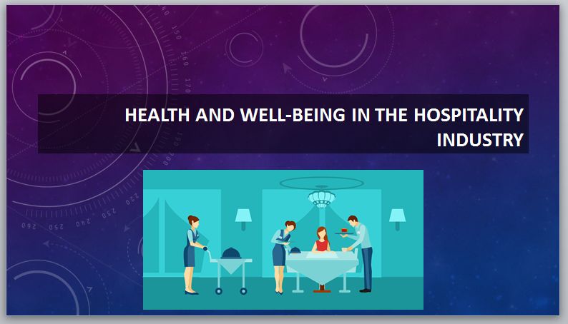
Slide 2
INTRODUCTION
In the fast-paced and demanding environment of the hotel and hospitality sector, the health and well-being of employees play a crucial role in their overall job satisfaction and performance. The physically and mentally demanding nature of the industry can have significant impacts on employees' well-being. Recognizing the importance of employee well-being is essential for creating a positive work environment and ensuring the long-term success of the sector. (Lo.K, 2005)
Slide 3
Overview of Literature
The literature on health and well-being in the hospitality industry emphasizes the importance of addressing the physical and mental well-being of employees. Key theories and concepts include ergonomic interventions, workload management strategies, and supportive communication and organizational culture. Studies highlight the positive impacts of these approaches on reducing work-related injuries, improving job satisfaction, and enhancing productivity. Current journal articles emphasize the need for comprehensive health and safety policies, technology solutions, work-life balance initiatives, and training programs to promote employee well-being. By drawing on the latest research, this paper aims to provide a comprehensive overview of the literature and its implications for the hospitality industry.
Slide 4
Application to the Hotel and Hospitality Sector
In the hotel and hospitality sector, one specific area to focus on in relation to health and well-being is the housekeeping department. Housekeeping employees face unique challenges due to the physically demanding nature of their work, exposure to cleaning chemicals, and high workload pressures. These factors can significantly impact their physical and mental well-being.
To address these challenges, hotels have implemented various management responses. For example, ergonomic interventions such as providing adjustable cleaning equipment and implementing proper lifting techniques have been introduced to reduce physical strain and injuries. Workload management strategies, such as optimizing cleaning schedules and implementing efficient task allocation systems, have been employed to alleviate time pressures and improve work-life balance.
Furthermore, hotels have recognized the importance of supportive communication and a positive organizational culture. Regular team meetings, open channels of communication, and recognition programs have been established to foster a sense of belonging and support among housekeeping staff. (O’neill, J.W. , 2011)
While these management responses have shown positive impacts, limitations exist. Resource constraints, such as budgetary limitations, can hinder the implementation of comprehensive well-being initiatives. Moreover, the transient nature of the workforce in the hospitality industry poses challenges in providing consistent support and training.
Overall, the application of management responses in the housekeeping department of the hotel and hospitality sector has been effective in improving employee well-being. However, ongoing efforts are necessary to overcome limitations and ensure a sustainable and supportive work environment.
Slide 5
Example 1 - Ergonomic Interventions
In the hotel and hospitality sector, ergonomic interventions have proven to be effective in improving the health and well-being of housekeeping employees. These interventions aim to minimize physical strain, reduce the risk of injuries, and enhance overall work comfort. (Haid.M, 2022)
One example of an ergonomic intervention is the introduction of adjustable cleaning equipment. Housekeeping employees often perform repetitive tasks such as vacuuming, mopping, and lifting heavy objects. By providing adjustable equipment, such as vacuum cleaners with adjustable handles or height-adjustable trolleys, hotels can ensure that employees can customize the equipment to their individual needs and reduce the risk of musculoskeletal injuries.

Slide 6
Example 2 - Workload Management Strategies
In the hotel and hospitality sector, workload management strategies have been implemented to address the impact of heavy workloads on the health and well-being of housekeeping employees. These strategies aim to optimize task allocation, prioritize workload, and promote work-life balance.
One effective workload management strategy is the implementation of efficient cleaning schedules. By analyzing guest occupancy patterns and peak periods, hotels can create well-planned cleaning schedules that distribute work evenly among housekeeping staff. This helps to prevent excessive workloads during busy periods and ensures that tasks are completed within a reasonable timeframe. (Kim.H, 2018)
Slide 7
Example 3 - Supportive Communication and Organizational Culture
Supportive communication and fostering a positive organizational culture are vital in promoting the health and well-being of housekeeping employees in the hotel and hospitality sector.
One example of a management response is the establishment of open channels of communication. Regular team meetings, one-on-one check-ins, and feedback sessions provide opportunities for housekeeping employees to express their concerns, share ideas, and receive support. This open communication allows for the identification of potential issues or challenges faced by employees and enables management to address them promptly.
Furthermore, hotels have recognized the importance of recognizing and valuing the contributions of housekeeping staff. Implementing recognition programs, such as Employee of the Month or appreciation events, helps create a culture of appreciation and support. This recognition not only boosts employee morale but also reinforces a sense of belonging and job satisfaction.
Slide 8
General Recommendations
Establish a holistic approach: Integrate health and well-being considerations into all aspects of the organization, from recruitment and training to performance evaluations and rewards systems.
Foster leadership support: Ensure that managers and leaders prioritize and actively support employee well-being initiatives, leading by example and promoting a culture of care and support.
Collaborate with industry stakeholders: Engage with industry associations, government bodies, and other stakeholders to share best practices, exchange knowledge, and collaborate on initiatives aimed at improving health and well-being in the hospitality industry. (Pienaar, J. , 2008)
Continuously monitor and adapt: Regularly monitor the effectiveness of implemented policies and management strategies, and be willing to adapt and evolve based on changing needs and emerging research.
Slide 9
Conclusion
In conclusion, addressing the health and well-being of housekeeping employees in the hospitality industry is crucial for their overall well-being, job satisfaction, and organizational success. Management responses such as ergonomic interventions, workload management, training programs, and supportive communication have shown positive impacts. Future policy and management options should focus on comprehensive health and safety policies, technology solutions, a supportive culture, work-life balance initiatives, training opportunities, collaboration, and regular assessments. By prioritizing employee well-being, the industry can create a sustainable and thriving work environment that enhances guest satisfaction and organizational performance. Continuous evaluation and adaptation of strategies are essential for a holistic approach to health and well-being in the hospitality industry.
Slide 10
References
Angioha, P. U., Nwagboso, S. N., Ironbar, A. E., &amp; Ishie, E. U. (2018). Underemployment: A
sociological and policy analysis of workers well-being in hospitality industry in Calabar, Cross
River State, Nigeria. IOSR Journal of Humanities and Social Science (IOSR-JHSS), 23(6), 57-66.
El-Gohary, H. (2020). Coronavirus and halal tourism and hospitality industry: Is it a journey to
the unknown?. Sustainability, 12(21), 9260.
Lo, K. and Lamm, F., 2005. Occupational stress in the hospitality industry-an employment relations perspective. New Zealand Journal of Employment Relations, 30(1), pp.23-47.
O’neill, J.W. and Davis, K., 2011. Work stress and well-being in the hotel industry. International journal of hospitality management, 30(2), pp.385-390.
Haid, M., Heimerl, P., Menhofer, A., Stummer, H. and Nöhammer, E., 2022. Workplace health promotion in the Austrian hospitality industry. Journal of Human Resources in Hospitality & Tourism, 21(2), pp.289-314.
Kim, H., Woo, E., Uysal, M. and Kwon, N., 2018. The effects of corporate social responsibility (CSR) on employee well-being in the hospitality industry. International Journal of Contemporary Hospitality Management, 30(3), pp.1584-1600.
Pienaar, J. and Willemse, S.A., 2008. Burnout, engagement, coping and general health of service employees in the hospitality industry. Tourism Management, 29(6), pp.1053-1063.

