
Generative AI-Based Scene Description and Navigation Assistance System for Visually Impaired Individuals
Shaidhul Hasan
Student Number: 2442113
MSc Data and Artificial Intelligence
Supervisor: Dr Abdhullah Naser
Contents
1. ABSTRACT 6
2. Introduction 7
2.1 Background of the study 7
2.2 Problem statement 10
2.3 Research aim 11
2.4 Research objectives 11
2.5 Proposed system overview 11
2.6 Scope of the study 12
2.7 Significance of the study 13
3: Literature Review 14
3.1 Introduction 14
3.2 Navigation challenges experienced by visually impaired individuals 14
3.3 Artificial Intelligence in assistive navigation 16
3.4 Computer vision 16
3.4.1 Image classification 16
3.4.2 Object detection 16
3.4.3 Semantic segmentation 17
3.4.4 Instance segmentation 17
3.4.5 Depth estimation 17
3.5 Deep learning and Convolutional Neural Networks 18
3.6 Development of object detection 18
3.6.1 Two-stage object detectors 18
3.6.2 One-stage object detectors 19
3.7 Evolution of the YOLO family 19
3.7.1 YOLOv1 20
3.7.2 YOLOv2 and YOLO9000 20
3.7.3 YOLOv3 20
3.7.4 YOLOv4 20
3.7.5 Later YOLO developments 20
3.7.6 YOLOv8 21
3.7.7 Suitability of YOLOv8 Nano for this research 22
3.8 Microsoft COCO dataset 22
3.8.1 COCO 2017 validation dataset 23
3.8.2 COCO caption annotations 23
3.9 Vision-language models 25
3.10 Image captioning 25
3.11 BLIP vision-language model 26
3.12 Evaluation of generated captions 27
3.12.1 BLEU 28
3.12.2 METEOR 28
3.12.3 ROUGE-L 28
3.12.4 Limitations of reference-based metrics 28
3.13 Hallucination in vision-language models 28
3.14 Verification and hallucination mitigation 29
3.15 Accessibility, speech output and user interaction 31
3.16 Recent assistive vision-language research 32
3.17 Trustworthy and responsible AI 32
3.18 Related work comparison 33
3.18.1 Sensor-based obstacle detection 33
3.18.2 Computer-vision object recognition 33
3.18.3 Image-captioning assistance 33
3.18.4 Multi-sensor and wearable systems 33
3.18.5 Proposed verification-based prototype 34
3.19 Identified research gap 35
4. Research Methodology 35
4.1 Introduction 35
4.2 Research design 36
4.3 Research philosophy and approach 37
4.4 Development environment 38
4.4.1 Main Python libraries 39
4.5 System requirements 40
4.5.1 Functional requirements 40
4.5.2 Non-functional requirements 40
4.6 AI models 41
4.6.1 YOLOv8 Nano 41
4.6.2 BLIP Base 42
4.6.3 Reasons for using pretrained models 42
4.7 Navigation-related classes and aliases 43
4.7.1 Alias dictionary 44
4.8 Double-Check Safety Guardrail design 45
4.8.1 Guardrail scope 45
4.9 Text-to-speech and final response decision 46
4.10 Dataset preparation 46
4.11 Reproducibility and data-leakage prevention 48
4.12 Inference-Parameter Tuning 49
4.13 Final YOLOv8 Evaluation Protocol 50
4.14 Navigation-Class Evaluation 51
4.15 BLIP Caption Evaluation 51
4.16 Object-Completeness Guardrail Evaluation 53
4.17 Mean Average Precision 54
4.18 Latency Evaluation 54
4.19 Reliability and Reproducibility 55
4.20 Ethical and Safety Considerations 55
4.21 Methodological Limitations 56
5. System Implementation 56
5.1 Introduction 56
5.2 Development Environment 57
5.3 Package Installation and Project Configuration 57
5.4 Navigation-Related Object Classes 58
5.5 Loading the AI Models 59
5.6 YOLO Object-Detection Implementation 59
5.7 BLIP Scene-Caption Implementation 60
5.8 Double-Check Safety Guardrail 61
5.9 Final-Response and Speech Generation 62
5.10 Complete Navigation-Assistant Function 62
5.11 Uploaded-Image Demonstration 63
5.12 Webcam Image Capture 63
5.13 Dataset Preparation Implementation 64
5.14 Inference-Parameter Tuning Implementation 65
5.15 Final Gradio Interface 66
5.16 Summary 66
6. Results and Evaluation 66
6.1 Introduction 66
6.2 Inference-Parameter Tuning Results 67
6.3 Final Overall YOLOv8 Results 68
6.4 Comparison with the Proposed F1 Target 69
6.5 YOLOv8 Confusion-Matrix Results 69
6.6 Precision–Recall Curve 71
6.7 F1-Confidence Curve 71
6.8 Navigation-Class Results 72
6.9 Individual Navigation-Class Performance 72
6.10 Overall Interpretation of the Object-Detection Results 73
6.11 BLIP Caption-Evaluation Results 74
6.12 BLIP Caption Interpretation 75
6.13 Guardrail Evaluation Results 76
6.14 Relationship Between Detection and Guardrail Results 77
6.15 Processing-Latency Results 78
6.16 Interpretation of Processing Speed 79
6.17 Summary of Main Findings 80
7. Discussion 80
7.1 Achievement of the Research Aim 80
7.2 Object-Detection Performance 81
7.3 Discussion of the F1 Target 81
7.4 BLIP Caption Performance 82
7.5 Effectiveness of the Guardrail 82
7.6 Processing Latency 83
7.7 Research Contribution 83
7.8 Limitations 83
8. Conclusion and Future Work 84
8.1 Overall Conclusion 84
8.2 Recommendations for Future Work 84
8.3 Final Statement 85
References 86

1. ABSTRACT
People with visual impairment can face difficulties when identifying obstacles and interpreting busy environments. This dissertation presents a generative AI navigation-assistance prototype that combines YOLOv8 Nano object detection, BLIP Base image captioning, a rule-based Double-Check Safety Guardrail and text-to-speech output. The system processes an uploaded image or a single webcam frame, identifies selected navigation-related objects, produces a natural-language scene description and blocks the caption when a YOLO-detected class is not represented. The prototype was implemented in Python using Google Colab and an NVIDIA Tesla T4 GPU. The COCO 2017 validation dataset was divided with seed 42 into 500 tuning images and an independent 4,500-image final-test subset. Eighteen inference configurations were compared, and the selected settings were confidence 0.15, NMS IoU 0.60 and image size 640. Across 11 navigation-related classes, YOLOv8 Nano achieved precision of 0.6533, recall of 0.5047, F1-score of 0.5624, mAP@0.50 of 0.4877 and mAP@0.50:0.95 of 0.3550. BLIP was evaluated on a 100-image sample drawn from the final-test subset and achieved BLEU-1 of 0.6725, BLEU-4 of 0.3183, METEOR of 0.5000 and ROUGE-L of 0.5620. The guardrail correctly classified all 50 controlled scenarios. Mean core-pipeline latency was 0.625 seconds, and mean end-to-end latency was 2.067 seconds. The results show that lightweight detection, captioning, verification and speech components can operate as one prototype. However, missed detections, single-frame operation, lack of distance estimation and absence of participant testing prevent its use as an independent mobility aid.

2. Introduction

2.1 Background of the study
Vision plays an important role in how people understand and move through their surroundings. It helps a person recognise obstacles, identify vehicles, locate doors and crossings, interpret traffic signals and understand the movement of other people. When vision is limited or completely absent, obtaining this information can become much more difficult. According to the World Health Organization, at least 2.2 billion people worldwide live with near or distance vision impairment [1].
People with visual impairment use different techniques and mobility aids when travelling. A white cane can help identify nearby obstacles, changes in surface level and the edge of a pavement. Guide dogs can help their owners avoid obstacles and follow familiar routes. Mobile navigation applications can also provide location information and turn-by-turn directions. These approaches are valuable, but each has limitations. For example, a white cane normally identifies an obstacle only when it is close to the user.
Outdoor and indoor environments can contain several objects at the same time. A street scene may include pedestrians, moving vehicles, parked vehicles, bicycles, buses, traffic lights and road signs. An indoor location may include chairs, doors, tables, stairs and other people. The position and movement of these objects can change quickly. For a navigation-assistance system to be useful, it should process visual information quickly and communicate the most important information in a clear form.
Recent research has introduced navigation datasets designed around accessibility and human movement. For example, the SANPO dataset provides large-scale egocentric visual data for outdoor human navigation and scene understanding [2]. Such work shows the growing research interest in developing computer-vision systems that understand environments from the user’s point of view. The 2025 SANPO study also highlights the importance of accessibility-focused navigation data.
Computer vision allows a machine to obtain useful information from images and videos. Object-detection models identify both the class and location of an object. Instead of only stating that an image contains a car, an object detector can locate the car using a bounding box and provide a confidence score. This information can support obstacle recognition and environmental awareness.
The Microsoft Common Objects in Context dataset, normally called COCO, is an important dataset for object detection, segmentation and image captioning. It contains complex everyday scenes in which objects appear in their natural surroundings [3]. The dataset supports 80 commonly used object-detection categories and provides standard annotations for evaluating detection models. The final prototype in this research uses a YOLOv8 Nano model with pretrained COCO weights and evaluates it using the official COCO 2017 validation images.
YOLO, meaning “You Only Look Once,” is a family of single-stage object-detection models. A single-stage detector predicts object locations and classes in one detection process, helping it achieve efficient inference. YOLOv8 Nano is the smallest standard YOLOv8 variant and was selected for this study because it has relatively low computational requirements. This is important for an assistive application where processing speed and deployment cost must be considered [4].
Although object detection provides useful labels, a list of object names may be difficult for a user to interpret. For example, the labels “person,” “car,” “bus” and “traffic light” do not explain how these objects are arranged. A natural sentence such as “People are standing near a bus on a city street” can be easier to understand. Therefore, the proposed system also uses a vision-language model.
Vision-language models process information from both images and natural language. BLIP, or Bootstrapping Language-Image Pre-training, was developed to support vision-language understanding and generation tasks [5]. It can analyse an image and generate a human-readable caption. The BLIP research demonstrated that the model can support image captioning, image-text retrieval and visual-question-answering tasks. The model and its design are described in the original BLIP paper.
However, a generated caption cannot automatically be considered completely accurate. Vision-language models may omit visible objects or include objects that are not supported by the image. This problem is commonly described as visual or multimodal hallucination. Recent research shows that hallucination remains an important reliability problem in multimodal systems [6]. This is particularly serious in assistive navigation because an omitted vehicle or traffic light may affect the usefulness of the guidance.
Researchers have explored verification and correction methods to make generated captions more faithful to visual evidence. Visual Fact Checker, for example, uses additional visual tools to support more accurate and detailed caption generation [7]. This provides evidence that a generation-and-verification workflow can improve the reliability of image descriptions. The Visual Fact Checker study supports the use of verification within caption-generation systems.
Based on this problem, the present research introduces a Double-Check Safety Guardrail. The guardrail uses the YOLO detection results as a second source of visual information. It checks whether the navigation-related object classes identified by YOLO are mentioned in the BLIP description. Common synonyms are also considered. For example, “person,” “people” and “pedestrian” are treated as related terms. If a detected navigation-related object is missing from the description, the description is blocked and a warning is produced.
The final stage is speech generation. Text output alone would not be sufficiently accessible for the intended user group. The system therefore uses Google Text-to-Speech to create an MP3 audio response. The gTTS library provides a Python interface for converting text into spoken output [8]. Its documented functionality includes text preprocessing, tokenisation and MP3 audio generation.
Together, these components create a complete pipeline from image input to spoken output. Nevertheless, the prototype is an academic research system. It provides on-demand processing of uploaded or webcam-captured images, rather than continuous video navigation. It must not be used as the only source of information for road crossing or other safety-critical decisions.

2.2 Problem statement
Existing navigation aids provide important support to people with visual impairment, but they do not always communicate detailed information about the complete environment. A white cane may indicate that an obstacle is present but cannot identify the object or explain the wider scene. A GPS application may provide directions but may not recognise a temporary obstacle, parked vehicle, nearby pedestrian or traffic light.
Object-detection systems address part of this problem by identifying objects from images. Nevertheless, object labels alone provide limited contextual information. A user may receive a list containing “person,” “car” and “bus” without understanding the relationship between those objects. Image-captioning models can provide more natural descriptions, but they may generate incomplete or inaccurate information.
This creates an important reliability problem. If an image-captioning model omits an object detected by the object detector, the spoken description may provide an incomplete representation of the scene. In an assistive context, reliability is more important than producing a fluent sentence. A description that sounds natural may still be unsafe or misleading.
The main research problem addressed in this dissertation is therefore:
How can object detection, Generative AI scene description and rule-based verification be combined to produce more reliable spoken environmental information for visually impaired individuals?
The research investigates whether YOLOv8 Nano can provide a lightweight visual-detection component, whether BLIP can generate understandable scene descriptions and whether a Double-Check Safety Guardrail can identify missing navigation-related object classes before the response is converted into speech.

2.3 Research aim
The main aim of this research is:
To design, implement and evaluate an on-demand AI-based scene-description and navigation-assistance prototype for visually impaired individuals by integrating YOLOv8 Nano, BLIP, a Double-Check Safety Guardrail and Google Text-to-Speech.

2.4 Research objectives
The objectives of this research are:
- To develop an object-detection component using the pretrained YOLOv8 Nano model.
- To identify navigation-related COCO objects, including people, vehicles, bicycles, traffic signals, seating objects and dogs.
- To generate natural-language scene descriptions using the pretrained BLIP image-captioning model.
- To develop a Double-Check Safety Guardrail that compares YOLO-detected classes with the content of BLIP-generated descriptions.
- To convert an approved description or safety warning into spoken audio using Google Text-to-Speech.
- To implement uploaded-image, webcam and graphical user-interface demonstrations in Google Colab.
- To tune YOLO inference parameters using a 500-image subset of the COCO 2017 validation dataset.
- To evaluate the selected YOLO configuration using a separate 4,500-image final-test subset.
- To evaluate BLIP caption quality using BLEU-1, BLEU-4, METEOR and ROUGE-L on 100 images.
- To evaluate the guardrail using 50 controlled functional test scenarios.
- To measure YOLO, BLIP, guardrail, speech-generation, core-pipeline and complete end-to-end processing latency.

2.5 Proposed system overview
The proposed system processes information through the following stages:
- The user uploads an image or captures a webcam frame.
- YOLOv8 Nano detects and localises objects.
- Non-navigation-related object classes are excluded from the guardrail comparison.
- BLIP generates a natural-language scene description.
- The guardrail checks whether detected navigation-related classes are mentioned.
- If all required objects are represented, the description is approved.
- If an object is missing, the description is blocked and replaced with a warning.
- gTTS converts the approved description or warning into spoken audio.
- The interface displays the annotated image, detected objects, caption, verification result and audio output.
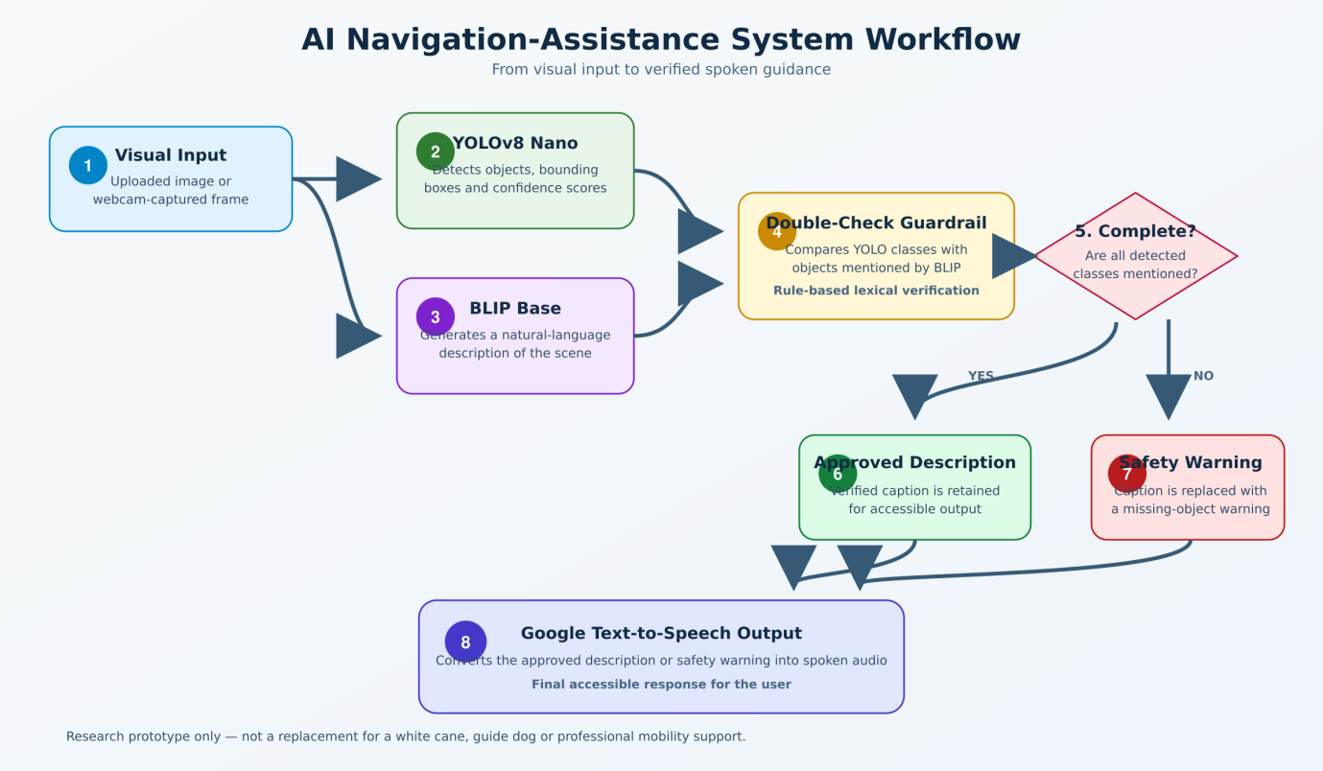
Figure 2.1: workflow of the proposed AI-based navigation-assistance system.

2.6 Scope of the study
The study focuses on the technical development and experimental evaluation of an academic prototype. The object-detection component is limited to the classes supported by the pretrained COCO model. Eleven classes were selected as navigation-related: person, bicycle, car, motorcycle, bus, truck, traffic light, stop sign, bench, chair and dog.
The research does not train YOLOv8 or BLIP from the beginning. Both models use pretrained weights. The hyperparameter experiment changes only inference settings: confidence threshold, Non-Maximum Suppression IoU threshold and input image size. Therefore, it should be described as inference-parameter tuning rather than model training or fine-tuning.
The quantitative object-detection evaluation uses the 5,000 images in the COCO 2017 validation dataset. A fixed random seed divides these images into 500 tuning images and 4,500 final-test images. The two groups do not overlap. BLIP is evaluated on 100 images selected from the final-test subset using the official COCO reference captions.
The guardrail is evaluated through 50 controlled scenarios. These scenarios test object names, plural terms, synonyms, complete descriptions and incomplete descriptions. This evaluation demonstrates functional correctness under the defined rules; it does not prove perfect performance on unrestricted natural language.
The system supports single-image upload, browser-based webcam capture and a Gradio graphical interface. It does not provide continuous video-stream navigation. It also does not estimate the physical distance or movement direction of an object. These functions remain outside the current scope.
No visually impaired participants were recruited. Consequently, the research evaluates technical performance rather than user satisfaction, mobility improvement or real-world safety.

2.7 Significance of the study
This research is significant because it connects object detection, natural-language generation, verification and speech synthesis within one accessible workflow. Many experimental systems focus on only one task, such as object recognition or image captioning. The proposed framework shows how these functions can be integrated into an end-to-end prototype.
The Double-Check Safety Guardrail is the main practical contribution. Instead of directly accepting a fluent BLIP caption, the system compares the caption with independently generated YOLO detections. This does not guarantee that the description is completely correct, but it provides a transparent verification step that can identify omitted object classes.
The use of lightweight pretrained models also supports cost efficiency. YOLOv8 Nano requires less computational capacity than larger object detectors. Using pretrained models avoids the high cost of collecting a custom dataset and training two large neural networks from the beginning. The prototype was developed using Google Colab and a Tesla T4 GPU, demonstrating that a meaningful experimental system can be produced using accessible cloud-computing resources.
The study also provides a structured evaluation covering object detection, caption quality, guardrail behaviour and processing latency. This is more informative than reporting only one accuracy score. The findings identify both strengths and weaknesses, providing a foundation for future work involving depth estimation, continuous video processing, mobile deployment and evaluation with visually impaired participants.

3: Literature Review

3.1 Introduction
This chapter reviews research related to assistive navigation, computer vision, deep learning, object detection and scene-description systems. It also examines the technologies used in the proposed prototype, including YOLOv8 Nano, the COCO dataset, BLIP, safety verification and text-to-speech.

3.2 Navigation challenges experienced by visually impaired individuals
Independent travel requires a person to collect and interpret different types of information. This includes the position of obstacles, the direction of a route, changes in ground level, moving vehicles, pedestrians, doors, road crossings and traffic signals. A sighted person can normally obtain much of this information visually and at a distance.
A 2024 review of navigation systems for visually impaired individuals found that modern solutions use combinations of GPS, computer vision, Radio-Frequency Identification, ultrasonic sensing, smartphone technology and wearable devices [9]. The review also identified limitations related to cost, usability, accuracy and operation across different environments.
Casanova et al. reviewed 89 studies concerning portable electronic travel aids published between 2020 and 2023 [10]. The authors found continued interest in camera-based and sensor-based assistance, but also identified a need for better user evaluation and practical testing. A technically accurate system may still be unsuccessful if its interface is difficult to understand, uncomfortable to wear or distracting during movement.
SLAM, or Simultaneous Localisation and Mapping, represents another important research direction. A SLAM system attempts to build a map while also estimating the user’s position within that map. Bamdad et al. reviewed the application of SLAM technologies for assisting visually impaired people [11]. Their review identified potential benefits for localisation and environmental understanding, alongside challenges involving dynamic environments, computational requirements and real-world implementation.
A recent scoping review found that trust in AI-enabled orientation and mobility technologies depends on system design, user interaction and the context in which assistance is provided [12].
Table 3.1: Comparison of common navigation aids.
Navigation aid | Main strengths | Main limitations
White cane | Affordable, reliable, portable and independent of electricity | Short detection range; cannot identify or describe objects
Guide dog | Supports obstacle avoidance and familiar-route travel | Expensive training and care; limited availability
GPS application | Provides outdoor route and location information | Limited indoor accuracy; does not understand immediate obstacles
Ultrasonic aid | Measures proximity to nearby surfaces | Normally provides little information about object type
Camera-based detector | Can identify and localise different objects | Performance can decline in poor lighting, occlusion and unusual scenes
Image-captioning system | Produces understandable descriptions | May omit objects or generate unsupported information
Multi-sensor system | Combines complementary information sources | Increased cost, power consumption, weight and complexity
Proposed prototype | Combines detection, captioning, verification and speech | Single-frame processing; no physical distance measurement or user study

3.3 Artificial Intelligence in assistive navigation
Artificial Intelligence refers to computational methods that perform tasks normally associated with human intelligence. These tasks include recognising patterns, interpreting language, identifying objects and making predictions. Machine learning is a branch of AI in which systems learn patterns from data rather than depending entirely on manually written rules.
Assistive navigation can use AI in several ways:
- Object detection can identify obstacles and environmental features.
- Image classification can assign one main category to an image.
- Semantic segmentation can classify individual image pixels.
- Depth estimation can estimate the relative distance of visible surfaces.
- Optical Character Recognition can read text from signs and documents.
- Image captioning can generate a sentence describing a scene.
- Speech synthesis can convert textual guidance into audio.
- Natural-language processing can interpret spoken user requests.

3.4 Computer vision
Computer vision is the field of AI concerned with extracting useful information from images and videos. A digital image is represented as a structured collection of pixel values. In a colour image, each pixel normally includes red, green and blue channel values. A computer-vision model processes these values to identify patterns such as edges, shapes, textures and complete objects.
Computer vision includes several related tasks:

3.4.1 Image classification
Image classification predicts the main category of an image. For example, a model may classify an image as containing a bus. However, classification normally does not identify where the bus is located and may not properly describe images containing several objects.

3.4.2 Object detection
Object detection identifies multiple objects and predicts their locations using bounding boxes. Each detection normally includes:
- The predicted class.
- A confidence score.
- Bounding-box coordinates.
This is the main computer-vision task used in the proposed prototype.

3.4.3 Semantic segmentation
Semantic segmentation assigns a class to each pixel. It can identify areas such as road, pavement, building and sky. This provides more precise information than a rectangular bounding box but normally requires more computational processing.

3.4.4 Instance segmentation
Instance segmentation separates different objects belonging to the same class. For example, it can distinguish between several individual people. This can be useful in crowded environments but is outside the present project’s scope.

3.4.5 Depth estimation
Depth estimation predicts the relative or physical distance of surfaces and objects. It may use stereo cameras, RGB-D sensors, LiDAR or monocular depth-estimation models. The current prototype does not implement depth estimation. Therefore, it should not be described as measuring whether an object is physically near or far.
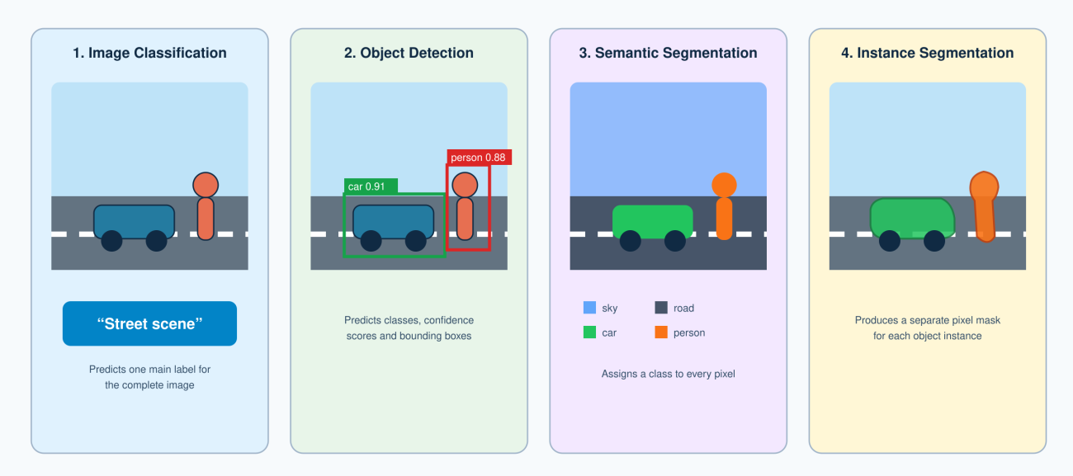
Figure 3.1: Comparison of common computer-vision tasks.

3.5 Deep learning and Convolutional Neural Networks
A neural network consists of connected computational units organised into layers. The input layer receives the data, hidden layers transform the data and the output layer produces a prediction. During training, a loss function measures the difference between the predicted result and the expected result.
A typical CNN includes:
- Convolutional layers for feature extraction.
- Activation functions for non-linear learning.
- Pooling or downsampling operations to reduce spatial size.
- Normalisation layers to support stable learning.
- Deeper feature-extraction blocks.
- Prediction layers for classification, localisation or segmentation.
Object-detection models normally contain three main parts:
- Backbone: Extracts visual features from the input image.
- Neck: Combines features from different spatial levels.
- Detection head: Predicts object classes, bounding boxes and confidence values.

3.6 Development of object detection
Object detection has developed from traditional feature-based methods to deep neural networks. Modern deep-learning detectors can be broadly divided into two-stage and one-stage models [13]. The 2024 object-detection survey explains this development and the continuing balance between speed and accuracy Development and challenges of object detection.

3.6.1 Two-stage object detectors
Two-stage detectors first identify possible object regions and then classify the proposed regions. Faster R-CNN introduced a Region Proposal Network that shares convolutional features with the detection network [14]. This improved the efficiency of earlier R-CNN approaches.

3.6.2 One-stage object detectors
One-stage detectors predict classes and bounding boxes directly without using a separate region-proposal stage. SSD, or Single Shot MultiBox Detector, predicts objects using feature maps from different network levels [15]. YOLO also treats detection as a single prediction problem [16].
Table 3.2: General comparison of detector types
Feature | Two-stage detector | One-stage detector
Typical examples | Faster R-CNN, Mask R-CNN | SSD, YOLO
Processing method | Region proposal followed by classification | Direct class and bounding-box prediction
Main traditional strength | High localisation and classification accuracy | Fast and computationally efficient inference
Main traditional limitation | Greater computational cost | Earlier models had weaker small-object accuracy
Suitability for this prototype | Less suitable for lightweight on-demand processing | More suitable because of speed and model-size options

The overlap between two boxes is measured using Intersection over Union:
$$IoU=\frac{Area of intersection}{Area of union}$$

3.7 Evolution of the YOLO family
YOLO changed object detection by treating the complete image as a single prediction problem. The first YOLO model divided the image into a grid and directly predicted bounding boxes and class probabilities [16]. It achieved fast inference but had difficulty with small objects and closely positioned objects.

3.7.1 YOLOv1
YOLOv1 demonstrated that detection could be performed using one neural-network evaluation [16]. Its unified design was faster than many region-proposal approaches. However, its grid-based prediction produced localisation errors, particularly where multiple small objects appeared in the same grid area.

3.7.2 YOLOv2 and YOLO9000
YOLOv2 introduced improvements including batch normalisation, anchor boxes and multi-scale training [17]. YOLO9000 extended the model to recognise a much larger number of categories by combining object-detection and image-classification data.

3.7.3 YOLOv3
YOLOv3 used a stronger Darknet-53 feature extractor and predictions at multiple scales [18]. Multi-scale prediction improved the detection of objects with different sizes. However, the model remained relatively computationally demanding compared with later lightweight variants.

3.7.4 YOLOv4
YOLOv4 combined several training and architectural techniques to improve accuracy and speed [19]. These included a CSPDarknet backbone, Spatial Pyramid Pooling and a Path Aggregation Network. YOLOv4 demonstrated that carefully selected training improvements could increase performance without making inference unsuitable for real-time applications.

3.7.5 Later YOLO developments
Later YOLO versions introduced changes to network structure, optimisation, model scaling and deployment. The YOLO family now supports tasks extending beyond bounding-box detection, including segmentation, classification, pose estimation and oriented bounding boxes.
A 2026 review traces the development of YOLO models from 2016 to 2025 and identifies anchor-free detection, lightweight architectures and multi-task support as important developments [20]. The review confirms that the YOLO family has continued to focus on the relationship between speed, accuracy and deployability.

3.7.6 YOLOv8
YOLOv8 was released by Ultralytics in 2023. Unlike the earlier YOLO versions that were mainly described through research papers, Ultralytics states that no formal YOLOv8 research paper was published because of the rapidly changing nature of the software [21]. Therefore, the official software repository and documentation are the most appropriate primary sources for its implementation details.
YOLOv8 is available in different sizes:
YOLOv8 Nano (yolov8n)
YOLOv8 Small (yolov8s)
YOLOv8 Medium (yolov8m)
YOLOv8 Large (yolov8l)
YOLOv8 Extra Large (yolov8x)
The proposed prototype loads:
yolo_model = YOLO("yolov8n.pt")
- Confidence threshold.
- Non-Maximum Suppression IoU threshold.
- Input image size.
This distinction is important. Changing inference parameters can alter which detections are retained, but it does not update the neural-network weights.
Table 3.3: Comparison of the main YOLOv8 model variants.
Model | Year | Main contribution | Relevant limitation
YOLOv1 | 2016 | Unified single-stage object detection | Difficulty with small and closely positioned objects
YOLOv2 | 2017 | Anchor boxes, batch normalisation and multi-scale training | Continued localisation limitations
YOLOv3 | 2018 | Darknet-53 and multi-scale prediction | Increased computational requirements
YOLOv4 | 2020 | Combined strong backbone, neck and training techniques | More demanding than lightweight alternatives
YOLOv8 | 2023 | Anchor-free detection, split head and scalable model sizes | Limited formal architectural publication; performance depends on data and settings
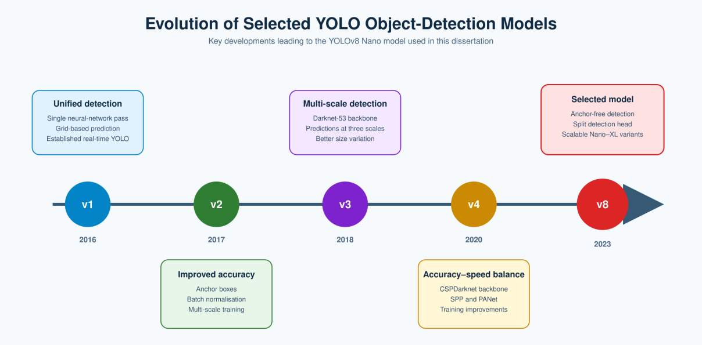
Figure 3.2: Development of selected models within the YOLO object-detection family.

3.7.7 Suitability of YOLOv8 Nano for this research
YOLOv8 Nano was suitable for the project for four reasons.
The model is therefore useful as a lightweight research component, but its output should not be considered a complete representation of the environment.

3.8 Microsoft COCO dataset
The quality of an object-detection model depends strongly on the data used during its development and evaluation. A dataset must contain enough variation to represent different object sizes, backgrounds, lighting conditions, viewing angles and levels of obstruction.
Microsoft Common Objects in Context, normally called MS COCO, was introduced to support research in object recognition, detection, segmentation and scene understanding [3]. Unlike datasets containing objects against simple backgrounds, COCO includes objects within complex everyday environments. For example, a person may appear beside a vehicle, inside a room or partly hidden behind another object.
The 80 detection categories include several classes relevant to navigation:
- Person
- Bicycle
- Car
- Motorcycle
- Bus
- Truck
- Traffic light
- Stop sign
- Bench
- Chair
- Dog

3.8.1 COCO 2017 validation dataset
The final notebook uses the 5,000 images in the official COCO 2017 validation dataset. These images include labelled bounding boxes and category information. The research creates two non-overlapping subsets:
- 500 images for inference-parameter tuning.
- 4,500 images for final object-detection testing.

3.8.2 COCO caption annotations
COCO also provides five human-written captions for many images. These captions describe important objects, actions and relationships. The final notebook uses the official captions to evaluate BLIP on 100 images selected from the 4,500-image final-test subset.
Table 3.4: Use of COCO data in the proposed research.
Dataset component | Number of images | Purpose
COCO 2017 validation set | 5,000 | Complete available evaluation dataset
Inference-tuning subset | 500 | Comparison of 18 YOLO inference configurations
Final object-detection subset | 4,500 | Independent final YOLO evaluation
BLIP evaluation sample | 100 | Caption-quality and block-rate evaluation
Webcam and upload images | Individual images | Qualitative prototype demonstration
The use of official annotations improves the reliability of the evaluation compared with manually written object lists. Nevertheless, performance on COCO does not prove that the system will perform equally well from a wearable camera or in an unfamiliar location. A future system would benefit from an accessibility-focused dataset such as SANPO [2].
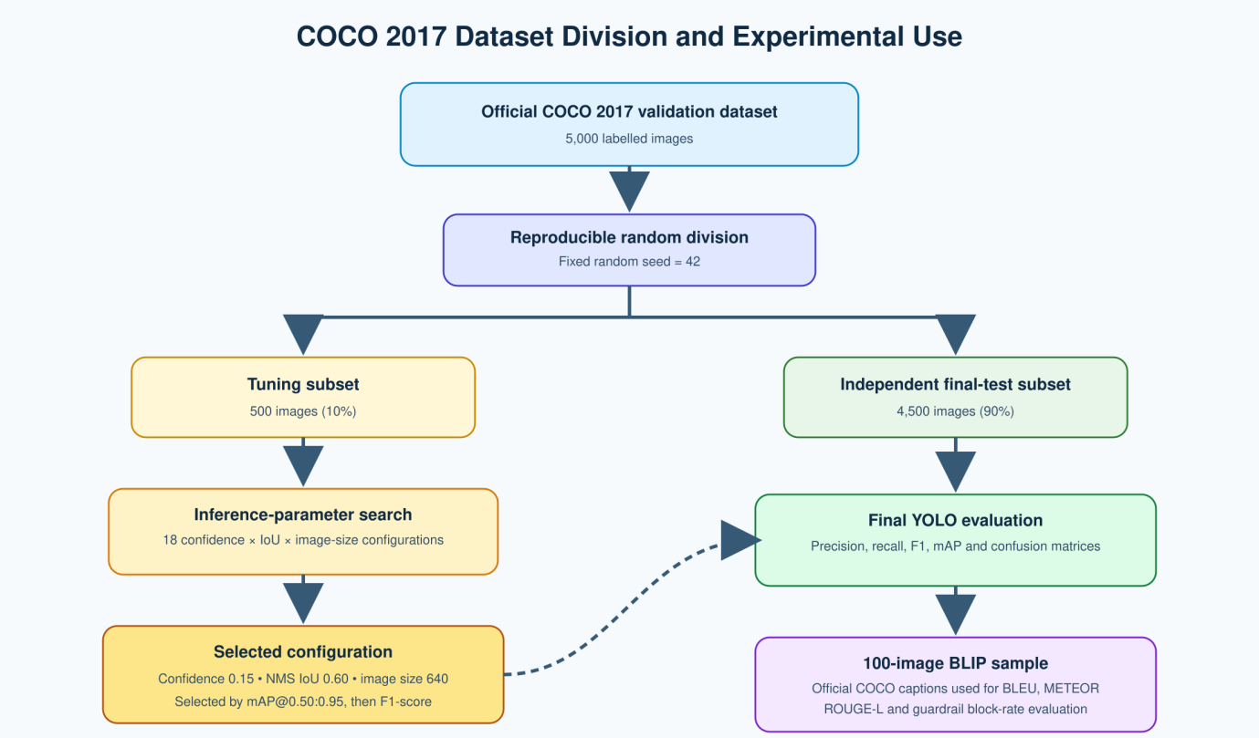
Figure 3.3: Division and use of the COCO 2017 validation dataset.

3.9 Vision-language models
A vision-language model learns relationships between visual and textual information. While a traditional image classifier predicts a class, a vision-language model can perform tasks involving both images and language. These tasks include:
- Image captioning
- Visual question answering
- Image-text retrieval
- Visual reasoning
- Image-grounded conversation
The Transformer architecture has become an important foundation for language and multimodal systems. Transformers use attention mechanisms to model relationships between elements in a sequence [22]. Unlike recurrent architectures, attention allows a model to process relationships between elements more directly.
Vision Transformers extended this approach to images by dividing an image into patches and processing the patches as a sequence [23]. CLIP later demonstrated that image and text encoders could learn shared representations from a large collection of image-text pairs [24]. These developments supported the rapid growth of multimodal and vision-language research.

3.10 Image captioning
Image captioning is the process of generating a textual description of an image. It combines visual feature extraction with language generation. A captioning system must identify important objects, recognise actions and form a grammatically understandable sentence.
For example, BLIP may generate:
“A group of people walking across a city street.”
This difference between general captioning and navigation-focused description supports the need for an additional verification process.

3.11 BLIP vision-language model
BLIP stands for Bootstrapping Language-Image Pre-training. It was introduced as a framework supporting both vision-language understanding and text generation [5]. BLIP was designed partly to address the problem of noisy image-text data collected from the internet.
The original BLIP framework introduced two important ideas:
- A multimodal mixture of encoder-decoder structures that can support different vision-language tasks.
- A captioning and filtering process that generates synthetic captions and removes noisy image-text pairs.
BLIP can be adapted for image-text retrieval, visual question answering and image captioning. The present research uses:
Salesforce/blip-image-captioning-base
This checkpoint is accessed through the Hugging Face Transformers library. The model is used without additional training.
The processing sequence is:
- The image is loaded using Pillow.
- The BLIP processor converts the image into model-compatible input.
- The input is transferred to the selected computing device.
- BLIP generates output tokens.
- The processor decodes the tokens into a readable sentence.
BLIP-2 later introduced a more compute-efficient method for connecting pretrained visual encoders with large language models [25]. However, the present project retains the original BLIP Base captioning model because it provides a comparatively lightweight and direct image-captioning pipeline.
Table 3.5: Comparison of YOLOv8 Nano and BLIP Base.
Feature | YOLOv8 Nano | BLIP Base
Primary task | Object detection | Image captioning
Input | Image | Image
Output | Classes, boxes and confidence scores | Natural-language sentence
Main strength | Efficient object localisation | Contextual, readable description
Main limitation | Does not explain the overall scene | May omit or hallucinate objects
Role in the prototype | Independent visual evidence | User-friendly scene description

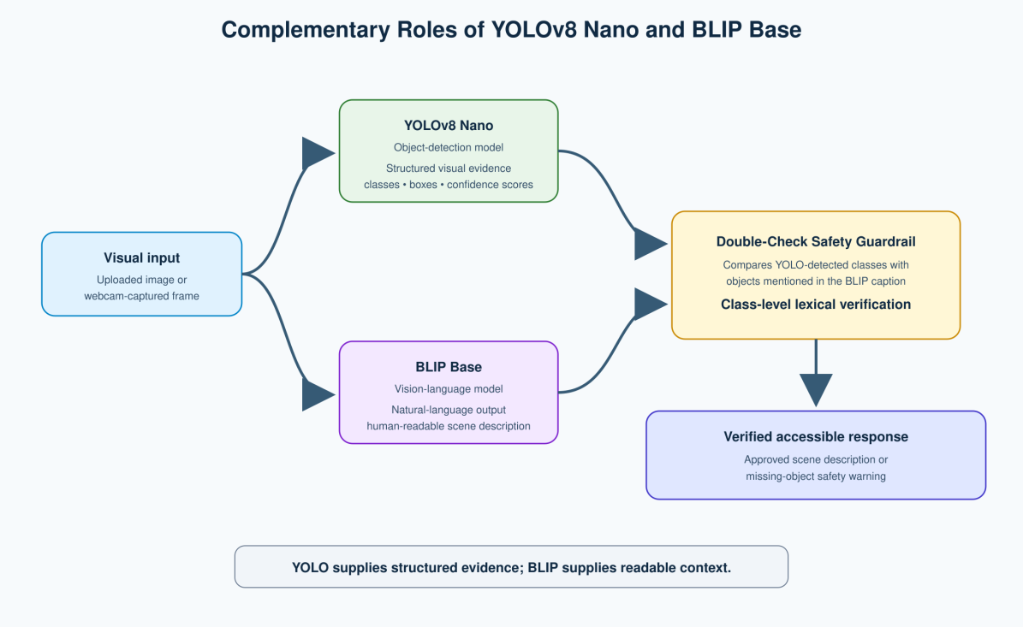
Figure 3.4: Complementary roles of YOLOv8 Nano and BLIP within the proposed system.

3.12 Evaluation of generated captions
Caption evaluation is difficult because different sentences may describe the same image correctly. Therefore, caption quality cannot be evaluated using ordinary classification accuracy.
The final notebook uses four reference-based metrics:
- BLEU-1
- BLEU-4
- METEOR
- ROUGE-L

3.12.1 BLEU
BLEU measures the overlap of word sequences between a generated caption and one or more reference captions [26]. BLEU-1 considers individual words, while BLEU-4 considers sequences containing up to four words.
BLEU is useful but does not fully measure meaning. Two sentences can communicate the same information while using different words.

3.12.2 METEOR
METEOR compares generated and reference text while considering word alignment, stemming and some forms of linguistic similarity [27]. It was developed partly to address weaknesses in simple exact n-gram matching.

3.12.3 ROUGE-L
ROUGE-L uses the Longest Common Subsequence between generated and reference text [28]. It measures similarity in word ordering without requiring every matching word to appear next to another matching word.
ROUGE was originally widely used for text summarisation, but ROUGE-L is also used as one indicator of caption similarity.

3.12.4 Limitations of reference-based metrics
Reference-based metrics should not be interpreted as direct measurements of navigation safety. Kapur et al. found that reference-based evaluation metrics may contain biases when applied to descriptions intended for blind and visually impaired users [29]. A caption can have strong word overlap with a general COCO reference while still omitting navigation-relevant information.

3.13 Hallucination in vision-language models
Hallucination occurs when generated content is not properly supported by the input. In a vision-language system, object hallucination may involve mentioning an object that is not visible. Incomplete visual grounding may also result in a model omitting or incorrectly describing visible objects.
A recent survey found that hallucination is a continuing problem across multimodal large language models [6]. Causes may include weaknesses in visual encoding, language bias, training-data patterns and overdependence on common object relationships.
Li et al. introduced Polling-based Object Probing Evaluation, known as POPE, to assess object hallucination in large vision-language models [30]. Their study found that commonly occurring objects and objects associated with visible content were more likely to be hallucinated. The POPE research demonstrates the importance of evaluating object-level factuality rather than judging only language quality.
Hallucination creates particular concerns in safety-related applications. A generated description may:
- Add an object that is not present.
- Omit a visible object.
- Misidentify an object.
- Describe an incorrect relationship.
- Misrepresent an action or direction.
- Use uncertain information as if it were certain.
However, the guardrail cannot verify every form of hallucination. It does not confirm:
- Whether a vehicle is moving or parked.
- Whether a person is crossing the road.
- Whether an object is to the left or right.
- Whether a traffic light is red or green.
- Whether a stated relationship is correct.
- Whether YOLO itself missed the object.
The guardrail should therefore be described as class-level lexical verification rather than complete semantic verification.

3.14 Verification and hallucination mitigation
Several approaches have been proposed to reduce vision-language hallucination. These include:
- Improved visual grounding.
- Alternative decoding methods.
- Model fine-tuning.
- Preference learning.
- Self-correction.
- External object detectors.
- Post-generation fact checking.
Visual Fact Checker is a training-free framework designed to improve detailed caption fidelity using visual grounding tools [7]. The approach illustrates the value of generating content and then checking it against additional visual evidence.
DAMRO examined attention mechanisms and reduced the influence of high-attention visual tokens associated with hallucination [31]. Its evaluation included POPE, CHAIR and other hallucination benchmarks. This shows that hallucination mitigation can operate within model attention and decoding. However, these approaches can be technically complex and model-specific.
The advantages of this method include:
- Simple implementation.
- Transparent decision rules.
- Low processing latency.
- Easy identification of missing classes.
- No need to retrain either model.
- Ability to add synonyms manually.
Its limitations include:
- Dependence on YOLO detection quality.
- Dependence on predefined navigation classes.
- Limited understanding of sentence meaning.
- Inability to verify object position or movement.
- Controlled vocabulary requirements.
- Possible errors caused by unusual wording.

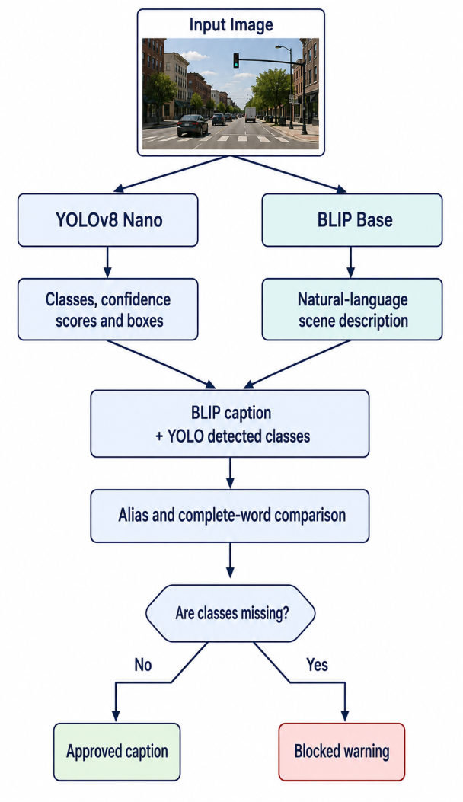
Figure 3.5: Class-level verification performed by the Double-Check Safety Guardrail.

3.15 Accessibility, speech output and user interaction
An assistive system must communicate information in an accessible way. Displaying object labels on a screen would not meet the needs of many intended users. Speech output provides a direct way to deliver environmental information.
Text-to-speech systems convert written language into spoken audio. Modern TTS systems can generate understandable speech with little delay. The present prototype uses the gTTS Python library [8].
The system converts two types of response into speech:
- An approved BLIP description.
- A safety warning explaining which detected object classes were omitted.
This design ensures that a blocked caption is not silently discarded. Instead, the user receives a warning containing the missing object information.

3.16 Recent assistive vision-language research
Recent studies show increasing interest in applying multimodal models to accessibility. However, they also identify limitations not always captured by general benchmarks.
Zhang et al. described “implicit motion blindness,” where AI systems may recognise the objects in a scene but fail to understand important movement, such as an escalator’s direction [32]. This is highly relevant to assistive navigation. Detecting the category “escalator” does not necessarily provide enough information to use it safely.
SANPO provides accessibility-focused egocentric data for human navigation [2]. Compared with ordinary third-person datasets, egocentric images are closer to the viewpoint of a person carrying or wearing a camera. This is important because object appearance, angle and scale can differ from standard dataset images.
Recent navigation models also combine visual input, language and environmental memory. NavMorph, for example, develops a world model that changes as new visual-language observations become available [33]. Such research goes beyond single-frame captioning and moves towards continuous embodied navigation. Nevertheless, it requires more complex datasets, models and evaluation than the current project.

3.17 Trustworthy and responsible AI
Assistive navigation is a safety-sensitive application. A system failure may have more serious consequences than an incorrect recommendation in a low-risk application. Responsible development therefore requires clear communication of limitations.
The NIST Artificial Intelligence Risk Management Framework identifies validity, reliability, safety, transparency, explainability, privacy and fairness as important characteristics of trustworthy AI [34]. The framework encourages organisations to identify and manage risks throughout the AI lifecycle.
The UNESCO Recommendation on the Ethics of Artificial Intelligence also emphasises human oversight, proportionality, safety and protection of human rights [35]. These principles are relevant because assistive technology should support user independence without encouraging unsafe dependence on an imperfect system.
The prototype includes several responsible-design decisions:
- It includes an explicit research-only warning.
- It does not claim to replace established mobility aids.
- It records confidence scores.
- It uses a visible guardrail decision.
- It separates controlled-test results from real-world claims.
- It reports weak as well as strong performance results.
- It does not claim physical distance estimation.
- It does not claim continuous video navigation.
- It does not store participant data because no user study was conducted.

3.18 Related work comparison
Previous assistive systems can be grouped into several categories.

3.18.1 Sensor-based obstacle detection
These systems use ultrasonic, infrared, LiDAR or depth sensors. They can provide reliable proximity information but may not identify the object or explain the complete scene.

3.18.2 Computer-vision object recognition
Camera-based systems can recognise multiple categories and provide richer information. However, many systems return labels rather than contextual descriptions.

3.18.3 Image-captioning assistance
Captioning systems provide natural-language summaries. They are easier to understand than lists of labels but may omit safety-relevant objects or produce hallucinated content.

3.18.4 Multi-sensor and wearable systems
Wearable systems can combine cameras, GPS, inertial sensors and depth information. They may provide stronger navigation functionality but normally require additional equipment and development cost.

3.18.5 Proposed verification-based prototype
The present system combines object detection and image captioning with a transparent lexical verification step. It also evaluates each major component separately rather than presenting only a final demonstration.
Table 3.6: Comparison between existing approaches and the proposed system.
Capability | Traditional aids | Sensor-based electronic aids | Object-detection systems | Captioning systems | Proposed prototype
Nearby obstacle awareness | Yes | Yes | Yes | Partial | Yes
Object-class identification | No | Limited | Yes | Partial | Yes
Natural-language description | No | Limited | No | Yes | Yes
Description verification | No | No | Not applicable | Usually no | Yes
Spoken output | No | Sometimes | Sometimes | Sometimes | Yes
Labelled dataset evaluation | Not applicable | Sometimes | Yes | Yes | Yes
Webcam/image interface | No | Device dependent | Often | Often | Yes
Physical distance measurement | Cane length only | Often | Not normally | No | No
Continuous navigation | Human controlled | Sometimes | Sometimes | Rarely | No

3.19 Identified research gap
The literature demonstrates significant progress in object detection, image captioning and assistive navigation. However, four connected gaps remain relevant to this dissertation.
First, object-detection systems often provide labels without explaining the complete scene. Although the labels may be accurate, they may not form a convenient spoken message.
The proposed research addresses these gaps by:
- Combining YOLOv8 Nano object detection with BLIP scene captioning.
- Introducing a transparent class-level Double-Check Safety Guardrail.
- Converting either the approved description or warning into speech.
- Evaluating YOLO using 4,500 labelled COCO images.
- Tuning inference parameters on a separate 500-image subset.
- Evaluating BLIP on 100 images using four caption metrics.
- Evaluating the guardrail using 50 controlled scenarios.
- Measuring individual-component and end-to-end latency.
- Providing upload, webcam and graphical demonstrations.

4. Research Methodology

4.1 Introduction
This chapter explains the methods used to design, implement and evaluate the proposed AI-based navigation-assistance prototype. It describes the research approach, development environment, datasets, AI models, system components, inference-parameter tuning and experimental procedures.
The project follows a quantitative experimental approach supported by qualitative prototype demonstrations. Quantitative testing measures the performance of YOLOv8 Nano, BLIP, the Double-Check Safety Guardrail and system latency. Qualitative demonstrations show how the complete system processes uploaded and webcam-captured images.
The methodology includes six major stages:
- Environment and model preparation.
- Prototype component development.
- COCO dataset preparation.
- YOLO inference-parameter tuning.
- Independent final evaluation.
- Complete prototype demonstration.

4.2 Research design
The research uses an experimental system-development design. This approach was selected because the project involves constructing a working AI prototype and measuring its technical performance.
The research is primarily quantitative because numerical measurements are collected for:
- YOLO object detection.
- BLIP caption generation.
- Guardrail classification.
- Component-level latency.
- Complete end-to-end latency.
A qualitative element is also included through the examination of generated captions, detected objects, annotated images, warnings and audio responses. These demonstrations help explain how the prototype behaves, but they are not used as replacements for quantitative results.
Table 4.1: Research design and evidence
Research component | Research method | Evidence produced
YOLO parameter selection | Quantitative experiment | Comparison of 18 configurations
YOLO final evaluation | Labelled dataset evaluation | Precision, recall, F1 and mAP
Navigation-class analysis | Per-class quantitative analysis | Results for 11 selected classes
BLIP evaluation | Reference-caption comparison | BLEU-1, BLEU-4, METEOR and ROUGE-L
Guardrail evaluation | Controlled functional testing | Accuracy, precision, recall, F1 and confusion matrix
Latency evaluation | Repeated timing experiment | Mean, median, standard deviation, minimum and maximum
Upload demonstration | Qualitative prototype test | Annotated image, caption, warning and audio
Webcam demonstration | Qualitative prototype test | Captured frame and complete response
Gradio interface | System demonstration | Accessible user-interface output

4.3 Research philosophy and approach
The project adopts a practical problem-solving approach. Its purpose is to investigate whether available pretrained AI technologies can be integrated into a working assistive-navigation prototype.
The research does not attempt to develop a new neural-network architecture. Instead, it investigates the practical integration of existing models and introduces a rule-based verification component. This is appropriate because the research problem concerns the reliability of generated scene descriptions rather than only the development of a higher-performing object detector.
A deductive structure is used in the evaluation. The literature suggests that:
- Object detectors can identify and localise objects.
- Vision-language models can produce readable descriptions.
- Generated descriptions can omit or hallucinate objects.
- Independent visual evidence may help verify generated content.
Based on these observations, the prototype was designed to test whether YOLO detection results could be used to verify BLIP-generated captions.
The main proposition tested by the prototype is:
A rule-based comparison between YOLO-detected navigation classes and BLIP-generated text can identify some incomplete scene descriptions before spoken output is delivered.

4.4 Development environment
The prototype was developed and executed in Google Colab. Colab was selected because it provides a browser-based Python environment and access to GPU hardware without requiring the user to purchase a high-performance local computer.
The final recorded environment included:
Component | Final configuration
Development platform | Google Colab
Programming language | Python 3.12.13
GPU | NVIDIA Tesla T4
CUDA availability | Enabled
CUDA version | 12.8
PyTorch version | 2.11.0+cu128
Main detector | YOLOv8 Nano
Detector weights | yolov8n.pt
Caption model | Salesforce/blip-image-captioning-base
Random seed | 42

The project records important version and configuration information in a reproducibility JSON file. This helps explain the environment in which the reported results were produced.
Complete reproducibility cannot be guaranteed across all hardware, operating systems and software versions. PyTorch documentation explains that identical results are not always guaranteed between different releases, platforms or CPU and GPU execution, even when the same random seed is used [36]. However, setting a fixed seed and recording software versions can reduce unnecessary variation. This limitation is acknowledged in the official PyTorch reproducibility guidance.

4.4.1 Main Python libraries
The notebook uses the following libraries:
Library | Purpose
PyTorch | Model execution and GPU support
Ultralytics | Loading, running and validating YOLOv8 Nano
Transformers | Loading the BLIP processor and captioning model
OpenCV | Image processing and annotation support
Pillow | Image loading and conversion
NumPy | Numerical processing
pandas | Results tables and CSV export
Matplotlib | Performance graphs
Seaborn | Confusion-matrix visualisation
scikit-learn | Guardrail metrics and confusion matrices
pycocotools | Access to official COCO annotations and evaluation support
NLTK | BLEU and METEOR calculations
rouge-score | ROUGE-L calculation
gTTS | Text-to-speech conversion
Gradio | Graphical user interface
IPython | Display of images, audio and notebook outputs
Package installation is performed in the notebook. The environment is then checked to confirm whether CUDA and the T4 GPU are available.
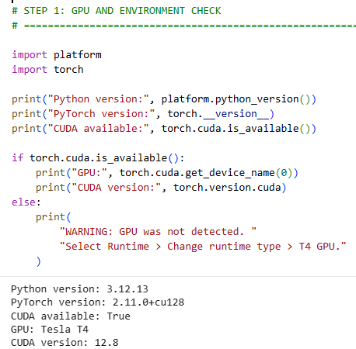
Figure 4.1: Google Colab hardware and software environment used for prototype development.

4.5 System requirements
The system was designed around several functional and non-functional requirements.

4.5.1 Functional requirements
The prototype should:
- Accept an uploaded image.
- Capture one webcam frame in Google Colab.
- Detect navigation-related objects using YOLOv8 Nano.
- Generate a natural-language caption using BLIP Base.
- compare detected classes with caption text.
- recognise common synonyms and plural terms.
- approve a caption when all selected detected classes are mentioned.
- block a caption when at least one selected class is missing.
- create a safety warning listing unique missing classes.
- convert the final response into speech.
- display an annotated image and processing results.
- provide a Gradio graphical interface.
- save evaluation results, graphs and configuration information.

4.5.2 Non-functional requirements
The prototype should also be:
- Understandable: Outputs should use clear language.
- Efficient: The lightweight YOLOv8 Nano model should support low-latency detection.
- Transparent: The guardrail should clearly show approved, verified and missing classes.
- Reproducible: Dataset lists, random seed, parameters and software versions should be saved.
- Accessible: The final response should be available as spoken audio.
- Cost-efficient: The system should use pretrained models and accessible cloud hardware.
- Cautious: The interface should contain a research-only safety disclaimer.
- Modular: Detection, captioning, verification and speech functions should be separable.
Table 4.2: Mapping requirements to implementation
Requirement | Implementation
Detect objects | YOLOv8 Nano
Generate scene description | BLIP Base
Verify object mentions | Double-Check Safety Guardrail
Handle synonyms | CRITICAL_ALIASES dictionary
Remove duplicate warnings | Unique detected-class set
Generate audio | gTTS
Capture webcam image | JavaScript-based Colab camera function
Provide GUI | Gradio Blocks interface
Store results | CSV, JSON, PNG and ZIP export
Warn users | Research-prototype disclaimer

4.6 AI models
Two pretrained AI models are used.

4.6.1 YOLOv8 Nano
YOLOv8 Nano is used as the object detector. The following model file is loaded:
yolo_model = YOLO("yolov8n.pt")
The model uses pretrained COCO weights. It is not trained again in this research. Its neural-network parameters remain unchanged throughout the experiments.
For every detected object, the detection function returns:
- Object class.
- Confidence score.
- Bounding-box coordinates.
- Detection latency.
The detector filters its outputs so that the prototype interface focuses on the 11 selected navigation-related classes.
The research tunes only inference settings. Ultralytics provides configurable prediction and validation parameters, including confidence threshold, IoU threshold and input image size [37]. These parameters influence which detections are retained and how the input is processed, but they do not change the learned model weights. The relevant options are documented in the Ultralytics configuration guide.

4.6.2 BLIP Base
The captioning component uses:
BLIP_MODEL_ID = "Salesforce/blip-image-captioning-base"
The notebook loads:
BlipProcessor
BlipForConditionalGeneration
The processor prepares an image for the model. BLIP then generates tokens, which are decoded into a natural-language sentence.
BLIP is also used with pretrained weights. No additional training or fine-tuning is performed. The model is moved to the GPU where available to improve processing time.

4.6.3 Reasons for using pretrained models
Pretrained models were selected for several reasons:
- Training YOLO or BLIP from the beginning would require substantial data and computing resources.
- COCO-pretrained YOLO weights already support common navigation-related categories.
- BLIP already supports image-to-text generation.
- The project focuses on system integration and verification.
- Pretrained models make the prototype more cost-efficient.
- The approach can be reproduced using public model checkpoints.
Table 4.3: Model configuration
Item | YOLOv8 Nano | BLIP Base
Model identifier | yolov8n.pt | Salesforce/blip-image-captioning-base
Task | Object detection | Image captioning
Model source | Ultralytics | Salesforce/Hugging Face
Weight status | Pretrained | Pretrained
Additional training | No | No
Main output | Classes, boxes and confidence | Natural-language caption
Evaluation data | 4,500 COCO images | 100 COCO images
GPU use | Yes | Yes

4.7 Navigation-related classes and aliases
YOLOv8 can recognise 80 standard COCO detection categories, but not every category has equal importance for the proposed prototype.
The following set was defined:
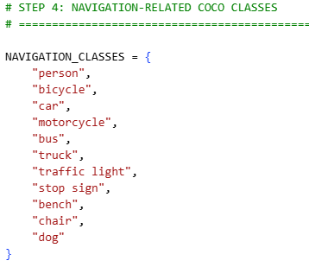
Figue 4.2: COCO Navigation related classes
These classes were selected because they represent:
- Road users.
- Vehicles.
- Traffic-control objects.
- Common seating obstacles.
- Animals that may affect movement.
Other COCO objects can still be detected by YOLO, but they are not all treated as safety-critical by the guardrail.

4.7.1 Alias dictionary
Natural-language captions may use a different word from the formal COCO class. For example:
- BLIP may say “people” instead of “person.”
- BLIP may say “bike” or “cyclist” instead of “bicycle.”
- BLIP may say “lorry” instead of “truck.”
- BLIP may say “traffic signal” instead of “traffic light.”
An alias dictionary is therefore used. The guardrail checks both the main class label and its recognised alternatives.
Table 4.4: Examples of guardrail aliases
COCO class | Accepted terms
Person | person, people, pedestrian, pedestrians, man, woman
Bicycle | bicycle, bicycles, bike, bikes, cyclist, cyclists
Motorcycle | motorcycle, motorcycles, motorbike, motorbikes
Truck | truck, trucks, lorry, lorries
Traffic light | traffic light, traffic lights, traffic signal, traffic signals
Bench | bench, benches
Chair | chair, chairs
Dog | dog, dogs

4.8 Double-Check Safety Guardrail design
The Double-Check Safety Guardrail is a rule-based verification component. It does not contain a separately trained neural network.
Its operation is:
- Receive the YOLO detections.
- Keep navigation-related classes.
- Remove duplicate class labels.
- Convert the BLIP caption to lowercase.
- Search for each class or recognised alias as a complete word or phrase.
- Create a list of verified classes.
- Create a list of missing classes.
- Record possibly hallucinated navigation terms.
- Approve or block the caption.
The decision rule is:
Status={Approved,​if the missing-object set is empty. Blocked,if one or more selected classes are missing​.
If the result is approved, the BLIP caption is retained. If it is blocked, the system creates a warning identifying the missing classes.
For example:
Warning. The generated description omitted the following
detected object classes: traffic light.
As shown in Figure 3.5, the guardrail receives outputs from both AI models, performs alias-based complete-word comparison and returns an approved or blocked decision.

4.8.1 Guardrail scope
The guardrail verifies class mentions only. It does not confirm:
- Object location.
- Object distance.
- Movement.
- Colour or state of a traffic light.
- Relationships between objects.
- Whether a YOLO detection is correct.
- Whether YOLO missed an object.
This limitation is intentionally stated in the notebook output:
“Class-level lexical comparison only. The result does not prove semantic correctness or real-world navigation safety.”
This statement should be included in the dissertation because it accurately limits the technical claim.

4.9 Text-to-speech and final response decision
The system creates speech only after producing the final response. The final response can be either:
- An approved BLIP caption.
- A missing-object warning.
Google Text-to-Speech converts the text into an MP3 file. The processing time is recorded separately so that online speech-generation time can be distinguished from the core AI pipeline.
The final response logic is:
If guardrail status = APPROVED:
final message = BLIP description
Otherwise:
final message = safety warning

Convert final message into speech

4.10 Dataset preparation
The quantitative object-detection experiment uses the official COCO 2017 validation dataset.
The notebook downloads:
- 5,000 validation images.
- Official object-detection labels.
- Official caption annotations.
The notebook then verifies:
- Total number of images.
- Number of tuning paths.
- Number of final-test paths.
- Missing image files.
- Overlap between subsets.
- Images with labels.
- Background images.
- YAML structure.
The recorded validation found:
Dataset check | Result
Total COCO validation images | 5,000
Tuning images | 500
Final-test images | 4,500
Overlapping images | 0
Tuning images with labels | 492
Tuning background images | 8
Final-test images with labels | 4,460
Final-test background images | 40
Tuning YAML | Valid
Final-test YAML | Valid
Images without object labels are not necessarily errors. Some COCO images may not contain a labelled instance from the relevant detection categories. These images can still help measure false-positive behaviour.
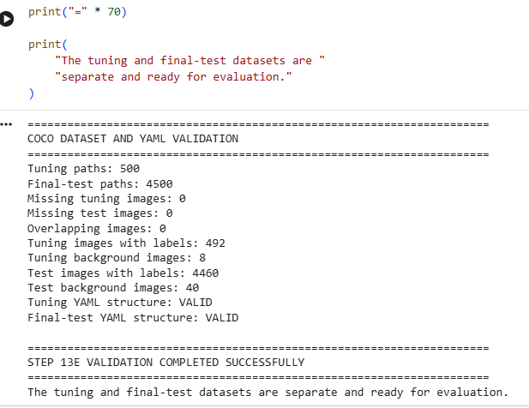
Figure 4.2: Validation of the COCO tuning and final-test subsets.

4.11 Reproducibility and data-leakage prevention
A fixed random seed of 42 is used to select the tuning and final-test images. The lists of image paths are saved as text files.
The methodology prevents direct tuning–test leakage by ensuring that:
- No image appears in both subsets.
- Only the 500 tuning images are used to compare parameter configurations.
- Final YOLO performance is measured on the separate 4,500-image subset.
- The selected parameters are saved before final evaluation.
- BLIP evaluation images come from the final-test group, not the tuning group.
The following artefacts are saved:
- Tuning-image list.
- Final-test-image list.
- Tuning YAML.
- Final-test YAML.
- Selected hyperparameters.
- Software and hardware configuration.
- Evaluation tables.
- Metric graphs.
- Confusion matrices.
- Final results summary.

4.12 Inference-Parameter Tuning
The YOLOv8 Nano model was used with its existing pretrained weights. Therefore, the model was not trained or fine-tuned on the COCO dataset during this project. Instead, three inference parameters were adjusted to find an appropriate configuration for the navigation-assistance system:
- Confidence threshold
- Non-maximum suppression IoU threshold
- Input image size
The confidence threshold controls the minimum confidence score required for an object detection to be accepted. A low threshold may detect more objects, but it may also produce more false detections. A high threshold can reduce false detections, but important navigation objects may be missed.
The values evaluated in the notebook are presented in the Table
Table 4.5: YOLOv8 inference-parameter search space
Parameter | Values tested | Number of values
Confidence threshold | 0.15, 0.25, 0.35 | 3
NMS IoU threshold | 0.40, 0.50, 0.60 | 3
Input image size | 480, 640 pixels | 2
Total combinations | (3 \times 3 \times 2) | 18

All 18 parameter combinations were evaluated using the 500-image tuning subset. The 4,500-image final-test subset was not used during parameter selection. This separation reduced the possibility of choosing settings that performed well only because the final evaluation images had already influenced the system design.
The tuning process selected the following configuration:
- Confidence threshold: 0.15
- NMS IoU threshold: 0.60
- Input image size: 640 pixels
The selected confidence threshold is relatively low because missing an important navigation object may be more harmful than reporting an additional uncertain object. However, this choice does not guarantee that every object will be detected. It only provides the best tested balance within the limited parameter grid.
The selected settings were stored and reused in later notebook steps. They were not manually changed during final testing.
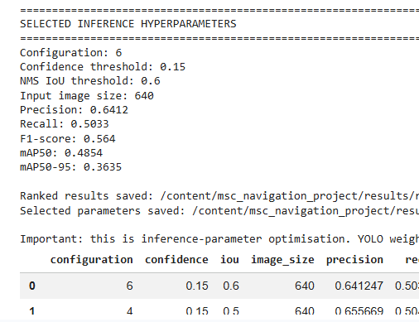
Figure 4.3: YOLOv8 inference-parameter tuning and selection of the final configuration.

4.13 Final YOLOv8 Evaluation Protocol
After selecting the inference settings, the YOLOv8 model was evaluated once on the independent 4,500-image final-test subset. This evaluation was intended to estimate how well the pretrained detector could identify and localise objects on unseen COCO validation images under the selected configuration.
The evaluation produced two groups of measurements:
- Overall COCO object-detection results
- Results for the 11 navigation-related classes used by the application
The final evaluation was performed using the same model weights and inference settings for every image. Predictions were not manually corrected. Images with no labelled object were also kept in the final-test subset. This was important because background images could reveal whether the model generated detections when no labelled object was present.
The detailed final numerical results should be reported in Chapter 5 rather than repeated in the methodology chapter.

4.14 Navigation-Class Evaluation
The system focused on 11 classes that were considered relevant to pedestrian navigation:
- Person
- Bicycle
- Car
- Motorcycle
- Bus
- Truck
- Traffic light
- Stop sign
- Bench
- Chair
- Dog
Results were extracted separately for these classes. Precision, recall, F1-score, mAP@0.50 and mAP@0.50:0.95 were calculated for each class
A macro average was then calculated across the 11 classes. In a macro average, each class contributes equally:
​ $Mmacro=\frac{1}{C}\sum_{c=1}^{c}{Mc}$
where Mc​ is the metric for class c, and C=11 is the number of navigation classes.
This means that a less common class, such as a stop sign, has the same influence on the macro result as a common class, such as a person or car. This approach was suitable because the system should not appear effective only because it performs well on frequently occurring objects.

4.15 BLIP Caption Evaluation
The BLIP Base model generated a natural-language description for each input image. A subset of 100 images was selected from the independent final-test set for caption evaluation. These images were not taken from the 500-image tuning subset.
Each selected image had official COCO reference captions. The BLIP-generated caption was compared with these human-written references using:
- BLEU-1
- BLEU-4
- METEOR
- ROUGE-L
BLEU measures the overlap of word sequences between a generated caption and one or more reference captions. BLEU-1 considers individual words, whereas BLEU-4 considers sequences containing up to four words. BLEU-4 is therefore stricter because a caption must share longer word patterns with the references.
A simplified modified n-gram precision can be expressed as:
$$pn​=\frac{∑ngram∈C​\min\left(CountC​\left(ngram\right),CountR​\left(ngram\right)\right)}{​∑ngram∈C​CountC​\left(ngram\right)}$$
where C is the candidate caption and R represents the reference captions.
METEOR considers word matching while giving attention to both precision and recall. It can offer a more flexible comparison than exact n-gram matching. ROUGE-L uses the longest common subsequence between the generated and reference text. The implementations used in the notebook were based on established text-evaluation packages, including NLTK for BLEU and METEOR [38] and Google Research’s ROUGE implementation [39].
The system also recorded the mean time required to generate a BLIP caption. This measurement helped identify the contribution of image captioning to the total system delay.
Table 4.6: BLIP caption-evaluation design.
Evaluation element | Method used
Evaluation sample | 100 images
Source | Independent 4,500-image final-test subset
Reference text | Official COCO human captions
Generated text | BLIP Base caption
Text metrics | BLEU-1, BLEU-4, METEOR and ROUGE-L
Additional measurements | Caption latency and guardrail decision
Model training | None

4.16 Object-Completeness Guardrail Evaluation
The guardrail was evaluated using 50 controlled lexical test scenarios. Each scenario included:
- A generated or example caption
- A set of object classes expected from YOLO
- An expected decision of either approved or blocked
The scenarios covered direct class-name matches, aliases, plural words, punctuation, missing objects and cases where a class name appeared only as part of another word.
Complete-word matching was used to reduce false matches. This is important because a short class name may appear inside an unrelated word. The guardrail normalised the caption to lowercase, removed unnecessary punctuation and compared the text with the alias collection for every detected class.
The decision rule was:
Decision={Approved, if all detected classes are represented. Blocked,​if one or more detected classes are missing​ .
The guardrail test used the following outcome categories.
Expected decision | System decision | Outcome
Approved | Approved | Correct approval
Approved | Blocked | False block
Blocked | Blocked | Correct block
Blocked | Approved | False approval
The 50 test scenarios were controlled tests of the implemented lexical rules. Consequently, even if the guardrail correctly handles every test case, this must not be described as proof of perfect real-world performance. Real captions may contain unexpected synonyms, spelling errors, ambiguous words or descriptions that were not represented in the controlled test set.

4.17 Mean Average Precision
Average precision summarises the precision–recall relationship for an object class. Mean average precision averages this result across multiple classes.
Two mAP measurements were retained:
- mAP@0.50, using an IoU threshold of 0.50
- mAP@0.50:0.95, averaged over thresholds from 0.50 to 0.95 in steps of 0.05
mAP@0.50:0.95 is stricter because it evaluates localisation quality at several overlap thresholds. The Ultralytics validation process reports these standard detection measurements [4], [40].

4.18 Latency Evaluation
Processing speed was evaluated because a navigation-assistance system must provide information within a useful period. A highly accurate description may have limited practical value if the user receives it too late.
The latency experiment separated the system into the following stages:
- YOLOv8 object detection
- BLIP caption generation
- Guardrail checking
- Core pipeline
- Text-to-speech generation
- End-to-end processing
After warm-up, 30 core-pipeline runs were measured. End-to-end processing was measured over 10 runs because it included additional operations, including text-to-speech generation.
Component | Recorded runs | Measurement purpose
Warm-up pipeline | 3 | Prepare models and GPU; excluded from results
YOLOv8 | 30 | Object-detection time
BLIP | 30 | Caption-generation time
Guardrail | 30 | Text-comparison and decision time
Core pipeline | 30 | Combined detection, caption and guardrail time
End-to-end system | 10 | Full process including speech generation
The median was also retained because it is less affected by occasional long executions. Minimum and maximum values were recorded to show variation between runs.
The text-to-speech stage used gTTS, which depends on an online service. Therefore, its execution time can be influenced by network conditions. The end-to-end latency should not be interpreted as a pure GPU benchmark.

4.19 Reliability and Reproducibility
Several actions were taken to improve experimental reliability:
- A fixed random seed of 42 was used.
- The tuning and final-test subsets had no overlap.
- The selected YOLO settings were reused without manual alteration.
- Pretrained model identifiers were explicitly stated.
- The Python, PyTorch, CUDA and GPU versions were recorded.
- Warm-up executions were excluded from timed results.
- Saved notebook outputs provided evidence of successful execution.
- Final metrics were exported as structured tables where appropriate.
The fixed seed supports repeatability of the dataset division. However, complete numerical reproduction is not always guaranteed when GPU operations, external services or library versions differ. PyTorch documentation explains that identical results are not guaranteed across every platform and software release, even when random seeds are controlled [36].
The use of gTTS introduces another variable because it depends on network access and external service response time. Repeating the same test under different network conditions may therefore produce a different end-to-end latency.

4.20 Ethical and Safety Considerations
The system processes images that may contain people. In a deployed application, this creates privacy concerns. Camera images should be processed only when required, stored for the shortest practical time and protected from unauthorised access.
The guardrail reduces one type of risk: omission of a class that YOLO has already detected. It cannot identify an object that YOLO failed to detect. It also cannot confirm that the full caption is factually correct. For example, it may confirm that the word “car” appears, but it does not verify every statement made about that car.
The prototype should therefore include a clear warning similar to the following:
This research prototype provides supplementary scene information. It must not replace a mobility aid, guide dog, trained assistant or the user’s own safety judgement.

4.21 Methodological Limitations
The methodology has several limitations.
First, the object detector and caption model were not trained specifically for navigation assistance. Both models used general-purpose pretrained weights. This reduces development cost but may limit performance for small obstacles, unusual viewpoints and navigation-specific hazards.
Third, only 100 images were used for automated caption evaluation. This sample provided an initial estimate but was smaller than the full object-detection test set.
Fourth, the guardrail was evaluated using 50 controlled lexical scenarios. These tests assessed the implemented rules but did not cover every possible sentence structure or synonym.
Fifth, distance estimation was not implemented. The system could report that an object was present, but it could not reliably state the object’s distance from the user.

5. System Implementation

5.1 Introduction
This chapter explains how the proposed generative AI navigation-assistance prototype was implemented in Google Colab. The implementation combined object detection, image captioning, caption verification and speech generation within one notebook.
The main components were YOLOv8 Nano, BLIP Base, the double-check safety guardrail and Google Text-to-Speech. YOLOv8 Nano identified navigation-related objects and produced bounding boxes, class names and confidence scores. BLIP Base generated a natural-language description of the complete scene. The guardrail compared the detected object classes with the generated caption. Finally, the approved description or warning was converted into speech.

5.2 Development Environment
The prototype was developed using Python in Google Colab. This platform was selected because it provided access to an NVIDIA Tesla T4 GPU without requiring a dedicated local computer [44].
Notebook Step 1 checked the software and hardware environment before loading the models. The recorded environment included Python 3.12.13, PyTorch 2.11.0 with CUDA 12.8 and an NVIDIA Tesla T4 GPU. CUDA availability was confirmed as True, showing that the deep-learning models could use GPU acceleration.
The notebook also displayed a warning explaining that identical numerical results are not guaranteed across every PyTorch release, platform or hardware configuration. A fixed seed improved reproducibility, but it could not remove every possible difference between computing environments.

5.3 Package Installation and Project Configuration
Notebook Step 2 installed the required Python packages. Ultralytics was used for YOLOv8, while Transformers was used to load the BLIP image-captioning model. Other packages supported image processing, numerical analysis, metric calculation, graph creation, speech generation and the graphical interface.
Notebook Step 3 imported these packages and created the main project directories. Separate folders were used for data, figures, results and system outputs. This structure kept the dataset, evaluation files, generated graphs and demonstration outputs organised.
The implementation used a random seed of 42. The seed was applied to Python, NumPy, PyTorch and CUDA when a GPU was available. The device-selection code automatically selected the Tesla T4 GPU. If CUDA was unavailable, the system could use the CPU, although model execution would be slower.
The notebook output confirmed:
Project folder: /content/msc_navigation_project
Device: 0
GPU: Tesla T4
Project configuration completed.
This output demonstrated that the project folders were created successfully and the GPU was selected.

5.4 Navigation-Related Object Classes
YOLOv8 Nano can identify the 80 object classes included in the COCO dataset. However, the prototype focused on 11 classes that were considered useful for navigation assistance:
- Person
- Bicycle
- Car
- Motorcycle
- Bus
- Truck
- Traffic light
- Stop sign
- Bench
- Chair
- Dog
These classes included road users, vehicles, road-control objects, seating and an animal that may be present near a pedestrian. The full COCO class set was still used during the overall model evaluation, while the 11 selected classes were used to calculate navigation-focused performance.
Notebook Step 4 also created aliases for the selected classes. These aliases allowed the guardrail to recognise different words with similar meanings. For example, person could be represented by words such as pedestrian, man, woman, boy or girl. A car could be described as a vehicle, automobile or sedan.
The alias system was necessary because BLIP did not always use the exact COCO class name. Without aliases, a correct caption containing “a man beside a vehicle” could be incorrectly blocked when YOLO detected a person and a car.

5.5 Loading the AI Models
The implementation used two pretrained models. The first was YOLOv8 Nano, loaded from the yolov8n.pt weights file. The second was Salesforce/blip-image-captioning-base, loaded through the Hugging Face Transformers pipeline.
The models were loaded once and reused. This reduced unnecessary delay because repeatedly loading the model weights for each image would make the application much slower.
YOLOv8 Nano was selected because it is a lightweight detector suitable for an efficiency-focused prototype. Its role was to identify objects and return their class names, confidence scores and bounding-box coordinates. The Ultralytics prediction interface supports image inference and structured access to detection results [41].
BLIP Base accepted an image and generated a short scene caption. Its purpose was to transform visual information into language that could be communicated to the user. Hugging Face provides pipeline interfaces for applying pretrained image-and-text models [42].
No model training or fine-tuning was carried out. The project used the existing pretrained weights. Only YOLO inference parameters were tuned.

5.6 YOLO Object-Detection Implementation
Notebook Step 6 implemented the main object-detection function. The function accepted an image and passed it to YOLOv8 Nano using the selected confidence threshold, NMS IoU threshold and input size.
The final settings were:
Confidence threshold: 0.15
NMS IoU threshold: 0.60
Input image size: 640 pixels
For every accepted detection, the system extracted the object name, confidence score and bounding-box coordinates. Navigation-related classes were stored in a structured list so that they could later be checked against the BLIP caption.
The function also produced an annotated copy of the input image. Bounding boxes and class labels were drawn over detected objects. This visual output helped demonstrate that YOLO had processed the image successfully.
The confidence threshold of 0.15 was relatively low. This allowed the system to retain more possible objects, but it could also increase false detections. The setting was selected through the 18-configuration tuning experiment rather than manually chosen after viewing the final-test results.

5.7 BLIP Scene-Caption Implementation
BLIP Base generated a natural-language description from the complete input image. For example, instead of returning separate labels such as person, car and traffic light, it could produce a sentence describing a street scene.
Notebook Step 7A tested the BLIP model before it was connected to the complete system. This test confirmed that the model could accept an image and return a generated caption.
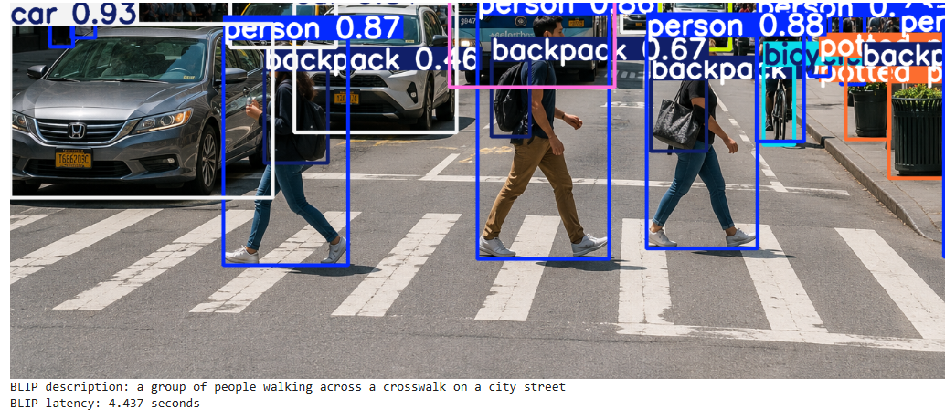
Figure 5.1: Notebook output showing initial functional test of the BLIP Base scene-captioning model.
The BLIP caption was easier to understand than a list of detected classes. However, the model could omit an object or describe it using a different word. The output was therefore checked by the guardrail before being treated as an approved description.

5.8 Double-Check Safety Guardrail
Notebook Step 8 implemented the double-check safety guardrail. The guardrail received the YOLO detections and BLIP caption. It extracted the unique navigation-related object classes and searched the caption for each class or one of its accepted aliases.
The caption was converted to lowercase and unnecessary punctuation was removed. Complete-word matching was used to reduce incorrect matches. For example, the class name car should not be accepted only because the letters appear inside the word carpet.
When every detected class was represented, the caption received an APPROVED status. If one or more detected classes were missing, it received a BLOCKED status. The function also returned lists of verified and missing objects.
Notebook Step 8A tested the guardrail using controlled descriptions.
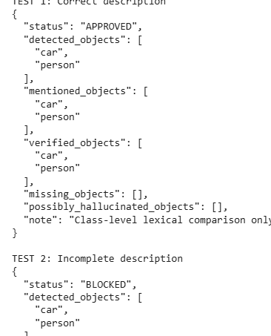
Figure 5.2: Notebook output showing functional test of the double-check safety guardrail.
The guardrail reduced the risk of accepting a caption that omitted an object already detected by YOLO. However, it could not identify an object missed by YOLO. It also did not verify distance, direction or movement. It should therefore be described as an object-completeness check, not a complete safety-validation system.

5.9 Final-Response and Speech Generation
Notebook Step 9 implemented speech generation using gTTS. This library converted a text response into an MP3 audio file [8]. Speech output made the prototype more appropriate for visually impaired users because the user did not need to read the scene description from the screen.
Notebook Step 10 implemented the final-response decision. When the guardrail approved a caption, the system prepared the scene description for speech output. When the caption was blocked, it produced a warning identifying the missing detected objects.
This separation was important because an incomplete caption should not be spoken as if it were fully verified. The user-facing output clearly showed whether the description was approved or blocked.
The use of gTTS introduced an internet dependency. Audio-generation speed could change according to network conditions, and speech generation could fail when the service was unavailable. This limitation is considered later in the discussion chapter.

5.10 Complete Navigation-Assistant Function
Notebook Step 11 connected the individual components into one complete function. After receiving a valid image, the function ran YOLOv8 Nano and created an annotated image containing bounding boxes and labels. BLIP Base then generated a natural-language caption from the same image.
The guardrail compared the detected navigation classes with the generated caption. If the caption passed the comparison, the system approved it. If an object class was missing, the original caption was blocked and replaced with a warning. The final description or warning was then converted into speech.
The complete function returned the annotated image, detected objects, BLIP caption, guardrail status, final response and audio output. Keeping these outputs separate made the system easier to examine during testing.

5.11 Uploaded-Image Demonstration
Notebook Step 11A allowed the user to upload an image from a local computer. The image was opened using Pillow and passed to the complete navigation-assistant function.
The demonstration displayed the annotated image and relevant textual outputs. It also generated an audio file containing the final response.
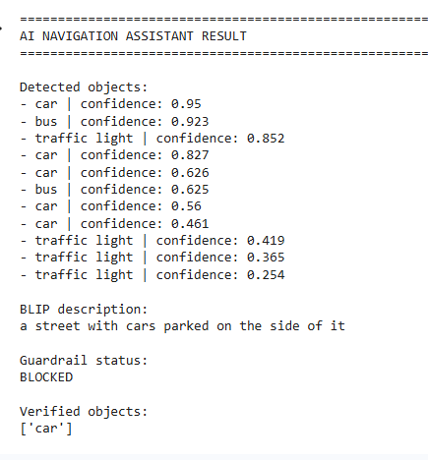
Figure 5.3: Notebook output showing complete navigation-assistance output for an uploaded image.

5.12 Webcam Image Capture
Notebook Step 12 implemented a Colab webcam-capture function using JavaScript. Google Colab cannot access a webcam using the same local OpenCV method normally used on a desktop computer. The JavaScript function opened the browser camera, allowed the user to capture one frame and returned the image to Python.
Notebook Steps 12A and 12B connected the captured frame to the navigation-assistant function. After taking a picture, the system processed it in the same way as an uploaded image.
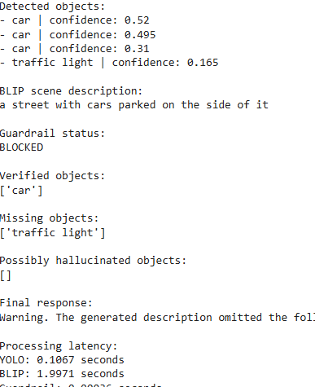
Figure 5.4: Notebook output showing single-frame webcam demonstration of the navigation-assistance prototype.

5.13 Dataset Preparation Implementation
Notebook Step 13A downloaded the COCO 2017 validation images and annotations. The validation dataset contained 5,000 images.
Notebook Steps 13B to 13E checked the dataset and created two separate subsets using the fixed seed of 42. A 500-image subset was used for inference-parameter tuning, while the remaining 4,500 images were reserved for final evaluation.
The output confirmed that the tuning and final-test subsets had zero overlap. It also showed that the tuning set contained 492 labelled images and eight background images. The final-test set contained 4,460 labelled images and 40 background images.
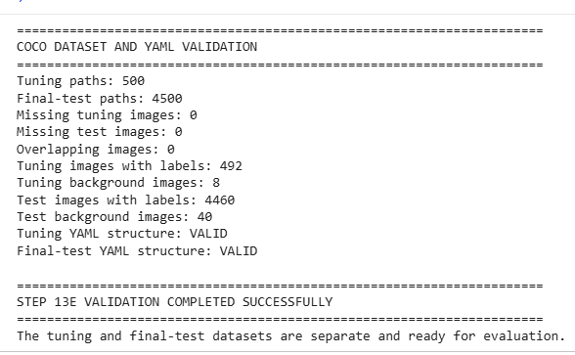
Figure 5.5: Notebook output showing validation of the independent tuning and final-test dataset subsets.

5.14 Inference-Parameter Tuning Implementation
Notebook Step 13F evaluated 18 YOLO inference configurations. The experiment combined three confidence thresholds, three NMS IoU thresholds and two image sizes.
Notebook Step 13G ranked the configurations and selected configuration 6. The output recorded the following tuning results:
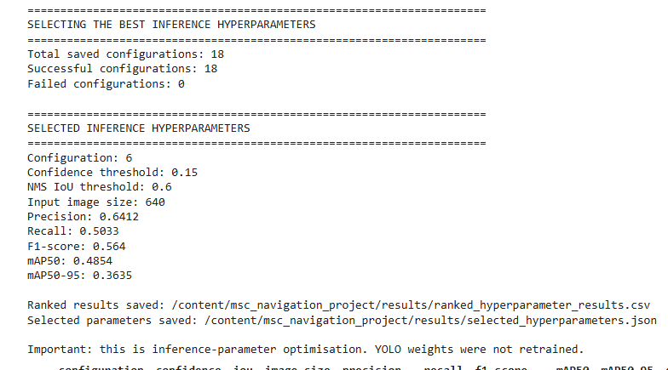
Figure 5.6: Notebook output showing the selection of the best YOLOv8 Nano inference configuration.

5.15 Final Gradio Interface
Notebook Steps 19A to 19D implemented the final Gradio graphical interface. Gradio was selected because it can connect a Python processing function to web-based input and output components [43].
The interface allowed the user to provide an image and receive an annotated image, generated description, guardrail decision and audio response. This made the prototype easier to demonstrate than executing the individual notebook cells manually.

5.16 Summary
This chapter explained how the navigation-assistance prototype was implemented in Google Colab. The system combined YOLOv8 Nano object detection, BLIP Base scene captioning, a rule-based object-completeness guardrail and gTTS speech generation.
The prototype supported uploaded images and single-frame webcam capture. A Gradio interface brought the main components together and displayed visual, textual and audio outputs. The notebook also implemented independent dataset splitting, inference-parameter tuning, model evaluation and result packaging.

6. Results and Evaluation

6.1 Introduction
This chapter presents the experimental results produced by the final notebook. It covers inference-parameter tuning, final YOLOv8 Nano evaluation, navigation-class performance, BLIP caption quality, guardrail performance and processing latency.
The numerical results were obtained from the saved notebook outputs. The 500-image tuning subset was used only to select the YOLO inference settings. The independent 4,500-image final-test subset was then used for the final object-detection evaluation.

6.2 Inference-Parameter Tuning Results
The tuning experiment evaluated 18 configurations containing different confidence thresholds, NMS IoU thresholds and input image sizes. All 18 configurations completed successfully.
Configuration 6 achieved the highest mAP@0.50:0.95 and was selected for the final evaluation. It used a confidence threshold of 0.15, an NMS IoU threshold of 0.60 and an input image size of 640 pixels.
The selected configuration achieved:
- Precision: 0.6412
- Recall: 0.5033
- F1-score: 0.5640
- mAP@0.50: 0.4854
- mAP@0.50:0.95: 0.3635
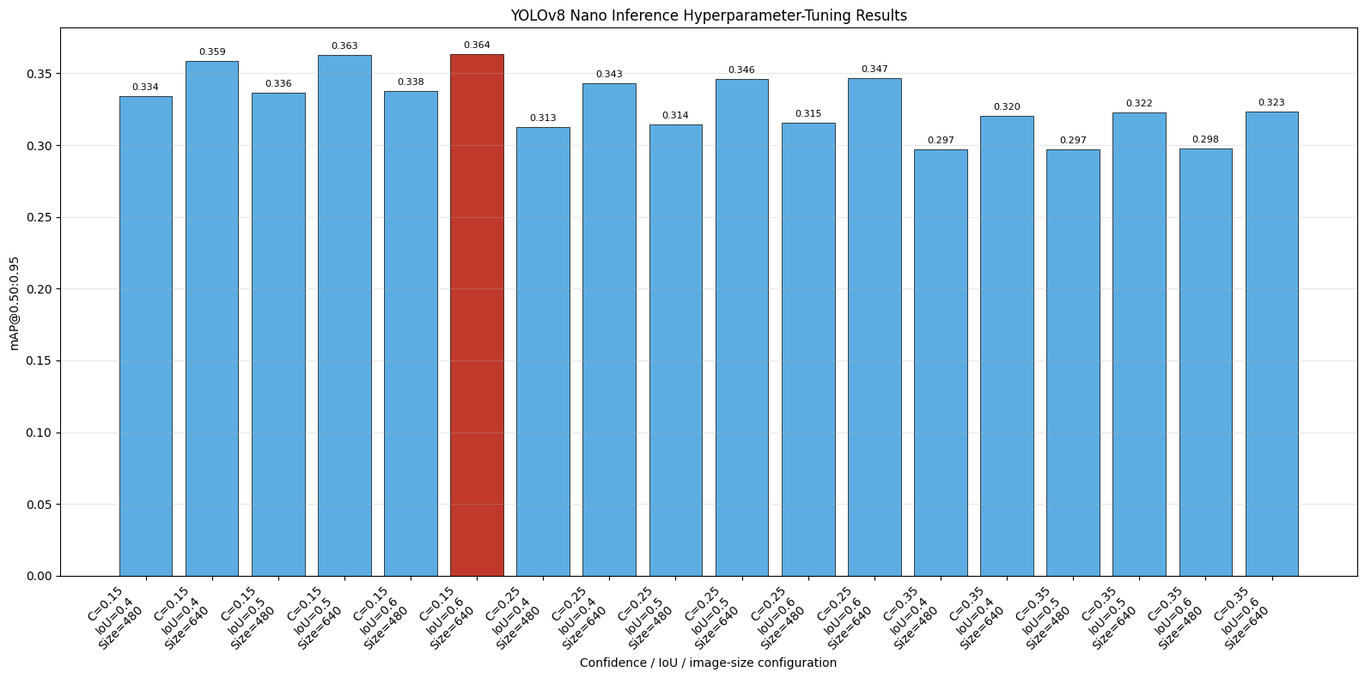
Figure 6.1: YOLOv8 Nano mAP@0.50:0.95 results across the 18 tested inference configurations
In Figure 6.1, the selected configuration is highlighted in red. The other configurations are shown in blue. The graph demonstrates that changing the inference settings influenced the recorded detection performance, although the differences between several configurations were relatively small.
The selected confidence threshold of 0.15 allowed the detector to retain more uncertain predictions. This supported recall, but it also increased the possibility of false positive detections. The image size of 640 preserved more image detail than 480 pixels, while the NMS IoU value of 0.60 allowed more overlap between predicted boxes before one was removed.
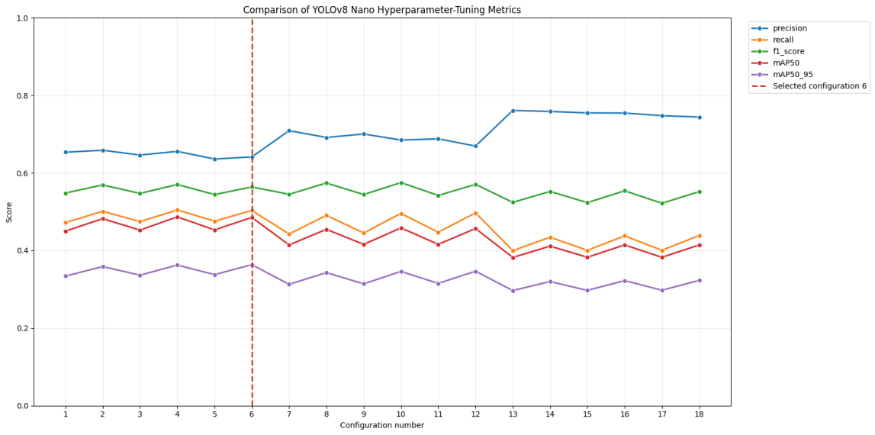
Figure 6.2: Comparison of precision, recall, F1-score and mAP across the 18 YOLOv8 Nano inference configurations.
Figure 6.2 compares the main tuning metrics. The vertical red line identifies configuration 6. Precision was generally higher than recall across the tested settings, indicating that the detector found it more difficult to identify every labelled object than to maintain correctness among its accepted detections.
It is important to describe this process as inference-parameter optimisation, not model training. The YOLOv8 Nano weights were unchanged.

6.3 Final Overall YOLOv8 Results
After selecting the inference settings, the model was evaluated once on the independent 4,500-image final-test subset. The subset contained 4,460 images with labelled objects and 40 background images. In total, 32,561 labelled object instances were evaluated.
The final overall results were:
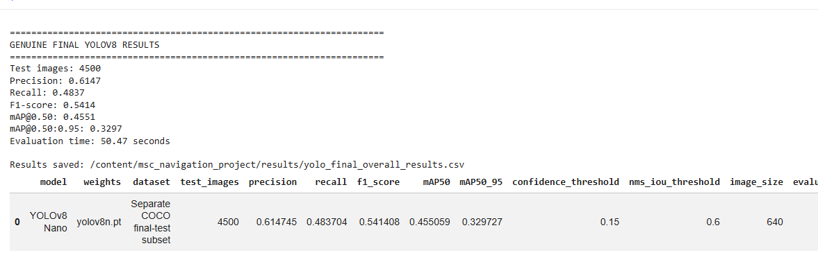
Figure 6.3: Final YOLOv8 Nano evaluation output for the independent 4,500-image test subset.
The final precision of 0.6147 was higher than the recall of 0.4837. This means that the accepted detections were more reliable than the model’s ability to find every labelled object. The difference is important for the proposed application because a missed object cannot be checked by the guardrail or added automatically to the generated description.
The final F1-score was 0.5414. This combined precision and recall into one measurement and showed that the general pretrained model had moderate detection performance on the complete 80-class COCO evaluation.
The mAP@0.50 result was 0.4551, while the stricter mAP@0.50:0.95 was 0.3297. The reduction at the stricter measurement indicates that accurate bounding-box localisation became more difficult as the required IoU threshold increased.

6.4 Comparison with the Proposed F1 Target
The final overall F1-score of 0.5414 did not reach the originally proposed target of 0.85. This result must be reported clearly and should not be changed, hidden or replaced with the guardrail F1-score.
Several factors help explain the difference. The project used the lightweight YOLOv8 Nano model with general COCO pretrained weights. The model was not trained or fine-tuned specifically for pedestrian navigation. In addition, the final evaluation covered all 80 COCO classes rather than only large and frequently occurring street objects.
The original target was therefore too ambitious for an unchanged lightweight pretrained detector. Nevertheless, the result does not make the dissertation unsuccessful. The project still implemented and evaluated a complete prototype, used an independent final-test subset and reported its limitations honestly.
The guardrail achieved an F1-score of 1.0000 on its controlled scenarios, but this is a different task. It must not be used as a replacement for the YOLO object-detection F1-score.

6.5 YOLOv8 Confusion-Matrix Results
The final YOLO evaluation produced both a raw confusion matrix and a normalised confusion matrix. The raw matrix shows the number of predictions for each ground-truth and predicted class. The normalised version makes it easier to compare classes with different numbers of instances.
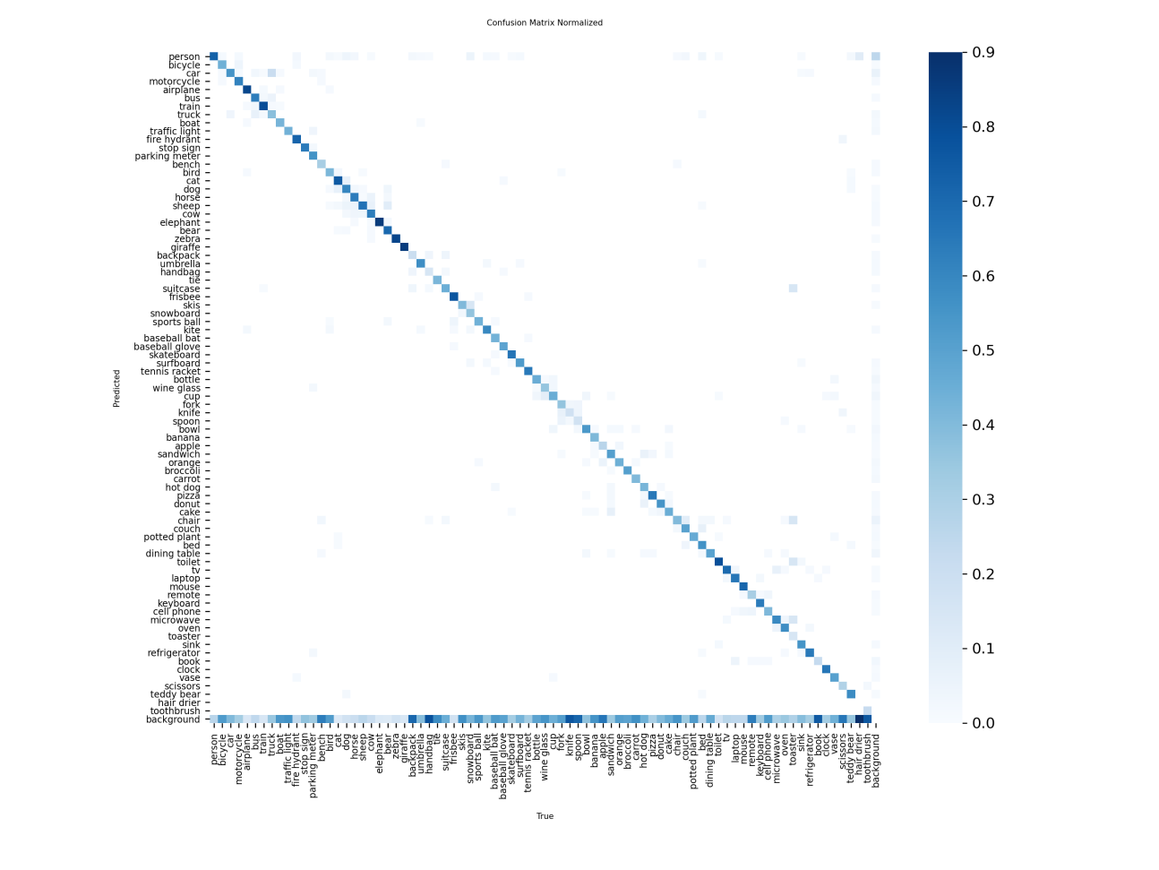
Figure 6.4: Normalised YOLOv8 Nano confusion matrix for the independent final-test subset.
The diagonal cells in Figure 6.4 represent correct classifications. Off-diagonal cells represent confusion between object classes. The background row and column represent false detections and objects missed by the model.
The confusion matrix contains all 80 COCO classes, making the individual labels relatively small on a standard portrait page. Therefore, the normalised matrix is presented across the available page width to support comparison. The raw matrix was retained as supplementary notebook evidence.
The matrix supports the overall metric results. The background-related errors show that some labelled objects were missed or incorrectly detected. These errors contributed to the lower recall score.

6.6 Precision–Recall Curve
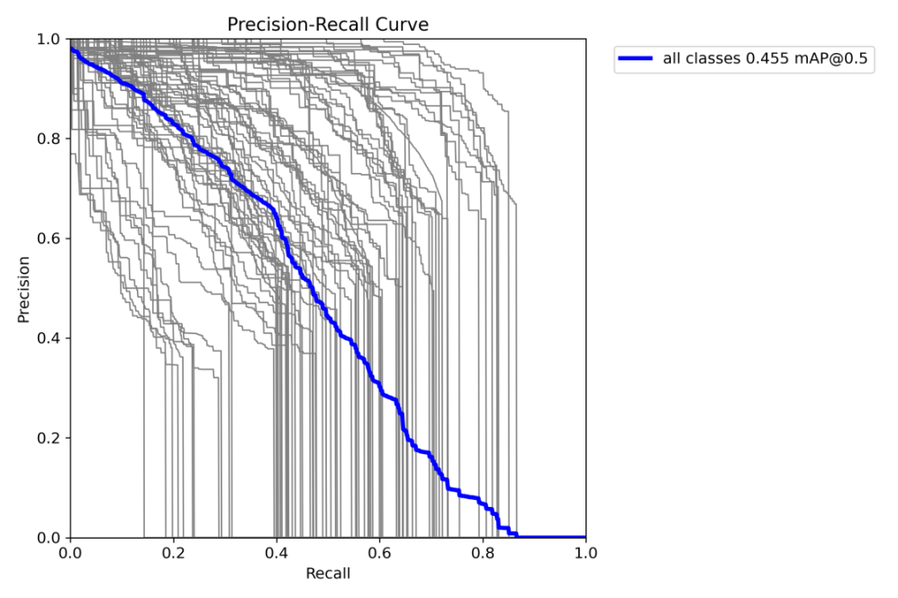
Figure 6.5: YOLOv8 Nano precision–recall curves produced during final evaluation
The precision–recall curve shows the relationship between the proportion of correct detections and the proportion of labelled objects successfully detected. A curve closer to the upper-right area represents stronger performance.
The figure shows that the model’s performance differed across COCO classes. Common and visually distinctive objects generally produced stronger curves, while smaller, less frequent or visually ambiguous classes produced weaker results. Overall curve supports the reported mAP@0.50 value of 0.4551.

6.7 F1-Confidence Curve
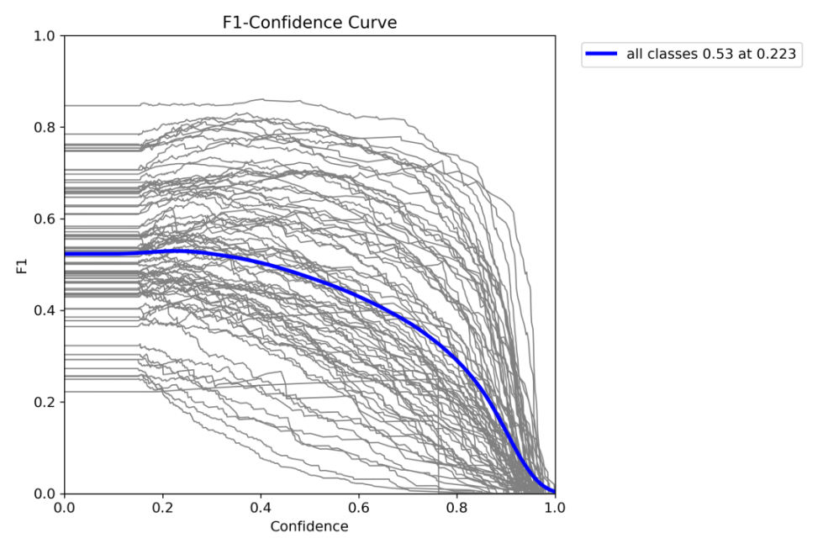
Figure 6.6: Relationship between F1-score and detection-confidence threshold during final YOLOv8 Nano evaluation.

6.8 Navigation-Class Results
The 11 navigation-related classes achieved better macro-average results than the overall 80-class evaluation:
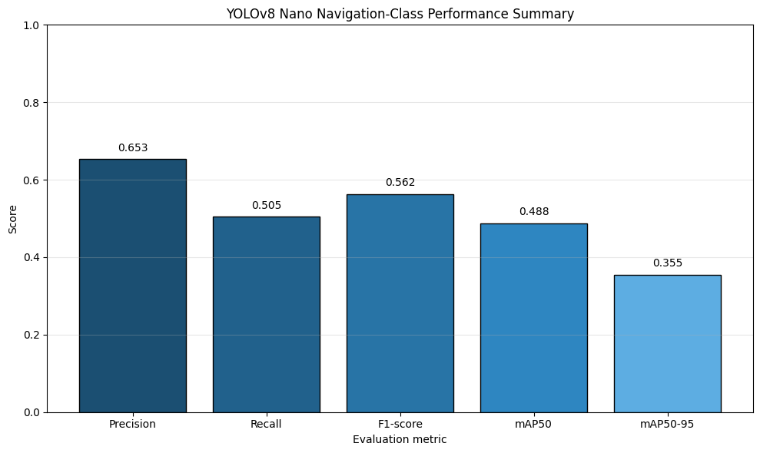
Figure 6.7: YOLOv8 Nano macro-average performance for the 11 navigation-related object classes.

The navigation-class precision of 0.6533 was higher than the overall precision of 0.6147. The navigation recall of 0.5047 was also higher than the overall recall of 0.4837. The navigation-class F1-score consequently increased from 0.5414 to 0.5624.
These results suggest that the selected navigation classes were slightly easier for the pretrained detector than the complete set of COCO classes. However, the navigation recall remained close to 0.50. Therefore, the detector still missed a substantial proportion of labelled navigation-related objects.

6.9 Individual Navigation-Class Performance

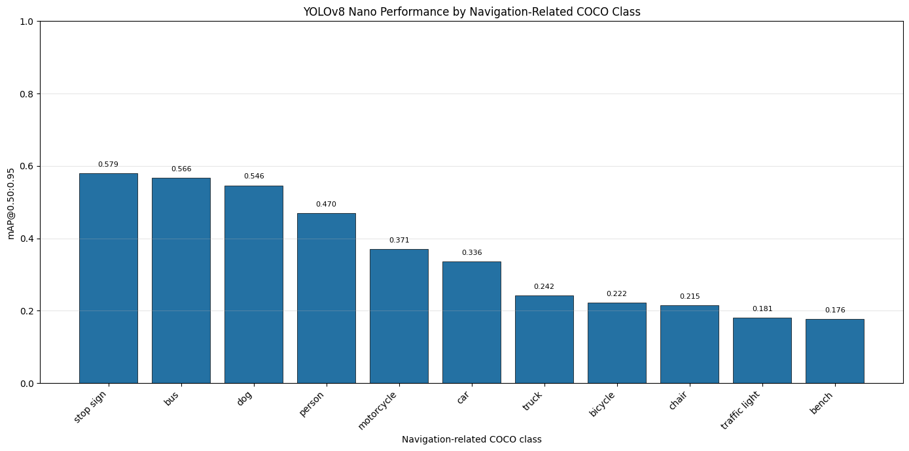
Figure 6.8: Class-level mAP@0.50:0.95 for the 11 navigation-related object classes.
The class-level results showed that performance was not equal across the navigation categories. The strongest reported F1-scores included person at 0.7191, bus at 0.6814, dog at 0.6736 and stop sign at 0.6561. Bench produced a lower F1-score of 0.3707.
The strong person result was useful because pedestrians frequently appear in street environments. Bus and stop-sign performance also supported the intended application. However, the weaker bench result demonstrated that the system could not detect every navigation-related class with the same reliability.
The differences may be connected to class frequency, object size, partial visibility, background similarity and variations in viewpoint. A bench may be partly hidden or visually similar to other seating objects. These explanations are reasonable interpretations, but the experiment did not separately test the effect of each factor.

6.10 Overall Interpretation of the Object-Detection Results
The object-detection evaluation shows that YOLOv8 Nano provided useful but imperfect predictions. It performed better on the selected navigation classes than across the complete COCO class set, but recall remained lower than precision.
The detector was suitable for demonstrating the proposed multi-component architecture because it was lightweight, compatible with the T4 GPU and capable of identifying common street objects. However, the results do not support using the prototype as an independent mobility or safety system.
The guardrail could check whether BLIP mentioned objects already detected by YOLO. It could not correct YOLO’s missed detections. Therefore, object-detection recall remained one of the main technical limitations of the complete prototype.

6.11 BLIP Caption-Evaluation Results
BLIP Base was evaluated using 100 images selected from the independent 4,500-image final-test subset. Each generated caption was compared with the official human-written COCO captions for the same image.
The notebook produced the following results: BLEU-1: 0.6725, BLEU-4: 0.3183, METEOR: 0.5000, ROUGE-L: 0.5620, Mean caption latency: 0.5255 seconds, Approved captions: 53, Blocked captions: 47, Block rate: 0.4700
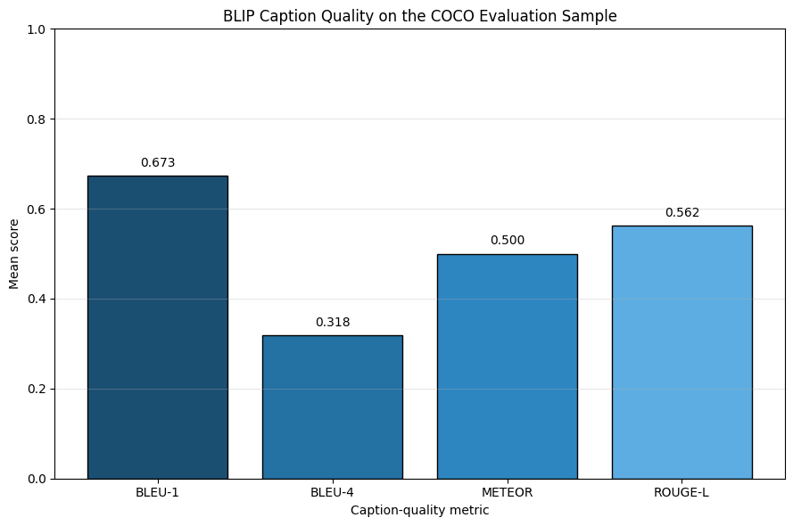
Figure 6.9: Automated caption-evaluation results for BLIP Base across 100 final-test images.
The BLEU-1 score of 0.6725 indicates that many individual words in the generated captions were also present in the reference captions. However, BLEU-4 was lower at 0.3183. This reduction was expected because BLEU-4 requires agreement across longer word sequences and is stricter than individual-word comparison.
The METEOR score was 0.5000, while ROUGE-L reached 0.5620. These results indicate moderate similarity between the generated captions and human-written COCO descriptions. The captions often represented the main content of the image but did not always use the same vocabulary or sentence structure as the reference descriptions.
Automatic text metrics do not provide a complete measure of caption quality. Several different sentences can describe the same image correctly. A caption can receive a lower score because it uses different words from the references, even when its meaning is reasonable. In contrast, a caption may share words with a reference while still omitting an important object.
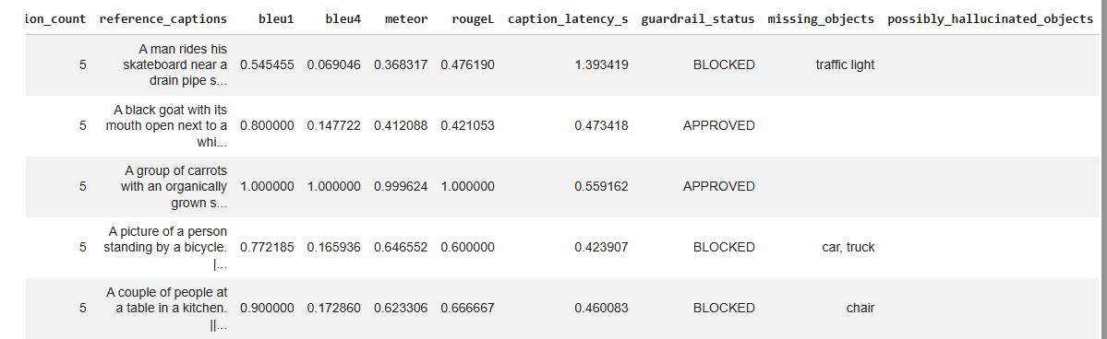
Figure 6.10: Sample-level BLIP caption-evaluation results showing automated text metrics, caption latency and guardrail decisions.

6.12 BLIP Caption Interpretation
The difference between BLEU-1 and BLEU-4 suggests that the generated captions often contained relevant individual words but did not reproduce longer human-written phrases exactly. This is reasonable because BLIP generated one short description, while the COCO references included several possible human descriptions for each image.
The result shown previously in Figure 4.2 provides a clear example. BLIP generated:
“A group of people walking across a crosswalk on a city street.”
This sentence correctly described the main activity. However, it did not mention all the objects detected in the scene, including cars, bicycles and backpacks. The example demonstrates that a natural and generally correct caption may still be incomplete for navigation assistance.
The block rate of 0.47 means that 47 of the 100 evaluated BLIP captions did not represent every relevant YOLO-detected class according to the implemented aliases and complete-word rules. The remaining 53 captions passed the object-completeness check.
This rate should not be interpreted as a 47% general BLIP error rate. Some captions may have been reasonable summaries while still omitting classes considered important by the guardrail. In addition, incorrect YOLO detections could cause an otherwise suitable caption to be blocked.

6.13 Guardrail Evaluation Results
The double-check guardrail was evaluated using 50 controlled lexical scenarios. The scenarios contained expected approved and blocked outcomes. They included aliases, plural forms, punctuation, direct class matches, missing objects and examples intended to test complete-word comparison.
The evaluation contained 31 expected approvals and 19 expected blocks. The guardrail produced:
Correct approvals: 31, Correct blocks: 19, False approvals: 0, False blocks: 0, Accuracy: 1.0000, Blocked precision: 1.0000, Blocked recall: 1.0000, Blocked F1-score: 1.0000, False-approval rate: 0.0000, False-block rate: 0.0000.
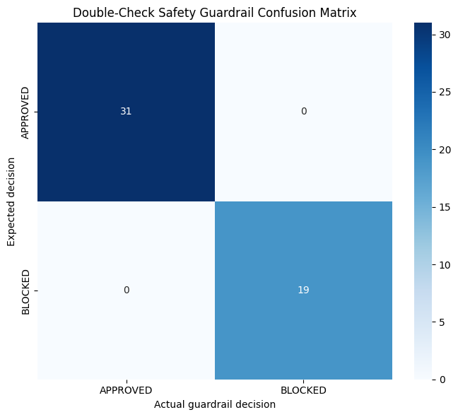
Figure 6.11: Confusion matrix for the double-check safety guardrail across 50 controlled scenarios.
The confusion matrix shows that all 31 expected approved cases were approved and all 19 expected blocked cases were blocked. There were no off-diagonal values, meaning that no false approval or false block occurred in the prepared tests.
The resulting accuracy, precision, recall and F1-score were all 1.0000. These results provide evidence that the implemented rules behaved as expected for the 50 prepared scenarios.
However, the result must be described as perfect performance on the controlled test scenarios, not perfect real-world guardrail accuracy. The scenario collection was designed around known class names, aliases and sentence patterns. Real captions may contain unexpected expressions, spelling variations, complex grammar or ambiguous language that was not included in the test set.

6.14 Relationship Between Detection and Guardrail Results
The guardrail result was stronger than the object-detection result because the two components performed different tasks.
YOLO had to identify and localise objects in complex images. Its final navigation-class F1-score was 0.5624. The guardrail only compared known object labels with words in controlled sentences, producing an F1-score of 1.0000.
The guardrail score must not be used to claim that the complete navigation-assistance system achieved 100% accuracy. The complete system still depended on the accuracy of YOLO and BLIP. If YOLO missed an object, the guardrail had no information about it. If YOLO produced a false detection, the guardrail could block a caption for failing to mention an object that was not actually present.
The guardrail therefore improved transparency and object-completeness checking, but it did not remove the underlying model limitations.

6.15 Processing-Latency Results
The core pipeline was measured over 30 recorded runs following three excluded warm-up runs. End-to-end processing was measured over 10 runs because it included additional operations such as text-to-speech generation.
The mean component results were:
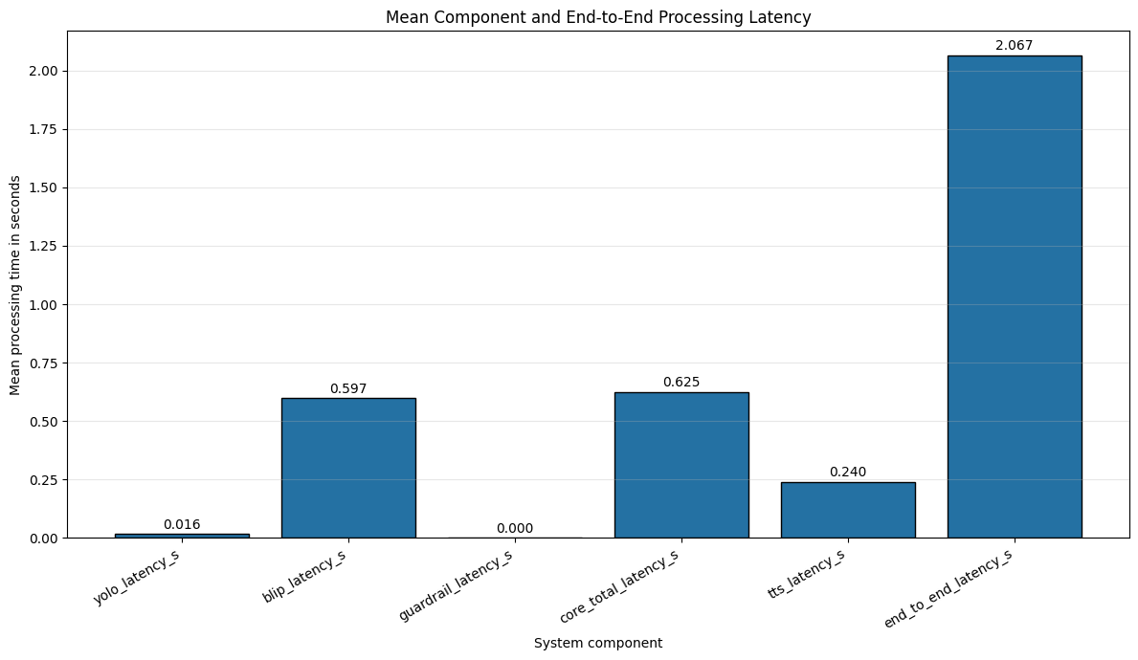
Figure 6.12: Mean processing latency of the main navigation-assistant components.
The largest part of the core processing time was BLIP caption generation, with a mean of 0.5973 seconds. YOLO required only 0.0157 seconds on average, while the guardrail required approximately 0.000174 seconds. This means that the rule-based checking stage added almost no computational delay.
The mean core-pipeline time of 0.6253 seconds was close to the combined YOLO, BLIP and guardrail time. The end-to-end mean was higher at 2.0667 seconds because it included additional file handling, speech generation and application overhead.
The end-to-end mean was also higher than its median. This suggests that some runs took longer than the typical execution. Network communication with the online gTTS service may have contributed to this variation.
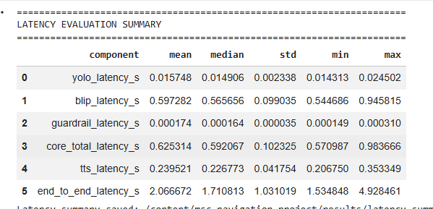
Figure 6.13: Notebook output containing repeated component and end-to-end latency measurements.

6.16 Interpretation of Processing Speed
The measured YOLO execution time shows that the lightweight detector operated efficiently on the Tesla T4 GPU. BLIP was considerably slower because image captioning required both visual encoding and language generation.
The core mean of 0.6253 seconds suggests that one image could be processed within approximately one second before the additional speech and interface operations were included. However, the final end-to-end mean was approximately 2.07 seconds. This delay may still be suitable for a research demonstration, but it may be too slow for situations requiring immediate hazard warnings.
The prototype did not measure continuous frames per second. It captured and processed one image at a time. Therefore, these results support interactive single-frame processing but do not demonstrate continuous real-time video performance.
The latency values were produced using a Tesla T4 GPU. A mobile phone, embedded computer or CPU-only machine could produce substantially different results.

6.17 Summary of Main Findings
This chapter presented the evaluation results for the proposed navigation-assistance prototype. After testing 18 inference configurations, YOLOv8 Nano was applied using a confidence threshold of 0.15, NMS IoU of 0.60 and an image size of 640 pixels.
On the 4,500-image final-test subset, YOLO achieved an overall F1-score of 0.5414. The 11 navigation-related classes achieved a slightly higher macro F1-score of 0.5624. Although this did not reach the proposed target of 0.85, it represents the genuine performance of a lightweight pretrained model without task-specific training.
BLIP Base achieved BLEU-1 of 0.6725, BLEU-4 of 0.3183, METEOR of 0.5000 and ROUGE-L of 0.5620 across 100 images. The guardrail approved 53 captions and blocked 47.
The guardrail correctly classified all 50 controlled scenarios, but this does not prove perfect real-world performance. Mean core-pipeline latency was 0.6253 seconds, while mean end-to-end processing time was 2.0667 seconds.
Overall, the system successfully combined object detection, scene captioning, caption checking and speech generation. However, missed detections, incomplete captions, online speech dependence and the absence of real-user testing remain important limitations.

7. Discussion

7.1 Achievement of the Research Aim
The main aim was to develop a generative AI prototype that could detect objects, generate a scene description, check the description and communicate the result through speech. This aim was achieved at the prototype level.
YOLOv8 Nano produced object classes, confidence scores and bounding boxes. BLIP Base generated a natural-language caption, while the guardrail checked whether the detected navigation classes appeared in that caption. The final approved description or blocked warning was then converted into speech.
However, the system should be considered a research prototype rather than a complete navigation product. It was not tested as an independent mobility aid or evaluated with visually impaired participants.

7.2 Object-Detection Performance
YOLOv8 Nano achieved an overall F1-score of 0.5414 and a navigation-class macro F1-score of 0.5624. The navigation-focused result was slightly stronger, suggesting that the selected 11 classes were more suitable for the intended application than the complete 80-class COCO set.
Precision was higher than recall. The navigation-class precision was 0.6533, while recall was 0.5047. This means that accepted detections were generally more reliable than the model’s ability to identify every labelled object.
Missed objects are an important concern for navigation assistance. If YOLO fails to detect an object, the guardrail cannot check whether BLIP included it. The lower recall therefore limits the safety value of the complete pipeline.
The detector was computationally efficient, with a mean latency of 0.0157 seconds on the Tesla T4 GPU. This supports the selection of YOLOv8 Nano as a cost-efficient model, although a larger or task-specific detector might achieve stronger accuracy.

7.3 Discussion of the F1 Target
The final detection F1-score did not reach the proposed target of 0.85. This difference should be reported honestly as part of the research findings.
The target was ambitious because the prototype used general pretrained YOLOv8 Nano weights without task-specific training or fine-tuning. The evaluation also used a large and varied benchmark dataset rather than a small set of carefully selected street images.
The lower result does not mean that the project failed. The dissertation produced a functioning system, used independent tuning and test subsets and reported genuine performance. Future work could investigate task-specific training, a navigation-focused dataset and larger YOLO models.
The guardrail F1-score of 1.0000 cannot be used as a replacement for the detection F1-score because the two components performed different tasks.

7.4 BLIP Caption Performance
BLIP achieved moderate agreement with the official COCO reference captions. BLEU-1 was 0.6725, BLEU-4 was 0.3183, METEOR was 0.5000 and ROUGE-L was 0.5620.
The higher BLEU-1 score suggests that the generated captions often contained relevant individual words. The lower BLEU-4 result indicates less agreement across longer phrases. This was expected because different sentences can correctly describe the same image.
Some BLIP captions correctly represented the main scene but omitted objects detected by YOLO. Across the 100 evaluated images, 53 captions were approved and 47 were blocked. The 47% block rate measures disagreement between the BLIP caption and YOLO class list; it should not be described as a general BLIP error rate.
Object omission and hallucination are recognised problems in vision-language models [45], [46]. These issues support the decision to include an additional checking stage before communicating a generated caption.

7.5 Effectiveness of the Guardrail
The guardrail correctly classified all 50 controlled scenarios, including 31 approved and 19 blocked examples. Its accuracy, precision, recall and F1-score were all 1.0000.
This result confirms that the implemented alias and complete-word rules worked correctly for the prepared scenarios. The guardrail also introduced almost no processing delay, requiring approximately 0.000174 seconds on average.
However, the guardrail depended on YOLO predictions and a manually defined alias dictionary. It could not check an object missed by YOLO, and it could incorrectly block a caption if YOLO produced a false detection. Real captions may also contain expressions that are not included in the alias collection.
Therefore, the guardrail improved transparency and caption-completeness checking, but it did not guarantee that every approved description was completely correct.

7.6 Processing Latency
The mean core-pipeline latency was 0.6253 seconds, while the mean end-to-end processing time was 2.0667 seconds. BLIP was responsible for most of the core delay, requiring 0.5973 seconds on average.
A delay of approximately two seconds may be acceptable for a general scene summary but may be too slow for an immediate hazard warning. The result was also recorded using a Tesla T4 GPU and an online gTTS service. Performance on a mobile device could be different.
The experiment processed one captured image at a time. It did not evaluate continuous video or frames per second. The system should therefore be described as interactive single-frame processing rather than full real-time video navigation.

7.7 Research Contribution
The main contribution was the integration of object detection and generative image captioning with a transparent double-check mechanism.
YOLO provided structured object information, BLIP produced understandable language and the guardrail checked whether the detected navigation classes were represented in the generated description. This approach was more transparent than communicating every generated caption without verification.
The prototype also evaluated the components separately using detection metrics, caption metrics, controlled guardrail tests and latency measurements. This made it possible to identify both the strengths and weaknesses of each part of the system.

7.8 Limitations
The prototype had several important limitations. It used general COCO images rather than a dedicated pedestrian-navigation dataset. Neither AI model was fine-tuned for the intended application.
Only 100 images were used for BLIP caption evaluation, while the guardrail was tested using 50 controlled scenarios. No formal evaluation was conducted with visually impaired participants.
The system did not estimate object distance, identify safe walking paths or track moving objects. It processed one image at a time and depended on an online service for speech generation.
These limitations mean that the system must not replace a white cane, guide dog, trained assistant or established navigation aid.

8. Conclusion and Future Work

8.1 Overall Conclusion
This study developed and evaluated a generative AI prototype for navigation assistance. The system combined YOLOv8 Nano object detection, BLIP Base image captioning, a double-check safety guardrail and text-to-speech output.
The prototype successfully processed uploaded and webcam-captured images. It detected navigation-related objects, generated scene descriptions and checked whether the descriptions represented the detected classes. If an object was missing, the system blocked the caption and produced a warning.
The final evaluation showed that the system was technically functional but not ready for independent real-world navigation. YOLOv8 Nano achieved a navigation-class F1-score of 0.5624, while BLIP produced moderate similarity to human-written reference captions. The guardrail performed correctly across the 50 controlled scenarios, and the core pipeline completed in an average of 0.6253 seconds.
These results demonstrate the value of combining object detection with generative captioning. However, they also show that an additional checking mechanism cannot remove every error produced by the underlying AI models.

8.2 Recommendations for Future Work
Future development should first use a dedicated navigation dataset containing pedestrian-view images, crossings, pavements, obstacles and different weather and lighting conditions. YOLO should then be fine-tuned using this task-specific data.
Larger or more recent object detectors could be compared with YOLOv8 Nano. This would help determine whether improved recall justifies additional computational cost.
Distance estimation should also be added. A monocular depth model such as Depth Anything V2 could provide information about how close an object may be [49]. However, distance estimates would require careful calibration and safety evaluation.
Continuous video and object tracking should replace single-frame capture. A tracker such as ByteTrack could help maintain object identities across video frames [50]. This could also reduce repeated spoken warnings.
The alias-based guardrail could be improved using semantic similarity or a dedicated language model. Any more complex guardrail would still need transparent testing to ensure that it does not introduce additional hallucinations Recent attention-intervention research provides another possible direction for reducing visual hallucination [47].
An offline text-to-speech engine should replace or support gTTS. This would reduce network dependence and improve privacy.
Most importantly, future work should involve visually impaired participants and accessibility specialists. Their feedback should guide the type, length, timing and priority of spoken information. WHO guidance also emphasises the importance of involving users and families in the assistive-technology process [48].

8.3 Final Statement
The need for accessible technology remains significant, with at least 2.2 billion people globally experiencing near or distance vision impairment [1]. Generative AI and computer vision offer promising opportunities, but navigation assistance requires high reliability and careful safety evaluation.
This dissertation demonstrated that object detection, image captioning, caption verification and speech output can be integrated into one cost-efficient prototype. Its main contribution was the double-check approach, which introduced a transparent verification stage before communicating a generated caption.

References

[1] World Health Organization, “Blindness and vision impairment,” Feb. 10, 2026. [Online]. Available: https://www.who.int/news-room/fact-sheets/detail/blindness-and-visual-impairment
[2] R. Waghmare et al., “SANPO: A scene understanding, accessibility and human navigation dataset,” in Proc. IEEE/CVF Winter Conf. Applications of Computer Vision, 2025.
[3] T.-Y. Lin et al., “Microsoft COCO: Common objects in context,” in Computer Vision–ECCV 2014. Cham, Switzerland: Springer, 2014, pp. 740–755.
[4] Ultralytics, “YOLO validation mode,” Ultralytics Documentation, 2026. [Online]. Available: https://docs.ultralytics.com/modes/val/
[5] J. Li, D. Li, C. Xiong, and S. Hoi, “BLIP: Bootstrapping language-image pre-training for unified vision-language understanding and generation,” in Proc. 39th Int. Conf. Machine Learning, 2022, pp. 12888–12900.
[6] Z. Bai, P. Wang, T. Xiao, T. He, Z. Han, Z. Zhang, and M. Z. Shou, “Hallucination of multimodal large language models: A survey,” arXiv:2404.18930, 2024.
[7] Y. Ge et al., “Visual Fact Checker: Enabling high-fidelity detailed caption generation,” in Proc. IEEE/CVF Conf. Computer Vision and Pattern Recognition, 2024.
[8] P.-N. Durette, “gTTS: Google Text-to-Speech,” gTTS Documentation, 2026. [Online]. Available: https://gtts.readthedocs.io/
[9] M. H. Abidi, A. N. Siddiquee, H. Alkhalefah, and V. Srivastava, “A comprehensive review of navigation systems for visually impaired individuals,” Heliyon, vol. 10, no. 11, Art. no. e31825, 2024, doi: 10.1016/j.heliyon.2024.e31825.
[10] E. Casanova, D. Guffanti, and L. Hidalgo, “Technological advancements in human navigation for the visually impaired: A systematic review,” Sensors, vol. 25, no. 7, Art. no. 2213, 2025, doi: 10.3390/s25072213.
[11] M. Bamdad, D. Scaramuzza, and A. Darvishy, “SLAM for visually impaired people: A survey,” IEEE Access, 2024, doi: 10.1109/ACCESS.2024.3454571.
[12] J. D. Hayh, S. Joseph, S. Dirks, and V. Namboodiri, “Technology and trust: A scoping review on AI-enabled orientation and mobility technologies for blind and visually impaired individuals,” J. Visual Impairment & Blindness, 2025, doi: 10.1177/10554181251355426.
[13] Z. Li, Y. Dong, L. Shen, Y. Liu, Y. Pei, H. Yang, L. Zheng, and J. Ma, “Development and challenges of object detection: A survey,” Neurocomputing, vol. 598, Art. no. 128102, 2024, doi: 10.1016/j.neucom.2024.128102.
[14] S. Ren, K. He, R. Girshick, and J. Sun, “Faster R-CNN: Towards real-time object detection with region proposal networks,” IEEE Trans. Pattern Anal. Mach. Intell., vol. 39, no. 6, pp. 1137–1149, 2017.
[15] W. Liu et al., “SSD: Single Shot MultiBox Detector,” in Computer Vision–ECCV 2016. Cham, Switzerland: Springer, 2016, pp. 21–37.
[16] J. Redmon, S. Divvala, R. Girshick, and A. Farhadi, “You Only Look Once: Unified, real-time object detection,” in Proc. IEEE Conf. Computer Vision and Pattern Recognition, 2016, pp. 779–788.
[17] J. Redmon and A. Farhadi, “YOLO9000: Better, faster, stronger,” in Proc. IEEE Conf. Computer Vision and Pattern Recognition, 2017, pp. 7263–7271.
[18] J. Redmon and A. Farhadi, “YOLOv3: An incremental improvement,” arXiv:1804.02767, 2018.
[19] A. Bochkovskiy, C.-Y. Wang, and H.-Y. M. Liao, “YOLOv4: Optimal speed and accuracy of object detection,” arXiv:2004.10934, 2020.
[20] Y. Tian, W. Xu, B. Yang, X. Yang, H. Guo, G. Wang, and H. Yu, “Development and evolution of YOLO in object detection: A survey,” Neurocomputing, vol. 669, Art. no. 132436, 2026, doi: 10.1016/j.neucom.2025.132436.
[21] Ultralytics, “YOLOv8,” Ultralytics Documentation, 2026. [Online]. Available: https://docs.ultralytics.com/models/yolov8/
[22] A. Vaswani et al., “Attention is all you need,” in Advances in Neural Information Processing Systems, vol. 30, 2017, pp. 5998–6008.
[23] A. Dosovitskiy et al., “An image is worth 16×16 words: Transformers for image recognition at scale,” in Proc. Int. Conf. Learning Representations, 2021.
[24] A. Radford et al., “Learning transferable visual models from natural language supervision,” in Proc. 38th Int. Conf. Machine Learning, 2021, pp. 8748–8763.
[25] J. Li, D. Li, S. Savarese, and S. Hoi, “BLIP-2: Bootstrapping language-image pre-training with frozen image encoders and large language models,” in Proc. 40th Int. Conf. Machine Learning, 2023, pp. 19730–19742.
[26] K. Papineni, S. Roukos, T. Ward, and W.-J. Zhu, “BLEU: A method for automatic evaluation of machine translation,” in Proc. 40th Annual Meeting Association for Computational Linguistics, 2002, pp. 311–318.
[27] S. Banerjee and A. Lavie, “METEOR: An automatic metric for MT evaluation with improved correlation with human judgments,” in Proc. ACL Workshop Intrinsic and Extrinsic Evaluation Measures, 2005, pp. 65–72.
[28] C.-Y. Lin, “ROUGE: A package for automatic evaluation of summaries,” in Text Summarization Branches Out, 2004, pp. 74–81.
[29] R. Kapur and E. Kreiss, “Reference-based metrics are biased against blind and low-vision users’ image description preferences,” in Proc. Third Workshop NLP for Positive Impact, 2024, pp. 308–314, doi: 10.18653/v1/2024.nlp4pi-1.26.
[30] Y. Li, Y. Du, K. Zhou, J. Wang, W. X. Zhao, and J.-R. Wen, “Evaluating object hallucination in large vision-language models,” in Proc. 2023 Conf. Empirical Methods in Natural Language Processing, 2023, pp. 292–305.
[31] X. Gong, T. Ming, X. Wang, and Z. Wei, “DAMRO: Dive into the attention mechanism of LVLM to reduce object hallucination,” in Proc. 2024 Conf. Empirical Methods in Natural Language Processing, 2024, pp. 7696–7712.
[32] X. Zhang, “The Escalator Problem: Identifying implicit motion blindness in AI for accessibility,” in Proc. IEEE/CVF Int. Conf. Computer Vision Workshops, 2025, pp. 6694–6702.
[33] X. Yao, J. Gao, and C. Xu, “NavMorph: A self-evolving world model for vision-and-language navigation in continuous environments,” in Proc. IEEE/CVF Int. Conf. Computer Vision, 2025, pp. 5536–5546.
[34] National Institute of Standards and Technology, Artificial Intelligence Risk Management Framework (AI RMF 1.0), NIST AI 100-1, Jan. 2023, doi: 10.6028/NIST.AI.100-1.
[35] UNESCO, Recommendation on the Ethics of Artificial Intelligence. Paris, France: UNESCO, 2021.
[36] PyTorch, “Reproducibility,” PyTorch Documentation, 2026. [Online]. Available: https://docs.pytorch.org/docs/stable/notes/randomness.html
[37] Ultralytics, “Configuration,” Ultralytics Documentation, 2026. [Online]. Available: https://docs.ultralytics.com/usage/cfg/
[38] NLTK Project, “Machine translation evaluation,” Natural Language Toolkit Documentation, 2026. [Online]. Available: https://www.nltk.org/api/nltk.translate.html
[39] Google Research, “ROUGE Score: A Python implementation of ROUGE-1, ROUGE-2 and ROUGE-L,” 2026. [Online]. Available: https://pypi.org/project/rouge-score/
[40] Scikit-learn Developers, “Classification metrics,” Scikit-learn Documentation, 2026. [Online]. Available: https://scikit-learn.org/stable/modules/model_evaluation.html#classification-metrics
[41] Ultralytics, “Model prediction with Ultralytics YOLO,” Ultralytics Documentation, 2026. [Online]. Available: https://docs.ultralytics.com/modes/predict/
[42] Hugging Face, “Image-to-text and image-text pipelines,” Transformers Documentation, 2026. [Online]. Available: https://huggingface.co/docs/transformers/tasks/image_text_to_text
[43] Gradio, “Interface,” Gradio Documentation, 2026. [Online]. Available: https://www.gradio.app/docs/gradio/interface
[44] Google, “Google Colaboratory FAQ,” 2026. [Online]. Available: https://research.google.com/colaboratory/faq.html
[45] X. Chen et al., “Multi-object hallucination in vision-language models,” arXiv:2407.06192, 2024.
[46] A. Seth, D. Manocha, and C. Agarwal, “HALLUCINOGEN: A benchmark for evaluating object hallucination in large visual-language models,” arXiv:2412.20622, 2024.
[47] L. Tang et al., “Not all tokens and heads are equally important: Dual-level attention intervention for hallucination mitigation,” Proc. AAAI Conf. Artificial Intelligence, vol. 40, no. 11, pp. 9439–9447, 2026, doi: 10.1609/aaai.v40i11.37904.
[48] World Health Organization, “Assistive technology,” Jan. 2, 2024. [Online]. Available: https://www.who.int/news-room/fact-sheets/detail/assistive-technology
[49] L. Yang, B. Kang, Z. Huang, Z. Zhao, X. Xu, J. Feng, and H. Zhao, “Depth Anything V2,” arXiv:2406.09414, 2024.
[50] Y. Zhang et al., “ByteTrack: Multi-object tracking by associating every detection box,” in Computer Vision–ECCV 2022. Cham, Switzerland: Springer, 2022, pp. 1–21.

