‘An exploration of themes of individual and environmental well-being.’

Abstract
Wellbeing could be described simplistically as an individual’s state of happiness and life satisfaction; yet it is subjective and complex (Dong & Qin, 2017). Environment wellbeing encompasses the state the environment’s health and vitality, suggesting that a lack of respect and protection of nature and ecosystems can result in poor wellbeing of an environment (Sharmin et al., 2021, Tallis et a., 2018). Many studies have explored the connection between the two, suggesting that they embody each other and should not be separated or simplified (Pfeiffer & Cloutier, 2016). This emphasizes the need for further research to include more diverse environments and individual experience and differences. (White et al., 2017, Sheidler et al., 2018). Following these studies, a report was carried to out to further explore the topic. One female participant’s semi-structured interview was pre-recorded and then transcribed verbatim before being provided to students for the purpose of an assessment of Thematic Analysis. The previous studies were supported by the findingg that well-being and environment appear synonymous which promotes the argument that environment should be included when discussing well-being, as they appear interlinked. Gaining more understanding of how individual differences and varied environments influence each other could be harnessed to help increase well-being, helping to inform policy and interventions for healthcare.

Keywords: well-being, environment, care, responsibility, neglect

Wellbeing could be described simplistically as an individual’s state of happiness and life satisfaction; yet, it is subjective and complex (Dong & Qin, 2017). Environment wellbeing encompasses the state the environment’s health and vitality, suggesting that a lack of respect and protection of nature and ecosystems can result in poor wellbeing of an environment (Sharmin et al., 2021, Tallis et a., 2018). Many studies have explored the connection between the two, suggesting that they embody each other and should not be separated or simplified (Pfeiffer & Cloutier, 2016). This emphasizes the need for further research to include more diverse environments and individual experience and differences. (White et al., 2017, Sheidler et al., 2018). Still, the influence that environment has on wellbeing is significant, with studies showing that a nature environment can offer not only relief from stress but an opportunity to reflect and overcome personal difficulties (Thomas, 2015). This could imply that caring for the environment is mutually beneficial to both individuals and the environment itself as individuals living in well-kept environments show greater life satisfaction and happiness (Kwon et al., 2019). Pavey et al. (2012) suggested that individual difference plays a part, finding that empathy was closely linked to engagement in pro-social behaviours such as recycling. Interestingly, some individuals feel extreme pressure to protect their environments, resulting in experiencing ‘green guilt’ (Asma, 2010). Following these studies this report was carried to out to further explore the topic.

Method
Participants
One female participant’s semi-structured interview was pre-recorded and then transcribed verbatim before being provided to students for the purpose of an assessment of Thematic Analysis. The qualitative study used a semi-structured interview design for the collection of data. Analysis of the data was conducted through the process of Thematic Analysis. The content of the interview questions would have been extensively researched and drawn from previous studies on well-being and environment.

Data Collection
Due to assessment purposes, the transcript of the interview was already made available to the students. Before the interview was conducted, informed consent would have been gained in written form. This form should provide information about the nature of the study, explain confidentiality and data protection through anonymisation, detailing the ethical guidelines that the research adheres to and confirms that the participant understands this and is happy to participate. During the interview the researcher should utilise an interview schedule to provide structure and encourage conversation. The interview should be recorded using a voice recorder and the participant should be made aware of the purpose of this. At the end of the interview the participant should be provided with a debrief form to thank them for their participation, which should be informative and reassuring. The aim of the research should be provided, inviting the participant to ask the researcher questions or air any concerns. It should also be made clear that the participant is able to withdraw their data from the study and who to contact to do so. Discussing wellbeing may cause distress so options of support should be also offered, in line with BPS ethical guidelines. There should also be information included on who to contact to make a complaint if the participant felt necessary. Data collection and transcription was previously completed before being provided to students. The participant would have been fairly recruited, ensuring an awareness of the nature of the research. Consent would be gained through written form, following ethical guidelines and informing the participant of confidentially and data protection. The interviewer should follow an interview schedule of their semi-structured questions on the topic of well-being and environment. The interview process should be recorded and the interviewee made aware that they are able to stop the interview at any time and avoid questions. The participant should be fully de-briefed after interview, provided with a de-brief form.

Data Analysis
All data collected should be carefully and accurately transcribed before using Braun and Clarke’s (2006) six step process of Thematic Analysis, Familiarisation, coding, generating themes, reviewing themes, defining and naming themes and finally, writing up. All data should be stored securely in line with data protection laws and BPS ethical guidelines.

Findings
 | Superoridinate Themes | Subordinate Themes | Quotes
1 | Wellbeing and environment are  intertwined
 | 1.1 | Wellbeing is multifaceted | “…so yeah I’d say it counts as all three, whereas before when I was younger I would have just thought of the physical side of it and neglected the actual, y’know, psychological part as well. But I understand now that to have a full sense of being well that you need to look after all of them.” (43-46)
 | 1.2 | Neglecting the environment affects wellbeing | “…should also look after the environment around them, because if you are living in a shithole you are not going to be happy –are you? Really?” (206-207)
 | 1.3 | Environment can positively affect wellbeing | “Um if I’m feeling particularly stressed I’ll try and go and have a walk around some woods or somewhere green, I find that really soothing” (95-97)
 | 1.4 | Equilibrium | “I think they can be all symbiotic, and I think that …people should look after themselves firstly, but should also look after the environment around them… So if something’s nice around you then you are probably going to enjoy living there a lot more…. I think the environment does have a positive effect on your attitude and how you feel…” (205, 207,209)
2 | We all have a responsibility
 | 2.1 | Care for self, others and environment | “that everyone should be kind to each other but to the environment as well. So if everyone is nicer and a bit more thoughtful and mindful about what they do towards themselves, but also environmentally” (217-219)
 | 2.2 | Lack of sense of responsibility causes frustration | “I found that if I just have a big old rant about people leaving their dog shit everywhere then I end up feeling quite angry and annoyed and there’s nothing I can do about it, so I just pick it up and put it in the bin.” (177-179)
 | 2.3 | Collective effort has a big impact | “especially by where we live, we live near a beach, and you can see that the community has made an effort, so when there’s little on the beach for example we all go out and tidy it up. It doesn’t actually have to be a collective day”
 | 2.4 | Engagement requires simplicity | “That’s a difficult one.. I think it’s got to come down to something simple and easy that everyone can do…” (216-217)
3 | You can’t pour from an empty cup
 | 3.1 | Neglect of self through life experiences | “And being in a carers role you end up looking after everyone else other than yourself” (71,72)
 | 3.2 | Epiphany of importance | “So I finally realised that the carer has to come first.. well…as everyone should, look after themselves first, not putting other people’s wellbeing above your own really – that’s the importance” (73-75)
 | 3.3 | Wellbeing should be prioritised | “Yes – I think probably people don’t think about it enough, but they should do, because you’re only here once aren’t you?” (79-80)
4 | Driving forces
 | 4.1 | Burdened by a duty of care | “So I pick up after our dogs and sometimes end up picking up after other dogs as well..” (191-192)
 | 4.2 | Finances | “I’ve got bills” and going around the house and turning everything off.. well that’s me..” (191-194)
 | 4.3 | Feelings of guilt and fear of judgement/Satisfaction | “So I’ve got to confess, it goes out of the window slightly then – so it goes straight in the bin without recycling – sorry!” (156-158)
 | 4.4 | Controlling the controllable | “So instead of moaning about it I’ll do something about it and pick up a can.” (135-136)
5 | A routine is vital
 | 5.1 | It takes time and effort, and discipline is vital | “But sometimes it has to be quite a strict routine. Um I’m more aware of when I’m starting to go on a bit of downward spiral and with all this kind of training and a bit of therapy I can – not so much avert it – but try and go another way, so it has to be routine.” (95-101)
 | 5.2 | The power of routine | “I have to keep an established routine, and that’s when I feel the best. Because at the moment I don’t take any medication for the depression and anxiety – I can keep that at bay, luckily, with a routine of getting up with the dogs, taking them for a walk,” (86-88)
 | 5.3 | Knowledge requires action to produce change | “So it is quite easy so you have to remind yourself to look after yourself, but once you do it more you do find it becomes a bit of a habit…” (106-108)
Table 1: All themes

Superordinate Theme 1: Wellbeing and environment are intertwined
Throughout the data the sense that wellbeing and environment have a reciprocal relationship was prominent. The participant repeatedly acknowledged that both impact and influence each other. This was illustrated through several subordinate themes.

Subordinate theme 1.1: Wellbeing is multifaceted
“…so yeah I’d say it counts as all three, whereas before when I was younger I would have just thought of the physical side of it and neglected the actual, y’know, psychological part as well. But I understand now that to have a full sense of being well that you need to look after all of them.” (43-46)

Age and life experience appeared to have given the participant an awareness of the complexity and subjectiveness of well-being. Understanding that well-being encompasses psychological and emotional health too, now acknowledging the importance of self-care.

Subordinate theme 1.2: Neglecting the environment affects wellbeing
“…should also look after the environment around them, because if you are living in a shithole you are not going to be happy –are you? Really?” (206-207)

Following the discussion of neglect of self, the participant also felt that neglecting an environment can have an emotional impact and affect life satisfaction.

Subordinate theme 1.3: Environment can positively affect wellbeing
“Um if I’m feeling particularly stressed I’ll try and go and have a walk around some woods or somewhere green, I find that really soothing” (95-97)
Interestingly, the participant also felt that the environment can also have a positive impact on wellbeing, nature.

Subordinate theme 1.4: Equilibrium
“I think they can be all symbiotic, and I think that …people should look after themselves firstly, but should also look after the environment around them… So if something’s nice around you then you are probably going to enjoy living there a lot more…. I think the environment does have a positive effect on your attitude and how you feel…” (205, 207,209)

The use of language, ‘symbiotic’, emphasised the concept of wellbeing and environment being interconnected. Essentially a domino effect, looking after one’s environment is looking after oneself.

The notion of well-being and environment being interlinked was significant, both well-being and environment influenced each other. It became evident through the participant’s self-awareness, that they deemed a well-kept environment essential for their own well-being.

Superordinate Theme 2: We all have a responsibility
A strong theme of ‘responsibility’ emerged, the weight of which was apparent whilst the participant discussed both their own understanding and the expectations of self and others and the impact on environment.

Subordinate theme 2.1: Care for self, others and the environment
“…everyone should be kind to each other but to the environment as well. So if everyone is nicer and a bit more thoughtful and mindful about what they do towards themselves, but also environmentally” (217-219)

The sense of responsibility for care of self was prominent. The participant did not make excuses or share out blame, interestingly the participant held themselves accountable for not only for their own care but also for the care of others and the environment.

Subordinate Theme 2.2: Lack of sense of responsibility induces emotion
“I found that if I just have a big old rant about people leaving their dog shit everywhere then I end up feeling quite angry and annoyed and there’s nothing I can do about it, so I just pick it up and put it in the bin.” (177-179)

This expectation of responsibility held of themselves was also reflected in their view of the behaviour of others, the participant used emotive language whilst describing how they feel when others do not behave the way they expect of them.

Subordinate Theme 2.3: Collective effort has a big impact
“…especially by where we live, we live near a beach, and you can see that the community has made an effort, so when there’s little on the beach for example we all go out and tidy it up. It doesn’t actually have to be a collective day” (117-119)

The beach cleaning habit appeared to be respected between locals. The participant seemed to identify with this sense of responsibility for their area and appreciate the community spirit.

Subordinate Theme 2.4 Engagement requires simplicity
“That’s a difficult one.. I think it’s got to come down to something simple and easy that everyone can do…” (216-217)
The in the same vein as ‘collective effort’, the participant suggested that caring for the environment should be uncomplicated and accessible to all. Reflecting the main superordinate theme, ‘we all have a responsibility’.

The theme of responsibility appeared to be a consistent expectation of self and others. Interestingly, the participant did not excuse themselves or shy away from responsibility, it was instinctive. This may give explanation to their appreciation of a collective effort, perhaps to share the load and relieve themselves of feeling the pressure and weight of responsibility alone.

Superordinate Theme 3: You can’t pour from an empty cup
Underlying the theme of responsibility, themes surrounding the importance of self-care developed. The view that neglecting oneself provokes a ‘knock on effect’ on others and impacts the ability to carry out responsibilities.

Subordinate Theme 3.1: Neglect of self through life experiences
“And being in a carers role you end up looking after everyone else other than yourself” (71,72)
The participant identified themselves as a carer and suggested that whilst caring for others, the inevitable outcome is neglecting and sacrificing their own needs.

Subordinate Theme 3.2: Epiphany of the importance of self-care
“So I finally realised that the carer has to come first.. well…as everyone should, look after themselves first, not putting other people’s wellbeing above your own really – that’s the importance” (73-75)

The participant shared the outcome of neglecting their own needs and shared a realisation of the importance of self-care. It appeared to be first-hand experience and strongly felt, this new view of self-care a contrast to previously held views of well-being.

Subordinate Theme 3:3 Wellbeing should prioritised
“Yes – I think probably people don’t think about it enough, but they should do, because you’re only here once aren’t you?” (79-80)

Reflecting on the topic of self-care, the participant suggested a lack of awareness throughout the general population. Notably, mentioning the fragility of life, revealing how important the participant feels self-care is for good health.
The participant’s life experience provided a new understanding and importance of looking after their well-being. The over-arching theme was that to care for others you must first care for yourself, this cannot be avoided or ignored.

Superordinate Theme 4: Driving Forces
Notably, the participant often behaved in a pro-social way. A number of subordinate themes emerged surrounding possible motivations for this.

Subordinate Theme 4:1 Burden of duty of care
“So I pick up after our dogs and sometimes end up picking up after other dogs as well...” (173)

This statement was illustrative of the participant’s acknowledgement of their own responsibility of care for their pets and the environment but more interestingly, it showed a compulsion to maintain the upkeep of the environment. Others may not deem this their responsibility however it appeared to be accepted by the participant.

Subordinate Theme 4:2 Finances

“I’ve got bills” and going around the house and turning everything off.. well that’s me..” (191-192)

The economic impact appeared to be a motivation to be more ‘eco friendly’. Although environmental language was used, the impact of usage appeared to be centred around saving money over protecting the environment.

Subordinate Theme 4:3 Feelings of guilt and the fear of being judged
“So I’ve got to confess, it goes out of the window slightly then – so it goes straight in the bin without recycling – sorry!” (156-158)
Whilst discussing recycling and times when they have failed to, the participant became apologetic. This fear of judgement was an example of the responsibility they feel and the expectations they hold of themselves and others.

Subordinate Theme 4:4 Controlling the controllable/Satisfaction
“So instead of moaning about it I’ll do something about it and pick up a can.” (135-136)

The actions of others provoked a negative emotional reaction from the participant, this was counteracted by taking action themselves and behaving in the way the expected of others. This appeared to provide not only relief from negative emotion but also satisfaction.

The motivations behind the participant’s behaviour appeared to be a mix of intrinsic and extrinsic motivations. The participant did benefit by behaving in a pro-social way, whether subtly through gaining satisfaction or overtly saving money.

Superordinate Theme 5: A routine is vital
The final superordinate theme identified how important a routine is for the participant to ensure that they meet the expectations they have created of themselves and maintain their well-being.

Subordinate Theme 5:1 It takes time and effort, and discipline is vital
“But sometimes it has to be quite a strict routine. Um I’m more aware of when I’m starting to go on a bit of downward spiral and with all this kind of training and a bit of therapy I can – not so much avert it – but try and go another way, so it has to be routine.” (95-101)

The difficulty of maintaining a routine and the need for continuity was shared by the participant. There was an awareness of the requirement to be firm with themselves, attributing success with being strict.

Subordinate Theme 5:2 The power of routine
“I have to keep an established routine, and that’s when I feel the best. Because at the moment I don’t take any medication for the depression and anxiety – I can keep that at bay, luckily, with a routine of getting up with the dogs, taking them for a walk,” (86-88)
Remarkably, the participant suggested that routine alone can manage their mental health, without the use of medication.

Subordinate Theme 5:3 Knowledge requires action to produce change
“So it is quite easy so you have to remind yourself to look after yourself, but once you do it more you do find it becomes a bit of a habit…” (106-108)

Although the participant shared that they have gained knowledge and understanding of wellbeing, they expressed the importance of combining this knowledge with action. Intent is commendable but it must be put into practice.
Routine stood out as a strong influence on the participant, creating a way for them to achieve their well-being goals. The most interesting impact routine had was on the ability to maintain their mental health through habit.

Discussion

The previous studies were supported by the finding that well-being and environment appear synonymous which promotes the argument that environment should be included when discussing well-being, as they appear interlinked. The view that well-being is multi-faceted and complex was also present. The participant shared their own experiences of how neglecting one’s well-being and environment impact each other, suggesting that there is a lack of awareness in the general population of the impact well-being and environment have, highlighting the need for further insight and awareness.
Interestingly the findings of Asma (2010) were also present, the participant displayed feelings of guilt and feared judgement whilst discussing caring for the environment. The theme of responsibility was profound, it appeared to be driven by the participant’s own expectations of themselves. This could be further explored to clarify whether it reflects the findings of Pavey et al. (2012), where behaviour may be related to levels of empathy or whether it is exclusively environmentally driven, ‘green guilt’. It could be argued that the participant is pro-active in caring for their surroundings because a pleasant environment reflects positively on their own well-being. This again supports the concept of both well-being and environment being linked.
Most surprisingly, the participant credited the environment for having a powerful and direct impact on their health, resulting in avoiding medication. This was a remarkable finding, one that should be further explored in conjunction with ‘routine’ which was also recognised as important by the participant. Further research could enhance treatment for individuals suffering with mental ill health.
However, echoing the previous studies of Thomas (2015) and White et al. (2017), it is difficult to generalise the findings as it is based on a single female’s perspective and a specific environment, close to a beach. Subjective well-being is difficult to measure and generalise; individual difference and life experiences need to be acknowledged and further insight gained into how varied environments, such as suburban, affect wellbeing differently.
Gaining more understanding of how individual differences and varied environments influence each other could be harnessed to help increase well-being, helping to inform policy and interventions for healthcare. Also, increased awareness of the impact of environment on well—being could encourage others to protect and care for their surroundings.

References

Asma, S. T. (2010). Green Guilt. The Chronicle of Higher Education, 56(18).
Braun, V., & Clarke, V. (2006). Using thematic analysis in psychology. Qualitative Research in Psychology, 3(2), 77–101. https://doi.org/10.1191/1478088706qp063oa
Dong, H., & Qin, B. (2017). Exploring the link between neighborhood environment and mental wellbeing: A case study in Beijing, China. Landscape and Urban Planning, 164, 71-80.
King, M. F., Reno, V. F., & Novo, E. M. L. M. (2014). The Concept, Dimensions and Methods of Assessment of Human Well-Being within a Socioecological Context: A Literature Review. Social Indicators Research, 116(3), 681–698. https://doi.org/10.1007/s11205-013-0320-0
Kwon, M., Pickett, A. C., Lee, Y., & Lee, S. (2019). Neighborhood physical environments, recreational wellbeing, and psychological health. Applied Research in Quality of Life, 14(1), 253-271.
Pavey, L., Greitemeyer, T., & Sparks, P. (2012). I Help Because I Want to, Not Because You Tell Me to: Empathy Increases Autonomously Motivated Helping. Personality & Social Psychology Bulletin, 38(5), 681–689. https://doi.org/10.1177/0146167211435940
Pfeiffer, D., & Cloutier, S. (2016). Planning for Happy Neighborhoods. Journal of the American Planning Association, 82(3), 267–279. https://doi.org/10.1080/01944363.2016.1166347
Schleicher, J., Schaafsma, M., Burgess, N. D., Sandbrook, C., Danks, F., Cowie, C., & Vira, B. (2018). Poorer without it? The neglected role of the natural environment in poverty and wellbeing. Sustainable Development, 26(1), 83-98.
Sharmin, M., Dey, S. R., & Islam, T. (2021). Measuring Economic, Social and Environmental Wellbeing of Asian Economies.
Tallis, H. M., Hawthorne, P. L., Polasky, S., Reid, J., Beck, M. W., Brauman, K., … & McPeek, B. (2018). An attainable global vision for conservation and human well‐being. Frontiers in Ecology and the Environment, 16(10), 563-570.
Thomas, F. (2015). The role of natural environments within women’s everyday health and wellbeing in Copenhagen, Denmark. Health & place, 35, 187-195.
White, M. P., Pahl, S., Wheeler, B. W., Depledge, M. H., & Fleming, L. E. (2017). Natural environments and subjective wellbeing: Different types of exposure are associated with different aspects of wellbeing. Health & place, 45, 77-84.

Appendices
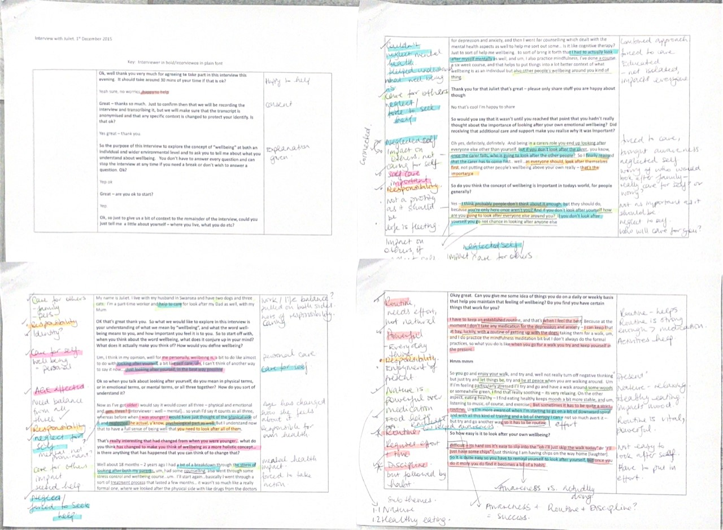
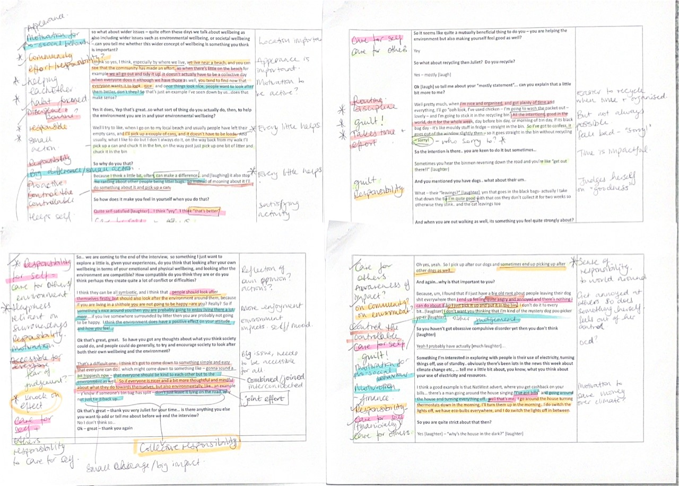

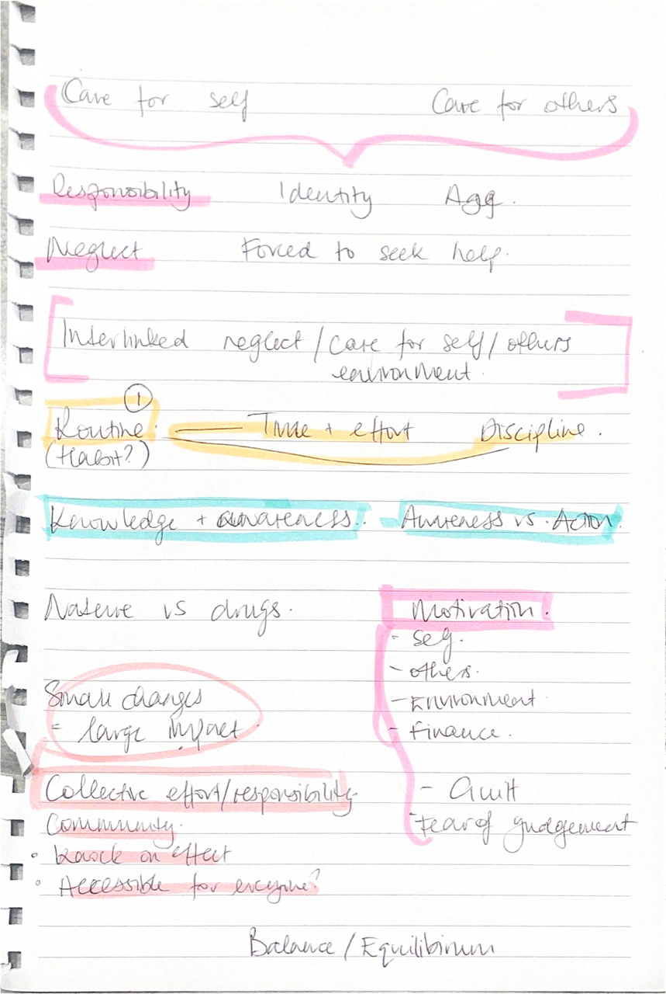

Ok, well thank you very much for agreeing to take part in this interview this evening. It should take around 30 mins of your time if that is ok?

Yeah sure, no worries, happy to help

Great – thanks so much. Just to confirm then that we will be recording the interview and transcribing it, but we will make sure that the transcript is anonymised and that any specific context is changed to protect your identify. Is that ok?

Yes great – thank you.

So the purpose of this interview to explore the concept of “wellbeing” at both an individual and wider environmental level and to ask you to tell me about what you understand about wellbeing. You don’t have to answer every question and can stop the interview at any time if you need a break or don’t wish to answer a question. Ok?

Yep ok

Great – are you ok to start?

Yep.

Ok, so just to give us a bit of context to the remainder of the interview, could you just tell me a little about yourself – where you live, what you do etc?

My name is Juliet. I live with my husband in Swansea and have two dogs and three cats. I’m a part-time worker and help to care for look after my Dad as well, with my Mum

OK that’s great thank you. So what we would like to explore in this interview is your understanding of what we mean by “wellbeing”, and what the word well-being means to you, and how important you feel it is to you. So to start off with, when you think about the word wellbeing, what does it conjure up in your mind? What does it actually make you think of? How would you define wellbeing?

Um, I think in my opinion, well for me personally, wellbeing is, a bit to do like almost to do with looking after yourself, a bit like self care, um, I can’t think of another way to say it now…. Just looking after yourself, in the best way possible

Ok so when you talk about looking after yourself, do you mean in physical terms, or in emotional terms, or mental terms, or all three together? How do you sort of understand it?

Now as I’ve got older I would say it would cover all three – physical and emotional and, um, three? [interviewer : well – mental]… so yeah I’d say it counts as all three, whereas before when I was younger I would have just thought of the physical side of it and neglected the actual, y’know, psychological part as well. But I understand now that to have a full sense of being well that you need to look after all of them.

That’s really interesting that had changed from when you were younger… what do you think has changed to make you think of wellbeing as a more holistic concept… is there anything that has happened that you can think of to change that?

Well about 18 months – 2 years ago I had a bit of a breakdown through the stress of looking after both my parents, um, had some counselling, also went through some stress control and wellbeing course…um.. I’ll start again…basically I went through a sort of treatment process that lasted a few months… it wasn’t so much like a really formal one, where we looked after the physical side with like drugs from the doctors for depression and anxiety, and then I went for counselling which dealt with the mental health aspects as well to help me sort out some… is it like cognitive therapy? Just to sort of help me wellbeing.. to sort of bring it forth that I had to actually look after myself mentally as well, and um, I also practice mindfulness, I’ve done a course, a six week course, and that helps to put things into a lot better context of what wellbeing is as an individual but also other people’s wellbeing around you kind of thing.

Thank you for that Juliet that’s great – please only share stuff you are happy about though

No that’s cool I’m happy to share

So would you say that it wasn’t until you reached that point that you hadn’t really thought about the importance of looking after your own emotional wellbeing? Did receiving that additional care and support make you realise why it was important?

Oh yes, definitely, definitely. And being in a carers role you end up looking after everyone else other than yourself. But if you don’t look after the carer.. you know, once the carer falls, who is going to look after the other people? So I finally realised that the carer has to come first.. well…as everyone should, look after themselves first, not putting other people’s wellbeing above your own really – that’s the importance

So do you think the concept of wellbeing is important in todays world, for people generally?

Yes – I think probably people don’t think about it enough, but they should do, because you’re only here once aren’t you? And if you don’t look after yourself how are you going to look after everyone else around you? If you don’t look after yourself you go not chance in looking after anyone else

Okay great. Can you give me some idea of things you do on a daily or weekly basis that help you maintain that feeling of wellbeing? Do you find you have certain things that work for you?

I have to keep an established routine, and that’s when I feel the best. Because at the moment I don’t take any medication for the depression and anxiety – I can keep that at bay, luckily, with a routine of getting up with the dogs, taking them for a walk, um, and I do practice the mindfulness meditation bit but I don’t always do the formal practices, so what you do is like when you go for a walk you try and keep yourself in the present.

Hmm mmm

So you go and enjoy your walk, and try and, well not really turn off negative thinking but just try and let things be, try and be at peace when you are walking around. Um if I’m feeling particularly stressed I’ll try and go and have a walk around some woods or somewhere green, I find that really soothing – its very relaxing. On the other aspect, eating healthy – I find eating healthy keeps moods a bit more stable, and um, listening to music, of course, and exercise. But sometimes it has to be quite a strict routine. Um I’m more aware of when I’m starting to go on a bit of downward spiral and with all this kind of training and a bit of therapy I can – not so much avert it – but try and go another way, so it has to be routine.

So how easy is it to look after your own wellbeing?

difficult – its hard cos it’s easy to slip into the “oh i’ll just skip the walk today” or “I’ll just have some chips” (just thinking I am having chips on the way home [laughter]. So it is quite easy so you have to remind yourself to look after yourself, but once you do it more you do find it becomes a bit of a habit…

so what about wider issues – quite often these days we talk about wellbeing as also including wider issues such as environmental wellbeing, or societal wellbeing – can you tell me whether this wider concept of wellbeing is something you think is important?

I think so yes, I think, especially by where we live, we live near a beach, and you can see that the community has made an effort, so when there’s little on the beach for example we all go out and tidy it up. It doesn’t actually have to be a collective day when everyone does it although we have those as well, you tend to find now that everyone wants it to look.. nice.. and once things look nice, people want to look after them better, don’t they? So that’s just an example I’ve seen down by us…does that make sense?

Yes it does, Yep that’s great..so what sort of thing do you actually do, then, to help the environment you are in and your environmental wellbeing?

Well I try to like, when I go on to my local beach and usually people have left their empty cans, and I’ll pick up a couple of cans, and it doesn’t have to be loads. And usually, what I like to do but I don’t always do it, on the way back from my walk I’ll pick up a can and chuck it in the bin, on the way past just pick up one bit of litter and chuck it in the bin

So why do you that?

Because I think a little bit, often, can make a difference… and [laughing] it also stop me ranting about other people being litter bugs. So instead of moaning about it I’ll do something about it and pick up a can.

So how does it make you feel in yourself when you do that?

Quite self-satisfied [laughter]… I think “yey”.. I think “that’s better”

So it seems like quite a mutually beneficial thing to do you – you are helping the environment but also making yourself feel good as well?

Yey

So what about recycling then Juliet? Do you recycle?

Yes – mostly [laugh]

Ok [laugh] so tell me about your “mostly statement”... can you explain that a little bit more to me?

Well pretty much, when I’m nice and organised, and got plenty of time and everything, I’ll go “ooh look, I’ve used chicken – I’m going to wash the packet out – lovely – and I’m going to stick it in the recycling bin. All the intentions, good in the world, do it for the whole week, day before bin day, or morning of bin day, if its black bag day - it’s like mouldy stuff in fridge – straight in the bin. So I’ve got to confess, it goes out of the window slightly then – so it goes straight in the bin without recycling – sorry!

So the intention is there.. you are keen to do it but sometimes…

Sometimes you hear the binmen reversing down the road and you’re like “get out there!!” [laughter]

And you mentioned you have dogs.. what about their um..

What – their “leavings?” [laughter] yes that goes in the black bags- actually I take that down the tip I’m quite good with that cos they don’t collect it for two weeks so otherwise they stink.. and the cat leavings too

And when you are out walking as well, its something you feel quite strongly about?

Oh yes, yeah. So I pick up after our dogs and sometimes end up picking up after other dogs as well..

And again…why is that important to you?

Because, um, I found that if I just have a big old rant about people leaving their dog shit everywhere then I end up feeling quite angry and annoyed and there’s nothing I can do about it, so I just pick it up and put it in the bin. I don’t do it to every bit…[laughter] I don’t want you thinking that I’m kind of the mystery dog poo picker up-er [laughter].

So you haven’t got obsessive compulsive disorder yet then you don’t think [laughter]

Yeah I probably have actually [much laughter]….

Something I’m interested in exploring with people is their use of electricity, turning things off, use of standby.. obviously there’s been lots in the news this week about climate change etc., … tell me a little bit about, you know, what you think about your use of electricity and resources.

I think a good example is that NatWest advert, where you get cashback on your bills… there’s a man going around the house singing “I’ve got bills” and going around the house and turning everything off.. well that’s me.. I go around the house turning thermostats down in the morning, I’ll turn them up in the morning…I do switch the lights off, we have eco-bulbs everywhere, and I do switch the lights off in between.

So you are quite strict about that then?

Yes [laughter] – “why’s the house in the dark?” [laughter]

So… we are coming to the end of the interview, so something I just want to explore a little is, given your experiences, do you think that looking after your own wellbeing in terms of your emotional and physical wellbeing, and looking after the environment are compatible? How compatible do you think they are or do you think perhaps they create quite a lot of conflict or difficulties?

I think they can be all symbiotic, and I think that …people should look after themselves firstly, but should also look after the environment around them, because if you are living in a shithole you are not going to be happy –are you? Really? So if something’s nice around you then you are probably going to enjoy living there a lot more….if you live somewhere surrounded by litter then you are probably not going to be happy. I think the environment does have a positive effect on your attitude and how you feel…

Ok that’s great, great. So have you got any thoughts about what you think society could do, and people could do generally, to try and encourage society to look after both their own wellbeing and the environment?

That’s a difficult one.. I think it’s got to come down to something simple and easy that everyone can do… which might come down to something like – gonna sound a bit hippiesh now – that everyone should be kind to each other but to the environment as well. So if everyone is nicer and a bit more thoughtful and mindful about what they do towards themselves, but also environmentally, like.. an example – y’know if someone’s bin bag has split – don’t just leave it lying on the road, why not just tie it back up…

Ok that’s great – thank you very Juliet for your time… is there anything you else you want to add or tell me about before we end the interview?
No I don’t think so…
Ok – great – thank you again .
Generating Themes
Care for Self
“I think in my opinion, well for me personally, wellbeing is, a bit to do like almost to do with looking after yourself, a bit like self care, um, I can’t think of another way to say it now…. Just looking after yourself, in the best way possible” (35-37)

“But if you don’t look after the carer.. you know, once the carer falls, who is going to look after the other people?” (72,73)

“So I finally realised that the carer has to come first.. well…as everyone should, look after themselves first, not putting other people’s wellbeing above your own really – that’s the importance” (73-75)

“And if you don’t look after yourself how are you going to look after everyone else around you? If you don’t look after yourself you go not chance in looking after anyone else” (80,81)

“Um if I’m feeling particularly stressed I’ll try and go and have a walk around some woods or somewhere green, I find that really soothing – its very relaxing. On the other aspect, eating healthy – I find eating healthy keeps moods a bit more stable, and um, listening to music, of course, and exercise. But sometimes it has to be quite a strict routine. Um I’m more aware of when I’m starting to go on a bit of downward spiral and with all this kind of training and a bit of therapy I can – not so much avert it – but try and go another way, so it has to be routine.” (95-101)

“Quite self-satisfied [laughter]… I think “yey”.. I think “that’s better”

So it seems like quite a mutually beneficial thing to do you – you are helping the environment but also making yourself feel good as well?

Yey” (140-145)

“I found that if I just have a big old rant about people leaving their dog shit everywhere then I end up feeling quite angry and annoyed and there’s nothing I can do about it, so I just pick it up and put it in the bin.” (177-179)

“I’ve got bills” and going around the house and turning everything off.. well that’s me..” (191-192)

“I think the environment does have a positive effect on your attitude and how you feel…” (209-210)

Care for others
“I live with my husband in Swansea and have two dogs and three cats. I’m a part-time worker and help to care for look after my Dad as well, with my Mum” (26,27)

“through the stress of looking after both my parents” (52,53)

“also other people’s wellbeing around you kind of thing.” (60,61)

“But if you don’t look after the carer.. you know, once the carer falls, who is going to look after the other people?” (72,73)

“And if you don’t look after yourself how are you going to look after everyone else around you? If you don’t look after yourself you go not chance in looking after anyone else” (80,81)

“So I pick up after our dogs and sometimes end up picking up after other dogs as well..” (173)

“that everyone should be kind to each other but to the environment as well.” (217-218)

Responsibility
“I live with my husband in Swansea and have two dogs and three cats. I’m a part-time worker and help to care for look after my Dad as well, with my Mum” (26,27)

“]… so yeah I’d say it counts as all three, whereas before when I was younger I would have just thought of the physical side of it and neglected the actual, y’know, psychological part as well. But I understand now that to have a full sense of being well that you need to look after all of them.” (43-46)

“as everyone should, look after themselves first, not putting other people’s wellbeing above your own really – that’s the importance” (73-75)

“I think probably people don’t think about it enough, but they should do, because you’re only here once aren’t you? And if you don’t look after yourself how are you going to look after everyone else around you? If you don’t look after yourself you go not chance in looking after anyone else” (79-81)

“So it is quite easy so you have to remind yourself to look after yourself, but once you do it more you do find it becomes a bit of a habit…” (106-108)

“I think so yes, I think, especially by where we live, we live near a beach, and you can see that the community has made an effort, so when there’s little on the beach for example we all go out and tidy it up. It doesn’t actually have to be a collective day when everyone does it although we have those as well, you tend to find now that everyone wants it to look.. nice.. and once things look nice, people want to look after them better, don’t they? So that’s just an example I’ve seen down by us…does that make sense?” (117-122)

“Quite self-satisfied [laughter]… I think “yey”.. I think “that’s better”

So it seems like quite a mutually beneficial thing to do you – you are helping the environment but also making yourself feel good as well?

Yey” (140-145)

“So I pick up after our dogs and sometimes end up picking up after other dogs as well..” (173)

“.. I go around the house turning thermostats down in the morning, I’ll turn them up in the morning…I do switch the lights off, we have eco-bulbs everywhere, and I do switch the lights off in between.” (192-194) Care for self/finance linked to environment?

“So if everyone is nicer and a bit more thoughtful and mindful about what they do towards themselves, but also environmentally, like.. an example – y’know if someone’s bin bag has split – don’t just leave it lying on the road, why not just tie it back up…” (218-221)

Identity
“I live with my husband in Swansea and have two dogs and three cats. I’m a part-time worker and help to care for look after my Dad as well, with my Mum” (26,27)

“I’ve got bills” and going around the house and turning everything off.. well that’s me..” (191-192)

Age is impactful
“Now as I’ve got older I would say it would cover all three – physical and emotional and, um, three? [interviewer : well – mental]… so yeah I’d say it counts as all three, whereas before when I was younger I would have just thought of the physical side of it and neglected the actual, y’know, psychological part as well.” (42-45)

Neglect
Neglect of Self
“I would say it would cover all three – physical and emotional and, um, three? [interviewer : well – mental]…(42-43)” (mental not prominent?)
“…when I was younger I would have just thought of the physical side of it and neglected the actual, y’know, psychological part as well. (43-45)”
“Well about 18 months – 2 years ago I had a bit of a breakdown through the stress of looking after both my parents” (52,53)
“I had to actually look after myself mentally as well” (58)
“And being in a carers role you end up looking after everyone else other than yourself” (71,72)
“difficult – its hard cos it’s easy to slip into the “oh i’ll just skip the walk today” or “I’ll just have some chips” (just thinking I am having chips on the way home [laughter]” (105-106)

Forced to seek help
“2 years ago I had a bit of a breakdown through the stress of looking after both my parents” (52,53)
“Just to sort of help me wellbeing.. to sort of bring it forth that I had to actually look after myself mentally as well” (57,58)

Interlinked – Neglected self/care for others + Environment
“But if you don’t look after the carer.. you know, once the carer falls, who is going to look after the other people? So I finally realised that the carer has to come first well…as everyone should, look after themselves first, not putting other people’s wellbeing above your own really – that’s the importance” (72,75)

“And if you don’t look after yourself how are you going to look after everyone else around you? If you don’t look after yourself you go not chance in looking after anyone else” (80,81)
“I think they can be all symbiotic, and I think that …people should look after themselves firstly, but should also look after the environment around them” (205-206)

“that everyone should be kind to each other but to the environment as well. So if everyone is nicer and a bit more thoughtful and mindful about what they do towards themselves, but also environmentally” (217-219)

Routine – Powerful – Discipline = Habit
“I have to keep an established routine, and that’s when I feel the best. Because at the moment I don’t take any medication for the depression and anxiety – I can keep that at bay, luckily, with a routine of getting up with the dogs, taking them for a walk,” (86-88)
“Um I’m more aware of when I’m starting to go on a bit of downward spiral and with all this kind of training and a bit of therapy I can – not so much avert it – but try and go another way, so it has to be routine.” (99-101)

“difficult – its hard cos it’s easy to slip into the “oh i’ll just skip the walk today” or “I’ll just have some chips” (just thinking I am having chips on the way home [laughter]. So it is quite easy so you have to remind yourself to look after yourself, but once you do it more you do find it becomes a bit of a habit…” (105-108)

“so when there’s little on the beach for example we all go out and tidy it up. It doesn’t actually have to be a collective day when everyone does it although we have those as well, you tend to find now that everyone wants it to look.. nice.. and once things look nice, people want to look after them better, don’t they?” (118-121)
“Well pretty much, when I’m nice and organised, and got plenty of time and everything, I’ll go “ooh look, I’ve used chicken – I’m going to wash the packet out – lovely – and I’m going to stick it in the recycling bin. All the intentions, good in the world, do it for the whole week, day before bin day, or morning of bin day, if its black bag day - it’s like mouldy stuff in fridge – straight in the bin. So I’ve got to confess, it goes out of the window slightly then – so it goes straight in the bin without recycling – sorry!” (153-158)

Awareness

Discipline

Time and effort
“…had some counselling, also went through some stress control and wellbeing course…um.. I’ll start again…basically I went through a sort of treatment process that lasted a few months… it wasn’t so much like a really formal one, where we looked after the physical side with like drugs from the doctors for depression and anxiety, and then I went for counselling which dealt with the mental health aspects as well to help me sort out some… is it like cognitive therapy? Just to sort of help me wellbeing..” (53-58)
“I had to actually look after myself mentally as well” (58)
“Well pretty much, when I’m nice and organised, and got plenty of time and everything, I’ll go “ooh look, I’ve used chicken – I’m going to wash the packet out – lovely – and I’m going to stick it in the recycling bin. All the intentions, good in the world, do it for the whole week, day before bin day, or morning of bin day, if its black bag day - it’s like mouldy stuff in fridge – straight in the bin. So I’ve got to confess, it goes out of the window slightly then – so it goes straight in the bin without recycling – sorry!” (153-158)

Knowledge/Awareness
“…had some counselling, also went through some stress control and wellbeing course…um.. I’ll start again…basically I went through a sort of treatment process that lasted a few months… it wasn’t so much like a really formal one, where we looked after the physical side with like drugs from the doctors for depression and anxiety, and then I went for counselling which dealt with the mental health aspects as well to help me sort out some… is it like cognitive therapy? Just to sort of help me wellbeing..” (53-58)
“I’ve done a course, a six week course, and that helps to put things into a lot better context of what wellbeing is as an individual but also other people’s wellbeing around you kind of thing.” (59-61)

“I had to actually look after myself mentally as well” (58)
“So I finally realised that the carer has to come first..” (73)
“Yes – I think probably people don’t think about it enough, but they should do, because you’re only here once aren’t you?” (79,80)

Awareness vs Action
“I had to actually look after myself mentally as well” (58)
“I have to keep an established routine, and that’s when I feel the best. Because at the moment I don’t take any medication for the depression and anxiety – I can keep that at bay, luckily, with a routine of getting up with the dogs, taking them for a walk, um, and I do practice the mindfulness meditation bit but I don’t always do the formal practices, so what you do is like when you go for a walk you try and keep yourself in the present.” (86-90)

“Um if I’m feeling particularly stressed I’ll try and go and have a walk around some woods or somewhere green, I find that really soothing – its very relaxing. On the other aspect, eating healthy – I find eating healthy keeps moods a bit more stable, and um, listening to music, of course, and exercise.” (95-98)

“Um I’m more aware of when I’m starting to go on a bit of downward spiral and with all this kind of training and a bit of therapy I can – not so much avert it – but try and go another way, so it has to be routine.” (99-101)

“So it is quite easy so you have to remind yourself to look after yourself, but once you do it more you do find it becomes a bit of a habit…” (106-108)

Nature Vs Pharmacology
“– I can keep that at bay, luckily, with a routine of getting up with the dogs, taking them for a walk, um, and I do practice the mindfulness meditation bit but I don’t always do the formal practices, so what you do is like when you go for a walk you try and keep yourself in the present.” (87-90)

“So you go and enjoy your walk, and try and, well not really turn off negative thinking but just try and let things be, try and be at peace when you are walking around. Um if I’m feeling particularly stressed I’ll try and go and have a walk around some woods or somewhere green, I find that really soothing – its very relaxing.” (94-97)

Healthy eating
“On the other aspect, eating healthy – I find eating healthy keeps moods a bit more stable, and um, listening to music, of course, and exercise.” (97-98)

Small Changes = Large impact
“I’ll pick up a couple of cans, and it doesn’t have to be loads.” (128)
“Because I think a little bit, often, can make a difference…” (134)
- Connection to dog walks? Small intervention?
“that everyone should be kind to each other but to the environment as well. So if everyone is nicer and a bit more thoughtful and mindful about what they do towards themselves, but also environmentally” (217-219)

Motivation
Self - health
“I have to keep an established routine, and that’s when I feel the best. Because at the moment I don’t take any medication for the depression and anxiety – I can keep that at bay, luckily, with a routine” (86-87)
“Um if I’m feeling particularly stressed I’ll try and go and have a walk around some woods or somewhere green, I find that really soothing – its very relaxing. On the other aspect, eating healthy – I find eating healthy keeps moods a bit more stable, and um, listening to music, of course, and exercise” (95-98)
“Um I’m more aware of when I’m starting to go on a bit of downward spiral and with all this kind of training and a bit of therapy I can – not so much avert it – but try and go another way, so it has to be routine” (99-101)

Self –
“Quite self-satisfied [laughter]… I think “yey”.. I think “that’s better”

So it seems like quite a mutually beneficial thing to do you – you are helping the environment but also making yourself feel good as well?

Yey” (140-145)

“….if you live somewhere surrounded by litter then you are probably not going to be happy. I think the environment does have a positive effect on your attitude and how you feel…” (208-210)

Others
“And if you don’t look after yourself how are you going to look after everyone else around you? If you don’t look after yourself you go not chance in looking after anyone else” (80-81)

Pro-social behaviour
Environment
“and once things look nice, people want to look after them better, don’t they?” (120-121)
“I’ll pick up a couple of cans, and it doesn’t have to be loads.” (128)
“Because I think a little bit, often, can make a difference… and [laughing] it also stop me ranting about other people being litter bugs. So instead of moaning about it I’ll do something about it and pick up a can.” (134-136)

“What – their “leavings?” [laughter] yes that goes in the black bags- actually I take that down the tip I’m quite good with that cos they don’t collect it for two weeks so otherwise they stink.. and the cat leavings too” (166-168) (Responsibility)

“So I pick up after our dogs and sometimes end up picking up after other dogs as well..” (173)

“if you are living in a shithole you are not going to be happy –are you? Really? So if something’s nice around you then you are probably going to enjoy living there a lot more….if you live somewhere surrounded by litter then you are probably not going to be happy. I think the environment does have a positive effect on your attitude and how you feel…” (206-210)

“that everyone should be kind to each other but to the environment as well. So if everyone is nicer and a bit more thoughtful and mindful about what they do towards themselves, but also environmentally” (217-219)

Finance
“I’ve got bills” and going around the house and turning everything off.. well that’s me.. I go around the house turning thermostats down in the morning, I’ll turn them up in the morning…I do switch the lights off, we have eco-bulbs everywhere, and I do switch the lights off in between.” (191-194)

Collective responsibility/Community effort
“especially by where we live, we live near a beach, and you can see that the community has made an effort, so when there’s little on the beach for example we all go out and tidy it up. It doesn’t actually have to be a collective day when everyone does it although we have those as well, you tend to find now that everyone wants it to look.. nice.. and once things look nice, people want to look after them better, don’t they?” (117-121)
“So I pick up after our dogs and sometimes end up picking up after other dogs as well..” (173)

“I think they can be all symbiotic, and I think that …people should look after themselves firstly, but should also look after the environment around them, because if you are living in a shithole you are not going to be happy –are you? Really? So if something’s nice around you then you are probably going to enjoy living there a lot more….if you live somewhere surrounded by litter then you are probably not going to be happy. I think the environment does have a positive effect on your attitude and how you feel…” (205-210)

“That’s a difficult one.. I think it’s got to come down to something simple and easy that everyone can do…” (216-217)
“that everyone should be kind to each other but to the environment as well. So if everyone is nicer and a bit more thoughtful and mindful about what they do towards themselves, but also environmentally” (217-219)

Knock on effect
“And if you don’t look after yourself how are you going to look after everyone else around you? If you don’t look after yourself you go not chance in looking after anyone else” (80-81)

“that everyone should be kind to each other but to the environment as well. So if everyone is nicer and a bit more thoughtful and mindful about what they do towards themselves, but also environmentally” (217-219)

Accessible for everyone
“That’s a difficult one.. I think it’s got to come down to something simple and easy that everyone can do…” (216-217)
Proactive
“So instead of moaning about it I’ll do something about it and pick up a can.” (135-136)

Guilt
“And if you don’t look after yourself how are you going to look after everyone else around you? If you don’t look after yourself you go not chance in looking after anyone else” (80-81)

“So I’ve got to confess, it goes out of the window slightly then – so it goes straight in the bin without recycling – sorry!” (156-158) sorry to who?

“Sometimes you hear the binmen reversing down the road and you’re like “get out there!!” [laughter]” (162)

Fear of judgement
“So I’ve got to confess, it goes out of the window slightly then – so it goes straight in the bin without recycling – sorry!” (156-158)

“ I don’t do it to every bit…[laughter] I don’t want you thinking that I’m kind of the mystery dog poo picker up-er [laughter].” (179-180)

“gonna sound a bit hippiesh now” (217)
Control the controllable
“So instead of moaning about it I’ll do something about it and pick up a can.” (135-136)

“I found that if I just have a big old rant about people leaving their dog shit everywhere then I end up feeling quite angry and annoyed and there’s nothing I can do about it, so I just pick it up and put it in the bin.” (177-179)

Equilibrium/Balance
Self
“…so yeah I’d say it counts as all three, whereas before when I was younger I would have just thought of the physical side of it and neglected the actual, y’know, psychological part as well. But I understand now that to have a full sense of being well that you need to look after all of them.” (43-46)

“Quite self-satisfied [laughter]… I think “yey”.. I think “that’s better”

So it seems like quite a mutually beneficial thing to do you – you are helping the environment but also making yourself feel good as well?

Yey” (140-145)

“that everyone should be kind to each other but to the environment as well. So if everyone is nicer and a bit more thoughtful and mindful about what they do towards themselves, but also environmentally” (217-219)

 | Superoridinate Themes | Subordinate Themes | Quotes
1 | Wellbeing and environment are intertwined
 | 1.1 | Wellbeing is multifaceted | “…so yeah I’d say it counts as all three, whereas before when I was younger I would have just thought of the physical side of it and neglected the actual, y’know, psychological part as well. But I understand now that to have a full sense of being well that you need to look after all of them.” (43-46)
 | 1.2 | Neglecting the environment affects wellbeing | “….if you live somewhere surrounded by litter then you are probably not going to be happy. I think the environment does have a positive effect on your attitude and how you feel…” (208-210)
 | 1.3 | Environment can positively affect wellbeing | “Um if I’m feeling particularly stressed I’ll try and go and have a walk around some woods or somewhere green, I find that really soothing (95?)
 | 1.4 | Equilibrium | “I think they can be all symbiotic, and I think that …people should look after themselves firstly, but should also look after the environment around them, because if you are living in a shithole you are not going to be happy –are you? Really? So if something’s nice around you then you are probably going to enjoy living there a lot more….if you live somewhere surrounded by litter then you are probably not going to be happy. I think the environment does have a positive effect on your attitude and how you feel…” (205-210)
2 | We all have a responsibility
 | 1.1 | Care for self, others and environment | “that everyone should be kind to each other but to the environment as well. So if everyone is nicer and a bit more thoughtful and mindful about what they do towards themselves, but also environmentally” (217-219)
 | 1.2 | Lack of sense of responsibility causes frustration | “I found that if I just have a big old rant about people leaving their dog shit everywhere then I end up feeling quite angry and annoyed and there’s nothing I can do about it, so I just pick it up and put it in the bin.” (177-179)
 | 1.3 | Collective effort has a big impact | “especially by where we live, we live near a beach, and you can see that the community has made an effort, so when there’s little on the beach for example we all go out and tidy it up. It doesn’t actually have to be a collective day”
 | 1.4 | Engagement requires simplicity | “That’s a difficult one.. I think it’s got to come down to something simple and easy that everyone can do…” (216-217)
3 | You can’t pour from an empty cup
 | 1.1 | Neglect of self through life experiences | “And being in a carers role you end up looking after everyone else other than yourself” (71,72)
 | 1.2 | Epiphany of importance | “So I finally realised that the carer has to come first.. well…as everyone should, look after themselves first, not putting other people’s wellbeing above your own really – that’s the importance” (73-75)
 | 1.3 | Care for others, requires care for self | “And if you don’t look after yourself how are you going to look after everyone else around you? If you don’t look after yourself you go not chance in looking after anyone else” (80,81)
 | 1.4 | Wellbeing should be higher in priorities | “Yes – I think probably people don’t think about it enough, but they should do, because you’re only here once aren’t you?” (79,80)
4 | Driving forces
 | 1.1 | Burdened by a duty of care | “So I pick up after our dogs and sometimes end up picking up after other dogs as well..” (173)
 | 1.2 | Finances | “I’ve got bills” and going around the house and turning everything off.. well that’s me..” (191-194)
 | 1.3 | Feelings of guilt and fear of judgement | “So I’ve got to confess, it goes out of the window slightly then – so it goes straight in the bin without recycling – sorry!” (156-158)
 | 1.4 | Controlling the controllable | “So instead of moaning about it I’ll do something about it and pick up a can.” (135-136)
 | 1.5 | Gaining satisfaction | “Quite self-satisfied [laughter]… I think “yey”.. I think “that’s better”
5 | A routine is vital
 | 1.1 | Knowledge requires action to produce change | “So it is quite easy so you have to remind yourself to look after yourself, but once you do it more you do find it becomes a bit of a habit…” (106-108)
 | 1.2 | It takes time and effort | “difficult – its hard cos it’s easy to slip into the “oh i’ll just skip the walk today” or “I’ll just have some chips” (just thinking I am having chips on the way home [laughter]. So it is quite easy so you have to remind yourself to look after yourself, but once you do it more you do find it becomes a bit of a habit…” (105-108)
 | 1.3 | Being disciplined is important | But sometimes it has to be quite a strict routine. Um I’m more aware of when I’m starting to go on a bit of downward spiral and with all this kind of training and a bit of therapy I can – not so much avert it – but try and go another way, so it has to be routine.” (95-101)
 | 1.4 | The power of routine | “I have to keep an established routine, and that’s when I feel the best. Because at the moment I don’t take any medication for the depression and anxiety – I can keep that at bay, luckily, with a routine of getting up with the dogs, taking them for a walk,” (86-88)

