

Programme

Master of Business Administration

Module

Marketing Management

Module Code

LCMB7024

Assignment Title

Marketing Environment Analysis

Student Name

Rahul Jaymalbhai Modhwadiya

Student ID Number

2539629

Word Count

2676 words

Submission Date

26 June 2026

Table of Contents
1 Introduction 1
2 Task 1: Marketing Environment Analysis 2
2.1 BHP’s Strategic Context 2
2.1.1 Company Background and Market Position 2
2.1.2 The Marketing Challenge of Transition Minerals 3
2.2 External Actor One: The Natural Environment 3
2.2.1 Climate Change as a Strategic Marketing Pressure 3
2.2.2 Natural-Resource-Based View and Competitive Advantage 4
2.2.3 Critical Tension: Transition Claims and Greenwashing Risk 4
2.3 External Actor Two: Industrial Customers and Value-Chain Partners 5
2.3.1 Business-to-Business Customer Expectations 5
2.3.2 Steelmakers as Co-Creators of Lower-Carbon Value 5
3 Task 2: Strategic Growth and Competitive Positioning 7
3.1 Applying the Ansoff Matrix 7
3.1.1 Strategic Options Available to BHP 7
3.1.2 Justification for Product Development 7
3.2 Recommended Growth Strategy 8
3.2.1 Positioning BHP as a Supplier of Verified Transition Materials 8
3.2.2 Lower-Carbon Copper as a Growth Platform 8
3.2.3 Potash and Related Market Development 9
3.2.4 Product-Level Carbon Assurance as a Marketing Capability 9
3.3 Competitive Positioning and Advantage 9
3.3.1 Differentiation Rather Than Pure Cost Leadership 9
3.3.2 Dynamic Capabilities and Portfolio Reconfiguration 9
3.4 Implementation and Key Performance Indicators 11
3.5 Critical Evaluation of Strategic Risks 11
3.5.1 Technology and Market Adoption Risk 11
3.5.2 Overall Strategic Judgement 12
4 Task 3: Critical Reflection on AI Usage 12
4.1 Tool Disclosure 12
4.2 Critical Evaluation of AI Output 12
4.3 Contribution Analysis 13
4.4 Ethical and Professional Reflection 13
5 Conclusion 13
6 References 14

Introduction
The metals and mining industry is the heart of the global low-carbon transition since it provides copper, iron ore, metallurgical coal, nickel, potash and other minerals needed to electrify, build infrastructure, construct and feed the world. Nonetheless, the industry is confronted with a high level of criticism towards the environment since mining activities produce mining products with high greenhouse gas emissions and local environmental effects (BHP Group, 2024; IEA, 2025a; World Steel Association, 2025). BHP Group has been chosen as the focus organisation in this report since it is one of the largest diversified mining companies in the world and is currently repositioning its portfolio due to copper, potash, iron ore and steel decarbonisation alliances (BHP Group, 2025a, 2025b).
The report is organized in line with the requirements of the assignment. The critical analysis of two external marketing environment actors that impact the transition of BHP to lower-carbon products in Task 1 focuses on the natural environment and the second on the industrial customers and value-chain partners. Task 2 proposes strategic growth strategy based on Ansoff Matrix and assesses the possibility of BHP developing competitive advantage as it moves towards lower-carbon business model. Task 3 gives a critical reflections of the usage of the Artificial Intelligence in the creation of the report. LO1 is discussed by critically evaluating marketing activities and how environmental analysis can help in making strategic marketing decisions. It tackles LO2 as it analyzes future marketing trends that are connected with climate technology, emissions information, artificial intelligence and sustainable value creation.

Task 1: Marketing Environment Analysis

BHP’s Strategic Context

Company Background and Market Position
The current strategy of BHP demonstrates the conflict between the growth and decarbonisation. BHP announced record annual copper production, record iron ore production, and robust operational performance and further investment in copper and potash as growth alternatives in FY2025 (BHP Group, 2025a). These results demonstrate that BHP possesses the funds and resource pool to invest in less carbon technology, cleaner operations and portfolio transformation. Nevertheless, they generate increased expectations on governments, investors, customers and communities that the sustainability assertions and claims of BHP are backed by quantifiable performance rather than formulations (ACCR, 2024; BHP Group, 2024; IEEFA, 2024).

The Marketing Challenge of Transition Minerals
The marketing environment that BHP is in is not simple since its products are both climate problem and climate solution. Copper underpins the electrification, power grid and renewable energy networks, with iron ore and metallurgical coal continuing to be associated with the highly carbon-intensive steel industry (IEA, 2025a; World Steel Association, 2025). Thus, it is not just operational decarbonisation that BHP faces, but also a plausible market positioning in the environment where industrial clients are becoming more and more demanding of traceability, low-carbon feedstock and quality data on emissions (BHP Group, 2025b; Nygaard, 2024). This implies that marketing strategy is informed directly by environmental analysis since BHP should show how its products will assist customers to decarbonise without exaggerating the environmental progress that it is making.

External Actor One: The Natural Environment

Climate Change as a Strategic Marketing Pressure
The most significant external marketing actor that has an impact on the transition of BHP is the natural environment. The natural environment is part of the marketing environment analysis that comprises of physical resources, climate conditions, energy systems and ecological constraints that influence organisational strategy (Kotler et al., 2024). In the case of BHP, climate change, water shortage, loss of biodiversity, air pollution, resource drainage and carbon regulation directly affect the demand of the products, trust and corporate legitimacy of the stakeholders (BHP Group, 2024; Hart, 1995; IEA, 2025a).
Of significance is the steel value chain. According to the World Steel Association (2025), the emissions of the steel industry are about 7%-8% of the total greenhouse gas emissions by humans around the world. This is important to BHP since iron ore and metallurgical coal are the main materials that are used in the process of steelmaking, which implies that the role of the Scope 3 emissions by BHP depends on the way its products are utilized by customers (BHP Group, 2024; BHP Group, 2025b). BHP has established a goal of cutting down on operational Scope 1 and 2 emissions by not less than 30% of the FY2020 levels by FY2030 and to achieve net zero operational greenhouse gas emissions by CY2050 (BHP Group, 2024). The broader climate credibility of the company, however, also relies on its ability to use its products in lower-emission steelmaking processes like direct reduced iron, electric smelting furnace technologies and production based on renewable energy sources (BHP Group, 2025c; IEEFA, 2024; World Steel Association, 2025).
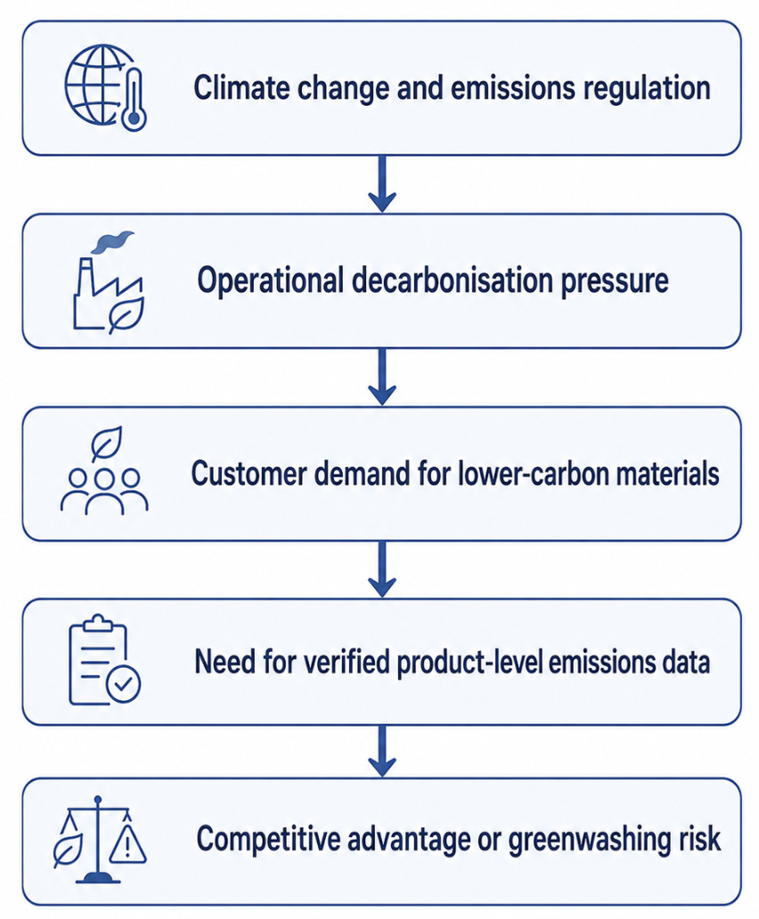
Figure 1. Natural environment pressures shaping BHP’s marketing transition
Source: BHP Group (2024), Hart (1995), IEA (2025a), and World Steel Association (2025).

Natural-Resource-Based View and Competitive Advantage
The natural-resource-based perspective can offer a practical theoretical perspective. According to Hart (1995), the prevention of pollution, product stewardship and sustainable development may turn out to be an origin of competitive advantage when the companies build competencies that are unlikely to be duplicated by their rivals. In the case of BHP, marketing with lower carbon content cannot be promoted through the use of words only. It has to be based on operational emissions reduction, acquisition of renewable energy, electrification of mines, management of methane, biodiversity planning, and water stewardship and customer collaboration (BHP Group, 2024; Bocken and Geradts, 2020; Geissdoerfer et al., 2018). That is why environmental analysis is directly related to the marketing strategy: it specifies which product characteristics, claims and collaborations will be plausible on the market.

Critical Tension: Transition Claims and Greenwashing Risk
The BHP environmental stance is controversial. BHP claims that not all the technologies to be fully decarbonised are commercially available yet and that Scope 3 emissions rely in part on steelmakers, suppliers, infrastructure providers and governments (BHP Group, 2024, 2025b). This position is quite logical since hydrogen-based steelmaking, electric smelting and carbon capture demand a significant amount of renewable electricity on a large scale, policy incentives, and the readiness of customers to pay (IEA, 2025a; Reuters, 2026a; World Steel Association, 2025). But, investor and climate analysts believe that the Scope 3 approach of BHP is not as robust as yet, since not all of the targets are firm measurable commitments but are stated as goals (ACCR, 2024; IEEFA, 2024). This poses a strategic marketing risk: when BHP starts marketing its sustainability more actively than it changes the production and customer-use channels, it can be accused of greenwashing (Delmas & Burbano, 2011; Torelli et al., 2020).

External Actor Two: Industrial Customers and Value-Chain Partners

Business-to-Business Customer Expectations
The second significant external driver is the network of industrial customers and partners of BHP, in particular, steelmakers, energy-transition producers, infrastructure companies and agricultural markets. Customers in business-to-business marketing are also becoming more concerned about the supply security, availability of emissions transparency, reliability, and quality of product and its suitability to their own decarbonisation targets, rather than just price and quantity (BHP Group, 2025b; Nygaard, 2024; Porter, 1985).
According to the International Energy Agency (2025a), copper is one of the essential materials in the electricity networks and clean energy technologies. It also states that the critical mineral supply chains are still highly concentrated with the average market share of the three leading refining countries of key energy minerals increasing to 86% in 2024 (IEA, 2025a). This presents a big opportunity to the BHP copper business. Nonetheless, and up surging demand does not necessarily mean competitive advantage. The clients and regulators demand increasingly responsible extraction, reliable emissions statistics and valid supply-chain requirements (IEA, 2025b; Nygaard, 2024; UNESCO, 2023). Thus, the marketing value proposition of BHP will need to shift further than the volume supply to a more responsible, lower-carbon, traceable materials.

Steelmakers as Co-Creators of Lower-Carbon Value
Customers of steel making pose a more challenging task. Some of the companies BHP has collaborated with include Tata Steel, POSCO, China Baowu, JFE Steel and HBIS in an effort to identify new and lower-emission steelmaking technology and carbon accounting approaches (BHP Group, 2022, 2025b; Tata Steel, 2022). Such alliances are strategically significant since they enable BHP to have a say in the way its iron ore can be exploited in the new steelmaking paths. BHP has also announced experiments with Pilbara ores in direct reduced iron processes, and the possible decrease in emissions-intensity in case of adding electric smelting technologies (BHP Group, 2025c). According to the stakeholder theory, these customers are not just mere buyers as they co-create the future market and product relevance at BHP (Freeman, 1984; Geissdoerfer et al., 2018).
Table 1. External marketing environment actors affecting BHP
External actor | Opportunity for BHP | Threat or limitation | Marketing implication
Natural environment | Demand for copper, potash and lower-carbon minerals | Climate risk, water stress, biodiversity concerns and Scope 3 scrutiny | Product claims must be verified and linked to measurable emissions performance
Steelmaking customers | Co-development of lower-emissions steelmaking pathways | High cost and slow adoption of green steel technologies | BHP must market technical collaboration, not only commodity supply
Governments and regulators | Policy support for critical minerals and decarbonisation | Carbon disclosure, litigation and greenwashing rules | Stronger need for transparent reporting and compliance-based messaging
Investors | Access to capital for transition minerals | Pressure on climate targets and fossil-fuel exposure | Strategy must show credible transition risk management
Communities and NGOs | Social licence and local legitimacy | Opposition to mining impacts and environmental damage | Marketing must integrate community, biodiversity and water stewardship
There are contradictions by industrial customers as well. Green steel is still costly and commercially unproven, so steelmakers desire less-carbon inputs. According to the recent industry reporting, the development of green steel is slower than the necessary level due to the lack of investment, policy assistance, the availability of hydrogen and readiness of the customers to pay (Reuters, 2026a; Reuters, 2026b). Thus BHP should not expect that all customers will be willing to pay a big green premium at once. Rather, it must employ partnership marketing, technical assistance, long-term offtake contracts and product-level emissions guarantee to lessen adoption obstacles (BHP Group, 2025b; Porter, 1985; Teece, 2007).

Task 2: Strategic Growth and Competitive Positioning

Applying the Ansoff Matrix

Strategic Options Available to BHP
Ansoff Matrix assesses growth in four possible ways including: market penetration, market development, product development and diversification (Ansoff, 1957). In the case of BHP, the strategic growth strategy that is best suited is product development facilitated by a selective market development. The penetration of the market would not be enough since the mere increase in the sale of more traditional iron ore and metallurgical coal can expose BHP to the accusations of Scope 3 (ACCR, 2024; IEEFA, 2024). This would also be a risky full unrelated diversification since the BHP strong areas are big mining and processing, logistics, commodity markets and industrial partnerships rather than consumer facing green technology businesses (Barney, 1991; BHP Group, 2025a).

Justification for Product Development
The product development is a strategic option since BHP will be able to modify the current products and strengths in order to suit the lower-carbon needs of customers. This consists of lower-carbon copper, product-level emissions information, iron ore that is adapted to direct reduced iron and electric smelting technology, ore beneficiation, mining operations that are powered by renewable energy, and potash as a growth product that is associated with food security (BHP Group, 2025a, 2025b; IEA, 2025a). This should be aided by selective market development where customers and areas with the most beneficial climate regulation, infrastructure development and clean-energy demand should be targeted.
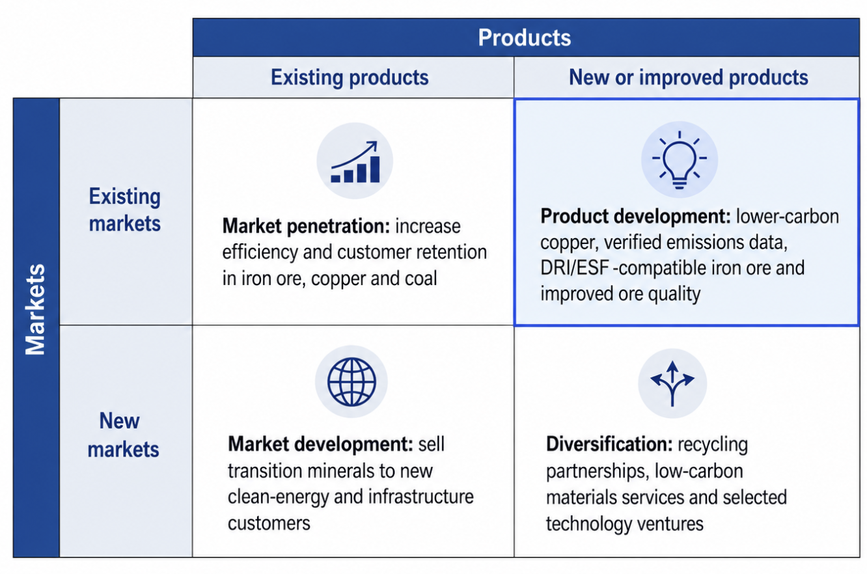
Figure 2. Ansoff Matrix for BHP’s lower-carbon growth
Source: Ansoff (1957), BHP Group (2025a), and IEA (2025a).

Recommended Growth Strategy

Positioning BHP as a Supplier of Verified Transition Materials
The suggested growth plan is to make BHP a provider of certified lower-carbon transition materials. This must entail four activities that are interrelated. First, BHP needs to speed up product development in iron ore through investing in ore beneficiation, blending, and pelletisation research and compatibility with direct reduced iron and electric smelting furnace routes (BHP Group, 2025c; IEEFA, 2024). This is significant in the sense that future steel customers would be more inclined towards ores that work effectively in the processes of low emissions. BHP should not be able to compete with producers with ores that are more naturally adapted to direct reduction, otherwise it will lose its competitiveness (ACCR, 2024; IEEFA, 2024).

Lower-Carbon Copper as a Growth Platform
Second, BHP needs to enhance its lower-carbon copper value. There is projected to be an increase in copper demand due to electricity grids, renewable power, electric vehicles and data infrastructure are copper-intensive (IEA, 2025a, 2025b). Nevertheless, copper cannot be promoted by BHP as a sustainable product per se. The company should demonstrate that it is decarbonising the production of copper using renewable electricity and energy efficiency, water management and mine-site innovation (BHP Group, 2024; Bocken and Geradts, 2020; Hart, 1995).

Potash and Related Market Development
Third, BHP ought to make use of potash as a similar diversification and market development prospect. The potash enhances agricultural productivity and food security, providing BHP with a growth story based on sustainability, without metals (BHP Group, 2025a). Nonetheless, the Jansen potash project also exhibits the risk of execution owing to the fact that mega capital projects are susceptible to inflation, time delays and inefficiencies (Reuters, 2025). Consequently, potash ought to be sold more as a long-term growth platform, as opposed to an immediate remedy to the climate-transition risk.

Product-Level Carbon Assurance as a Marketing Capability
Fourth, BHP ought to create product-based carbon assurance as a marketing capacity. The need of customers to access dependable information on emissions as a tool to aid procurement, reporting and regulatory compliance is growing (BHP Group, 2025b; Nygaard, 2024). This renders emissions data to be a part of product. A tonne of copper or iron ore with plausible emissions data might be more valuable than a tonne of such that is sold without the same. This is also indicative of relationship marketing since customers can utilize trusted data to enhance their own sustainability reporting, and minimize the risk in procurement.

Competitive Positioning and Advantage

Differentiation Rather Than Pure Cost Leadership
BHP ought to adopt differentiation strategy and not pure cost leadership. According to Porter (1985), cost leadership, differentiation or focus are some of the ways in which firms can attain competitive advantage. Cost efficiency is still a factor in commodity markets; however, the transition to lower-carbon in BHP necessitates an investment in technology, collaboration, data security and shift in operations (BHP Group, 2024; Teece, 2007). The only way in which it would be defeated would be competing based on price and not being able to finance these changes. The concept of differentiation is more suitable, as BHP can compete based on responsible supply, transparency of emissions, technical support and long-term cooperation with customers (Bocken & Geradts, 2020; Geissdoerfer et al., 2018; Porter, 1985).

Dynamic Capabilities and Portfolio Reconfiguration
This is also recommended by the dynamic capabilities theory. Teece (2007) makes the argument that competitive advantage in the dynamic environment should be based on sensing opportunity, seizing it and reconfiguring resources. BHP feels the copper, potash and lower-carbon steel inputs demand; it is taking advantage with customer relationships and portfolio investment; it is reconfiguring through shifting strategic focus to future-facing commodities (BHP Group, 2025a, 2025b; IEA, 2025a). This reconfiguration is however, not complete since BHP continues to be exposed to metallurgical coal and Scope 3 emissions. Competitive advantage of the company will thus lie in whether or not it can credibly handle the transition as opposed to rebranding existing products.
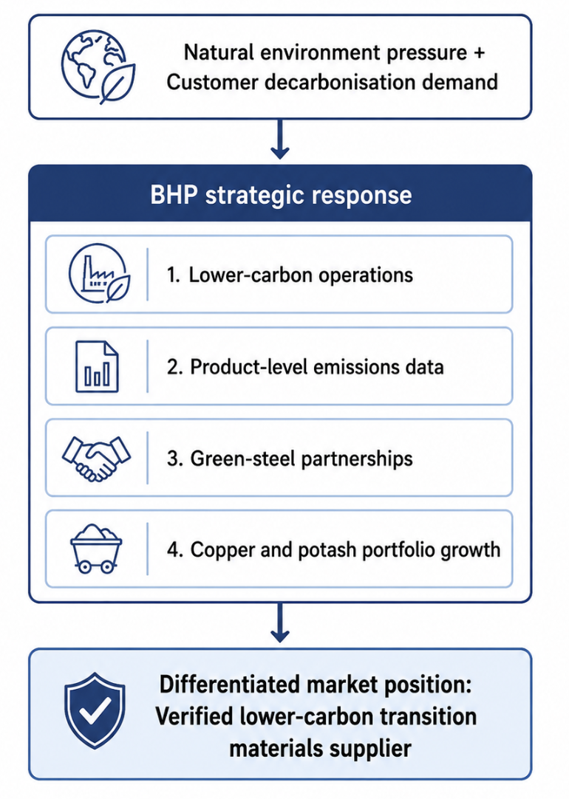
Figure 3. Proposed lower-carbon competitive positioning framework for BHP
Source: BHP Group (2024, 2025b), Hart (1995), Porter (1985), and Teece (2007).

Implementation and Key Performance Indicators
The strategy is to be carried out based on quantifiable marketing and operational measures. In the absence of quantifiable indicators, sustainability communication may look more of a symbolic approach than a strategic one (Delmas and Burbano, 2011; Torelli et al., 2020). BHP must thus tie its marketing statements to actual performance data, such as the percentage of its sales that is covered by third-party product carbon data, the reduction of its emissions relative to baseline and the number of steelmaker trials it has completed, the percentage of its electricity consumption that is covered by renewable electricity, and the customer contracts it has signed with its lower-carbon products (BHP Group, 2024, 2025b; Nygaard, 2024).
Table 2. Strategic roadmap for BHP’s lower-carbon growth
Strategic action | Time horizon | Marketing objective | Suggested KPI
Expand product-level emissions assurance for copper and iron ore | 1–2 years | Build customer trust and reduce greenwashing risk | Percentage of sales with third-party verified product carbon data
Increase renewable power and mine electrification | 1–6 years | Reduce operational carbon intensity | Scope 1 and 2 emissions reduction against FY2020 baseline
Develop DRI/ESF-compatible iron ore solutions | 2–6 years | Protect future relevance in green steel markets | Number of commercial steelmaker trials and long-term customer agreements
Strengthen lower-carbon copper positioning | 1–4 years | Capture clean-energy and electrification demand | Copper volume sold to grid, renewable and EV-linked customers
Manage Jansen potash delivery with capital discipline | 2–7 years | Build credible food-security growth platform | Production milestones, cost variance and customer offtake progress
Source: BHP Group (2024, 2025a, 2025b), IEA (2025a), Porter (1985), and Teece (2007).

Critical Evaluation of Strategic Risks

Technology and Market Adoption Risk
The suggested plan is associated with a number of risks. To begin with, there is the uncertainty of technology that may slow down customer adoption. The hydrogen steelmaking and electric smelting demand high amounts of renewable energy, new facilities and facilitating regulation (IEA, 2025a; Reuters, 2026a; World Steel Association, 2025). Second, the willingness of customers to pay is not guaranteed as the less carbon steel and minerals can be more expensive (Reuters, 2026b). Third, the climate credibility of BHP might be undermined by the fact that its operational progress may be compensated by some further increase in the number of carbon-intensive value chains (ACCR, 2024; IEEFA, 2024). Fourth, capital discipline is needed in transforming a portfolio since the mining projects are usually large and can lead to cost overruns and delays (BHP Group, 2025a; Reuters, 2025).

Overall Strategic Judgement
These risks notwithstanding, product development that has been backed by selective market development is the best choice. It enables BHP to exploit the current capabilities and be flexible to meet the demands of the future customer. The trick is not to generalize the concept of sustainability, but make targeted, tested and customer-oriented changes known. This would align the marketing activities of BHP to the environmental transition and competitive advantage. In this regard, the future success of BHP will not just be based on what it mines, but how well it can prove that its products promote decarbonisation of customers and value-chain that can be measured.

Task 3: Critical Reflection on AI Usage

Tool Disclosure
Only the categories allowed in this assessment were treated by Artificial Intelligence: research support, proofreading and creative support. The ChatGPT assisted in the research process by aiding in the identification of the first search terms, comparison of broad themes of sources, and summary of background materials, then relevant academic and industry sources were chosen manually. Proofreading was also done by using AI, such as grammatical checking, sentence clarity, and academic expression. Also, the figures of the report such as the environmental pressure diagram, Ansoff Matrix, and competitive positioning framework were created with the help of AI-supported creative tools.
The final submission was not written using AI, nor was it used to write code, or to substitute independent academic judgement. The student developed the report structure, selection of cases, critical analysis and recommendations. BHP reports, IEA data, worldsteel information, academic articles, and independent analysis were all credible sources that were used to validate all company claims, statistics, and examples.

Critical Evaluation of AI Output
The risk of using AI was the most important, and it was that it might produce incorrect or unsubstantiated output. Even though AI is able to create academic writing of a high quality, it might come up with artificial sources, inaccurate figures, or statements that seem plausible, but are not substantiated (Bender et al., 2021; Dwivedi et al., 2023). To reduce this risk, all AI-assisted content was checked manually. The BHP-specific data was checked with the annual report and climate transition disclosures of BHP. The comparison was carried out on broader industry assertions with the plausible external sources such as IEA, World Steel Association, ACCR, and IEEFA. References were also verified to make sure that they were in place, related, and also supported the particular arguments presented. Any wording of AI that was generic or unsupported, was eliminated or reformulated into critical evidence-based analysis.

Contribution Analysis
AI was used to assist in authorized support, such as research support, proofreading, and creative support. It facilitated the determination of search words, better grammar, and facilitated the development of figures. Nonetheless, BHP selection, environmental actors choice, the use of the Ansoff Matrix, and the ultimate recommendations were made out of self-academic prerogative. The analysis made by the student was not substituted by AI.

Ethical and Professional Reflection
There is a problem of transparency, accountability, bias, confidentiality and professional competence in the use of AI in marketing analysis. In sustainability marketing, AI can also promote the risk of greenwashing when it produces convincing environmental messages which are not backed by evidence (Delmas and Burbano, 2011; Torelli et al., 2020). Another issue is that AI can also repeat the dominating corporate discourses in case the user does not incorporate critical or independent resources (Bender et al., 2021; Dwivedi et al., 2023). Marketers should thus professionally reveal all AI applications where necessary, verify all claims, safeguard confidential data and be responsible for final products (UNESCO, 2023). The application of AI in this report was ethical as it was presented as a learning and drafting assistant, and the selection of evidence, its verification, and critical assessment were left in the hands of human operators.

Conclusion
BHP is being influenced by the natural environment and industrial customers in its value chain in its transition towards lower-carbon products. Pressures by the natural environment include climate change, emissions control, water and biodiversity issues, and greenwashing. Industrial customers pose an opportunity and constraint as they require lower-carbon material but at a high cost and with uncertain technologies. The solution suggested is development of the product along with selective development of the market with the goal of lower-carbon copper, green-steel-compatible iron ore, confirmed emissions statistics and controlled growth of potash. Differentiation and dynamic capabilities, technology partnerships and transparent carbon assurance should be used to develop competitive advantage. In conclusion, a marketing problem that BHP must face does not only lie in communicating sustainability but demonstrate that its products and relationships can help in achieving quantifiable decarbonisation without impacting its ability to make a profit.

References
ACCR. (2024). BHP climate transition action plan analysis. Australasian Centre for Corporate Responsibility. https://www.accr.org.au/research/bhp-climate-transition-action-plan-analysis/
Amegboleza, A. A., & Ülkü, M. A. (2025). Sustainable energy transition for the mining industry: A bibliometric analysis of trends and emerging research pathways. Sustainability, 17(5), 2292. https://www.mdpi.com/2071-1050/17/5/2292
Ansoff, H. I. (1957). Strategies for diversification. Harvard Business Review, 35(5), 113–124. https://hbr.org/1957/09/strategies-for-diversification
Barney, J. (1991). Firm resources and sustained competitive advantage. Journal of Management, 17(1), 99–120. https://journals.sagepub.com/doi/10.1177/014920639101700108
Bender, E. M., Gebru, T., McMillan-Major, A., & Shmitchell, S. (2021). On the dangers of stochastic parrots: Can language models be too big? Proceedings of the 2021 ACM Conference on Fairness, Accountability, and Transparency, 610–623. https://dl.acm.org/doi/10.1145/3442188.3445922
BHP Group. (2022). BHP and Tata Steel reinforce commitment to decarbonise steelmaking in India. https://www.bhp.com/news/media-centre/releases/2022/07/bhp-and-tata-steel-reinforce-commitment-to-decarbonise-steelmaking-in-india
BHP Group. (2024). Climate Transition Action Plan 2024. https://www.bhp.com/sustainability/climate-change/climate-transition-action-plan
BHP Group. (2025a). Annual report 2025. https://www.bhp.com/investor-hub/reports-and-presentations/annual-report
BHP Group. (2025b). Value chain GHG emission reductions. https://www.bhp.com/sustainability/climate-change/value-chain-ghg-emission-reductions
BHP Group. (2025c). Steelmaking decarbonisation. https://www.bhp.com/news/bhp-insights/2025/12/steelmaking-decarbonisation
Bocken, N. M. P., & Geradts, T. H. J. (2020). Barriers and drivers to sustainable business model innovation: Organization design and dynamic capabilities. Long Range Planning, 53(4), 101950. https://www.sciencedirect.com/science/article/pii/S0024630119304754
Delmas, M. A., & Burbano, V. C. (2011). The drivers of greenwashing. California Management Review, 54(1), 64–87. https://www.ioes.ucla.edu/wp-content/uploads/2017/04/2011-Delmas-Cuerel-Burbano-California-Management-Review.pdf
Dwivedi, Y. K., Kshetri, N., Hughes, L., Slade, E. L., Jeyaraj, A., Kar, A. K., Baabdullah, A. M., Koohang, A., Raghavan, V., Ahuja, M., Albanna, H., Albashrawi, M. A., Al-Busaidi, A. S., Balakrishnan, J., Barlette, Y., Basu, S., Bose, I., Brooks, L., Buhalis, D., ... Wright, R. (2023). “So what if ChatGPT wrote it?” Multidisciplinary perspectives on opportunities, challenges and implications of generative conversational AI for research, practice and policy. International Journal of Information Management, 71, 102642. https://www.sciencedirect.com/science/article/pii/S0268401223000233
Freeman, R. E. (1984). Strategic management: A stakeholder approach. Cambridge University Press. https://www.cambridge.org/core/books/strategic-management/9AAFD8E0BD2780C59D33C2EBD6D1A75F
Geissdoerfer, M., Vladimirova, D., & Evans, S. (2018). Sustainable business model innovation: A review. Journal of Cleaner Production, 198, 401–416. https://www.sciencedirect.com/science/article/pii/S0959652618321951
Hart, S. L. (1995). A natural-resource-based view of the firm. Academy of Management Review, 20(4), 986–1014. https://www.jstor.org/stable/258963
IEA. (2025a). Global critical minerals outlook 2025. International Energy Agency. https://www.iea.org/reports/global-critical-minerals-outlook-2025
IEA. (2025b). Critical minerals data explorer. International Energy Agency. https://www.iea.org/data-and-statistics/data-tools/critical-minerals-data-explorer
IEEFA. (2024). BHP is lagging its peers on Scope 3 and steel technology transition. Institute for Energy Economics and Financial Analysis. https://ieefa.org/resources/bhp-lagging-its-peers-scope-3-and-steel-technology-transition
Kasneci, E., Sessler, K., Küchemann, S., Bannert, M., Dementieva, D., Fischer, F., Gasser, U., Groh, G., Günnemann, S., Hüllermeier, E., Krusche, S., Kutyniok, G., Michaeli, T., Nerdel, C., Pfeffer, J., Poquet, O., Sailer, M., Schmidt, A., Seidel, T., ... Kasneci, G. (2023). ChatGPT for good? On opportunities and challenges of large language models for education. Learning and Individual Differences, 103, 102274. https://www.sciencedirect.com/science/article/pii/S1041608023000195
Kotler, P., Armstrong, G., Harris, L. C., & He, H. (2024). Principles of marketing (19th ed.). Pearson. https://www.pearson.com/en-gb/subject-catalog/p/principles-of-marketing/P200000003371
Nygaard, A. (2024). Green promotion and marketing communication. In Green marketing and entrepreneurship. Springer. https://link.springer.com/book/10.1007/978-3-031-50333-7
Porter, M. E. (1985). Competitive advantage: Creating and sustaining superior performance. Free Press. https://www.simonandschuster.com/books/Competitive-Advantage/Michael-E-Porter/9780684841465
Reuters. (2025). BHP logs record copper output but flags Jansen delay and cost blowout. https://www.reuters.com/business/bhp-logs-record-copper-output-flags-jansen-delay-cost-blowout-2025-07-17/
Reuters. (2026a). Steel industry sounds alarm over slow progress on green steel. https://www.reuters.com/business/environment/steel-industry-sounds-alarm-over-slow-progress-green-steel-2026-06-19/
Reuters. (2026b). Iron ore industry sees a bright future, but green steel fades. https://www.reuters.com/commentary/reuters-open-interest/iron-ore-industry-sees-bright-future-green-steel-fades-2026-06-18/
Tata Steel. (2022). Tata Steel signs MoU with BHP to explore low carbon iron and steelmaking technology in India. https://www.tatasteel.com/newsroom/press-releases/india/2022/tata-steel-signs-mou-with-bhp-to-explore-low-carbon-iron-and-steelmaking-technology-in-india/
Teece, D. J. (2007). Explicating dynamic capabilities: The nature and microfoundations of sustainable enterprise performance. Strategic Management Journal, 28(13), 1319–1350. https://onlinelibrary.wiley.com/doi/10.1002/smj.640
Torelli, R., Balluchi, F., & Lazzini, A. (2020). Greenwashing and environmental communication: Effects on stakeholders’ perceptions. Business Strategy and the Environment, 29(2), 407–421. https://onlinelibrary.wiley.com/doi/10.1002/bse.2373
UNESCO. (2023). Guidance for generative AI in education and research. https://www.unesco.org/en/articles/guidance-generative-ai-education-and-research
World Steel Association. (2025). Sustainability indicators report 2025. https://worldsteel.org/wider-sustainability/sustainability-indicators/

