Student Name: Miss Folasade Alabi
Student ID: 1817626
Module Name: Introduction To Physiology
Module Code: BMHP5023
Lecturer Name: Shaila Hassain
Assessment: Case Study Report – Type 2 Diabetes

1. Introduction
Being in the social and health works, I encounter individuals, mostly adults, in the United Kingdom diagnosed with Type 2 diabetes mellitus (T2DM). This report examines the health conditions and well-being of people living with this condition across physical, mental, emotional, and social dimensions. It also explores how diabetes affects their daily lives and proposes evidence-based strategies to promote their life quality and health. Understanding the lived experiences of individuals with T2DM is important because it provides insight into the challenges they face and highlights the areas where targeted interventions and health promotion strategies can make meaningful improvements.
In everyday health and social care practice, the prevalence of Type 2 diabetes reflects broader public health patterns, including rising obesity rates, reduced physical activity, and increasing dietary risks within many communities. These trends often intersect with socioeconomic factors such as income, access to healthy foods, education levels, and cultural beliefs about health. Therefore, when assessing the well-being of individuals with T2DM, it is important to consider important aspects of the condition that are not medical-related, but also the broader determinants of health that shape an individual’s risk profile and their ability to manage the condition effectively.
Diabetes mellitus refers to a chronic disorder of metabolism in which blood glucose remains elevated because the body produces too little insulin or cannot properly respond to the insulin it makes (World Health Organization [WHO], 2023). There are two main types: Type 1 diabetes develops when the immune system destroys the pancreatic beta cells, causing a complete lack of insulin, while Type 2 diabetes, which happens when the body becomes resistant to insulin or does not produce enough to maintain normal glucose levels (Diabetes UK, 2024). Type 2 diabetes is far more common and accounts for around 90% of all diabetes cases globally.
Factors that contribute to the development of Type 2 diabetes include excess body weight, low levels of physical activity, poor dietary habits, advancing age, hypertension, and certain ethnic backgrounds (NHS, 2023). Many adults living with Type 2 diabetes align with several of these risk factors, often presenting with sedentary lifestyles, reliance on processed foods, and a family history of the condition. These risk factors interact with one another, meaning an individual may develop diabetes due to a combination of genetic susceptibility and lifestyle choices over several years.
Type 2 diabetes primarily affects the endocrine system, particularly the pancreas, which produces insulin, and the liver and muscle cells, which respond to it. When this regulation system fails, glucose accumulates in the blood, leading to hyperglycaemia and associated complications. Over time, if unmanaged, this can cause long-term damage to the heart, kidneys, blood vessels, nerves, and eyes. Understanding how diabetes disrupts endocrine function is therefore essential for recognising why comprehensive lifestyle management is necessary for maintaining long-term well-being.
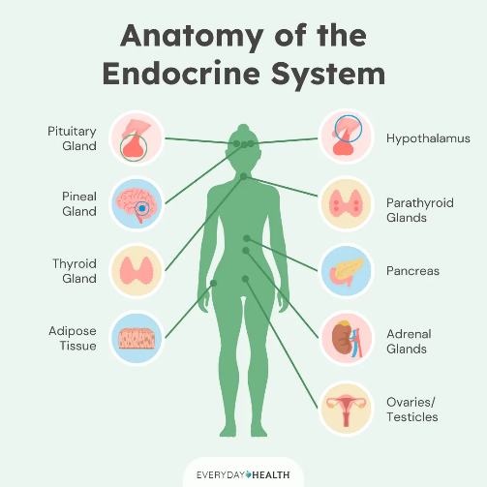
1The Endocrine System and Insulin Function (Rui, 2017)

2. Blood Sugar Regulation
Blood glucose levels are controlled through the coordinated actions of two key pancreatic hormones: insulin and glucagon. After eating, rising glucose levels trigger the pancreas (specifically the beta cells) to release insulin. Insulin enables glucose to enter cells, particularly those in the liver, muscles, and adipose tissue, where it can be used immediately for energy or stored as glycogen for later use. This process supports energy balance and ensures that the body has a stable supply of fuel.
When glucose levels drop, the pancreas responds by releasing glucagon from its alpha cells. Glucagon signals the liver to break down stored glycogen into glucose, allowing blood sugar levels to rise again and maintain homeostasis (Hall & Hall, 2020). This constant balancing act between insulin and glucagon operates through a negative feedback system, which is essential for keeping internal conditions stable. Any disruption to this process can lead to symptoms such as tiredness, irritability, dizziness, or increased hunger due to unstable glucose availability.
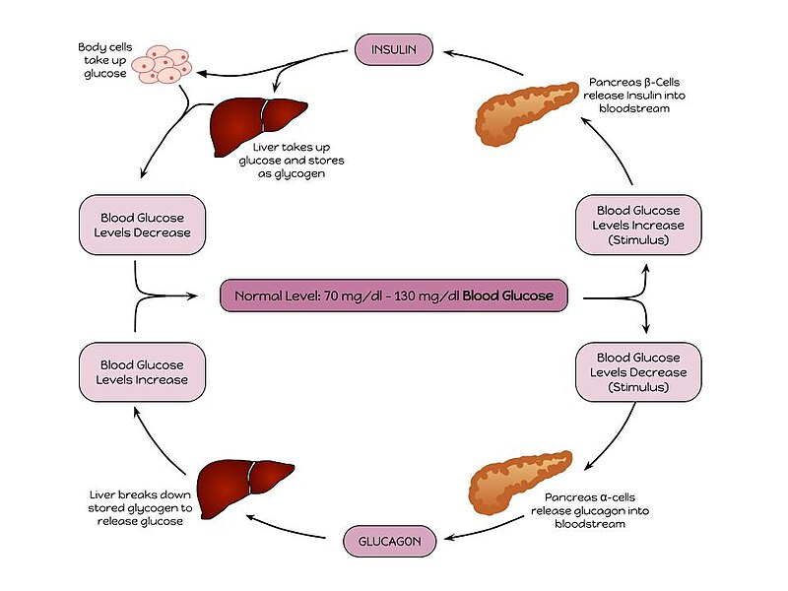
2(Blood Glucose Regulation Cycle)(Wikipedia Contributors, 2019)
For many adults with Type 2 diabetes, insulin resistance gradually develops, often influenced by years of poor dietary habits and low physical activity. In this state, the pancreas may still produce insulin, but the body’s cells respond less effectively, resulting in persistently elevated blood glucose. Over time, the pancreas may struggle to keep up with the increased demand and begin producing insufficient amounts of insulin, worsening overall glucose control. High blood sugar over time can cause tiredness, blurred vision, constant thirst, and increased urination, and may eventually lead to problems like nerve damage, kidney issues, and heart disease. (Papatheodorou et al., 2022).
To reduce the risk of complications, maintaining healthy glucose levels, typically between 4–7 mmol/L before meals and below 8.5 mmol/L two hours after eating, according to NHS recommendations, is essential. Irregular readings or frequent fluctuations indicate impaired glucose tolerance and highlight the body's reduced capacity to maintain homeostasis. Without effective regulation, individuals become more vulnerable to acute episodes like hypoglycaemia and long-term complications that negatively affect quality of life.
3. Cellular Metabolism and Physical Health Evaluation
Cellular metabolism refers to the set of chemical processes that allow cells to produce energy, primarily through glycolysis and oxidative phosphorylation. Insulin is central to this process because it enables glucose to move from the bloodstream into cells, where it can be converted into energy. In individuals with Type 2 diabetes, however, insulin resistance reduces glucose uptake, forcing the body to rely more heavily on fatty acids as an alternative energy source. This increased use of fatty acids raises circulating free fatty acids, which can damage tissues and contribute to the development of atherosclerosis (Roden & Shulman, 2019). As a result, the body becomes less efficient at energy production, often leading to persistent tiredness and reduced physical stamina.
A large proportion of adults living with Type 2 diabetes are overweight or obese, and many follow routines characterised by limited movement, sedentary work environments, and an absence of regular exercise. Their diets may include high amounts of processed foods, fast foods, sugary drinks, and refined carbohydrates, with fewer whole grains, vegetables, and nutrient-dense meals. These patterns make glucose control more difficult and reinforce insulin resistance. Although regular exercise is known to improve insulin sensitivity, barriers such as long working hours, lack of motivation, financial stress, or limited awareness often prevent individuals from achieving recommended activity levels.
Beyond the physical aspects, emotional and social factors also influence the well-being of people with Type 2 diabetes. Some individuals may feel isolated due to busy schedules, restricted social interactions, or the psychological burden of managing a chronic illness. To cope with stress, some may turn to smoking or alcohol—behaviours that increase cardiovascular strain and worsen metabolic health. Ongoing stress and anxiety can elevate cortisol levels, which in turn raise blood glucose (Van Cauter et al., 2020). Poor sleep habits, including getting less than six hours of sleep per night, further disrupt hormonal balance and impair glucose regulation.
Psychologically, many adults experience anxiety about their long-term health, especially concerns related to complications such as neuropathy, kidney damage, vision impairment, or limb amputation. Chronic stress activates the release of hormones like cortisol and adrenaline, which further reduce insulin sensitivity and make blood sugar management more challenging (Hackett & Steptoe, 2017). These emotional responses illustrate how deeply interconnected physical, mental, and social health are in diabetes care. Type 2 diabetes is not confined to biological mechanisms alone; it affects the person as a whole, shaping their lifestyle, mental state, and everyday relationships.
.
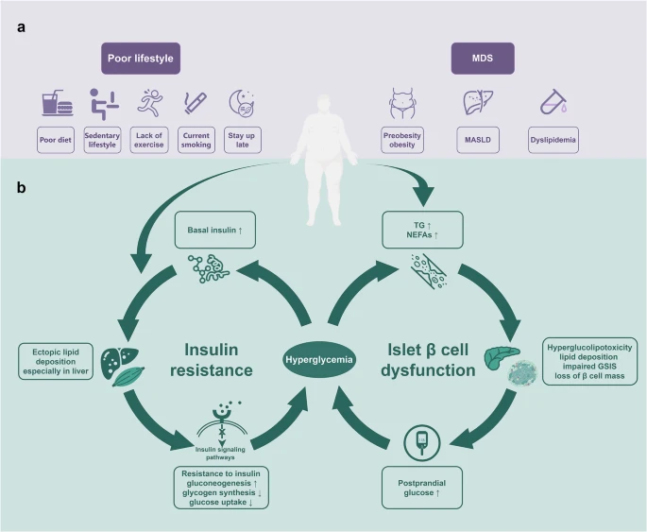
3(Effects of Type 2 Diabetes on Cellular Metabolism)(Lu et al., 2024)
4. Recording and Tracking Blood Sugar Levels for Type 2 Diabetes
Checking and tracking blood sugar regularly is vital for managing Type 2 diabetes properly. It helps people see how behaviours like eating habits, stress, and exercise affect their glucose control (NICE, 2023). These checks may be done with finger-prick tests or with continuous glucose monitoring (CGM) devices.
Many adults with Type 2 diabetes check their glucose levels at home using either portable meters or digital monitoring apps that help track patterns over time. Keeping these records allows them to identify what causes their blood sugar to rise or fall, giving them the opportunity to adjust their meals, activity levels, or medication accordingly. This awareness is especially useful for recognising how certain foods or stressful situations contribute to hyperglycaemia and helps individuals develop healthier routines that support better long-term outcomes..

4(Example of Daily Blood Glucose Tracking Chart)(Jones, 2020)
If blood sugar is not tracked consistently, individuals risk unrecognized hyperglycaemia (high blood sugar) or hypoglycaemia (low blood sugar), which can lead to severe complications such as diabetic ketoacidosis or hypoglycaemic coma (ADA, 2023). Additionally, unmonitored glucose levels hinder healthcare professionals’ ability to tailor treatment plans effectively, increasing the risk of organ damage and reduced quality of life. Monitoring is also essential for evaluating the effectiveness of prescribed medications and determining whether adjustments are needed.
Tracking blood sugar also gives individuals insight into patterns they may not have recognised otherwise. For example, some adults discover that they consume sugary snacks during busy work shifts without realising how strongly these foods affect their glucose readings. With accurate data, dietitians and healthcare professionals can provide more personalised advice, helping people make healthier choices that align with their goals. Regular monitoring also encourages accountability and promotes active involvement in managing the condition, which is essential for long-term health.
5. Recommendations
To improve overall health and well-being among adults living with Type 2 diabetes, a combination of lifestyle modifications, medical management, and health promotion interventions is recommended. Tailoring these strategies to individual needs is important because people vary in their health literacy, motivation levels, and access to resources.
Lifestyle Modifications
A structured exercise plan is important to enhance insulin sensitivity, control weight, and reduce cardiovascular risks. The NHS recommends at least 150 minutes of moderate aerobic activity per week (NHS, 2023). Activities such as brisk walking, cycling, or swimming should be gradually introduced. For individuals unused to exercise, even short bouts of movement throughout the day can improve glucose control. Resistance training twice per week can further improve metabolic health.
Nutritionally, adopting a Mediterranean-style diet rich in fruits, vegetables, lean proteins, and whole grains while minimising processed foods and sugary beverages is beneficial. This dietary pattern improves glycaemic control and reduces inflammation in individuals with diabetes (Estruch et al., 2018). Increasing fibre intake, choosing complex carbohydrates, and reducing portion sizes can also help stabilise blood sugar levels throughout the day.
Smoking cessation support and alcohol moderation are essential. The NHS Stop Smoking Service can provide behavioural therapy and nicotine replacement options, while limiting alcohol to no more than 14 units per week, as recommended by Public Health England, reduces liver strain and glucose fluctuations. Cutting back gradually can help reduce withdrawal symptoms and increase long-term success rates.
Adequate sleep hygiene should be encouraged by setting consistent bedtimes, reducing screen exposure before sleep, and managing stress through mindfulness or cognitive behavioural therapy (CBT). Relaxation activities such as deep breathing or gentle stretching can improve sleep quality and reduce stress-induced glucose spikes.
Medical and Health Promotion Interventions
General practitioners (GPs) should review medication plans regularly. If lifestyle changes alone do not achieve target glucose levels, metformin may be prescribed as the first-line medication. This oral hypoglycaemic agent improves insulin sensitivity and reduces hepatic glucose production (NICE, 2023). For some individuals, additional medications or injectable therapies may be recommended depending on how their body responds.
Community-based diabetes education programmes, such as the NHS Diabetes Prevention Programme (NDPP), provide lifestyle coaching and self-management education, which have been shown to reduce the risk of diabetes-related complications (Public Health England, 2021). These programmes also create opportunities for peer support, helping individuals feel less isolated.
Socially, adults with diabetes may benefit from strengthening their support networks by engaging in local community groups or diabetes support forums. Employers can also promote workplace wellness programmes that encourage physical activity and healthy eating. Supportive environments significantly increase the likelihood that individuals will adhere to recommended lifestyle changes.
.

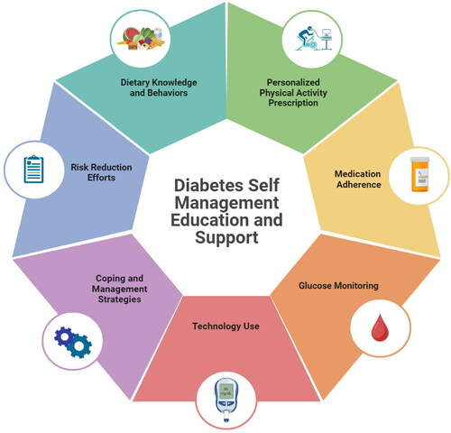
5(Lifestyle and Health Promotion Strategies for Type 2 Diabetes)(Saenz et al., 2024)

6. Conclusion
This report examined the experiences of adults in the UK living with Type 2 diabetes. The discussion highlighted the physiological mechanisms of blood sugar regulation, the impact of lifestyle on cellular metabolism, and the importance of consistent blood glucose monitoring. It also explored the interconnected nature of physical, emotional, and social health in diabetes management.
It was evident that diabetes management requires an integrated approach addressing physical, emotional, and social factors. Lifestyle modifications such as healthy eating, regular exercise, smoking cessation, and improved sleep can greatly enhance metabolic control. Combined with structured health promotion strategies and NHS diabetes support programmes, adults living with Type 2 diabetes can achieve better glycaemic control, improved mental well-being, and an overall better quality of life.

REFERENCES
American Diabetes Association (2023) Standards of medical care in diabetes—2023. Diabetes Care, 46(Supplement 1), pp. S1–S154. doi: 10.2337/dc23-S001.
Diabetes UK (2024) What is Type 2 diabetes? Available at: https://www.diabetes.org.uk/ (Accessed: [14/11/2025]).
Estruch, R., Ros, E., Salas-Salvadó, J., Covas, M.I., Corella, D., Arós, F. and Martínez-González, M.A. (2018) ‘Primary prevention of cardiovascular disease with a Mediterranean diet’, New England Journal of Medicine, 378(25), p. e34. doi: 10.1056/NEJMoa1800389.
Hackett, R.A. and Steptoe, A. (2017) ‘Type 2 diabetes mellitus and psychological stress—a modifiable risk factor’, Nature Reviews Endocrinology, 13(9), pp. 547–560. doi: 10.1038/nrendo.2017.64.
Hall, J.E. and Hall, M.E. (2020) Guyton and Hall textbook of medical physiology. 14th edn. Elsevier.
Jones, J. (2020) ‘8 Best Blood glucose chart ideas | blood glucose chart, blood sugar, blood sugar chart’. Pinterest. Available at: https://www.pinterest.com/jaymejones85/blood-glucose-chart/ (Accessed: [14/11/2025]).
Lu, X., Xie, Q., Pan, X., Zhang, R., Zhang, X., Peng, G., Zhang, Y., Shen, S. and Tong, N. (2024) ‘Type 2 diabetes mellitus in adults: Pathogenesis, prevention and therapy’, Signal Transduction and Targeted Therapy, 9(1), p. 262. doi: 10.1038/s41392-024-01951-9.
National Institute for Health and Care Excellence (NICE) (2023) Type 2 diabetes in adults: Management (NG28). Available at: https://www.nice.org.uk/guidance/ng28 (Accessed: [14/11/2025]).
NHS (2023) Living well with Type 2 diabetes. National Health Service. Available at: https://www.nhs.uk/conditions/type-2-diabetes/ (Accessed: [14/11/2025]).
Papatheodorou, K., Banach, M., Bekiari, E., Rizzo, M. and Edmonds, M. (2022) ‘Complications of diabetes 2017’, Journal of Diabetes Research, 2022, pp. 1–3. doi: 10.1155/2022/1903421.
Public Health England (2021) NHS Diabetes Prevention Programme: Progress report. Available at: https://www.gov.uk/government/publications/ (Accessed: [14/11/2025]).
Roden, M. and Shulman, G.I. (2019) ‘The integrative biology of type 2 diabetes’, Nature, 576(7785), pp. 51–60. doi: 10.1038/s41586-019-1797-8.
Rui, L. (2017) ‘Brown and Beige Adipose Tissues in Health and Disease’, Comprehensive Physiology, 7(4), pp. 1281–1306. doi: 10.1002/cphy.c170001.
Saenz, C., Salinas, M., Rothman, R.L. and White, R.O. (2024) ‘Personalized lifestyle modifications for improved metabolic health: The role of cultural sensitivity and health communication in Type 2 diabetes management’, Journal of the American Nutrition Association, 44(3), pp. 1–14. doi: 10.1080/27697061.2024.2413368.
Van Cauter, E., Polonsky, K.S. and Scheen, A.J. (2020) ‘Roles of circadian rhythmicity and sleep in human glucose regulation’, Endocrine Reviews, 41(5), pp. 733–758. doi: 10.1210/endrev/bnaa019.
Wikipedia Contributors (2019) ‘Blood sugar regulation’, Wikipedia. Available at: https://en.wikipedia.org/wiki/Blood_sugar_regulation (Accessed: [14/11/2025]).

