What helps me learn language and mathematics?: An analysis of a child’s learning in mathematics and language with recommendations for ensuring progress.

‘Language and maths should be the underlying focus for almost all subjects’ (Welsh Government, 2013). Following this, the purpose of this assignment is to show the ways in which children learn language and mathematics through a Professional Teaching Experience (PTE). The pupil to be discussed is a 5-year-old middle attaining boy in a large reception class, who attended a large scale primary school in a deprived area of South West Wales. The child was made aware that taking part was optional, and they were made to feel comfortable, which follows the BERA (2018, p.9) ethical guidelines for educational research under consent. See appendix 1 for conformation and permission letter.

The information gathered about the child for this assignment has been collected following the mosaic approach. Clark and Moss (2011) state how children’s perspectives are brought together through a range of methods such as photographs; observations or interviews etc. different sources will be used to collect the child’s perspective which can then be used with the educator to understand the child’s view. By following this approach, the material collected can then be used by the educator to reflect upon and in turn create a way for the child to progress in their learning. This shows that the information gathered can be used in a number of ways, not only finding out what the child knows, and how they like to learn, but how they can move their learning on.

Nottingham (2013) states how important attitude, skills and knowledge (A.S.K) are when it comes to the learning process and children’s education process should include a development of all three. Having considered this point, these three roles are vital when encouraging children to become competent learners, which is supported by Donaldson (2015, p.29) who’s one of the four purposes is to create ‘ambitious, capable learners’. In order to reach these conclusions to find out how children learn and ways to progress their learning the A.S.K model will be followed and the data will be analysed and summarised.

Child A had a very natural introverted nature. He was shy, usually kept himself to himself and had the same group of friends who he normally played with and spoke to. In English lessons he was always reluctant to join in, often walking away not wanting to do the activities. He was very competent in his abilities but did not enjoy some aspects of English lessons, when asked in an interview about how English made him feel and what helped him learn we were able to see what he enjoyed and did not enjoy as much (appendix 2). Grigg (2015) states that learning language needs to start in the primary school.

His attitude towards English activities were somewhat reserved and he never seemed to be enjoying activities such as writing, and also reading in schemes such as Read, Write, Inc. However, when not instructed to use these skills he was fairly able to use his speaking, ‘reading’ and listening skills. Barrs and Pidgeon (1993) state how they found girls to continually read better than boys. Having considered this statement, it could provide some links to why boys usually shy away from reading activities as boys seem to be under needless pressure to conform to masculine stereotypes even in a school environment from a young age.

When observing child A in the role play area his use of language skills was very natural and he enjoyed playing the role of Percy the Park Keeper and being the leader of the area. As he was still very young and not able to read yet, I observed how he would sit with the other children in the reading corner and ‘read’ them a story using the pictures and using his imagination to create his own version of the story, this play activity is also covered by the speaking skill to ‘use talk to create a storyline in symbolic/imaginative play’ (Welsh Government, 2015). Grigg (2015) states how the behaviour of children in outside classroom contexts can be very useful as you get more of an insight into the children’s interactions. Having said this, Ho and Kane (2013) state how having two people conduct observations provide the most reliable information as they are able to check what the other has written. Having considered this point, the observations may not be as reliable as they could be, but having conversations with the class teacher and teaching assistants in the class helped to validate my observations.

The learning objective for one of the lessons taught by myself was to ‘retell familiar stories in a simple way, using pictures to support’. See appendix 3 to see the skills covered in this particular lesson. This session was a shared reading lesson, and during this child A was engaged whilst listening to the story of Percy the Park keeper and asked to hear it twice as he loved it so much. Having considered this, copies of Percy the Park Keeper were put into the reading corner for the children to go back to if they wished, and whilst observing the children in amser enfys, child A would utilise this and look at this book. Through the activity, he was able to answer all the questions orally and correctly, which displayed good listening skills, as he concentrated and focused throughout the whole story in order to display these skills. He was then able to sequence the pictures in the order in which the story happened. However, when it came to writing a word, or sentence next to the picture in his book he refused as he said he didn’t like writing. Eventually he came around to writing next to the pictures in his book and his work was done almost independently, with a little bit of help on the writing (appendix 4). Askew and Ross (1988) and Davison (1985) report how boys usually enjoy subjects such as sports and factual lessons like a technology lesson, rather than ‘traditional’ subjects such as English. They also state how speaking and listening is done naturally when boys play and learning is occurring without them realising. This statement is supported by OFSTED (1993) who talk about how boys have a negative attitude towards reading compared to girls. The stigma towards boys and English could possibly come from the children’s home life and the expectation for masculinity to be embedded in them. This is supported by Seidler (1980) who suggests that masculinity is an expectation that men feel they can never be at peace with. Considering these points, this could be the reasoning for Child A’s dislike towards some aspects of Language such as writing. This is a concept that can be considered when planning for future lessons, and incorporating fun elements to English lessons such as outdoor activities, and treasure hunts could be considered as a focus for Child A.

During the period of my PTE placement, I found that Child A used his knowledge and skills acquired through language sessions not only in English but across the curriculum. Despite the fact Child A was an introvert, he would take part with in the majority of sessions such as Welsh, and he would also enjoy describing items when in the talking tent in the classroom in Amser Enfys (free time). UNESCO describes how ‘a person is literate who can, with understanding, both read and write a short simple sentence on his everyday life’ (DES, 1975, p.10), however Street (1997) argues that definitions like these are inadequate and limiting. He sees literacy from an ideological viewpoint, he does not only see literacy as a set of skills just for literacy events but views it from a social and cultural perspective. This is important when considering the knowledge of language, because although you need the basic skills to be able to use it, it is not just something that is used in language sessions but across the curriculum and in social circumstances.

After observing child A in language sessions for the four weeks that I was on placement, I would say that he would be at outcome Gold in Language, Literacy and Communication when it comes to Oracy and Reading, and Writing (appendix 5). He was able to retell the story of Percy the Park Keeper, cutting out pictures and sequencing them in the correct order and enjoyed listening to the story and answering questions about the book. Even though Child A was not able to read he was able to hold a book the correct way around, and turn the pages the correct way, as well as using the pictures to create his own narrative from the story. However when it came to his writing he needs to follow modelled writing rather than writing by himself.

To help develop and further progress the learners skills and knowledge in language as a whole there are many things that can be taken into consideration after reviewing and analysing the interviews, observations, work samples and the pictures taken throughout my PTE placement. I would carry on providing not only child A, but all of the children with a language rich environment which would help to support and develop their language skills. I would ensure that I would carry on differentiating tasks for each of the different attaining groups as this seemed to provide the children with challenging tasks but not to challenging where they could not complete them. Firstly, Child A’s writing. He could practice key words of the different themes that would be placed in the writing corner. In the writing corner child A could look at a picture e.g. of a fox with the word fox written underneath, he could then copy the letters to form the word on a mini whiteboard, and in this area there are two children allowed at a time, therefore taking into consideration Child A’s answer of enjoying activities where he is able to work with his friends. This would provide an opportunity for him to practice his letter formation, and therefore be encouraged to do it in his own time within Amser Enfys. Being able to read and write helps you to understand the world and equips you with skills that can not only be used throughout the curriculum but can be utilised in social situations also, and opens doors throughout the child’s life. This is supported by Donaldson (2015) who states that we need to prepare children to be ready to learn throughout their lives.

Secondly, tackling the negative attitude towards reading. Anderson (2003) and Holland (2003) both suggest how usually boys’ play includes fighting, guns, killing which is frequently stopped for seeming not appropriate, however these negative views towards boys’ imagination is therefore causing boys to lose interest in reading. As stated by Whitehead (1990) the use of literacy through story books can create an eagerness in a child to read more. Having considered this statement it is important for a teacher to choose the correct approach when it comes to the choice of book provision that will engage children, and especially boys. Considering child A cannot read, this is still a piece of research than can be considered as he is already beginning to learn to read. Child A should carry on with the Read, Write Inc. programme that runs every morning. DfEs (2006a, p.53) states how ‘in order to comprehend written texts children must first learn to recognise, that is decode the words on the page’. Phonics are key when learning to read and spell. To further develop child A’s reading skills, reading with more experienced readers could be an approach that could be developed between a year 5 pupil and a pupil in reception, ‘one to one sessions can help with the identification of struggling readers’ (Wyse and Jones, 2008, p.75) this therefore could be an approach that could be brought in to help with the practicing of reading.

Lastly, Chomsky (1975) and Hall (2003) both describe that when a child is born, as they grow their desire to communicate gets stronger. Child A’s speaking skills can be developed further through the playful exploration of role-play areas and also conversing with other children and adults. Wallace (2008) suggests how foundation phase is crucial in young children’s development from birth to the age of 8.

Child A had more of a positive attitude when it came to mathematics. When asked in a small interview (see appendix 6) child A stated how he enjoyed maths because he was ‘doing things’. From this, I believe child A enjoyed maths more as a whole because the activities were more hands on, and usually included items such as small and big blocks, numicon and sometimes different every-day items. Child A was able to show me the areas in which he could carry out maths activities on our learning walk. There was maths area where challenges would be set out and explained to the children daily and would be able to use this if in amser enfys. Although child A was a shy character he was able to communicate clearly with staff and was able to communicate his needs and also he wasn’t afraid to ask for help in maths if needed or if he had any questions.

He showed good motivation when it came to mathematics, and was always eager to answer and from observations from other mathematics sessions not taught by myself (see appendix 7) he would sit at the front and always volunteer his answers. This is supported by Douglas (1964) and Davie et al. (1972) who both suggest that boys normally perform better academically in maths in the early years as they enjoy the structure of the subject, with exceptions.

Through observations of child A in social situations he would use his counting skills in break times, outside when using the giant blocks to build towers, he would use vocabulary such as ‘add one more’ or ‘take one away’ when building towers and wanting them at a certain height (see appendix 8). He enjoyed this situation especially when explaining to the other children in the yard what he meant by these phrases. Grigg (2015) and Ollerton (2003) both suggest how reciprocal teaching and learning should provide beneficial communication where the children can talk about what they know and have learnt. Considering this point, child A was clearly demonstrating skills he had learnt from mathematics and applying them to a different situation.

One of the topics for mathematics that I had to cover was shapes. We did a carousel of activities daily and one of the activities included a treasure hunt which was outdoors and required the children to find eight 3D shapes and then come back in to the groups and sort the shapes into the correct criterion (appendix 9). After learning about shapes, during snack time before morning break child A confidently described his orange as a sphere one day and then remembered every day when another child or himself had an orange as fruit for their snack he would tell me that the shape was a sphere, eventually this caught on with the other children and therefore they then started to call spherical items a sphere, and he had helped to develop the other children’s learning. Haylock and Cockburn (2008) both report how practitioners usually use common objects, stories, words or pictures to help familiarise younger children with concepts of key mathematical concepts. This is also demonstrated in OFSTED’s (2011) report on Good Practice in Primary Mathematics, where with a reception class they gave the children to the experience to use £1 in any way they wanted (with help from the teacher) and it showed to develop the children’s understanding of maths and made it fun for them and relatable.

Throughout my time teaching pupil A, I feel he progressed with his learning of mathematics well. During the different maths activities he enjoyed hunting for the different shapes, and could name 2D shapes and some 3D shapes such as cube and sphere. Child A needed some extra support when reinforcing the shapes and recognising them, but using every-day objects such as balls, dice, boxes in the feely bag at the beginning of the lesson helped to cement his understanding. Bruner (1996) and Gardner (2003) both suggest how real-life first hand experiences help aid children’s learning and understanding. The Cockcroft Report (1982) emphasised the need to enhance and develop children’s curiosity and their enthusiasm towards mathematics. We also sung number rhymes using the interactive whiteboard, to help reinforce one to five and also recognising numbers above five to ten. Child A really enjoyed the activities which included, one more and one less as we incorporated the big blocks from outside and sometimes smaller blocks too. We would also match the numbers to the blocks to help recognise numbers. However, child A did not enjoy writing out sums and would need support when writing his numbers, usually copying numbers from a number line.

Askew (2015) states that learning shapes is just as important as learning numbers and building on children’s knowledge of shapes should be started from a young age. Developing their mathematical language connected to shapes is key in their understanding, therefore relating it to everyday objects such as an orange which child A associated with a sphere is therefore building his problem-solving skills in order to make the link.

When teaching mathematics modelling can be a useful approach to enable learning for all children with all abilities by showing step by step processes. This is supported by Bandura (1986) who states modelling is a useful tool to engage and encourage children’s learning. Child A was able to count and recognise numbers from 1-10 with the struggle on a few numbers, he was able to do this by himself. Following the Zone of Proximal Development (Vygostsky, 1978), when counting from 10-20 child A needed help from myself or other members of staff and this therefore is his Zone of Proximal Development (ZPD) for counting, where after some time, with guidance from staff members he will be able to do this independently. Therefore working within child A’s ZPD for counting will encourage his skills to grow and will not hinder his learning. Scaffolding is also an approach that is closely linked with ZPD as it talks about the help given from a more competent learner to a less competent learner whilst working towards a goal, it is something that is constructed during the process and then when it is no longer needed, it is no longer used (Bruner, 1996).

However, Haston (2007) suggests how modelling can sometimes hinder children’s learning rather than assist their learning and understanding. Having compared these views, through personal observations from other lessons and from lessons taught by me, I found that child A benefited greatly from modelling especially in mathematics. The teacher usually followed a metacognitive approach towards modelling where the teacher would talk through her thinking process whilst carrying out the problem visually or on the interactive white board. Duplass (2006) describes this process as a thinking-out-loud approach.

To progress child A’s dislike of writing out sums, I would recommend that he would practice his number writing skills on pieces of paper, or in the sand pit to help him to recognise certain numbers and become familiar with writing them, this would evidently be something he would need to choose in his free time in school during amser enfys and would need to be offered to him. I believe that when teaching mathematics to younger children especially it is far more important to teach them the process and how to get there rather than looking at the right or wrong answer. Using these steps are helpful to find where the misconception came in and be able to intervene and help the children overcome this. Bird (2009) supports this stating that more attention should be given to how a solution is reached rather than what the solution is. Also, as stated by Anghileri (2005, p.3) ‘mathematical knowledge is not something that is acquired by listening to teachers and reading text books but something that learners themselves by seeking out meanings and making mental connections’.

After observing child A in mathematic sessions for the four weeks that I was on placement, I would say that he would be at outcome 1 (appendix 10). Child A is mainly achieving an Outcome 1 according to my observations and analysing the data. I assessed child A’s number skills and he was able to recognise numbers one to ten, and he is also beginning to recognise his 2d shapes and some 3d shapes. However he is hitting some aspects of Outcome 2 such as reciting up to number 10 and backwards, and also knowing and using his 2D and 3D shapes, however overall he shows more of the aspects of Outcome 1.

The teacher would give the children monthly targets for mathematics or language that would be kept on the wall (appendix 11). The children would then be called to check their targets to see if they’re achieving them. Cowley (2003) supports this by describing how setting targets for children to achieve can motivate them to learn and she talks about how children enjoy meeting number targets so believes it is beneficial to give them an aim. This is also supported by Donaldson (2015) states how our children should set their goals and enjoy the challenge. Grigg (2015) also states how planning comes down to setting goals (objectives and aims), evolving approaches and is also about choosing what to teach and how you want to teach it. Using these monthly targets is useful when planning as it enables you as a teacher to know where children are struggling. Child A struggled with recognising the number 3 and 5 in September but by November he was able to recognise 3 and 5 and more. Black and William (1998) both describe that when assessment is formative it becomes a vital part of the learning and teaching process where the information which is collected from the assessment should then be used to change how the lessons are taught and therefore meeting the children’s needs in order to enhance their learning and understanding. By using data collected throughout the PTE is a valuable tool in order to change your teaching strategies to suit and benefit the children.

To conclude this piece of writing, it is clear to see from analysing the data and the information from the evidence, interviews, observations and experience as a whole that child A was able to learn Language through having books read to him, and looking at picture books and creating the stories himself, from the role play areas, communication with adults and peers, Read, Write, Inc. and having words modelled for him to help develop his writing. When it comes to learning mathematics he found it useful to use ICT resources, the outdoors, blocks, and numicon and everyday objects such as a ball.
After following the A.S.K model to analyse the data, and collected the data following the mosaic approach it is evident that both these are important when studying how a child learns language and mathematics. Using both, I was able to understand what outcome the child was at and what he would need to do in order to progress his learning further.

Reference List
Anderson, M. (2003) Reading Violence in Boys’ Writing. Language Arts.

Anghileri, J. (2005). Children's mathematical thinking in the primary years. London: Continuum.

Askew, M. (2015) A Practical Guide to Transforming Primary Mathematics. Routledge.

Askew, S. and Ross, C. (1988). Boys Don’t Cry. Milton Keynes: Open Univ. Press

Bandura, A. (1986) Social Foundations of Though and Action: A Social Cognitive. Englewood Cliffs NJ: Prentice Hall.

Barrs, M. and Pidgeon, S. (1993). Reading the difference. London: CLPE.

Bird, R (2009) Overcoming Difficulties with Number. Available at:
file:///C:/Users/1705104/Downloads/Bird,%20R.%20(2009)%20Overcoming%20Difficulties%20with%20%20Number%20(1).pdf
(Accessed 21st March 2019)

Black, P. and Wiliam, D. (1998). Inside the Black Box. London: GL Assessment.

British Educational Research Association [BERA] (2018) Ethical Guidelines for Educational Research. fourth edition: London. Available at:
https://www.bera.ac.uk/wp-content/uploads/2018/06/BERA-Ethical-Guidelines-for-Educational-Research_4thEdn_2018.pdf?noredirect=1
(Last Accessed 24/03/2019)

Bruner, J. (1996) The Culture of Education. Cambridge: Harvard.

Chomsky, N. (1975) The Logical Structure of Linguistic Theory. New York/London: Plenum Press.

Clark, A. and Moss, P. (2011) Listening to Young Children: The Mosaic Approach (2nd ed.) National Children’s Bureau

Cockcroft Report (1982) Mathematics Counts. London: HMSO.

Cowley, S. (2003) Teaching Clinic. London/New York: Continuum.

Davie, R. et al. (1972) From Birth to Seven. London: Longman.

Davison, J. (1985) Boys Will Be…? The English Curriculum. Gender. English Centre Publication.

DES (1975) A Language for Life (The Bullock Report). London: HMSO.

DfEs (2006a) Independent Review of the Teaching of Early Reading (The Rose Report). London: DfEs

Donaldson, G. (2015) Successful Futures. Cardiff: Crown copyright. Available at: http://gov.wales/docs/dcells/publications/150317-successful-futures-en.pdf
(Accessed: 22nd March 2019)

Douglas, J.W. B. (1964) The Home and the School. London: MacGibson & Kee.

Duplass, J. (2006) Middle and High School Teaching: Methods, Standards and Best Practices. Boston: Houghton Mifflin Company.

Gardner, H. (2003) Multiple intelligences. New York: BasicBooks.

Grigg R. (2010) Becoming an Outstanding Primary School Teacher, Harlow: Pearson.

Hall, K. (2003) Listening to Stephen Read – Multiple Perspectives on Literacy. Berkshire: Open University Press.

Haston, W. (2007) Teacher Modelling as an Effective Teaching Strategy.

Haylock, D. and Cockburn, A. (1997) Understanding Mathematics in the Lower Primary Years. London: Paul Chapman.

Ho, A.D. and Kane, T. J. (2013) The Reliability of Classroom Observations by School Personnel. Bill and Melinda Gates Foundation.

Holland, P. (2003) We Don’t Play with Guns Here: War, Weapons and Superhero Play in the Early Years. Milton Keynes: Open University Press.

OFSTED (1993) Boys and English. London: OFSTED.

OFSTED (2011) Good Practice in Primary Mathematics: Evidence from 20 Successful Schools. London: OFSTED.

Ollerton, M. (2003) Getting the Buggers to Add Up. London: Continuum.

Nottingham, J. (2013) Encouraging Learning. Oxon: Routledge

Seidler, V. (1980) ‘Trusting Ourselves’ in Clarke, S. One Dimensional Marxism. London: Atkison and Bourbay.

Street, B (1997) The Implications of the “New Literacy Studies” for Literacy Education, English in Education

Wallace, S. (2008) A Review of Initial Teacher Training in Wales. Cardiff: Welsh Government

Welsh Government (2015) Curriculum for Wales: Foundation Phase Framework. Cardiff: Crown Copyright. Available at:
https://gweddill.gov.wales/docs/dcells/publications/150803-fp-framework-en.pdf
(Accessed: 18th March 2019)

Welsh Government (2013) Curriculum Planning Guidance. Cardiff: Crown Copyright. Available at:
https://learning.gov.wales/docs/learningwales/publications/130124curriculumplanningguidanceen.pdf
(Accessed: 19th March 2019)

Whitehead, M. (1990) Language and Literacy in the Early Years 0-7. London: Sage Publications.

Wyse,D. and Jones, R. (2008) Teaching English, Language and Literacy. 2nd Edition. New York/London: Routledge.

Vygotsky, L. (1978) Mind in Society The Development of Higher Physiological Processes. United States: Harvard College.

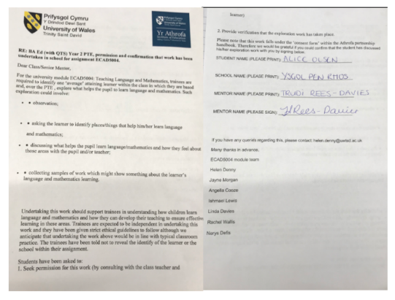
Appendix 1
Conformation and Permission Letter.
Appendix 2 – Interview about Language and thoughts and feelings
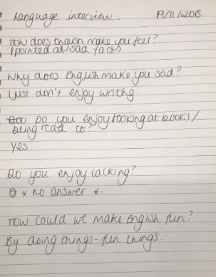

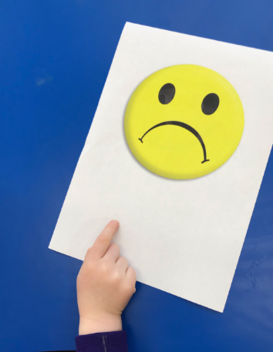
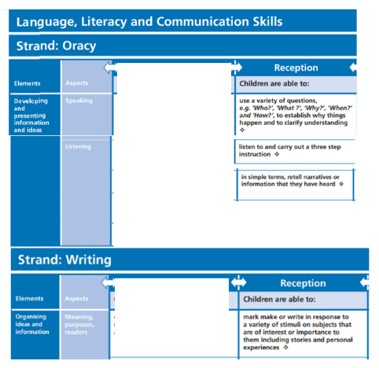
Appendix 3
Skills covered for Percy Park Keeper Story.

Welsh Government (2015) Curriculum for Wales: Foundation Phase Framework. Cardiff: Crown Copyright. Available at:
https://gweddill.gov.wales/docs/dcells/publications/150803-fp-framework-en.pdf
(Accessed: 18th March 2019)

Appendix 4
Percy Worksheet

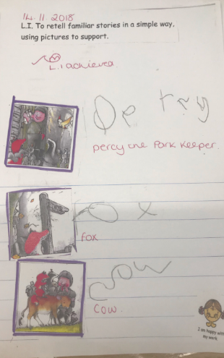

Appendix 5

Language Outcome

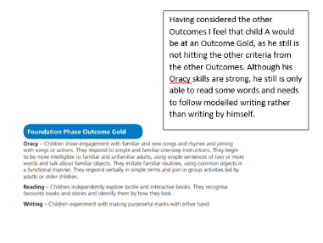

Welsh Government (2015) Curriculum for Wales: Foundation Phase Framework. Cardiff: Crown Copyright. Available at:
https://gweddill.gov.wales/docs/dcells/publications/150803-fp-framework-en.pdf
(Accessed: 18th March 2019)

Appendix 6
Interview for Maths and feelings

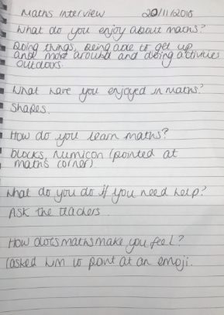

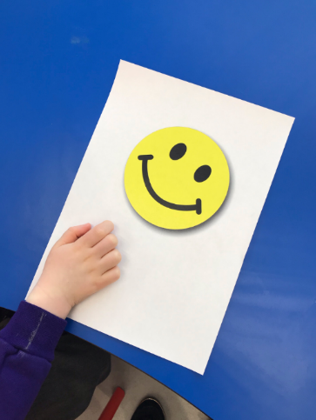

Appendix 7 – Observation
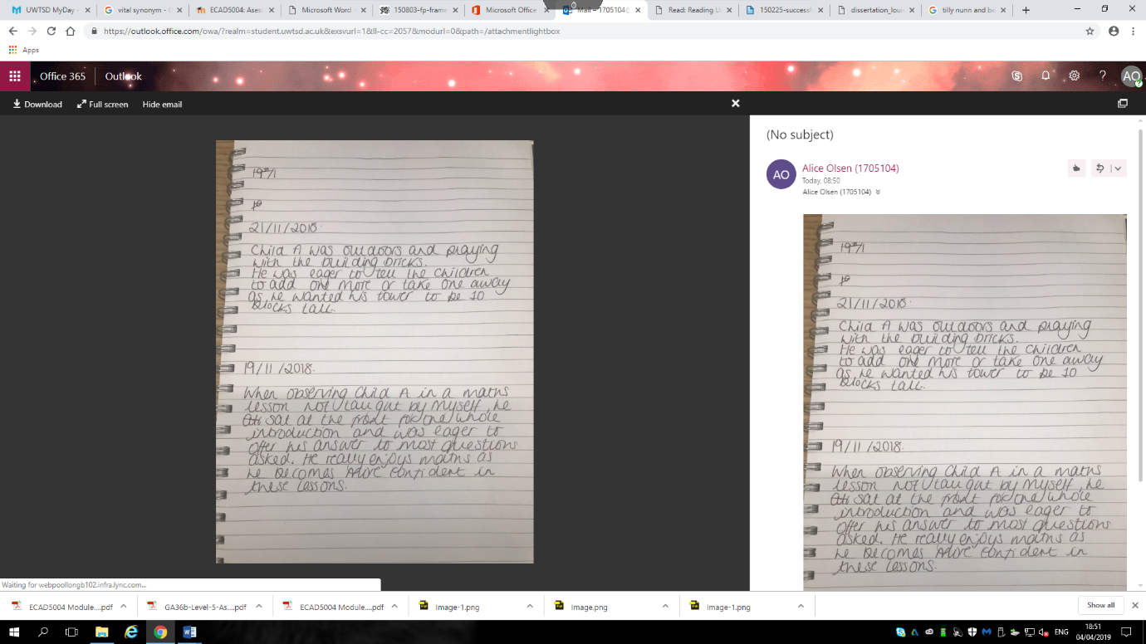

Appendix 8 – Observation outdoors

Appendix 9
Maths Curriculum Covered

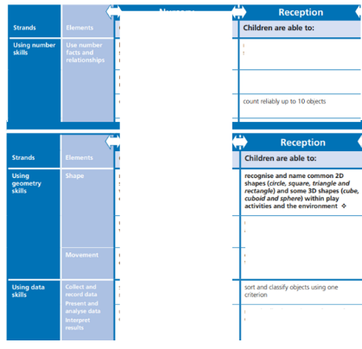

Welsh Government (2015) Curriculum for Wales: Foundation Phase Framework. Cardiff: Crown Copyright. Available at:
https://gweddill.gov.wales/docs/dcells/publications/150803-fp-framework-en.pdf
(Accessed: 18th March 2019)

Appendix 10

Mathematical Development Outcome
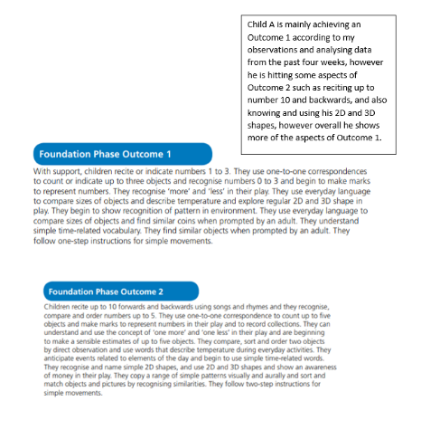

Welsh Government (2015) Curriculum for Wales: Foundation Phase Framework. Cardiff: Crown Copyright. Available at:
https://gweddill.gov.wales/docs/dcells/publications/150803-fp-framework-en.pdf
(Accessed: 18th March 2019)

Appendix 11
Target Pictures



