

Assessment 1 – Blog
BMBM4009: Contemporary Challenges – Making a Difference.

Manfred Zeka - 2213558

Link to Blog site

Please follow the link below
https://contemporarychallengesuwtsd.blogspot.com/

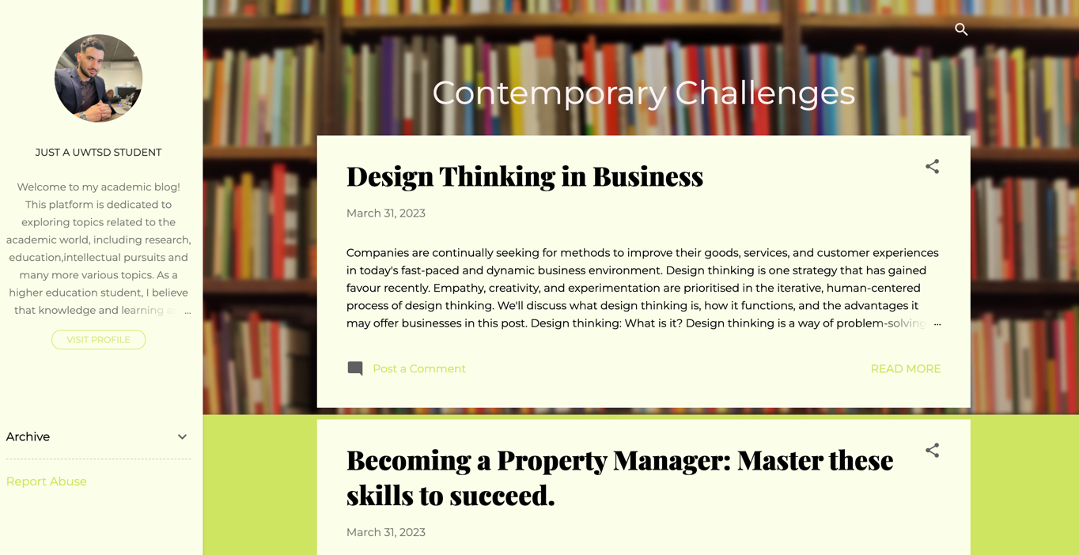

References

Korinek, A. and Stiglitz, J.E., 2017. Artificial intelligence, worker-replacing technological progress and income distribution. NBER working paper, 24174.
Brundage, M., Avin, S., Clark, J., Toner, H., Eckersley, P., Garfinkel, B., Dafoe, A., Scharre, P., Zeitzoff, T., Filar, B. and Anderson, H., 2018. The malicious use of artificial intelligence: Forecasting, prevention, and mitigation. arXiv preprint arXiv:1802.07228.
Roloff, M.E., Putnam, L.L. and Anastasiou, L., 2003. Negotiation skills. Handbook of communication and social interaction skills, pp.801-833.
Pereira, L., Santos, R., Sempiterno, M., Costa, R.L.D., Dias, Á. and António, N., 2021. Pereira Problem solving: Business research methodology to explore Open Innovation. Journal of Open Innovation: Technology, Market, and Complexity, 7(1), p.84.
Carr, S.D., Halliday, A., King, A.C., Liedtka, J. and Lockwood, T., 2010. The influence of design thinking in business: Some preliminary observations. Design Management Review, 21(3), pp.58-63.

