Name: Kaela Thompson
Student number: 1802446
Programme of Study: Photography in the Arts
Module: ADAD5003
Words: 2319

Question 1:
Using at least 3 examples, consider how image makers have utilised digital technology to explore at least one of the following: Conflict, Identity, the Surveillance State, the Technological World?

Figures List
Figure 1: McCullin, D. (1968) Shell-shocked us marine, the battle of the hue. Available: https://www.tate.org.uk/whats-on/tate-britain/exhibition/don-mccullin (Accessed: 11 November 2019).
Figure 2: Nachtwey, J. (1996) Ruins of kabul from civil war. Available: http://www.jamesnachtwey.com/ (Accessed: 11 November2019).
Figure 3: Peress, G. (1994) Rwanda. Available at: https://www.magnumphotos.com/photographer/gilles-peress/ (Accessed: 11 November 2019).
Figure 4: Capa, R. (1937) Crowds running for shelter as the air-raid alarm sounds. Available at: https://www.magnumphotos.com/photographer/robert-capa/ (Accessed: 11 November 2019).
Figure 5: Taro, G. (1937) Brunete. Available at: https://www.bbc.co.uk/news/magazine-25108104 (Accessed: 12 November 2019).
Figure 6: Fenton, R. (1855) The valley of the shadow of death. Available at: https://blog.scienceandmediamuseum.org.uk/remembrance-day-part-1-photographing-war-fenton-crimean/ (Accessed: 1 December 2019).

There is always some sort of conflict happening in this world, and it is never-ending. Photographers have a dominant position to inform and share the powerful messages their images hold. ‘Images are becoming increasingly recognized as powerful components of International Relations’ (Duncombe, 2016, p. 728-729), which suggests that images have a lot more power than people think. Images can be seen as proof of historical events, which means that people can empathise and experience a situation through an image. War photography can be extremely dangerous if they are right in the middle of the action. Nick Fitzhugh is a filmmaker and thinks ‘the public has become desensitised to what they see in the media, almost no matter how powerful it is’ (Fitzhugh, 2016). Photographers risk their lives to take the perfect shot, but sometimes it is just down to luck and being in the right place at the right time. However, many photographers have been captured and killed in warzones in the past. The photographer Adam Ferguson says, ‘As a photographer, you feel helpless. Around you are medics, security personnel, people doing good work. It can be agonisingly painful to think that all you are doing is taking pictures’ (Ferguson, 2009). On the other hand, photographing conflict and war can capture the heroes that are fighting for their country. Exclusive images are taken of families being reunited with each other, so it is not all negative.
‘For an “identity” or inter-group conflict to occur, the opponents must assign an identity to themselves and their adversaries, each side believing the fight is between “us” and “them”’ (Malek, 2013). Conflict and identity are connected because it is usually two different identities that start a battle. This can include religion, gender, or race, for example. So when photographers are capturing images of war, they are also taking photos of different identities. War photography showing conflict and identity is useful historical information because some identities could end up extinct one day in the far future.
Furthermore, throughout history, there have been many paintings and interpretations of fighting and war, with a clear visual representation. When photography was invented, there was a new medium to explore this battle representation. Artwork documenting war has been portrayed in many different ways, and so is seen in different ways also. Such as heroic, painful, rational, or celebrated. ‘As the First and Second World Wars rolled through Europe, official schemes were established in which artists were commissioned by the British government to capture, document and memorialise the war efforts’ (Tate, 2015). The government knew these wars would be significant and wanted to capture history taking place, which could be then used to inform younger generations. However, the government did not always want the truths of war to be presented, so many photographers had to be ‘safe’ and ‘acceptable’ with their photography.
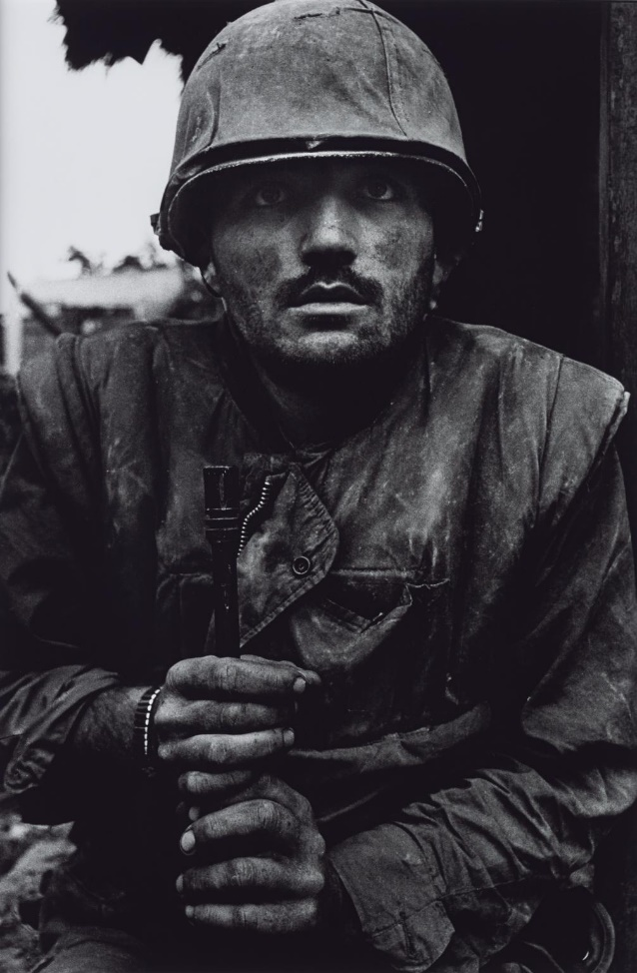

Figure 1
This image in figure 1 displays a marine wearing his uniform, taken by Don McCullin. The marine looks shocked and scared, with his face and hands covered in dirt, and he is grabbing onto a gun. It is hard to tell what is in the background, as the marine is the main focus of the image and fills most of the frame. However, it could be the buildings of the war site he is fighting at. Also, this image has a very dark contrast and has been presented in black and white, which adds to the murky and dim setting. The image was one of seven images taken at The Battle of Hue in 1968, during the Vietnam War (National Galleries). Viewing this image, the reader feels the emotion and terror going through the soldier’s mind and body. The reader may also wonder who the marine is and what his life was like before the war. Someone who may have been in this situation before could have memories brought back, and other soldiers could relate to the fantastic image. ‘The value of a work of art will be a function both of the value of the feeling that it transmits and of its ‘infectiousness’ and the clarity with which it transmits that feeling’ (Neil, 2005). Neil suggests that images can be ‘infectious’, and that is how to determine a successful image.
McCullin has used digital technology to explore conflict and war by showing the terror and realisation of a marine and how the horrors can affect someone. This can undoubtedly be seen in figure 1 because of the look on the marine’s face, which pulls the reader into the image. His images have an overwhelming impact on viewers and can leave a lasting impression.

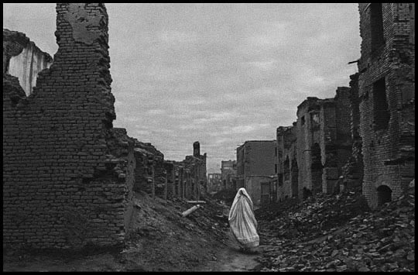

Figure 2

Figure 2, photographed by James Nachtwey, shows a woman wearing white, amongst rubble and destroyed buildings. The figure has an identity, but the image is not focused on her, so we cannot see her face, and the focus is on the devastated buildings. Nearly all of the buildings are ruined and unliveable. The photograph is in black and white, and it is a very cloudy and murky day. This photo was taken in the capital city of Afghanistan, Kabul, at the end of a civil war that lasted from 1996-2001, also after four years of conflict (Council on Foreign Relations, 2014). This photograph is part of a series called Afghanistan, with each image presenting the destruction of the civil war (Nachtwey, 2019). This image is important because it stands out from the rest. It is a powerful and brave statement, and of course, readers have an emotional response to it. In the article ‘No Home in Sight’, Nachtwey’s images are called ‘haunting’ (Vick, 2014, p.24), and this word describes his images perfectly because the white figure appears almost ghost-like.
Also, this photo displays the aftermath of war and makes the reader think about wanting to end war and conflict because it creates so much damage. By doing this, Nachtwey has definitely helped to spread the scenes of conflict through digital technology. As Nachtwey says, ‘the events I have recorded should not be forgotten and must not be replaced’ (Nachtwey, 2019). These are wise words, and images should be taken to capture unique moments that cannot be remade. ‘Must not be replaced’ also sounds like a hint that photographers should not have to photograph wars because there should not be any in the first place.
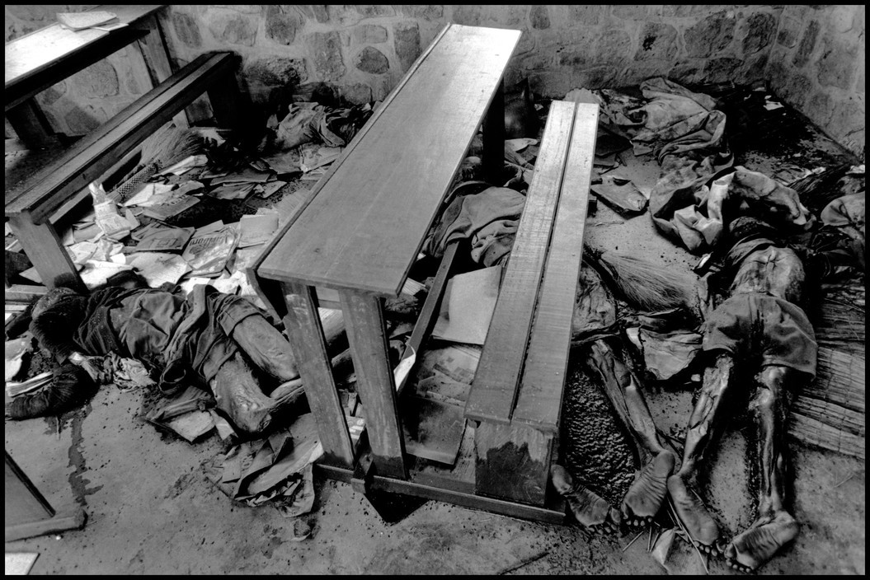
Figure 3

An enormous consequence of war and conflict is death. Death is an uncomfortable topic and is very hard on the photographers. Gilles Peress took this image in figure 3. This image shows dead bodies of refugees spread around on the floor of a classroom in Nyarubuye, photographed in 1994 (Magnum Photos, 2019) during the Rwandan civil war when 800,000 people were slaughtered in just 100 days (BBC, 2019). The colours black and white, appear to be a common theme with war photography, and it makes the images seem more depressing and sad. Figure 3 is very detailed; however, Peress has only captured the arms and legs of the dead bodies as a sign of respect. Peress is a historical photographer and does not care about ‘good photography’ (Magnum Photos, 2019) because it is more valuable and meaningful to share moments in history, and photography is an excellent way to capture historical memories. For example, it would be difficult to recreate this exact photo of a murder scene as it is a snapshot in time.
Peress has utilised digital technology to show the aftermath of war and the disastrous effects it has on the people living in towns and cities. Again, this image has a very emotional response and can upset the reader because death is traumatic and scaring on people's lives. Sometimes the photographer wants to purposefully create a reaction and response for the reader, such as tension or feeling uncomfortable so that the reader is exposed to the unknown and starts thinking differently out of their comfort zone. Most photographers aim to receive a reaction from their images; however, Peress takes images to document history.

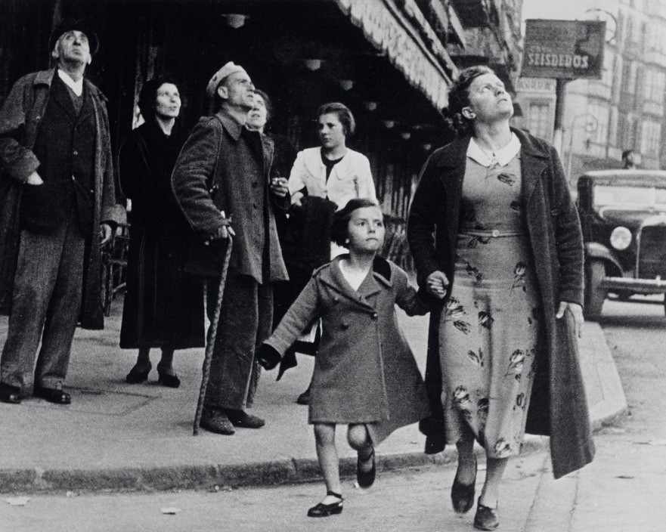
Figure 4
During war and conflict, life still has to go on for the families at home, and living in a war zone means you have to adapt. Supplies are limited, and the people have to make the best out of a bad situation. Robert Capa is a wartime photographer and took the image in figure 4. This photo was taken in Bilbao, Spain, in May 1937 (Magnum Photos, 1937). The image is black and white, and people can be seen looking up towards the sky as an air-raid alarm sounds. Two figures are positioned more towards the foreground of the image crossing the road, with a group of people behind them. There is a car in the background and tall buildings, and the people are wearing clothes appropriate for that era. Robert Capa himself was killed after stepping on a landmine shortly after arriving at Hanoi in 1954 (Daily Mail, 2013). He hated war and photographed it to share with others why he felt so strongly. As Capa said, “If your photos aren’t good enough, you’re not close enough” (Magnum photos, 1937), which is why Capa liked to be surrounded by all the action. Capa utilised digital technology to explore conflict and identity because he is showing real life at that time.
Moreover, this image is on the other end of conflict photography because it displays the non-violent side of war. People still have jobs to go to and need to make money to look after their families. Hope is a crucial aspect for wartime families because there are no certainties, and they have to put on a brave face.

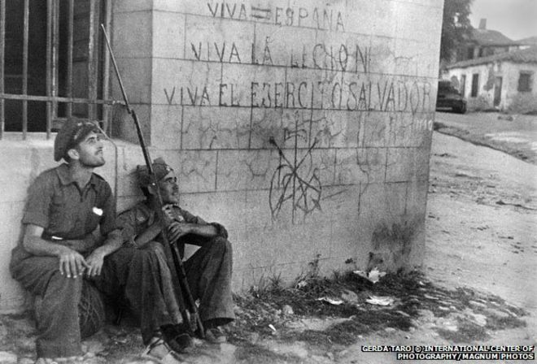
Figure 5
Conflict can link to identity because people believe they have control over other people and what they say and do. Many times, conflict can start because of a disagreement with people's certain beliefs. Towns and cities are destroyed, and thousands of people are killed. All of these things have been captured on camera by war photographers, and new different images are produced with each war.
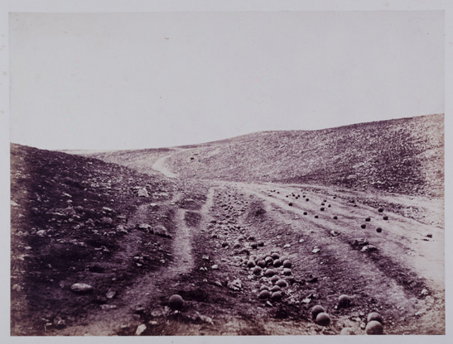
Also, Gerda Taro captured the image in figure 5, taken in 1937 in Brunete, Spain, during the Spanish Civil War (Gee, 2013). Republicans sit next to a wall with Nationalist slogans and symbols, and the two men seem to be looking up towards the sky. Also, the image is in black and white, so the overall tone appears gloomy and dull. Taro was a Jewish émigré from Nazi Germany but unfortunately died in hospital after a collision with a tank and was the first female war photojournalist to be killed in action (Gee, 2013). Taro, as well as Capa, has explored conflict and identity through digital technology. Working together, Taro and Capa’s images were taken in extreme circumstances, which shows just how important photographers feel about capturing these moments in history. ‘Taro was motivated by a desire to raise awareness of the plight of Spanish civilians and the soldiers fighting for liberty’ (Magnum photos, 2019). Taro was not worried about the danger of creating her work and focused on capturing history.

Figure 6

The earliest systematic coverage of conflict were images taken by Roger Fenton (Harding, 2012). The image in figure 6 was taken in 1855, during the Crimean War, and is Fenton’s most famous image. Fenton’s war photographs were new for the time, and people had previously only been able to look at paintings of war as historical references. ‘Absent of life, or lives lost, this desolate portrayal of the scene communicates the dismal aftermath, in which the emptiness acts as a symbol of the tragedy of war’ (Harding, 2012). In the image, we can see an open valley of land with cannonball’s dotted around, which is the aftermath of a battle. The empty land has a considerable impact because the land in the image looks lost and empty, and there is still a feeling of struggle and loss. Fenton’s images had long exposures of 20 seconds, but luckily, there are no people in figure 6 to keep still. He also had a portable darkroom in a little van where he could instantly develop his photos once he had taken them. However, many of Fenton’s other images were staged, so only a minimal level of blurriness was made.
On the other hand, some people believe Fenton is not an exact war photographer because he only took ‘positive’ images of the war and did not show the real horrors (Harding, 2012). This can be a problem with photography because it is not always easy to tell which images are staged and which are not. However, photography is not always about the truth, and some of Fenton’s images were used for commercial purposes. As an image-maker, Fenton has used digital technology to explore conflict because he is presenting a powerful image. Even though it is just empty land, it is a historical site.

Furthermore, image makers have utilised digital technology to explore conflict and identity by taking risks and capturing once in a lifetime moments of history. However, although specific historical images may have been staged, they are no different from the classic war paintings from hundreds of years ago. The famous war paintings such as ‘Battle of Chesma at Night’ (Aivazovsky, 1848), for example, obviously did not capture that moment in time right then and there, as a camera can. As soon as the camera and photography were invented, it began to replace drawing and painting as a media to record events. The coverage of wars dramatically changed the way the general public viewed them, and the real truths started to be shown. Digital technology has changed and developed throughout the years, transforming the effects of conflict photography. Suddenly there were new ways to record events and new ways to learn about history. War creates such a mess and leaves everyone feeling depressed, so to record wartime events as they are, is a brave and dangerous thing to do.

Bibliography

Aivazovsky, I. (1848) Battle of chesma at night. Available at: https://explorethearchive.com/the-18-greatest-war-and-battle-paintings-of-all-time (Accessed: 30 November 2019).
BBC (2019) Rwanda genocide: 100 days of torture. Available at: https://www.bbc.co.uk/news/world-africa-26875506 (Accessed: 28 November 2019).
Council On Foreign Relations (2014) The Taliban in Afghanistan. Available at: https://www.cfr.org/backgrounder/taliban-afghanistan (Accessed: 28 November 2019).
Daily Mail (2013) The celebrated work of photographer Robert Capa, famous for capturing some of the world’s most fearsome battles, who would have been 100 this week. Available at: https://www.dailymail.co.uk/news/article-2467382/Incredible-war-photos-Robert-Capa-born-100-years-ago-week.html (Accessed: 29 November 2019).
Duncombe, C. (2016) ‘The violence of the image: Photography and international conflict. Edited by Liam Kennedy and Caitlin Patrick’, 92, 3, pp. 728-729. DOI: 10.1111/1468-2346.12618
Ferguson, A. (2009) The guardian. Available at: https://www.theguardian.com/media/2011/jun/18/war-photographers-special-report (Accessed: 29 November 2019).
Fitzhugh, N. (2016) The guardian. Available at: https://www.theguardian.com/tv-and-radio/2016/jul/26/life-and-death-as-a-war-photographer-netflix-series (Accessed: 29 November 2019).
Gee, A. (2013) BBC. Available at: https://www.bbc.co.uk/news/magazine-25108104 (Accessed: 30 November 2019).
Harding, C. (2012) Science and media museum. Available at: https://blog.scienceandmediamuseum.org.uk/remembrance-day-part-1-photographing-war-fenton-crimean/ (Accessed: 1 December 2019).
Magnum Photos (2019) Gerda Taro. Available at: https://www.magnumphotos.com/newsroom/politics/gerda-taro-first-woman-war-photographer-to-die-in-the-field/ (Accessed: 1 December 2019).
Magnum Photos (2019) Giles peress. Available at: https://www.magnumphotos.com/photographer/gilles-peress/ (Accessed: 28 November 2019).
Magnum Photos (1937) Robert capa. Available at: https://www.magnumphotos.com/photographer/robert-capa/ (Accessed: 29 November 2019).
Malek, C. (2013) Identity conflicts. Available at: https://www.beyondintractability.org/coreknowledge/identity-issues (Accessed: 30 November 2019).
Nachtwey, J. (2019) Witness photography by james nachtwey. Available at: http://www.jamesnachtwey.com/ (Accessed: 28 November 2019).
National Galleries (date unknown) National galleries scotland. Available at: https://www.nationalgalleries.org/art-and-artists/130204/shell-shocked-us-marine-battle-hue (Accessed: 28 November 2019).
Neil, A. (2005) Art and emotion. Oxford university press.
Tate (2015). Capturing conflict through art. Available at: https://www.khanacademy.org/partner-content/tate/conflict-contradiction/art-and-conflict/a/capturing-conflict-through-art (Accessed: 30 November 2019).
Vick, K. (2014) ‘No home in sight’, Time, 183(4), pp. 24. Available at: https://web-b-ebscohost-com.ezproxy.uwtsd.ac.uk/ehost/detail/detail?vid=1&sid=60111cc4-505a-41bd-a900-6f7cdd36f6a9%40pdc-v-sessmgr04&bdata=JnNpdGU9ZWhvc3QtbGl2ZQ%3d%3d#AN=94236603&db=bth (Accessed: 1 December 2019).

