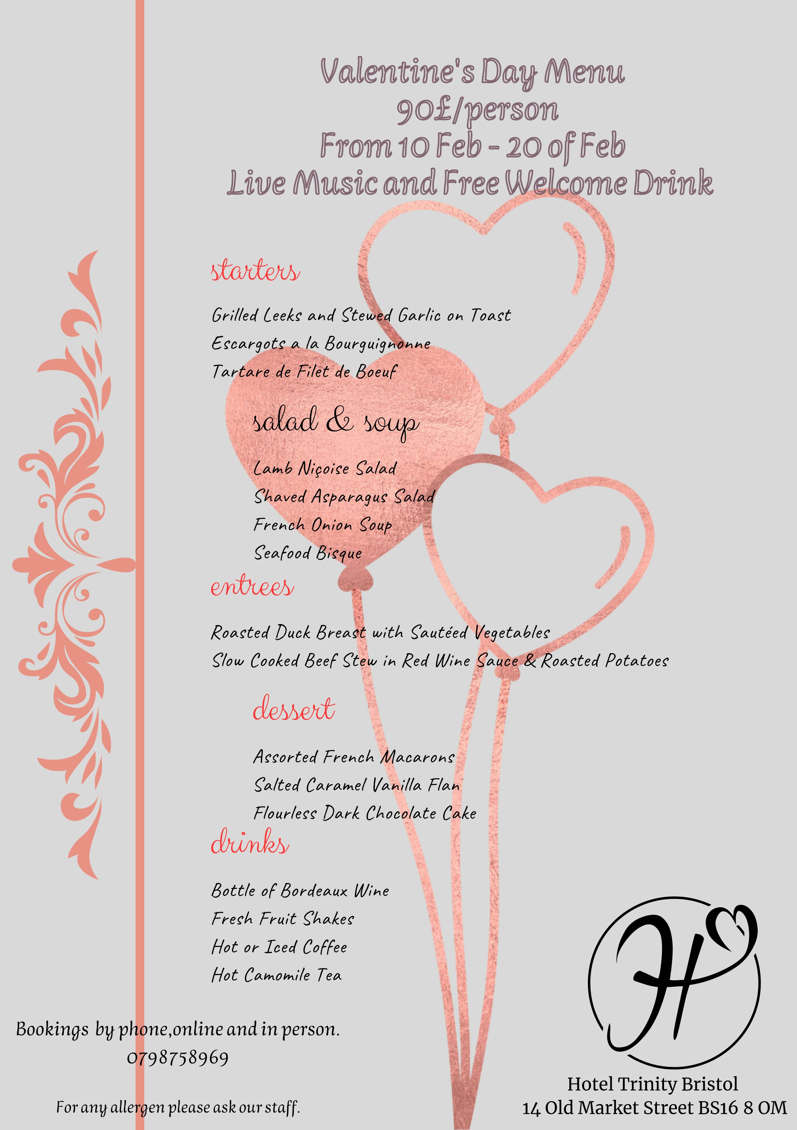
REFERENCE LIST:

Northstar Hotel

Available at: https://northstar-hotel.com/pages/menus/
(
Accessed: 10 feb
2023)
Holel Alpina

Available at:
https://www.hotelalpina.com/en/culinary/meals-hotel-obergurgl.html
(
Accessed :12 feb
2023)
The Savoy
Available at:https://www.thesavoycollection.com/the-savoy/
(
Accessed :11 feb
2023)

