Shake Muhammad Repon Miah ID:2430024
Module: Employability and Career Development Task 1 Job Interview
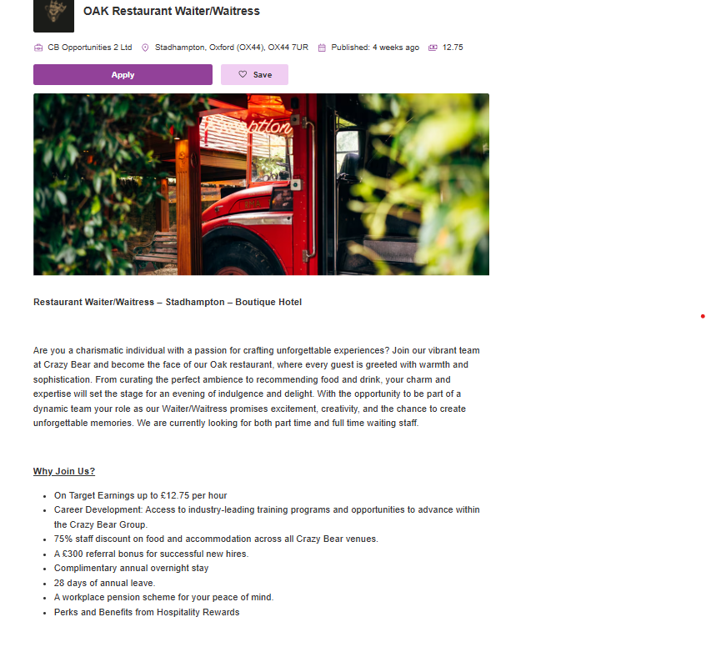

My Cv:
Shake Muhammad Repon Miah
56 COXE Street, London
📧 Email: Reponmiah4uk@yahoo.co.uk
📞 Mobile: 07845229521

Professional Profile
I’m a dedicated and results-driven professional with over 7 years of experience in the pharmaceutical and hospitality industries. I Demonstrates strong skills in operations, customer service, and administrative coordination, with a proven ability to work effectively in both corporate and service-oriented environments. I Adapt at building relationships, managing teams, and ensuring operational excellence across diverse settings.
Career Objective
To leverage my experience and interpersonal skills in a challenging role that allows me to contribute to organizational success, while continuously developing my professional and managerial competencies.

Education
Master of Social Science (M.S.S) – Political Science
National University, Bangladesh
Bachelor of Social Science (B.S.S) (Honours) – Political Science
National University, Bangladesh

Work Experience
Olive & Thyme, London – Restaurant Supervisor
Jan 2023 – Present
- Supervise daily restaurant operations to ensure smooth service and high guest satisfaction.
- Lead and coordinate a team of staff members, providing training, guidance, and performance feedback.
- Manage table allocations, reservations, and customer complaints efficiently.
- Ensure strict compliance with food hygiene, safety, and operational standards.
- Assist management with scheduling, inventory control, and stock ordering.
- Foster a positive and productive work environment to maintain high team morale.

Korbin & Kings, London – Restaurant Team Member
Jan 2021 – Dec 2022
- Delivered exceptional customer service in a high-paced dining environment.
- Supported restaurant operations including table service, order handling, and guest satisfaction.
- Ensured compliance with food hygiene and safety standards.
- Collaborated with kitchen and management teams to maintain service efficiency and quality.
ACME Global Medicine Company, Bangladesh – Sales & Operations Executive
Jan 2015 – Dec 2019
- Managed sales operations and distribution of pharmaceutical products across assigned regions.
- Developed and maintained relationships with healthcare professionals and retail partners.
- Prepared sales reports, monitored market trends, and supported product marketing activities.
- Coordinated with internal departments to ensure smooth logistics and customer satisfaction.
Key Skills
- Customer Service Excellence
- Team Coordination & Supervision
- Communication & Interpersonal Skills
- Problem Solving & Decision Making
- Administrative and Sales Support
- Time Management and Multitasking
- Microsoft Office (Word, Excel, Outlook, PowerPoint)
Languages
- English (Fluent)
- Bengali (Native)
Interests
Travelling, Community Service, Reading, and Culinary Arts

References
Available on Request.

Cover letter: Shake Muhammad Repon Miah

Mr. Matthew Mullan
General Manager
Hilton London on Park Lane
22 Park Lane
London W1K 1BE
United Kingdom
Date: 11/15/2025

Dear Mr. Mullan,
I am writing to express my keen interest in the Customer Service Officer position at Hilton London on Park Lane, as advertised. Please find attached my CV for your consideration.
With over seven years of combined experience in the hospitality and pharmaceutical industries, I have developed a strong foundation in customer service, team collaboration, and operational support. My previous roles at Korbin & Kings, London, and ACME Global Medicine Company, Bangladesh, have helped me cultivate the interpersonal, organizational, and problem-solving skills essential for delivering exceptional guest experiences in a prestigious environment such as Hilton.
At Korbin & Kings, I contributed to the smooth operation of daily restaurant services by ensuring guest satisfaction, maintaining service quality, and supporting team efficiency during peak business hours. Prior to this, my experience at ACME Global Medicine Company strengthened my communication, administrative, and coordination abilities — skills that translate directly to ensuring seamless guest service and professional front-of-house operations.
I take pride in my ability to handle multiple priorities under pressure while maintaining a calm and courteous demeanor. My strong commitment to service excellence and teamwork aligns closely with Hilton’s core values of hospitality, integrity, leadership, teamwork, and ownership.
I would be honored to bring my enthusiasm, adaptability, and dedication to Hilton London, contributing to its reputation as one of the city’s leading luxury hotels. Thank you for considering my application. I look forward to the opportunity to discuss how I can add value to your team.
Thank you for your time to looking my Cv through. I look forward to it.
Yours sincerely,
Shake Muhammad Repon Miah

