

INTERNATIONAL MARKETING(LCMB7006)

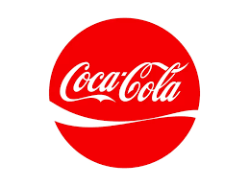

STUDENT NAME: RUBY
STUDEN ID NO: 2225797
LECTURER: TUSHARA BELENDRAN
WORD COUNT:5000
SUBMISSION DATE: 21 AUGUST 2023

Executive summary
The overall discussion of this report is on identifying the international marketing of the popular carbonated drink brand Coca-cola within their UK and Indian business. STP strategy, Ansoff matrix and directional development strategy show the different market position of Coca-cola in the UK and India. The UK has more political stability than India and it assists Coca-cola in expanding its business successfully.

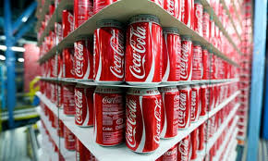

Table of Contents
Introduction 3
Background information about the company 3
Macro environment 4
Porters 5 Forces model of Coca-cola in the UK and India 6
SWOT analysis 8
Segmentation, targeting and positioning to Coca-Cola 9
Marketing mix elements (4Ps) 13
Directional development strategy 17
Ansoff matrix model for Coca-Cola 19
Conclusion and Recommendations 20
References 22

List of Figures
Figure 1: Political Index of the UK 5
Figure 2: Hofstede Cultural Dimensions between the UK and India 6
Figure 3: Market Capital of Coca-cola in the UK 9
Figure 4: Positioning Map of Coca-cola in the UK 12
Figure 5: Product positioning of Coca-Cola in India 13
Figure 6: Positioning Map of Coca-cola in India 14
Figure 7: Coca-Cola ranking in the UK 15
Figure 8: Marketing channels of Coca-Cola in the UK 17
Figure 9: Product positioning of Coca-Cola in the UK 19
Figure 10: Ansoff matrix model for Coca-Cola 20

List of Tables
Table 1: STP strategy for Coca-Cola 13

Introduction
International marketing or global marketing defines the process of distributing, promoting and advertising a product of a company at the international level. International marketing is important for extending the geographical area of a company and providing services or products to new countries. The main purpose of this report is to identify the international marketing of the popular carbonated drink brand Coca-cola. India and the UK are selected for comparing their international marketing strategy to promote Coca-Cola. This study has provided brief background information of this brand including the marketing position of the product Coca-cola. Several macro and micro models are used for comparing the marking strategies and business conditions of Coca-cola in India and the US. The macro-environmental models are PEST, “Hofstede’s Cultural Dimensions model”, STP, 7ps and “Porter's 5 Forces”. The micro models used to develop this comparative analysis are SWOT, Ansoff matrix and directional development strategy. Based on the issues of international marketing of Coca-cola in India and the US, some effective suggestions are to this beverage brand.

Background information about the company
Coca-cola is one of the renowned carbonated drinking manufacturing and retailing companies that started its operation in the US. The main portfolio of Coca-cola is to manufacture soft drinks as per customer’s choice and demand. The popular products of this brand are Coca-cola, Fanta, Sprite, and others. The purpose of this brand is to “refresh the world and make a difference” (Coca-cola.com, 2023). This is a customer-centric brand and aimed to meet the choice and demand of the customers by providing high-quality drink items. Therefore, using functional business strategies, Coca-cola has expanded its business in the UK, India, Germany and 200 more countries (Investors.coca-colacompany.com, 2023). Coca-cola ranks 33rd in the list of popular carbonated drink brands and in 2023, the August market capital of this business organisation is GBP 262.53 billion (Coca-cola.com, 2023). In the context of entering a new market or country, Coca-cola uses a unique franchising distribution strategy. Currently, this company has 82.5 thousand employees worldwide (Statista.com, 2023). Coca-cola has started to invest in sustainability and a green economy from the year 2018. This carbonated drink company has taken the initiative to transform its packaging system into green packaging by 2050. In addition, they have aimed to use at least 50% of recycling materials for waste reduction by 2030. These positive initiatives are added to the internal marketing strategies of Coca-cola in order to ensure a successful business expansion.

Macro environment
Political factor
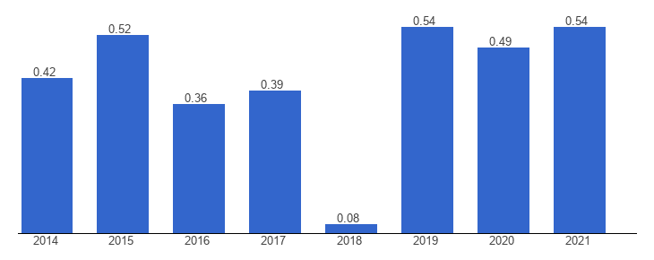

Figure 1: Political Index of the UK
(Source: Theglobaleconomy.com, 2023)
UK: The political stability of the UK was 0.54 in 2021 which can allow Coca-cola to process international marketing strategies with minimum political barriers (Theglobaleconomy.com, 2023).
India: In 2021, the PSI of India was -0.62 and Coca-cola can face issues while expanding business in this country (Theglobaleconomy.com, 2023).
Economical Factor
UK: In 2020, the UK government regarding the “British Soft Drinks Association” invested GBP 20 million in a sustainable production line (Britishsoftdrinks.com, 2023).
India: India's soft drink market expects a “significant growth” after 2023 and Coca-cola can use this opportunity in future (Timesofindia.indiatimes.com, 2023).
Social and Cultural Factor
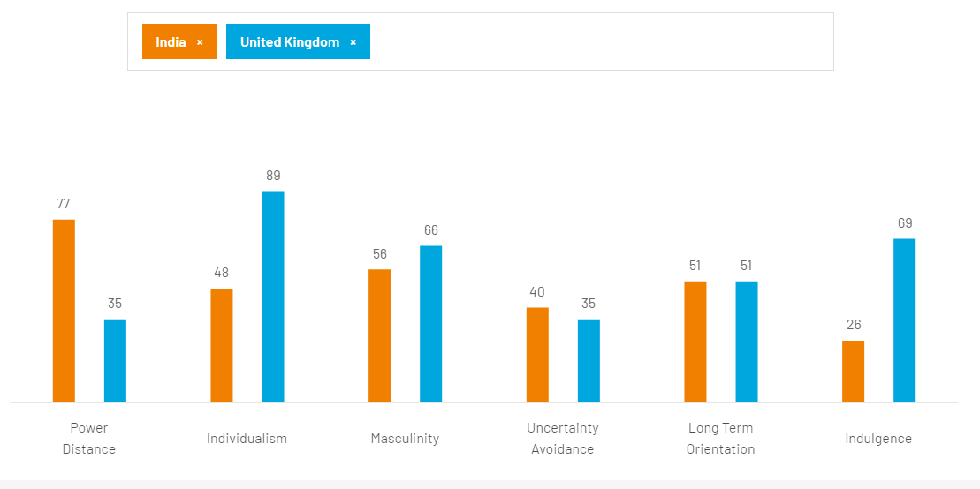

Figure 2: Hofstede Cultural Dimensions between the UK and India
(Source: Hofstede-insights.com, 2023)
Power Distance
In the segment of power distance, India scores 77 which represent the dependent nature of the employees in business organisations. On the other hand, with a score of 35 in power distance, Coca-cola can depend on their employees for business development.
Individualism
India has a low score “of 48” in individualism which represents the performance of the employees of Coca-cola depending on external factors such as friends, families and others. There is a low chance for Coca-cola in facing these types of issues in the UK (Hofstede-insights.com, 2023).
Masculinity
In masculinity with scores of 56 and 68 in India and the UK respectively, the competitive environment in the business environment has been identified (Hofstede-insights.com, 2023). Coca-cola has to face the issues of the competitive environment in both of these countries.
Uncertainty Avoidance
India scores 40 in uncertainty avoidance which represents their low investment for future risks. Same to this context, the UK scored 35 in this segment and Coca-cola has a chance of facing future risks.
Long Term Orientation
Both these countries have the same score of 51 in long-term orientations and Coca-cola has to experience pragmatic and normative societies while processing with marketing activities.
Indulgence
In India, with a score of 26, Coca-cola faces the issue of restraint culture (Hofstede-insights.com, 2023). In the UK, this company does not face these types of issues in international marketing.
Technological factors
UK: The food department and safety department of the UK use Industry X.0 for operating manufacturing models, value chain and production processes (Foodanddrinktechnology.com, 2023). Coca-cola can use the effectiveness of this new technology while process with manufacturing tasks in this country.
India: The GDP ratio of India in R&D is only 0.7% and Coca-cola gets less opportunity for technological manufacturing development (Thehindu.com, 2023).

Porters 5 Forces model of Coca-cola in the UK and India
Threat of new entrants
The first market forces the “Threat of new entrants” that affects Coca-cola highly in India. As per current news, a “significant growth” in soft drink consumption has been identified in India (Economictimes.indiatimes.com, 2023). The shifting population of demographics, urbanisation and increasing rural consumption are some real factors behind this growth. The start-up business organisation in India are cconcerned about the negative impact of the carbonated drinks and essentiality of the sustainable healthy drink item “Threat of new entrants” high for Coca-cola. On the other hand, the threat of new companies is moderate in the UK (Coca-cola.com, 2023). In the UK, Coca-cola has captured the market in an effective manner. The start-up companies of the UK are not able to affect Coca-cola hugely.
Bargaining power of buyers
Coca-cola has different customers base in both the UK and India and they have different bargaining power. In India, this company has mostly direct End-users who buy the products for consumption and this type of customer or buyer has zero bargaining power. Based on the views of Kaplanlioǧlu and Ecer (2023), the end-users have commonly low or zero bargaining power while buying a product. On the other hand, the UK Coca-cola also handles the fast-food chain companies, retailers and vendors as buyers of this product. Therefore, fast-food chain owners have low to medium business bargaining power. However, this carbonated drink company follows a value-based pricing policy (Coca-cola.com, 2023). It allows this business organisation to fix the prince level based on a competitive market environment. It makes the bargaining power of different types of buyers of Coca-cola low.
Bargaining power of suppliers
Another market force to Coca-cola is the bargaining power of the suppliers which is low in both the UK and India. Based on the corporate report of these business organisations, their connection with several suppliers has been identified. These are the raw materials suppliers, labour suppliers and delivery suppliers Coca-cola use the contractual process to buy raw materials from the suppliers (Coca-cola.com, 2023). It helps in keeping a constant price of materials even in a changing environment. It makes the bargaining power of both the UK and India’s suppliers low. However, this business organisation uses a functional strategy and concerns the value chain members (Coca-cola.com, 2023). In other words, coca-cola tries to work for deep collaboration with its internal and external members. It ensures that suppliers of this business organisation are offered a reasonable price for their service. In 2023, 3 billion transactions were made from 3 lakh shops in India (Economictimes.indiatimes.com, 2023). It states the effective collaboration between the suppliers and Coca-cola.
Threat of new substitute
The threat of substitutes is one of the most important forces to Coca-cola which in the total demand forecasting depends. In the UK, the “threat of new substitutes” to Coca-cola is high as the population of this country uses to consume milkshakes, coffee, fruit juice and others at the same time as Coca-cola. Based on the views of Rogers et al. (2020), in recent two years, 10% of consumption levy drinks has increased in the UK. It states that the population of this country consumes various types of soft drinks. On the other hand, the threat of new substitutes is moderate in India. It has been identified that the existing items capture the soft-drink market of India (Economictimes.indiatimes.com, 2023). It makes the power of new substitutes in this country low compared to Coca-cola.
Competitive rivalry
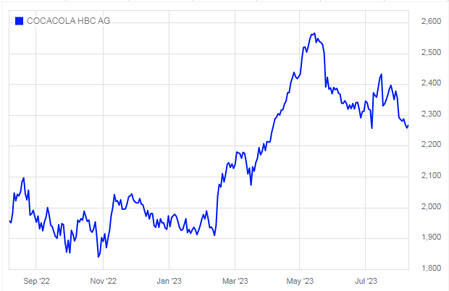

Figure 3: Market Capital of Coca-cola in the UK
(Source: Londonstockexchange.com, 2023)
The competitive rivalry in India is high to Coca-cola as the global soft-drink giant is also present in this country. ITC, Dabur and Parle are three strong competitors of Coca-cola in India (Economictimes.indiatimes.com, 2023). These business organisations provide healthier and fruit-based drinks to the Indian population. On the other hand, the competitive rivalry of Coca-cola is moderate to high in the UK. The market capital of this carbonated brand in the UK is GBP 8444.46 m in 2023 (Londonstockexchange.com, 2023). They have invested a huge in manufacturing, marketing and advertising to keep the customer segment of Coca-cola. Competitive business organisations such as Pespsi-co and others follow Coca-cola for business development.

SWOT analysis
Strengths
Coca-cola has a strong brand identity in both the UK and India and this is the most important strength for this company for ensuring the growth and development rate. Worldwide population consumes 630 8-ounce soft-drinks in every serving (Statista.com, 2023). Coca-cola has selected its product line by using the opportunity and captures a huge segment of customers. In India, Coca-cola provides various types of soft drinks such as Fanta, Limca, Maaza, and others (Coca-cola.com, 2023). In this country, they have more than 1,5 million outlets. On the other hand, Coca-cola uses the concept of brand awareness while entering the cities of the UK. The report states that Coca-cola has 98% of brand awareness while entering the UK (Statista.com, 2023). The marketers of the UK company Coca-cola target soft drinkers before launching any new product.
Weaknesses
In India, Coca-cola faces business challenges due to the competitive business environment in their operating market. The global companies of soft-drink such as PepsiCo and ITC affect the product diversification process of Coca-cola in a negative manner. In this country, 84% of investment in the soft-drink market is generated in recent two years (Economictimes.indiatimes.com, 2023). There has been an effective contribution of these competitive organisations. On the other hand, the UK population sufferers from high health issues like diabetes and obesity. 28% of the population in the UK suffers from obesity and it increases their health concerns (Diabetes.org.uk, 2023). The high sugar level of the items of Coca-cola can increase the health issues of the customers. Coca-cola invests in new product lines by considering the health issues that promote the extra operational budget.
Opportunities
Coca-cola has started to invest in the community programs in India such as health programs, water conservation and education. Recently, Coca-cola has invested in a “500-rain water harvesting structure” in 22 states (Coca-cola.com, 2023). In the context of international marketing, this contribution assists this brand to capture the Indian market. On the other hand, “Topo Chico Sabores”, Diet Coke, Coke Zero, smart water and others are some new items of Coca-cola taht have zero sugar levels (Investors.coca-colacompany.com, 2023). In future, these products can be helpful for targeting the young population of the UK who are heath concerns.
Threats
In both countries the UK and India, changing business environments, high competitive rivalry, and changing customer preferences are some threatening factors to Coca-cola. On the other hand, this carbonated drink company has faced financial uncertainty because of the global pandemic Covid-19 (Investors.coca-colacompany.com, 2023). The border closure, restrictions in international business and transportation issues have disrupted the international strategies of Coca-cola in a negative manner.

Segmentation, targeting and positioning to Coca-Cola

Brand-Coca-Cola | The UK | India | Similarities | Differences
Segmentation | Coca-Cola has strong market segmentation in the UK and has a 35.39 % market share as a carbonated soft drink company (Statista.com, 2023). | The majority of people in India prefer Coca-Cola as a soft drink. A total of 20% of the market share has been taken by Coca-Cola in the Indian carbonated soft drink market (Statista.com, 2023). | Both countries have significant people's choices to have Coca-Cola as a soft drink. | India is more culturally diverse than the UK and various communal people have a significant choice of carbonated soft drinks.
Targeting | The primary target of Coca-Cola is younger customers of the age group of 10-25 years. | The primary audience of Coca-Cola in India belongs to the age group of  10 to 35 years. | Most of the younger generation Prefer Coca-Cola as their soft drink. | Middle-age groups and even old age groups like Coca-Cola in India rather than the UK.
Positioning | 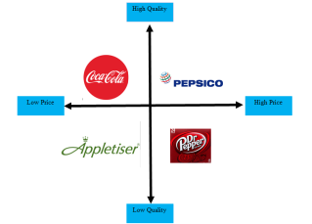 | 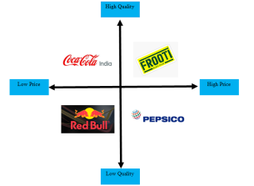 | Pepsico is emerging as the biggest competitor of Coca-cola. | Parle Agro’s Frooti has significant market dominance and is the biggest competitor of Coca-Cola in India.

Table 1: STP strategy for Coca-Cola
(Source: Self-developed)
Analysis
Coca-Cola is the leading carbonated soft drinks brand operating its business across the globe. The UK and Indian market shows significant market segmentation, targeting and market positioning in such markets. Coca-Cola has 35.39% of the market share in the UK market which reflects that people of the UK irrespective of geographic and demographic location have strong faith in the soft drink product of Coca-Cola (Statista.com, 2023). In the UK market, Coca-Cola shows significant brand awareness and customer loyalty that reflects 97% of its brand awareness held in the UK (Statista.com, 2023).
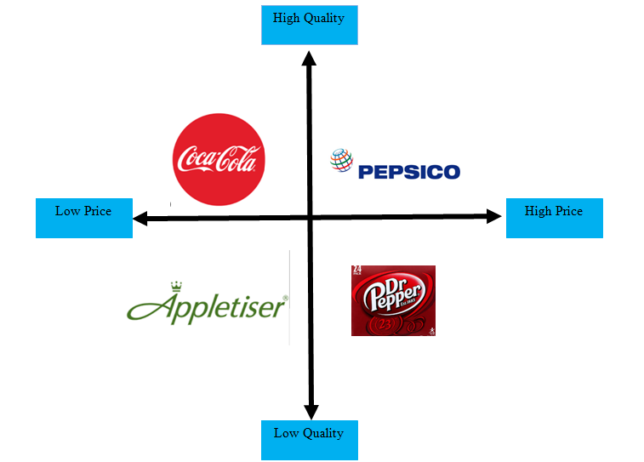

Figure 4: Positioning Map of Coca-cola in the UK
(Source: Self developed)

From the targeting segment, the younger people of the 10 to 25 years age group are the primary audience of Coca-Cola in the UK. Market positioning shows that Coca-Cola has significant market dominance in the UK's carbonated soft drink industry as well as facing significant competitors' environments that impact the market proposition of Coca-cola. Pepsico, Appletiser and Dr Pepper are the biggest competitors of Coca-Cola in the UK market. The high-quality and affordable cost proposition of Coca-Cola determines its market sustainability in the UK market.
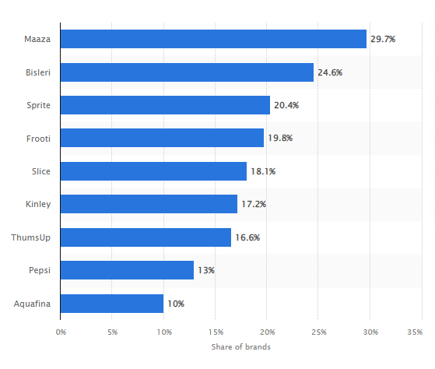

Figure 5: Product positioning of Coca-Cola in India
(Source: Statista.com, 2023)

As discussed by Singaram et al. (2019), India is a more culturally diverse country that shows a significant market proposition for Coca-Cola in the carbonated soft drinks industry in India. Younger generations emerge as the primary audience of Coca-Cola in India and besides that middle and old age group also has a significant preference to choose Coca-Cola over other soft drinks in the Indian market. In comparison to the UK market, the Indian market offers only 20% market share for Coca-Cola but that has a significant impact on the customers (Statista.com, 2023). Thums Up and Sprite are the two products of Coca-Cola which are significantly driving the carbonated soft drinks market of India and can increase the market share of Coca-Cola by 20%. Sprite has 15 % of the market share and emerges as a multi-dollar product for Coca-Cola (Economictimes.indiatimes.com, 2023). Thumbs Up also has significant market dominance that follows the spirit. Pepsico emerges as the global competitor for Coca-Cola and it is also facing competitive rivalry in both the Indian and The Uk markets. With more cultural diversity and according to the taste choice Frooti is the product of Parle Agro is the biggest competitor of Coca-Cola in the Indian market (Economictimes.indiatimes.com, 2023). Hence, Parle Argo and Pepsico set high-market competitors for Coca-Cola in the Indian market. Therefore, the segmentation, targeting and position of Coca-Cola in the different market segments of the UK and Indian markets are compared and analysed based on similarities and differences that maintain the sustainability of Coca-Cola in the carbonated soft drinks industry.
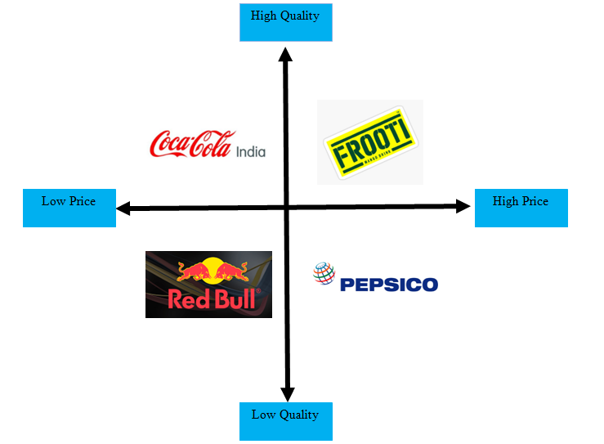

Figure 6: Positioning Map of Coca-cola in India
(Source: Self developed)

Marketing mix elements (4Ps)
The marketing mix effectively enhances the marketing and market entry strategy for Coca-Cola in the UK and Indian markets. As opined by Tucker and Au, (2019), the 4Ps marketing mix reframes the business proposition of Coca-Cola and enhances its business suitability and competitiveness (Lynch, 2018). Product statement, pricing, place of the business and market promotion of the product are the various steps that Coca-Cola takes to promote its business proposition in the UK and Indian markets.4Ps marketing mix effectively analyse the market and business scenario for Coca-Cola in both countries.
Product
Coca-Cola is a global brand that has significant market dominance in the carbonated soft drinks industry across the globe. With it’s headquartered in Atlanta, Georgia of the United State, Coca-Cola has nearly USD 0.99 billion in annual revenue. In the UK market, Coca-Cola has significant market dominance that shows through its country ranking in the UK of 23,701 and global ranking of 311,159 (Similarweb.com, 2023). “Fanta”, “Coca-Cola Diet Coke”, and “Coca-Cola zero sugar” are the most popular products of Coca-Cola in the UK market. On the other hand “Thums Up”, “Sprite”, “7-Up” and “Maaza” are the most significant product of Coca-Cola that has strong market demand from the Indian market.

Price
Affordability and quality are the main USPs of Coca-Cola to maintain its competitive advantage in the global soft drinks industry. As discussed by Guo and Wen, (2021), the management of Coca-Cola focuses on lowering the price of their various products that effectively improve the customers' proposition for the brand. Coca-Cola offers various carbonated soft drinks products of different sizes and quantities and affordable pricing making it its most popular brand across the globe. The average pricing of any two-litre products of Coca-Cola in the UK cost £2.12. The very low price and best taste of the product of Coca-Cola hold significant market dominance in the UK. On the other hand, India is emerging as the most sustainable market for Coca-Cola and affordability in the pricing of the products of Coca-Cola increases its market position in the Indian carbonated soft drinks industry. A two-litre product of Coca-Cola cost INR 100 in the Indian market. Hence, affordability in the pricing and variety of the product range Coca-Cola offers customers in both the UK and Indian markets to pick Coca-Cola as their soft drinks brand among the other competitors.
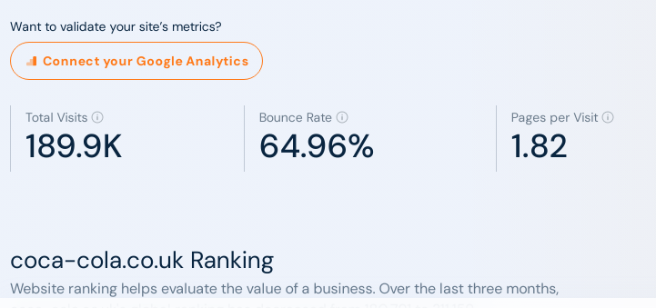

Figure 7: Coca-Cola ranking in the UK
(Source: Similarweb.com, 2023)

Place
Coca-Cola has significant dominance across the globe and is emerging as the best carbonated soft drink brand in the world. Pepsico and other competitors have developed a significant market impact on Coca-Cola that may impact its business. Looking at the market position according to the regional and domestic marketplace, Coca-Cola receives positive responses that improve its sustainability in the soft drinks industry. As discussed by Liu, (2021), market entry strategy helps Coca-Cola to enter into a new market. Analysing the external and internal market analysis based on the socio-economic and cultural structure of the country may generate market insights for Coca-Cola. Foreign direct investment, joint venture, franchising and exporting are the different market entry strategy methods that Coca-Cola takes to enter the UK and Indian markets (Kuzey et al. 2021). The UK and India have different market environments based on their socio-economic and cultural propositions. The UK has strong economic stability and offers better opportunities for Coca-Cola to operate their business in the UK. Estimation shows that 12.08 million of people in the UK consumed original Coca-Cola and another 9.05 million people in Great Britain consumed Diet Coke (Statista.com, 2023).On the other hand, India has more diverse socio-economic and cultural aspects than the UK. Multiple cultural aspects of the Indian market determine the consumption of Coca-Cola products by Indian customers. India’s per capita drinks consumption has almost doubled to 84 per year and most customers like to have Sprite and other Coca-Cola products (Economictimes.indiatimes.com, 2023). Coca-Cola uses strategic partnership and acquisition strategy besides foreign direct investment, franchising and joint venture to enter the Indian market. Acquisition of the “Maaza” from Parle Agro is a significant market entry strategy that Coca-Cola had taken that effectively improved the market proposition of Coca-Cola in the Indian context.“Maaza” is emerging as the best product of Coca-Cola in the Indian market and set intense competition for other competitors (Economictimes.indiatimes.com, 2023). Hence, both the market of India and the UK needs a market strategy that includes proper market analysis for the organisation.
Promotion
Coca-Cola enhances a better marketing strategy online that effectively improves the customer proposition and improves brand awareness across the world. Both the Indian and the UK markets need a significant marketing proposition based on the customer's specifications and socio-economic-cultural structure. Coca-Cola’s UK operation centre enhances a marketing process that shows the UK has a 52.57% target audience for Coca-Cola and emerges as the best market for soft drinks brands (Similarweb.com, 2023). 30.34% people of age group are the primary target audience of Coca-Cola in the UK and digital market analysis shows that almost 189.9k visitors visit the Coca-Cola official website in the UK(Similarweb.com, 2023). Coca-Cola uses social media networks, technology and the product purchasing history of the customers to analyse the demand of the market. In the UK market, 24.69% of the direct channels sell, 70.46% of the organic search and 4.77% of referral marketing emerge as the marketing portfolio of Coca-Cola in the UK market (Similarweb.com, 2023).On the other hand, wide diversity in the Indian market offers the chance for Coca-Cola to enhance its effective marketing strategy to hold dominance. As discussed by Singaram et al. (2019), traditional media and promotional campaigns emerge as the best source of the marketing process in the Indian market. In the current business environmental context Social media, Google Analytics and other digital media sources show their potential in the marketing processes of Coca-Cola. Customer campaigns in the Indian context such as "Happiness" and "Share A Coke" are effective marketing campaigns of Coca-Cola in the Indian market that significantly improves the customer's propositions (Vincent and Kolade, 2019). As discussed by Liu, (2020), digital marketing strategy and better distribution as well as wholesale marketing strategy improve the marketing process of Coca-Cola in the Indian market.
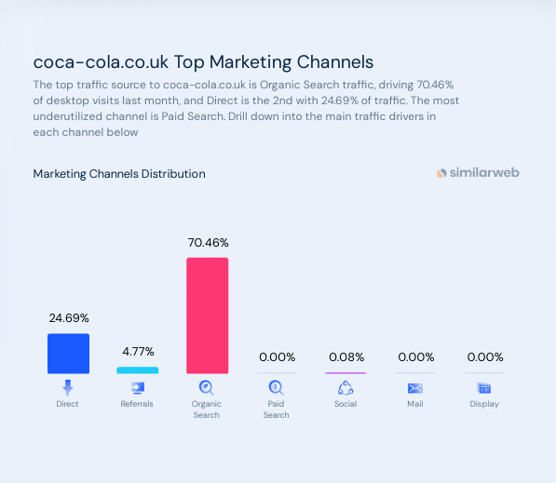

Figure 8: Marketing channels of Coca-Cola in the UK
(Source: Similarweb.com, 2023)

Directional development strategy
Directional development strategy states the development and execution of plans that effectively increase profit and maintain the sustainable development of the organisation. As discussed by Liu and Feng, (2019), directional development strategies help Chinese organisations to adopt green productivity that improves the profit margin for the business. The direction of the development and business plans of the organisation determine the business sustainability and progression in a positive direction. The growth strategy consists of determining the new business proposition through the introduction of new products and services that may generate new income sources for the business organisation. Vertical proposition and growth strategy help the business to enhance profitability through the new proposition of business (Hesterly and Barney, 2014). Coca-Cola can use a growth strategy by improvising its product that improves the horizontal growth of the company. Coca-Cola enhances healthier production by reducing the sugar content and encouraging the potential customers of both India and the UK customers to taste the new product of Coca-Cola. Horizontal marketing strategy and supply chain management effectively maintain the sustainable growth of Coca-Cola in the global context (Huse et al. 2022). A directional strategy develops stability management for the organisation to assess the business risks and execute the perfect mitigation plans to maintain the business stability. As opined by Nwachukwu and Chladkova, (2019), analysis of the market environment and competitors’ analysis help the organisation to assess their performance. Risk assessment and contingency planning improve the stability and growth of the organisation. Coca-Cola as a global brand analyses the market condition and assesses the risks to maintain its stability. The retrenchment strategy improves the cost of the business operation and reduces the production cost effectively cutting down the workforce and maintenance cost of the organisation. As discussed by Tao et al. (2020), reducing compensation and benefits, and reducing the production and operation costs may help the organisation to bounce back from the adverse situation that they face due to the unprecedented events of the market. On the contrary Cheema et al. (2020), Environmental and social responsibility improves the organisation's sustainability and enhances the retrenchment process without reducing the workforce compensation. Coca-Cola’s CSR practice and environmental sustainability improve its brand proposition and business sustainability in the global markets including India and the UK. Coca-Cola’s donation of INR 50 crore towards the vaccination programme and providing safety kits to the Indian front liner staff who deal with the covid 19 reflects a great social proposition of Coca-Cola (Economictimes.indiatimes.com, 2023). Better waste management, Fruit economy, water conservation and CSR practice are the various sustainable practices of Coca-Cola that set its sustainable development. Hence, a directional development strategy helps Coca-Cola to maintain its sustainable growth and develop a strong market position in the UK and India.
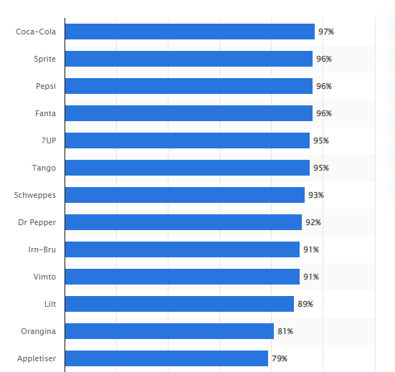

Figure 9: Product positioning of Coca-Cola in the UK
(Source: Statista.com, 2023)

Ansoff matrix model for Coca-Cola
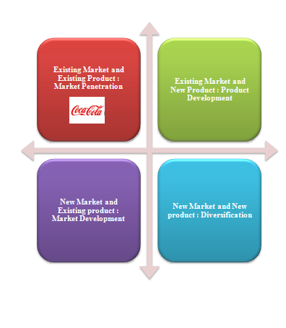

Figure 10: Ansoff matrix model for Coca-Cola

(Source: Self-developed)

Ansoff's matrix model effectively states the various market strategies that businesses can take to enhance their market penetration in the existing or new market with the existing or new products. Coca-Cola has significant existing market dominance and a wide product range that reflects its existing product portfolio. Based on the view of Clarissia, (2020), this model effectively states the business scenario of Coca-Cola with the existing market and existing product. The business environment may develop challenges such as economic and competitor challenges that significantly impact the business process of Coca-Cola in the exciting market. Focusing on India and the UK's socio-economic, political and cultural stability determines the existing market growth of Coca-Cola. Hence, it could use the market penetration strategy to enhance its existing market with the existing product. Market penetration strategy incorporates the management practice of Coca-Cola to enhance a better business model for better customer attraction. Offering a discount on the product of Coca-Cola and focusing on the healthier proposition can effectively increase the market penetration of the soft drinks brand in both the Indian and UK markets. As opined by Deshpande et al. (2020), digital marketing, social media awareness and influential branding can effectively improve the market penetration of Coca-Cola in the India and UK’s carbonated soft drinks market. Customisation and personalisation based on the customers' specifications can help Coca-Cola to modify its existing product and develop a unique proposition that differentiates Coca-Cola from other competitors. Environmental sustainability and CSR practice also improve the brand loyalty of Coca-Cola in the UK and Indian markets which also improve the market penetration of the soft drinks brand.

Conclusion and Recommendations
Conclusion
It can be concluded that Coca-Cola is a global brand that has developed significant market dominance in the carbonated soft drinks market across the world. Coca-Cola operates in the UK, India, Germany and more than 200 countries and develops significant market capital of GBP 262.53 billion in August 2023. This soft drinks industry adopted green sustainability practices in its business operation in 2018 and aims to recycle and waste management that effectively reduce 50% of the waste reduction by 2030. The political stability of 0.54 shows a strong market for Coca-Cola in the UK market and -0.62 on the Indian political index shows challenges for Coca-Cola to expand its business in India. Significant growth of the Indian market and British soft drinks market show more opportunities for Coca-Cola in the future context. Other socioeconomic and cultural factors of both the Indian and the UK market offer opportunities and significant challenges for Coca-Cola. External and internal business environments also impact the business operation of Coca-Cola in the UK and India. Porter's 5 Forces model and SWOT analysis effectively analyse the different market environments for Coca-Cola in the different market segments of the UK and India. STP strategy effectively describes the market segmentation, target Audience and positioning map for Coca-Cola in India and the UK context. Different socio-economic and cultural segments of the Indian and UK markets set various competitors' scenarios that impact Coca-Cola's market position. Pepsico and Parle Agro emerge as the competitors for Coca-Cola in the UK and Indian Context. 4Ps marketing strategy and different demographic conditions of the countries set various market positions for Coca-Cola and better marketing practices increase the customer's proposition and brand awareness of its products. Directional development strategy has shown the different stability and retrenchment conditions for business that also help Coca-Cola to enhance its environmental practice and CSR process to increase its brand values across the globe.
Recommendation 300
Diversity implementation in the product line and business practice may help Coca-Cola to improve its operation in the Indian and UK markets. Based on the point of view of Orhero and Okolie, (2023), diversity implementation improves employee engagement. Improve product diversity lining and improve segmentation of the products of Coca-Cola to help the customers to choose their specific Coca-Cola products. Segmentation of the market and analysis of customers' propositions may help Coca-Cola to enhance its customer market and reach its target audience. Effective market segmentation and managing diversity in the business process may improve the market share of Coca-Cola as well as improve its sustainable performance (Wang, 2021). Carbonated soft drinks have a significant impact on health that lead to an increase in the chance of obesity, hence, Coca-Cola may shift its focus to reduce its sugar content use in its product. “Diet Coke '' and other healthy products may effectively improve the business performance of Coca-Cola in the global market including India and the UK. As discussed by Maani Hessari et al. (2019), public meet and awareness campaigns about less sugar usage in the product of Coca-Cola may improve the interrelation of the CDC perspective of health. Hence, a better healthier proposition of Coca-Cola may improve its brand loyalty and “Zero sugar Coke '' may develop a strong market awareness across the globe. Understanding different market segments such as India and the UK may help Coca-Cola to enhance their product statement to the customers of the region and social and environmental responsibility may help the company to develop strong brand loyalty. Thermal waste management, green business proposition and environmental sustainability may improve the business sustainability of Coca-Cola (Adeniyi et al. 2022). Overall, Coca-Cola may improve its technological and organisational processes and enhance a more customer-centric approach that may improve the business competitiveness of the soft-drink brand.

References
Adeniyi, A.G., Amusa, V.T., Iwuozor, K.O. and Emenike, E.C., (2022). Thermal recycling strategy of Coca-Cola PVC label films by its co-carbonization with Terminalia ivorensis leaves. Cleaner Engineering and Technology, 11, p.100564.
Britishsoftdrinks.com, (2023).2020 Annual Report. Available at:https://www.britishsoftdrinks.com/write/MediaUploads/BSDA_Annual_Report_2020.pdf[Accessed on:07.08.2023]
Cheema, S., Afsar, B. and Javed, F., (2020). Employees' corporate social responsibility perceptions and organizational citizenship behaviors for the environment: The mediating roles of organizational identification and environmental orientation fit. Corporate Social Responsibility and Environmental Management, 27(1), pp.9-21.
Clarissia, S.M.S., (2020). A study on Ansoff Matrix Technique: As a growth strategy and an adaptive learning technique adopted in the leading brand of products. BIMS Journal of Management, 18.
Coca-cola.com (2023). Coca-cola great Britain.Available at: https://www.coca-cola.com/gb/en [Accessed on 8th August 2023]
Coca-cola.com (2023). Our Brands.Available at: https://www.coca-cola.com/gb/en/brands. [Accessed on 8th August 2023]
Coca-cola.com (2023). Our Brands.Available at: https://www.coca-cola.com/gb/en/brands. [Accessed on 8th August 2023]
Coca-cola.com, (2023). In britain. Available at:https://www.coca-cola.com/gb/en[Accessed on:07.08.2023]
Coca-cola.com, (2023). Sustainability. Available at:https://www.coca-cola.com/in/en/sustainability#:~:text=Focusing%20on%20a%20world%20without,in%20our%20packaging%20by%202030.[Accessed on:07.08.2023]
Deshpande, A., Kee, D.M.H., Shankar, D., Segi, S., Charles, E.A., Parameswaran, K. and Vellmurugan, M., (2020). Influence of strategic branding in soft drink market in Indian and Malaysian context: Study on Coca Cola to remain Top of the Mind Brand (TOMB). Asia Pacific Journal of Management and Education (APJME), 3(1), pp.82-93.
Diabetes.org.uk, (2023).clinical guidelines for overweight and obesity in england updated. Available at:https://www.diabetes.org.uk/about_us/news/clinical-guidelines-overweight-and-obesity-england-updated#:~:text=Obesity%20is%20the%20biggest%20modifiable,cost%20to%20the%20wider%20economy.[Accessed on:07.08.2023]
Economictimes.indiatimes.com (2023).Coca Cola pledges Rs 50 crore towards facilitating vaccination, providing safety kits in India.Available at: https://economictimes.indiatimes.com/industry/cons-products/food/coca-cola-pledges-rs-50-crore-towards-facilitating-vaccination-providing-safety-kits-in-india/articleshow/82310282.cms[Accessed on 8th August 2023]
Economictimes.indiatimes.com (2023).India's per-capita soft drink consumption to be almost double to 84 bottles a year by 2021: VBL.Available at: https://economictimes.indiatimes.com/industry/cons-products/food/indias-per-capita-soft-drink-consumption-to-be-almost-double-to-84-bottles-a-year-by-2021-vbl/articleshow/68950836.cms?from=mdr [Accessed on 8th August 2023]
Economictimes.indiatimes.com (2023).Maaza to be another billion-dollar brand for Coca-Cola in 2 yrs; not worried about entry of Reliance .Available at: https://economictimes.indiatimes.com/industry/cons-products/food/maaza-to-be-another-billion-dollar-brand-for-coca-cola-in-2-yrs-not-worried-about-entry-of-reliance/articleshow/95254489.cms?from=mdr [Accessed on 8th August 2023]
Economictimes.indiatimes.com (2023).Parle Agro's Frooti beats PepsiCo's Slice to win back the no. 2 slot after a decade.Available at: https://economictimes.indiatimes.com/industry/cons-products/food/parle-agros-frooti-beats-pepsicos-slice-to-win-back-no-2-slot-after-a-decade/articleshow/52230711.cms?from=mdr [Accessed on 8th August 2023]
Economictimes.indiatimes.com (2023).Soft drinks market: Thums Up hits a decade-high market share of 20%.Available at: https://economictimes.indiatimes.com/industry/cons-products/thanda-matlab-thums-up/articleshow/94359829.cms?from=mdr [Accessed on 8th August 2023]
Economictimes.indiatimes.com, (2023).Synopsis. Available at:https://economictimes.indiatimes.com/industry/cons-products/food/indian-soft-drink-market-expected-to-see-significant-growth-says-pepsico-bottler-varun-beverages/articleshow/98579808.cms?from=mdr[Accessed on:07.08.2023]
Economictimes.indiatimes.com, (2023).Synopsis. Available at:https://economictimes.indiatimes.com/industry/cons-products/food/coca-cola-drove-3-billion-transactions-in-india-in-jan-march-quarter/articleshow/99738601.cms?from=mdr[Accessed on:07.08.2023]
Economictimes.indiatimes.com, (2023).Synopsis. Available at:https://economictimes.indiatimes.com/industry/cons-products/food/indias-per-capita-soft-drink-consumption-to-be-almost-double-to-84-bottles-a-year-by-2021-vbl/articleshow/68950836.cms?from=mdr[Accessed on:07.08.2023]
Economictimes.indiatimes.com, (2023).Synopsis. Available at:https://economictimes.indiatimes.com/industry/cons-products/food/local-rivals-eat-into-market-share-of-coca-cola-pepsico/articleshow/61568213.cms?from=mdr[Accessed on:07.08.2023]
Foodanddrinktechnology.com, (2023).Digital technologies are key for UK food and drink industry. Available at:https://www.foodanddrinktechnology.com/news/19809/digital-technologies-key-uk-food-drink-industry/[Accessed on:07.08.2023]
Guo, X. and Wen, M., (2021), December. Research on Competitive Strategy of Coca-Cola Company. In 2021 3rd International Conference on Economic Management and Cultural Industry (ICEMCI 2021) (pp. 2879-2885). Atlantis Press.
Hesterly, W. and Barney, J., (2014). Strategic management and competitive advantage. Pearson/Education.
Hofstede-insights.com, (2023).COUNTRY COMPARISON TOOL. Available at:https://www.hofstede-insights.com/country-comparison-tool?countries=india%2Cunited+kingdom[Accessed on:07.08.2023]
Huse, O., Reeve, E., Bell, C., Sacks, G., Baker, P., Wood, B. and Backholer, K., (2022). Strategies used by the soft drink industry to grow and sustain sales: a case-study of The Coca-Cola Company in East Asia. BMJ Global Health, 7(12), p.e010386.
Imhanzenobe, J., (2021). Achieving competitive advantage and financial sustainability through acquisition and restructuring strategies. Journal of Accounting and Taxation, 13(3), pp.217-225.
Investors.coca-colacompany.com, (2023).Our Purpose. Available at:https://investors.coca-colacompany.com/strategy#:~:text=Refresh%20the%20World.&text=We're%20present%20in%20almost,world%20and%20make%20a%20difference.[Accessed on:07.08.2023]
Kaplanlioǧlu, Ö. and Ecer, S., (2023). Network Neutrality in the Internet with Congestion Sensitive End Users and Content Providers Yoǧunluia Duyarli Son Kullanicilar ve Içerik Saǧlayicilar ile Internette Aǧ Tarafsizliǧi. Bogazici Journal, 36(2).
Kuzey, C., Dinc, M.S., Khan, F.U. and Raj, V., (2021). Foreign Direct Investment Decision-Making Motives for Multinational Enterprises: A Study of Eight Firms in an Emerging Economy. Journal of Management, Economics, and Industrial Organization, 5(1), pp.39-64.
Liu, L., (2020). Coca Cola: A Study on the Marketing Strategies for Millenniums Focusing on India. Scientific Journal of Intelligent Systems Research Volume, 2(01).
Liu, S., (2021). A Report on Strategic Analysis and Recommendations of Coca-Cola. International Journal of Frontiers in Sociology, 3(17).
Liu, Y. and Feng, C., (2019). What drives the fluctuations of “green” productivity in China’s agricultural sector? A weighted Russell directional distance approach. Resources, Conservation and Recycling, 147, pp.201-213.
Londonstockexchange.com, (2023).Coca-Cola HBC AG. Available at:https://www.londonstockexchange.com/stock/CCH/coca-cola-hbc-ag/company-page[Accessed on:07.08.2023]
Lynch, R., 2018. Strategic management. Pearson UK, 8th Edition.
Maani Hessari, N., Ruskin, G., McKEE, M.A.R.T.I.N. and Stuckler, D., (2019). Public meets private: conversations between Coca‐Cola and the CDC. The Milbank Quarterly, 97(1), pp.74-90.
Nwachukwu, C. and Chladkova, H., (2019). Firm resources, strategic analysis capability and strategic performance: organisational structure as moderator. International Journal for Quality Research, 13(1), pp.75-94.
Orhero, A.E. and Okolie, U.C., (2023). Workplace Diversity and the Performance of Coca-Cola Company in Benin City, Edo State, Nigeria. PERSPEKTIF, 12(3), pp.844-859.
Rogers, N.T., Pell, D., Penney, T.L., Mytton, O., Briggs, A., Cummins, S., Rayner, M., Rutter, H., Scarborough, P., Sharp, S.J. and Smith, R.D., (2020). Anticipatory changes in British household purchases of soft drinks associated with the announcement of the Soft Drinks Industry Levy: A controlled interrupted time series analysis. PLoS medicine, 17(11), p.e1003269.
Similarweb.com (2023). coca-cola.co.uk.Available at: https://www.similarweb.com/website/coca-cola.co.uk/#overview.[Accessed on 8th August 2023]
Singaram, R., Ramasubramani, A., Mehta, A. and Arora, P., (2019). Coca Cola: A study on the marketing strategies for millenniums focusing on India. International Journal of Advanced Research and Development, 4(1), pp.62-68.
Singaram, R., Ramasubramani, A., Mehta, A. and Arora, P., (2019). Coca Cola: A study on the marketing strategies for millenniums focusing on India. International Journal of Advanced Research and Development, 4(1), pp.62-68.
Statista.com (2023).Cola brands of Coca-Cola ranked by number of consumers in Great Britain from 2013 to 2021. Available at: https://www.statista.com/statistics/312797/leading-cola-brands-of-coca-cola-in-the-uk-by-number-of-users/#:~:text=Leading%20cola%20brands%20of%20Coca,2021%2C%20by%20number%20of%20consumers&text=In%202021%2C%20an%20estimated%2012.08,popular%20drink%20by%20Coca%2DCola.[Accessed on 8th August 2023]
Statista.com (2023).Distribution of carbonated soft drinks in India from 2019 to 2024, by brand. Available at: https://www.statista.com/statistics/1333144/india-carbonated-soft-drinks-share-by-brand/[Accessed on 8th August 2023]
Statista.com (2023).Leading soft drink brands ranked by brand awareness in the United Kingdom in 2022. Available at: https://www.statista.com/statistics/1346279/most-well-known-soft-drink-brands-in-the-uk/.[Accessed on 8th August 2023]
Statista.com (2023).Retail sales revenue of the leading carbonate brands in convenience stores in the United Kingdom (UK) in 2022. Available at: https://www.statista.com/statistics/1194496/leading-carbonated-drink-brands-retail-sales-revenue-uk/.[Accessed on 8th August 2023]
Statista.com (2023).Share of soft drink brands across India in 2016. Available at: https://www.statista.com/statistics/1346279/most-well-known-soft-drink-brands-in-the-uk/.[Accessed on 8th August 2023]
Statista.com, (2023).Coca-Cola brand awareness, usage, popularity, loyalty, and buzz among soft drink drinkers in the UK in 2022. Available at:https://www.statista.com/forecasts/1352667/coca-cola-soft-drinks-brand-profile-in-the-uk[Accessed on:07.08.2023]
Statista.com, (2023).Number of employees of the Coca-Cola Company worldwide from 2007 to 2022. Available at:https://www.statista.com/statistics/254562/coca-colas-number-of-employees-worldwide/[Accessed on:07.08.2023]
Statista.com, (2023).Per capita consumption of carbonated soft drinks in 2019 in the ten most populated countries worldwide. Available at:https://www.statista.com/statistics/505794/cds-per-capita-consumption-in-worlds-top-ten-population-countries/[Accessed on:07.08.2023]
Tao, Y., Xu, G. and Liu, H., (2020). Compensation gap, retrenchment strategy and organizational turnaround: a configurational perspective. Journal of Organizational Change Management, 33(5), pp.925-939.
Theglobaleconomy.com, (2023).United Kingdom: Political stability. Available at:https://www.theglobaleconomy.com/United-Kingdom/wb_political_stability/#:~:text=Political%20stability%20index%20(%2D2.5%20weak%3B%202.5%20strong)&text=The%20average%20value%20for%20the,from%202021%20is%200.54%20points.[Accessed on:07.08.2023]
Thehindu.com, (2023).India’s R&D. Available at:https://www.thehindu.com/opinion/op-ed/indias-rd-estimates-are-an-incomplete-picture/article66545931.ece[Accessed on:07.08.2023]
Timesofindia.indiatimes.com, (2023).Synopsis. Available at:https://timesofindia.indiatimes.com/business/india-business/indian-soft-drink-market-expected-to-see-significant-growth-says-pepsico-bottler-varun-beverages/articleshow/98579521.cms?from=mdr[Accessed on:07.08.2023]
Tucker, J. and Au, A., (2019). Reframing the marketing strategy for online education. International Journal of Information, Business and Management, 11(3), pp.176-186.
Vincent, E. and Kolade, A., (2019). Persuasive communication: Semiotic analysis of “Share-a-Coke” advertising campaign. World Journal of Innovative Research, 7(2), pp.1-6.
Wang, J., (2021), October. How Coca Cola and Pepsi use segmentation in consumer product industry. In 2021 International Conference on Public Relations and Social Sciences (ICPRSS 2021) (pp. 866-870). Atlantis Press.

