

LLEOLIAD: Coleg Sir Gar  LEFEL 5  CYFNOD ARHOLIADAU  MAI 2024 | LOCATION: Coleg Sir Gar  LEVEL 5  EXAMINATION PERIOD  MAY 2024

CÔD Y MODWL: SGEE5005
MODULE CODE: SGEE5005

AROS & CYFATHREBU DIGIDOL
Signals & Digital Communications

amser: 2½ awr
TIME: 2½ HOURS

ATEBWCH POB UN O RAN A
answer all of section A

ATEBWCH two ALLAN O three YN RHAN B
answer two out of three in section B

Equipment or materials required.
Adnoddau neu ddefnyddiau sydd eu hangen.

Cyfrifiannell/Calculator

Formulae

$$m= \frac{V_{max}- V_{min}}{V_{max}+ V_{min}}=\frac{V_{modulation}}{V_{carrier}}$$
$V_{min}=E_{C}-mE_{c}$, $V_{max}= E_{C}+mE_{c}$

$E_{c}=\frac{V_{max} + { V}_{min}}{2}$, $E_{s}=\frac{V_{max} - { V}_{min}}{2}$

$$V=\frac{{mE}_{c}}{2}$$
$$v=\left[E_{c}+v_{s}\right]cos\left(ω_{c}t\right)$$

$P_{sideband}= \frac{1}{2}m^{2}P_{carrier}$, $P=\sum{\frac{E^{2}}{2R} }$
$$f_{c}=\frac{f_{max}+f_{min}}{2}$$
Δf_{c} = f_{max} – f_{c}
$β=\frac{Δf_{c}}{f_{s}}$
$$e=E_{c}cos({ϖ_{c}t+ m_{f} sin{ ϖ}_{s}t)}$$

$\overline{ρ_{v}}=\frac{\overline{v_{r}}}{\overline{v_{i}}}$, $\overline{ρ_{v}}=\frac{\overline{Z_{L}}-Z_{0}}{\overline{Z_{L}}+Z_{0}}$
VSWR = $\frac{1+|\overline{p_{v}}|}{1-|\overline{p_{v}}|}$ = $\frac{\left|\overline{V_{I}}\right|+|\overline{V_{R}}|}{\left|\overline{V_{I}}\right|-|\overline{V_{R}}|}$
$$\overline{V_{L}}=\overline{V_{I}}+\overline{V_{R}}$$
$$\overline{Z_{in}}=\frac{Z_{0}^{2}}{\overline{Z_{L}}}$$
$$Z_{0}=\frac{138}{\sqrt{k}}\log{\frac{D}{d}}$$
DR = 20log₁₀(N)
q = Voltage Range / N
V_{QN} = q / √12
SQNR = rms Signal Voltage / V_{QN}
PART A – Answer ALL 10 questions.

A1. Draw the modulation envelope of 3 amplitude modulated waveforms with modulation factors of 1, 0.5 and 1.5 respectively.
(3 marks)

A2. The maximum peak-to-peak voltage of an AM wave is 35mV and the minimum
peak-to-peak voltage is 9mV. Calculate the modulation factor.
(2 marks)

A3. State 3 advantages of FM over AM.
(3 marks)

A4. A 250MHz carrier is frequency modulated by a 10kHz audio sine wave. If the carrier voltage is 4V and the maximum frequency deviation is 60kHz, write down the voltage equation of the FM wave in radians.
(4 marks)

A5. A transmission line is connected to a mismatched load such that a standing wave is set up within the line. If the incident wave has a magnitude of 10V and the reflected wave a magnitude of 4V the calculate
i. The VSWR
ii. The magnitude of the reflection co-efficient ρ_{v}.
(4 marks)

A6. Sketch the block diagram of an AM superheterodyne radio receiver and explain the function of each block.
(7 marks)

A7. Explain how a flash ADC works.
(4 marks)

A8. A coaxial cable has an inner conductor diameter of 0.4mm and uses a dielectric insulator of constant 2.15. Calculate the necessary outer diameter to achieve a characteristic impedance of 75Ω.
(4 marks)

A9. With the aid of suitable diagrams, explain how Frequency Shift Keying (FSK) works
(3 marks)

A10. A 50Ω transmission line is connected to a load impedance of 120 + j60Ω. Calculate the reflection co-efficient ρv and express the answer in polar form.
(6 marks)

Total Marks for Part A = 40

PART B – Only answer 2 of the following 3 questions (B1, B2, B3)
*If you answer all 3, only B1 and B2 will be marked*

Question B1 – Modulation

a. Show mathematically that the instantaneous voltage of an AM wave is:

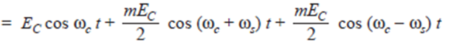
(5 marks)

b. An AM wave is represented by the expression:

v = 14 (1 + 0.65 cos 25120t) sin (5.027 × 10⁶ t) volts

i. What are the minimum and maximum amplitudes of the AM wave?
ii. What frequency components are contained in the modulated wave?
iii. What is the amplitude of each component?
(6 marks)

c. A frequency modulated voltage wave is given by the equation:

e = 18 cos (5 × 10⁸t + 6 sin (3000 t))
Find:
i. The carrier frequency
ii. The signal frequency
iii. The modulation index
iv. The maximum frequency deviation
v. The power dissipated by the FM wave in a 10Ω resistor
- marks)

d. A carrier wave of peak amplitude 30 volts is frequency modulated by a sinusoidal message of peak amplitude 15 volts and frequency 20KHz using an FM modulator with the transfer characteristic shown in figure 1.2. Using this transfer characteristic, determine:

    - The maximum frequency deviation (δF_{C})
    - The modulation index (β)
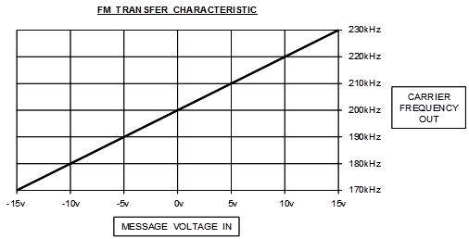

Figure 1.2

    - Use the Bessel Tables in table 1 below to sketch the amplitude spectrum of this FM wave. Label the amplitude and frequency of each component and explain clearly how each value was obtained. Calculate and indicate the bandwidth of the waveform on this spectrum.

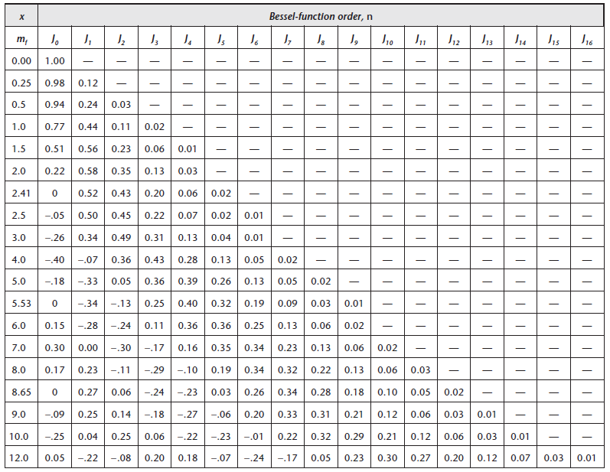

Table 1

(12 marks)

Total Marks for Question B1 = 30

Question B2 – Digital Modulation

a. A speech signal with a value of 4.7Vrms and maximum frequency 3.4KHz is transmitted as a PCM signal using a 10 bit quantiser which covers the voltage range -16 to +16 volts. Calculate:
i. The dynamic range of this system in dB.
ii. The signal-to-quantisation noise ratio for this signal giving the answer in dB.
(6 marks)

b. Explain how a successive approximation ADC works.
(6 marks)

c. With the aid of a transmitter block diagram and a constellation diagram, explain the basic principle of QPSK modulation and explain how it can be achieved by vector addition using 2 bi-phase modulators.
(9 marks)

d. With the aid of a constellation diagram explain the basic principle of carrier modulation by 16-QAM.
(5 marks)

e. Explain what is meant by the terms `quantisation` and ‘quantisation error’.
(4 marks)

Total Marks for Question B2 = 30

Question B3 – Ethernet and the ISO Model

- Using the diagram of the multiplexing structure shown in Figure B3.1, explain how a 2Mbit/s E1 service would be combined onto the STM trunk.

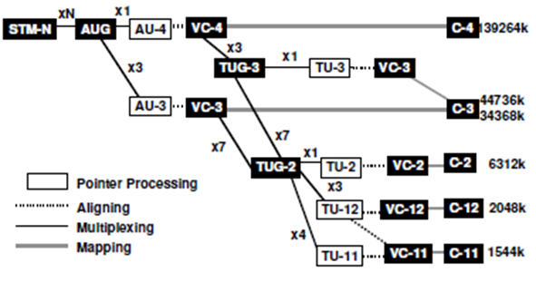
Figure B3.1
(5 marks)

- A 5m length of air-spaced, loss-free 50Ω transmission line is terminated with a complex load of 90 + j40. A 50Ω signal generator, which on open circuit gives a 10Vrms sinusoid at a frequency of 14MHz, is now connected to the input of this line.

i. Calculate the reflection co-efficient for the load end of the line in polar form.
ii. Sketch a vector diagram showing the incident and reflected voltages at the load.
iii. Calculate the load voltage in cartesian form
(14 marks)

- With G = 99, a decoder with CRC receives the following 2 messages and check digits:

Message 567412, check digits 43
Message 985314, check digits 55

In which message must there have been errors?
(3 marks)

- Draw a diagram showing the basic structure of a STM-1 frame.
(4 marks)

- Figure B3.2 shows the path overhead for high and low order virtual containers. Explain what the following low order overheads are used for: V5, J2, N and K4.

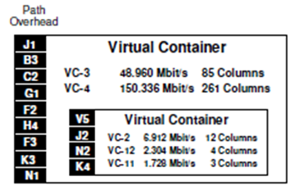
Figure B3.2
(4 marks)

Total Marks for Question B3 = 30

Diwedd/End

