Callum Evans (2116012)

Introduction to web and database concepts
(ACCA4023

Context Diagram
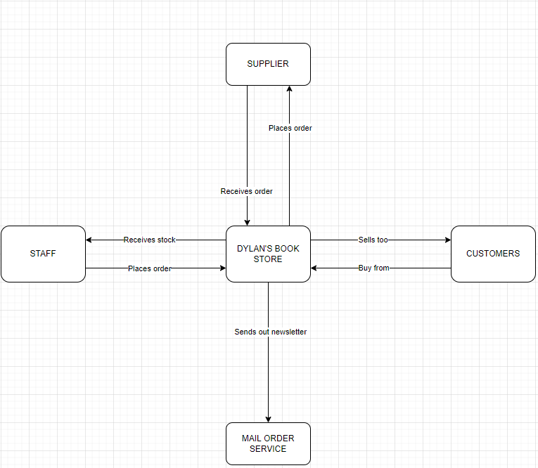
The diagram above is the Context Diagram, this shows what the main areas in the database should be and what each of the entities are and what their actions need to be to continue getting the things done within the Book store. So, looking at the Diagram you can see that Dylan’s bookstore needs to place orders to the supplier then the supplier would send back the required order to the bookstore. Dylan’s bookstore then sells too the customers, and the customers buy from the store. Dylan’s Book Store also sends out newsletters to the customers that have applied for the newsletters. So, Dylan’s Book Store sends the newsletters to the Mail Order Service. Dylan’s Book Store would then give the stock to the Staff so the staff can stock the books in the store. The Staff would let the store know what needs to be ordered.

Level 0 DFD
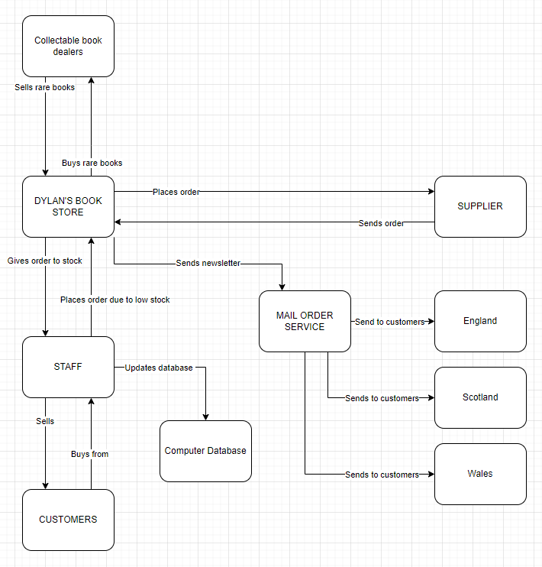
The Level 0 DFD is more complex than the Context Diagram but still very similar to it. The Dataflow diagram is an extension of the context diagram. So, as you can see above added to this diagram is computer database, collectable book dealers, England, Scotland, and Wales. I will be talking about the things added so there isn’t a mostly repeated. So, starting at the start, Dylan’s bookstore would buy rare and limited books from the Collectable book dealers, the Collectable book dealer would then sell and send back the rare books back to Dylan’s bookstore. Then down to staff. When an order or a customer buys a book, they would update the computer database to show quantities levels of each book. So then if the quantity levels are low, they would then tell the store and then order more from the supplier. The store also sends out newsletters to the mail order service that sends to customers around the UK that is signed up.

Entity Relationship Diagram
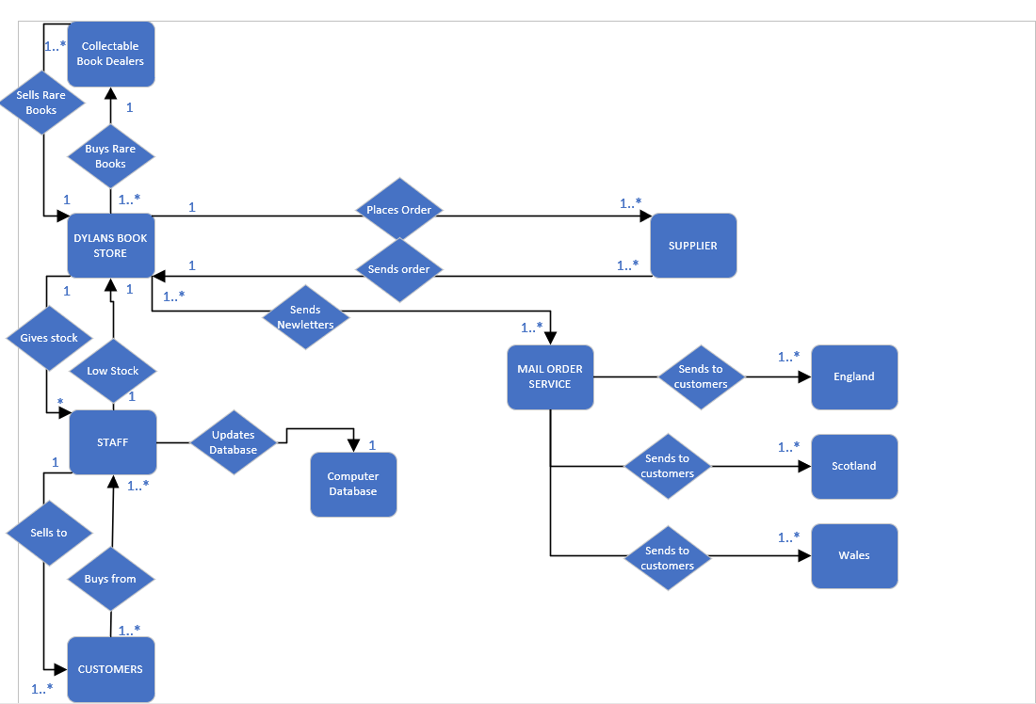

The ERD or Entity Relationship Diagram shows what the Level 0 DFD shows but adds relationship and actions. So, the diamond shapes are actioning the rounded rectangle is the entity. You can also see 1s, *s, or 1..*. So, an example of these being used would be Dylan’s bookstore buys 1..* which mean 1 to many rare books from the 1 collectable book dealer. The Collectable book dealer then sells one to many rare books back to the 1 Book store. Dylan’s bookstore places one to many orders with the supplier and the supplier sends one to many orders to the Book store. Book store send one to many newsletters to many mail order service and the they send the newsletters to many customers in England, Scotland, and Wales. The Book store gives one to many stock to the staff and the staff would give 1 low stock notification to the book store. One staff member sells books to one to many customers and one to many customers buys from one to many staff members.

Report Outcomes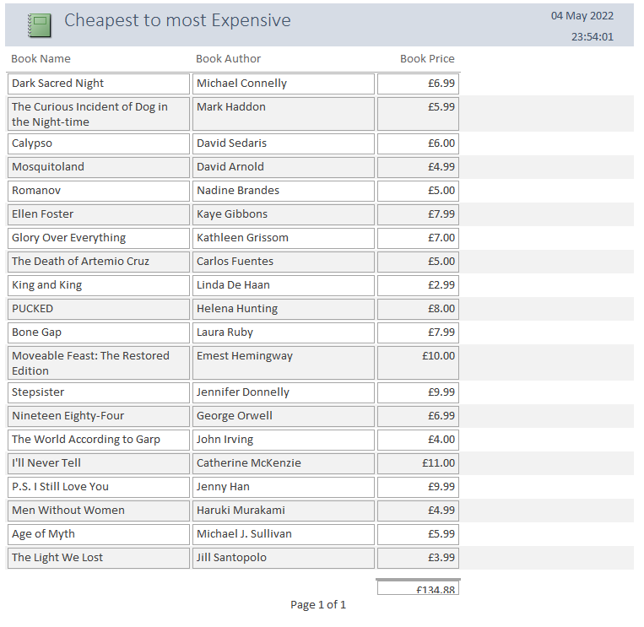
This report shows all books and the price total of each.
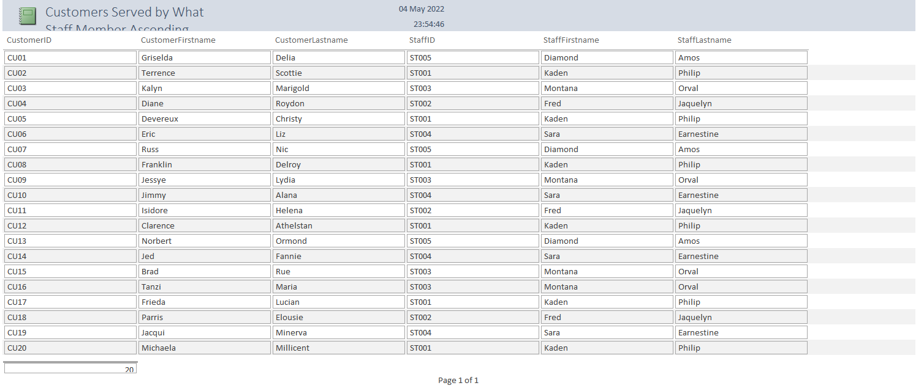
This report shows what staff members served what customers.
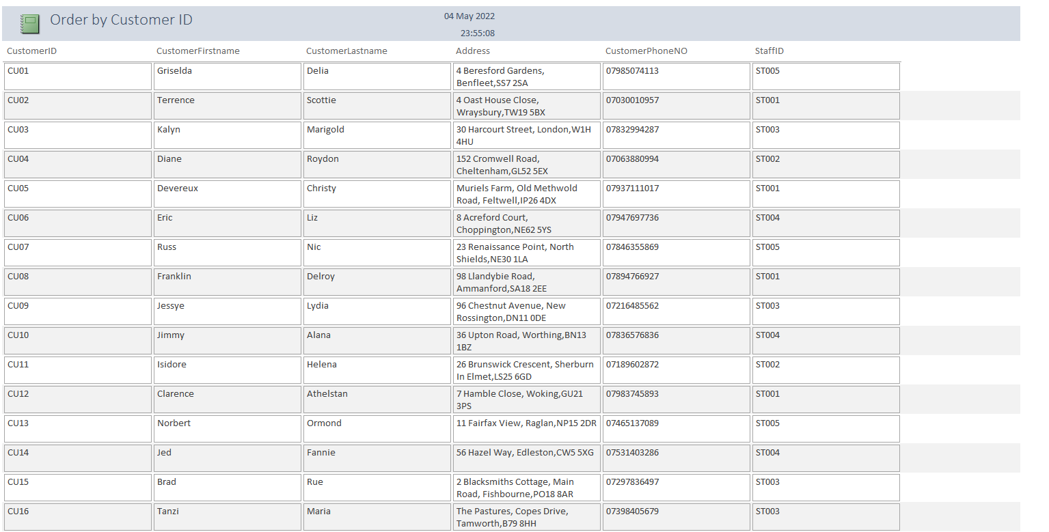
This report shows customers ordered in their ID in ascending order.

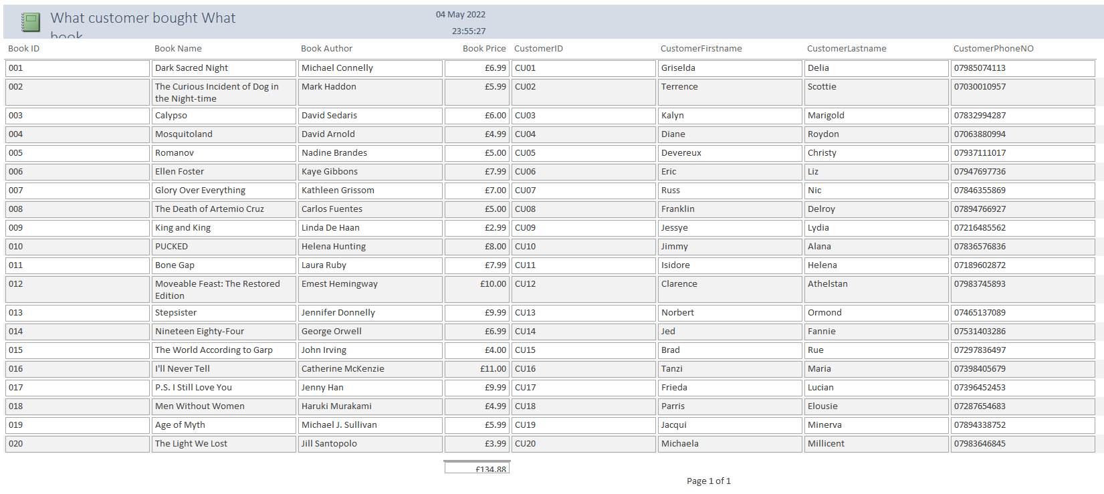
This report shows what customer bought what book. It shows the book name, author, and price.

Forms being used
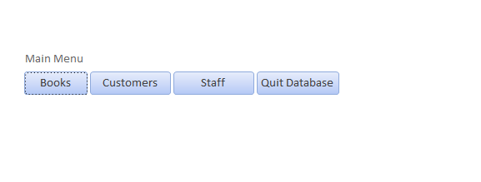
This form is the main menu that has a macro linked to it. The macro opens the form when the database is firstly launched. It allows you to open each of the forms, so when you click books it will open the books form, customers open the customers form and Staff open the staff form. When Quit database is clicked it will close all the database.

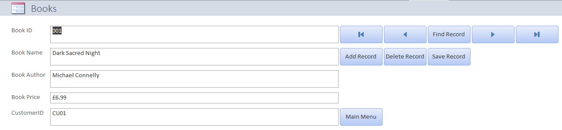
This form shows what books the store has in stock. The button on the right allows the user to navigate through the form. It also allows the user to find a certain record, add a record, delete a record, and save a record added. Then there is a Main Menu button added to allow the user to go back to the menu and either close the database or check other forms.

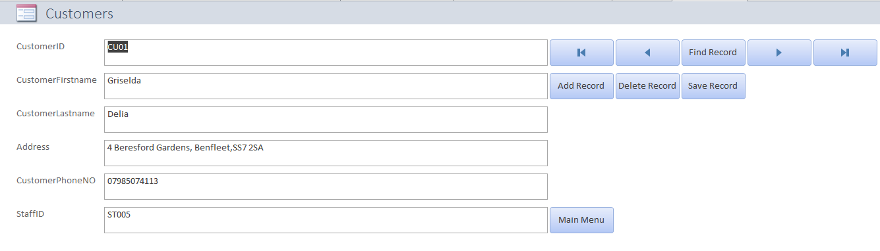
This form shows all the customers that are in the database and shows what staff member has served them. The button on the right allows the user to go to the start of the form, allows you to go to the previous input, allows you to find a certain record you want to, it allows you to go to the next record and skip to the last inputted record. There is a button to add a new record, delete an old record and allows the user to save a record added into the form. Then at the bottom there is a main menu button that allows the user to go back to the main menu to either exit the database or go into another form.
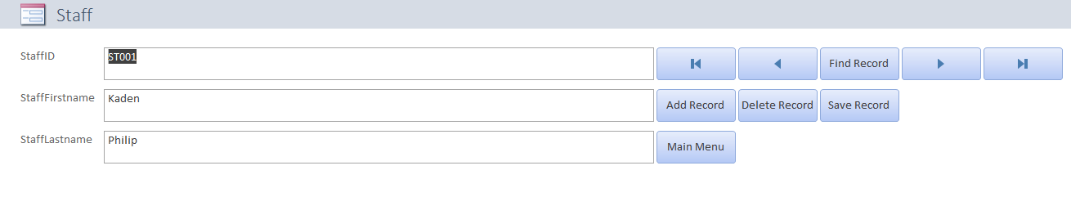
This form shows the staff members that work for the bookstore. The button on the right allows the user to go to the start of the form, allows you to go to the previous input, allows you to find a certain record you want to, it allows you to go to the next record and skip to the last inputted record. There is a button to add a new record, delete an old record and allows the user to save a record added into the form. Then at the bottom there is a main menu button that allows the user to go back to the main menu to either exit the database or go into another form.

