
Assignment Title: Assessment 1
Blogging to communicate
Marketing Fundamentals

Student name: Dan Joita
ID Student: 2124449
Word Count: 1929
Contents
1St blog: Background analysis of McDonald's 3
2nd blog: Products of McDonald's 5
3rd blog: Price of foods in McDonald's in the UK 7
4th blog: Outlets of McDonald's in the UK and the world (Distribution) 9
5th blog: Promotional strategies of McDonald's 11
6th blog: Features of the products of McDonald's 12
7th Blog: Branding strategy of McDonald's in the UK market 14
8th Blog: Advertisement strategy of McDonald's in the UK market 16
Reference 18

1St blog: Background analysis of McDonald's
Today everyone knows that McDonald's is the most reputed fast-food business chain company in the current world. Currently, this fast-food business company is doing business in around 120 countries in the world (Leavy, 2010). The journey of McDonald's started at the hands of two brothers named Dick and Mac Donald. The two brothers opened the first outlet of McDonald's in 1940 in San Bernardino, California, United States. At that time, McDonald's offered only hotdogs to their customers. Day by day, the reputation of McDonald's hotdogs increased due to its excellent test. In 1967, McDonald's launched their outlets in different European countries like Canada, Germany, the UK, etc.
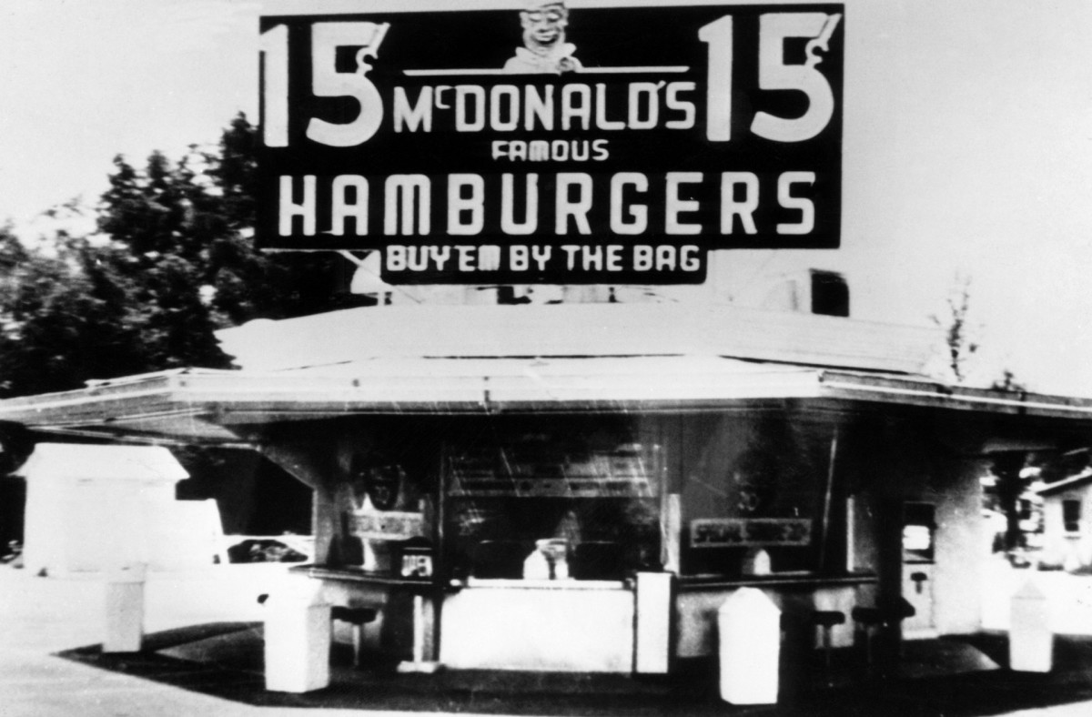

Day by day, their brand value spread over the town. It was the story of 1962, McDonald's offered a big Hamburger along with a hotdog (Korb et al., 2017). So, McDonald's got more acceptance in the eye of their customers. Moreover, the two brothers focused on social marketing to increase the sales of c. Another important strategy of McDonald’s was to provide sponsorships to different reputed companies and international events. Even McDonald's was the main sponsor in the world cup- 1994 and the Olympic world cup-1976.
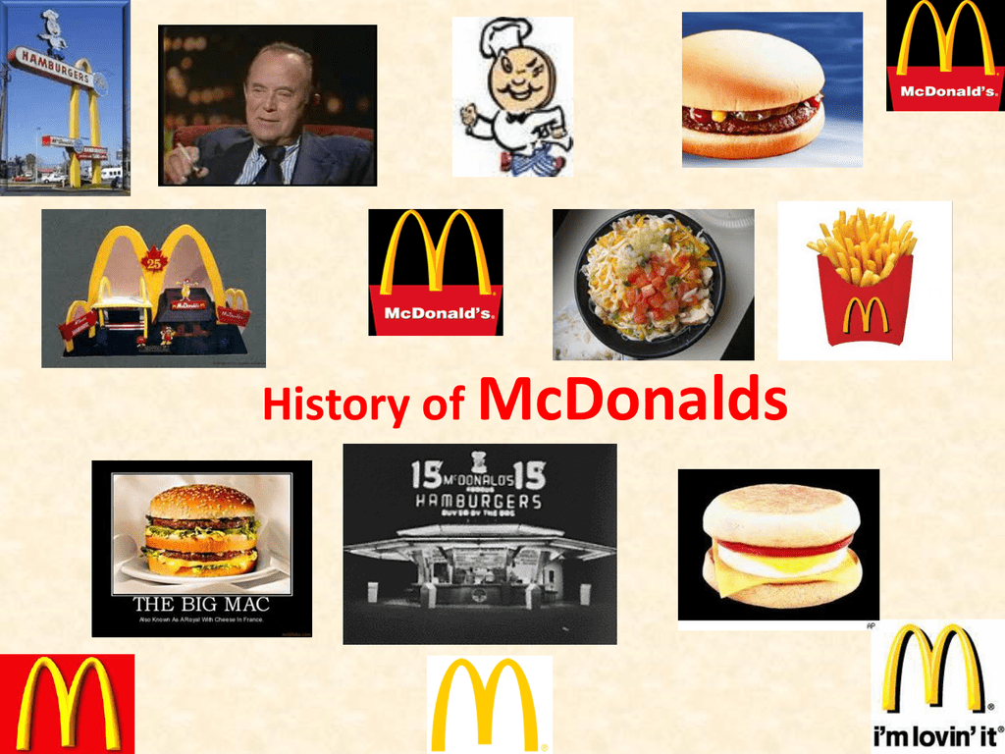

2nd blog: Products of McDonald's
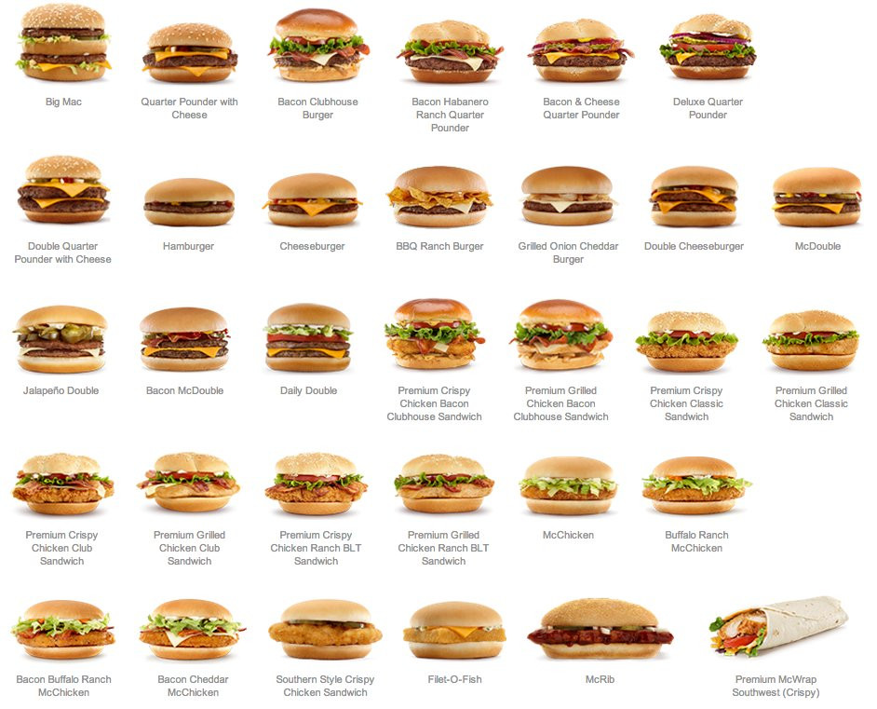

Varieties of food
McDonald's started its business with only Hotdogs and hamburgers. But now, this multination fast food chain company offers different types of burgers which have different sizes and tastes also. Today, the two brothers are not here. But they built a strong brand value for this company. It is seen that McDonald's always makes food items according to the demands of its customers (Rajawat et al., 2020).
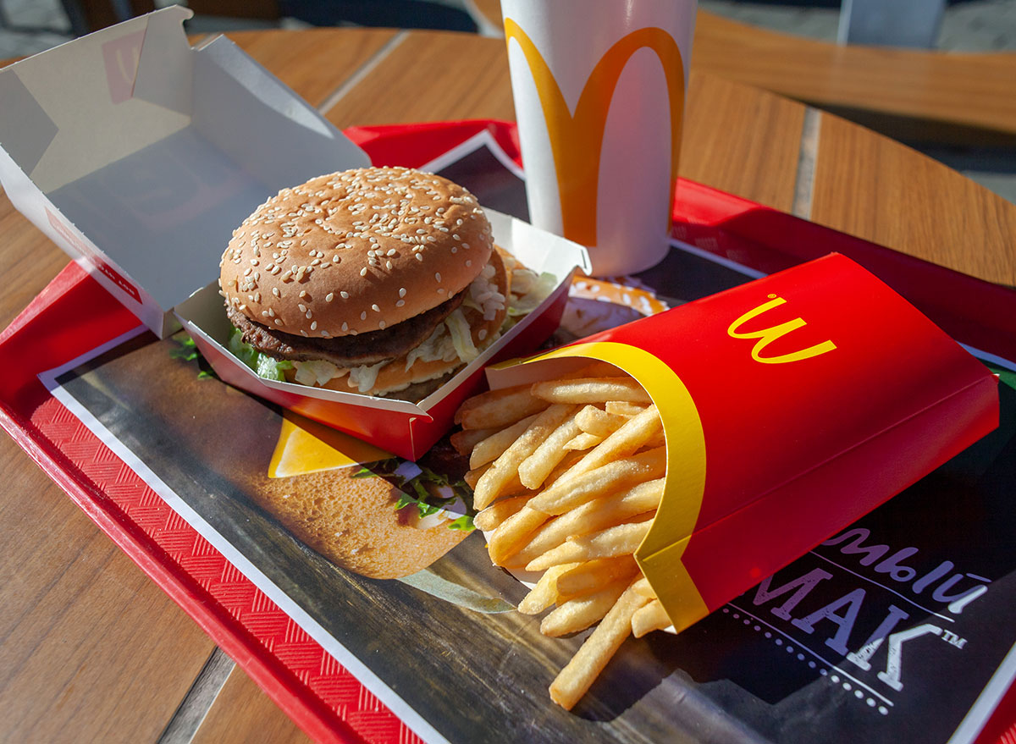

Items that make McDonald's different from its competitors
Different fast-food items such as Cheeseburger, Hamburger, Mini-Burger, Chicken Nuggets, Snack Wraps, French fries, grilled chicken sandwiches, BBQ Chicken sandwich salads, oatmeal, Apple Pie, McRib, etc. McDonald's doesn’t only provide fast food, it also offers different types of processed and packaged food (Scott, 2012). Before preparing food, McDonald's always tries to serve the best food to their customers. That is the reason why McDonald's has become one of the most reputed fast-food companies in the world. The sales of McDonald's are also so high in the UK. People in the UK love to eat McDonald's food. That is the reason why the motto of this company is - " I am loving IT ". The most selling item of McDonald's is its French fry.

3rd blog: Price of foods in McDonald's in the UK

McDonald's is so sensitive about the pricing strategy. McDonald's is so committed to its regular customers. That’s the reason for why McDonald's ensures proper value for money for their foods. The price of each item of McDonald's is comparatively less than its business competitors. That is the reason why McDonald's has good acceptancy in the eye of their customers. The annual revenue of McDonald's is around $23.223B, which is actually 20.9% increase from 2020. McDonald's normally keeps the same price of its every outlet in all around the world (Priyono, 2017).

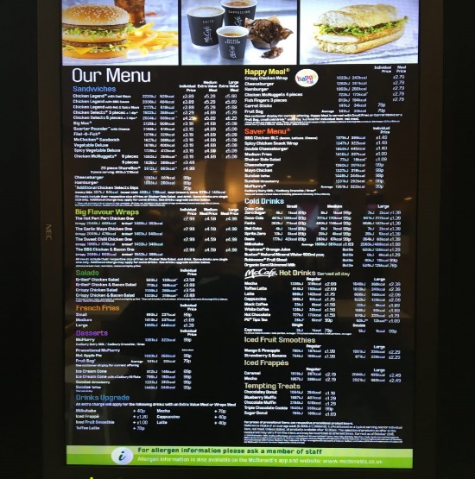

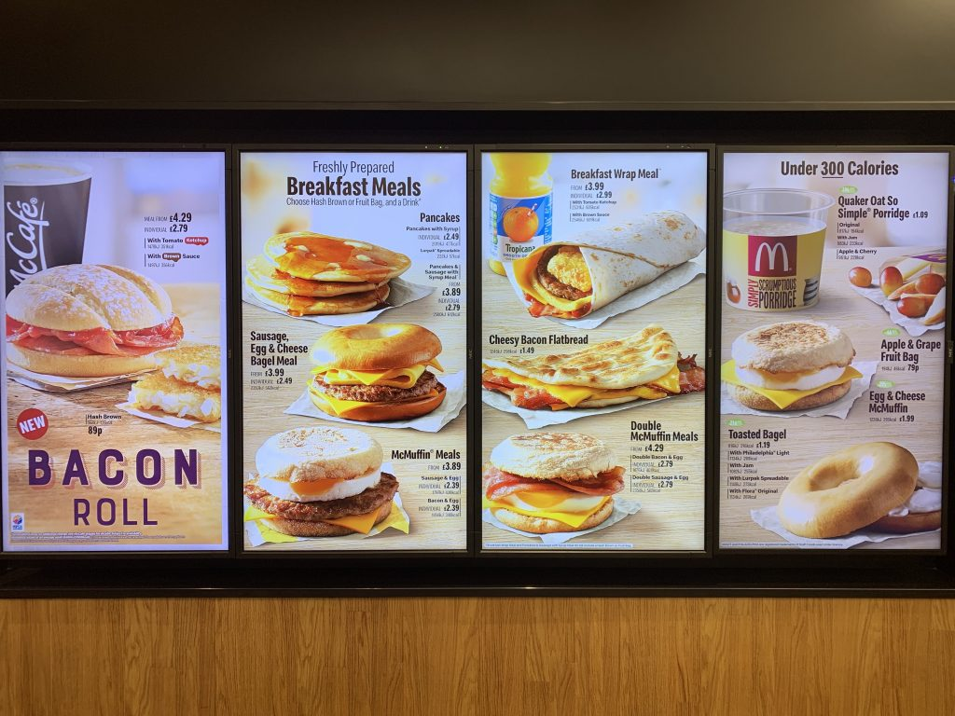

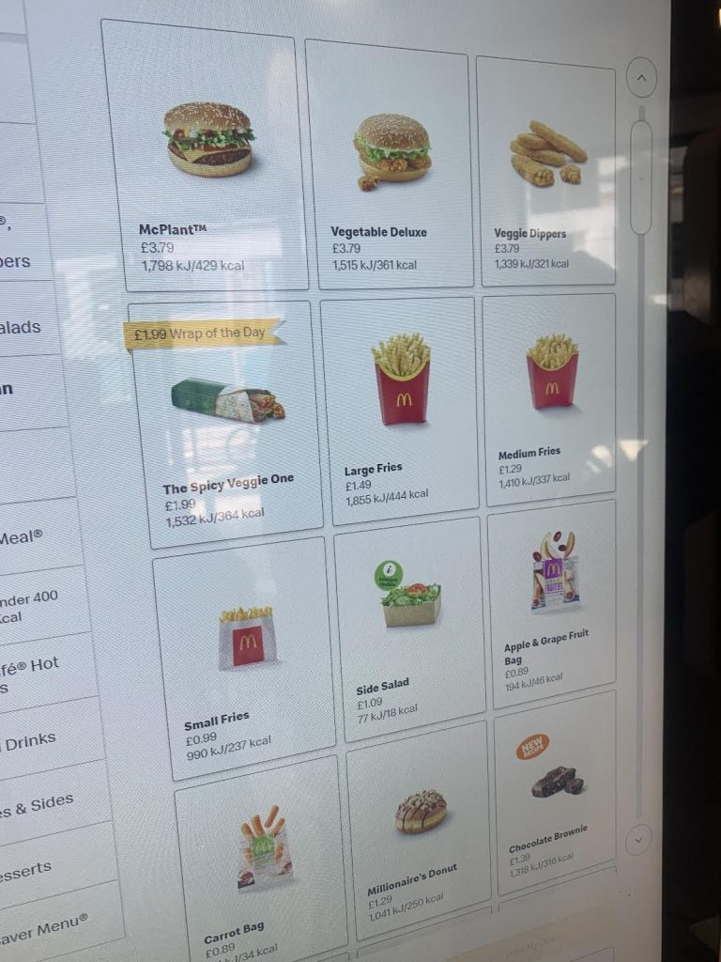

It is seen that McDonald's has a different-priced food menu. The price of Hamburgers at McDonald's is between £0.89 to £1.50. It depends on the size and quality of the Hamburger. The range of price of a McChicken Sandwich is between £3.00 to £5.00. The price of Family size McChicken Sandwich is higher than the regular size. It is early said that McDonald's has reputation for its French- Fry which cost around £0.50 to £0.80. The rate of Big mag is around £5.00. The price of Chicken pieces 3/4/5 is around £4.0/ £6.0 / £7.6 which is an extra big meal.

4th blog: Outlets of McDonald's in the UK and the world (Distribution)
The current condition of the global market
McDonald's is a fast-food business company that mainly provides food from its outlets or its retailer's outlets. In that case, the customers can directly purchase foods from outlets. The foods of McDonald's are sold in around 38000 locations all around the world in around 120 countries in the world. It is seen that around 93% of McDonald's foods are sold by retailers (Crawford et al., 2015). McDonald's heavily depends on retailers in case to sell its food.
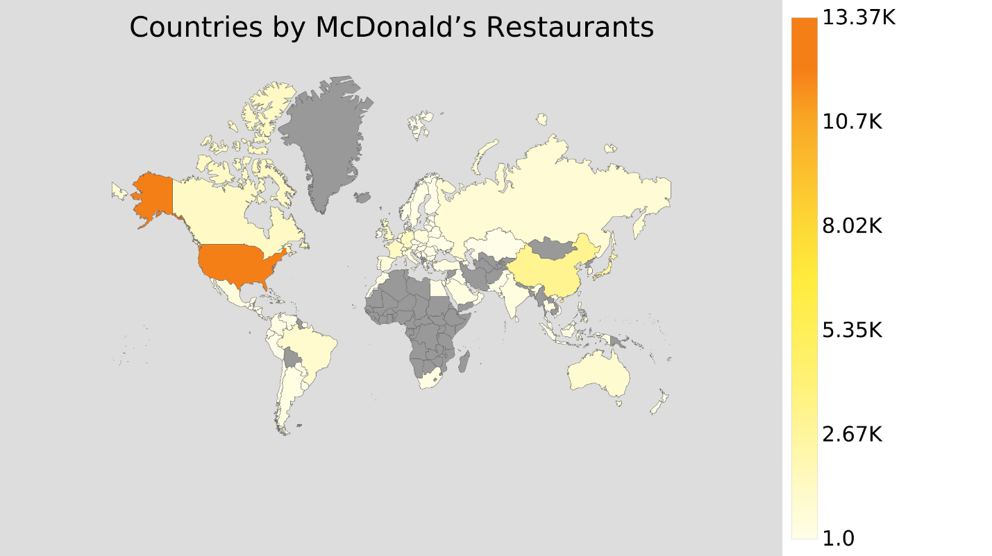

Demands of McDonald's in the UK market
McDonald's has a very good demand in the UK market. That is the reason why McDonald's has around 12800 outlets in the UK market. A good number of employees are currently working in the UK market as a member of McDonald's. Currently, 140000 employees are working in different outlets of McDonald's (Mondhurailingam et al., 2015).
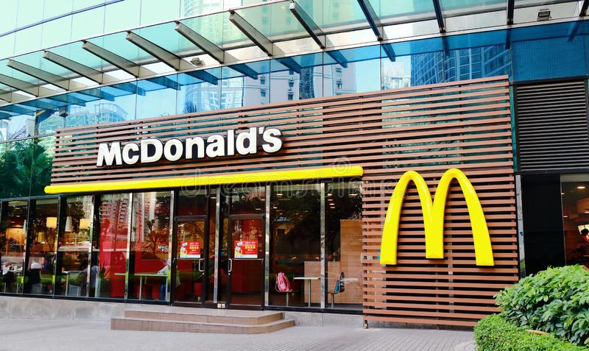
McDonald's also sells its products through online platforms. Customers can easily order their food from McDonald's. McDonald's has a very good delivery system. In that case, the customer must order his food from McDonald's. Then McDonald's prepares the food and sends it to the customer by using several delivery channels. In that case, McDonald's becomes so conscious about the packaging of the food. After getting the packet of food, the customer pays the bill of food to the delivery boy, or he can directly pay McDonald's.

5th blog: Promotional strategies of McDonald's

Like other food business companies, McDonald's is so sensitive about its business promotion and brand value despite being the most successful fast food business company not only in the UK but also in the whole world. For promoting their business, McDonald's uses several online and offline platforms. In the case of the online platform, McDonald's uses its website and social media. Sometimes McDonald's gives some coupons and free offers to attract more customers (Sharma, 2014). McDonald's proposed a franchise as a promotional incentive. It would function by making sales of commodities that would result in stamps for properties that may result in rewards like money, vehicles, vacations, and televisions.
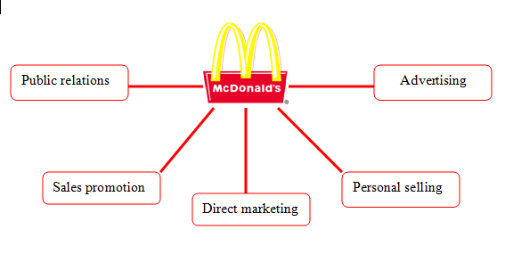

To prevent any possible deception against its clients, McDonald's had implemented excellent pricing techniques in the UK market. There are around 13000 outlets of McDonald's in the UK market. Proper market analysis and pricing strategy is the main reason for capturing targeted customers here. The business advertised its goods and services online and in other media, including TV, radio, movies, and print.

6th blog: Features of the products of McDonald's
Quality of products of McDonald's in UK market
It is early said that McDonald's is sensitive about its customer choice and preference. That is the reason why McDonald's is very selective to select raw materials from their suppliers for preparing foods. In a recent study, consumers claimed that among all of the major fast-food restaurants, McDonald's served the best foods within the best price.
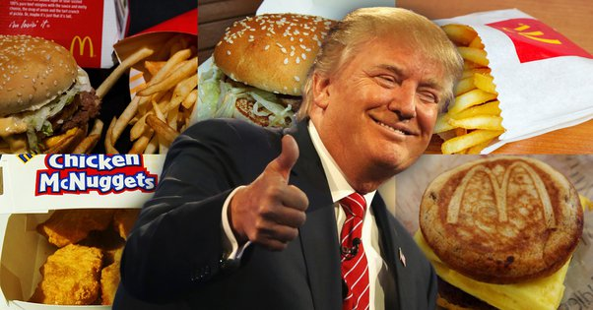
The company came in at number 12 (out of 12) in a study done by RBC Capital Markets, a major international investment firm (Sailesh et al., 2018). The central management of McDonald's claims that- " Because of this, we only utilize premium products, such as 100% beef patties without additives, fillers, or preservatives. Additionally, we use a special selection of crisp, high-quality apples like Gala and Pink Lady. Explore McDonald's ingredients in-depth to learn what makes our cuisine so wonderful". McDonald's builds up a very good relationship with its suppliers. They build a good relationship with the best suppliers to get the best raw materials to make foods. The authority of McDonald's believes that good sale is the outcome of good supplies. All the vegetables, beef, pork, sauce, and other ingredients of McDonald's are fresh and quality full. That is the reason why McDonald's foods have different tastes and qualities.
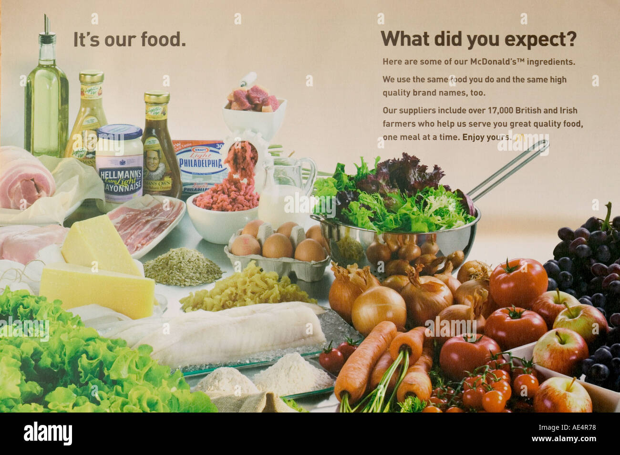
Healthy foods
The foods of McDonald's are called healthy foods since most of their foods are healthier than its competitors. The management team of McDonald's claims that " We are so committed to our customers. We serve food that is healthier for our customers. The rate of calories of every item is mentioned in the food catalog of McDonald's so that the customer may understand this before eating. Statistics showed that around 50% of UK people are suffering from diabetics and cardiac problems (Kee et al., 2020). Especially the rate is incredibly high for the senior citizen. That is the reason why every outlet of McDonald's is so sincere about the products. Moreover, McDonald's sponsor various events on medical events to increase the consciousness of people about their health issue.
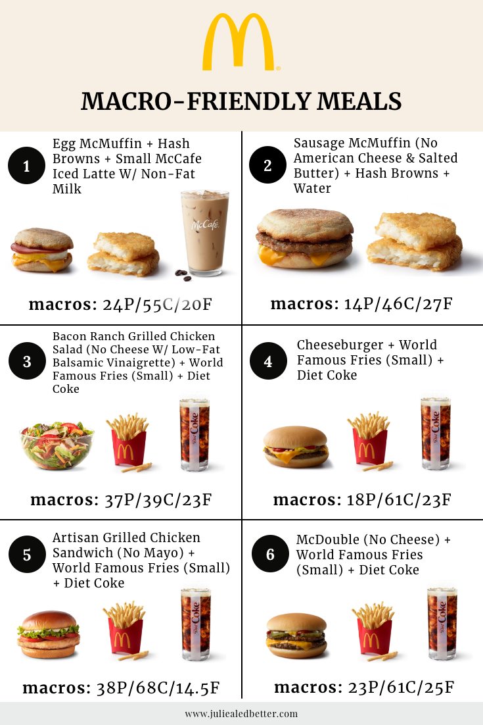

7th Blog: Branding strategy of McDonald's in the UK market

Consistency service and pricing strategy
A strong management team of McDonald's works for increasing the brand value of McDonald's in every local market. In the case of the UK market, the age of most of the customers is between 35-45 (Ceil, 2017). Most of the customers are health conscious. They come to the outlets of McDonald's just because of the quality food. That is the reason why McDonald's offers consistent service and quality food to its customers.
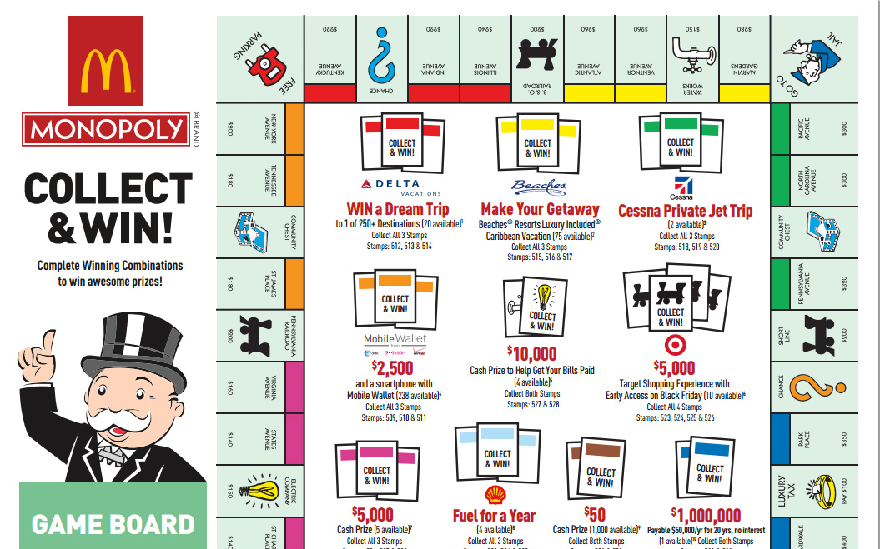

Good market posting and distribution
The management team of McDonald's claims that- " We do our best to satisfy the needs of our customers". The market research team of McDonald's always conducts proper market research. Moreover, all the outlets of McDonald's are located at the center point of the cities so that the customers can get easy access there. McDonald's has around 12000 outlets in the UK market which are mostly located at the main point of different cities in the UK. McDonald's is also so conscious about the distribution strategy of its products. In that case, the customers can purchase food from their restaurant, or they can place an order from a different online app. In that case, McDonald's maintains a good relationship with the retailers since retailers play a big role to increase the sales of McDonald's.
Market expansion strategy
McDonald's believes about the market expansion strategy to increase the brand value. It is early said that McDonald's entered into UK market in 1967. At that time, there were only few outlets in London and Manchester. Day by day, the number of outlets of McDonald's is increased. Now McDonald's has the greatest number of fast-food outlets in UK market. There are around 12000 outlets of McDonald's in all around the UK. Around 35000 employees are working in there.
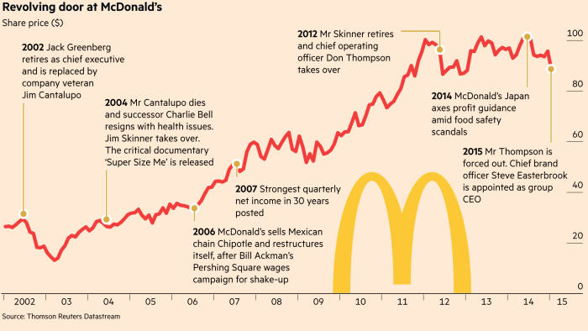
The current mission of McDonald's is to launch around 500 outlets in the UK due to meet the demands of the customers.

8th Blog: Advertisement strategy of McDonald's in the UK market
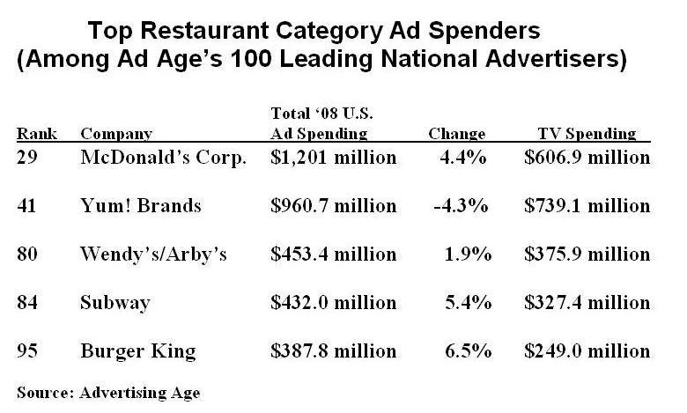
The most notable McDonald's promotion strategy is advertising. The company runs commercials on TV, radio, print, and online media. On the other side, its company's restaurants use sales promotions to entice additional consumers. The authority of McDonald's claims that -"Daily, McDonald's feeds 38 million customers worldwide. Every day, one million Britons dine at McDonald's". McDonald's takes pride in using both conventional and guerrilla marketing techniques to spread its promotional messages to a wide audience as well as to its core clientele. The business spends roughly $2 billion on advertising to run innovative campaigns using various delivery channels. All the delivery channels of McDonald's are so committed to their customers. Different delivery channels deliver the processed foods of McDonald's within a period.
Moreover, McDonald's provides sponsor to various events in UK for their business promotion. Such an example, McDonald's gave a big sponsor for inter- school football championship (Chhabra, 2021). Like this, McDonald's also sponsors in different international events and programs in the UK market to increase its acceptancy.
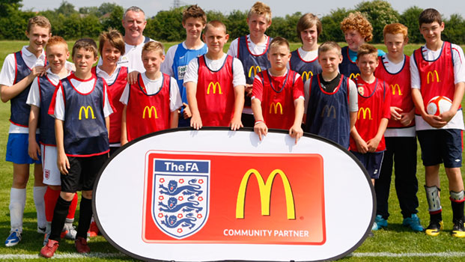


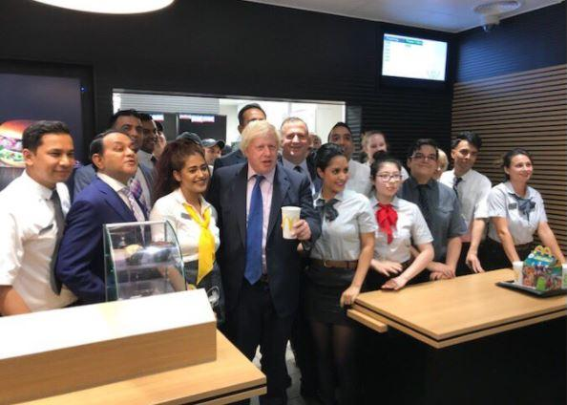

Sometimes McDonald's invites Hollywood celebrities or famous sports persons or even political figures to their outlets. As people consider celebrities as their icons, they follow them everywhere. That is the reason why McDonald's invites them in various cases in their outlets.

Reference
Ceil, C., 2017. Service Quality and Branding Strategies at McDonald's. Available at SSRN 2984100.
Chhabra, N.L. and Sharma, S., 2021. Employer branding: a strategy for improving employer attractiveness. International Journal of Organizational Analysis.
Crawford, A., Humphries, S.A., and Geddy, M.M., 2015. McDonald's: A Case Study in Glocalization. Journal of Global Business Issues, 9(1).
Korb, D., Marzouk, P., Deu, J., Oury, J.F. and Sibony, O., 2017. Effectiveness of elective cervical cerclage according to obstetric history. Journal of Gynecology Obstetrics and Human Reproduction, 46(1), pp.53-59.
Leavy, B., 2010. Design thinking–a new mental model of value innovation. Strategy & leadership.
Mondurailingam, M., Jeyaseelan, V. and Subramani, A.K., 2015. Comparative study on customer satisfaction towards KFC and McDonalds, Chennai. ZENITH International Journal of Multidisciplinary Research, 5(6), pp.50-62.
Priyono, I., 2017. Effect of Quality Products, Services, and Brand on Customer Satisfaction at McDonald's. Journal of Global Economics, 5(2), pp.1-4.
Rajawat, A., Kee, D.M.H., Malik, M.Z.B.A., Yassin, M.A.Q.B.M., Shaffie, M.S.I.B.A., Fuaat, M.H.B., AlDosari, N. and Santoso, M.E.J., 2020. Factors: responsible for McDonald's performance. Journal of the Community Development in Asia (JCDA), 3(2), pp.11-17.
Sailesh, R. and Kumar, N., A Study on Advertisement and Sales Promotion Strategies at Mc McDonald’S & BURGER KING: An empirical study. Journal homepage: www. jr. com ISSN, 2582, p.7421.
Scott, G.J. and Suarez, V., 2012. From Mao to McDonald’s: emerging markets for potatoes and potato products in China 1961–2007. American journal of potato research, 89(3), pp.216-231.
Seo, S. and Jang, S.S., 2013. The roles of brand equity and branding strategy: A study of restaurant food crises. International Journal of Hospitality Management, 34, pp.192-201.
Sharma, N., 2014. A STUDY OF THE MARKETING STRATEGIES OF Mcdonald's (Doctoral dissertation).

