Kinesiology workshop 1
Anthropometric Measurements
Understanding human performance and designing training programmes requires a comprehensive knowledge of the structure and functions of the human body. From the perspective of athletic performance the inter-relationships between the neuro-musculoskeletal systems are paramount.
However, before describing the movement characteristics of the action we must understand the characteristics of the athlete and this often starts with measuring anthropometric characteristics. Whilst not definitive, and where possible these characteristics can be used to monitor growth and training adaptations.
There are a wide range of measuring techniques employed including DEXA scans, underwater weighting, MRI but these are often outside the scope of most personal trainers.
The purpose of this session is to develop your understanding of the physical structure of the skeletal system and to develop robust techniques in taking this measurement.
For protocols see: https://wwwn.cdc.gov/nchs/data/nhanes3/manuals/anthro.pdf
Task 1: Common Anthropometric Measures
Measure | Subject 1 | Subject 2 | Subject 3 | Subject 4
Main activity
Height
Weight
Waist Circumference
Hip Circumference
Arm Girth
Calf Girth
Wrist circumference

Questions: In what ways might this information be useful to a health or fitness consultant?

Calculate:
 |  | Subject 1 | Subject 2 | Subject 3 | Subject 4
BMI (kg/m²) | Wt/ht²
Waist to Hip ratio | Waist/ hip
Waist to height ratio | Waist / ht
Ponderal Index (kg/m³) | Wt/ht³

Task 2: Skinfolds and body fat
The following are the nine anatomical sites (as illustrated in Figure 2) that are most commonly used in the assessment of skinfold thickness:

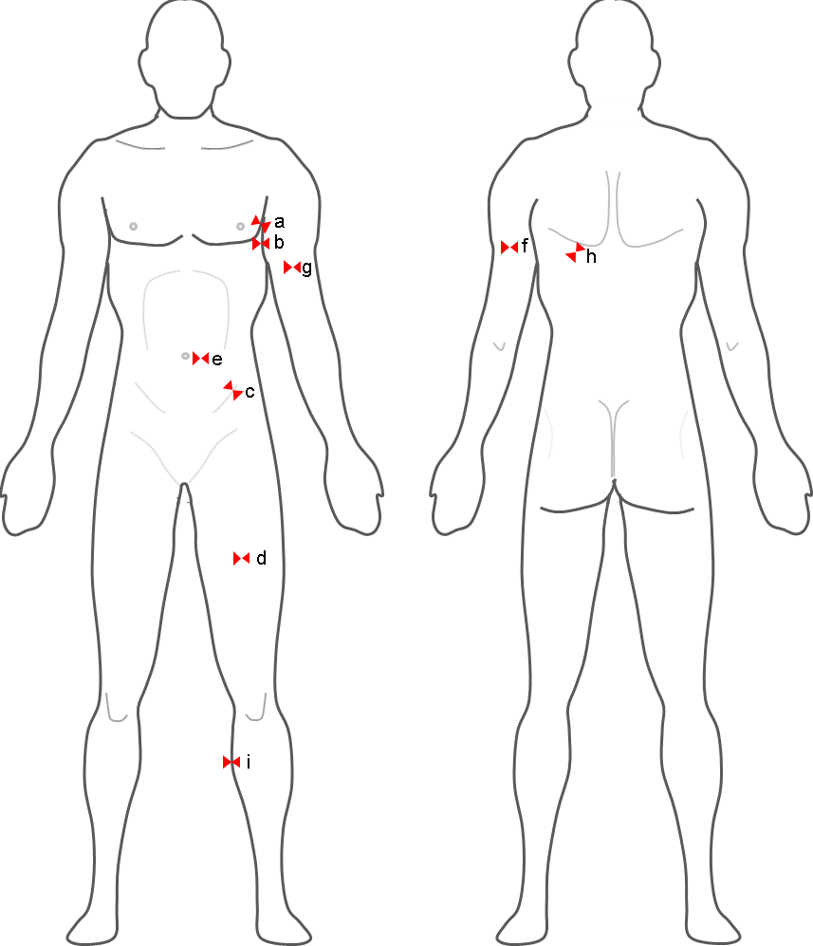
- Chest or pectoral skinfold: For men, get a diagonal fold half way between the armpit and the nipple. In women, a diagonal fold 1/3 of the way from the arm pit to the nipple.
- Mid-Axillary: A vertical fold on the mid-axillary line which runs directly down from the center of the armpit.
- Supra-iliac or flank: A diagonal fold just above the front forward protrusion of the hip bone (just above the iliac crest at the midaxillary line).
- Abdominal: A horizontal fold about 3 cm to the side of the midpoint of the umbilicus and 1 cm below it.
- Quadriceps or mid-thigh: A vertical fold midway between the knee and top of the thigh (between the inguinal crease and the proximal border of the patella).
- Triceps: A vertical fold midway between the acromion process and the olecranon process (elbow).
- Biceps: A vertical pinch mid-biceps at the same level the triceps skinfold was taken.
- Subscapular: A diagonal fold just below the inferior angle of the scapula.
- Medial Calf: The foot is placed flat on an elevated surface with the knee flexed at a 90° angle. A vertical fold taken at the widest point of the calf at the medial (inner) aspect of the calf.
Task 3: Determine body fat by taking the following skinfold measurements (note down only your own values from 3 different people measuring you).
 | Measure 1 | Measure 2 | Measure 3 | Average
Biceps
Triceps
Subscapula
Suprailiac.
% Body fat
Calculate;
Fat Mass
Lean Mass
Weight gain or loss if;
Male (15% fats)
Female (20% fat)

Structure of the skeleton

Axial and Appendicular Skeleton The Spine
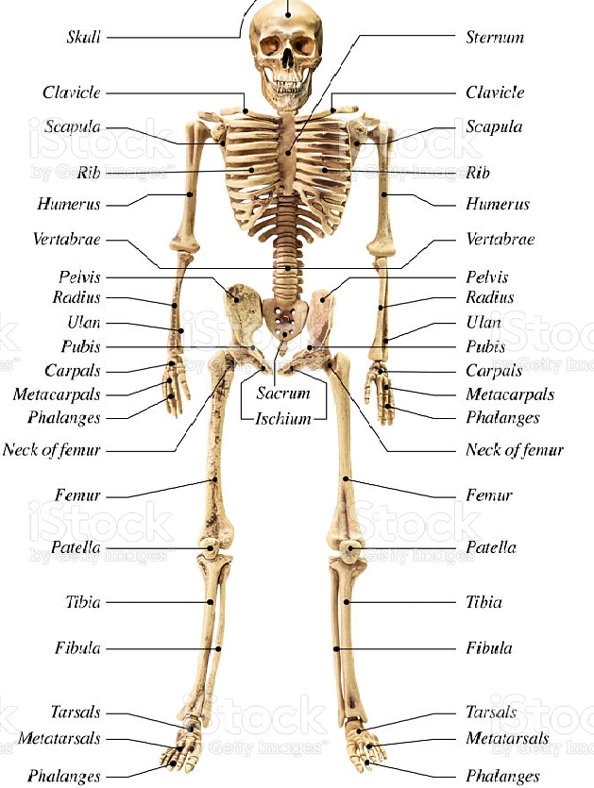
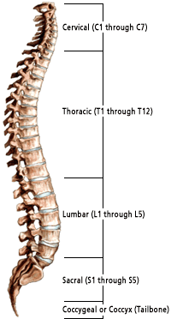

The Bones themselves also have various features that are important for their health as well as locations for articulation, attachments for ligaments and tendon.
Task 4: Learn the names of the bones; Include the regions of the spine, but there is no need for the individual bones of the hands and feet (carpals, metacarpals and phalanges is fine)
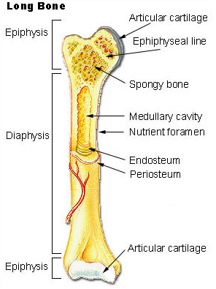
ou will also notice that the bones are not smooth and there are various grooves and lumps on them that all for their various functions.
Task 5: Measure the following Characteristics for your group.
Locate on the skeleton first and transfer to measure on the subject.
Measure | Subject 1 | Subject 2 | Subject 3 | Subject 4
Leg length
(Greater trochanter to lateral malleolus)
Length of femur
(Greater trochanter to lateral condyle)
Knee Height
Length of humerus
(head of humerus to the lateral epicondyle.
Biacromial breadth
Biliac width
Epicondyle width (Humerus)
Condyle width (Femur)
Structure on the bone | Definition
Articular process | A projection that contacts an adjacent bone.
Articulation | The region where adjacent bones contact each other—a joint.
Canal | A long, tunnel-like foramen, usually a passage for notable nerves or blood vessels.
Condyle | A large, rounded articular process.
Crest | A prominent ridge.
Eminence | A relatively small projection or bump.
Epicondyle | A projection near to a condyle but not part of the joint.
Facet | A small, flattened articular surface.
Foramen | An opening through a bone.
Fossa | A broad, shallow depressed area.
Fovea | A small pit on the head of a bone.
Labyrinth | A cavity within a bone.
Line / Ridge | A long, thin projection, often with a rough surface.
Malleolus | One of two specific protuberances of bones in the ankle.
Meatus | A short canal.
Process | A relatively large projection or prominent bump.
Ramus | An arm-like branch off the body of a bone.
Sinus | A cavity within a cranial bone.
Spine | A relatively long, thin projection or bump.
Suture | Articulation between cranial bones.
Trochanter | One of two specific tuberosities located on the femur.
Tuberosity | A projection or bump with a roughened surface.
Tubercle | A projection or bump with a roughened surface, generally smaller than a tuberosity.

Task 6: Worksheet 1 - Bones
What is the study of bones called?
Other than for structure and protection list 4 functions of the skeletal system?

How many bones in the body are freely moveable?
What are bone cells called?
What are cells that deposit bone called?
How many bones comprise the spine?
What are the 5 region s of the spine called, and how many bones in each?

Name 1 and describe the characteristics and functions of a long bone

Name 1 and describe the characteristics and functions of a sesamoid bone?

Name 1 and describe the characteristics and functions of an irregular bone?

Name 1 and describe the characteristics and functions of a short bone?

What occurs at the epiphyseal plate?
What is another name for the shaft of a long bone?
What is the periosteum?
In which structures do you find the blood vessels within a bone?
What is the purpose of canaliculi?
What are the two types of bone called?
What is the function and where would you find bone marrow?

