Understanding and Engaging in the Customer Experience
(BMSK5003_LON)

Lecturer: Tanja Nathan
Student: Ionela-Madalina Saiz (1605699)

August 2018

ALDI – Customer relationship

Contents
I. Introduction 2
II. Understanding Customer Experience 2
Five Core Dimensions of Customer Engagement Value Framework 3
III. A brief history of ALDI 4
a. Key focus: 4
b. ALDI Management System Principles: 5
c. ALDI SWOT Analysis: 6
IV. The Importance of Customer Service 6
Trading Laws and Policies: 7
ALDI Business Principles 7
V. Engaging in Customer Experience 8
ALDI and The Customer 8
VI. Customer Relationship Management 9
Implementing a clear customer experience strategy 11
Recruiting the right people for the right place 11
VII. ALDI Management System 12
VIII. ALDI enterprise system 13
IX. Sustainable business 14
X. Ethical Sourcing Statement 17
XI. Conclusions 18
XII. References 19

Introduction
The above statement will evaluate the relationship between one of the UK most successful discounter, ALDI, and its customers. Customer experience can be defined as the behavior, opinions or other types of feedback, that a customer can provide to a firm through the purchase of goods or services (ALDI, 2017). If we can use a proper tool to introduce my workplace, ALDI, well its very simple “Everyday Amazing” and “Value For The Money," that is what consumers look these days. Also, this paper will outline the background and challenges that ALDI was currently facing to satisfy its customer needs and to keep the leadership position on the market.
Nevertheless, ALDI marketing strategy to attract people to buy their products is we can say ‘a German one’ because a store is a discount one, they still use even more discounts to sell the products that are in danger to be lost due to the expiration date. However, due to globalization and because the world is changing so fast, this retailer is trying to adapt and keep up with the changes, being flexible whit its consumer needs, within the boundaries of course, because always will be a satisfied customer and unsatisfied one you cannot have just happy ones.
But except all these challenges that retailer is facing and a massive scale of competitors such as LIDL another big retailer on the discount supermarket chain market, ALDI managed to survive in the UK and to have a quite impressive success on the market. Furthermore, ALDI keeps its leadership in the market due to its low-cost products and high-quality strategy. ALDI concept ‘the employer is not paying the wages, the customer is paying the wages, the employer is only handling the money,' motivate its employees to look after customers and to provide them the best service.
The staff that they train helps as well on the revenue growth, get them reworded by promoting them at the workplace that makes the employee give his best for the organization and find himself appreciated all this is a win-win for the German retailer. The supply chain that they use is also a solid point they have because they look into sustaining the future by helping farmers to sell their products thing that contributes as well to the country economy.

Understanding Customer Experience
Customer experience can be defined as the behavior, opinions or other types of feedback, that a customer can provide to a firm through the purchase of goods or services. Firms can have a tough task when is about to engage with customers, to derive tangible value out of the interaction firms adopted this idea and had success. Conducting a various approach, such as online surveys, or practical learning tools for schools and colleges, many companies had increased their values and from their activities have raised the cost for their customers as well.
Being engaged in customers activities, firms have allocated many resources, such as time and money, having a primary objective to convert a buyer's propensity to buy a product/service into an actual purchase. Using this method, customers can develop loyalty to a brand or product, and furthermore can influence its future development, by advertising it is using a simple strategy as "word of mouth." Marketers notice this critical factor and start to track customers purchase behavior, to get more information about their perceptions about the product, about their needs, how can be overcome, developed or improved.
Besides, every customer has its specific behavior, and not always firm can relate on identify and differentiate it. Hence, managers continuously alter their marketing strategies depending on customers reactions to their product/services. Furthermore, customers can interact/engage with firms/organizations in a myriad of ways. (ALDI, 2017)

Five Core Dimensions of Customer Engagement Value Framework

Customer Lifetime Value (CLV)
Customer Knowledge Value (CKV)
Customer Referral Value (CRV)
Customer Influence Value (CIV)
Business to Consumer (B2C)
Customer Brand Value (CBC)

Source: Author

Customer Knowledge Value (CKV)
Business to Business (B2B)
Customer Brand Value (CBC)
Business Reference Value (BRV)
Customer Lifetime Value (CLV)
Customer Influence Value (CIV)

Source: Author

A brief history of ALDI
Karl and Anna Albrecht (Siepmann), founded a small off store in Essen-Schoenbeck, situated on the ground floor, while the family lived on the first floor of the building till the 1950s. The chief manager of the business was Anna, and she trained her two sons, Karl and Theo Albrecht to do so in retail trade. The family business had real success and since 1947they decided to expand the business. By 1950s, the two brothers opened around 300 stores across the eastern Ruhr Valley and Aachen. Despite their success in business, they decided to split, and one established his company as ALDI North, and the other one establishes his as ALDI South.
Among time they have changed their stores capacity, moving from a small store without self-service, to new self-service discounted food stores, having as the central principle the ones that we know today, with 400 fast-moving lines of high-quality goods. Being from the beginning a successful business without to compromise their primary focus, the customer with a car, ALDI opened stores with a minimum of 100 car parking spaces.
Motivated by his previous success in Germany, in 1968, Karl Albrecht bought Her Hofer, a chain of supermarkets, and also retained the Hofer name, due to the brand awareness and loyalty. Making his first acquisition in the USA, by buying the Benner Tea Company in 1976, ALDI, opened its first stores in the USA. Also, being successful in the USA, by 2011, ALDI USA had more than 1150 stores across 31 States, 29 Regional Offices including a Corporate Office, and the benefit of significant opportunities for further expansion in the USA.
Birmingham, 1990, ALDI went to open its first store and established a network of over 700 stores nationwide, which are supported by 11 strategically placed Regional Offices and Distribution Centers. At ALDI, the primary focus is the customer service, which is critical for its success, because poor customer service will be the main reason why someone chooses to shop elsewhere. Every ALDI employee is seen as representative of the business and ALDI put a value on this. Offering customers a fantastic customers service opportunity, is called "the super service icon."

Key focus:
- Efficiency -selling products directly from pallets located on the shop floor
- Co-operation
- Clearly defined areas of responsibility
ALDI business approach means that it's discounter retail (selling a small range of items, at lower prices).
Company aims and objectives:
- To increase their competitive advantages by developing an organization that is extraordinarily efficient
- To produce an optimum profit to finance new stores, warehouses, and other facilities essential to their operation
- To provide secure future for all employees
- To keep staffing costs to a minimum
ALDI is pride in having the fastest and friendliest staff in retail with its approach to work "Treat People the way you would like to be treated."

ALDI Management System Principles:
- Clear communication (always keep employees informed and sharing information)
- Giving clear directions about different tasks
- Monitoring the personnel performance and progress, advising how to improve
- Give clear feedback, (ALDI, 2017).
At ALDI is very important that its employee to follow on a daily basis its corporate principles in all situation and with everyone, whether or not they are in a leadership position.
Providing value and quality to their customer by following retailer purpose and values which are: consistency, simplicity, responsibility.

ALDI SWOT Analysis:
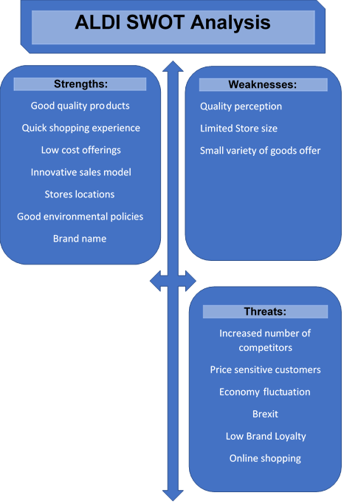

Opportunities:
Customer relationship
Use of innovation and technology
Continued expansion
Increase Brand Loyalty and awareness

Source: Author

The Importance of Customer Service
Customer satisfaction is a critical point for ALDI’s success because without the customers they cannot have a business.
Annually having more than 300 million customers to pass through their doors, which means, on average, that a dedicated Store Employee will serve over 30000 customers.
This means that will be 30000 opportunities to show customers that they are the priority.
Doing so, the Store Employee will offer Friendliest Service, Appearance, Fastest Service.
Operating small stores, give its customers the chance to have their total attention.

The two types of Customers Service:
- Responsive: -resolves issues; -matches expectations; - maintains loyalty.
- Proactive: - drives sales; -exceed expectations; -wins loyalty.
Customer Service Measures
To assess the customer experience in their stores, they have developed a customer feedback program which allows them to know what they get right and what they need to improve the shopping experience for their customers in their stores. ALDI has an online customer satisfaction survey, "Tell ALDI," where the customers have a chance to win prizes ($200). (ALDI, 2017)

Trading Laws and Policies:
- Due Diligence (it’s a legal requirement for Aldi to take all reasonable precautions to avoid a breach of any trading law).
- Health and Hygiene Requirements for Food Handlers
- Trade Description Act
- The Consumer Protection Act
- Weights and Measures
- The Liability and Defective Products Act
- The General Product Safety Regulations
- Sale of Alcohol Laws
- ALDI Challenge 25
- ALDI 60 Day Product Returns Policy
- Produce Date Code Rule

ALDI Business Principles
ALDI as a sustainable business wants to be fair, open and honest in everything that the company does, with customers, suppliers or Government department.
5 Corporate Responsibility Principles:
- Ali Customers – Encouraging families to live well
- Aldi Supply Chain – Investing in Long-Term Relationship
- Aldi Environment – Committed to Sustainable Sourcing
- Aldi People – Giving a fair deal to people
- Aldi Community – Supporting Local Causes
To maintain its business leadership in the markets, for ALDI, as corporate organization, is vital to adopt and manage with responsibility its business principles. For instance, the retailer is promoting and recruiting people according to with its business principles. However, sometimes this process of encouraging people from inside is a real success, sometimes is a failure because the newly promoted managers tend to fail in their position, because of lack of experience, inadequate managerial skills, and business bits of knowledge (ALDI, 2017).

Engaging in Customer Experience
Working daily with incredible, dedicated people to ensure for its customers a fairer procedure between Aldi and its suppliers, also, raising money for great causes, inspiring kids to eat fresh and sourcing sustainable foods. For example, ALDI started partnered with Teenage Cancer Trust and aimed to raise £5 million by 2020. To rich this goal, the retailer needs its employees and customers to come together to make this happen by meeting a life-changing fundraising target (Trust, 2018).
Focused on customers and being involved in different causes support, such as the Government Childhood Obesity Strategy, Aldi, since 2017 removed more than 3000 tons of sugar from a broad range of product, select that one for kids, such as biscuits, jams, marmalades, yogurts, fizzy drinks, juice drinks and peanut butter. Furthermore, since March 2018, had restricted the sale of energy caffeine drinks to under 16s.
Besides, had used a smart idea, based on customer health, and since 2015, had installed Healthier Checkouts, which means at checkout, customers can make a last-minute purchase and choose between dried fruits, nuts, and snacks (ALDI, 2017).

ALDI and The Customer
The Customer is every person who attends to purchase goods or services from a company or organization. An organization cannot exist and develop as a business without its customers. Furthermore, the customer is that one who can influence the way that the company further develop and survive. The marketers were facing challenges in how to manage the organization effectively, to offer the best service and to in touch with the latest technologies and techniques, also to stay aligned with a possible growth and profits. Among time, has been proved that the significant asset for business is its customers.
Today the customer is more knowledgeable and in permanent change, can be more demanding, more profiled, informed and regularly knowing what they want or need. For every business is hard to keep its customers happy and for a long time. ALDI, as a retailer is facing this challenge as well, and always try to focus on customer behavior, needs, and how those needs can be satisfied and how to exceed the customer expectation. At ALDI, every employee is seen as a face for the company, and every employee is responsible for presenting the company in the best way possible.
It, not an easy job to make customers happy, especially for those who work as Store Assistants, Store Managers, they are the most exposed when it is about the face-to-face interaction with the customer. Dealing every day with thousands of people, from different background and with different moods, for these employees every day is a challenge to manage them and to satisfy the needs in the best way possible. Being a Store Assistant and dealing every day with people and trying to listen, to adapt at every one need, to offer the best service possible, to try to remain calm in the most challenging situation, is physically and psychically consuming. Not everyone is coming to the store to buy and beneficiate from excellent service.
Many people are coming to a little chat with somebody, for example, the elderly persons, that ones who don't have anyone to live with them and for them it challenging to find someone else to communicate at their edge. Others are suffering from different health problems and require particular attention to find out what they what and how you can help them. At ALDI, having as a motto "Treat People the way you would like to be treated," makes customers feel important and valuable for the company, and in this manner, the company gained trust in the relationship between ALDI as an organization and its customers (ALDI, 2017).

Source:
Author

Customer Relationship Management
Customer relationship marketing (CRM) can be defined as a business process where organizations build through marketing activities and strategies, relationships with their clients can develop customer loyalty and brand value (Vardhan, 2014).

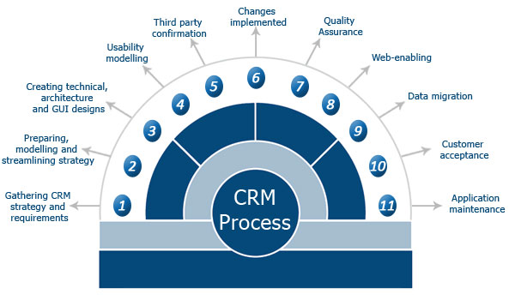
(Quora.com, 2018)
Customer Relationship Management (CRM) is a business strategy to manage and select customers to optimize a long-term value. Using CRM as a comprehensive strategy and process of acquiring, retaining and partnering for selected customers to create superior value for the company.
CRM also provides:
- a means and a method to enhance an individual experience for customers and transform them in customers for life;
- functional and technological means of identifying, capturing and retaining customers;
- A cohesive view of the customer across the enterprise (physic.minimalistics.co, 2018). The organizations tend to have happy customers and try to improve customers service to improve customers level of satisfaction.

Implementing a clear customer experience strategy
The marketers need to apply a clear plan and to make the difference between a "slogan" and a policy.
Main keys to implementing a clear customer experience strategy:
- A good understanding of the overall organizational visions and missions
- Organization's well-established customer service path, slogan, and values
- Main-focus on the responsibility of customer service for every department/business
- Using a comprehensive communication program to share the customer experience strategy
- Guarantee that this approach does not conflict with added business policies. Today’s we can see the presence of a sharp dichotomy in many organizations who declare that for them the main priority is to improve the customer's service, and, they are introducing stringent cost-cutting measures (Nash, 2014).

Recruiting the right people for the right place
For many companies, the recruiting process is taking place in the old way and tends to concentrate more on the functional expertise, technical competence, and knowledge rather than interpersonal skills. Missing the main point, the attitude, which a lack of it can drastically impact client satisfaction levels. However, the researches among time proved that the most critical requirement is the attitude, and functional expertise and skills are the ones who can be taught.
Therefore, in selecting the right people, according to with Nash (2014), it's critical to define the job requirements, to implement and develop differently based- scenarios assessment/interviews centers to screen and select candidates. Furthermore, to start involving more staff members in the recruiting process and to ensure an objective evaluation, not a subjective one such as "Be Like Me" (Nash, 2014).
For ALDI, the recruiting process is based on matching its business principles, furthermore, the retailer is recruiting its peoples accordingly. The company tends to promote insiders rather than hiring, assuming that sometimes this process has its advantages and disadvantages. For example, new managers, freshly supported, prove it lack-of managerial skills, vital for their position, such as communication skills, leading skills and business pieces of knowledge. For some of them, once they get a new position, they forget the company basic principles and ethics and start to run the business on their own. This is bringing between employee frustration and incapacity of co-operation with these types of managers.

ALDI Management System
The management system can be defined as tested and documented accurate methods specially developed to assure efficiency through standard practices. Management system could contain information about organizational management, corporate policies, accountability, quality control procedures, employees training, supply chain and trade fair policies, distribution and marketing (BusinessDictionary, 2018).
ALDI Management System is a continuous process based on its beliefs and values, that the organization developed over time, which is used to illustrate and guidelines its organization and management style.
The Company management system is written for all its employees and must be followed by everyone, whether or not they have leadership responsibilities. ALDI encourage all employees to follow in a daily-bases the company principle and cooperative leadership management systems and to take ownership of their role. It is all about Company values and quality that they provide to customers by freest and efficiency (ALDI, 2017).

Regional Managing Director
Finance Administration Director
Logistics Director
Trading Director
Property Directors
Store Operations Directions
Health &Safety Manager
Property Managers
Logistics Section Managers
Quality Control Leader
Store Management
Logistic Section Leaders
Administrations Assistants
Quality Control Assistants
Trading Assistants
Store Employees
Property Assistant
Logistics Employees

Area Managers

Source: Author

ALDI enterprise system
An enterprise system can be defined as a packaged application who support, processes, manage and automate business data. One of its characteristics is complexity, which means that the enterprise system is a complicated process based on customized modules specific to every business (Gulla, 2004). ALDI is vital to have an enterprise system to be able to manage and run the business.
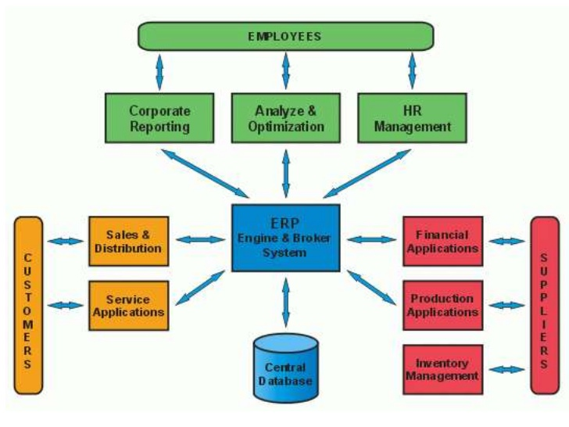
(Anon., 2018)

Sustainable business
Sustainability is based on three main factors which include environmental, economic longevity and social items, who can assure the existence of a firm on the market. Pollution raised critical level worldwide, and environmental initiatives are required, such as ISO 14000 certification, pollution prevention, recycling of materials, waste reduction and sustainable forms of energy (Schoenherr, 2012).
"Sustainable development is a development that meets the needs of the present without compromising the ability of future generations to meet their own needs" (The Bruntland Report, 1987). Furthermore, sustainable development requires addressing a series of issues to measure innovation and its connection to identify business performance. At ALDI, sustainable development is an essential element, and the company is investing a considerable amount of resources in innovation and sustainable development.
The United Nations (UN) had nothing not as much as this ambitious goal at the top of the priority list when it embraced the Agenda 2030 for Sustainable Development in September 2015. The motivation incorporates 17 Sustainable Development Goals intended to understand humankind's most squeezing challenges, for example, battling neediness and appetite, diminishing imbalance and stopping environmental change.
To guarantee that these objectives are met, everybody needs to cooperate which mean that global companies have to come together, to unify their strengths to reduce pollution, to promote responsible consumption and productions patterns. ALDI decisions to sustain those efforts have profound implications among the entire value chain, wherever is about sustainability actions or improvements (North, 2017).
Purchasing quality and Corporate Responsibility (CR) – preestablished sustainable requirements by respecting their suppliers and their production facilities, such as:
- Decent work and economic growth – to include, promote and sustain economic growth, full and productive employment and decent work for everyone;
- Responsible production and consumption – to ensure sustainable consumption and production patterns
- Life below water – to conserve and sustainably use the oceans, seas and marine resources for sustainable development;
- Life on land – to protect, restore and promote sustainable use of terrestrial ecosystems, sustainably manage forests, combat desertification, and halt and reverse land degradation and halt biodiversity loss;
- Partnership for the goals - Strengthen the means of implementation and revitalize the global organization for sustainable development (North, 2017).
Cultivation and production:
- Zero hunger - End hunger, accomplish nourishment security and enhanced sustenance and advance maintainable farming;
- Clean water and sanitation - Guarantee accessibility and supportable administration of water and sanitation for all;
- Decent work and economic growth - Advance supported, comprehensive and feasible financial development, full and profitable business and fair work for all;
- Responsible consumption and production - Guarantee economic sustainability and production designs;
- Life below water – Save and reasonably utilize the seas, oceans and marine assets for manageable improvement;
- Life on land - Secure, reestablish and advance the sustainable utilization of earthbound biological systems, economically oversee woods, battle desertification, and stop and switch arrive debasement and end biodiversity misfortune;
- Partnership for the goals - Reinforce the methods for using and revive the worldwide association for economic advancement (North, 2017).
Warehousing and logistics:
- Climate action – Urgent actions required to reduce climate change and its impacts;
- Life on land - Ensure, reestablish and advance the reasonable utilization of natural biological communities, economically oversee woodlands, battle desertification, and end and turn around arrive debasement and end biodiversity misfortune (North, 2017).
Stores and employees:
- Zero hunger;
- Decent work and economic growth;
- Responsible consumption and production;
- Climate action.
Customers and sales:
- Responsible consumption and production (North, 2017)
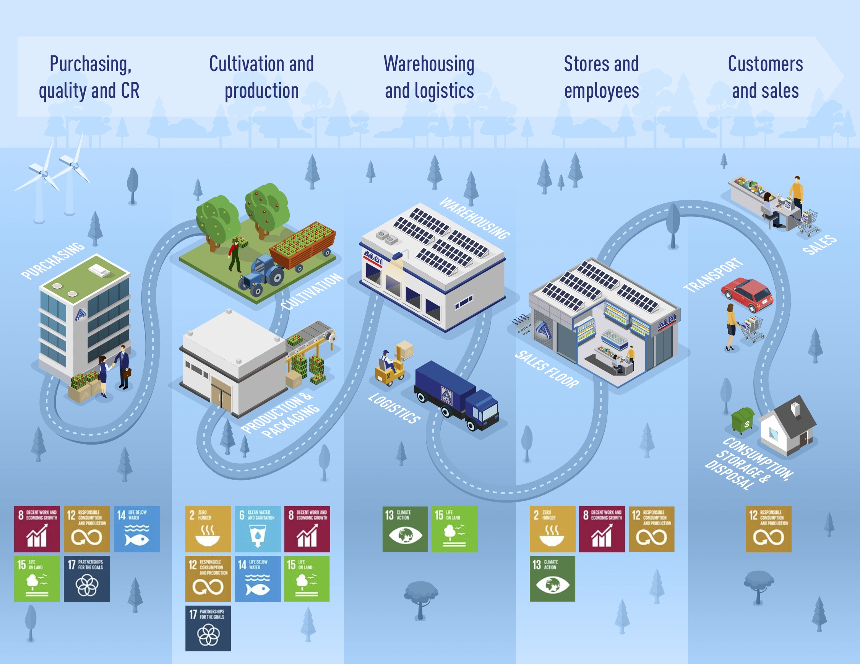
(North, 2017)

Ethical Sourcing Statement
ALDI requires from its suppliers to enhance their ethical sourcing practices, an organization having as the primary focus on social responsibility. ALDI CSR managers had carried out sessions with their suppliers to outline how important is for the company to source programs and audits regimes. For example, have been established new rules, benchmarks changes, and systems all within the new timetable framework. Aldi suppliers have to be part of an international ethical sourcing group, to have their audit for their supply chain and manufacturing operations.
Company suppliers also must to have internal ethical sourcing policies and share accepted third-party audits. If Company's supplier's breach of good retailer benchmarks, the company reserve its rights to suspend or to terminate its relationship with that respective suppliers. Furthermore, the retailer focusses on providing low cost of healthy food, maintaining at the same time its leadership position on the market (Whitehead, 2017).
ALDI set up a Social Monitoring Programme (SMP) who include improving working conditions, production facilities, and sites used in the manufacturing process for Aldi products. This program focusses more on suppliers from countries with lower social and environmental standards than the UK. Aldi Social Monitoring Programme compliance scheme or certifications:
- Business Social Compliance Initiative (BSCI)
- Supplier Ethical Data Exchange (Sedex)
- International Council of Toy Industries (ICTI)
- SA8000 (Independent social compliance certification)
- Electronic Industry Citizenship Coalition (EICC)
To verify if their suppliers are meeting Aldi ethical requirements, are carried on these audits by independent third-party organizations. Remediation of issues is sorted out on a case-by-case premise, dependent on various variables including the seriousness of the problem, advance against Corrective Action Plan and the readiness of the provider and generation office to work mutually towards change.
In 2013, ALDI sponsored a program, called Stronger Together, a collective initiative which aims to train businesses with the information and capitals to tackle the issues of labor exploitation, human trafficking and modern slavery in global supply chains. This workshop seeks to identify any misuse of the human rights worldwide on the retail sector. Also, having agreed ‘Common Principles,' the retailer expects from its supply chain partners to act consequently under the Modern Slavery Act and to report any labor exploitation (ALDI.com, 2018).
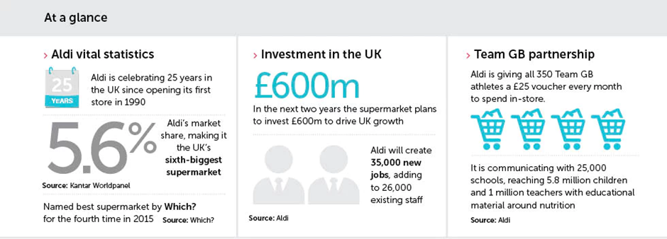
(Anon., 2018)

Conclusions

ALDI stores and supermarkets are offering high-quality products at low prices, and its target is everyone where cheaper groceries has influence and where people tend to choose ALDI rather than significant competitors. Its leadership position on the market comes from its low costs business strategy which is not relying on the past success of the company and always focus on finding and improving its competitive advantages.
The company is offering ample opportunities, and not only for its customers, for its employees as well. People tend to choose ALDI not just for low prices but for excellent quality for the money they pay. Furthermore, ALDI was awarded many times as the friendliest supermarket in the UK, which means that people chose it for the best service quality that they receive even if they shop in-store or online.
Finally, this paper will conclude with a reflection on what ALDI as a discounter can do for future growth and to improve customer relationship. In my opinion, ALDI can achieve this by relying on factors as obtaining the leadership in organic offers via marketing and in-store offers; to open new stores in central areas, to update its in-store technology, to invest more resources in training and customer service development.

References
ALDI.com, 2018. www.aldi.co.uk. [Online]
Available at: https://www.aldi.co.uk/about-aldi/corporate-responsibility/suppliers/monitoring-our-suppliers
[Accessed 24 August 2018].
ALDI, 2017. Aldi Handbook. 2017 ed. U.K.: FSC.
ALDI, 2017. Store Employee Workbook. September ed. UK: FSC.
Anon., 2018. www.google.co.uk. [Online]
Available at: https://www.google.co.uk/search?rlz=1C1AVFC_enGB793GB793&biw=1366&bih=662&tbm=isch&sa=1&ei=D1GGW6WNK4PKgAbhtaaYCQ&q=aldi+enterprise+system&oq=aldi+enterprise+system&gs_l=img.12...0.0.0.163653.0.0.0.0.0.0.0.0..0.0....0...1c..64.img..0.0.0....0.jPTZk9xirhI#
[Accessed 28 August 2018].
Anon., 2018. www.google.co.uk. [Online]
Available at: https://www.google.co.uk/search?q=aldi+supply+chain&rlz=1C1AVFC_enGB793GB793&source=lnms&tbm=isch&sa=X&ved=0ahUKEwjZ5tOhnoDdAhXKOcAKHeKwDyEQ_AUICigB&biw=1366&bih=613#imgrc=zBfnC8toP_TegM:
[Accessed 23 August 2018].
BusinessDictionary, 2018. www.businessdictionary.com. [Online]
Available at: http://www.businessdictionary.com/definition/management-system.html
[Accessed 24 August 2018].
Gulla, J. A., 2004. Introduction to Enterprise Systems, Norway: Norwegian University of Science and Technology.
Nash, S. &. D., 2014. blogspot.com. [Online]
Available at: http://preethishri.blogspot.com/2014/08/customer-relationship-management-6.html
[Accessed 28 July 2018].
North, A., 2017. www.cr-aldinord.com. [Online]
Available at: https://www.cr-aldinord.com/2017/sustainability-report/highlights/sdgs-and-supply-chain/
[Accessed 24 August 2018].
physic.minimalistics.co, 2018. physic.minimalistics.co. [Online]
Available at: https://www.google.co.uk/search?q=customer+relationship+management+definition&rlz=1C1AVFC_enGB793GB793&tbm=isch&source=iu&ictx=1&fir=5VC-H66Oil1-nM%253A%252C0nFyTL0sqpi2iM%252C_&usg=__WRqHt7RlWc_69RKhGYTzrHcfV7Q%3D&sa=X&ved=2ahUKEwiDpIS4lb_cAhUEa8AKHZ1KDx
[Accessed 27 July 2018].
Quora.com, 2018. Quora.com. [Online]
Available at: https://www.google.co.uk/search?q=crm+process&rlz=1C1AVFC_enGB793GB793&source=lnms&tbm=isch&sa=X&ved=0ahUKEwip65TF0oXdAhXLK8AKHWLuB0EQ_AUICigB&biw=613&bih=634#imgrc=4uQb-mDeTjTW9M:
[Accessed 22 August 2018].
Schoenherr, T., 2012. The role of environmental management in sustainable business development: A multi-country investigation. International Journal of Production Economics, 140(1), pp. 116-128.
Trust, T. C., 2018. ALDI, England & Wales: Fundraising Regulator.
Vardahan, H., 2014. blogspot.com. [Online]
Available at: http://preethishri.blogspot.com/2014/08/crm-process.html
[Accessed 28 July 2018].
Vardhan, H., 2014. blogspot.com. [Online]
Available at: http://preethishri.blogspot.com/2014/08/real-meaning-of-crm.html
[Accessed 27 July 2018].
Whitehead, R., 2017. navigator-asia.com. [Online]
Available at: https://www.foodnavigator-asia.com/Article/2017/09/13/Suppliers-must-expand-ethical-sourcing-to-avoid-Aldi-sanctions
[Accessed 24 August 2018].
World Commission on Environment and Development (1987). Our Common Future. Oxford University Press

