Alina-Valeria Buzuloiu
2029963

Assessment 1
Blogging to communicate

LCBB4004
Marketing Fundamentals

Lecturer: Tushara Balendran

June 2022

CONTENTS
Introduction……………………………………………………………………. 3
History of a brand ………………………………………………………...…… 4
The Community fair trade program……………………………………………. 6
Overcoming negative impact and loss of customers ………………………….. 8
Return, Recycle, Repeat scheme………………………………………………. 9
The Body Shop marketing strategies …………………………………………. 10
Going vegan …………………………………………………………………… 11
References ……………………………………………………………………… 12

INTRODUCTION

In essence, morally responsible consumers have always existed, but three new forces have entered the picture. As people get older, they become more ethical, environmentally conscious, and socially progressive than previous generations.
More and more people are becoming aware about the existential crisis our world is facing today. The environment is polluted, biodiversity is struggling with species at the brink of extinction, and global inequalities are showing a rapid growth, and acute economical crisis that is affecting everybody.
In the actual context, when consumers are making more conscientious choices when buying products, markets and suppliers are developing new ways and products to align with the trends of sustainability and climate friendly politics.
Cosmetics industry has seen major changes driven by consumers trends within the last decades, from banning animals testing, developing recyclable packages or biodegradable ones, using of natural certified ingredients, in an effort to reduce their impact on environment.
The Body Shop was among the pioneer companies that advocated for cosmetics that are not only benefiting its clients but also the environment, and they continued this trend throughout their existence, since its humble beginnings in a small shop, and continue to do so by developing new projects and campaigns to inform and raise awareness over the current environmental issues.
Since it was foundation, The Body shop addressed a niche market in cosmetic industry by creating products using natural ingredients, engaging communities around the world to help reduce poverty, addressing social issues by campaigning against HIV, domestic abuse and help protecting environment, as well as encouraging its clients to accept their natural beauty.
The following posts will show how The Body Shop evolved from a small shop to a worldwide company, how it influenced markets, campaigns that had a positive impact on society, how it overcame difficulties and how it continues to be a leading brand in sustainable affordable cosmetics, as well as how it ensures loyalty from its clients.

HISTORY OF A BRAND
“There is no power on Earth apart from business capable of making the changes we desperately need for the continued survival of the planet… Businesses have to put justice and sustainability at the heart of what they do.” - Anita Roddick, founder of The Body Shop. (Anita Roddick, 2008)
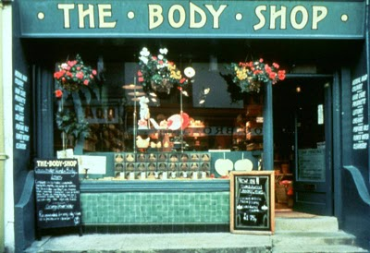
The first Body Shop store opened in 1976 as a tiny, green-painted shop on the streets of Brighton, England. It’s founder, Anita Roddick, was a human rights activist and environmental campaigner and she started by creating 15 skincare products from natural, exotic, ingredients in her own house, infused with environmental and social responsibility. She packaged them in recyclable urine sample bottles because she got them for free from a nearby hospital, each bottle being labelled manually. Despite being hand-made, and hand-mixed, they received a lot of attention.
Compared to the major brands in the beauty industry, it had a very different approach on beauty. Simple ingredients from all over the world were ethically sourced and natural, and then mixed in uncomplicated packaging that was easy to refill, creating products and beauty treatments for all body types that let women feel beautiful on their own terms, without promising spectacular transformations.
Since it first opened, it has had rapid expansion, and in 1987, she acquired the "Body Shop" name rights (Haake and Seuring 284-294). Even so, the business was growing at a 50% yearly pace. Body Shop's popularity was rising quickly. One of the aspects contributing to the business's appeal is its involvement in social problems (Wycherley 120-127).
Since it was founded, The Body Shop has expanded worldwide, operating more than 3,000 stores in more than 70 countries around. The brand has now more than 30 million clients globally and provides a selection of more than 1,200 cruelty-free cosmetics. The company share its founder’s values, opposing animal testing and advocating for human rights.
Since the beginning, The Body Shop started with cosmetics made of vegetable ingredients, such as Body Butter, hemp, and peppermint foot lotion. With a blend of natural components, it emphasized an environmentalist perspective on the cosmetics sector, as well as offering a wide variety of prices, capturing the full market niche, while engaging in various environmental issues such as Protect Our Planet, and Defend Human Rights.

Question: What do you know about The Body Shop?
Comments

THE COMMUNITY FAIR TRADE PROGRAM

The Body Shop has a strong commitment to fair trade and launched their own initiative in 1987, called “Trade not aid”, in order to help reducing “the suffering and poverty around the world” (Anita Roddick, 2008). In doing so, it modified its sourcing method with the goal of eventually sourcing all of its products directly from manufacturers producer groups that Anita Roddick met while travelling.

The Trade Not Aid program developed in time and evolved into the Community Trade program, which now sources ingredients and 60 different kinds of accessories from producer groups in 22 countries, from shea butter from Ghana to recycled paper bags from India, with more than 15% of accessories sold in stores from community trade suppliers and over 65% of the ingredients used in products. The company hopes to reach an 80% share in the upcoming years.
Anita Roddick, was the first in the organisation to promote social justice in the business world, and the Community Trade team. Now the entire company and its departments follow on her initiative.
The Body Shop's Community Trade business model considers the need for complete traceability and quality assurance necessary to develop a recognised worldwide cosmetics brand. The brand adds value to the human and environmental stories from the supply chain, where smallholder or community harvesting may provide high levels of quality control for fragile, frequently wild gathered crops, and it’s imperative that the environmental and social sustainability requirements are met.

The Body Shop achieves a "three-way win" through Community Trade: suppliers gain from the fair deal provided by the company (fair pricing, forecasting, and predictable demand); the Body Shop brand gains from sustainable, traceable access to agricultural expertise and quality ingredients; and customers gain from items that live up to their high standards for ethical sourcing and high standards of quality.
In the cosmetics sector, there aren't many companies with this level of commitment to ethical business, and The Body Shop is ensuring transparency by regular updates on their website and social media channels such as Facebook, Twitter etc.
Question: Do you buy products containing Fair trade ingredients?
Comment

OVERCOMING NEGATIVE IMPACT
AND LOSS OF CUSTOMERS

In 2007, The Body Shop was sold to L'Oreal for £652 million, and it was a huge surprise to The Body Shop's customers. The brand was well known for been against anti-animal testing, campaigning against large corporations that continued to use the practice. Naturally, the public did not like the decision, despite L'Oreal statement that they only test a small sample of their products' safety on animals.
In theory, both businesses would undoubtedly benefit from the sale in terms of expansion potential and if Body Shop maintained its moral standards and made use of L'Oreal's extensive research and development resources as well as their global marketing campaign, the company would eventually grow into another multinational giant. (Schwartz 192-206).
Although The Body Shop defended the decision to become part of L’Oreal by emphasising that their of extensive research and well-established market of natural ingredients would have a positive impact on L’Oreal transition to eco-friendly, sustainable products, their customers were disappointed and felt betrayed. Their beloved brand lost it’s standards and morals and aligned with the enemy for profit, so their sales continued to decline and more customers chose to shop at other retailers for more natural products.
In the end, The Body Shop was sold to Natura & Co in 2017 for 1 billion euros, a B corp company dedicated to resolving the climate crisis and defending human rights, which carries on the Body Shops aim of motivating organisations, governments, and individuals to take action in developing a global framework to put an end to cosmetic animal experimentation everywhere and forever.
Question: Would you still buy products from a company that would become part of a corporation you don’t agree with their views and policies?
Comments:

RETURN, RECYCLE, REPEAT SCHEME
From the beginning, the first two challenges for The Body Shop were recycling and animal-free testing. These challenges aligned with Anita's beliefs, and it was clear that both internal and external efforts were being made to make this an industry standard.
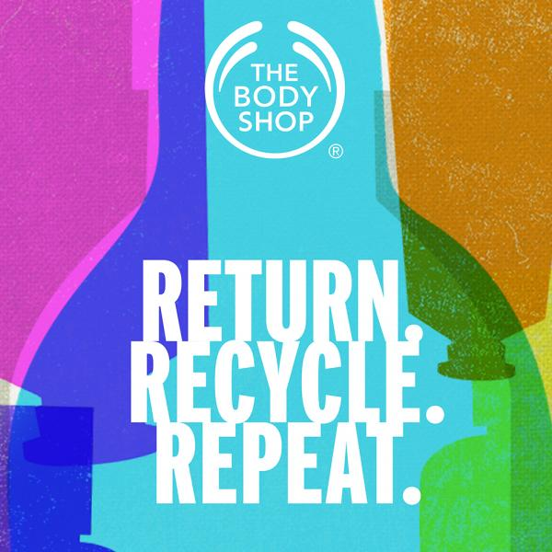
The first scheme recycling scheme was initiated by founder Anita Roddick in 1993, called “Bring back our bottle”, then in 2019 the “Return, Recycle, Repeat” scheme was launched, followed in 2020 by the refill scheme with stations in 500 stores worldwide, which encouraged its customers to return the packaging to The Body Shop stores, where special boxes were placed near the till. (https://www.thebodyshop.com/en-gb/about-us/brand-values/sustainability/return-recycle-reuse/a/a00011)

The novelty is that unlike other brands, which accept only clear plastic, The Body shop accepts everything, including black and coloured plastic, and it offers a clear and transparent explanation of how the packaging are recycled through their official website and the social media channels.
The company created the campaign with the goal to encourage clients to adopt more environmentally friendly buying habits and by offering incentives like points through the loyalty scheme – The Body Shop club, or vouchers in stores, they ensure a constant stream of loyal customers.
Question: Do you recycle?
Comments

THE BODY SHOP MARKETING STRATEGIES

Since its beginnings, The Body shop targeted mostly women who worked and wanted to look more attractive, by developing a series of products for daily care routines, easy to use and efficient. In time, the company widen their range by adding products destined for men. Unlike other competitors, The Body Shop never made bold claims about their products, emphasizing on the benefits offered by using natural ingredients and their properties.
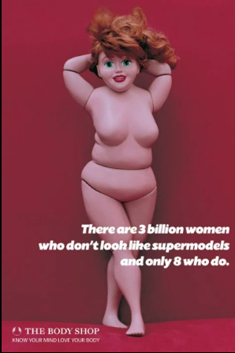
Campaigning continues to be an important part of The Body Shop's value system. Throughout history, they have campaigned to prevent HIV, end domestic violence, and oppose animal testing, among other things.
In 1997, The Body shop was one of the first companies to initiate a campaign to promote self-esteem amongst women and to fight against stereotypes of ideal body image, by launching The Ruby campaign, with the slogan “There are 3 billion women who don’t look like supermodels and only 8 who do” featuring a red-haired doll size 16. Ruby challenged openly the mainstream beauty industry's influence and inspired a worldwide debate about body image and self-esteem. The campaign received a huge positive impact.
In all their campaign, the core values of the company are visibile, like activism, feminism, gender equality, recycling and waste reduction, as well as ingredients stories, and through social media their presence is constant, with simple, fresh content and relatable to their customers.
Question: Are your buying choices influneced by ads campaigns?
Comments

GOING VEGAN
For the past 45 years, The Body Shop has been a champion of sustainability efforts in the beauty industry. After all, the brand was founded in 1976 on the principles of using ethically sourced and naturally based ingredients. The brand still stands by this premise today.
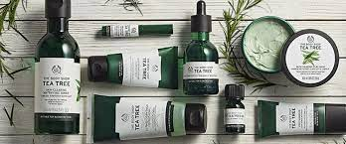
The Body Shop is expanding its sustainability initiative, aiming to be the first global beauty brand to have 100% of its product formulations certified by The Vegan Society by 2023.
In a statement, Lionel Thoreau, the Global Brand Director of The Body Shop declared that the next stage in sustainability and environmental commitments is creating vegan beauty products, making The Body Shop a destination for ethically-minded customers.”
The Body Shop's decision to abandon all animal-based products and ingredients is undoubtedly aimed at the growing number of conscious consumers, with statistics indicating a rapid growth in demands from brands to take actions against climate change.
No doubt this decision will have a positive impact on the brand image and sales, generating a stream of new clients, as well as strengthening the relationships with the existing loyal customers.

Question: Are you more or less likely to buy a product if it is vegan?
Comment

REFERENCES

Haake, Henry. and Stuart Seuring. Sustainable procurement of minor items – exploring limits to sustainability. Sustainable Development 17.5, (2009): 284-294.
Roddick, Anita. 1985. Macdonald, London. The Body Shop, 244 pp.
Schwartz, Burt. Environmental strategies as automorphic patterns of behaviour. Business Strategy and the Environment 18.3, (2009): 192-206.
Wycherley, Ian. Greening supply chains: the case of The Body Shop International. Business Strategy and the Environment 8.2, (1999): 120-127.

