Word count (1000)

Chapter 4

Analysis of Results

4.1 Introduction
This chapter will provide a critical analysis and discussion of the results while providing a systematic presentation of the findings. A total of 46 participants completed the questionnaire. The purpose of this research is to explore police officer perceptions on the effects of shift patterns on work home life balance and mental health.

4.2 Participant experience

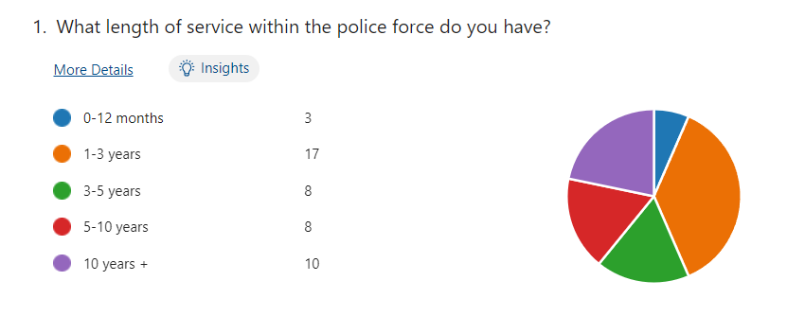
Question 1) What length of service within the police force do you have?
Figure 1- 46 Responses
7% of the participants had been in the police force for 0-12 months with 37% for 1-3 years, 17% for both 3-5 years and 5-10 years and 22% for 10 years+. It appeared from the research that majority of people who took part in the questionnaire were relatively new to the force however there are those who had experience with over 10 years.
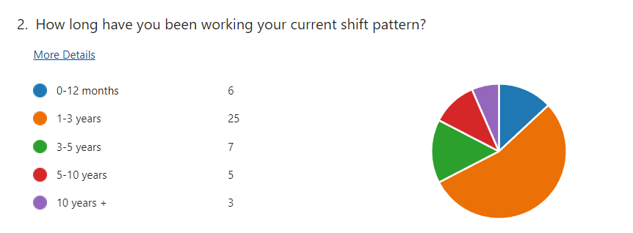
Question 2) How long have you been working your current shift pattern?
Figure 2- 46 Responses
This question is important as it displays those who are working shifts and those who no longer work shifts. This will allow for a comparison where we might see what affect shift patterns have had on those with longer service in the police force.
4.3 Participant views
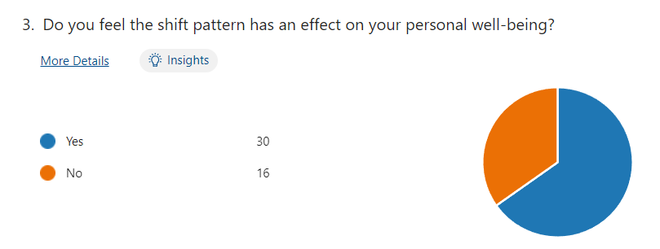
Question 3) Do you feel the shift pattern has an effect on your personal well-being?
Figure 3- 46 Responses
65% of the participants agreed however, 35% disagreed. This answer by participant showed that many people believe that their wellbeing is directly affected by shift pattern work. Rohwer, E et al., (2002) discuss the threat to general health along with mental health and the threat to their personal life and relationships.
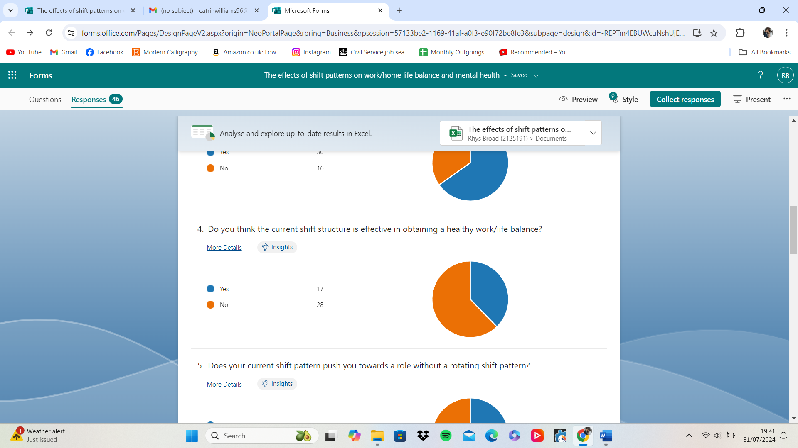
Question 4) Do you think the current shift structure is effective in obtaining a healthy work/life balance?
Figure 4- 46 Responses
38% of participants said yes however, 62% said no. This as a follow-up question to the previous identifies directly that there is a clear feeling from participants that working these shifts make it difficult for them to obtain the healthy balance between work and home. This is supported by research conducted by (Granholm Valmari, E. et al., 2023)

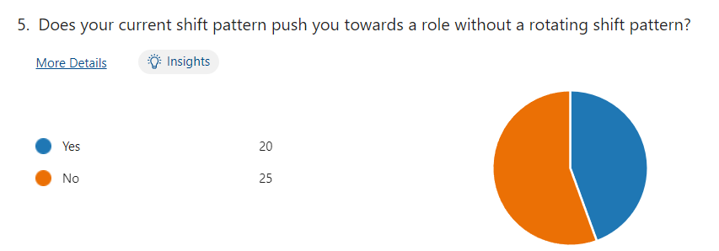
Question 5) Does your current shift pattern push you towards a role without a rotating shift pattern?

Figure 5- 46 Responses
This displays that participants although feeling that the role of an officer and working a shift patter maybe detrimental to well-being they would rather remain in a role with a shift pattern. This will hope to be expanded on later in the text section where they can write their own reflections on the topic.
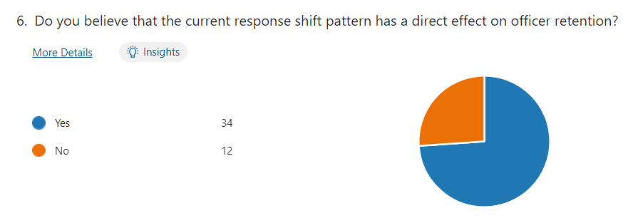
Question 6) Do you believe that the current response shift pattern has a direct effect on officer retention?
Participants have made it clear that where officers are working shifts it may have a direct effect on the forces ability to retain that officer. This however on the back of being asked in the previous question whereby participants working shifts would not go for a role without shift patterns. It has been said that officers who might experience struggle between work life and home life are not as likely to recover mentally after their shifts (Elgmark Andersson et al., 2013).
Figure 6- 46 Responses

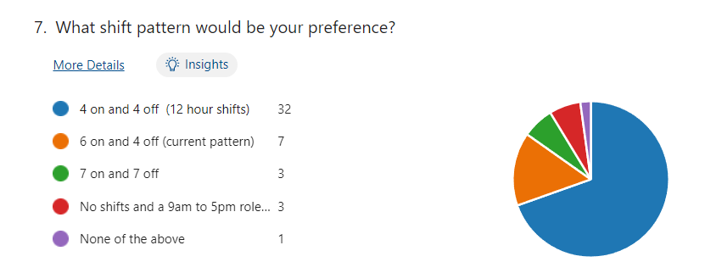
Question 7) What shift pattern would be your preference?
Figure 7- 46 Responses
Where here there is a majority for 4 on and 4 off for a shift pattern would suggest both a dislike of the current pattern but also a need for a more appropriate split between work and the home life.
Question 8) Do you feel that working a shift pattern such as the current pattern (6 on and 4 off) has an effect on your mental health?
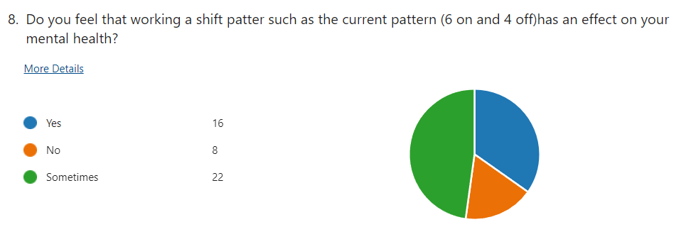

Figure 8- 46 Responses

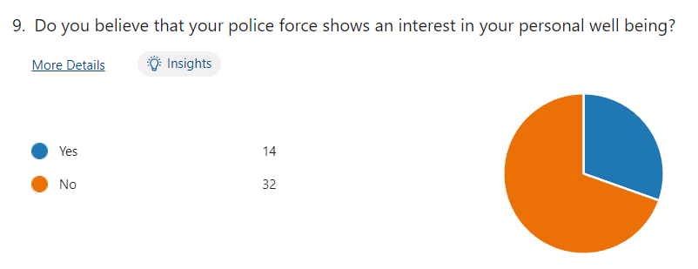
Question 9) Do you believe that your police force shows an interest in your personal well-being?

Figure 9- 46 Responses
Research by (Rohwer, E et al., 2002) suggest that shift pattern can have a direct effect on the wellbeing which a large majority on candidates would agree with. Research suggest that well-being takes a heavy toll on relationships and physical health also.

Question 10) Do you feel your police force values and listens to your feedback?
This question displays how officers currently feel like their feedback might not be valued and the force does not look to implement employee feedback.
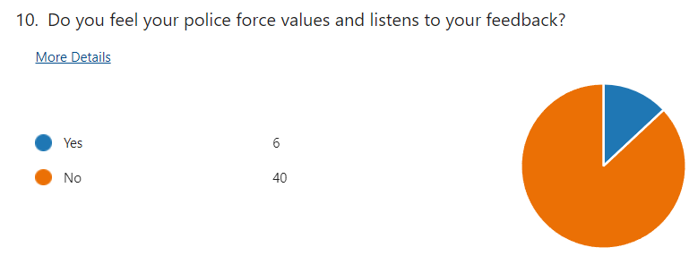
Figure 10- 46 Responses

Question 11) Please feel free to use the text box below to expand on any answers or make any comments with your thoughts on this topic.
“This entire force is too focused on stats. They do not care about officer well being until they get called up on it.” – Participant A

“I believe the current shift patterns do work to some extent but more variety and better well being incentives could benefit staff moving forward.” – Participant B

“I currently work 8 - 4 Monday to Friday, which creates a good work life balance. Have previously worked 6 / 4 shift pattern which was very tiring but I understand was a necessary for the role I was performing at the time.” – Participant C

“I am currently in a Mon-Fri role but have worked 6 on 4 off shifts for many years prior to my current role.” – Participant D

“As I have not had a long length of service in the police i have answered no to the question about feeling listened to as i have experienced only 1 listening group with SMT and awaiting to see if any changes are made as a result of force feedback.” – Participant E

“The current shift pattern does not allow for a family life during the working set and needs to be changed.” – Participant F

“Often unable to raise concerns as do not want to cause issues. Work life balance is not good, hard to use AL when wanted due to staffing levels. Cancelled rest days for training days/ops.” – Participant G

4.4 Summary
This chapter has discussed the themes that emerged from the research process. My research findings can clearly be seen to build upon existing knowledge, and I have comprehensively shown that police officers’ have very clear ideas about the varying factors contributing to their personal work life balance and mental health.

