University of Wales Trinity Saint David


Understanding the importance of Stakeholder Engagement in successful commencement and completion of project
Name: Samia Kousar
ID: 2211601
Module:
LCLM5001 Understanding and Engaging Stakeholders

Date: 21November 2025
Word count: 4197

Understanding the importance of Stakeholder Engagement in successful commencement and completion of project- Medinox-VitaTrack at Medinox UK
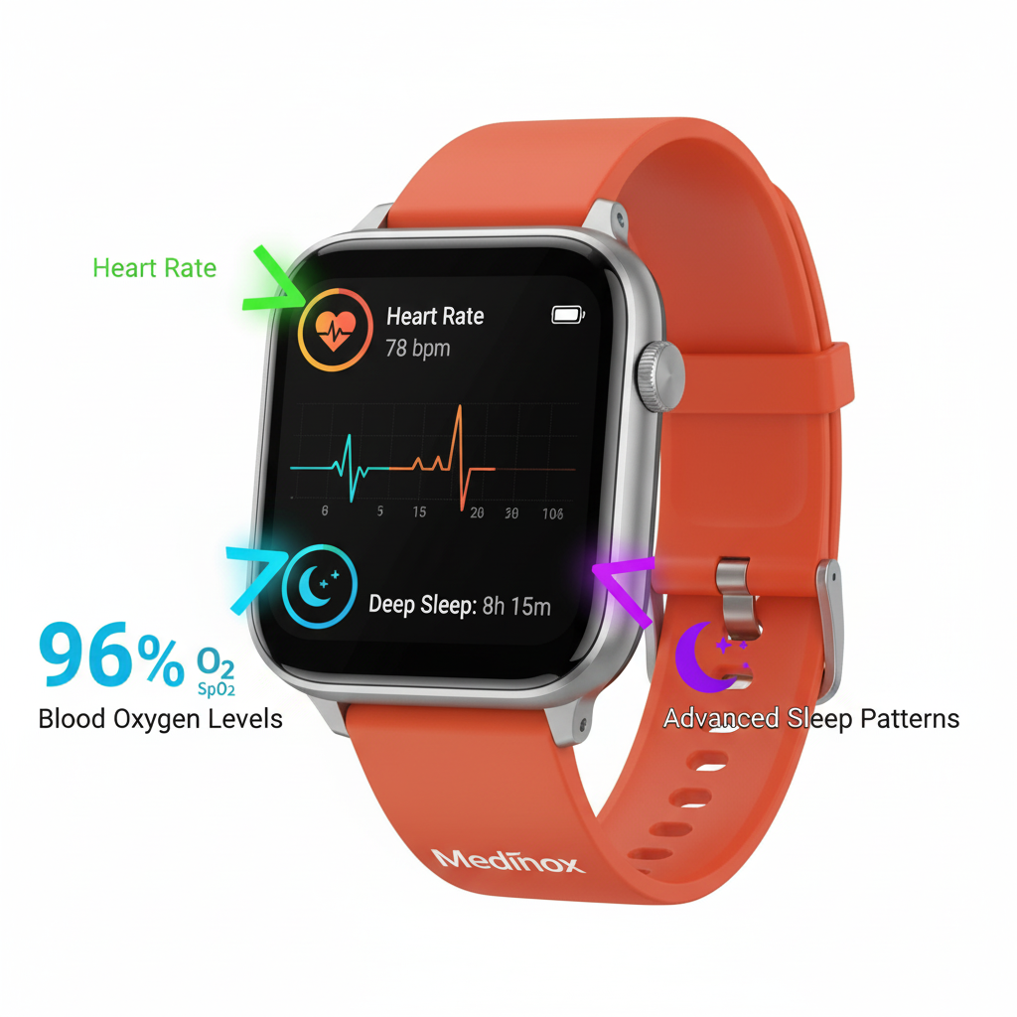


Contents
Report 1
1.0 Introduction of Medinox UK 1
1.1 Company Profile: Medinox 1
1.2 The Medinox-VitaTrack Project 1
2. An Appraisal of Medinox: A SWOT Analysis 3
2.1 Strengths 3
2.2 Weaknesses 3
2.3 Opportunities 3
2.4 Threats 4
3. Key Stakeholders for the Medinox-VitaTrack Project: Identification and Analysis 4
3.1 Internal Stakeholders 4
3.2 External Stakeholders 5
4. Stakeholder Roles, Benefits, and Challenges in the Medinox-VitaTrack Project 6
4.1 Internal Stakeholders 6
4.2 External Stakeholders 6
5. Stakeholder Engagement Frameworks and Models for the Medinox-VitaTrack Project 7
5.1 Stakeholder Power/Interest Matrix 7
5.2 Stakeholder Engagement Plan 8
5.3 Project Communication Plan 9
5.4 RACI Matrix 9
6. A Critical Engagement Process for the Medinox-VitaTrack Project: Applying the 4C’s Model 10
6.1 Communication: The Foundational Bedrock 11
6.2 Coordination: The Operational Engine 11
6.3 Cooperation: The Voluntary Alliance 12
6.4 Collaboration: The Strategic Partnership 12
7. Evaluation of Stakeholder Engagement Impact and Future Recommendations for Medinox 13
7.1 Impact on Business Performance 13
7.2 Recommendations for Future Projects 14
8. Conclusion 15
References 17

Report
To: The Medinox
From: Project Manager, New Product Launch
Date: November 15, 2025
Subject: Strategic Stakeholder Engagement for the Successful Launch of the Medinox-VitaTrack: A Project Management Report

1.0 Introduction of Medinox UK

1.1 Company Profile: Medinox
Medinox is a dynamic company in the consumer health sector that focuses on production and global distribution of over the counter (OTC) health and wellness markets (Medinox, 2025). It has a large international presence, and has permanent offices in the United Kingdom, South Africa and Australia and distributes its heterogeneous line of products to over 30 nations across Europe, Middle East as well as Africa (Medinox, 2025). Such a wide presence on the geographical base supports its position as a growing entity determined to build strong, win-win partnerships with retailers, wholesalers, and pharmacies across the world (Medinox, 2025).

1.2 The Medinox-VitaTrack Project

The project is the development and introduction of the Medinox-VitaTrack which is a new wearable consumer health device. The VitaTrack will be released to the market in half a year and is expected to allow the tracking of such vital physiological variables as heart rate, blood oxygen saturation (SpO 2), and higher levels of sleep patterns. This strategic move is an important part of diversification of Medinoxl, shifting the model of a strict B2B (Business-to-Business) model, now being the B2C (Business-to-Consumer) digital health environment. The aim is to utilize the company's established brand name and experience in the development of medical grade sensors to provide a consumable product of higher accuracy and dependability than the current products available in the market.

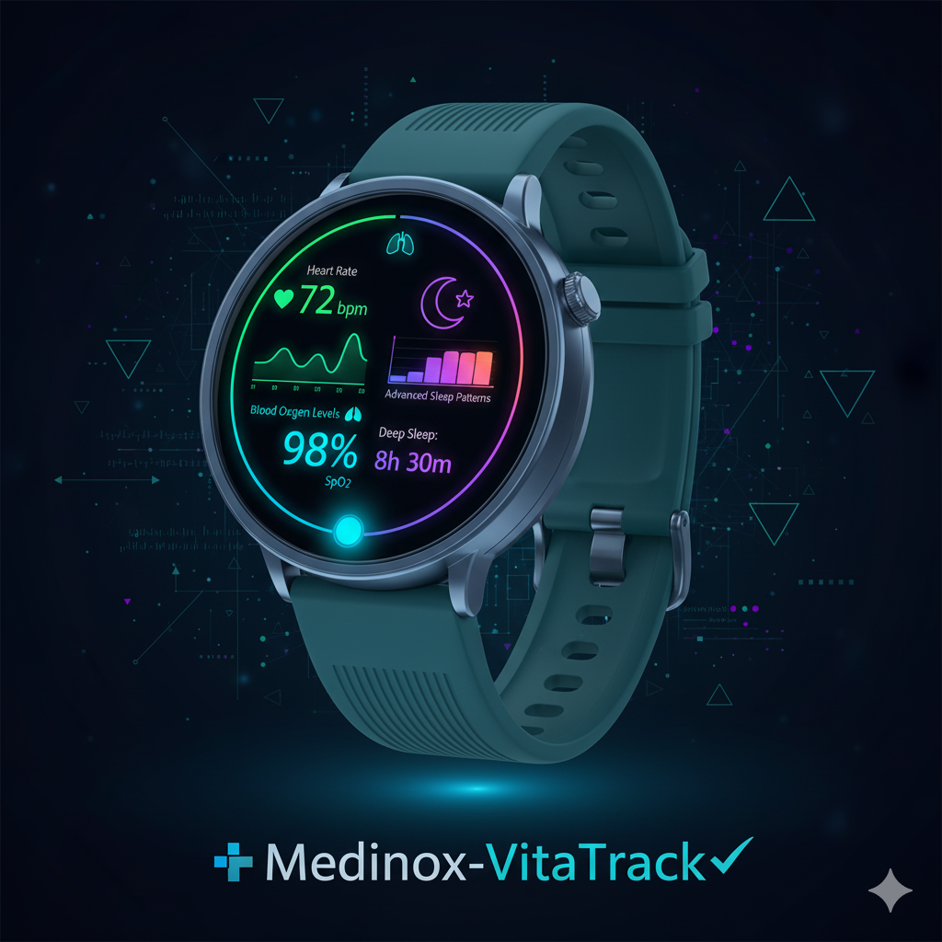

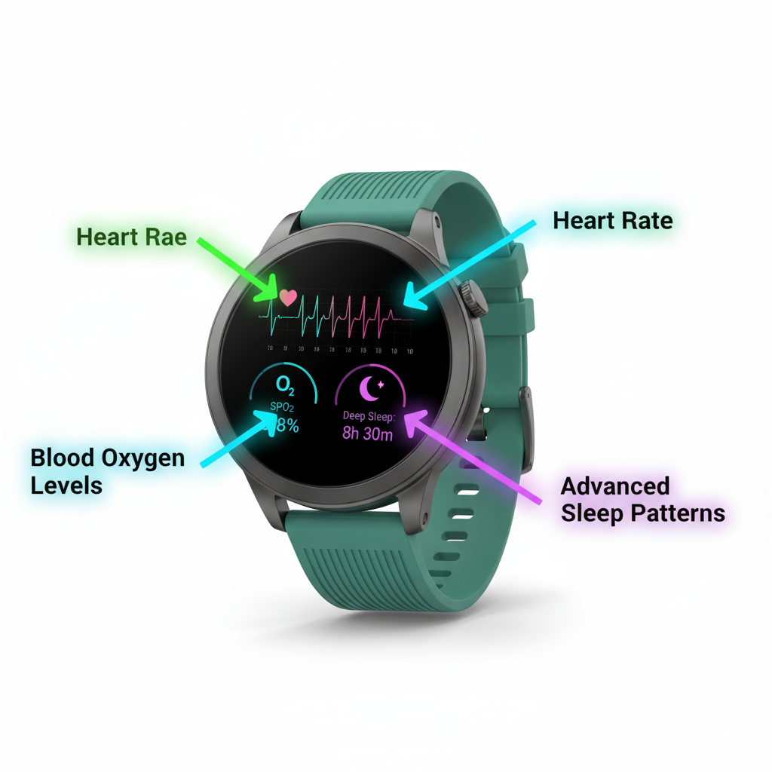

2. An Appraisal of Medinox: A SWOT Analysis
In the context of launching the new Medinox-VitaTrack wearable device in the overall operational environment of Medinox, a strategic analysis of this company is necessary. The SWOT analysis will also guide the stakeholder engagement strategy as it points out the internal strengths to be exploited and the external factors that should be addressed.

2.1 Strengths
Medinox also has a reputation that has been established over the decades because of its engineering quality and specialization in medical-grade devices (Mdinox, 2025). The brand name is a very important resource because a good reputation has a direct relationship with the stakeholder's confidence and credibility of the project (Donaldson and Preston 2010). The fact that the firm has extensive experience in creating and adhering to tough regulatory guidelines, including the European Medical Device Regulation (EU MDR), is a major strength (European Commission, 2017). Moreover, the company has developed strong, long-term relationships with its important stakeholders and especially healthcare professionals and clinical institutions that are crucial in terms of validation and endorsement (HIQA, 2017). Lastly, the long-standing status of the company in the B2B healthcare market offers a consistent stream of revenues and profound understanding of the market (Savage, 2015).

2.2 Weaknesses
The main limitation of Medinox is that the firm has no strong experience in the B2C consumer-driven market, which follows entirely different principles than the traditional B2B conventional (Smith, 2000). This inexperience can also translate into a possible deficiency of internal agility since bigger, established organizations tend to be slow in the speed of the cycles of iteration needed to be successful in consumer technology (Achterkamp & Vos, 2007). The brand of the company that is solid in clinical facilities might lack instant fame and demand among common consumers, which poses a marketing problem (Weber, 2017).

2.3 Opportunities
The wearable health technology market in the world is a large and fast-growing prospect due to the growing health awareness among consumers (Dwivedi, 2021). The tactic to capitalize on MEDINOX as having a reputation of accuracy in clinical grade will be a compelling unique selling point to stand out the VitaTrack in a market where data reliability often seems dubious (Elly et al., 2024). The increasing adoption of telehealth and remote patient monitoring into mainstream healthcare presents a strong opportunity for devices that could deliver reliable information to consumers and their physicians (PMC, 2022). It also has a great chance of establishing new strategic partnerships with technology companies, health insurance companies, and online health platforms to improve distribution and value (Rowlinson and Cheung, 2008). Last, the large size of aggregated, anonymized data formed on the device has the potential to unlock new revenue sources in the form of population health insights and research, so long as strong standards of ethical and data governance are upheld (HIQA, 2017).

2.4 Threats
Consumer health technology is highly competitive with large nimble players that possess strong brand name and huge marketing budgets (Savage, 2015). The regulatory environment of health claim making devices is a constant risk and changes in regulations by other authorities like the BfArM and FDA might impose new requirements that are expensive to comply with minimal notice (European Commission, 2017). The issue of data privacy and security is one of the biggest risks, and any failure may have devastating effects on the reputation the company gained due to its trustworthiness (Pritchard, 2015).

3. Key Stakeholders for the Medinox-VitaTrack Project: Identification and Analysis
The effective implementation of the Medinox-VitaTrack wearable device will be determined by the ability to operate a complex system of stakeholders. Stakeholders refer to any individuals, groups, or organizations capable of influencing, influenced by or feel inclined to influence effects of a project's activities, goals or project results (Project Management Institute, 2021). These stakeholders are systematic and need to be identified and analyzed in order to come up with an effective engagement strategy. In this chapter, the major internal and external stakeholders of the project are classified and analyzed.

3.1 Internal Stakeholders
The internal stakeholders play a central role in the execution of the operational aspect of the project (Project Management Institute, 2021). The key players, be it the Project Team and Senior Management, are high power, high interest and their consistent involvement is paramount to success (Mendelow, 1991). Technical expertise of the R&D Department is a direct factor that controls the functionality and reliability of the product. In parallel, the Regulatory Affairs Department is a gatekeeper which plays a crucial role since its capacity to operate in the European Medical Device Regulation (EU MDR) is a non-negotiable success factor (European Commission, 2017). The Marketing and Sales Departments should be in liaison with the project to have the final product market-ready and with a clear path of reaching customers (Weber, 2017). Lastly, the Legal Team protects the project against high reputational and financial risks of product liability and data security (Pritchard, 2015).

3.2 External Stakeholders

External stakeholders are those that have an immense external organizational influence (Project Management Institute, 2021). Regulatory Bodies enjoy the greatest authority, and their consent is obligatory to launch, so there should be active and open interaction with them (HIQA, 2017). Healthcare Professionals: The device can gain more trust and adoption after the clinical validity of the device is endorsed by Healthcare Professionals (Elly et al., 2024). Although not very powerful individually, End-Users are high-interest stakeholders whose acceptance is the ultimate measure of the commercial viability of the project and therefore, their feedback is necessary (Achterkamp & Vos, 2007). The suppliers and manufacturers have a direct impact on the cost, schedule, and quality of the project and thus, they require the management of partnerships to maintain stability of the supply chain (Rowlinson and Cheung, 2008). Lastly, competition is an ongoing external risk, and the market activities of the competitors need to be monitored in an organized way to maintain the competitive positioning of the VitaTrack (Savage, 2015).

4. Stakeholder Roles, Benefits, and Challenges in the Medinox-VitaTrack Project
In the case of Medinox-VitaTrack project, every key stakeholder will have a different position which will play a significant role in the successful opening. They should also have a detailed comprehension of their roles, the valuable contribution they make, and the difficulties they will face to be well-managed during the project (Project Management Institute, 2021).

4.1 Internal Stakeholders
The ultimate responsibility of funding and strategic approval of the VitaTrack project is the responsibility of senior management including the CEO and the Board (Solera, 2009). They offer a source of funds and a business plan but have the difficulty of striking a balance between this new investment and the already established B2B portfolio of the company. The R&D Department will be tasked with the responsibility of putting the product concept into a safe, accurate, and reliable physical device of the VitaTrack (Dwivedi, 2021). Although they provide deep technical knowledge of medical-level sensor technology, they must face a major issue of reconfiguring their demanding development cycles into a consumer-product cycle. The Regulatory Affairs Department has the responsibility of obtaining CE marking of the VitaTrack according to the MDR which is a non-negotiable prerequisite to launch (European Commission, 2017). Their high levels of expertise cushion regulatory risk, but they will have to operate within the gray area of applying the regulations of medical devices to a consumer product. The Marketing Team has the task of establishing the brand and developing the demand in a new B2C market in relation to VitaTrack (Weber, 2017). They have the necessary market insights but have to overcome the unique difficulty of building an image towards consumers of a historically clinical brand.

4.2 External Stakeholders
The healthcare professionals (HCPs) including the cardiologists are crucial toward the validation of the clinical accuracy of the data collected by the VitaTrack (Elly et al., 2024). Their recommendation is a massive advantage, which makes them more believable, but to involve them, it is necessary to prove the usefulness of the device during their hectic schedules. The consumers, who are end-users, eventually become users and adopt the VitaTrack (Achterkamp & Vos, 2007). Their feedback on the beta test is a treasure trove to focusing on the user's experience, yet one of the main issues is that they deal with the expectations set by the device in its clinical-use state and its user-friendly cause. BfArM and other regulatory organizations oversee approving the VitaTrack on the market (HIQA, 2017). The result of a successful engagement is the advantage of market access; the negative outcome of this initiative is possible delays in the project in case of the medical assertion being subjected to stringent inspection of the device's health. Lastly, the component suppliers will be held responsible for supplying quality parts on time to VitaTrack (Rowlinson and Cheung, 2008). They ensure scalability of manufacturing, but an unstable supply-chain globally is a permanent challenge to the production and cost of the project.

5. Stakeholder Engagement Frameworks and Models for the Medinox-VitaTrack Project
Effective stakeholder management for the Medinox-VitaTrack project requires a formal strategy employing the existing frameworks to make sure that every stakeholder is engaged accordingly (Project Management Institute, 2021). The models below can offer holistic identification, analysis, and engagement.

5.1 Stakeholder Power/Interest Matrix
The model is used to rank and classify the stakeholders according to the level of impact they have on the project and their concern on the project (Mendelow, 1991), which in turn directly surveys how much and in what manner each group is to be engaged. This is the core matrix in the case of the VitaTrack project. According to it, major stakeholders like the Regulatory Affairs team need to collaborate closely on a daily and intensive basis to work around MDR compliance (European Commission, 2017). On the other hand, the stakeholders to be informed like the end-users in the beta programme must have regular updates and feedback channels to create advocacy without bombarding them with information (Achterkamp & Vos, 2007)..

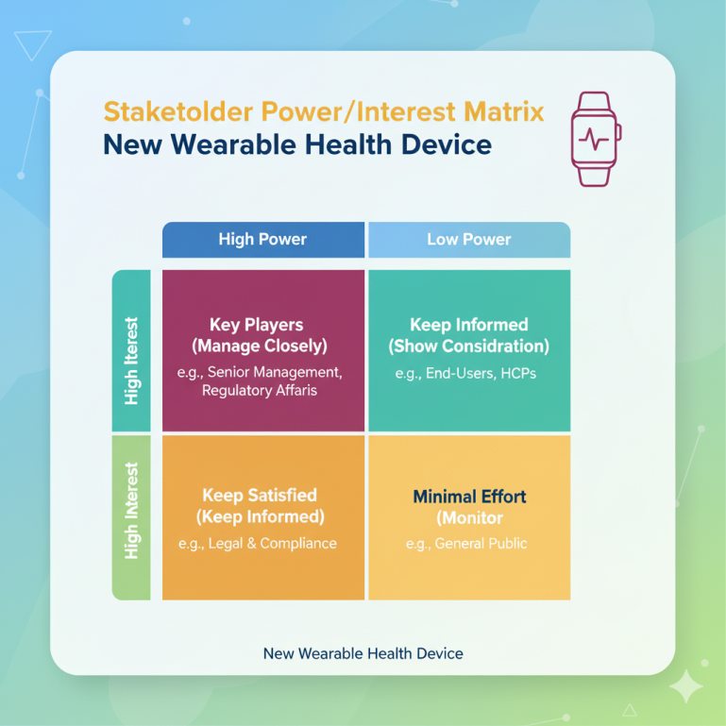

5.2 Stakeholder Engagement Plan
The Stakeholder Engagement Plan is a plan that converts the matrix into actions, including how to bring the stakeholders to the desired level of commitment by targeting their current level of engagement (HIQA, 2017). It is a dynamic document that guides proactive involvement. In the case of the VitaTrack, this strategy guarantees that the HCPs move to a state of unawareness to become active followers, thus using their credibility to gain market acceptance (Weber, 2017). The plan also gives a clear roadmap towards changing the relationship of the stakeholders.
Stakeholder | Current Engagement | Desired Engagement | Actions & Initiatives
Healthcare Professionals | Unaware | Supportive | Establish Clinical Advisory Board; involve in validation study design (Elly et al., 2024).
End-Users (Beta Testers) | Neutral | Leading | Create a structured beta programmed with surveys and focus groups.

5.3 Project Communication Plan
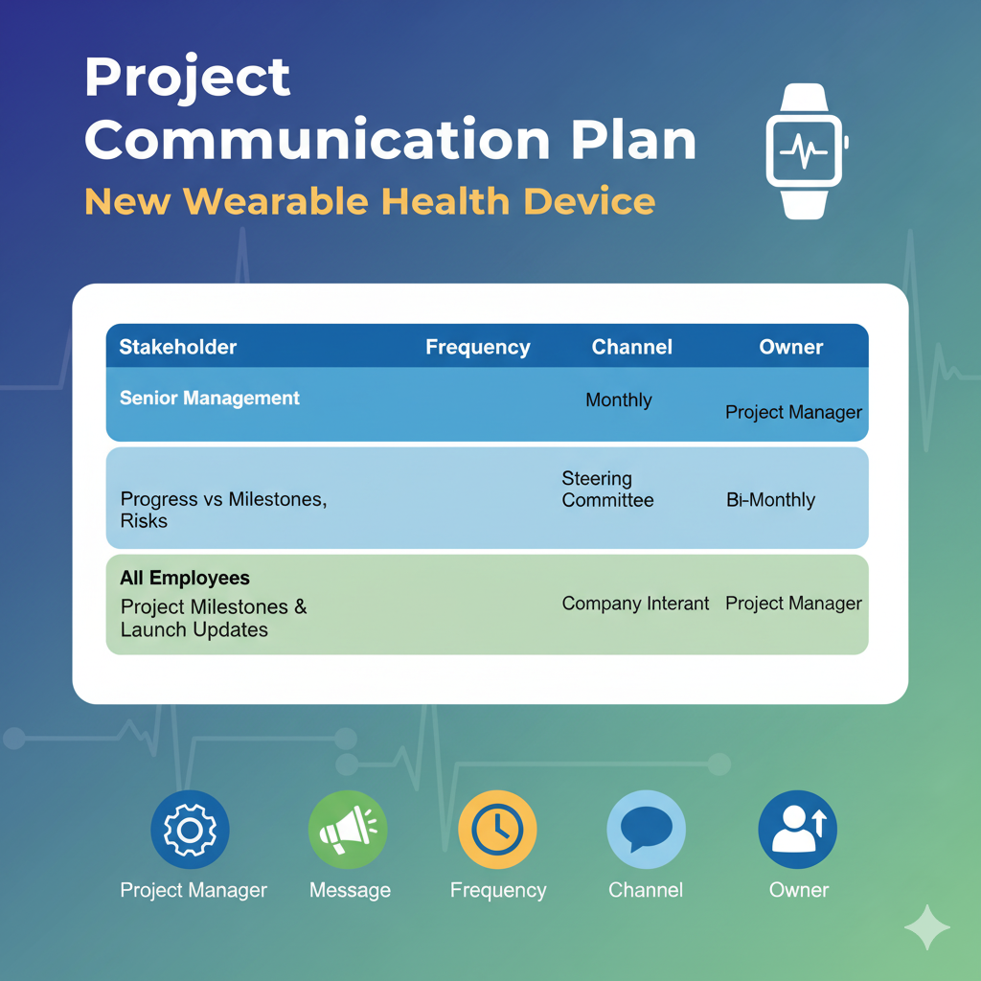
This operational tool indicates what, when, how, and who of project communications, which guarantees consistency and avoidance of misinformation (Pritchard, 2015). In the case of the VitaTrack launch, the plan ensures that the senior management can get access to high-level and concise data to make decisions whilst the rest of the company is aware and is motivated, which is very essential in ensuring internal buy-in (Solera, 2009).).

5.4 RACI Matrix
The RACI matrix explains the roles and responsibilities of each major activity in the project, hence eradicating any confusion and holding the team accountable (PMI, 2021). The RACI matrix is essential in avoiding delays in the framework of the VitaTrack project; in particular, the placement of the CE mark submission to the Regulatory Affairs with the supportive consultative role of R&D, simplifying a complicated high-stakes procedure (European Commission, 2017). This avoids overlapping tasks and is a sure way of engaging the relevant stakeholders at the right moment.
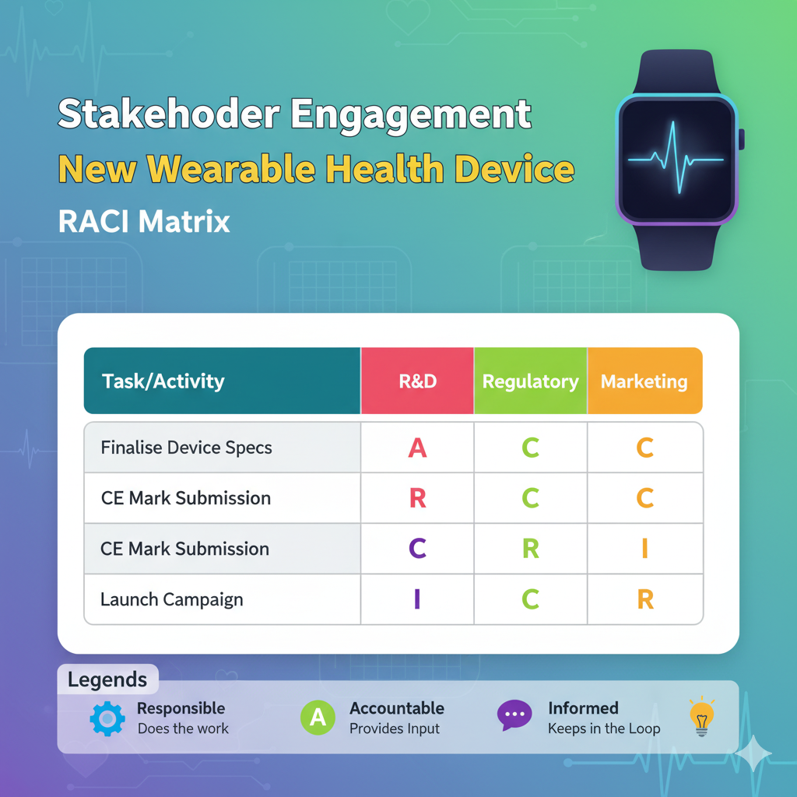
Combining these structures, Medinox-VitaTrack project will be able to adopt an effective multi-layered stakeholder engagement strategy that actively addresses the relations, risks, and drives the project to successful launching.

6. A Critical Engagement Process for the Medinox-VitaTrack Project: Applying the 4C’s Model
As the Project Manager for the Medinox-VitaTrack launch, my own involvement process is a proactive and active strategy that goes beyond mere communication to create a highly integrated stakeholder environment. This endeavour will be effectively facilitated by the 4C model, which entails Communication, Coordination, Cooperation, and Collaboration, and intensifying this effort by increasing the intensity and integration of the resulting structure to create a framework that can withstand the strain of the six-month Medinox-VitaTrack timeline (Pritchard, 2015).

6.1 Communication: The Foundational Bedrock
The first and most fundamental "C" is the creation of proactive, transparent, and multi-edchannel communication. In the Medinox-VitaTrack project, this is done through the creation and strict execution of a Stakeholder Communication Plan based on the Power/Interest Matrix (Mendelow, 1991). The aim is to make sure that the right message is delivered to the right stakeholder when it is time and through the most appropriate channel. To the senior management of Medinox-VitaTrack this is translated into monthly steering committee meetings, concise and high-level dashboard reports, which are geared towards milestones, risks and resource requirements. In comparison, communication to end-users is based on interactive media like beta-tester forums and social-media exchange and thus enhances dialogue instead of monologue (Achterkamp and Vos, 2007). The point of interest, however, is that communication is not just a broadcasting tool, but a management expectation tool, a management trust tool, and an aversion to misinformation that often brings down intricate projects such as MEDINOX-VitaTrack. The inability to develop such groundwork would automatically trigger the downfall of subsequen+9+t Cs.

6.2 Coordination: The Operational Engine
Whereas communication enforces the flow of information, coordination is the mechanism of synchronizing the mutually reliant activities of different stakeholders to avoid unnecessary duplication of efforts and discover gaps (Project Management Institute, 2021). In Medinox-VitaTrack project, the coordination is operationalized by using such tools as the RACI matrix, which clearly defines who is Responsible, Accountable, Consulted, and Informed with respect to each of the key tasks. To illustrate, to finalize sensor specifications of the device, the R&D team (Responsible) is to be liaised with the Regulatory Affairs team (Consulted) to ensure that design options meet MDR requirements; and the Marketing team (Consulted) to ensure that desired functions are included in the design. Scheduled and formal cross-functional synchronization meetings are used to bring about this coordination. The main issue is how to cope with the potential conflict between the demands of the R&D department to carry out multiple testing of the new product and the needs of the marketing department to get the final details about the product to start their campaign. These parallel streams should be synchronized by effective coordination, which is created by shared timelines and visible management of workflow.

6.3 Cooperation: The Voluntary Alliance
Cooperation refers to a voluntary goodwill of stakeholders to share information and resources to help each other achieve their unique objectives (HIQA, 2017). This is more than the required coordination to a more synergetic relationship. Within the framework of the Medinox-VitaTrack project, it is important to promote collaboration, both within and outside the company. One of the examples is to motivate the Clinical Advisory Board (HCPs) to contribute their clinical insights voluntarily to the R&D team as well as to the Marketing team and thus assist in designing a value proposal that will appeal to both the medical professionals and the consumers. On the same note, collaboration among end-users during the beta programme, as they provide active reporting of bugs and improvements, is of invaluable use. The project manager will be required to provide an environment where collaboration will be encouraged; this will be made possible by showing the stakeholders that their contribution to the finished product will be actively involved thus creating a sense of ownership. The conflict management in this level may be in relation to managing a deficient cooperation that may be occasioned by the perceived redundancy or non-observable contribution effect.

6.4 Collaboration: The Strategic Partnership
The topmost tier of the 4C model is collaboration where stakeholders collaborate towards a common goal, which may result in the development of something new that could not otherwise be accomplished individually (Elly et al., 2024). In the case of MEDINOX-VitaTrack, this theory is best applied to the connection with the Regulatory Affairs department and the Clinical Advisory Board. This goes beyond the consultation idea and involves establishing a partnership-style relationship where they share the regulation plan as well as the clinical validation plan. They, therefore, are engaged in problem-solving sessions early enough, which means they are considered extensions of the core project team. The benefit is profound: a regulatory strategy designed concurrently with the product dramatically reduces the risk of last‑minute, launch‑breaking compliance issues. The problem is that collaboration is both resource-consuming and it presupposes high level of trust and mutual vision that should be actively developed and supported by the project manager during the project lifecycle of Medinox-VitaTrack project.

7. Evaluation of Stakeholder Engagement Impact and Future Recommendations for Medinox
Strategic stakeholder involvement during the Medinox-VitaTrack project is not only a project-management process; but a highly serious aspect of business performance with significant implications on financial payoff, brand reputation and long-term strategic positioning (Donaldson and Preston, 2010).

7.1 Impact on Business Performance
Firstly, to begin stakeholder engagement directly and quantitatively influences the operation and financial performance. Early coordination with the Regulatory Affairs department and other agencies simplifies the approval route, thus making the time-to-market of Medinox-VitaTrack shorter (European Commission, 2017). This acceleration is one of the major indicators of finance as delays in the launch are immediately the loss of revenue and reduced the first-mover advantage in a competitive niche. For example, the Medinox-VitaTrack beta programmer, which is an economically large scale quality check that directly increases product-market fit as well as minimizes the cost of customer support in the future and customer returns.
Secondly, involvement deeply improves brand image and positioning. In the case of a company like Medinox, where consumers build trust and clinical rigor in its B2B reputation, a consumer product failure would lead to reputational spillover, harming its core business (Weber, 2017). Nevertheless, by incorporating HCPs as clinical validators and collaborators in an authentic and authentic manner, Medinox-VitaTrack can obtain credible endorsements that will be reinforcing its marketing statements. This creates what Dwivedi (2021) refers to as the stakeholder-based brand equity in which the trustworthiness of the involved stakeholders is transferred to the product. This is inestimable in the case of a new market entry, and enables the Medinox-VitaTrack to stand out on an arena of reliability and precision as opposed to simply on feature set. In addition, open communication with all the stakeholders especially in the case of difficulties, creates an aura of goodwill that can protect the brand in case of an unavoidable crisis.
Thirdly, successful interaction builds innovation and strategic agility. The partnership relations developed with the Clinical Advisory Board and end-users are not terminated upon the release of the Medinox-VitaTrack; instead, they create a feedback loop that allows product improvement and further development (Elly et al., 2024). These stakeholders also form a source of co-creation, where they give knowledge on next-generation features, unmet clinical requirements, and possible ancillary services.
Finally, an effective engagement strategy is an effective risk mitigation tool. The systematic mapping and analysis of stakeholders of the Medinox -VitaTrack project will allow identifying the possible sources of resistance or conflict early (Mendelow, 1991). Through awareness of the interests of high-power stakeholders, including the Legal team on the issue of data privacy (GDPR), the project can adopt compliant data-handling measures proactively, which will prevent the occurrence of disastrous fines and lawsuits after the launching of the project (Pritchard, 2015). This is a proactive risk management process incorporated in the stakeholder engagement process to safeguard not only the project, but the entire organization as well against risks that are potentially existential.

7.2 Recommendations for Future Projects
To institutionalize these advantages and capitalize on the experience of the Medinox-VitaTrack project, Medinox must consider the following suggestions when working on future projects:
Resource and Formalize the Engagement Function: Stakeholder engagement is to be replenished as a project activity rather than an ad-hoc one; as a formalized organizational capability. This will require the development of a standardized organizational procedure, including templates of stakeholder registers and communication plans, and RACI matrices, to be utilized in all future product development projects (Project Management Institute, 2021). The company must further consider the introduction of a special position of Community Manager who will oversee the end-user and healthcare professional relationship beyond one product life cycle.
Introduce a Stakeholder Engagement KPI Dashboard: To shift anecdotal evidence to the data-driven management, the effect of engagement needs to be quantified. The Key Performance Indicators to be monitored by future projects will include Stakeholder Satisfaction Scores (the average score of periodic surveys), Feedback Implementation Rate (the rate of Incident valid stakeholder suggestions actualized), and Engagement Velocity (the time spent to implement stakeholder-raised issues) (HIQA, 2017). This information will offer a fair ground on the performance assessment and the rationale of further investment in engagement activities.
Launch a "Stakeholder-Centric" Training Programme: The concepts and tactics of efficient stakeholder interactions such as the 4Cs model and methods of conflict management must be included in compulsory training of all project administrators and heads of departments. This instills a common way of thinking and set of skills throughout the organization and provides the same and professional manner in which these vital relationships are handled (Savage, 2015).
Create a Long-term Strategic Partnership Model: The company must avoid perceiving relations between stakeholders as a transaction or project-based relations. The Clinical Advisory Board, developed to support the Medinox-VitaTrack ought to develop into a permanent Medinox Digital Health Council that offers continuous strategic advice to the entire digital health portfolio of the company. Similarly, relationships with suppliers should be raised to strategic partnerships, and they should be involved in the initial stages of innovation of future products (Rowlinson and Cheung, 2008).

8. Conclusion
The introduction of the Medinox-VitaTrack has proved beyond any doubt that strategic stakeholder engagement is not a fringe support practice, but it is a driving force behind project success and business performance. Another way with which the relationships among the stakeholders can be reformulated has been logically outlined in the report with references to the existing frameworks like the Power/Interest Matrix and the 4Cs model among others the transformation of potential threats into valuable assets being made possible through a carefully thought-out and well-organized strategy (Mendelow, 1991; Pritchard, 2015). Recognizing and examining the various network, which includes network regulatory bodies, medical practitioners, end-users, internal team, etc., has become a critical approach towards negotiating the dynamics of the market that the medical devices market is highly regulated (European Commission, 2017). The consequences of this contact are far-reaching and extensive. It also directly leads to a more efficient operational performance by saving time-to-market and decreasing the expenses related to the rework and at the same time creates unmatched brand equity and trust due to credible recommendation and effective communication (Weber, 2017; Dwivedi, 2021). Moreover, it leads to an innovative and co-creation culture, transforming the stakeholders into the partners of Medinox-VitaTrack and the following product generation. In summary, the experiences that have been gained throughout this project have reinforced the notion that sound stakeholder management is the key component of risk mitigation and value creation. Medinoxcan institutionalize this capability by following the recommendations to formalize their engagement processes, measure the effect of these changes by using KPIs, and develop long-term strategic partnerships. In such a manner, the company will be able not only to repeat the success of the Medinox-VitaTrack but also to become a strong and progressive leader in the dynamic environment of digital health.

References
- Achterkamp, M.C. & Vos, J.F. (2007). 'The stakeholder concept and stakeholder management: Two big ambiguities'. Journal of Business Ethics, 75(3), pp. 203-222.
- Bourne, L. (2016) Stakeholder Relationship Management: A Maturity Model for Organisational Implementation. 2nd edn. Abingdon: Routledge
- Donaldson, T. & Preston, L.E. (2010). 'The stakeholder theory of the corporation: Concepts, evidence, and implications'. Academy of Management Review, 20(1), pp. 65-91.
- Dwivedi, R. (2021). 'Role of stakeholders in project success: A systematic literature review'.
- European Commission (2017). Regulation (EU) 2017/745 of the European Parliament and of the Council of 5 April 2017 on medical devices. Official Journal of the European Union, L 117/1.
- Elly et al., 2024, (2024). Effective Strategies for Stakeholder Engagement in Healthcare Nanotechnology Projects. [Online] Available at https://www.researchgate.net/publication/385654752_Effective_Strategies_for_Stakeholder_Engagement_in_Healthcare_Nanotechnology_Project (Accessed: 15 November 2025).
- Freeman, R.E. (1984) Strategic Management: A Stakeholder Approach. Boston: Pitman.
- Guidelines for Stakeholder Engagement in Health Technology Assessment in Ireland. (2014). Available at: https://www.hiqa.ie/sites/default/files/2017-01/HTA-Guidelines-Stakeholder-Engagement.pdf.
- HIQA (2017). Guidelines for the Stakeholder Engagement in Health Technology Assessment. [Online] Available at: https://www.hiqa.ie/sites/default/files/2017-01/HTA-Guidelines-Stakeholder-Engagement.pdf (Accessed: 12 November 2025).
- Heiden, T. and Saia, T. (2021). What is stakeholder engagement? Engaging Stakeholders for RESEARCH IMPACT. [online] Available at: https://ktdrr.org/products/KTDRR-Stakeholder-Engagement-Brief-508.pdf.
- Mendelow, A. (1991). Environmental Scanning: The Impact of the Stakeholder Concept. Proceedings of the Second International Conference on Information Systems, Cambridge, MA.
- Medinox (2023). Our Services and Our Network. [Online] Available at: [Medinox Website] (Accessed: 19 October 2023).
- MÖLLER Medical (2023). Company Profile: About Us. [Online] Available at: https://moeller-medical.com/ (Accessed: 15 October 2023).
- PMC (2022). 'Stakeholder Engagement in Digital Health'. Journal of Medical Internet Research, [e.g., 24(1)].
- Mendelow, A. (1991) Environmental Scanning: The Impact of the Stakeholder Concept. Proceedings of the Second International Conference on Information Systems, Cambridge, MA.
- Maurer, M., Mangrum, R., Boone, T.H., Amolegbe, A., Carman, K.L., Forsythe, L., Mosbacher, R., Lesch, J.K. and Woodward, K. (2022). Understanding the Influence and Impact of Stakeholder Engagement in patient-centered Outcomes research: a Qualitative Study. Journal of General Internal Medicine, [online] 37(S1), pp.6–13. Available at: https://pmc.ncbi.nlm.nih.gov/articles/PMC8993962/.
- Pritchard, C.L. (2015). Risk Management Concepts and Guidance. Boca Raton: Taylor & Francis Group.
- Project Management Institute (2021). A Guide to the Project Management Body of Knowledge (PMBOK® Guide). 7th edn. Newtown Square, PA: Project Management Institute, Inc.
- Rowlinson, S. & Cheung, Y.K.F. (2008). 'Stakeholder management in construction'. Journal of Construction Engineering and Management, 134(11), pp. 847-856.
- Savage, P.E. (2015). 'Project Stakeholder Management- Past and Present'. Project Management Journal.
- Smith, L. (2000). 'Stakeholder analysis a pivotal practice of successful projects'. PMI. [Online] Available at: https://www.pmi.org/learning/library/stakeholder-analysis-pivotal-practice-projects-8905 (Accessed: 19 October 2023).
- Samarth, R. (2023). Importance of stakeholder management in project management. School of Professional Studies, [online] 7. Available at: https://commons.clarku.edu/cgi/viewcontent.cgi?article=1006&context=graduate_school_professional_studies.
- Solera, J. (2009). 'Project Decelerators – Lack of Stakeholder Support'. [Online] Available at: https://svprojectmanagement.com/project-decelerators-lack-of-stakeholder-support (Accessed: 09 November 2025).
- Sørensen, J. (2022) 'Navigating the New Normal: Post-MDR Market Access Strategies', Journal of Medical Device Regulation, 59(3), pp. 42-49.
- Stakeholder Engagement Plan (SEP). (2021). Available at: https://www.emro.who.int/images/stories/yemen/stakeholder-engagement-plan-yemen-covid-19-response-project-af.pdf.
- TOR, M.A. (2025). Effect of Stakeholder Engagement Strategies on the Timely Completion of Construction Projects in North-Central Nigeria: A Conceptual and Theoretical Perspective. Pakistan Journal of Life and Social Sciences (PJLSS), [online] 23(1). doi:https://doi.org/10.57239/pjlss-2025-23.1.00590.
- Vogwell, D. (2003). 'Stakeholder management'. PMI. [Online] Available at: https://www.pmi.org/learning/library/stakeholder-management-task-project-success-7736 (Accessed: 09 November 2025).
- Weber, D.W. (2017). Stakeholder Management. Bingley: Emerald Publishing Limited.
- Wilson, R. (2014). A Comprehensive Guide to Project Management Schedule and Cost Control. Upper Saddle River: Pearson Education LTD.

