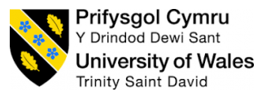

How a school develops one aspect of its SDP: a report that critically reflects on the actions, impact and evidence base.
 | Target | What I have done in this assignment...
Target 1 | Always develop arguments fully, ensuring that literature is used as support. | Ensured that all arguments are fully developed, drawing upon appropriate literature for reference.
Target 2 | Provide more creativity and innovation when offering solutions to issues. | Offered more innovative solutions to any potential issues, again using literature as support.

Student Number: 1903170

Word Count: 2712

Report Context
This report will focus upon one action point taken from a School Development Plan (SDP), designed by School X. Action point 1.3 of the school’s 2019/2020 strategy [see Appendix 1] plans to ensure opportunities for pupils to develop vocabulary across the curriculum. This target is one of five that have been grouped under an umbrella priority, which is to “raise standards in core subjects by deepening and extending vocabulary use.” This report will demonstrate how this action point is being implemented across the school and its impact will be critically measured using a wealth of evidence and literature.
School X is an urban Catholic primary school in Swansea that consists of around 500 pupils. The faith-based nature of the school produces a wide-ranging cohort demographic, in which 13% of pupils receive free school meals and 39% of pupils have English as an additional language (Welsh Government, 2019a). The school heavily considers the curriculum for 2022 throughout its SDP and is in advanced stages of implementing numerous features of the curriculum throughout the school.

School Development Plans
A school’s development process consists of multiple important stages, from initial self-evaluation to an eventual review of impact; SDPs therefore play a vital role in allowing each stage to smoothly progress from one to the next. Welsh Government (2014a, p. 7) suggests that there are four main stages to the school development planning cycle [see Figure 1] and this cycle allows a clear vision to be set for “what the school is aspiring to achieve.”
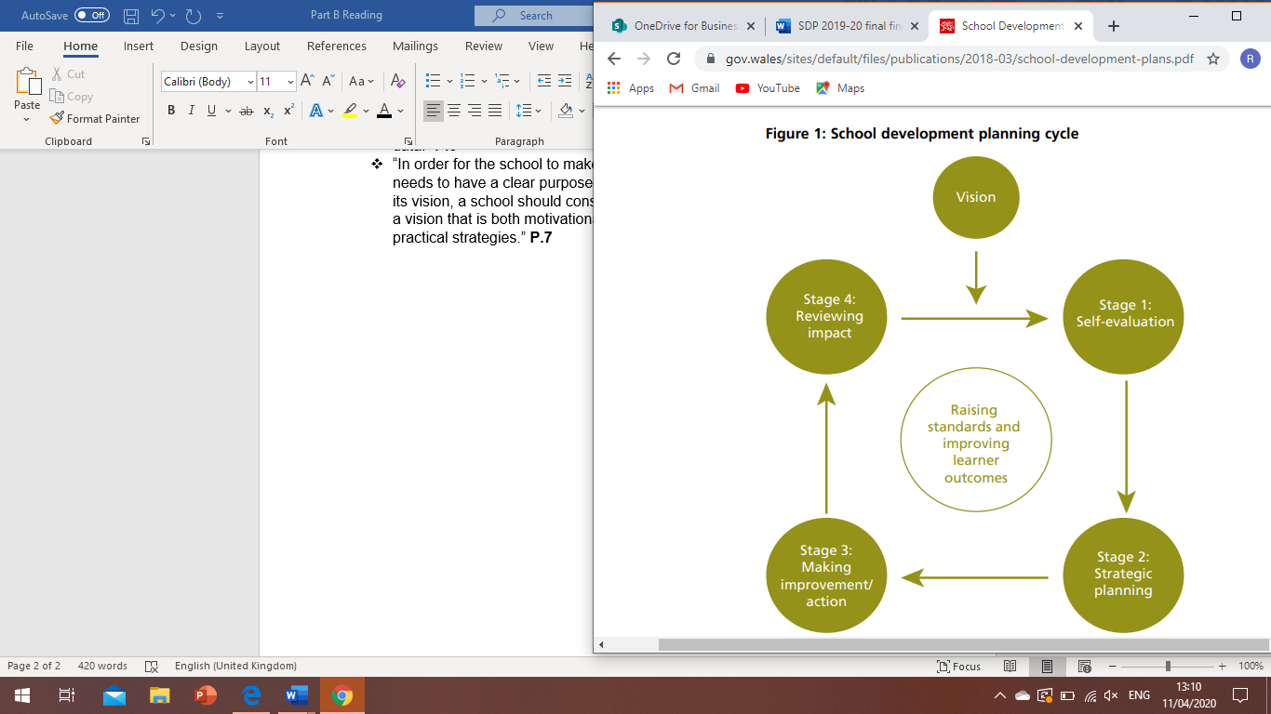
Figure 1. School development planning cycle (Estyn, 2014a).
The development of a more coherent school evaluation process across Wales, in which collective professional responsibility promotes improvement, is a major priority recommended by the OECD (2014).This self-evaluation process underpins the entirety of the SDP, in which the areas for development and main priorities in turn inform the strategic planning and implementation stages (Welsh Government, 2014b). School X’s SDP contains a number of aims and milestones that form part of its regular tracking procedures; much of this initial self-evaluation emerges from progress made on the previous year’s priorities and how this relates to the school’s Estyn post-inspection plan. Hanover Research (2014) stresses the importance of both internal and external reviews when evaluating performance and School X uses a productive balance of internal assessment and improvements suggested by Estyn when evaluating prior action.
It has been commonly emphasised that the process of strategic planning and target setting must involve all school partners and stakeholders, in order to produce effective outcomes across all elements of the school and its curriculum (Drakeford, 2012; Welsh Government, 2014a). Consequently, each stakeholder is able to bring individual support where necessary and success criteria for each target is able to be more explicit (Brighouse and Woods, 2013). Additionally, Hanover Research (2014, p.11) argues that development targets must be “rigorous yet attainable” – while challenging goals ensure that improvement occurs, if they become too unreasonable, this may lead to low stakeholder morale and may negatively affect school improvement. There are also instances where planned targets have become superficial in order to fulfil external pressures, often from governments, and thus targets must always remain innovative and realistic (Xaba, 2006). Schildkamp (2019) suggests that creating primarily whole school targets could be a solution to maintaining both high levels of challenge and success. However, it could be argued that assigning many action points to all staff stakeholders may become too overwhelming and therefore authentic, individual specialisms should be drawn upon when planning strategically.
The final stages of the development process are to implement the action points and to then review their impact. Organisations and academics again underline the value of all stakeholders during these stages, where staff and partners aid with the improvement of the school targets and then come together to collectively review the entire process (Brighouse and Woods, 1999; Drakeford, 2012). Moreover, in order to use SDPs to their fullest potential, they must be constantly updated throughout the implementation stage, while the impact review should consider the current context of the school (Welsh Government, 2014a).

Expanding Vocabulary across the Curriculum
Draft statutory guidance for Languages, Literacy and Communication (LLC) places much emphasis on the learning of relevant vocabulary across the curriculum, with equal focus given to the developing of vocabulary when speaking and writing (Welsh Government, 2019b). There are a variety of ways in which vocabulary can be effectively taught, via reading, seeing, hearing, and using words within meaningful contexts (Bintz, 2011). However, many studies suggest that the amount of instructional time allowed for vocabulary development is inadequate and therefore, as School X aims to do, devoting more time to vocabulary expansion across the curriculum is necessary (Graves, August and Mancilla-Martinez, 2012).
Allowing opportunities for learners to read regularly and widely is a common technique recommended by academics on how to expand vocabulary. Using repeated reading in combination with word meaning explanations is an effective method, in which direct explanation alongside visual context allows learners to make explicit connections between words and their meanings (Biemiller and Boote, 2006; Graves, August and Mancilla-Martinez, 2012). Importantly, this method is able to be employed widely across the curriculum in order to improve vocabulary. However, Bromley (2007, p.533) contends that “direct instruction in vocabulary influences comprehension more than any other factor” as it allows for greater focus upon spelling patterns and phonic sounds. It could be argued that a balanced diet of regular reading and direct instruction may be most beneficial in developing vocabulary across the curriculum.
Providing learners with important context and relating vocabulary to prior experiences can be very effective in developing word knowledge (Bromley, 2007). Graves (2016) goes a step further by suggesting that incorporating context and definitional information simultaneously is the strongest instruction method. Moreover, delving deeper into word meanings by using comparisons and contrasts, by focusing on prefixes and suffixes, or by simply focusing on the root word are the principal ways in which definitional information can be further supported. Blachowicz and Cobb (2007) also stress the role played by classroom environments in stimulating vocabulary development, where word walls, appropriate libraries and language games may all be present. Overall, no matter the selected pedagogical methods, learners must regularly encounter rich vocabulary instruction through a variety of contexts and mediums in order to extend their vocabulary knowledge throughout the curriculum (Graves, 2016).

Developing the Action Point
Action point 1.3 emerges on School X’s 2019/2020 SDP as a direct response to its most recent Estyn report, in which literacy skills are to become fully embedded through a meaningful approach to teaching and learning. Self-evaluation of the success of the previous year’s smaller goals allowed for the in-depth refinement and modification of each main priority area, in order to stimulate continuous progression. Furthermore, overall progress since the last Estyn inspection is analysed in relation to each main priority, and this helps to decide which priorities need more finetuning than others. This internal review of each action point and overarching priority is an extremely effective way of maintaining constant school improvement (Hanover Research, 2014).
In terms of planning, School X focuses strongly on deploying its staff and resources to their maximum potential. Although action point 1.3 is a target that is fundamentally assigned to “all staff”, the lead co-ordinator for LLC is allocated foremost responsibility for ensuring that this goal is achieved. Moreover, in line with government guidelines, the school addresses its “professional development needs” provision to ensure that the staff body is well-equipped with the knowledge and experience to sufficiently meet the objective (Welsh Government, 2012). This is done through termly subject area meetings, INSET days and after-school feedback sessions; a specific section of the SDP is also utilised to address a long-term staff development plan. The involvement of stakeholders does not occur regularly within planning. However, a specific action point of the SDP states the intention to provide stakeholders with a deeper understanding of school development via first-hand experiences involving pupils. This shows the school’s awareness of its need to improve in this area, as stakeholders can play a vital role in providing criticality within the context of school and curriculum development (Brighouse and Woods, 1999). Termly milestones [see Appendix 2] also allow regular internal reviews to occur and as a result, the SDP becomes actionable and the school is able to have a pragmatic approach towards meeting its targets (Hanover Research, 2014).
The school carefully shares its budget across the priorities, with each action point allocated a specific amount [see Appendix 2] to aid with its completion. The funding for action point 1.3 directly relates to how the school connects with its local community, which is another requirement put forward by Welsh Government for SDPs (2014a). It allows local guest speakers to visit, affords vocabulary expansion sessions with local schools, and provides learners the chance to attend events such as the Big Conversation. Consequently, learners may be exposed to a variety of real-life contexts in which vocabulary comprehension can thrive at its authentic best (Bromley, 2007).
There are a number of ways in which School X has implemented action point 1.3 of their SDP [see Appendix 3]. There is an overall focus on acknowledging and expanding vocabulary throughout the school day, and vocabulary should engulf all areas of the curriculum. The SDP lists various examples of materials that teachers have at their disposal in order to develop vocabulary, many of which would assist greatly in providing meaningful contexts and would allow words to be used actively in authentic ways (Bromley, 2007). Additionally, frequent encounters with new words provides learners with more opportunities to expand their comprehension of vocabulary and therefore by ensuring that all pupils are “word healthy”, School X aims to provide an increased exposure to new language (Graves, 2016).
Additional plans for improvement include the introduction of Vocabulary Ninja, colour-coded word walls in classrooms, and a greater emphasis on using individual “vocabulary attack” books. Vocabulary Ninja provides learners with daily, rich language that they are able to analyse and therefore understand in greater depth; it also allows teachers to create opportunities within the daily timetable to focus heavily on vocabulary development. Classroom word walls divide vocabulary into their word types and consider the relevant cross-curricular themes so that learners have constant reference to important vocabulary. This therefore allows pupils to be more word conscious as they become immersed in a word-rich environment (Blachowicz and Cobb, 2007). Furthermore, individual “vocabulary attack” books were introduced into the classroom during the previous academic year, but upon review senior management decided that more attention should be afforded to their use. Subsequently, individual classroom provision across the curriculum regularly includes the updating of vocabulary books, in which definitions and applicable examples are recorded. However, School X must ensure that this does not become token practice, as studies suggest that the use of language books without context or meaning has little effect on language development (Xaba, 2006; Bintz, 2011).
At the end of each academic year, the senior leadership team and governing body collaboratively measure the impact of each main priority [see Appendix 4], as directed by Welsh Government (2014a). For action point 1.3, the focal point of data analysis is pupil performance in National Tests, which will contribute largely to the appraisal of that specific target. For each main priority, if “good progress” has been made, the school reduces its emphasis on it. However, if “strong”, “satisfactory” or “limited” progress has been achieved, School X adjusts the priority for the forthcoming year, ensuring that more attention is afforded to the particular areas where progress has been deemed insufficient – an example of this is the greater significance of “vocabulary attack” books for 2019/2020. Through collaborative evaluation of the effectiveness of each priority, School X strives to allow standards to be raised and outcomes to be improved for all learners (Brighouse and Woods, 1999).

Reflection and Evaluation
Upon review, there are many ways in which School X utilises its SDP to its maximum potential. Termly reviews throughout each year allow the school to be pragmatic in its management of each priority and action point; Welsh Government (2014a) emphasises how development plans should be constantly live and thus through the regular evaluation and reconditioning of action points where necessary, School X produces an actionable and practical development process (Hanover Research, 2014). Furthermore, it is clear that each of the main stages in Figure 1 have been carefully considered in this SDP and this helps to create a constructive balance between planning, implementing and reviewing (Welsh Government, 2014b).
Within action point 1.3, the school has allocated a vast amount of resources and ideas to allow this target to be met effectively [see Appendix 2 and 3]. The SDP lists multiple ways in which learners’ vocabulary may be developed across the curriculum and consequently, teachers have been provided with ample support to assist with improved teaching and learning. Moreover, School X not only recognises the importance of providing learners with maximum exposure to a variety of new language, but also plans for the future curriculum by incorporating authentic contexts for learning and promoting cross-curricular links (Donaldson, 2015). Through providing contextual information and constant real-life examples, combined with the multifarious ways in which definitional information is learned, School X attempts to maximise the success of this action point in 2019/2020.
There are also ways in which some elements of School X’s development plan may be improved. Although stakeholders are heavily involved in the first and final stages of the school development cycle shown in Figure 1, there is little evidence to suggest that they play a major role in the planning or implementation of targets. Welsh Government (2014a) does not explicitly communicate that stakeholders must be involved during Stage 3 of the development cycle, however it could be argued that recurrent links with the community and reviews with external stakeholders throughout the school year would be extremely beneficial for the school’s ambition to constantly update its SDP targets. Through this more regular involvement, appreciative enquiry and collective review would go even further towards creating a fully pragmatic document (Brighouse and Woods, 1999). In addition, many of the SDP’s action points are assigned to the entire staff body and it could be argued that this does not allow for enough target-specific progress to occur. While some action points are delegated to certain staff members, further devolution of the majority of responsibilities may allow goals to be shared more evenly; this would potentially result in more analogous progress across the entire SDP.
In planning and implementing action point 1.3, School X has little room for improvement, albeit the evaluation process could be further evolved. Schildkamp (2019) highlights the renewed attention that is afforded to formative assessment and therefore by using National Tests results as its primary review method, School X may be neglecting other important data. Pupil voice meetings, internal curriculum lead reviews or external stakeholder analysis would arguably be equally as useful in providing the necessary data upon review.

Summary
Overall, this review of School X’s development plan has been extremely beneficial in a number of ways. Firstly, it has provided the opportunity to review an important school document in great depth – a document that will become exceedingly important throughout teaching practice. This SDP was a great example of how a school plans for, implements, and reviews multiple targets across an academic year. Moreover, there has been the opportunity to delve deeper into a specific action point, the school’s motivations in selecting and developing it, and its corresponding literature. This will also prove very important for the future, particularly if I am assigned my own core responsibilities within a development plan. I would be able to better exercise corporate responsibility and lead colleagues and projects, in line with current professional teaching standards (Welsh Government, 2019c).
In terms of the specific action point, this review has further stressed to me the importance of creating authentic contexts when teaching, while also maintaining consistent cross-curricular links to allow learners to make strong connections between a variety of content. Many of the action points outlined in School X’s SDP look towards the new curriculum for 2022 and Donaldson’s (2015) pedagogical principles, and this experience has further highlighted the importance of constant, effective school development, in order to develop and maintain a successful curriculum throughout Wales.

Reference List
Biemiller, A. and Boote, C. (2006) ‘An effective method for building meaning vocabulary in primary grades’, Journal of Educational Psychology, 98(1), pp. 44-62.

Bintz, W. (2011) ‘Teaching vocabulary across the curriculum’, Middle School Journal, 42(4), pp. 44-53.

Blachowicz, C. and Cobb, C. (2007) Teaching vocabulary across the content areas. Virginia: ASCD.

Brighouse, T. and Woods, D. (1999) How to improve your school. London: Routledge.

Brighouse, T. and Woods, D. (2013) The A-Z of school improvement: principles and practice. London: Bloomsbury.

Bromley, K. (2007) ‘Nine things every teacher should know about words and vocabulary instruction’, Journal of Adolescent & Adult Literacy, 50(7), pp. 528-537.

Donaldson, G. (2015) Successful Futures: Independent Review of Curriculum and Assessment Arrangements in Wales. Available at: https://gov.wales/sites/default/ files/publications/2018-03/successful-futures.pdf (Accessed: 19th March 2020).

Drakeford, B. (2012) The whole-school audit: development planning for primary and special schools. Oxford: Routledge.

Estyn (2014) Estyn Inspection Report [of School X]. Available at: https://www.estyn.gov.wales/provider/6703309 (Accessed: 13th March 2020).

Graves, M. (2016) The vocabulary book: learning and instruction. New York: Teachers College Press

Graves, M., August, D., and Mancilla-Martinez, J. (2012) Teaching vocabulary to English language learners. New York: Teachers College Press.

Hanover Research (2014) Best Practices for School Improvement Planning. Available at: https://www.hanoverresearch.com/media/Best-Practices-for-School-Improvement-Planning.pdf (Accessed: 25th March 2020).

OECD (2014) Improving Schools in Wales: An OECD perspective. Available at: https://www.oecd.org/education/Improving-schools-in-Wales.pdf (Accessed: 22nd March 2020).

Schildkamp, K. (2019) ‘Data-based decision-making for school improvement: Research insights and gaps’, Educational Research, 61(3), pp. 257-273.

Welsh Government (2012) Performance management for teachers. Available at: https://hwb.gov.wales/storage/068248bb-698a-46a9-b120-5520268f6762/performance-management-for-teachers.pdf (Accessed: 25th March 2020).

Welsh Government (2014a) School development plans. Available at: https://gov.wales/sites/default/files/publications/2018-03/school-development-plans.pdf (Accessed: 25th March 2020).

Welsh Government (2014b) Rewriting the future: Raising ambition and attainment in Welsh schools. Available at: http://www.wales.gov.uk/topics/educationandskills/schoolshome/raisingstandards/rewriting-the-future-schools (Accessed: 25th March 2020).

Welsh Government (2019a) My Local School [for School X]. Available at: http://mylocalschool.gov.wales/School/6703309?lang=en (Accessed: 13th March 2020).

Welsh Government (2019b) Draft statutory guidance. Area of learning and experience: languages, literacy and communication. Available at: https://dera.ioe.ac.uk/33314/6/draft-statutory-guidance-languages-literacy-and-communication.pdf (Accessed: 14th March 2020).

Welsh Government (2019c) Professional standards for teaching and leadership. Available at: https://hwb.gov.wales/storage/19bc948b-8a3f-41e0-944a-7bf2cadf7d18/professional-standards-for-teaching-and-leadership-interactive-pdf-for-pc.pdf (Accessed: 25th March 2020).

Xaba, M. (2006) ‘The difficulties of school development planning’, South African Journal of Education, 26(1), pp. 15-26.

Appendix 1

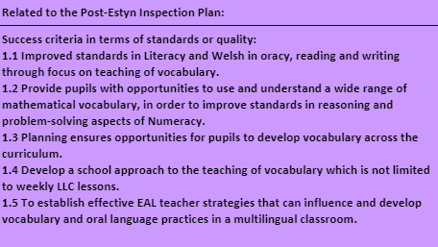

Action point 1.3: Planning ensures opportunities for pupils to develop vocabulary across the curriculum.

Appendix 2

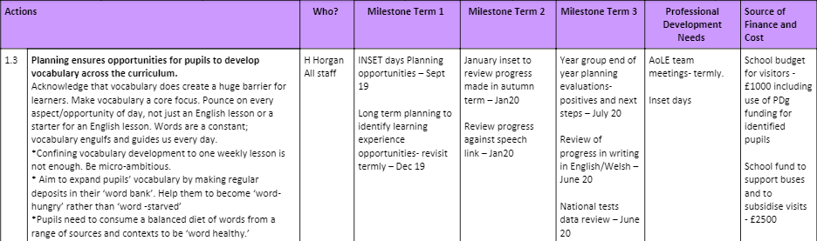

Termly milestones allow School X to internally review its performance on a regular basis.

Appendix 3
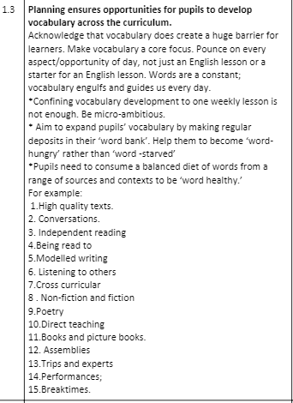

Some of the planned actions in order to meet action point 1.3.

Appendix 4

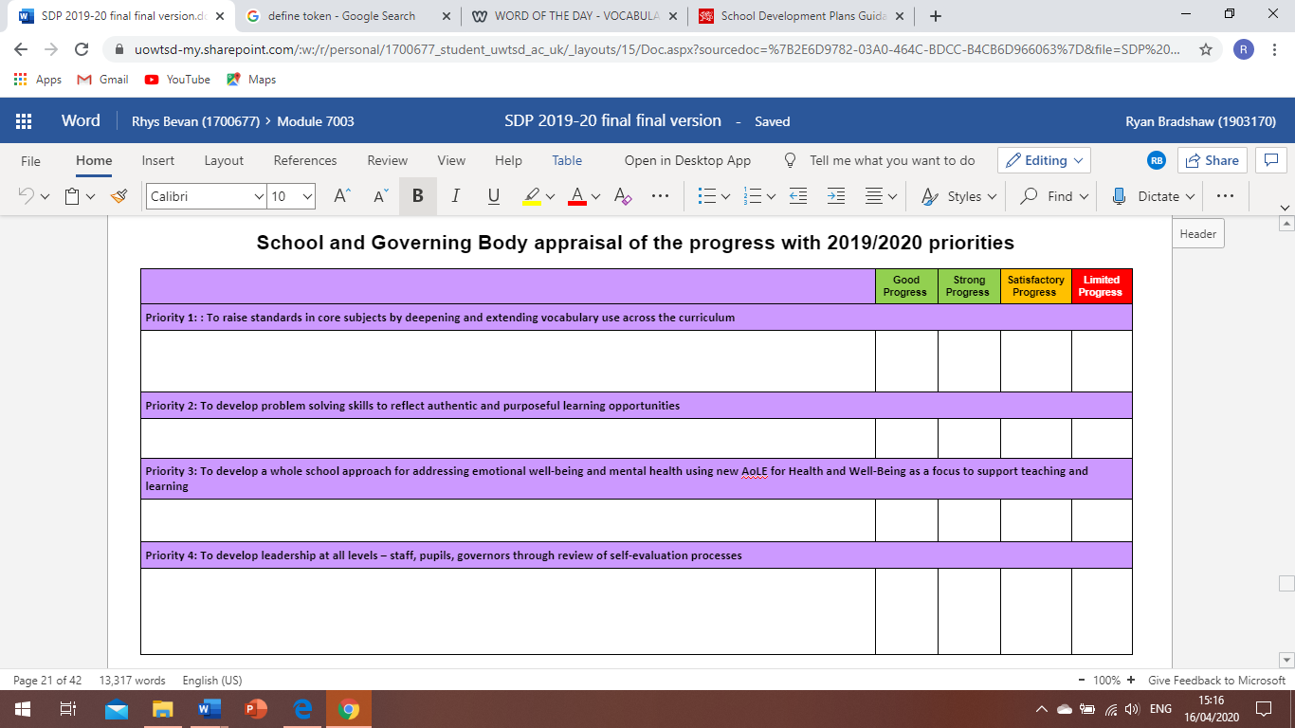

2019/2020 appraisal template of School X’s priorities.

