University of Wales Trinity Saint David

Foreign Languages and Cultural Awareness

Student: Nicolae Feraru 2225689 Lecturer: Giulia Chifari

Module: BMIH5003 Wordcount: 1003

Intercultural competence report

Executive summary
This report has found significant differences between Italian and English social and business culture, with Italians being found as more social and less individualistic. Next this report has found that the reason for these deep-rooted differences being due to the warm weather, the family oriented Italian culture and the concept of “la dolce vita”, then this report uncovers that the CEO’s national culture impacts the subordinates. And lastly the recommendations were to train all new employees on cultural differences, language fluency and taking advantage of their multiculturalism.

Content table
Introduction
Key differences
Analysis
Challenges of intercultural Leadership
Conclusion
Recommendations
References

Introduction
This report is going to cover the key differences between England and Italy, concerning the hospitality sectors, then this report is going to analyse and compare the two countries using the GLOBE projects culture and leadership study, lastly discussing the challenges of intercultural leadership in the hospitality industry, looking over areas of conflict in managing an intercultural team.

Key differences
The first notable difference between England and Italy concerning work is the concept of riposo in Italy, where most businesses except restaurants shut down for the afternoon, so that employees can rest during the days hottest hours, only to return later on to carry on business. This is something that English businesses do not have simply due to the lack of necessity, as English weather tends to stay relatively cool and workers feel comfortable throughout the day, which doesn’t compare to Italian weather that may sometimes reach 37+ degrees Celsius in the hotter days. So its clear to see why Italians take rests during the day. (Bartlett, 2014)

Another difference is attitudes to punctuality, with English business and social culture placing a high value on punctuality, as turning up late is seen as rude, and a sign of disrespect. While in Italy, turning up late a few minutes often goes unnoticed and isnt discussed or looked down upon. (Santella, 2009)

While communication is also incredibly different, with Italians usually speaking very passionately, and direct, and are not afraid to be loud, angry or talk about more taboo subjects, while Italians are very animated during conversations. Contrary to English communication culture which tends to understate and avoid conflict, while body language is kept minimal and tone is also kept quiet and polite. (Lewis, 2009)

Analysis
Analysing the differences it is clear that Italians are a much more social and laid back society, while English culture is more individualistic and polite. But how so? This comes from the deep-rooted traditions and attitudes to life, Italians are much more social due to many factors, with one of them being the much more family oriented culture of Italians, it is normal for Italians to have a much larger family with 8+ cousins, all being close together and seeing each other regularly, while big family events that gather over 20 members of the extended family als being normal, compare that to the much smaller and isolated families within the UK, where cousins aren’t usually very close, and family events are much smaller. (Harper, 2010)

‘’La dolce vita’’ meaning ‘’the sweet life’’ may also be another reason why Italians are much more social, with this concept encouraging Italians to live their best life, and enjoy all of lifes finest delicacies, couple that with the constant beautiful weather that also encourages people to get out and socialise. Contrary to the UKs emphasis on personal success, saving, and enjoying life on planned occasions. (Ricciardi, 2012)

Challenges of Intercultural Leadership
The biggest challenge of intercultural leadership is the differences between leader and subordinates, the transitional period until the leader has made note of everyone’s cultural differences and adapted to them, there may be conflict within the hotel, for example using the example from earlier, let’s say the Italian employees joining the Hotel in July turn up to work 2 minutes late. The CEO will understandably become angry with me, the general manager for allowing behaviour like this, forcing me to become stricter on timing and provoking the Italian worker to break their cultural norms, potentially causing arguments. (Barnett, 2018)

Another factor to consider is the national culture of the CEO, as GLOBE’s studies have found national culture to directly impact a CEO’s ideal leadership style, which then affects their behaviour and ultimately their effectiveness, the graph below visualises this:

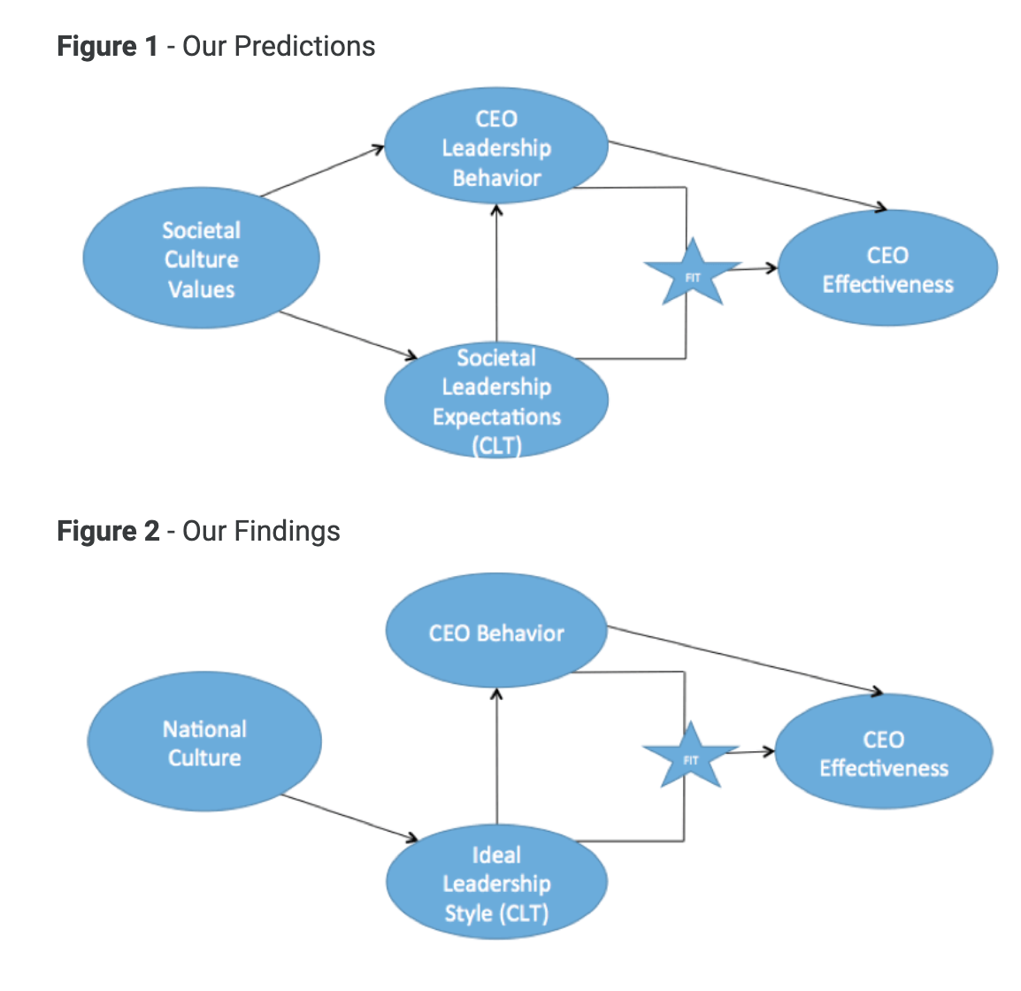

This means that to some degree the team will have to get used to the CEO’s culture and adapt to that culture, as the leadership style and behaviour will directly force that. (Cherkowski, 2016)

Another challenge could be the communication barriers that come with a multicultural hotel, with some words or metaphors not making sense in the other language, in the hospitality industry where operations usually get chaotic due to how busy a hotel can get, those few seconds really matter, and the language barrier can force crucial mistakes and add to the chaos. While another aspect of communication challenges is the difficulty in motivating staff, When I will be managing these new Italian employees from July onwards, I may struggle to motivate them to work harder, as studies have shown that the right words at the right time can motivate the human mind to become more productive, by there being a language barrier im therefore going to be struggling to say the right words that everyone can understand. (Armstrong, 2020)

Conclusion
In conclusion there are multiple differences between English and Italian culture, with the reason being deep-rooted social differences like ‘’la dolce vita’’, although these differences can cause problems in an multicultural business setting, with differences in culture, and the CEO’s national culture also leaking into the rest of the staff.

Recommendations
My recommendation for the hotel is that firstly all new Italian staff are trained on the most common cultural differences and educated on how to conduct while being in the UK. This is to ensure that arguments stemming from cultural differences are kept to a minimum. (Sucher, 2015)
Another recommendation is to make sure the staff can understand English to an acceptable level and also speak it semi-fluently, this is to make sure the hotel won’t suffer from the communication difficulties that could impede daily operations or force mistakes during busy hours. (Nkitseng, 2019)

My final recommendation is to take advantage of the influx of Italian workers, and play to the advantage of having authentic Italians at the hotel, With the hotel being a multicultural hotel and spa, it should include Italian specials for its restaurant and/or breakfast, having the Italian staff bringing the specialties and engaging with the customer directly about the history of the dish and about Italy itself, making the guests feel like they’re in Italy builds rapport and can benefit the hotel massively by playing to their strengths.

References

Bartlett, D.M., 2014. Socio-economics and business organisation in the chestnut industry: a comparison between Italy (Tuscany) and England (Kent).

Santella, P., Drago, C., Polo, A. and Gagliardi, E., 2009. A Comparison among the director networks in the main listed companies in France, Germany, Italy, and the United Kingdom.

Lewis, A., Carrera, S., Cullis, J. and Jones, P., 2009. Individual, cognitive and cultural differences in tax compliance: UK and Italy compared. Journal of Economic Psychology, 30(3), pp.431-445.

Harper, D. and Faccioli, P., 2010. The Italian way: food and social life. University of Chicago Press.

Ricciardi, A., 2012. After La Dolce Vita: A Cultural Prehistory of Berlusconi's Italy. Stanford University Press.

Barnett, L. and Carter, E., 2018, May. Challenges to leadership in intercultural settings: intercultural interactions and knowledge management: research From Thailand. In ICMLG 2018 6th International Conference on Management Leadership and Governance (pp. 60-67).

Cherkowski, S. and Ragoonaden, K., 2016. Leadership for diversity: Intercultural communication competence as professional delveopment. Teacher Learning and Professional Development, 1(1).

Armstrong, J.P., 2020. Assessing intercultural competence in international leadership courses: Developing the global leader. Journal of Leadership Education, 19(4), pp.1-19.

Sucher, W. and Cheung, C., 2015. The relationship between hotel employees’ cross-cultural competency and team performance in multi-national hotel companies. International Journal of Hospitality Management, 49, pp.93-104.

Nkitseng, T.C., 2019. Effective Cultural Diversity Training Programmes for Hotels. University of Johannesburg (South Africa).

