Sean Ellis
P147196
Module: MX6X01791
Lecturers: John Caroll and julian Hainsworth |
Game ‘Achievements’ as Rewards in Games

Declaration
This document is all the work of Sean Ellis. Any work that is not, is correctly referenced.
Signed:

06/12/2017

Abstract
This study analysed the use of game Achievements to reward players in video games. A variety of games were examined and their use of Achievements discussed, highlighting the implications they could have on the player’s experience.
Alternative methods to reward players were discussed, and the conclusion was drawn that Achievements should not act as a replacement, but should be used to add an additional layer of challenge.
The potential exploitation of players with a passion for unlocking Achievements was examined, by discussing a number of games that had been filled with easily earned rewards.
Suggestions were made on how to implement Achievements that add value, and negative applications of the reward systems were highlighted.
This dissertation determined that game Achievements offer multiple benefits to players, but must be used responsibly by developers.

Contents
Introduction 4
Literature Review 5
Guiding Players 7
Just for “Fun” 8
Bragging Rights 9
Affecting Player Immersion 10
Open to Exploitation 12
Striking the Right Difficulty 13
Alternative rewards in games 15
Adding Value to Achievements 17
Conclusion 18
References 19
Image References 21
Bibliography 22

Introduction
Several types of rewards exist for video games, including high scores and bonus levels, but in 2004 Microsoft introduced a new type of award, Achievements.
Achievements are awarded to players, via on-screen notifications, for completing tasks set by the game’s developers. Since their introduction, Achievements have been adopted in various forms by a number of other platforms, including Sony’s PlayStation and Valve’s Steam.
The challenges set to earn the Achievements vary considerably, with many asking players to apply high levels of skill, collect items or explore hidden secrets.
The purpose of this dissertation is to analyse several Achievements in a variety of games, and discuss the implications they have on the player. The conclusion will discuss how Achievements can be implemented to improve game experiences, and what practices should be avoided.

Literature Review
There is a scientific explanation to human’s urge for recognition and reward. When rewarded, the human brain releases a neurotransmitter called dopamine, which is a message that travels through the nervous system. Dr Eric Berg explains “this neurotransmitter has the effect of giving you pleasure” (Dr. E. Berg, 2017).
As children, many were rewarded with stickers to encourage certain behaviours, later in school, grades are representations of hard work and achievements. Even as adults, in workplaces, the ‘stick and carrot’ system is often still applied, which sees employers rewarded and incentivised for extra efforts. Career analyst, Dan Pink, explains that the modern mentality of employers is often “If you want people to work better, you reward them, right? Bonus, commissions, incentivise them”. (Ted, 2009)
Computer games also offer rewards, and these come in a variety of forms. Game Achievements, in their conventional sense, were first introduced on Microsoft’s Xbox 360. “Achievements are high scores with personality. Debuting with Halo 2 on the Xbox 360” (S. Rogers, 2014). On the Xbox platform, when players complete certain goals set by the game’s developers, they receive an on-screen notification stating, “Achievement Unlocked” (see image 1). Lists in the console’s menu inform the players of the conditions that must be met to unlock the rewards.

Image 1: Xbox Achievement notification
Microsoft’s Achievements are accompanied by points, the number of which is usually (but not always) determined by the difficulty of the challenge. The points are added to the Gamerscore, which acts as a high score that spans across all games that have been played on the Xbox system.
Even after completion, players can be tempted to revisit a game to earn more achievements and play in different ways. “Achievements are a great way to for the designer to point out to players the gameplay concepts that they otherwise may not think of attempting” (S. Rogers, 2014). As an example, the game ‘Lego Harry Potter Years 1-4’ offers players an achievement for playing as a character named Snape, and completing a challenge whilst hiding in a barrel. (Gamesradar 2013)
Valve’s PC gaming platform, Steam, also offers Achievements, minus the Gamerscore found on Microsoft’s platform, and Sony’s PlayStation rewards players with Trophies, ranking from bronze to platinum. When this report discusses “Achievements”, it refers to the digital rewards available on all three platforms.
Aside from using Achievements, games use many other forms of rewards. Arkane Studio’s game, Dishonoured (2012), offers multiple endings, which are unlocked based on the players choices and performance. In addition, players are often rewarded with items, such as weapons or armour, that can help them progress through the game or make the experience more enjoyable. Aesthetic rewards, that have no impact on gameplay, can also be found in games such as Battlefield 1, where players are given new textures, called skins, to apply to their weapons. This allows players to customise their avatars for online matches, which in turn shows the community that they are of a certain level or have accomplished a certain goal.
Rewards don’t always have to be tangible, digital gifts though. Richard Rouse explains in his book, ‘Game Design Theory and Practice’ that players can also be awarded with new and unexpected areas that are textured or lit in different ways (R. Rouse, 2004). Examples of this could include a hidden cave with reflecting lights dancing off the rocks, or a suddenly bright, secret chamber with golden walls and contrasting rubies. But even subtler rewards can provide a sense of accomplishment; “audio-visual bells and whistles” as Richard Rouse describes them, such as a chime played in the Zelda series when discovering a treasure chest, are a great way to let players know they are doing something right
Even in non-digital games, such as board-games, players are often rewarded as a means of motivation. Monopoly sees players becoming rich as they earn more money and own more properties, and checkers allows players to stack their pieces on top of each other to create more powerful foes once they have reached the other side of the board. Like computer games, role playing board-games allow dungeon masters to award players with spells, currency or weapons. “There are also alternative rewards you can give outside of both money and Items. You can give bonus experience points if someone does something really cool in a game or completes a major story arc” explains Matt Mercer, Dungeon Master for the TV show, Critical Role. (Geek and Sundry, 2016)

Guiding Players
Burnout Paradise is a racing game that applies Achievements for purposes beyond ‘challenge and reward’. It implements them in a way that guides players through its open world, and exposes them to many of its features. Journalist for website Game Informer, Andrew Reiner, said in an article about Achievement ‘Do’s and Don’ts’, “Burnout Paradise and Gears of War 2 are the perfect examples. With dedicated achievement sets for each mode (ranging from the “try it out” type of achievement to the “give it your all” style), these games effectively use achievements as a guided tour to new gameplay innovations.” (Gam Informer, 2009)
Looking through the list of Achievements, it becomes apparent that many of them are used to introduce the player to new mechanics. One such Achievement is called “Looking Good”, for which the description is “Repair your first wrecked car”. In Burnout Paradise, cars take damage when players crash into other racers or objects, which in turn affects the performance of the vehicle. The “Looking Good” achievement encourages players to visit a repair shop, which can help introduce them to the mechanic of spending in-game currency to fix any damage sustained whilst racing or exploring.
Other Achievements, including “Off the Beaten Path”, which asks players to drive through 25 gates in Paradise City, encourage and reward exploration. Crashing through gates can open up previously inaccessible routes that often reveal more secrets, short cuts or challenges. This sort of implementation of Achievements in video games can lead to a cascade of rewards, where one challenge leads a player to another, keeping the player motivated and engaged.

Just for “Fun”
In some cases, developers use Achievements to promote experimentation or to provide a chance to experience the game in different ways. Many Achievements can be perceived as humorous and have little to no relevance to the core structure of the game. Video Game enthusiast and writer for Kotaku, Kevin Wong, said “My favourite trophies and achievements in video games are the gimmick-based ones. They’re not about finishing a level or getting a certain amount of headshots. They’re about doing something specific, often something outlandish, silly, deliberately provocative, or plain screwed up”. (Kotaku, 2016)
In role playing game Fable 2 (2008), developer Lion Head Studios set players several tasks that have no effect on the gameplay or the story’s outcome. In one instance, players are rewarded with “The Goth” Achievement for dying their character’s hair black and wearing black clothes. Although meeting these requirements does not have an impact on the mechanics or the player’s progression, it encourages them to customise their character and make them look unique.
Other Achievements such as one found in Brothers (2015), developed by game studio Star Breeze, can be unlocked by interacting with the game’s world and characters. Early in the game, an NPC (Non-Player Character) can be seen playing with a ball. The player can approach the little girl and take the ball off her, after which they can either give it back, keep hold of it or throw it down the lane. However, if the player explores a little further and throws the ball down a well, they unlock the “Wishing Well” Achievement. Once again, players are rewarded for trying different things that have no relevance to the overall goal of the game.
These sorts of rewards can open the player’s eyes to other aspects of the game, and encourage them to experiment with objects and NPCs in ways they otherwise may not have.
Designer and founder of computer game studio, Misfits Attics, Tim Keenan, explained in an interview with gaming website, True Achievements, that he likes to reward players for doing things that aren’t necessary to complete a game, and points out that he likes his Achievements to be fun. “I think half the fun is naming the achievement, so if we can come up with some humorous or ironic titles for the extra things players will do, all the more fun”. (True Achievements, 2012).

Bragging Rights
Many games offer Achievements for skill based tasks, such as Blizzard Entertainment’s online shooter, Overwatch, which challenges players to “Win 100 games in Quick or Competitive Play”. Likewise, the tactical first-person game, Counter Strike: Global Offence, rewards players for killing 10,000 enemies.
Game designer Scott Rogers explains that many gamers thrive on competition, even if it is against themselves, and that they “love having the bragging rights that comes with getting a high score” (S. Rogers, 2014)
According to researchers, Diana I. Tamir and Jason P. Mitchell, during daily conversations people spend between 30% and 40% percent of the time talking about themselves. The studies conducted in Harvard University suggest that, like when being rewarded, neurotransmitters are released during self-disclosure “Here, we suggest that humans so willingly self-disclose because doing so represents an event with intrinsic value, in the same way as with primary rewards such as food and sex” (Proceeding of National Academy of Sciences of the United States of America, 2012).
This research, combined with the statement made by Scott Rogers, could support the theory that some players enjoy growing their library of digital rewards, so they can show the rest of the world what they have accomplished.
During online matches, players can see how many Trophies or Achievements their opponents and team mates have, or they can simply search for recently met players or friends to compare statistics.
“For those that love to collect them, Trophies are that gold star of recognition” (PlayStationLifeStyle, 2017)

Affecting Player Immersion
When designing games, many developers strive to make players forget about their surroundings and feel completely immersed in a digital world. When discussing player immersion, game designer Richard Rouse explains “They have forgotten that they are playing a game at all, just as a film audience may forget they are in a theatre or a book’s reader may become completely swept up in the lives of the story’s characters” (R. Rouse, 2004).
Enslaved: Odyssey to the West (2010), developed by Ninja Theory, is a post-apocalyptic game in which machines have brought upon the end of humanity (see image 2). Players are introduced to a character called Pigsy, who over time becomes friends with the protagonist, Monkey. During an interview with Eurogamer, the game’s lead writer, Tameem Antoniades, discusses the interaction between players and NPCs. “How much further could we push player empathy? Can you feel all the kinds of feelings you would do in a real relationship? Protection, disappointment, comfort, derision and so on?”
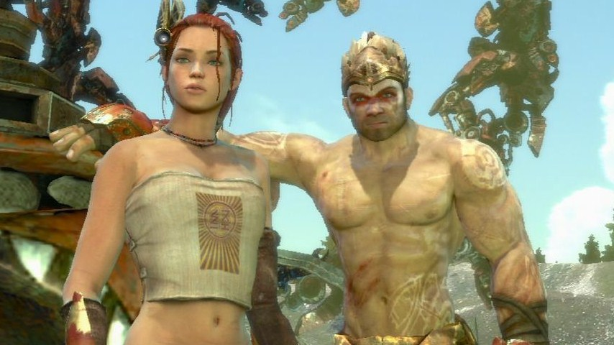
Image 2: Enslaved: Odyssey to the West
However, during one of the game’s closing scenes, Pigsy sacrifices himself to save some of the other characters in the game. “It’s a selfless act that calls for a moment of grief, yet immediately after this scene an achievement appears with the words “Smoky bacon,” thus devaluing the importance of the character’s sacrifice and showcasing the disconnect between the game’s mechanics and its narrative”, explains entertainment and culture journalist, Esmeralda Portillo (Gamecrate, 2014).
This example demonstrates that a poorly timed, and titled, Achievement notification can break the immersion that developers aim to create. Ninja Theory, could have given the Achievement a more appropriate name, such as “To Lost Friends”, which could have enforced the feeling of empathy Tameen Anotoniades discussed in this interview. However, instead of using this opportunity, a humorous name was assigned to the Achievement, which directly affected a player’s experience.
Scott Rogers explains his book, Level UP, that other developers focus on reducing the amount of information displayed in the HUD (Heads Up Display) to provide a clear, undisrupted view of the game’s world. “The result makes for a very cinematic and immersive experience”. An example of this can be found in Dead Space (2008), a game that features no HUD, and instead conveys information, such as health and ammo, with lit cells on the protagonist’s armour. Despite these design choices, Achievement notifications still regularly flash up on the screen, congratulating the player for “crafting a weapon” or “defeating 30 enemies”, which could potentially serve as reminders that they are only playing a game. (Xbox Achievements, 2008)
With this in mind, timing should be considered as to when Achievement notifications are triggered. Instead of displaying notifications during cutscenes or during a game’s action, they could be displayed at the end of a level or during a loading screen. This would allow the player to enjoy the experience without any interruption, and could keep them immersed in the game’s universe.

Open to Exploitation
Achievement Hunter, as the name suggests, is a term for players with a commitment to unlocking Achievements in video games. Websites, such as True Achievements, publish articles on what challenges to expect in upcoming games, as well as lists and guides on how to unlock Achievements in existing games. Along with forums for players to discuss strategies and share experiences, True Achievements also provides a leader-board, so players can keep track of their rank as a “Hunter”.
Websites, including Game Informer, offer lists of games featuring Achievements that are easy to unlock. Many Achievement Hunters use these lists, and other resources, to decide which games to purchase next.
100% Achievements is an online community group, with over 35,000 members that do not consider a game to be completed, until every single Achievement has been earned. In an article for PC Gamer, journalist, Tyler Wilde, interviews one of the groups long standing members. “You know, I think it gets more and more addictive, I guess. There’s definitely a line you cross eventually as an Achievement Hunter where you’re searching out games for their achievements”. (PC Gamer, 2016)
Gaming website Kotaku reported “Some developers have recently taken to front-loading subpar games with thousands of achievements. Now a single click can have you drowning in achievements, for better or worse. Steam users call these sorts of games Achievement Spam.” (Kotaku, 2017) This could be an indication that some developers are exploiting reward systems, and targeting Achievement enthusiasts to boost their sales.
Further supporting this theory, designer and CEO of game studio Gearbox, Randy Pitchford, explains that the inclusion of easily earned Achievements can potentially increase a game’s sales “The time it takes to include easy Achievements is minimal, because you're designing Achievements anyway, and you can probably affect your sales by something like 10 and 40 thousand units” (Destroctoid, 2010).
‘Running through Russia’, a game released on Steam in May 2017, features 4000 Achievements. To put this into perspective, Burnout Paradise featured a total of 50 Achievements. Gaming website, PC Gamer, reported “Our own Tyler Wilde played it for around two minutes and unlocked 49 achievements” and goes on to advise “Running through Russia is not a very good game”. (PC Gamer, 2017)
In June 2017, gaming website, Polygon, reported that Sony had removed a title from the PlayStation Network, called 1000 Top Rated (Polygon, 2017). Platinum Trophies are designed to be the most difficult to unlock, as they require every bronze, silver and gold Trophy to be earned in a game before they are awarded. However, 1000 Top Rated, which saw players solving puzzles by sliding pictures together, reportedly awarded a Platinum Trophy after as little as 20 minutes of gameplay. The developers made no secret of this either. In the launch trailer for the, the game is advertised as “the world’s fastest platinum Trophy game” (GameTrailers, 2017).
Although Sony has not officially revealed why the game has been removed from the store, the developer, which calls itself Top Rated, said “Sony has pulled the game temporarily and asked me to change the game's name & not mention trophies in the Store trailer” (Polygon, 2017). If this is true, it would suggest that Sony’s only issue lies with the marketing of the game, and not the amount of time it takes to earn a platinum Trophy.

Striking the Right Difficulty
Whereas many titles challenge players to explore their worlds or beat high-scores, some games award their Achievements for tasks as simple as completing a level.
The Walking Dead series, by developer Tell Tale, is an episodic, story driven game that offers players multiple-choice decisions, which can directly affect the narrative. However, all of the Achievements found in season one, two and three, are unlocked during key points of the campaign, regardless of what choices the player has made (see image 3). Tell Tale could have rewarded players based on personal decisions they made, encouraging them to complete the game multiple times whilst making different choices, but instead everyone received the same Achievements providing they completed the game.

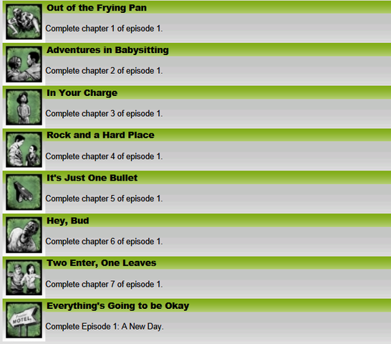
Image 3: The Walking Dead Season 1 Achievements

In a different example, puzzle and platforming game, Contrast (2013), developed by Compulsion Games, rewards players with an Achievement every time they finish a level.
“Contrast pumps out achievements when any stage is finished” (Game Informer, 2017)
These types of Achievements offer no new experiences or challenges, as completing every level is already a requirement to finish the game. Although this may tempt Achievement Hunters to continue playing, even if they are no longer invested in the story, mechanics or characters, a game should always be enjoyable by its own merits. Players should be rewarded for advancing from one level to the next, but there are many other ways to achieve this.
In his book, Well Played 1.0: Video Games, Value and Meaning, Drew Davidson uses Super Mario Bros as an example. He explains that at the end of a level, players are rewarded with a mini game in which the protagonist, Mario, must reach the top of a flag pole. “It’s a fascinating pattern that has rarely been copied, but I find it absolutely brilliant: reward the player for completing your level by letting them compete in a fun, low-risk minigame” (D. Davidson, 2010). The visuals also change between every level in Super Mario Bros, ranging from bright blue skies to dark dungeons beneath the ground, rewarding players with something new to look at every time they reach a new stage.
On the opposite end of the spectrum, are Achievements that are infamously difficult to unlock, with many requiring vast amounts of time, focus and repetition.
Mega Man 10, by developer Capcom, offers an Achievement called Mr Perfect, that according to gaming website, IGN, “only masochists should attempt” (IGN, 2015). The conditions required to unlock this reward, ask players to complete the entire game without taking any damage. This means a player could reach the final level, take a single hit from an enemy, and have to start over again.
“Mega Man 10 Achievements are typically unreasonable” (Kutaku, 2010)
Musical party game, Rockband 2, sees participants playing and singing along to licensed songs using guitar, drum and microphone peripherals. One of the game’s Achievements, ‘The Bladder of Steel’, challenges players to complete a playlist of 84 songs without pressing the pause button. The playlist lasts a reported six hours, with no way for players to take a break without failing the task (Xbox Achievements, 2008). Instead of adding anything new to the game, the Bladder of Steel Achievement simply challenges the players patience, stamina and perseverance.
Achievements should enhance a game and be fun for players to unlock. To make a challenge enjoyable, the right difficulty balance must be struck to engage the player. Make them too easy and they won’t feel rewarding, make them too hard and players could get discouraged and lose interest (N.Whitton, 2012). In his book about video game design, Guy W. Lecky-Thompson, discusses the importance of making players feel like they have accomplished something, and deserve the rewards. “The risks have to be paved to that the player believes he is justified in taking the reward because it was earned” (G. W. Lecky-Thompson, 2007)

Alternative rewards in games
Aside from using conventional Achievement systems to motivate players, some developers use a wide variety of other methods to engage players. Many were used before Achievements were introduced in 2004, and are still implemented today.
Super Mario 3D World, developed by Nintendo, is a game that features several characters with different skills (see image 4). Some characters can jump higher or further, some can run faster, and others have different types of attacks. Power-ups that can be found within the game’s levels, grant temporary abilities such as climbing walls or throwing fire balls, until the player takes damage.
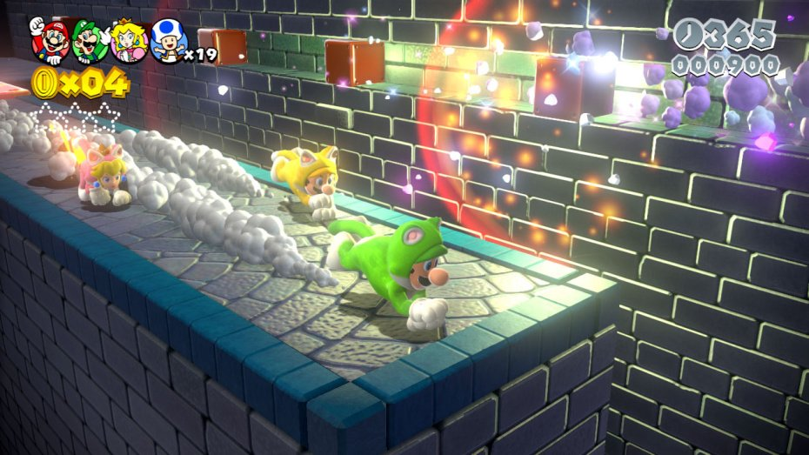
Image 4: Super Mario 3D World

Many of the 117 levels in Super Mario 3D World feature secret exits, some of which can only be accessed using a particular character or power-up, or a combination of both. Part of the objective lies within finding the secret exits, but reaching them often brings a new set of challenges. In one example, the path leading to a secret exit is barely visible at the top of the screen. The only way to access it, is to use the Cat-Suit power-up, which allows players to climb up walls. However, this power-up cannot be found within the level in question. The solution is for players to find the Cat-Suit in a different level, return to the previous level and reach the secret exit without taking damage, as they would otherwise lose their power-up. Once the exits are accessed, players are rewarded with new levels to play, which are often filled with their own secrets.
The secret exits offer challenges on several tiers, encouraging players to explore all corners of a level, decide what strategy is needed, then apply their skills to achieve their goal.
Multiple levels in Super Mario 3D World can only be unlocked by completing the games story, and these levels offer a new set of challenges and rewards for players to discover. One of these rewards is a new character that comes with her own set of unique abilities. These abilities can then be used in previous levels to find more hidden exits and items. This implementation creates more gameplay without additional content, by giving players a reason to revisit levels with new goals.
Super Mario 3D world features many other challenges, such as a book that can be filled with stamps of characters and enemies, and green stars that are hidden throughout the levels. But regardless of the challenge’s nature, they all feed into each other. Players can complete tasks to unlock new levels or characters, which gives them access to even more challenges and different ways to play. This essentially creates a constant loop of gameplay, challenge and reward.
It is worth mentioning that the Nintendo Wii U, the games console Super Mario 3D World was exclusively released for, does not offer any sort of overarching Achievement system such as the ones found on the Xbox, PlayStation or Steam platforms.
Metal Gear Solid 4, for the PlayStation 3, is a stealth based game in which players control special operations soldier, Snake. Developer, Kojima Productions, rewards players with items that can be used throughout the games campaign. One such item is a digital camera, that is hidden away in one of the earlier levels. Once discovered players can take pictures in the game and view them by accessing the in-game photo album. Pictures can then be stored to the PlayStation 3’s hard drive, attached to a message and sent to friends. Although it doesn’t offer the players any sort of advantage, the digital camera is a tangible reward that offers players a new, and potentially fun activity.
The hardest difficulty setting in Metal Gear Solid 4 is called the Boss Extreme Mode, and can only be unlocked by completing the game. Completing the Boss Extreme mode is made more challenging by allowing the player to carry less items, increasing the damage enemies can take and decreasing the damage players can take. However, players can complete other challenges in a lower difficulty setting to unlock new weapons and camouflage suits, which they can then use as an aid to complete the Boss Extreme mode. This creates another cycle that can keep players engaged, by encouraging them to unlock rewards to make it easier to unlock even more rewards.
Metal Gear Solid 4 and Super Mario 3D World demonstrate that in-game rewards can be used as tools to motivate players and extend play time. Items that alter statistics, such as how high the player can jump or how easily they can be spotted by an enemy, can further reward the player by giving them new ways to approach challenges.

Adding Value to Achievements
Contrary to the rewards offered by games such as Metal Gear Solid 4 and Super Mario 3D World, game Achievements do not offer anything other than digital proof of a player’s accomplishments.
However, developer and publisher, Ubisoft, offer their own reward system, that isn’t linked to Achievements. First announced in 2015, Club Ubi allows players to sign up to the reward program and earn points, called Units, by completing challenges.
Unlike the digital rewards offered by Sony, Microsoft and Valve, Units can be spent on in-game content through Club Ubi’s online store. Here, players have access to new weapons, soundtracks, armour and many other items. In addition, players can trade in a number of Units to get discounts on selected games.
“The Ubisoft Club is a free to join loyalty rewards program that offers extra game content, limited edition goodies, and discounts in the shop to members” (PC Gamer, 2015)
Units can be earned and accumulated in any Ubisoft game, regardless of what platform it is played on. This could prompt a player to revisit a game to complete more challenges and earn more currency. The newly earned Units could then be used to enhance the experience in a different game altogether, or spent on a discount for the players next purchase.
To add more value to Achievements and Trophies, a similar system could be adopted, which would see players being awarded with credits for their efforts. However, stricter guidelines would have to be introduced to ensure the challenge matches the reward. Although the terms and conditions on Achievement and Trophy implementation are protected by NDAs (Non- Disclosure Agreements), examples set by games such as Run through Russia, would suggest that little is being done by platform holders to regulate the quality of the associated challenges.
If not policed correctly, the system could be exploited, with developers attempting to boost sales with easily earned credits. These regulations could include restricting the amount of credits that can be awarded, based on the retail price of the game. As an example, platform holders could dictate that games should never award credits that equate to more than 10% of the titles price. This would mean, a game priced at £4.99 would not be able to award more than £0.49 worth of credits. Consequently, the player would not benefit financially if they purchased a title for the sole reason of earning additional credits. If said game were to be sold digitally at a discount, the credits could be adjusted accordingly by the platform holders.

Conclusion
A permanent, digital record of accomplishments allows players to share what they have achieved with the online community and their friends. These “bragging rights” can motivate players to invest additional time into a game, considering the Achievements are implemented responsibly.
Achievements should not be used to artificially extend the life time of a game without adding value, and shouldn’t exploit players with a passion for unlocking digital rewards. Instead, they should provide a sense of accomplishment which can only be achieved if the level of challenge matches reward. This is something that platform holders could support by introducing a set of guidelines that determine how difficult it is to unlock Achievements and Trophies.
Achievements can be used to draw attention to particular aspects of a game, and to introduce players to new mechanics. But they can also be used to offer players new experiences and encourage them to explore and experiment with a games world.
Players should be rewarded for completing a level and advancing to another. But as Drew Davidson explained, there are several options developers can explore that don’t involve awarding Achievements for doing something that is already a key requirement to finish the game.
Developers should also contemplate the affect an on-screen notification could have on the players immersion. If great efforts have been made to make the player feel like they are part of a different world, then developers should consider delaying Achievement notifications until the timing is most appropriate.
It is also important to remember that Achievements are not a substitute for in game rewards, but should instead act as an additional layer of challenges for players. Super Mario 3D World demonstrated how loops of gameplay, challenges and rewards can be created without the use of Achievements, and developers should continue to explore new ways to keep players engaged.
However, the responsibility on how and when to use Achievements in video games, remains the responsibility of the developers and designers.

References
Dr. Eric Berg, 2017. What is Dopamine? Available at: https://www.youtube.com/watch?v=NUNorglHg1U&t=47s [Accessed 24/10/2017]
Ted, 2009. Dan Pink – The Puzzle of Motivation. Available at: https://www.ted.com/talks/dan_pink_on_motivation [Accessed 24/10/2017]
Rogers. S, 2014. Level Up 2nd Edition. New Jersey: Wiley
Rouse, R. 2004. Game Design Theory and Practise – Second Edition. Texas: Wordware Publishing
Geek and Sundry, 2016. Rewarding Your Players. Available at: https://www.youtube.com/watch?v=6EhHdS--HBM&t=195s [Accessed 25/10/2017]
TrueAchievements, NA. Burnout Achievements. Available at: https://www.trueachievements.com/game/Burnout-Paradise/achievements [Accessed 25/10/17]
Gameinformer, 2009. Achievement Do's and Don'ts. Available at: http://www.gameinformer.com/b/news/archive/2009/09/26/feature-achievements-bad-good-do_2700_s-don_2700_ts-right-wrong.aspx [Accessed 25/10/2017]
Proceeding of National Academy of Sciences of the United States of America, 2012. Disclosing information about the self Id intrinsically rewarding. Available at: http://www.pnas.org/content/109/21/8038.full [Accessed: 25/10/2017]
Kotaku, 2016. The 15 most twisted Video Game Achievements. Available at: https://kotaku.com/the-15-most-twisted-achievements-in-gaming-1755499258 [Accessed: 26/10/2017]
Gameradar, 2016. Why I Love: Earning Trophies and Achievements in old Games. Available at: http://www.gamesradar.com/why-i-love-earning-trophies-and-achievements-old-games/ [Accessed: 26/10/2017]
TrueAchievements, 2012. Interview with Misfits Attic. Available at: https://www.trueachievements.com/n5911/ta-interview-with-misfits-attic [Accessed on: 27.10.2017]
PlaystationLifeStyle, 2017. Trophy Theory: Trophies, What Are They Good For? Available at: http://www.playstationlifestyle.net/2017/03/29/trophy-theory-ps4-trophies-what-are-they-good-for/#FvwIvFJOoDmbccr7.99 [Accessed on: 29.10.2017]
R. Rouse, 2004. Game Design, Theory and Practice. Texas: Wordware Publishing Inc.
Gamecrate, 2014. How Notifications Undercut Gaming Immersion. Available at: https://www.gamecrate.com/not-now-how-notifications-undercut-gaming-immersion/8748 [Accessed: 29/10/17]
Destroctoid, 2010. Pitchford: Easy Achievements Translate to Sales. Available at: https://www.destructoid.com/pitchford-easy-achievements-translate-to-sales-151315.phtml [Accessed: 29/10/2016]
PC Gamer, 2016. The life of a top Steam achievement hunter. Available at: http://www.pcgamer.com/steam-achievement-hunters/ [Accessed: 20/10/2017]
Kotaku, 2017. Achievement Spam Games Are Causing Controversy. Available at: https://steamed.kotaku.com/achievement-spam-games-are-causing-controversy-on-steam-1796528445 [Accessed 23/10/17]
Game Informer, 2017. Growing Guide of Easy Achievements for Xbox One. Available at: http://www.gameinformer.com/b/features/archive/2016/05/05/a-growing-guide-of-easy-achievements-for-xbox-one.aspx [Accessed: 26/10/17]
N.Whitton, 2012. Using Games to Enhance Learning and Teaching: A Beginner's Guide. Oxon: Routledge
PC Gamer, 2017. A game with over 4,000 achievements has just launched on Steam. Available at: http://www.pcgamer.com/a-game-with-over-4000-achievements-has-just-launched-on-steam/ [Accessed: 31/10/17]
Kotaku, 2017. Sony Pulls 'Easiest PS4 Platinum Trophy' Game From Store. Available at: https://kotaku.com/sony-pulls-easiest-ps4-platinum-trophy-game-from-store-1796516867 [Accessed: 25/10/2017]
Kotaku, 2010. Mega Man 10 Achievements are Typically Hard. Available at: https://kotaku.com/5455012/mega-man-10-achievements-are-typically-unreasonable [Accessed]
GameTrailers, 2017. 1000 Top Rated Official Easiest PS4 Platinum Trophy Trailer. Available at: https://www.youtube.com/watch?v=WEPzvZEae9E [Accessed: 30/10/2017]
Polygon, 2017. World’s fastest platinum trophy’ game raises PlayStation Store quality issues. Available at: https://www.polygon.com/2017/6/29/15894338/ps4-easy-trophy-game-removed-worst-playstation-store-games [Accessed 31/10/17]
Davidson, D. 2010. Well Played 1.0: Video Games, Value and Meaning. Pittsburgh: Carnegie Mellon University
Xbox Achievements, 2008. Rockband 2 Achievements. Available at: https://www.xboxachievements.com/game/rock-band-2/achievement/19425-The-Bladder-of-Steel-Award.html [Accessed 02/11/17]
IGN, 2015. The 11 Hardest Achievements in Video Games. Available at: IGN 2015 - http://uk.ign.com/articles/2015/06/30/the-11-hardest-achievements-in-video-games [Accessed 20/11/17]
PC Gamer, 2015. The Ubisoft Club, Ubi's new online rewards program, opens its doors. Available at: http://www.pcgamer.com/the-ubisoft-club-ubis-new-online-rewards-program-opens-its-doors/ [Accessed: 29/11/17]

Image References
Xbox Live Indie Games, 2011. Xbox360_Xchievement. Available at: http://xboxforums.create.msdn.com/forums/t/74028.aspx [Accessed: 06/12/17]
Complex, 2013. Monkey and Trip. Available at: http://www.complex.com/pop-culture/2013/02/25-of-the-most-realistic-video-game-romances/enslaved-odyssey-to-the-west [Accessed: 17/11/17]
Xbox Achievements, 2012. The Walking Dead Xbox Achievements. Available at: https://www.xboxachievements.com/game/the-walking-dead/achievements/ [Accessed: 20/11/17]
Boxmash, 2013. Mario-3D-World-20. Available at: http://www.complex.com/pop-culture/2013/02/25-of-the-most-realistic-video-game-romances/ [Accessed: 29/11/17]

Bibliography
R. Rouse, 2004. Game Design, Theory and Practice. Texas: Wordware Publishing Inc.
Schell. J, 2014. The Art of Game Design: A Book of Lenses. Florida: CRC Press
Xbox Achievements. Available at: https://www.xboxachievements.com [Accessed 24/10/17]
TrueAchievements. Available at: https://www.trueachievements.com/n5911/ta-interview-with-misfits-attic [Accessed on: 27.10.2017]
GamingLives, 2010. I Love Achievements, I Hate Achievements. Available at: http://www.gaminglives.com/2010/11/26/i-love-achievements-i-hate-achievements [Accessed: 25/10/2017]

