

University of Wales Trinity Saint David School of Engineering
Project Planning
M5X01176
Reza Shafie-Pour Motlagh
1810478
Word count: 2300
Table of Contents
1. Introduction 3
1.1 Abstract 3
2. Member Roles, Personality Traits, & Belbin Model 4
2.1 Member Roles 4
2.2 Personality Traits For my Role & Belbin Relation 6
3. Detailed list of Tasks 8
3.1 Group Tasks 8
3.2 Personal Tasks 9
3.3 Preliminary BOM 9
9
4. Milestone Dates & Gateway Objective 10
4.1 Milestone Dates 10
4.2 Gateway objective 11
5. Risk Assessment 12
6. Gantt Charts 14
6.1 Personal Gantt Chart 14
6.2 Group Gantt Chart 15
15
7. References 17

Introduction

Abstract
Project REV is an Electric Powered Hillclimb car aimed at competing in the national hill climb championship around the UK. We have been split up into four different teams: powertrain, aerodynamics, chassis, and simulation; with each group charged with designing and costing each component needed to create a competitive car. The purpose of this project is two-fold; to allow us to experience the trials and tribulations of working in groups for an extended period, and what it takes to excel in a group environment where you need to put the success of the group over individual success. We, the powertrain group, must liaise with the chassis group to place the motors and batteries, the aero group to determine what foot print we can work with and what downforce generating devise they’ll need to use, and the simulation group to provide them with accurate power, torque, and weight figures to allow them to accurately simulate the driving dynamics of the car.
The championship’s regulations that we are tasked to work within are very ambiguous and are very much still a work in progress, meaning there are some areas open for interpretation. Areas such as tyre choice, power output and maximum power storage allowed, and any form of class system are non-existent. This allows us to have a more-free reign over design and component choice which will make for a faster and more advanced car. We plan on using all the driver aids and data acquisition systems we can, which include but are not limited to: Traction control, ESP, ABS, and Launch control. All of these systems will allow for a more confident driving experience, and a faster car which will take advantage of the highly advanced systems on offer these days.

Member Roles, Personality Traits, & Belbin Model

Member Roles
- Reza Shafie-Pour: Motor
  - Specify torque and power requirements/limitations
    - This was determined to be a limit of 3400Nm of tractive force at launch, and a max power limit of 870Kw at 53m/s, far more than we will be using
  - Select motors that fit with our desired special requirements, torque/power requirements, and torque vectoring ability
- Steffan Robinson: Cooling
  - Specfy the cooling requirements
    - Calculate the amount of energy that will need to be expunged through the cooling system
    - Determine if radiators are needed, and specify volume of water required
- Tim Stanbury: Power Storage
  - Select power storage method i.e. batteries, super capacitors, or BatCap hybrid
    - It was determined that we will be using the Sony VTC5A 18650 battery cell, with the total amount needed being 3,400 cells
    - Total energy of these cells will be 115Mj, far exceeding our requirement of 50Mj
- George Dalton Brown: Motor controller and Data Acquisition
  - Determine controller specifications, inputs and outputs, and sensor choice
  - Select driver aide package: ABS, TC, ESP, LC
  - Motor controller selected: RMS PM250DZ
- Peter Olliffe: Regulations
  - Provide a form of checks and balances for the team; determine whether components or designs are legal
  - Specify safety requirements
- Dan Wilcox: Duty Cycle
  - Determine the run time for a typical hill climb in the championship we have been told to adhere to
  - Provide worst case scenario figures for the team to design the car around
- Jeff Ellis: Gearbox
  - Design a drop-down ratio gearbox
    - This will provide a motor to wheel speed drop, a well as a torque multiplication factor
      - These ratios have been determined to be from 2.5:1 at the lowest to 4.6:1 at the highest
      - This increases torque at the wheels to 2500Nm to 4600Nm
        - This will allow us to control the slip factor of the tyres at launch giving us the fastest possible acceleration off the starting line
- Responsibilities Specific to my role:
    - The motors selected were originally two Emrax 348s, however the mass of the power storage devices needed to power these effectively for our duty cycle was far more than we could justify
    - Given the mass of power storage to motor output power ratio, two Emrax 268 were selected
      - The specifications for the motors are as follows (combined): 460Kw, 1000Nm (before drop gear ratio), 268mm diameter and 98mm depth, Liquid cooled, peak power at 4500rpm
    - Motor location and mounting system
      - A cage was designed by the chassis group that allows for quick removal if needed, location was determined based on aero and suspension mounting point locations
    - Work with the chassis group to specify the tyre specification that we will require, and rolling radius to determine the motor to wheel speed ratio
    - Receive feedback from the simulation group on whether the power level is high enough to be competitive in a relatively heavy hillclimb car, make adjustments to motor selection based off of these results
    - Obtain a cost figure for each motor, two Emrax 268s

Personality Traits For my Role & Belbin Relation
The personality traits required for my role are reasonably simple; investigative, creative thinker, and a firm decision maker trait are needed to be able to make the important motor selection decision.
My highest ranked personality trait on the “Self-Perception Inventory” test created by Dr. R Meredith Belbin was Completer Finisher. The defined parameters of this trait are: “Completer finishers are adept at areas of work which require careful follow-through, close concentration and a high degree of accuracy.” (Belbin, 2019) This is an accurate representation of what is needed to complete my role successfully as the motor selection and all of the other component and groups are dependent on the power output, location of the motors, and the weight of the power storage needed to provide enough power to the motors at the power level we specify. It is mentioned in the breakdown of the Belbin model, that Complete Finishers may be susceptible to holding themselves to such a high standard that they would be less likely to ask for help, or to have that task passed on to someone else, as they fear that it will not be completed to the same extreme standard. This is accurate for my role, as I have had a hard time trusting the work of other group members, not because I do not think they aren’t capable, but because any work that I don’t have a hand in completing I tend to find untrustworthy. This is because I have not seen the research process, calculations, or deductions the member has made to reach the conclusion that they came to. I have helped to negate this shortfall of mine by actively offering to help with tasks outside of my own and going over the calculations and research during the group meeting time.
The Belbin Inventory we completed in lecture was very telling about each of the group members, as you could accurately categorize the personality of an individual and compare it to how they are in real life. My personality an almost extreme type A personality, which according to the definition means: “Type A individuals tend to be very competitive and self-critical. They strive toward goals without feeling a sense of joy in their efforts or accomplishments. Interrelated with this is the presence of a significant life imbalance. This is characterized by a high work involvement. Type A individuals are easily ‘wound up’ and tend to overreact. They also tend to have high blood pressure (hypertension).” (McLeod, 2017) Along with these traits, type As’ are extremely competitive, time urgent, and aggressive, all traits that fully identify myself. These traits can relate to the Belbin model because either Completer Finish is someone who takes great pride in their ability to provide the best work possible, often leading to hostile behavior to someone who doesn’t perform the same, or even worse someone who tries to prevent them from lowering their quality of work. The relation between type A/type B to the Belbin model is accurate when the opposite is considered. For example, a type B personality is relaxed, patient, and easy going which would lend themselves to be a Co-Ordinator on the Belbin model. This would be an accurate comparison because the coordinator is responsible for dealing with the team members, outside suppliers or vendors, and should help smooth over internal conflict, essentially someone who has great people skills. The Belbin model is a reasonably accurate tool to utilize when choosing specific areas for each member of the team to take on the responsibility for.

Detailed list of Tasks

Group Tasks

Personal Tasks

Preliminary BOM

Milestone Dates & Gateway Objective

Milestone Dates

Gateway objective

The gateway objective for the powertrain group is to provide a motor and power storage solution that allows the car to remain competitive through the power levels, mass, and ease of use by the driver. This objective can be quantified and measured in many ways: has the motor been selected, what form of power storage will be mass efficient yet provide the power and run time needed, what is the drivability of this combination, what auxiliary controllers and sensors will be needed, and how safe is this package as a whole. The car needs to be quick enough to reach a higher top speed than the rest of the competitors, however, be controllable enough to inspire confidence for the driver to push to the limit of the cars ability, not to the limit of their confidence. The following chart provides a breakdown to the costs of the components, cost of man hours for research and design, and the progress and measurable factors of each facet of this objective.

Risk Assessment
There are two primary concerns when choosing the motors that would prevent a successful decision in due time. The primary concern is not being able to provide the motors with enough power with the size constraints we are under. It’s easy to provide enough power needed for our run time, however trying to do this while having a specific volume of space we can use for power storage makes this decision much more difficult. If 10,000 18650 cells are needed to provide the motors with enough power and run time; This quantity of batteries is not realistic due to the space they would take up and the available space for the battery packs to be located in. We have considered using batteries, battery pouches, capacitors, and battery-capacitor hybrids, however a special 18650 cell has been determined to be enough for our power requirements. These cells are Sony VTC5A 18650 cells, that can discharge at a rate of 35A continuous with temperature monitoring. This allows us to only need 3400 cells, giving a total weight of 162.5kg. A concession to using these battery cells will be the careful temperature monitoring and cooling they require to discharge at such a rate, however we are hypothesizing that they will work well as they will only be discharging for a maximum time period of 75 seconds at a time, and that Is for a worst case scenario. The Emrax 268 motors will require, at a worst case scenario (a yellow flag half way up a run meaning we need to turn around and start again), 50mJ of energy, and the batteries we have selected in the quantity we have chosen will be able to provide 114mJ of power, more than enough. 162.5kg is an acceptable mass for the battery packs, as the motors themselves only weigh 20kg each. If you compare these figures to the engine, gearbox, and fuel system that was in the car originally, which came to approximately 225kg, the weight of the batteries, motors, and motor controllers is very comparable. We have an estimated weight figure of 245kg for these components, and for an EV, this is a very competitive power storage and motor combination; especially considering the power to weight ratios this will allow for, roughly 1000 BHP/Ton.
The second potential problem that can arise would be the sheer voltage and power levels the electrical system will be providing and dealing with. This is a massive safety concern that affects everyone involved in the entire project as it has the potential to harm, even kill, anyone who lays a finger on the car. The motors require 250V, and the battery packs will be discharging a total of 1750 Amps, which is more than enough to kill the entire team at once. To mitigate this risk we will be creating 100 smaller packs, which each pack only producing 25v, less than what is required to harm someone. 7 batteries will run in series to provide the 25V per pack, and in turn 100 of these individual packs will be run in parallel to create the energy needed for the power we need. These individual packs are the safest to produce, and allow us to position them in ways that wouldn’t be possible with much larger packs.

Gantt Charts

Personal Gantt Chart

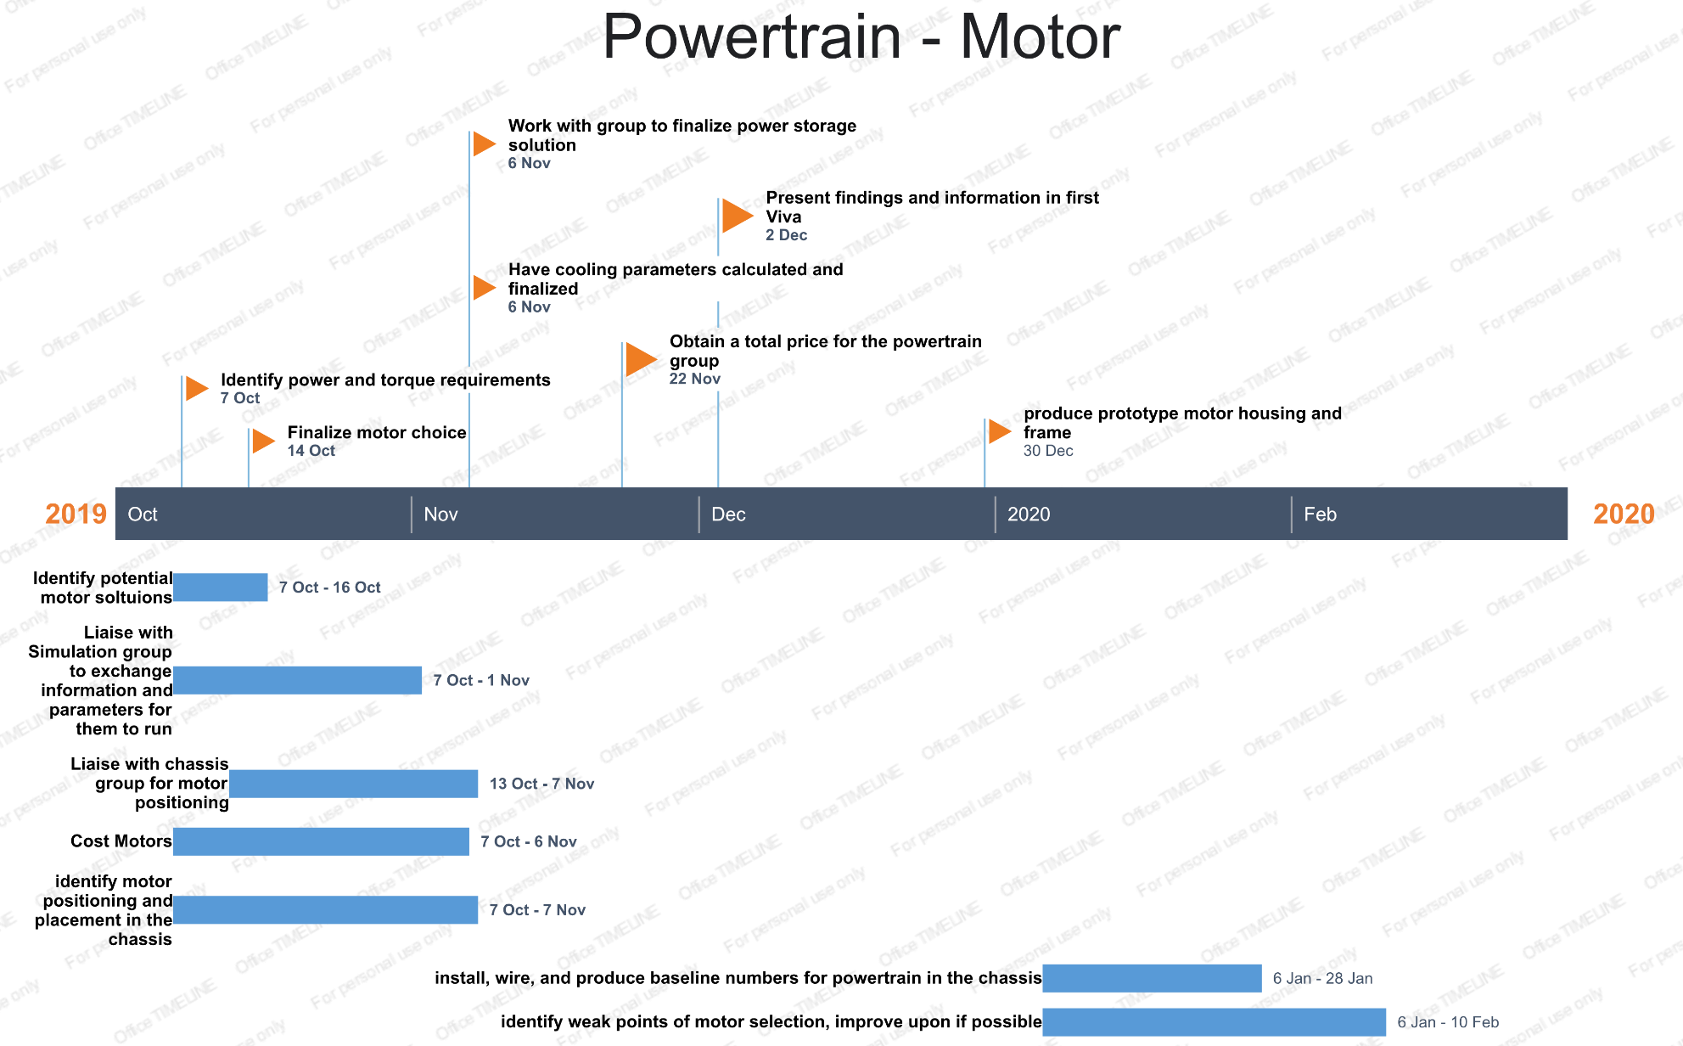

Group Gantt Chart

References
Engage and develop the talent around you, Belbin (2019). Belbin. [online] Belbin.com. Available at: https://www.belbin.com/about/team-role-spotlight-completer-finisher/.
McLeod, S. A. (2017). Type A personality. Retrieved from https://www.simplypsychology.org/personality-a.html

