Thomas Myers - 1704226
Smart and Connected Devices 2
Internet of Things - Smart Cities Applications
Dr Mabrouka Abuhmida

Abstract

As the dawn of a new decade approaches, there has been a rapid increase in the development of technological devices in the previous ten years with in particular the Internet of Things (IOT)[1]. The Internet of Things is simply the interconnection between and end device to the internet. This internet connection can vary from wired to wireless. For example, a computer connected to the Internet by an internet enabled router via an ethernet cable and a mobile device connected to the internet via a wireless router are both considered as Internet of Things. Internet of Things devices are not just based on user devices. The Internet of Things devices vary from Smart meters[2] to autonomous cars[3] as all of these have the ability to be connected to the internet.

Introduction

The following report will outline and demonstrate a number of solutions on the usage of energy. Most importantly, the main aim of the report is to elaborate a clear way to control energy consumption across either a home, institute or a public building. Solutions to control energy consumption will be demonstrated by analysing available Internet of Things (IoT) devices that have the capability to be controlled via the internet to benefit the homeowner. An explanation is to be given on each Internet of Things device and also why the highlighted device benefits the homeowner to keep their energy use efficient. Features such as ease of use (when applicable), ways of connectivity, possible interfaces while also of course the benefits of having the highlighted device connected to the internet for the end user. The cost of the highlighted device will also be displayed with an analysis of if the device is cost effective ahead of traditional and more common devices used before the introduction of Internet of Things devices.

Contents:

- Abstract
- Introduction
- Current Energy situation in Great Britain without IoT
- Devices to aid energy efficiency
4.1 Motion Sensors
4.2 Light Sensors
4.3 Temperature Sensors
- Conclusion
- References

3. Current Energy Solution in Great Britain without IoT

Without the use of the Internet of Things devices in Great Britain, the overall energy consumption remains at a much higher amount than what is necessary. Energy generated from households, buildings, institutes and overall powering of road safety devices had to be lowered. A large number of people in homes, buildings and institutes tend to leave unnecessary lighting on which contributes to the rise of energy bills for that particular household, building or institute.
Elements of energy consumption such as lighting, appliances and central heating could all be adapted to become more energy efficient. This is with the use of Internet of Things. There are many factors that contribute to the use of energy across great britain that the use of Internet of Things cannot help aid but there are many factors such as lighting, central heating etc that can aid energy consumption and it is expected that the implementation of Internet of Things device within these households, buildings and institutes will rise dramatically within the next decade.

4. Devices to aid energy efficiency

4.1 Motion Sensors

The first sensor to be spoken about in this report are motion sensors. There are many different types of motion sensors used for a number of reasons from energy consumption to intrusion detection. The main types of motion sensors include: ‘Ultrasonic, Microwave, Tomographic, Passive Infrared (PIR) and combined types.’[4] Motion sensors can be applied for a number of reasons including energy efficiency, security, ‘smart doorbell’ [5] and more. A Passive Infrared sensor can detect motion outside a home or institute which is a major benefit within security. This becomes a major benefit to the end user as with an Internet of Things device connected it can record the movement within the proximity of the motion sensor to the device which alarms the end user that somebody is near by and to be aware. Furthermore, an infrared sensor is used within today's world on automatic doors. The motion sensor detects when somebody is within proximity of the door and the door automatically opens (commonly sliding doors). This is commonly used within public buildings. This feature will not be needed in this particular demonstration as automatic doors could use more energy than a regular door as a stock door would only be opened manually therefore no electric energy could be consumed.

The Motion Sensor type needed for this particular demonstration is the Passive Infrared sensor. This is due to the Passive Infrared sensor has the capability to detect motion when somebody is near which has many benefits when attempted to be more energy efficient. The practical application of the passive infrared sensor will be used to turn lights on and off when somebody is present. This is a huge benefit to a homeowner as the particular light will no longer be unnecessarily on to waste unnecessary energy. With the use of Internet of Things, the motion sensor can be controlled from an end device if the sensor is connected to a wireless internet router. A good, cost effective smart motion sensor that can be applied to a home or building is the ‘Samsung SmartThing’[6] motion sensor. The Samsung SmartThing motion sensor allows the end user to control the lights from their internet enabled end device via an app with a easy to use interface. Below are examples of the Samsung SmartThing motion sensor and the interface provided by the downloadable application.

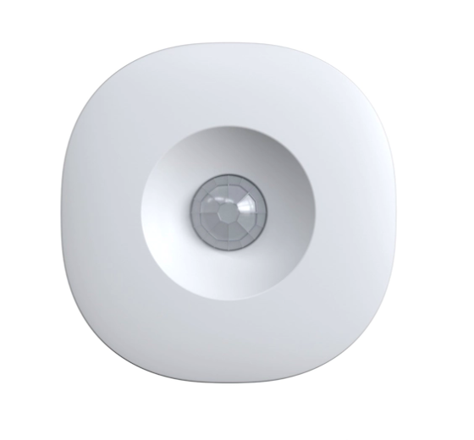
[10] https://www.samsung.com/us/smart-home/smartthings/sensors/samsung-smartthings-motion-sensor-2018-gp-u999sjvlbaa/?CID=afl-ecomm-cjn-cha-092118-&cjevent=bbf15c4b1dc911ea834d00ec0a18050c&utm_source=Upfeat+Media+Inc&utm_medium=affiliate&adcontent=8955708#specs
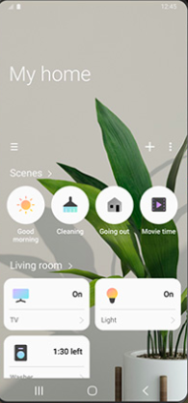

[10] https://www.samsung.com/us/smart-home/smartthings/sensors/samsung-smartthings-motion-sensor-2018-gp-u999sjvlbaa/?CID=afl-ecomm-cjn-cha-092118-&cjevent=bbf15c4b1dc911ea834d00ec0a18050c&utm_source=Upfeat+Media+Inc&utm_medium=affiliate&adcontent=8955708#specs

The Samsung SmartThing application can converse more energy by notifying the end user via the SmartThing application that the TV connected is either on or off. This is beneficial if the end user unintentionally have left the television on. This feature is only applicable if the Television is manufactured by Samsung and connected wirelessly to a wireless router. This feature is very cost effective by not only the purchase price but to a homeowners outgoing monthly energy payments when applied correctly.

4.2 Light Sensors

The second sensor to be spoken about in this report are light sensors. Light sensors have many practical uses in today’s world. Arguably the most common practical use for a light sensor is within in mobile phones with the ‘brightness control’[7] feature. This particular feature is very beneficial as it can detect the amount of light in a specific area and turn the brightness up or down accordingly depending on the amount of light within the area. This can help within reducing the strain on the eyes, especially in a dark room. More common practical uses of light sensors involve ‘security’[7] and ‘placement detection’[7] Similar to motion sensors, light sensors also have a range of sensor types used for different purposes. Some of the main types of light sensors are as follows: ‘photovoltaic cell, phototransistor, photoresistor, phototube, photomultiplier tude, photodiode and charge coupled device’.[8] While these are all different types of light sensors, none of these are energy efficient meaning that none of the sensor types are fit to purpose for this demonstration. The main type of light sensor needed for this particular demonstration is the ‘light dependent resistor’[9]. The light dependent resistor is able to conserve energy due to the sensor being ‘passive’. Furthermore, this particular light sensor is essential when attempting to conserve energy due to it not having any dependency on electricity. Below is an example of a Light Dependent Resistor.

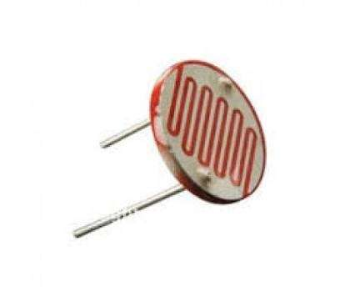
[11] https://www.quora.com/What-are-the-different-applications-of-LDR

The practical application of the light dependent resistor sensor in this particular demonstration will be the use of LDR in a street light. Before Internet of Things device was being implemented into everyday life, regular street lights used to be timed to turn on when the sun started to come down at a certain time of the season. As the sunrise and sunset varies at different seasons, the timing of the lighting of the street lights would have to keep being manually altered to be in sync with the light within the environment. Now with the introduction of a light dependent resistor that can no longer be the case. Using a light dependent resistor within a street light is beneficial as the sensor can adjust the light not only when the sun sets and rises but when weather conditions adjust during the day. This is a fantastic energy efficient solution as the street lights no longer light when the sun hasn't fully set and natural light is still within the atmosphere. Furthermore, light sensors can be applied inside a building as well as outside within the atmosphere. Light sensors can be applied within homes to detect when light is needed within the home e.g dusk to dawn. Applying light sensors within a home is beneficial as the sensor saves money for the home/building owner in the long run as the controlled lights will no longer be unnecessarily lit as the sensor detects the natural lighting within the environment and adjusts the lighting depending on how much light is necessary. These lights can still be turned on manually regardless of the light in the atmosphere. A major benefit of implementing a light sensor within a household or institute is that if somebody has left a light on manually the light sensor can detect this and dim the lights. Furthermore, some light sensors have the capability to be controlled remotely via Internet of Things devices. The use of Internet of Things is beneficial as the light can be manually turned on and off remotely by the end user. This is possible if the light sensor has the capability to be connected to the home or institutes wireless router which enables an end device to control the settings of the light sensor via an app on an end device. With all of the benefits listed above, light sensors are very cost effective as a reduction in a home or institutes energy bill can be reduced dramatically when applied correctly.

4.3 Temperature Sensors

The next Internet of Things feature set to be explained are ‘Smart Thermostats’[12]. The main purpose of smart thermostats is to connect the internet to a homeowners central heating to monitor a users central heating daily/weekly/monthly usage. Furthermore, a smart thermostat has the capability to control the whole central heating through an application available on an Internet of Things end device. There are many different brands that have Smart Thermostats available to their customers with some brands more popular than others. For this particular demonstration, the ‘Nest’[13] smart thermostat will be used as it is compatible with voice assistants.

The ‘Nest Thermostat E’[14] has the capability of controlling the whole of the households central heating. This is made possible via connection to an Internet of Things device. Both the Smart thermostat and the end device must be connected to the internet to allow the communication of data while also the control of the central heating in the home. The Nest Thermostat has a range of ways to control your central heating including scheduling heating times. This feature is beneficial when attempting to conserve energy as the central heating would not be on at unnecessary times meaning less energy consumption within the household. Furthermore, the Nest Thermostat is compatible with a number of different types of boilers which means that there is a low risk of the thermostat being incompatible. Another feature that the Nest Thermostat has is the capability to ‘learn your heating and cooling preferences’[15] which means adaptation into when the temperature of the central heating is turned up or down based on the habits of the homeowner. In the long term, the nest thermostat is very cost effective as it will help reduce the overall monthly total of the homeowners energy bill as the homeowner has complete control of the central heating via the Nest Thermostat smart application provided meaning less energy consumption when applied in the correct manner. Although the Nest Thermostat is cost effective, the particular hardware needed costs around£198’[14] in selected distributors which is not ideal. However, in the long run the reduction in the overall total monthly cost of the energy bill would make up for the money spent in the long run as the previous energy bill without the implementation of the Nest Thermostat would be a significant increase compared to the energy bill with the Nest thermostat implemented.

5. Conclusion

In Conclusion, There are many ways that sensors can connect to Internet of Things devices to control the energy consumption within either a household, building or institute. With Internet of Things devices becoming increasingly popular as the years go on, many solutions have been developed to control the consumption of energy around cities across Great Britain and all over the world within More Economically Developed Countries. With the application of Internet of Things devices, the use for human interaction within energy solutions can be controlled with the use of automation meaning the process of energy consumption becoming less time consuming for workers around the energy sector and also smart home owners who have access to Internet of Things devices. One of the main sensors that contribute to the consumption of energy while applied correctly is a motion sensor. For example, with the use of a motion sensor the consumption of light energy used will significantly decrease as the lights will only light when motion is detected in the room. When motion is no longer detected, the light will go out which saves money on the homeowners energy bill. Another sensor that contributes to energy consumption is a light sensor. This is because a light sensor has the capability to adjust the light depending on the natural lighting within the environment the light sensor is placed in. Due to the lights continuously being dim while adjusting to the sunlight, the overall monthly price of the homeowners energy bill would decrease significantly as less light energy is being used with the light rarely resorting to high power.

6. References

[1] - https://www.wired.co.uk/article/internet-of-things-what-is-explained-iot
[2] - https://www.smartenergygb.org/en/about-smart-meters
[3] - https://www.theverge.com/autonomous-cars
[4] - https://www.elprocus.com/working-of-different-types-of-motion-sensors/
[5] - https://www.vox.com/2019/9/5/20849846/amazon-ring-explainer-video-doorbell
[6] - https://www.samsung.com/us/smart-home/smartthings/sensors/samsung-smartthings-motion-sensor-2018-gp-u999sjvlbaa/?CID=afl-ecomm-cjn-cha-092118-&cjevent=bbf15c4b1dc911ea834d00ec0a18050c&utm_source=Upfeat+Media+Inc&utm_medium=affiliate&adcontent=8955708#specs
[7] - https://blog.endaq.com/how-light-sensors-work
[8] - https://www.elprocus.com/light-sensor-circuit-with-applications/
[9] - https://www.electronics-notes.com/articles/electronic_components/resistors/light-dependent-resistor-ldr.php
[10] - https://www.samsung.com/us/smart-home/smartthings/sensors/samsung-smartthings-motion-sensor-2018-gp-u999sjvlbaa/?CID=afl-ecomm-cjn-cha-092118-&cjevent=bbf15c4b1dc911ea834d
[11] - https://www.quora.com/What-are-the-different-applications-of-LDR
[12] - https://www.moneysavingexpert.com/utilities/smart-thermostats-explained/
[13] - https://nest.com/uk/
[14] - https://store.google.com/gb/product/nest_thermostat_e
[15] - https://www.digitaltrends.com/home/what-is-a-smart-thermostat/

