

Module Title: Concepts and Processes Level 5
Place and Placelessness
Module Code: M5X01604
Module Leader: Brendan Burns
Location: Crit Room 3 A309A
Schedule: Friday’s 12:30 – 17:00

Start Date: 6th October 2017
End Date: 19th January 2018
Feedback 16th February 2017

Module Content Page 2
How to start (Your input) Page 3
Learning Outcomes Page 4
Key points of this module Page 4
Timetable of sessions Page 5
Details of weekly session Page 6-9
Visual Prompts Page 10
Assessment and Dates Page 14
Bibliography Page 15

Module Content

The aim of the module is to expand upon the student’s ability to conduct speculative conceptual and processed based enquiry. This module should build upon information attained through previous modules with an emphasis upon developing appropriate relationships between practice and concepts.

The module allows the student to build a solid foundation of creative self-awareness, gained though experimentation. Students are encouraged to develop an increasingly attuned level of self-reflection and to self-assess in an open and honest manner. In particular, students are encouraged to examine why their work is appropriate to our contemporary situation.

It is key that the students think critically about their approaches to art practice and research other artists who have similar or diverse methods of working. It is crucial that the student initiates and build an appropriate body of knowledge and research base of the possibilities offered by historical and contemporary practitioners.

Students should document all aspects of the processes related to this module and should become conversant with a range of appropriate methods of documentation such as; sketchbooks, text, photographic, audio, video, performance, blogs etc.

There are no restrictions upon the materials and methods through which concepts and processes are expressed.
Advice will be given, prior to assessment, as to how processes can be documented and conveyed.

All documentation of processes, experiments and finished work will be eligible for the assessment, which will be conducted in mid-January 2016.

The Concept and Process module consists of weekly group-based activities which include; seminars, workshops, group crits, lectures and discussions. Parallel to these group sessions are regular one to one tutorials conducted in the studio spaces. Students should attend all scheduled teaching and are encouraged to attend lectures and events in other schools in order to broaden their appreciation of creative possibilities and alternative forms of practice.

Conceptual and Processes-Based practice should be explored using a wide range of materials, techniques and modes of practice. The student may find it necessary to utilise unfamiliar approaches in order to explore aspect of our contemporary situation and sense of ‘Place – Placelessness’. In addition, the student should develop self-reflection as to why their ideas and processes
are appropriate to our contemporary zeitgeist and consider deeply your intended audience.

It is recommended that a period of extensive research, enquiry, personal reflection into which aspects of ‘Place – Placelessness’, are to be tackled preceding extensive experimentation into expressing these attributes using a wide variety of materials and processes. This is a very open theme of work, which needs to be claimed and owned by you. Your Place, your Now. Your Work. This is your own theme not just a module for assessment.

Great consideration should be given to the relationship between the concept and the means of realisation to reflect aspects of Place – Placelessness’.

Considerable research should be embarked upon exploring how both historical and contemporary artists have responded to aspects of their ‘Place’. Use social history, political environment, environment and location, literature, music, dance and performance as initial research.

In addition, consideration should be given to the means by which the work is presented and the context which would be most appropriate and take on board our responsibility to sustainability.

How to start

- Use a journal to aid Self-reflection. Sincere confrontation of theme and its personal meaning to you.
- Be open to everything at this stage, do not close down possible avenues of research and thinking.
- Embrace ‘Not Knowing’ and ‘Value Doubt’.
- Remember what’s in your head needs to find its way onto paper. Draw diagrams, concepts, thoughts, doodles, write across imagery, use photographs, which look at personal spaces and place. Take rubbings, samples, record sounds, using moving imagery, printed media, social media. Literally everything is a source of possibility. Do not make to many judgements at this stage, which will force you down the ‘comfortable’ route, only working with the safe, what you already know.
- Remember – this work should take you somewhere new in the way you create, present, discuss, present and think.
- Avoid rushing to the ‘answer’ now. Avoid ‘old baggage’ from the past.
- You must fill a sketchbook/journal straight away with all the above. Do not be precious, there is no one ‘right way’ The only wrong way is to avoid doing anything until you think you know what you are doing, or do nothing at all.
- What `are the most radical ways of thinking about ‘Place’.
- Working from this initial sketchbook/journal of possibilities, select no less than 6 to further research and develop.
- Your studio space MUST look like your sketckbook/journal by the end of week1.
- Go to the library and go through past and present periodicals, newspapers, books.
- Research via social media and the internet. (we will sart watching some YouTube clips and TED talks)
- Walk through the streets of Swansea as though you are a visitor from another planet, look with fresh eyes and listen as though for the first time.
- When at home, look with eyes wide open as if it’s not yours.
- Please remember to show us how you think, externalise that thought onto another material. Transcend it into the visual.

Learning Outcomes

Learning Outcomes
Module Learning Outcomes being Assessed:
- The ability to develop speculative and experimental learning processes to test ideas as they formulate.

- Articulate concepts through the development of visual language in the realisation of a personally conceived body of work.

3. The student should develop the ability to analyse and synthesise sophisticated and nuanced relationships between material and intent.

Key Points of this Module

- To show your ‘THINK’ your thought processes responding to the theme Place – Placelessness.
- Be Speculative.
- Use the skills already acquired but you must learn new ones.
- Develop and present self-awareness and self criticality.
- Be open minded
- Value Doubt
- Experiment with a variety of materials and processes. Mix unusual combinations.
- Challenge scale
- Engage and use group discussions, share and learn together.
- Be more productive than ever.
- The only wrong is not to make or think.

Timetable of Sessions

All sessions are compulsory and will be held in
Crit Room 3 A309A on Friday’s between 12.30 & 17:00
Attendance is critical and registers are taken.

Friday 6th October Introduction – Group Seminar
Friday 13th October Lecture ‘Place’ Brendan Burns
Friday 20th October Visit Glynn Vivian
Friday 27th October 3-5 student tutorial seminar
Friday 3rd November Sketchbooks & Journals
Friday 10th November Concepts & Processes
Friday 17th November Individual Tutorials & Group A task
Friday 24th November Individual Tutorials & Group B task
Friday 1st December Group Crit / Presentations
Friday 8th December Materiality & Place
Friday 15th December Group Seminar - Audience
Christmas Vacation Self Directed work
Friday 12th January What do we need to do for next week?
Friday 19th January Group Crit / Presentations

Weekly intro to follow aims & objectives.

Friday 6th October Introduction – Group Seminar
Reading together through the module descriptor we will emphasise the importance of starting at the beginning. Avoid bringing past baggage and assumptions to this body of new work. We will learn to ‘value doubt’ and learn techniques and processes to make visual what you think. We will open this theme ‘Place – Placelessness up in its broadest sense through presentations, group discussions and film footage. The aim here in this session will be to make sure everybody fully understands the starting point, but to also value and be confident in ‘not knowing’ where this may lead.

Friday 13th October Lecture ‘Place’ Brendan Burns
Using personal experience and a body of work, Brendan Burns will present a lecture titled ‘Place’. We will also look at important text from ‘Place and Placelessness’ by E Relph, as well as ‘Poetics of Space’ by Gaston Bachelard.

Friday 20th October Visit Glynn Vivian
Having had a period to begin your response to the theme, and learning to take ownership of it, we will visit the exhibition by Helen Sear ‘ …the rest is smoke’. We will also look at the permanent collection through the premise ‘Place & Placelessness’. Sear’s “Ideas of mortality and temporality are explored through a series of works in which agricultural landscapes marked for production and consumption are seen to exist simultaneously as magical spaces, imprinting themselves on the body and mind of the viewer”.

Friday 27th October 3-5 student seminar
This will be an important opportunity to begin to discuss and share initial ideas and works. Whilst I work with small groups of 3-5 students, the remaining group will be set a series of tasks, which will generate new work and concepts going forward.

Friday 3rd November Sketchbooks & Journals
Valuing the processes of using both Sketchbooks or ‘Workbooks’, and Personal Journals will be the focus in today’s session. We will look at examples of working processes and aim to build confidence in your own personal relationship with these books. Questioning and the ability to be self-critical within your practice is a crucial transferable skill, which will undoubtedly affect your creative future.

Friday 10th November Concepts & Processes
We will endeavour to ask more advanced demands and questions of this modules theme. Through lecture, open discussion and group work we will test whether our work to date is challenging, experimental, self-reflective, contemporary, speculative and sophisticated as we move into the second half of the module.

Friday 17th November Individual Tutorials & Group A task
I will hold individual tutorials within your studio space for this session, You will be expected to write up a short 500 word account of our discussion, outlining the main themes as well as goals for next week. I will see half the group this week and half the following. Attendance is compulsory whichever group you are in, as I will set the remainder a group project, which will be presented at assessment.

Friday 24th November Individual Tutorials & Group B task
As week previous.

Friday 1st December Group Crit / Presentations
All students must attend this important mid module critique and presentation. This will be an important opportunity for feedback as well as feedforward advice from both staff and fellow students.
Each student will have only 5 minutes where the remaining group discusses their works. We will ‘tune into your works frequency’. The student will take notes and have a brief opportunity to respond to the groups responses.

Friday 8th December Materiality & Place
Feeling is a Material. A Lecture will present the theme ‘Materiality and Place’. We will present and question new approaches and material opportunities that have as yet been overlooked within this module. We will encourage a sincere experimental and open-ended approach, to build confidence in managing uncertainty.
We will discuss the difference between a virtual encounter of artwork and a transcendence into a unification with the work, to know it’s ‘knowing’.

Friday 15th December Group Seminar – Audience
Who is your intended Audience?
Having spent 10 weeks building and establishing a wide range of research, experiments, writings, concepts, samples etc. We will in this session look at potential ‘audience’, audiences of the past and present, there changing roles and influences upon the Arts.

Christmas Vacation Self Directed work
We have only 2 remaining formal sessions and weeks when we return from Christmas, please use this time wisely.

Friday 12th January What do we need to do for next week?
We will use this session to make sure we are on target for next weeks crit and assessment of the module. Group seminar and individual tutorials will provide the platform to assist sincere guidance in students attaining their potential within this module.

Friday 19th January Group Crit / Presentations
All students MUST attend this final session in order to present
ALL work produced within this module. Once again we will set a post critique 500 word self assessment of your presentation and the works provided within the module.

Visual Prompts


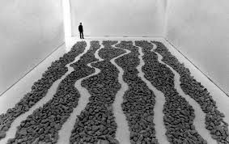

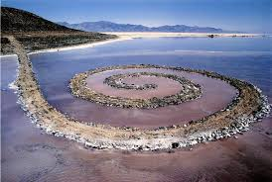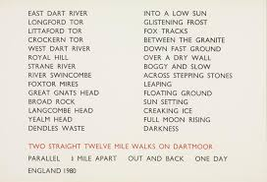

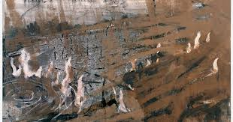
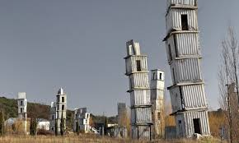

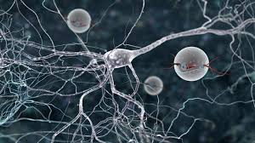



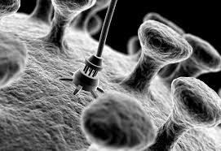
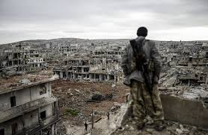

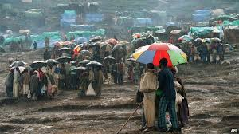

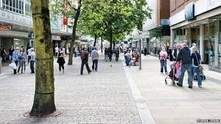


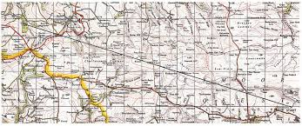

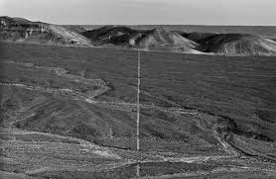

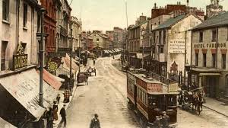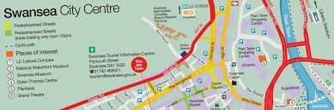

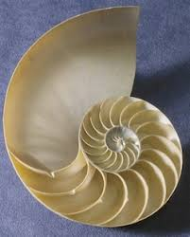

Assessment and Dates

The Concept and Process module will be assessed using the attached Common Assessment Marking Criteria and students will be provided with written feedback and the opportunity to discuss your performance in a studio tutorial.
The information below indicates how each learning outcome for this module will be assessed;

LEARNING OUTCOME 1

As a result of this module students will have the ability to develop speculative and experimental learning processes to test ideas as they formulate. Students are encouraged to expand upon the experimentation and concepts explored in previous modules and to find methods appropriate to this creative evolution. All experimental practice and processes will be accessed so must be documented in an appropriate manner eg. sketches, diagrams, text, photography, video, models, audio, pictorial work, etc.

LEARNING OUTCOME 2

Articulate concepts through the development of visual language in the realisation of a personally conceived body of work. An emphasis will be placed ascertaining why this work in appropriate to and reflective of, aspects our contemporary condition. Evidence should be presented to clarify these areas of examination and the reasoning behind identifying these themes. There are no restrictions on medium, methods or modes of practice.

LEARNING OUTCOME 3

The ability to analyse and synthesise sophisticated and nuanced relationships between material and intent. The student should provide background work, which can be in any media, which displays investigation into this relationship. This will include thorough and honest self-assessment to establish why these relationships are successful and why aspects are considered less successful.

ASSESSMENT
Description of each assessment component and its weighting, together with an example for new forms of assessment:

Assessment Component 100%
A portfolio of work to include no less than 6 components

Bibliography

Essential

Bachelard, G, (2013) Intuition of the Instant, Illinois: Northwestern University Press

Feuvre, L (ed), (2010) Failure, London: Whitechapel Gallery

Higgs, M & Nobel, P(2000) Protest and Survive, London: Whitechapel

Recommended

Bachelard, G, (2014) Poetics of Space, London: Penguin Classics

De Certeau, M (2011) The Practice of Everyday Life, California

Coelewij, L (2014) Dumas: The Image as Burden, London: Tate Publishing; 1 edition

Doherty, C (ed) (2009) Situation, London: Whitechapel Gallery

Dillon, B (ed), (2011) Ruins, London: Whitechapel Gallery

Massumi, B (2013) Semblance and Event: Activist Philosophy and the Occurrent Arts, Massachusets: MIT Press

