Name | Student Number | Date | Lecturer’s Name | Your score
To be filled by the marker
___/40
You will have 90 minutes to complete this assessment. It is divided into three sections: note-taking, paraphrasing and writing a paragraph.
---------------------------------------------------------------------------------------------------------------------
1. Take diagrammatic notes from the passage below using the space provided:

As a student you have got a lot on your plate - academic work, social life, work commitments, career plans, relationships and finances - sometimes stress can get in the way of this juggling act. When you recognise that you have become overwhelmed with stress, adopt a few strategies to help you manage your triggers more effectively. Those strategies could include exercising; you simply need to get your heart racing, for example by going for a brisk walk or a bike ride. Another suggestion is to try mindfulness, a relaxation technique originating in Buddhism. It is used by clinicians to improve patients' physical and mental health as it can significantly lower stress levels. Thirdly, why not speak to your friends and family - they know you best and care about you the most. What is more, studies suggest that socialising with a friend just once a week can reduce your stress levels and improve your mood as much as therapy or counselling. Simple time management techniques can also help you to feel more relaxed and focused. Try creating a written schedule, breaking your tasks down into manageable chunks, planning accordingly and allocating yourself time every day to relax or socialise. Finally, an obvious but often overlooked solution: get enough sleep, as no one functions at 100% when they're tired.
Adapted from: https://www.prospects.ac.uk/applying-for-university/university-life/5-ways-to-manage-student-stress

Space for your notes (max 12 marks):
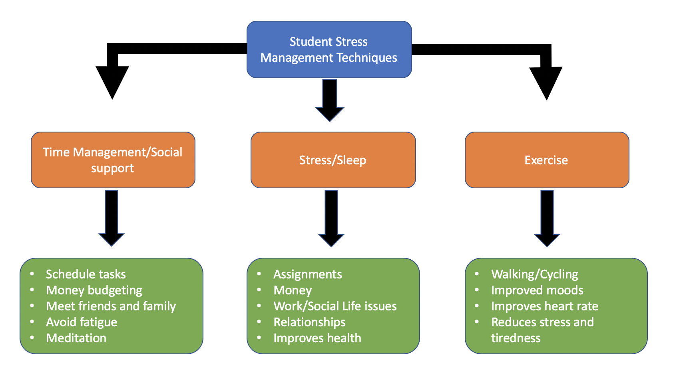

2. Paraphrase the following sentences (max 3 marks for each, max 12 marks in total):

a) Good time management techniques can help you feel more relaxed and focused.

Type here: Effective time management techniques can enhance your ability to remain composed and attentive.

b) Speaking to your friends and family can significantly lower stress levels.
Type here: Communicating with your family and friends can greatly ease your stress.

c) University life offers numerous opportunities for personal growth and development.
Type here: University life provides a wide range of possibilities for personal advancement.

d) Attending lectures regularly is crucial for understanding course material.

Type here: going to lecturers on a regular basis is vital for grasping subject matters

3. A-) Write 4 Strategies for managing a student budget and reducing costs while at university. (8marks)

B) In a paragraph of 8 sentences, share your personal experience of when you have used or plan to use any of these tips. (8marks)

(max 16 marks in total)

3. A | Write your strategies here.  1. Plan expenses in advance at the start of each month  2. Prioritise needs over wants.  3. Take advantage of public transport discount for students  4. Save a small amount of money each month for emergencies
3.B | Write your paragraph here. Your paragraph must be written in full sentences (no bullet points) and in an academic style.  Developing strong budgeting skills is a fundamental skill which will help students become more stable when it comes to financial issues. If you have poor management when it comes to money it can lead to debt and unnecessary stress. For example, I once was in a situation where I failed to realise everyday purchases can accumulate over time. As a result, I then started planning what essential and non-essential purchases I needed monthly. I also started to make a habit of saving money on the side for a rainy day, or any emergencies ever came up. When I implemented the changes to my daily life it made a difference to me by making me feel more secure and financially stable in case of unexpected cost ever came up. In conclusion, careful budgeting skills plays a important role in a student life in maintaining financial stability at university.

