

Module: BMIH4002 Food & Beverage Operations
Assignment 1: Student Journal
Lecturers: Jaliya de Silva, Dale Clarke, Ka Po Chong

Student Name:
Alexandra Iuliana Tocila
Student ID: 2224084
Date of Submission
20/09/2023

Contents
Part 1: Restaurant Concept 3
Introduction 3
Target Audience 3
Reasoning Behind Menu Choices 3
Conclusion 4
Part 2: Menu Design 5
References 8

Part 1: Restaurant Concept
Concept Name: La Luminère

Introduction
"La Luminère" is a fusion culinary establishment that harmoniously combines the intricate techniques of French gastronomy with the delectable and vibrant tastes inherent in Middle Eastern cuisine. Situated within the bustling heart of the United Kingdom, this location serves as a convergence point for many culinary cultures.

Target Audience
Our target demographic consists of individuals with a refined palate who possess a deep appreciation for the culinary arts, particularly concerning French and Middle Eastern cuisines. These individuals are enthusiastic about exploring novel and innovative culinary experiences inside their own kitchens. The target audience of our establishment comprises middle-aged professionals, couples commemorating significant occasions, and international tourists seeking unique gastronomic experiences.

Reasoning Behind Menu Choices
- Fusion Cuisine: The amalgamation of French and Middle Eastern culinary traditions exemplifies the concept of fusion cuisine, wherein an effort is made to cater to both traditionalists seeking authenticity and innovators exploring novel culinary techniques. Usman and Boyaci (2019) asserts that Middle Eastern cuisine's widespread appeal can be attributed to its robust flavour and diverse range of ingredients. On the other hand, French food is highly regarded for its meticulousness and expertise. A harmonious integration of flavour and technique is achieved when the elements are combined.
- Diversity: To cater to a diverse array of dietary needs, our menu has been thoughtfully curated to include items free from allergens and those suitable for individuals following vegetarian or vegan diets. This ensures that our establishment remains inclusive and capable of catering to a broader range of clientele.
- Seasonality & Sustainability: The contemporary societal focus on environmental concerns has elevated the need to procure food items that align with seasonality and sustainability. Batat (2022) argues that utilising seasonally available items guarantees their freshness and caters to the preferences of ecologically concerned individuals.
- Special Occasions: The restaurant's menu was meticulously crafted to cater to special occasions, such as anniversaries, birthdays, and other essential life events, considering the unique concept of fusion cuisine. Diners will encounter an extraordinary experience characterised by the unique amalgamation of refined French elements and profound Middle Eastern influences.

Conclusion
The analysis above leads to the determination that La Luminère transcends the conventional definition of a restaurant since it offers a whole gastronomic encounter. Situated within the facilities of a hotel boasting a four-star rating, this experience guarantees to be a unique and extraordinary journey, seamlessly blending the timeless allure of France with the captivating mystique of the Middle East. The Hotel Trinity is situated in its designated location.

Part 2: Menu Design
Title: A Night at La Luminère: A Culinary Ballet of France & The Middle East
The Proposed Menu Concept
The gastronomic offering consists of a meticulously curated five-course tasting menu skilfully crafted to intricately interlace the culinary traditions of France with the Middle East, therefore evoking a narrative that encapsulates the essence of both regions. Every individual dish serves as a performative element, guiding the consumer on a culinary journey characterised by the amalgamation of many culinary traditions and the harmonious interplay of various tastes.
Appetizers
Levantine Foie Gras  Delicate French foie gras served on a bed of tabbouleh and sprinkled with pomegranate reduction.  Description: A symphony of French pleasure and Middle Eastern freshness, providing a tantalising start to your gastronomic journey.  Price: £25 | 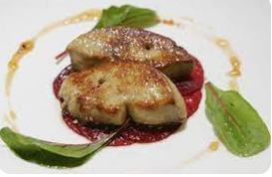
Fattoush & Chevre Salad  Crispy Arabic bread with fresh greens and creamy French goat cheese.  Description: A light mix that combines the Middle East's rustic beauty with France's subtle creaminess.  Price: £20 | 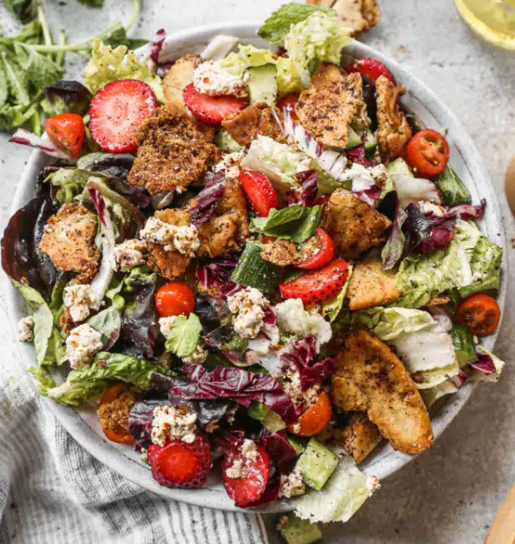
Main Courses
Ratatouille Shawarma  Middle Eastern marinated lamb wrapped in French ratatouille vegetables and served with rosemary-infused hummus.  Description: A meal rich with character and flavour where the Provence region meets the busy streets of Beirut.  Price: £40 | 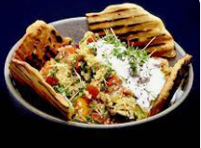
Saffron Bouillabaisse  Traditional French fish stew with Arabic spices and saffron, served with za'atar crostini.  Description: A coastal hug between Marseille and the Middle Eastern Mediterranean coasts.  Price: £35 | 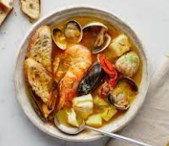
Side Dishes
Harissa Ratte Potatoes  Roasted baby French potatoes with a spicy Tunisian harissa sauce.  Description: An explosive juxtaposition of French finesse and North African passion.  Price: £10 | 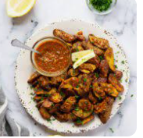
Truffle Falafel  Middle Eastern chickpea balls with a delicious hint of French truffles.  Description: A hint of French truffle excess elevates the humble falafel to sumptuous heights.  Price: £15 | 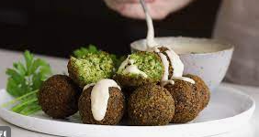
Desserts
Baklava Crème Brûlée  Traditional French custard dish with flaky phyllo pastry layers and honey-nut syrup.  Description: A dessert that embodies the spirit of La Luminère, where classic French traditions meet Middle Eastern luxury.  Price: £20 | 
Rose Macaron with Tahini Filling  Delicate French macarons filled with creamy sesame tahini and flavoured with Middle Eastern rose.  Description: A beautiful whisper of Parisian streets intertwined with aromatic Arabic gardens.  Price: £18 | 
Beverages
Merlot & Mint Tea Fusion
Rich French Merlot wine with a dash of cool Middle Eastern mint tea.
Description: An unusual mix of strong French grapes and perfumed winds from Arabian evenings.
Price: £15
Chamomile Lavender Lemonade
A soothing drink made with European chamomile, French lavender, and spicy Middle Eastern lemon.
Description: A calming cocktail, ideal for ending your epicurean voyage.
Price: £12
Sustainability and Seasonality
At La Luminère, our dedication extends beyond the stimulation of gustatory senses. We proactively acquire sustainable products from nearby farms, guaranteeing that our culinary offerings include exceptional taste and a commitment to environmental stewardship. By adopting a seasonal approach, we guarantee that every item is shown in its optimal state, resulting in the creation of meals characterised by freshness, rich taste, and alignment with the natural environment.

References
Batat, W. (2022). Consumers’ perceptions of food ethics in luxury dining. Journal of Services Marketing, 36(5), 754-766.
Usman, M. Q., & Boyaci, A. S. (2019) An Automatic Food Recognition System for Middle-Eastern Cuisines. Diabetes, 101, 125. Available at: https://www.researchgate.net/profile/Muhammad-Usman-135/publication/340894491_An_Automatic_Food_Recognition_System_for_Middle-Eastern_Cuisines/links/603ddc974585154e8c6e19c4/An-Automatic-Food-Recognition-System-for-Middle-Eastern-Cuisines.pdf (Accessed: 17 September 2023).
Images extracted from:
https://www.epicurious.com/recipes/food/views/bouillabaisse-238411
https://www.koppertcress.com/en/recipes/curry-ratatouille-and-couscous-bowl
https://www.koppertcress.com/en/recipes/curry-ratatouille-and-couscous-bowl

