Creativity, Leadership, Value Creation and Contemporary Technology in Health and Social Care
Module: BMHP5014
Student Name: Marie Achille Kouakou
Student Number: 2438126
Course: Level 5 Health and Social Care
University: UWTSD
Submission Date: 8th November

Task 1 – Concept Map

Concept map topic: Creativity, Value Creation and Health & Social Care Improvement
Creativity, value creation and improvement in health and social care are connected. Creativity means thinking of new ideas or new ways of doing things. In health and social care, creativity can help workers solve problems and find better ways to support patients and service users.
For example, staff may think of a new way to help patients make appointments or communicate with healthcare workers. New ideas can help improve the way care is provided.
Leadership is also important because good leaders can encourage staff to share their ideas and work together. Leaders can support staff when they want to try new ways of working.
Value creation means making care better and more useful for patients and service users. This can include better quality of care, better safety, less waiting time and a better experience for patients. Porter (2010) explains that value in healthcare is linked to the results patients receive compared with the resources used.
Technology can also help improve health and social care. For example, online appointments and digital health records can make services easier to access and can save time.
Overall, these ideas work together. Creativity helps create new ideas, leadership helps support these ideas, technology can help put them into practice, and value creation can lead to better care and better outcomes for patients and service users.

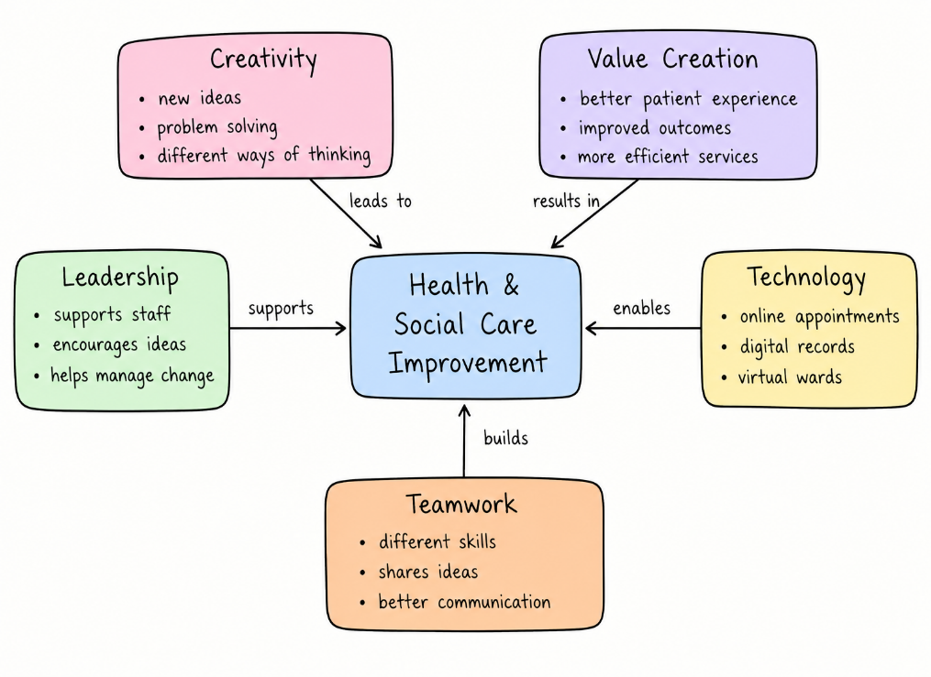

Task 2 – Self-Reflection of Group Activity

For this activity, my group was asked to think of different uses for a paperclip. The aim was to understand the difference between divergent and convergent thinking. I came up with [insert number] ideas and shared them with my group. We listened to each other and discussed the different ideas.
At first, I found the activity quite easy because there were no wrong answers during the first stage. This helped me feel more comfortable sharing my ideas. This was the divergent thinking part of the activity. Divergent thinking means thinking of many different ideas and possible solutions without judging them straight away.
After this, we moved to convergent thinking. We looked at the ideas we had produced and decided which ones were the most useful and realistic. I took part in discussing the ideas and thinking about whether they would work and if there could be any risks. This helped me understand that not every creative idea can be used, so ideas need to be checked before being put into practice.
Using Gibbs’ Reflective Cycle helped me think about what I learned from the activity (Gibbs, 1988). I learned that both types of thinking are important. Divergent thinking helps us create many ideas, while convergent thinking helps us choose the most suitable one.
I can use this learning in health and social care by thinking of different ways to solve problems before choosing the safest and most useful solution.

Task 3 – Case Study of a UK Innovation

Leeds Frailty Virtual Ward
An example of innovation in the NHS is the Leeds Frailty Virtual Ward. The service was created to provide care for older people with moderate to severe frailty in their own homes instead of always sending them to hospital. The service can support up to 37 patients each day and had saved more than 21,500 hospital bed days since the pilot started in November 2019 (NHS England, 2023).
Creativity was important because the NHS team looked for a different way of providing care. Instead of only using hospital beds, the team developed a service that brings hospital-level care to the patient's home. Patients can receive blood tests, medication reviews, fluids, observations and other treatments at home. The service also uses a team of different health professionals who work together to decide the best care for each patient (NHS England, 2023).
Technology also supports this new way of working. NHS England explains that virtual wards can use digital technology, video consultations and remote monitoring to help health professionals follow a patient's condition while they are at home. This can help staff make decisions and respond when a patient's health changes (NHS England, 2025).
The innovation created value for patients and their careers because they could receive care in a familiar environment rather than spending unnecessary time in hospital. Patients reported feeling listened to and treated with dignity and respect. The service can also reduce the risk of problems linked to hospital stays, such as falls and hospital-acquired infections (NHS England, 2023).
Overall, the Leeds Frailty Virtual Ward shows how creativity can help the NHS find a different solution to pressure on hospital beds. It combines new ways of working, teamwork and technology to provide more personalized care and improve the experience of patients and their families.

Task 4 – Research Task

Digital Exclusion Among Older People
One current issue in health and social care is digital exclusion among older people. Many health and social care services now use websites, apps, online appointments and video calls. However, some older people may not have the skills, equipment or support needed to use these services.
Ting et al. (2023) studied digital exclusion among older people who were using health services in South West England. The researchers found that some older people with frailty had difficulty accessing video consultations. Having a support network, such as family or other people who could help, could make it easier for them to use digital services. This shows that providing an online service does not always mean that everyone can access it. Health and social care workers therefore need to consider the individual needs of older people when using technology.
Wale et al. (2025) reviewed research about ways of helping older adults with digital exclusion in social care. The researchers found that support with using technology can help older people become more confident. However, there was limited research specifically about digital exclusion in social care. This suggests that more support and research are needed to make sure older people are not left behind as services become more digital.
Overall, digital exclusion can make it harder for some older people to use health and social care services. Staff can help by explaining technology clearly, offering support and providing non-digital options when needed. This can make services more accessible and fair for different service users.

Task 5 – Podcast

Podcast title: My Idea for Component 2

VOICE

Task 6 – NHS Leadership Framework Analysis

Key Components of the NHS Leadership Framework
Leadership is important in the NHS because healthcare workers need to work together and provide safe and effective care. The NHS Leadership Academy provides learning in different areas of leadership, including communication, managing people, managing change, coaching, influencing stakeholders and understanding yourself (NHS Leadership Academy, 2026).
Communication is important because leaders need to share information clearly with staff, patients and other professionals. Good communication can reduce misunderstandings and improve teamwork.
Managing people involves supporting staff, listening to their concerns and helping them work effectively as a team. Leaders also need to give feedback and encourage staff to develop their skills.
Managing through change is important because the NHS is constantly developing new services, technology and ways of working. Leaders need to help staff understand changes and adapt to them.
Coaching can help staff develop their confidence and skills. A leader can support employees by asking questions, listening and helping them find solutions.
Influencing stakeholders means working with different people who may be involved in a project or change. This can include healthcare professionals, managers, patients and other organizations (NHS Leadership Academy, 2026).
Overall, these components help NHS leaders support staff, improve teamwork and provide better care.

How Communication Can Encourage Creativity
I have chosen communication because it can help create an environment where staff feel comfortable sharing ideas. A leader who listens to staff can find out about problems and possible improvements. Staff working directly with patients may have useful ideas about how care could be improved.
For example, a nurse may suggest a simpler way of organizing patient information. A good leader should listen to the idea, discuss whether it is safe and consider how it could be tested. Leaders can also encourage team discussions where everyone has an opportunity to give their opinion.
The NHS Leadership Academy highlights effective communication as an important part of leadership development (NHS Leadership Academy, 2026). Good communication can therefore help staff work together, share creative ideas and support improvements in patient care.

Task 7 – Self-Reflection Journal Entry
During this module, I learned that creativity is important in health and social care. Before starting the module, I mainly thought creativity was about coming up with new ideas. I now understand that creativity can also help solve problems and improve the way care is provided.
The paperclip activity helped me understand the difference between divergent and convergent thinking. I learned that it is useful to first think of many possible ideas and then choose the ideas that are safe, realistic and useful.
I also learned more about value creation. I understand that creating value in health and social care is not only about saving money. It can also mean improving the quality of care, making services easier to access and giving patients a better experience.
Leadership was another important part of my learning. I learned that good leaders should listen to staff and encourage them to share ideas. This can help create a positive environment where people feel comfortable suggesting improvements.
This module has changed the way I think about my future professional practice. As someone interested in working in healthcare, I will try to be open to new ideas and think about how changes could improve the experience and outcomes of patients and service users.

Reference List
Clement, S. et al. (2015) ‘What is the impact of mental health-related stigma on help-seeking? A systematic review of quantitative and qualitative studies’, Psychological Medicine, 45(1), pp. 11–27.
Gibbs, G. (1988) Learning by doing: A guide to teaching and learning methods. Oxford: Further Education Unit, Oxford Polytechnic.
NHS England (2023) Providing rapid care to people in their own home rather than going to hospital, through a frailty virtual ward in Leeds. Available at: NHS England (Accessed: 17 September 2026).
NHS England (2025) A guide to setting up technology-enabled virtual wards. Available at: NHS England (Accessed: 17 September 2026).
NHS Leadership Academy (2026) Leadership Learning Zone. Available at: NHS Leadership Academy (Accessed: 17 September 2026).
Porter, M.E. (2010) ‘What is value in health care?’, New England Journal of Medicine, 363(26), pp. 2477–2481.
Ting, J.J. et al. (2023) ‘A multicenter cross-sectional observational study to determine the effect of living with frailty on digital exclusion from video consultations: Access-VIGIL’, Journal of the American Medical Directors Association, 24(11), pp. 1705–1711.
Wale, A. et al. (2025) ‘Effectiveness of interventions for addressing digital exclusion in older adults in the social care domain: Rapid review’, JMIR Aging, 8, e70377.

