How does the Zone of Interest explore the idea of the audience's unknowingness and how does the sound design reinforce this?

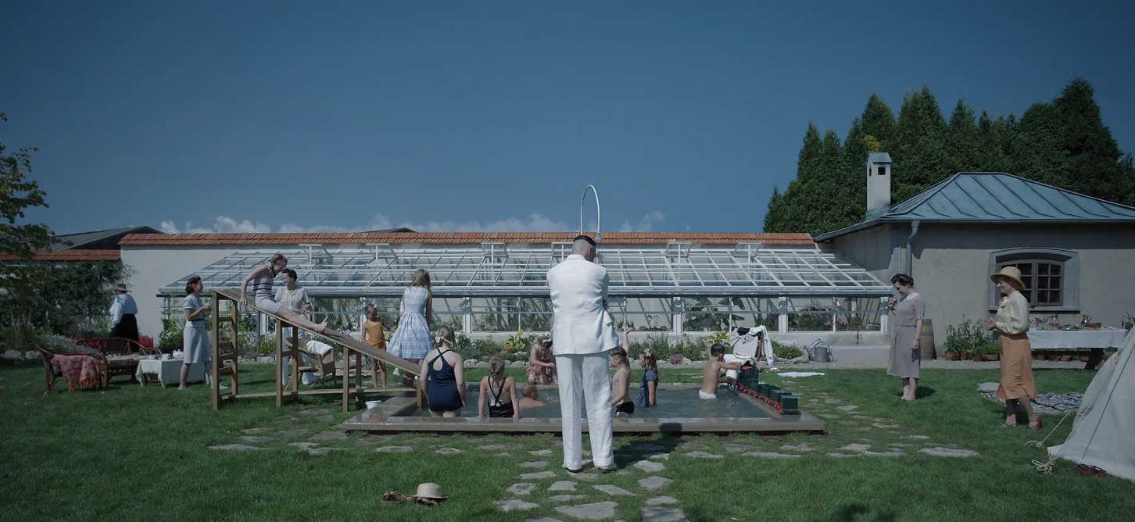
(image: google)

"I wasn't really paying attention... I was too busy thinking how I would gas everyone in the room".
(The Zone Of Interest, 2023)

During this film, we see many a moment of muted colours and unspoken truths that shield and disguise the viewer from the horrors next door as we follow along with the Höss family’s standpoint next to the Auschwitz Concentration camp throughout the time set, The Holocaust, using their perspectives and purposefully placed camera angles that hide the so-called elephant in the room. In this essay we will explore how in The Zone Of Interest, a viewer’s lack of perceptive can be an asset or hinderance to the storytelling and how throughout the sound design is so important to this matter.

A WELCOMING TO THE END

"For an unnerving couple of minutes, there's no picture, just waves of a haunting atonal drone that eventually fades out." (Martin, L. (2024)).

The first time watching this film, I knew how important it was going to be and when I tell you nothing could have prepared me for how incredibly thought out it was when in the first few minutes, we were struck instantly by a sound I'd never heard before. In the beginning of this film we start off with a powerful piece of sound design, luring the audience in. Firstly, This cinematic sound purposefully puts us in a state of unknowing and unsure if this piece is going to lead us into danger due to its drone like sound or a peaceful setting, so we as the viewers must decide what our perception is. Near to the end, orchestral instruments and sounds that come in later and as we near the end of this melancholic yet glorious sound we are met with sounds of nature, flora and fauna which then using just our ears can imagine what the images that lie ahead are going to project and then the first scene that we do cut to is a family out in nature having a picnic. However, this piece of ringing noise draws in the viewers curiously as it suggests not all is usual with this family we see after and sort of reveals that they do not know what lies ahead in this film it keeps us completely in the dark as all we can rely on is a sense of hearing which tells us as a viewer how sound plays a big part in this film and its storytelling but also relies on the views personal view of what this droning sound makes us feel and how we are going to go into this film. This is so important and is a big asset is engaging the audience, we want to see more, we want to know more, which keeps people watching. What we have in sound, we do not have in sight, so we do not know that this cold welcome is to a dark time, and only the beginning. As Martin L. said in their piece on the BBC, they talk about how important this first moment in the film is because it sets us right up to know what you're about to watch something that is incredibly powerful.

A SUDDEN TERROR

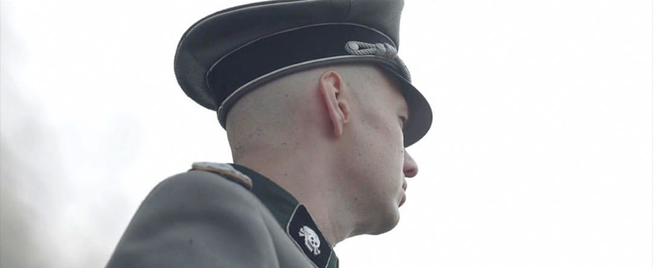
(image: google)

In a scene near the beginning of the film, we have Höss and his wife discussing matters of the day, joking and laughing before bed, a seemingly usual and predictable scene that we see following along with this nuclear family, until suddenly the film cuts to a low angle shot of Commander Höss the next day and what we can see is smoke above him and him keeping a blank face, again a seemingly not unusually set but what we can hear tells a different story, blood curling screams and shrieks and shouts of terror fill the atmosphere as guns are shooting and sound of mechanical works thymically churning and sounding. Although, we can't see what is happening before us and that sight is deceiving and only shows us his face with smoke, the sound design tells what lies beyond our sight and what reveals the truth of the situation on the evil, almost as if our sight is giving a false narrative of good. This plays very well into the storytelling as unlike the other scene similarly to the other scene sight and hearing work well together to keep the truth away from the audience to show the perspective of the Höss family as we are looking through their lens, their camera, we must rely on what we hear so we can really grasp the true experience as perfect it may be this is a film you hear, you dont see. Also, just how different the two scenes are from the bedroom scene to the sudden cuts of the camp how different those two scenes play very well because it's sudden flip grasps the viewers’ attention so vastly that we can't not hear the sounds of the screaming and the crying.

THE KINDNESS IN SILENCE


(image from Instagram: metrograph)

My personal favorite of the scenes in this film that had an emotional effect was the scene where after Höss’s wife's is disappointed after the departure of her mother, a Jewish worker walks into the greenhouse doing his work and he is stopped by the wife who offers him a cigarette, swiftly after he takes the cigarette and starting to get back to work she stops him, expecting him to just stay and have that moment with her, both just in silence smoking their cigarettes. This was the most powerful scene for me and that gave me chills, because of how disgustingly peaceful it is, a woman who is with the man who's the commander of the Auschwitz concentration camp, who's actively seeking harm and torture against these people, and then in a split moment of unhappiness this woman decides to not treat these people and workers from the camp like beneath her and asks him to just stop and share a moment with her, almost comparing as if her banal sadness for her sudden mother's leaving from the home compares to a man who is trapped involuntarily in a camp, almost suggesting that that kind of sadness that they both experienced was on some sort of same level in some sick way, it shows the goodness in that moment in that character of having a peaceful moment with him but knowing everything that you do as the audience about this character it's sickens to think that for brief moment due to a small matter she thinks in some way she shares that troubles that he does which is simply untrue. We are also empowered by this moment by the sound and the fact that there is just the absence of it there isn't any it is just complete silence that allows you to then soak up what is happening before you and the almost twisted nature of it that allows us then to compare the goodness of people and the evil of people and how sometimes there can be mixes in within which sits nicely within the storytelling. As much as I appreciate the silence in this scene, I do believe that the absence of it is a bit of a hindrance to the story as I believe a bit of dialogue between the characters would help progress the story seeing something so unlikely would maybe question the viewers thinking. However the sound design does help through the story as we hear workers still working in the background to remind us where we are again as I've discussed many a time in this piece essay that the whole point of the zone of interest is the sight deceives what we know and expect is happening and it tries to guide us in a certain way by the Höss family's perspective to believe they are doing some good and yet they use sound to alter and remind us That it is purposely filmed like this so that we unlike a lot of films we think we don't see what we hear.

THE FUTURE AWAKENS

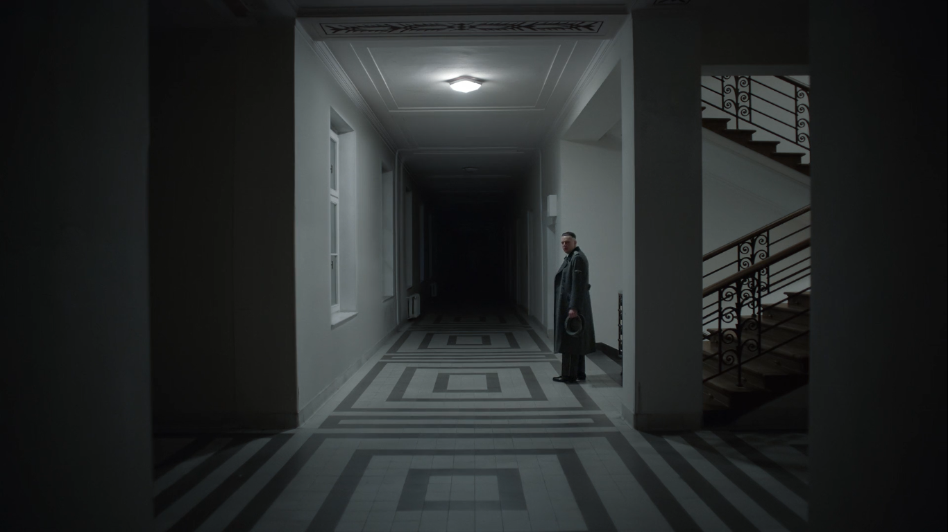
(image: google)

In this scene, Commander Höss walks down the stairs of the offices building, to go home but as he makes his way down the stairwell suddenly we see him begin to retch and gag as we can hear the sounds echo through the empty hallways, overcome with a sudden illness he carries on down the stairs and it happens again as the viewers are unsure at this point whether it is illness that he has been hit with but in the next few shots we are sure. The next shots the sound gives way and gives time for what we see on screen which is the then cut to the present as workers and cleaners clean for what becomes the Auschwitz concentration camp Museum we see shoes, back braces and belongings to the concentration camp workers, their pictures on the walls with names and documentation and even clothes that were worn in the camp. The scene contains sound only of cleaning vacuums on the general footsteps of the people keeping this place in pristine condition and as we cut back to Commander Höss he looks down the hallway horrified almost to suggest he saw a glimpse of what the future liked looked like or silence of where he was presented the gravity of the situation he was in not being distracted by family or parties or meetings being alone silent hallway depicted exactly what evil he was doing. I believe the sound design plays nicely with how the commander stops to take a moment and realize the depth of the situation he is in. Even though, I do not see it as a hindrance of the sound design, I do not he believes that the hearing part carried this part of the story and that our sight unusually for this film as we've explored and seen, is the one telling the truth and bringing us forth come to what is the devastating results of the camp on the Holocaust the sound this time simply guides and helps the footage let us in. In war films in general, audiences find themselves having to look away due to the severity and gruesome nature clearly of it but Glazer's The Zone of Interest, shows the audience not to look away as uncomfortable as it may feel, even though having to see this experience through the Höss’s family’s perspective can still be just as a stomach-churning watch.

"The ending is like a monstrous distortion of the workaholic’s nightmare. His labour will not be celebrated." (Dowd A.A.)

THE END OF YESTERDAY

In the outro of this film right after the scene in the silent hallway we cut to a dark black screen again but instead of the hauntingly beautiful music from the beginning we are met with high pitched vocals but are more horrifying after because you know now what's happened and the music works as a sort of peace just go with that and it truly depicts evil without giving the audience a thought of what it could be and whether it was good or evil it was just truly horrifying and plays into the credits so as the viewer you can leave watching this film feeling quite unnerved I'm unable to not think about the meaning. The sound design really does cause the viewer to stop and think after the film because without it, it wouldn’t have the same effect and it wouldn't be able to tell its story correctly without it but also I think effectively plays with that again unknowingness so it makes the viewer curious and want to know more which then brings an external want for more knowledge and curiosity about the film or the real life events that took place during this time of history which Jonathan Glazer has directly talked about with this film.

CONCLUSION

In conclusion the sound design of this piece perfectly depicts how the unknowingness of the viewers experience are supported by sight and hearing, although oddly parallel to each other magically go well in this storytelling of this horrific story whether it was just the quiet moments all of a sudden shrieks of terror, Jonathan Glazer's The Zone of Interest perfectly takes from the book and creates a cinematic experience for all viewers of what possibly it was like for a family next to the Auschwitz concentration camp, the family were not blind to what was happening but did everything in their power to not focus on it and the sound design perfectly depicts this and actually reveals the truth of what is happening in these people's lives, not just then but in present day. I think that's the best part of a film is when it actually holds on for days on end it truly gets you to think and I mean think about what you have seen what the director's vision is, I think the way that they have relied on the sound design to reveal the story as we all truly know it is very well done and it also isn't an easy watch, they don't make this piece of film light heartedly and without true effect especially in the scenes talked about which watching for the first time gave me chills, the sound design created by the crew truly depicts a alarming story of real life into the a film that gets the audience curious and wanting to watch more.

"Truly horrifying how many people are going to watch this movie, rate it highly and bestow it awards and whatever, and then still be pro-Israel. This is literally about you." (Micheal B. 2023).

BIBLIOGRAPHY

- Dowd, A.A. (2024). The Zone of Interest’s Final Moments Are a Nazi Workaholic’s Nightmare. [online] Vulture. Available at: https://www.vulture.com/article/the-zone-of-interests-vomit-inducing-ending-explained.html.

- Google (n.d.). The Zone of Interest. [online] Available at: https://www.google.com/search?client=safari&sca_esv=ff38142a395c5c92&rls=en&q=the+zone+of+interest

- ‌Letterboxd.com. (2023). A ★★★ review of The Zone of Interest (2023). [online] Available at: https://letterboxd.com/mitchell/film/the-zone-of-interest/ [Accessed 20 Dec. 2024].

- Martin, L. (2024). The Zone of Interest: How the most horrifying sounds in film history were created. [online] www.bbc.com. Available at: https://www.bbc.com/culture/article/20240216-the-zone-of-interest-how-the-most-horrifying-sounds-in-film-history-were-created.

- Metrograph (2024). THE ZONE OF INTEREST. Available at: https://www.instagram.com/metrograph/p/C-gWDWDziOD/?img_index=1.

- Film: The Zone Of Interest. (2023).

