

Student’s Name: Swayam Nareshbhai Vaghasiya

Student’s number: 2226331

Module code and title: LCHS 7007 – Population Health and Digital Health Promotion

Lecturer’s name: Dr Diola Bijlhout

Assignment title: Part A – Blog
Part B – Poster design
POPULATION HEALTH AND DIGITAL HEALTH PROMOTION

Table of Contents
Part A- Blog 3
Blog 1- Effective discussion on an existing digital technology presently applied for a digital health promotion intervention 3
References 6
Blog 2- Critically discuss the impact of a digital technology designed for a digital health promotion intervention 7
References 9
Part B- Poster Design 10
1. Background 10
2. Health promotion values and principles 11
3. Behaviour change theory 12
4. Expected outcome 13
5. Conclusion 14
References 15

Part A- Blog

Blog 1- Effective discussion on an existing digital technology presently applied for a digital health promotion intervention
How Accurate Are Fitness Watches For Measuring Hypertension?
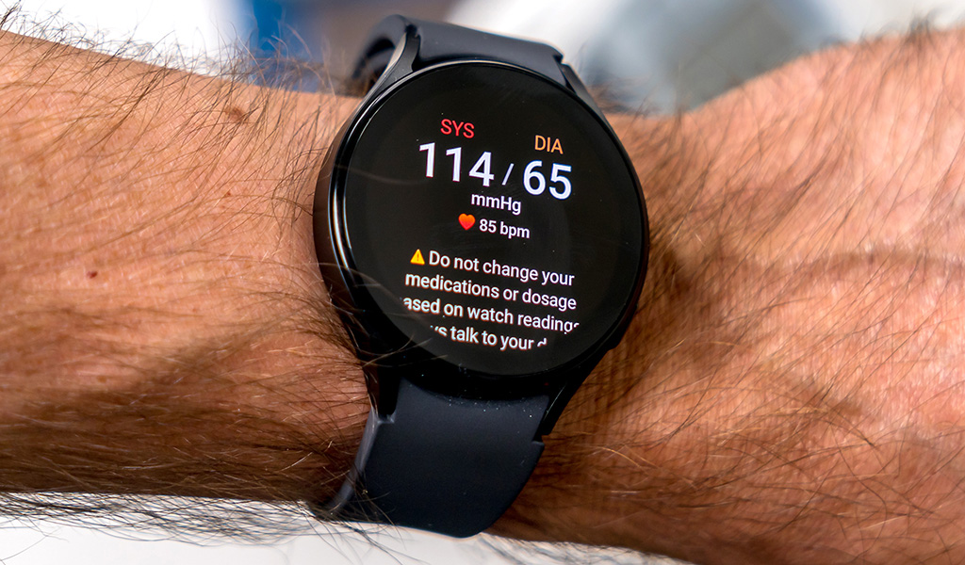
Wearable fitness watches are being enhanced and popular as people are now looking for ways to monitor their health and fitness on their own. However, how appropriate these digital technology-based devices are when it comes to tracking blood pressure for detecting hypertension like public health issues is a matter of concern.
Why hypertension is a public health problem?
Hypertension or high blood pressure indicates a health condition in which an individual's blood vessels are too high in pressure (140/90 mmHg or more than that) (Zhou et al., 2021). It is a common health issue; however, it can be serious if it is not treated on time (Fuchs and Whelton, 2020). Most of the cases, people with high blood pressure do not feel the symptoms. Thus, the only way to get blood pressure checked. Things that enhance the risk of having hypertension include older age, being obsessed or overweight, not being physically active, genetics, too much alcohol consumption and a high-salt diet (Flack and Adekola, 2020). It is a public health problem as it if left uncontrolled as well as undiagnosed high blood pressure can lead towards heart attack, heart enlargement and eventually heart failure (World Health Organisation, 2023). Thus, WHO (World Health Organisation) supports the countries in this world to reduce hypertension as a public health issue through offering new guidelines.
How fitness watches like digital technology is applied in health promotion and subsequent detection of the public health issue connected to blood pressure?
Fitness watches are effectively sensitive towards blood pressure monitoring and therefore it measures blood pressure at the wrist. Fitness watches apply an oscillometric method in the evening and morning, as this electronic sensor measures the blood pressure of the individual automatically (Kwon et al., 2019). As an outcome, the fitness watch's cuff is automatically inflated. Another technique that is utilised in these watches is PPG which is a heart rate sensor applying a pulse oximeter and applying the principle of light absorption happen while the sensor illuminates skin.
How do fitness watches promote health?
Digital technologies such as fitness watches are playing a key role in healthy behaviours supporting and delivering public health interventions. Therefore, the survey conducted through Attest in 2019 reflected that millennials are more interested to own a fitness watch rather than members of any other generation in the UK (Laricchia, 2022). Thus, 37.6% of millennials responded, they have claiming to own such a device for health promotion (Laricchia, 2022). The brand that is mostly popular for these fitness watches offering are Apple and Fitbit.
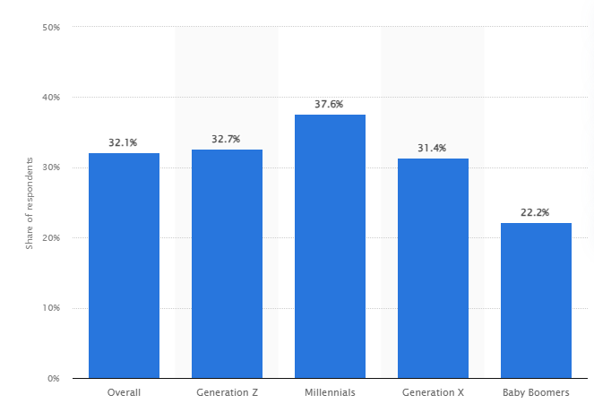
(Source: Laricchia, 2022)
What is the impact of fitness watches on health promotion?
In order to determine the impact of fitness watches in health promotion, the advantages and shortfalls related to them are required to determine.
Advantages/ Pros
- Simple to use
- Keep individuals informed and motivated
- Help in adjusting the fitness program
- Check blood pressure at any time from anywhere
- Aid in managing high blood pressure and other health problems
Shortfalls/ Cons
- Sensitive to movement
- These are not as precise as a sphygmomanometer
How the shortfalls related to fitness watches can be addressed?
In order to significantly address the shortfalls related to fitness watches wearing the watch on the less dominant arm or wrist is essential. Along with these, updating the software as well as keeping the sensors clean is a must.

References
Flack, J. M., and Adekola, B. (2020). Blood pressure and the new ACC/AHA hypertension guidelines. Trends in cardiovascular medicine, 30(3), 160-164. Available at: https://www.sciencedirect.com/science/article/pii/S1050173819300684 (Accessed on 26th July 2023)
Fuchs, F. D., and Whelton, P. K. (2020). High blood pressure and cardiovascular disease. Hypertension, 75(2), 285-292. Available at: https://www.ahajournals.org/doi/full/10.1161/HYPERTENSIONAHA.119.14240 (Accessed on 26th July 2023)
Kwon, S. B., Ahn, J. W., Lee, S. M., Lee, J., Lee, D., Hong, J., ... and Yoon, H. J. (2019). Estimating maximal oxygen uptake from daily activity data measured by a watch-type fitness tracker: cross-sectional study. JMIR mHealth and uHealth, 7(6), e13327. Available at: https://mhealth.jmir.org/2019/6/e13327/ (Accessed on 26th July 2023)
Laricchia, F., (2022). Share of respondents who own a smart watch/health-tracker computing device in the United Kingdom in 2019 (UK), by generation. Available at: https://www.statista.com/statistics/1044033/uk-smartwatch-health-trackert-ownership/(Accessed on 26th July 2023)
World Health Organisation, (2023). Hypertension. Available at: https://www.who.int/news-room/fact-sheets/detail/hypertension#:~:text=The%20World%20Health%20Organization%20(WHO,treatment%20of%20hypertension%20in%20adults. (Accessed on 26th July 2023)
Zhou, B., Perel, P., Mensah, G. A., and Ezzati, M. (2021). Global epidemiology, health burden and effective interventions for elevated blood pressure and hypertension. Nature Reviews Cardiology, 18(11), 785-802. Available at: https://www.nature.com/articles/s41569-021-00559-8 (Accessed on 26th July 2023)

Blog 2- Critically discuss the impact of a digital technology designed for a digital health promotion intervention
Public Health Issue, Diabetes Measuring Technology Has Come A Long Way
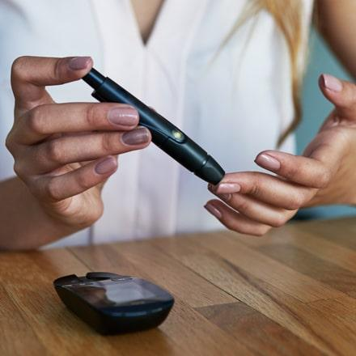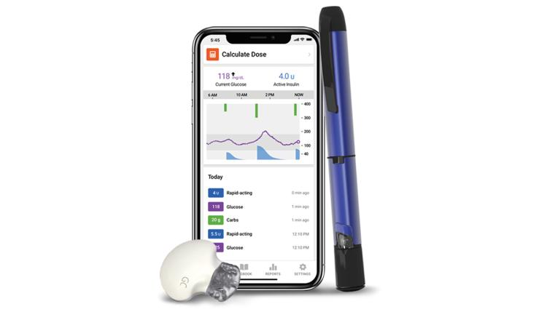
The new generation of digital technologies applied in blood glucose level monitoring and insulin delivery devices can simplify your routine.
Why diabetes is addressed as a public health problem and why it is a concern?
People with diabetes are found to have a higher risk of health issues including stroke, heart attack and kidney failure (Singer et al., 2022). In 1994, when the CDC (Centers for Disease Control and Prevention's) diabetes program declared that diabetes had reached the proportion of epidemic, then it started to consider a public health problem. Additionally, from 2000 to 2019, there was a 3% increase in diabetes mortality rates by age (World Health Organisation, 2023a). This is a concerning fact as it can cause permanent vision loss through blood vessels damaging the eyes (Mushtaq and Siddiqui, 2021). Henceforth, many people with diabetes are observed to develop issues with the feet from nerve damage as well as poor blood flow. Thus, potential blood glucose measurement in a continuous manner is essential with using cutting-edge technologies.
Description of designed digital technology
In this instance, the latest technology-based designed glucose meter can be a smart insulin pen. As it can be a reusable injector pen with an effectively intuitive smartphone application that can help diabetic people to better manage their insulin delivery without being highlighted (Kesavadev et al., 2020). This smart technology-based system will calculate as well as track the doses and provide alerts, reminders and reports. It can come in the form of an add-on feature to your present insulin pen or a reusable form that applies prefilled cartridges rather than vials or disposable pens.
How designed digital technology can be implicated in health promotion and subsequent public health problem addressing?
Smart insulin pens that are going to design here with add-on features can help in significant health promotion as well as public health problem addressing as they can be more affordable and easy to use rather than other available glucose measurement devices as it can improve people's lifestyle that depends on insulin to manage their diabetes (Heinemann et al., 2022). In fact, as it will contain a cartridge, a disposable needle and a dial to measure dosage, therefore this advanced technology-based glucose meter can be in popularity for its simple use, accurate and convenient insulin delivery.
Impact of designed digital technology in health promotion
In order to address the impact of designed digital technology on health promotion, the detection of the related benefits and drawbacks is essential.
Benefits
- Ease of use, particularly for children and older adults
- Able to fine-tune highly accurate doses delivery
- Portable, convenient and discreet nature of pens
- Capable to accurately pre-set doses using dial
- Time-saving due to prefilled, pre-set insulin levels
Disadvantages
- Available to self-injection only
- Restricted to use in all types of insulin through a pen
- Higher cost than the vial method
- Lacking universal coverage through insurance providers
The way drawbacks can be addressed
In order to address the shortfalls of smart insulin pens, always checking the medicine types and their storing temperature and condition are a must. Convincing the insurance providers to include these aspects is required.

References
Heinemann, L., Schnell, O., Gehr, B., Schloot, N. C., Görgens, S. W., and Görgen, C. (2022). Digital diabetes management: a literature review of smart insulin pens. Journal of Diabetes Science and Technology, 16(3), 587-595. Available at: https://journals.sagepub.com/doi/full/10.1177/1932296820983863 (Accessed on 26th July 2023)
Kesavadev, J., Saboo, B., Krishna, M. B., and Krishnan, G. (2020). Evolution of insulin delivery devices: from syringes, pens, and pumps to DIY artificial pancreas. Diabetes Therapy, 11(6), 1251-1269. Available at: https://link.springer.com/article/10.1007/s13300-020-00831-z(Accessed on 26th July 2023)
Mushtaq, G., and Siddiqui, F. (2021, February). Detection of diabetic retinopathy using deep learning methodology. In IOP conference series: materials science and engineering (Vol. 1070, No. 1, p. 012049). IOP Publishing. Available at: https://iopscience.iop.org/article/10.1088/1757-899X/1070/1/012049/pdf (Accessed on 26th July 2023)
Singer, M. E., Dorrance, K. A., Oxenreiter, M. M., Yan, K. R., and Close, K. L. (2022). The type 2 diabetes ‘modern preventable pandemic’and replicable lessons from the COVID-19 crisis. Preventive Medicine Reports, 25, 101636. Available at: https://www.sciencedirect.com/science/article/pii/S2211335521003272 (Accessed on 26th July 2023)
World Health Organisation, (2023a). Diabetes. Available at: https://www.who.int/news-room/fact-sheets/detail/diabetes (Accessed on 26th July 2023)

Part B- Poster Design
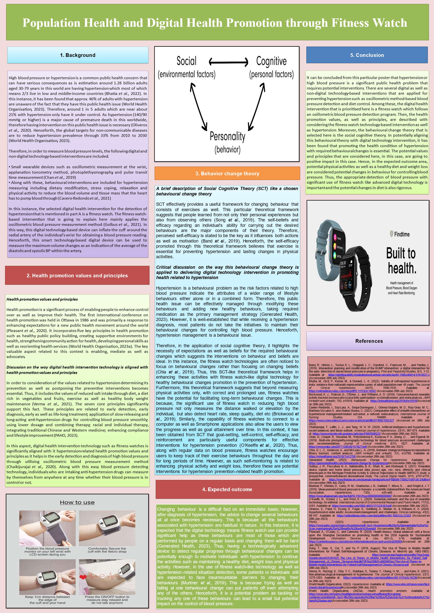

References
Band, R., Hinton, L., Tucker, K. L., Chappell, L. C., Crawford, C., Franssen, M., ... and Yardley, L. (2019). Intervention planning and modification of the BUMP intervention: a digital intervention for the early detection of raised blood pressure in pregnancy. Pilot and Feasibility Studies, 5(1), 1-12. Available at: https://pilotfeasibilitystudies.biomedcentral.com/articles/10.1186/s40814-019-0537-z (Accessed on 26th July 2023)
Bhatia, M., Dixit, P., Kumar, M., & Dwivedi, L. K. (2022). Validity of self‐reported hypertension in India: evidence from nationally representative survey of adult population over 45 years. The Journal of Clinical Hypertension, 24(11), 1506-1515. Available at: https://onlinelibrary.wiley.com/doi/pdf/10.1111/jch.14542 (Accessed on 26th July 2023)
Brickwood, K. J., Watson, G., O'Brien, J., and Williams, A. D. (2019). Consumer-based wearable activity trackers increase physical activity participation: systematic review and meta-analysis. JMIR mHealth and uHealth, 7(4), e11819. Available at: https://mhealth.jmir.org/2019/4/e11819(Accessed on 26th July 2023)
Cavero-Redondo, I., Saz-Lara, A., Sequi-Dominguez, I., Gómez-Guijarro, M. D., Ruiz-Grao, M. C., Martinez-Vizcaino, V., and Alvarez-Bueno, C. (2021). Comparative effect of eHealth interventions on hypertension management-related outcomes: a network meta-analysis. International Journal of Nursing Studies, 124, 104085. Available at: https://www.sciencedirect.com/science/article/pii/S0020748921002327 (Accessed on 26th July 2023)
Chaikijurajai, T., Laffin, L. J., and Tang, W. H. W. (2020). Artificial intelligence and hypertension: recent advances and future outlook. American Journal of Hypertension, 33(11), 967-974. Available at: https://www.ncbi.nlm.nih.gov/pmc/articles/PMC7608522/ (Accessed on 26th July 2023)
Chan, G., Cooper, R., Hosanee, M., Welykholowa, K., Kyriacou, P. A., Zheng, D., ... and Elgendi, M. (2019). Multi-site photoplethysmography technology for blood pressure assessment: challenges and recommendations. Journal of clinical medicine, 8(11), 1827. Available at: https://www.mdpi.com/2077-0383/8/11/1827/pdf (Accessed on 26th July 2023)
Chia, G. L. C., Anderson, A., and McLean, L. A. (2019). Behavior change techniques incorporated in fitness trackers: content analysis. JMIR mHealth and uHealth, 7(7), e12768. Available at: https://mhealth.jmir.org/2019/7/e12768 (Accessed on 26th July 2023)
Generated Health, (2023). Behavioural Change for Hypertension. Available at: https://generatedhealth.com/behavioural-change-for-hypertension(Accessed on 26th July 2023)
Golbus, J. R., Pescatore, N. A., Nallamothu, B. K., Shah, N., and Kheterpal, S. (2021). Wearable device signals and home blood pressure data across age, sex, race, ethnicity, and clinical phenotypes in the Michigan Predictive Activity & Clinical Trajectories in Health (MIPACT) study: a prospective, community-based observational study. The Lancet Digital Health, 3(11), e707-e715. Available at: https://www.thelancet.com/journals/landig/article/PIIS2589-7500(21)00138-2/fulltext (Accessed on 26th July 2023)
Muntner, P., Shimbo, D., Carey, R. M., Charleston, J. B., Gaillard, T., Misra, S., ... and Wright Jr, J. T. (2019). Measurement of blood pressure in humans: a scientific statement from the American Heart Association. Hypertension, 73(5), e35-e66. Available at: https://www.ahajournals.org/doi/full/10.1161/hyp.0000000000000087 (Accessed on 26th July 2023)
O’Keeffe, N., Scheid, J. L., and West, S. L. (2020). Sedentary behavior and the use of wearable technology: An editorial. International Journal of Environmental Research and Public Health, 17(12), 4181. Available at: https://www.mdpi.com/1660-4601/17/12/4181/pdf (Accessed on 26th July 2023)
Oliveros, E., Patel, H., Kyung, S., Fugar, S., Goldberg, A., Madan, N., & Williams, K. A. (2020). Hypertension in older adults: Assessment, management, and challenges. Clinical cardiology, 43(2), 99-107. Available at: https://onlinelibrary.wiley.com/doi/pdfdirect/10.1002/clc.23303 (Accessed on 26th July 2023)
PAHO, (2023). Hypertension. Available at: https://www.paho.org/en/topics/hypertension#:~:text=Hypertension%20is%20preventable%20or%20can,maintaining%20a%20healthy%20body%20weight. (Accessed on 26th July 2023)
Pleasant, A., O’Leary, C., and Carmona, R. (2020). Health literacy: Global advances with a focus upon the Shanghai Declaration on promoting health in the 2030 Agenda for Sustainable Development. Information Services & Use, 40(1-2), 3-16. Available at: https://content.iospress.com/articles/information-services-and-use/isu200080(Accessed on 26th July 2023)
Song, T., Qian, S., Cui, T., and Yu, P. (2019, August). The Use of Theory in Mobile Health Interventions for Patient Self-Management of Chronic Diseases. In MedInfo (pp. 1982-1983). Available at: https://www.researchgate.net/profile/Ting-Song-5/publication/335381825_The_Use_of_Theory_in_Mobile_Health_Interventions_for_Patient_Self-Management_of_Chronic_Diseases/links/5d79f1ba299bf1cb809983ec/The-Use-of-Theory-in-Mobile-Health-Interventions-for-Patient-Self-Management-of-Chronic-Diseases.pdf (Accessed on 26th July 2023)
Verma, N., Rastogi, S., Chia, Y. C., Siddique, S., Turana, Y., Cheng, H. M., ... and Kario, K. (2021). Non‐pharmacological management of hypertension. The Journal of Clinical Hypertension, 23(7), 1275-1283. Available at: https://onlinelibrary.wiley.com/doi/pdfdirect/10.1111/jch.14236(Accessed on 26th July 2023)
World Health Organisation, (2023). Hypertension. Available at: https://www.who.int/news-room/fact-sheets/detail/hypertension(Accessed on 26th July 2023)
World Health Organisation, (2023a). Health promotion emblem. Available at: https://www.who.int/teams/health-promotion/enhanced-wellbeing/first-global-conference/emblem#:~:text=It%20incorporates%20five%20key%20action,%2C%20mediate%2C%20and%20advocate(Accessed on 26th July 2023)

