

LOCATION: Swansea | LLEOLIAD: abertawe
LEVEL 6 | LEFEL 6
EXAMINATION PERIOD | CYFNOD ARHOLIADAU
JANuary 2022 | IONAWR 2022

MODULE CODE: ACCA6022
COD Y MODWL: ACCA6022
SWITCHING, ROUTING AND WIRELESS ESSENTIALS
TIME: 2 HOURS

Name :

Student ID :

Date & Time :

This is an individual practical test, held under examination conditions. This task will be executed in a packet tracer activity file and submitted via Moodle.

This paper is marked out of 100.

Topology

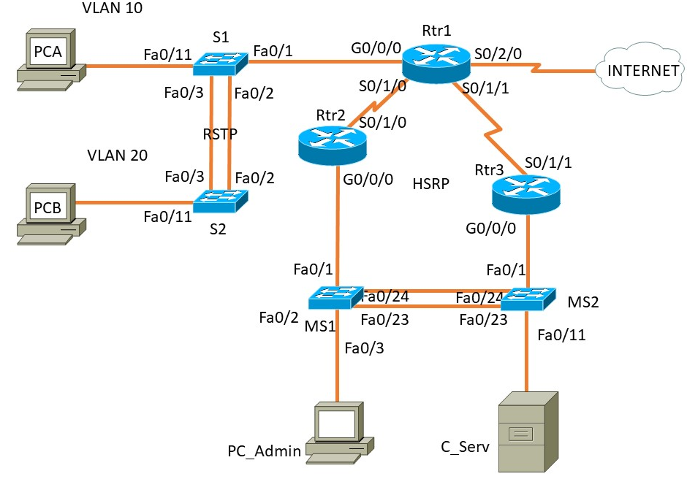

Addressing Table

Device | Interface | IP Address | Subnet Mask | Default Gateway
Rtr1 | G0/0/0.10 | 192.168.10.1 | 255.255.255.0 | N/A
 | G0/0/0.20 | 192.168.20.1 | 255.255.255.0 | N/A
 | G0/0/0.49 | - | -
 | S0/2/0 | 10.0.0.1 | 255.255.255.252 | N/A
 | S0/1/0 | 10.0.12.1 | 255.255.255.252 | N/A
 | S0/1/1 | 10.0.23.1 | 255.255.255.252 | N/A
Rtr2 | S0/1/0 | 10.0.12.2 | 255.255.255.252 | N/A
 | Gi0/0/0 | 172.27.0.1 | 255.255.255.0 | N/A
Rtr3 | S0/1/1 | 10.0.23.2 | 255.255.255.252 | N/A
 | Gi0/0/0 | 172.27.0.2 | 255.255.255.0 | N/A
MS1 | VLAN 1 | 172.27.0.4 | 255.255.255.0 | 172.27.0.3
MS2 | VLAN 1 | 172.27.0.5 | 255.255.255.0 | 172.27.0.3
S1 | VLAN 10 | 192.168.10.2 | 255.255.255.0 | 192.168.10.1
S2 | VLAN 20 | 192.168.20.2 | 255.255.255.0 | 192.168.20.1
C_Serv | NIC | 172.27.0.254 | 255.255.255.0 | 172.27.0.3
PC-A | NIC | DHCP | DHCP | DHCP
PC-B | NIC | DHCP | DHCP | DHCP
PC-Admin | NIC | DHCP | DHCP | DHCP
VLAN Table
VLAN | VLAN Name | Device
10 | WorkStat10 | S1, S2
20 | WorkStat20 | S1, S2
39 | Bench | S1, S2
49 | Native | S1, S2

Task 1: IN-CLASS ASSESSMENT (10 Marks)
  - Inter-VLAN Routing Challenge (2.5 Marks)
  - EtherChannel Additional Activity (2.5 Marks)
  - WLAN Additional Activity (2.5 Marks)
  - EIGRP Challenge (2.5 Marks)

Task 2: - Device Configuration (80 marks)
- Basic Configuration: (On all devices) (1 Mark)
  - Configure hostname on all devices
  - Disable DNS lookup
  - Set Domain Name accaexam.com

- VLAN and STP Configuration (12 Marks)
- Configure VLANs as shown in the table.
- Set Switch Interfaces appropriately as Trunk and Access ports as per the scenario enabling a successful and feasible network connectivity.
- On switches S1 and S2, configure Rapid PVST+ as spanning tree mode.
- Configure PortFast and BPDU Guard on the interfaces connected to PCs. Shutdown all unused ports.

- Configure Interfaces: Configure all devices with IP address shown in the above tables and network topology. (5 Marks)

- DHCP Configuration Configure Router Rtr1 as a DHCP Server. (15 Marks)
DHCP Pool Name: | RtrVlan10 | RtrVlan20 | Rtr172Net
Exclude IP Address | 1st 5 Usable IP Address | 1st 5 Usable IP Address | 1st 5 Usable IP Address and last 5 Usable IP Address
Network: | 192.168.10.0/24 | 192.168.20.0/24 | 172.27.0.0/24
Default Router: | 192.168.10.1 | 192.168.20.1 | 172.27.0.3
DNS Server: | 172.27.0.254 | 172.27.0.254 | 172.27.0.254
Domain Name | acca6022.com | acca6022.com | acca6022.com

- EIGRP Configuration (25 Marks)
- Configure EIGRP 123 on Rtr1, Rtr2 & Rtr3. Advertise directly connected SRWE Networks ONLY. Disable automatic summarization and set LAN interfaces to Passive.
- Set Router ID, 1.1.1.1 on Rtr1, 2.2.2.2 on Rtr2 and 3.3.3.3 on Rtr3.
- Set the bandwidth on serial links to 512kbps.
- On all Serial interfaces, change the hello-interval to 30s.
- On Rtr1, configure default route using Se0/2/0 as exit interface and propagate the default route to all other EIGRP routes.
- Enable EIGRP authentication using MD5 and configure key chain named NET-KEY with 1 key-string accaexam.

- EtherChannel Configuration (10 Marks)
- On MS1, configure an PAgP EtherChannel on interfaces connected to MS2. Use group 1 and enable PAgP unconditionally.
- On MS2, configure an PAgP EtherChannel on interfaces connected to MS1. Use group 1 and enable PAgP only if a PAgP device is detected.
- HSRP Configuration (12 Marks)
- Configure HSRP on Rtr2 and Rtr3. Group: 1, Virtual IP address: 172.27.0.3. Make Rtr2 as the primary router with a priority 150.

Task3: Network connectivity (10 marks)
Using ping command, verify end-to-end connectivity:
From PC-A, ping PC-B, C_Serv & PC-Admin. Is it successful? ___yes/no_____

Verify HSRP is working as expected
Issue the shutdown command on Rtr2 G0/0/0, and then re-issue the following commands to verify that HSRP is working as expected:
From PC-Admin, ping 172.27.0.1. Ping should not be successful _____
From PC-Admin, ping default gateway. Is it successful? ________
From PC-Admin, ping PC-A. Is it successful? ________

Submission Requirement
The packet tracer file should be saved as “studentname_id” and uploaded onto Moodle. In addition to packet tracer file, you must also submit

- the output of show running-configuration command in a text file for all devices configured.
- This document with Task 3 completed

All documentation for your solution should be submitted electronically on Moodle.
It is your responsibility that you submit all the outputs and files correctly.

