Student Name: Abigail Davies
Student Number: 2114472
Course: BSC2-PT Computing (Software Engineering)
Module Name: Introduction to Web and Database Concepts
Assignment Title: Database Analysis and Design CW 2 of 2

Contents
Introduction 4
Design 4
Context Diagram 4
Level-0 DFD Diagram 5
Entity Relationship Diagram 6
Documentation 7
Suitable tables created 7
Suitable fields created 9
Suitable foreign keys created 11
Verify the design meets user requirements 11
Table design meets the rules of third normal form 11
Evidence 12
Entity Relationship Diagram 12
Functions 13
Produce calculation in report 13
Produce Master and Embedded forms 15
Forms 16
Queries 20
Reports 21
Menu displayed immediately after the database opens 24
Brief User Guide 24
Conclusion 25
Abbreviations 26
References 27

Figure 1 4
Figure 2 5
Figure 3 6
Figure 4 7
Figure 5 7
Figure 6 8
Figure 7 8
Figure 8 9
Figure 9 9
Figure 10 10
Figure 11 10
Figure 12 12
Figure 13 13
Figure 14 13
Figure 15 14
Figure 16 14
Figure 17 15
Figure 18 16
Figure 19 16
Figure 20 17
Figure 21 17
Figure 22 18
Figure 23 18
Figure 24 19
Figure 25 20
Figure 26 20
Figure 27 21
Figure 28 21
Figure 29 22
Figure 30 23
Figure 31 23
Figure 32 24
Figure 33 24

Introduction

This report documents the development process involved in creating a computerised system for Dylan’s Book Store. The design process is based upon the specification list that was provided by the business. Dylan’s Book Store is located in Swansea and has been successfully running for many years. Therefore, one of their main requirements was that the system must be user-friendly so that they could continue to provide their service at a high standard.

Design

Context Diagram
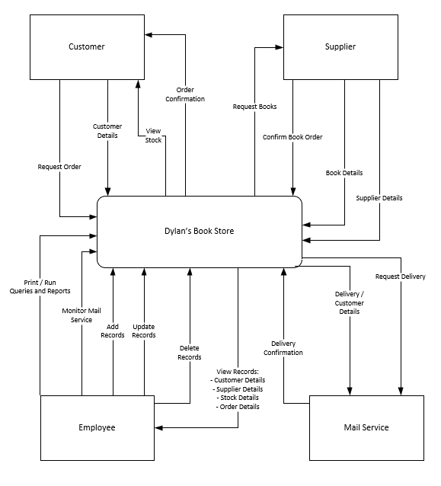
Figure 1

Figure 1 is a context diagram to show how the data flows between each interface. This explains how each interface interacts with the main process. According to some websites such as Geeksforgeeks, a context diagram is also known as a level-0 data flow diagram (DFD) [1].

Level-0 DFD Diagram
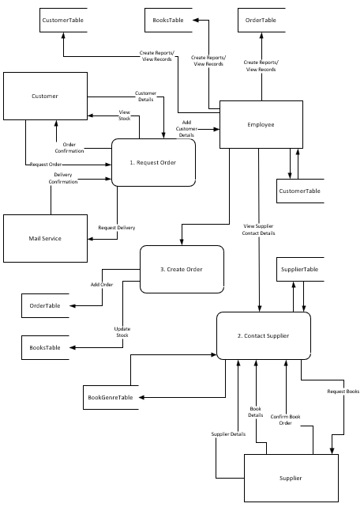
Figure 2

Entity Relationship Diagram

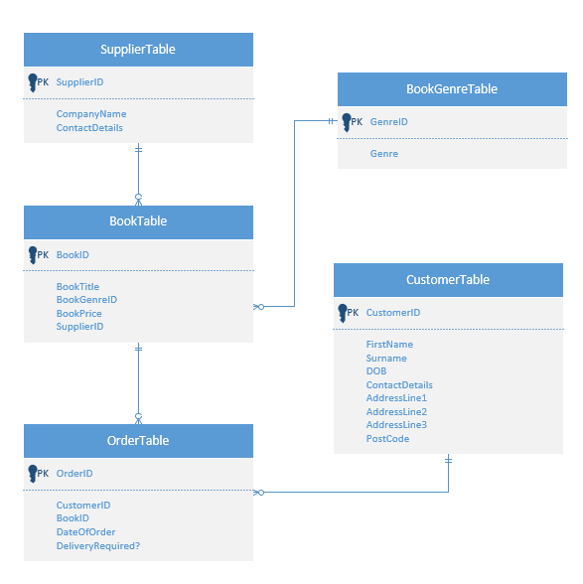
Figure 3

Figure 3 is a logical design of an entity relationship diagram. This highlights the three main objects: entities, relationships, and attributes [2]. The above diagram also draws attention to the specific attributes which are the primary keys. A primary key is used to uniquely identify a record [2].

Documentation

Suitable tables created

I have created five tables for Dylan’s Book Store:
BookTable
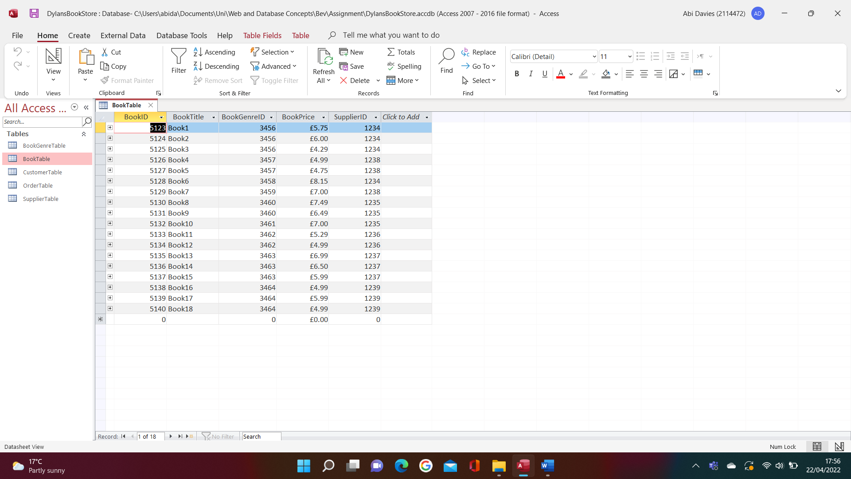
Figure 4
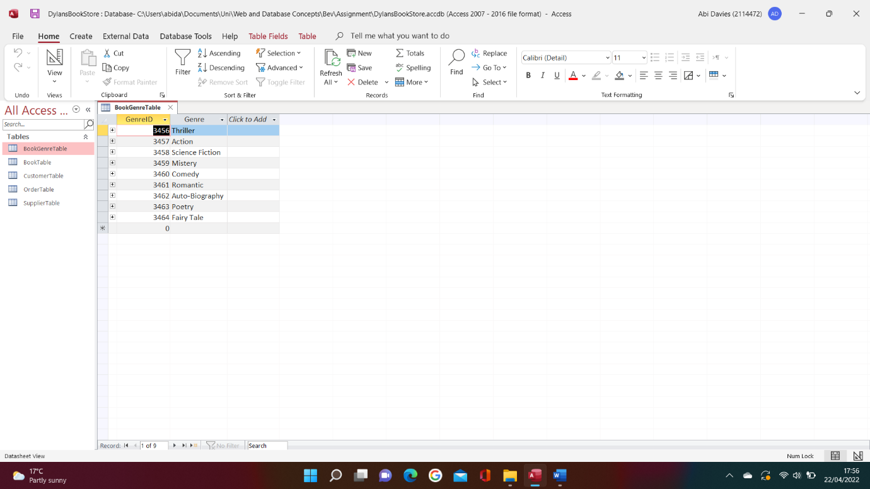
BookGenreTable
Figure 5
SupplierTable
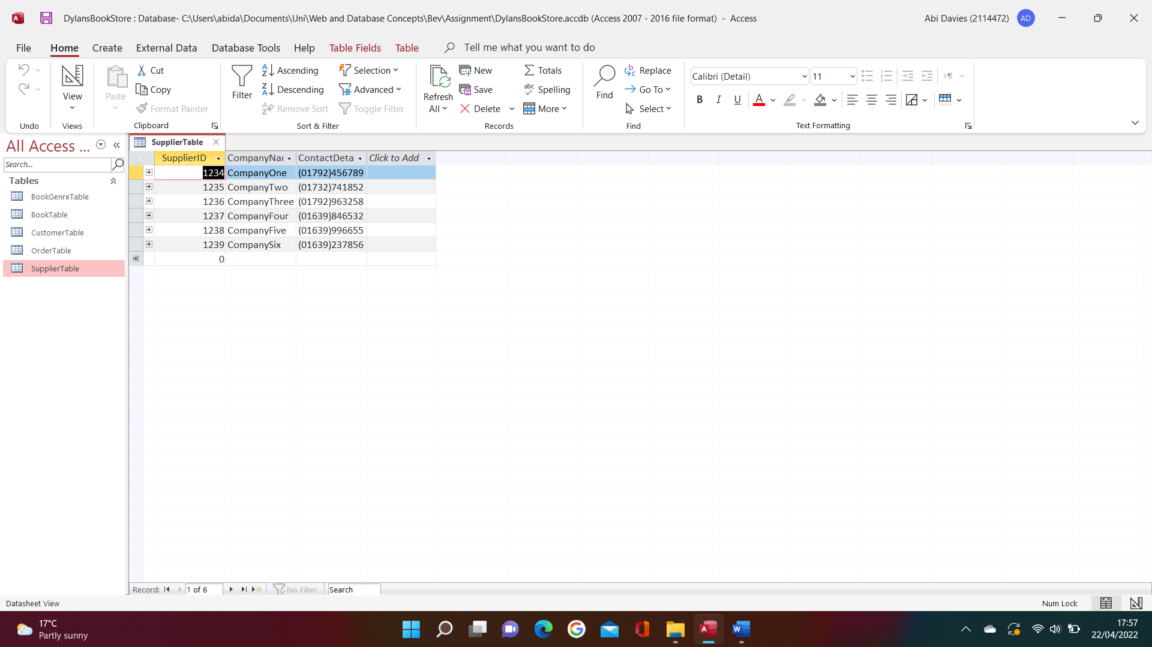
Figure 6
CustomerTable
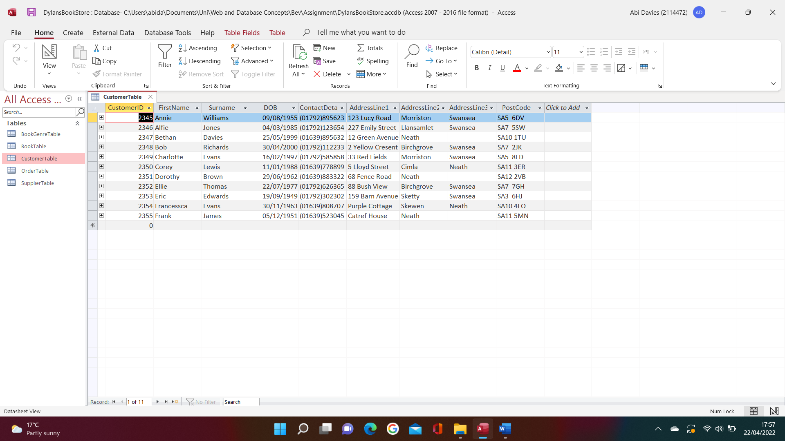
Figure 7

OrderTable
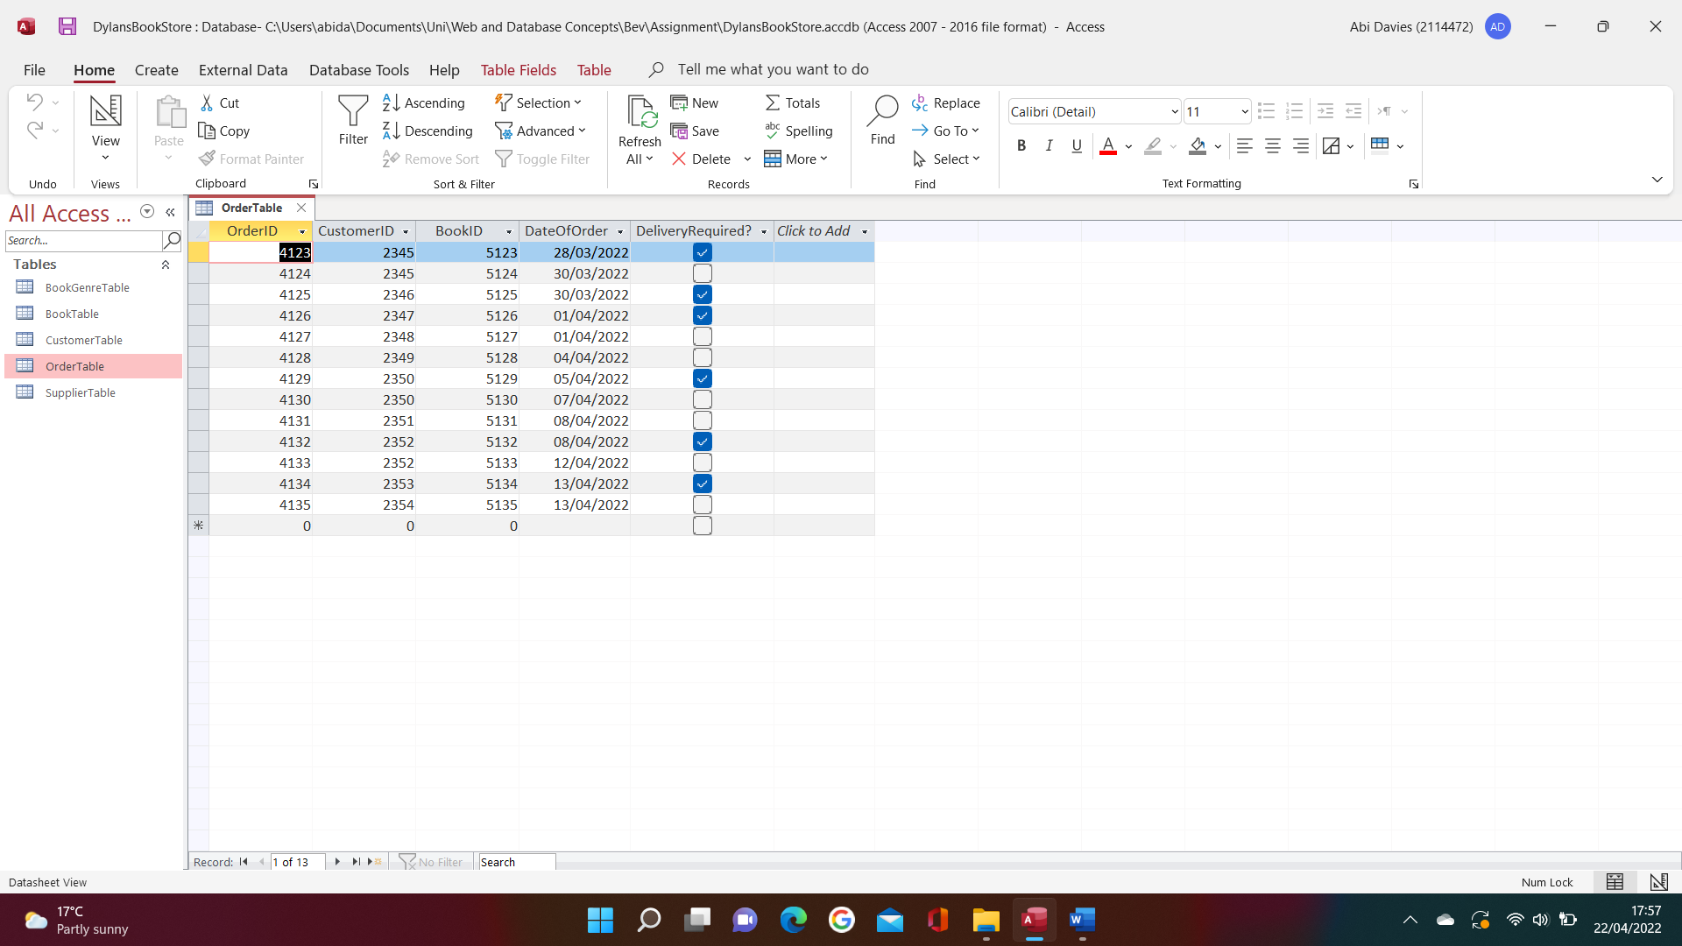
Figure 8

Suitable fields created

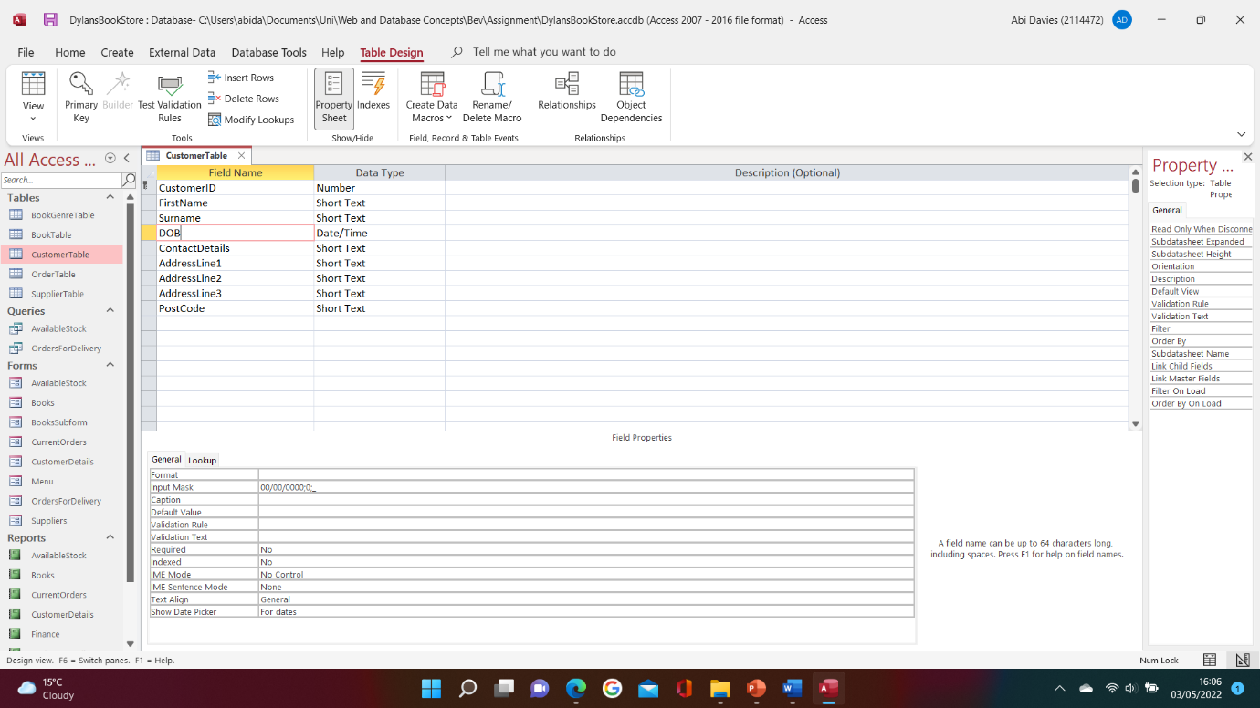
Figure 9
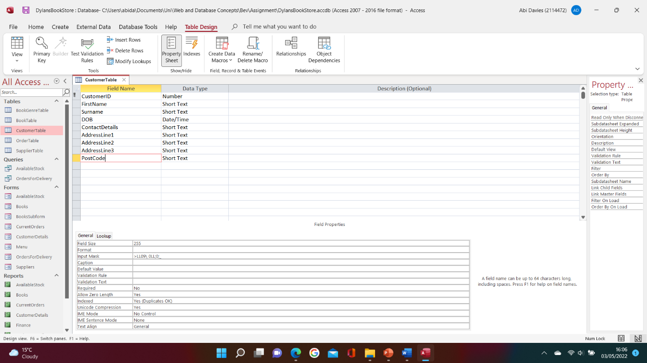
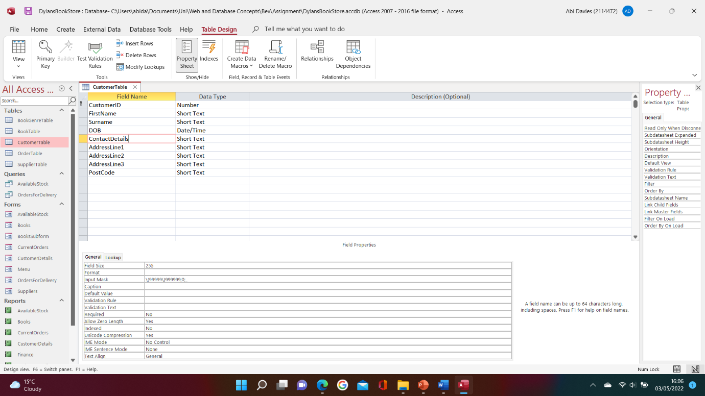
Figures 9, 10 and 11 are screenshots of the validation rules / input masks that I’ve implemented in my database. I’ve used this to ensure the format of the data that is entered is accurate. The images are screenshots of the customer table, although I have also duplicated these rules in other sections of my database. For example, the suppliers table also holds contact details, so I have ensured that the same format is applied there.
Figure 10
Figure 11

Suitable foreign keys created

A foreign key is a component of a relational database that allows relationships to form between tables. In other words, it links one table to another using the primary key [3]. The foreign keys in Dylan’s Book Store database are:

- Order Table
- CustomerID
- BookID

- Book Table
- BookGenreID
- SupplierID

Verify the design meets user requirements

As part of the user requirements for this system, the user should be able to follow the same steps as they have been whilst working with a paper system. One point would be that employees should be able to place orders with suppliers. I’ve included this in the system by having a suppliers table which includes their contact details. This will allow the employee to request a book using the details in the table and then they will be able to add it to the book table once it arrives. The system could be enhanced by having an additional table which records which books have been requested so that repeated requests are not sent to the supplier.
Secondly, Dylan’s Book Store have also requested that the system is user-friendly and created in Microsoft-Access. I believe I have also met this requirement by ensuring the buttons are in the same place on each page. This simplifies the Microsoft-Access system by allowing the user to understand how the program works through repetition.
Lastly, it was also requested that the user had access to many functions such as the ability to view, amend, add, and delete data from any table, as well as run queries and print out any reports. This has been implemented throughout each form so that the user has full access, in a user-friendly manner.

Table design meets the rules of third normal form

The database I’ve created meets the rules of third normal form. This means it also meets the rules for first and second normal form. According to the teach ICT website, the rules involved in first normal form are that there is no repeated data, the data is atomic, and each record has a primary key [4]. Second normal form requires the previous steps, as well as ensuring the primary key used is simple, e.g., ID of table [5]. Finally, the last rule that is required to make a database design third normal form is that non-key attributes cannot reply on each other. This is to prevent redundant data within the system [6]. I have applied all five rules to my database.

Evidence

Entity Relationship Diagram
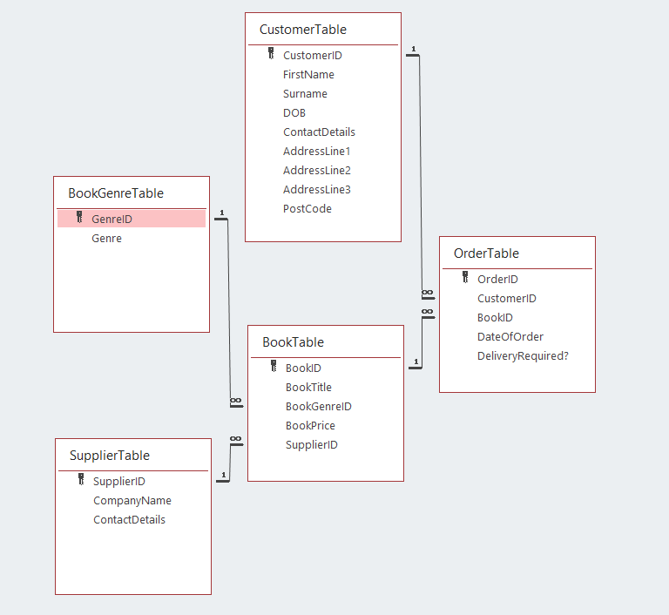
Figure 12

Functions

Produce calculation in report
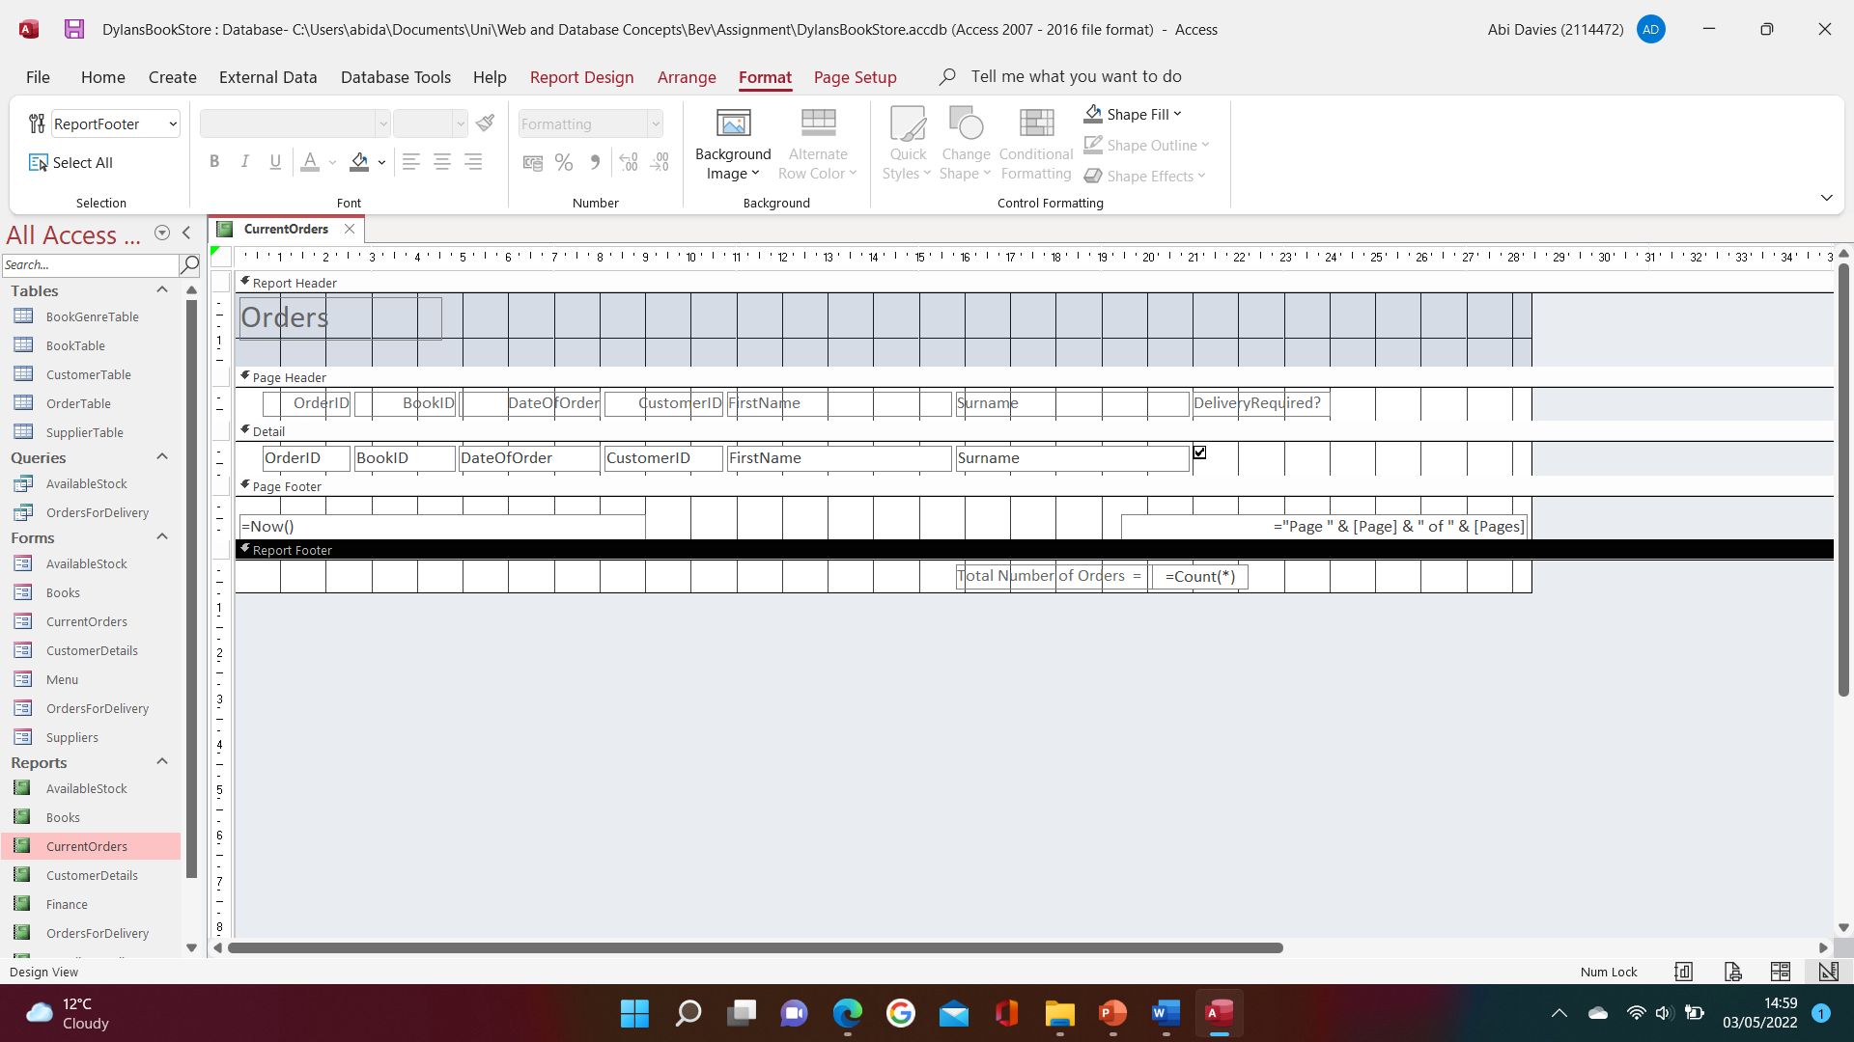
Figure 13

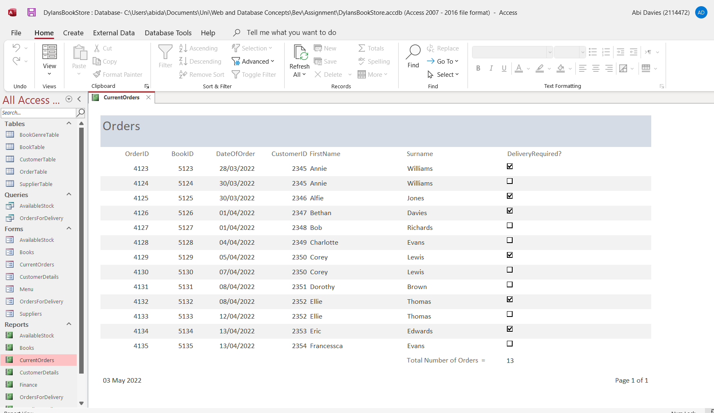
Figure 14
Figures 13 and 14 are screenshots of one of the reports I’ve created in the database. The report looks at current orders and calculates the total.
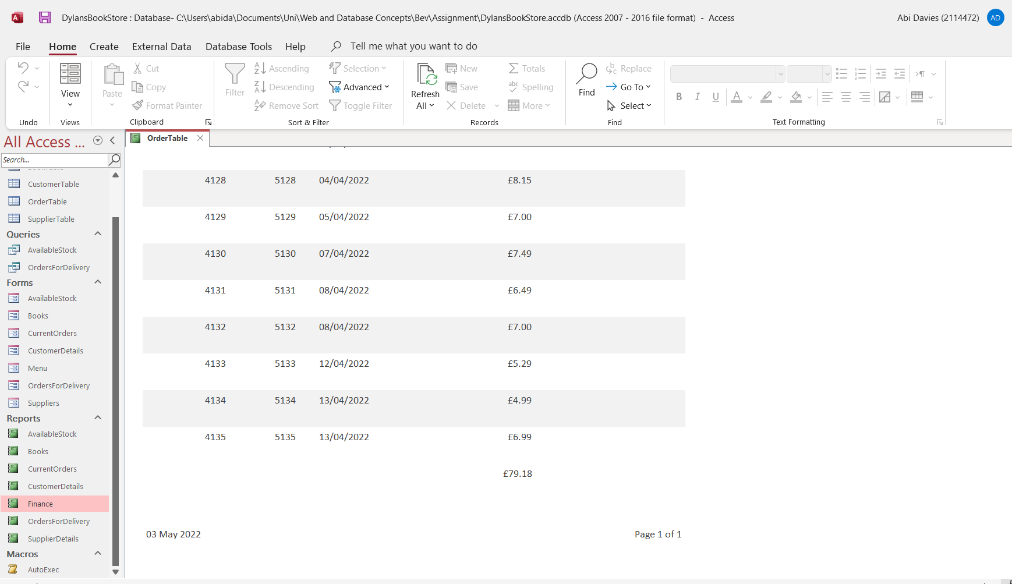
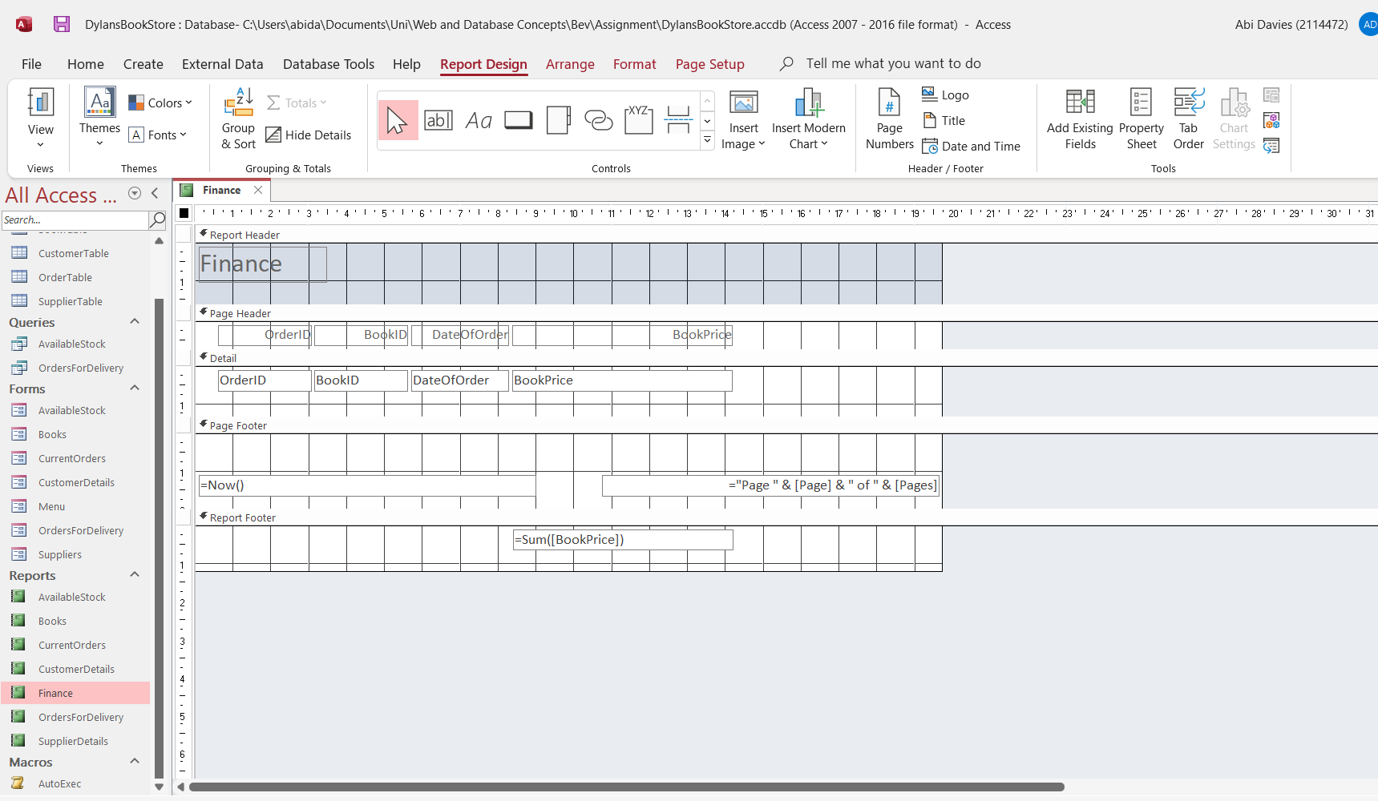
Figures 15 and 16 are screenshots of the finance report which looks at the total income received from orders.
Figure 15
Figure 16

Produce Master and Embedded forms
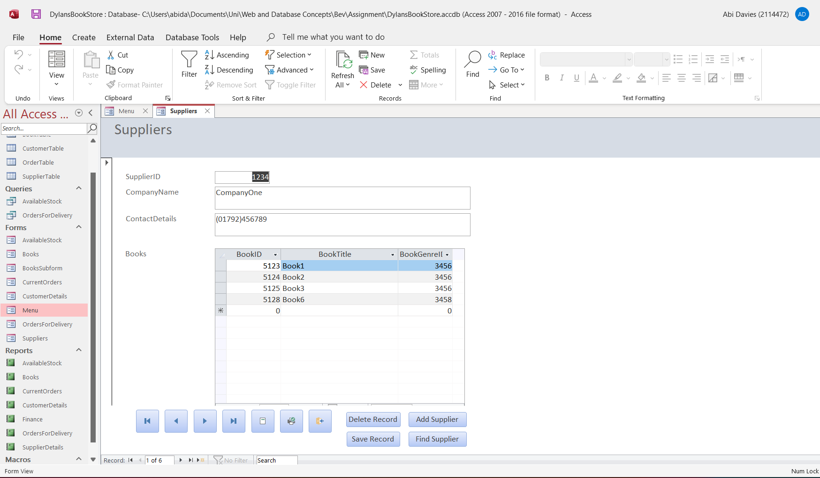
Figure 17

Figure 17 is a screenshot of the suppliers’ form which allows the user to look through the suppliers and see which books are provided from each one.

Forms

Form1 – AvailableStock
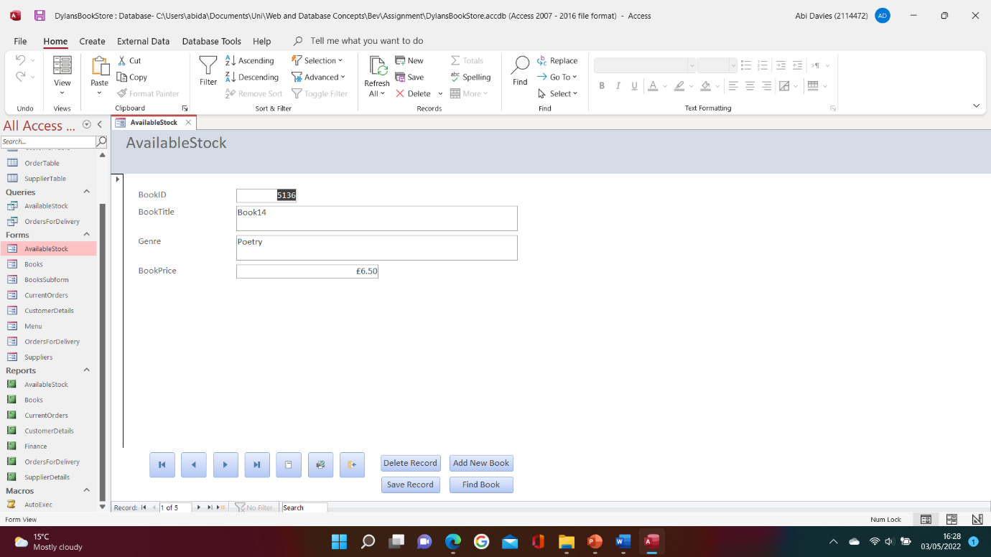
Figure 18

Form2 – Books

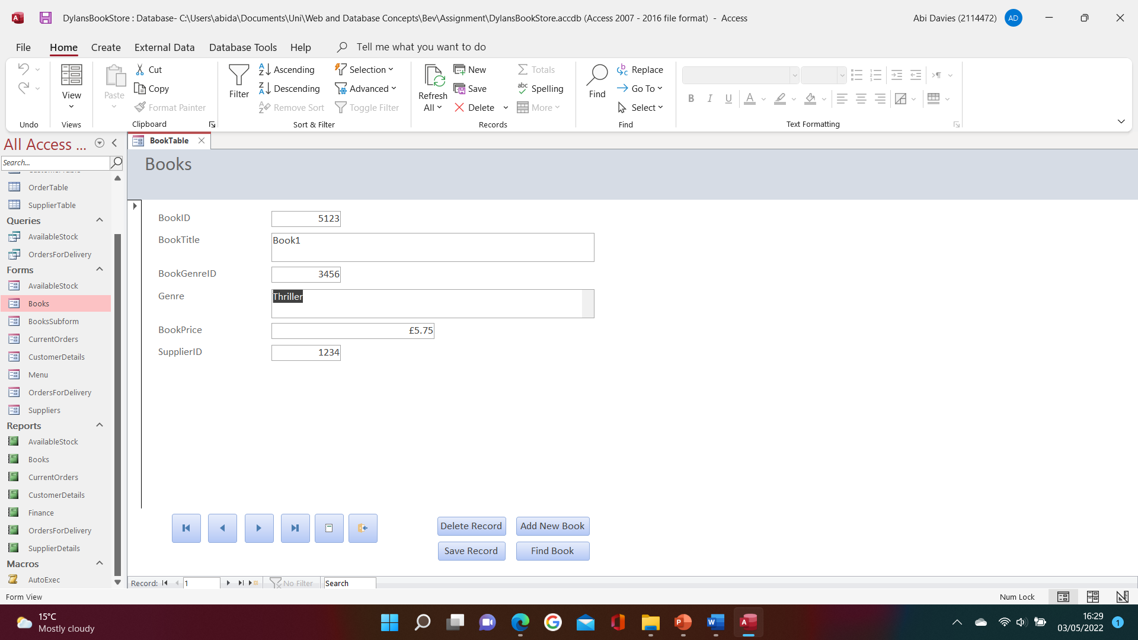
Figure 19

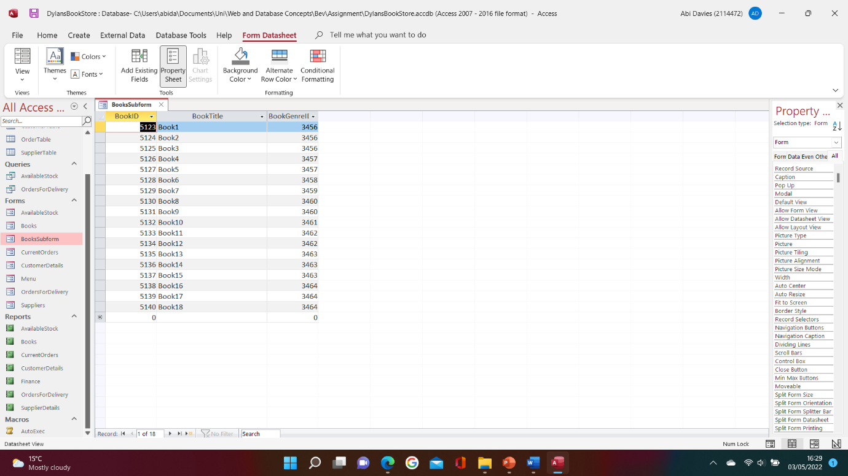
Form3 – BooksSubform
Figure 20

Form4 – CurrentOrders

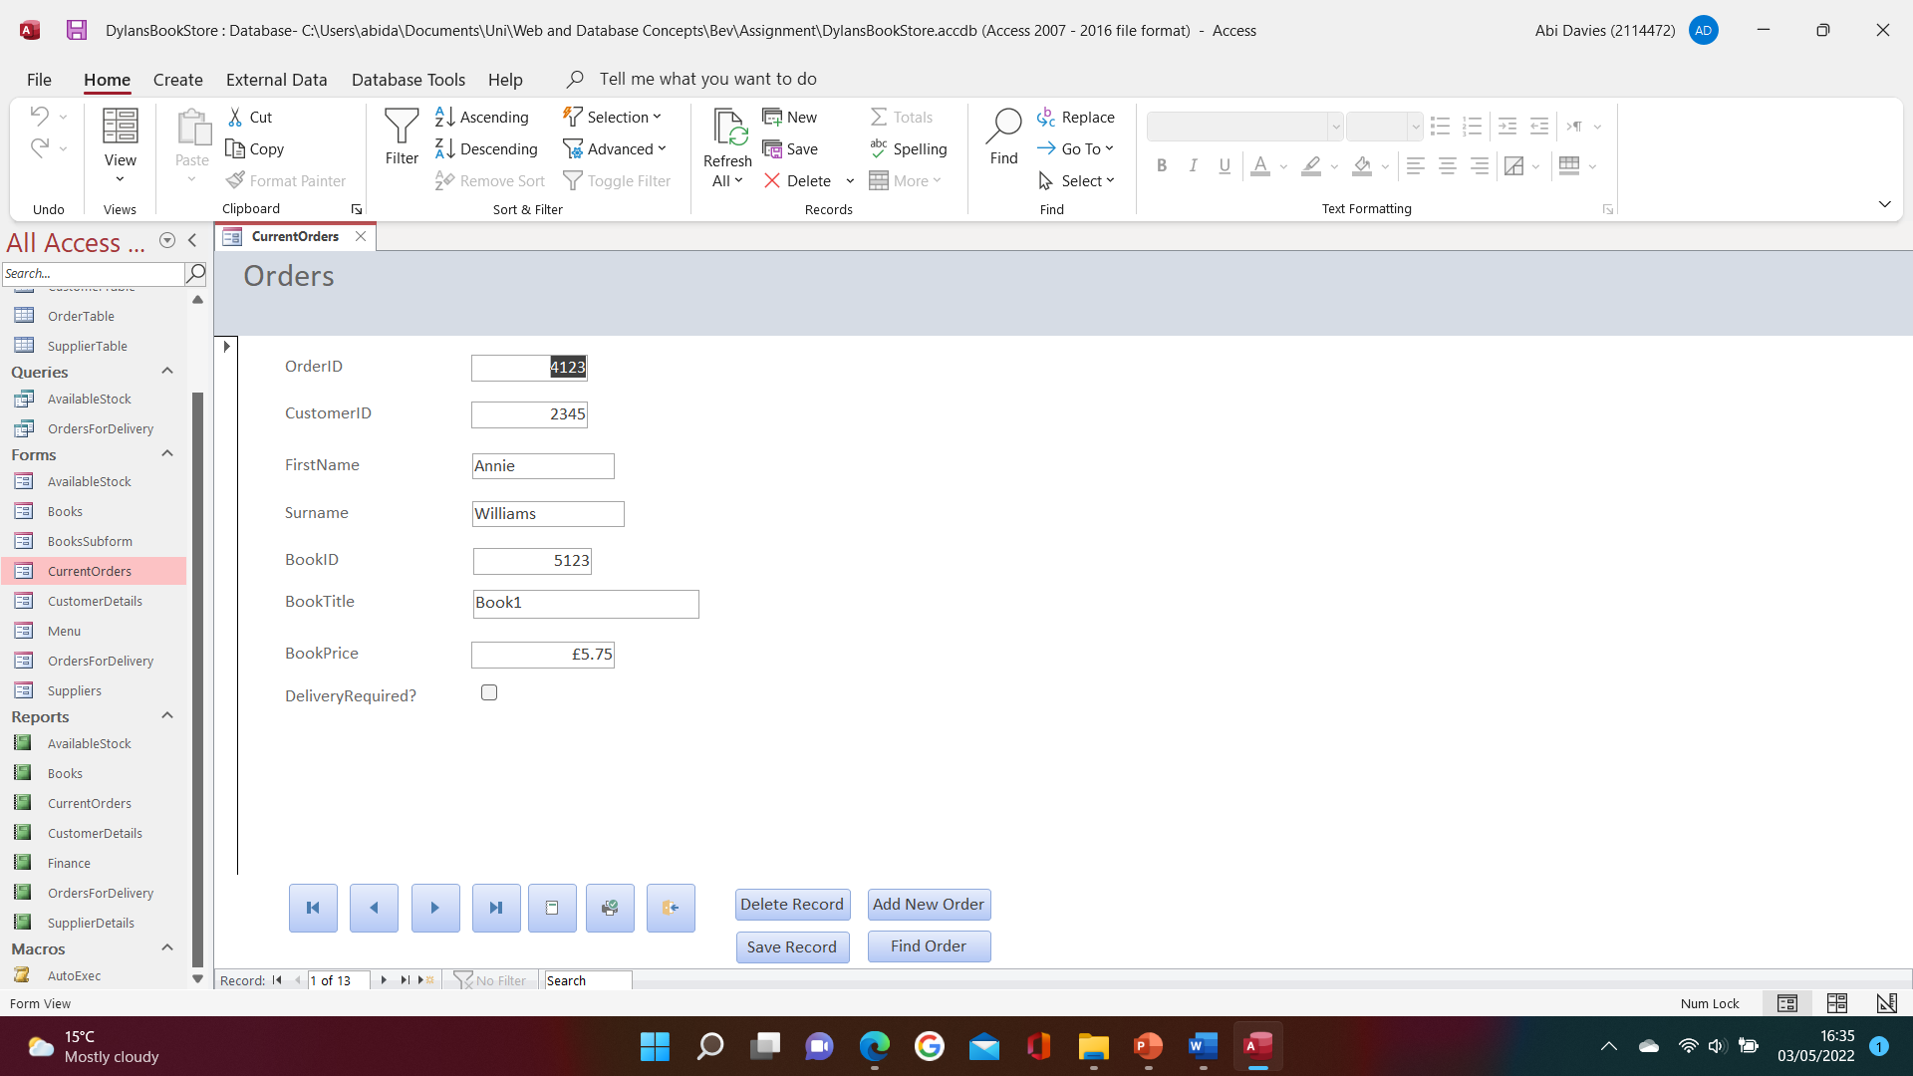
Figure 21

Form5 – CustomerDetails
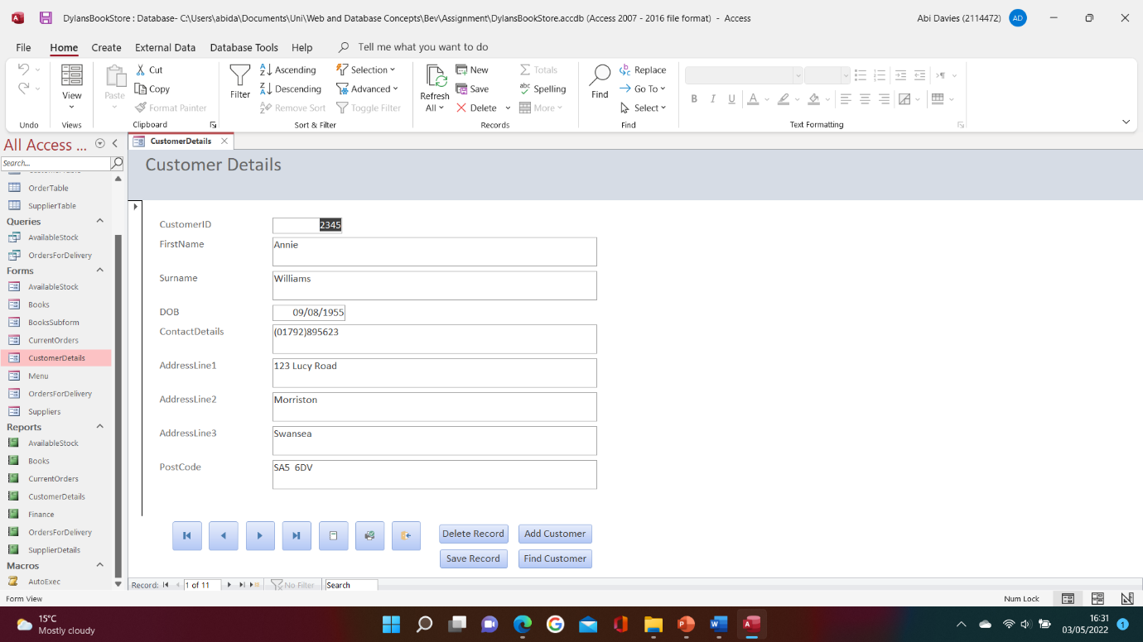
Figure 22

Form6 – Menu

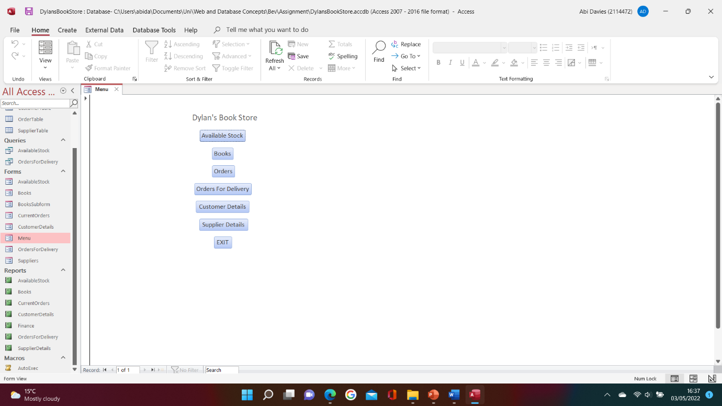
Figure 23

Form7 – OrdersForDelivery

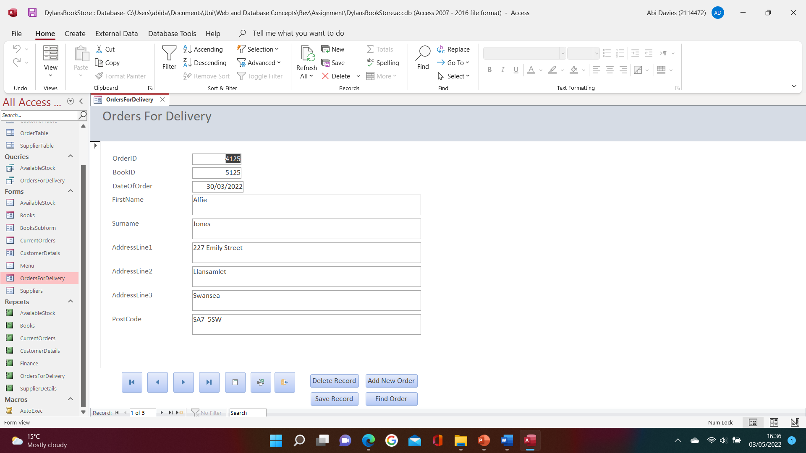
Figure 24

Form6 – Suppliers

(Figure17)

Queries

Query1 – AvailableStock
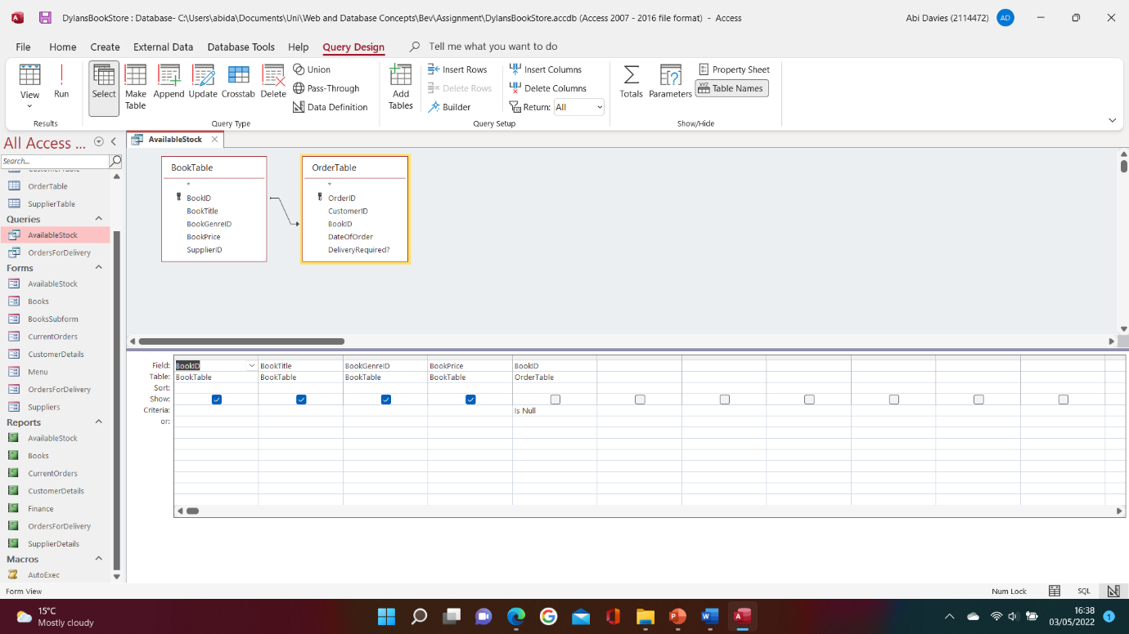
Figure 25

Query2 – OrdersForDelivery
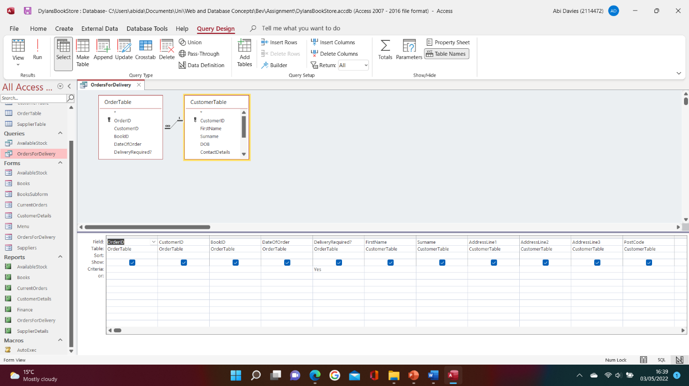
Figure 26

Reports

Report1 – AvailableStock
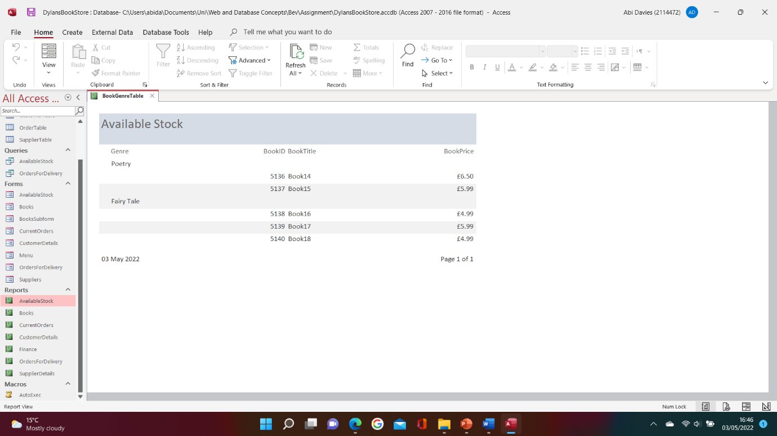
Figure 27

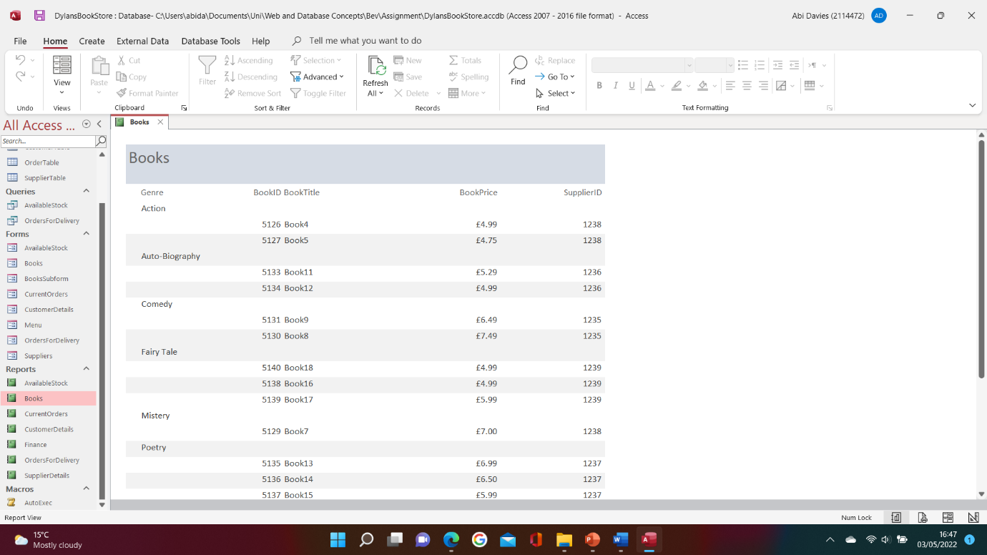
Report2 – Books
Figure 28

Report3 – CurrentOrders

(Figure14)

Report4 – CustomerDetails

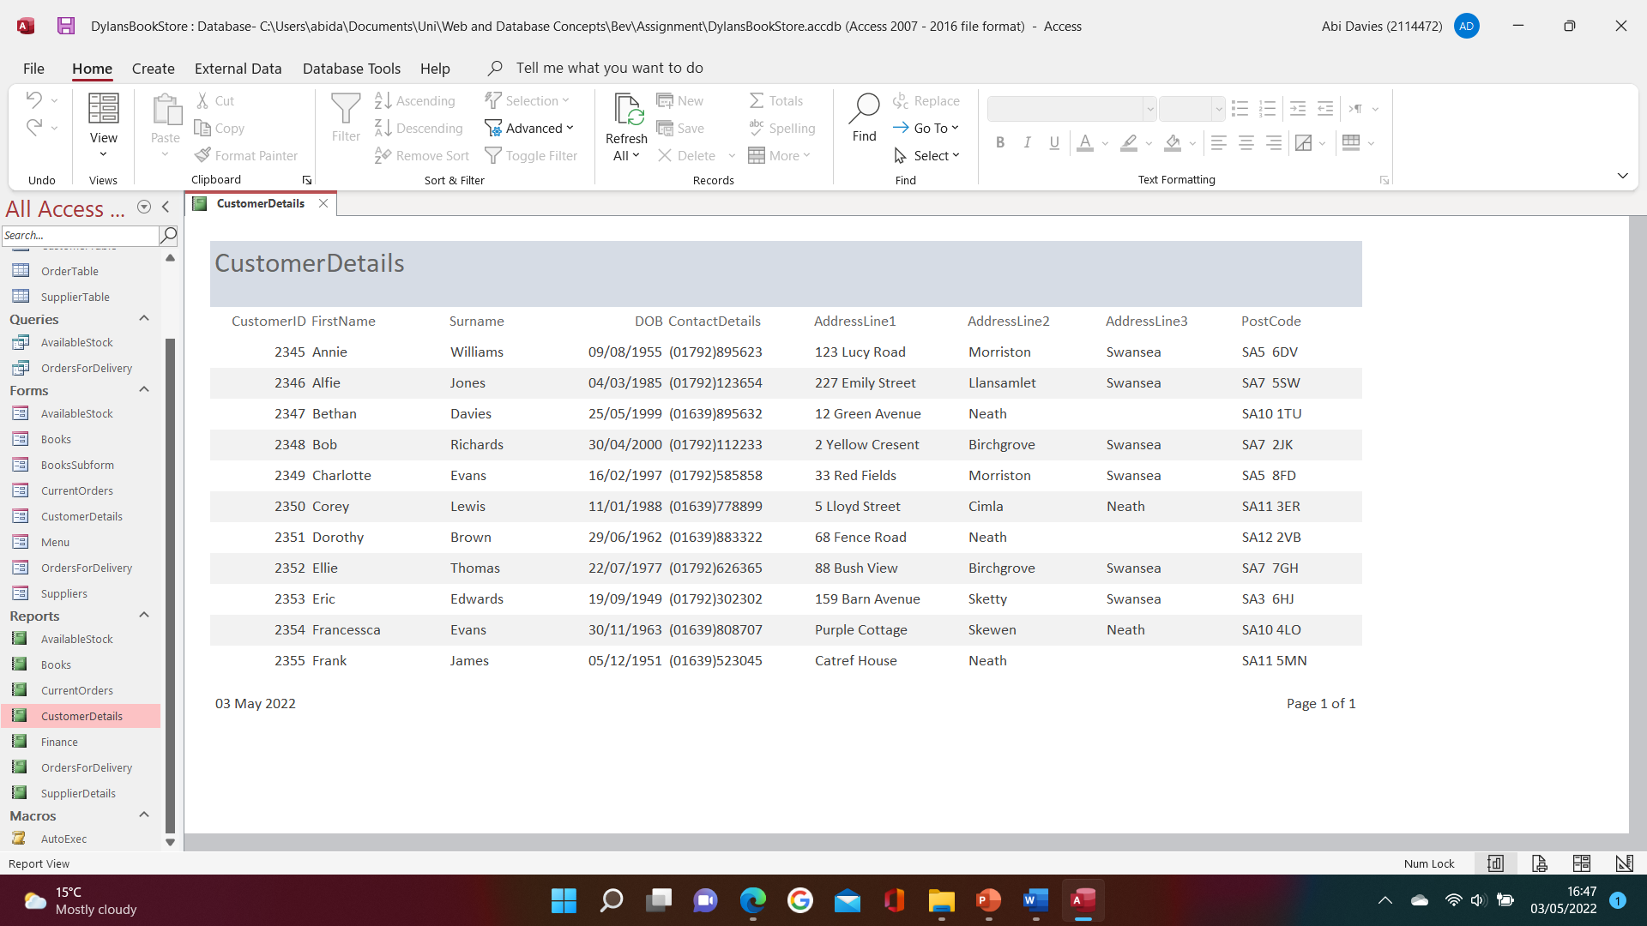
Figure 29

Report5 – Finance

(Figure16)

Report6 – OrdersForDelivery

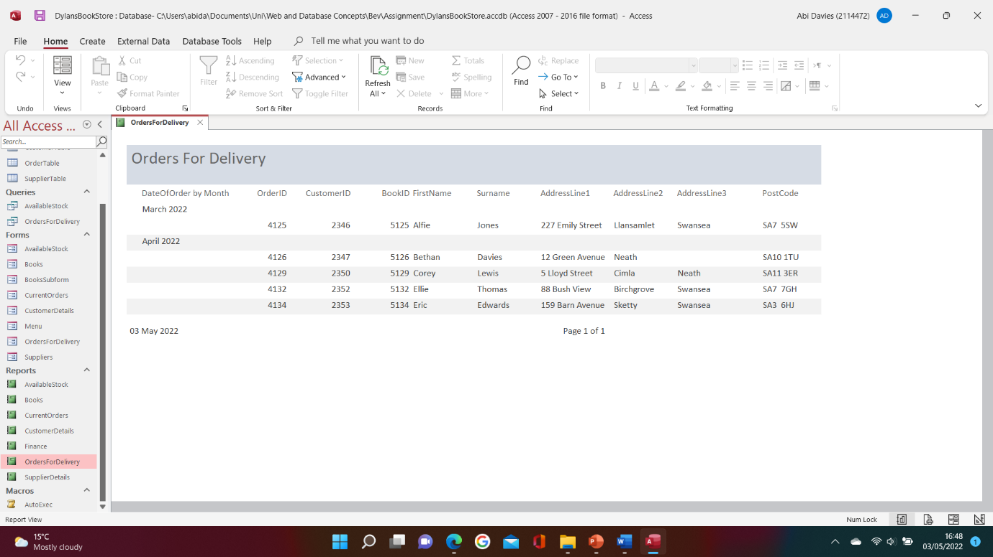
Figure 30

Report7 – SuppliersDetails

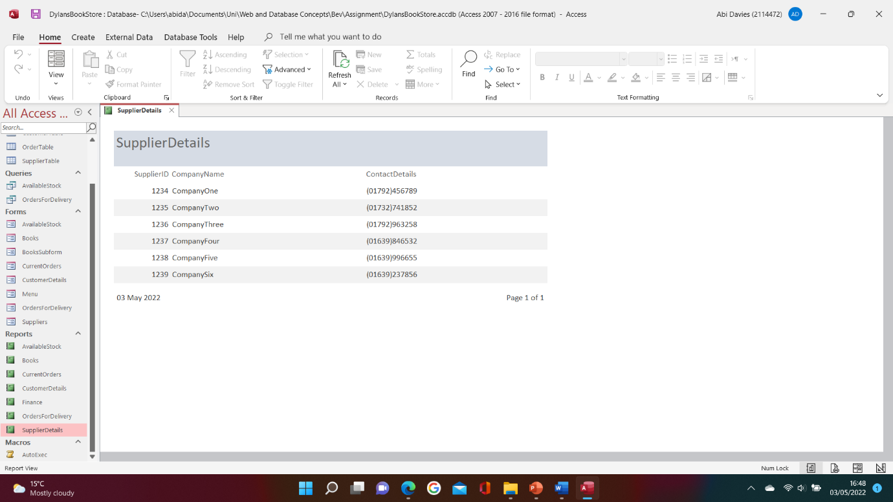
Figure 31

Menu displayed immediately after the database opens
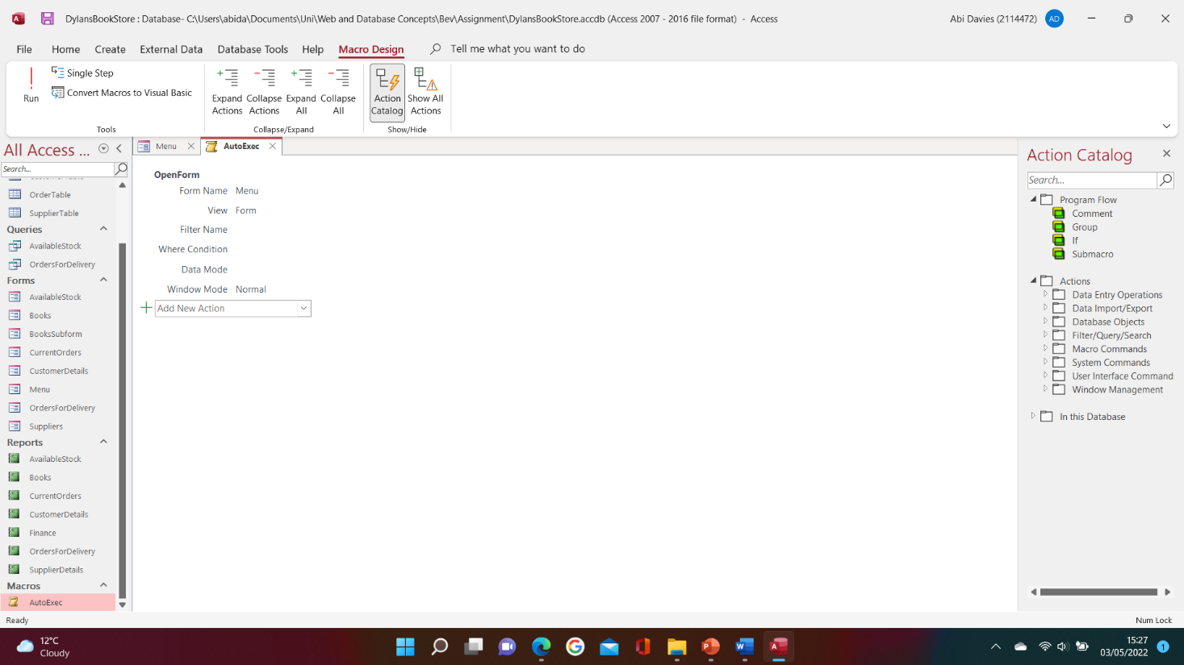
Figure 32

Figure 32 is a screenshot of the macro that I created. I’ve called it ‘Autoexec’ so that it is automatically executed when the application is opened.

Brief User Guide

When the user opens the access database file, the menu form will appear which is shown in figure 23. To view the different forms, the user will be required to click on the buttons labelled. Following this, the chosen form will appear, e.g., if the user chooses the first button ‘Available Stock’, the form that shows the books that are available to purchase will appear (figure 18).
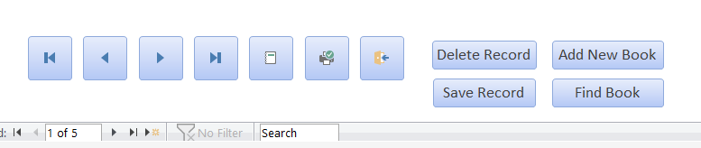
Figure 33
Starting from left to right, each button has a different function. The first button in figure 33 allows the user to go to the first record. This is followed by the buttons that allow the user to move backwards and forwards by one record. The fourth button allows the user to go to the last record. The next two buttons are related to the report for this form, e.g., the fifth button gives the user a preview of the report and the sixth button allows the user to print the report. The exit button is followed by this, allowing the user to return to the menu. The last four buttons are quite self-explanatory. They allow the user to delete, add, save amendments, and find a record. All eleven buttons are present across the forms and in the same location, to keep it clear and understandable for the user.
Finally, the user can exit the program from the main menu page, (figure 17), by clicking on the ‘EXIT’ button. This will exit the application and return the user to their desktop.

Conclusion

To conclude, I have created a menu-driven database system that is easy to use. It allows the user to view, add, amend, and delete data from all the tables, as well as print and view any reports. I have also ensured that the menu is displayed automatically when the file is opened to assist in simplifying the navigation of the system. However, in my opinion, a future improvement would be to include the business logo on the main page to make it more aesthetically pleasing. Finally, I also believe that having a login page prior to the menu page would also enhance the system. This would prevent unauthorised access to the system, allowing the business to stay compliant with the Data Protection Act and/ or prevent loss of data.

Abbreviations

DFD – Data Flow Diagram

References

[1] Geeksforgeeks, “Levels in Data Flow Diagrams (DFD)”, Geeksforgeeks, Oct. 28, 2020. [Online]. Available: https://www.geeksforgeeks.org/levels-in-data-flow-diagrams-dfd/. [Accessed 16th April 2022]

[2] T.J Teorey, Database modeling and design logical design, 5th ed., Amsterdam: Morgan Kaufmann, 2011. [E-book].

[3] J Rabelo, “Foreign Key”, techopedia, Aug. 14, 2020. [Online]. Available: https://www.techopedia.com/definition/7272/foreign-key. [Accessed 3rd May 2022]

[4] Teach-ICT, “First Normal Form - 1NF”, Teach-ICT. [Online]. Available: https://teach-ict.com/as_a2_ict_new/ocr/AS_G061/315_database_concepts/normalisation/miniweb/pg3.htm. [Accessed 4th May 2022].

[5] Teach-ICT, “Second Normal Form 2NF”, Teach-ICT. [Online]. Available: https://teach-ict.com/as_a2_ict_new/ocr/AS_G061/315_database_concepts/normalisation/miniweb/pg6.htm. [Accessed 4th May 2022].

[6] Teach-ICT, “Third Normal Form”, Teach-ICT. [Online]. Available: https://teach-ict.com/as_a2_ict_new/ocr/AS_G061/315_database_concepts/normalisation/miniweb/pg9.htm. [Accessed 4th May 2022].

