Contents page

- Description - Background to LGBT families

- Feelings- how I felt throughout

- Evaluation- positive and negative parts

- Analysis- why the experience was positive or negative

- Conclusion- what I have learned from this experience and how I can make it better for next time

- Action plan- specific actions I can take to build my knowledge and skills

LGBT families
Description-
LGBT stands for lesbian, gay, bisexual and transgender and along with heterosexual these are terms used to define people’s sexual orientation or gender individuality (Ireland,2018). The history of LGBT community is complex due to society does not understand gays, bisexuals, lesbians and transgender as a norm, due to this LGBT community’s still struggling for real equal rights, there are different forms to how they get discriminated to people being unfriendly or more serious problems resulting in being refused employment (LGBT community essay , 2019). As part of our group we created a campaign for LGBT through social media sites, we chose to do this campaign as we could see there is not enough services available to LGBT families within the community which is a big concern. We presented as a group our own presentation on LGBT families and chose our own slide to research and evaluate. I chose to talk about the pros and cons of LGBT families and found it very interesting to find out information on it as this is a topic I have never researched before or even spoke about so I did find it hard speak about it as the topic was not something I would usually choose. Our aim within the group was to direct LGBT families in the right direction to gaining the services they required. Whilst speaking about my experience I will be using Gibbs model to reflect on it, it is a good model to work through an experience. Gibbs reflective cycle was first introduced by Graham Gibbs in 1988 to give structure to learning experiences, gaining a framework for examining experience, which allows you to learn from your experiences and make a better plan next time (Gibbs, 2019).
Feelings-
Since researching I’ve found a lot of interesting facts for LBGT families and how things have changed from years ago to now, there is a lot more help out there and good community centres for the families to go to if needed but more still needs to be done as there is still a high risk of LBGT families suffering with mental health due to the criticism they have from society (parents, carers and families , 2019). I found that a lot of young people are finding it hard to talk to there parent about their sexuality which has a big impact on their health however, due to the increase in LGBT centres it provides young people with safe and welcoming environment who may feel isolated or need someone to talk to (stonewall, 2019).
we had to do a group presentation and choose our group of 4 and decided to do the presentation on LGBT families, after we got our group we then had to make a plan for us all and decide which part would be the best for each of us to talk about in the presentation. Once we all decided what part to talk about we then went off to research heavily into the topic to gain more knowledge on the topic as it was a topic most of us have never researched before or know anything about it. Gaining more knowledge on a topic can be difficult especially if it’s a topic you find hard to relate with but knowledge is not specialized information on a specific topic knowledge is every aspect of human life, such as family, health and current affairs. It is not easy to gain general knowledge but doing simple things as reading books, journals and communication with peers of friends can help with your general knowledge (Warwick,2019). We then set up a group chat and spoke on there if we needed to ask each other something or needed help with something regarding our presentation, I found this worked very well for me as communication throughout made it easier to understand and have the support when needed. Good communication in the workplace is one of the most important skills, effective communication means you are able to listen to others and also use each other’s ideas and opinions to make a successful presentation (Touro, 2019).
Evaluation-
As we researched our topics mine was pros and cons for LGBT families, I found this very difficult to research as there is not enough information on it and evidence to prove this. families of gay children were once seen as the enemy by support groups due to it being an anti-gay culture and children felt like they could not talk to their parents as they felt they would disapprove of them, which had a big effect on the children due to having less support and more mental health problems (The Washington post, 2019). However, there is a lot more support for LGBT families now, charity events, places for any age LGBT member to go if support is needed or just to talk to someone if they feel lonely or find it hard to talk to their parents (FFlag, 2019). I managed to collect enough research to present in my presentation, in the run up to the event I felt very nervous as I do not like presentations, I find it hard to present properly when I’m nervous so this has a big effect on me when I’m in this situation. Its known that feeling a little nervous before an exam or presentation can be good for you as it can make you more alert and improve your performance however, feeling to nervous can make you feel tired and unable to concentrate which can result in your performance not being to the standards you wish for (NHS,2019). Once we had presented our presentation I was glad it was done and felt like I did enough for it but I think I could have done better with how I presented it but I tried my best which is the most important part. we then had one to one feedback with our module tutor on our presentations, and my feedback I received was good which made me feel happy and relieved.
Analysis-
There was a good atmosphere when walking into the room to do our presentation which made the experience more relaxed and easy to talk however, as I did find this subject very hard to talk about and research, I have also found it nice to talk about a different topic to what I would usually choose and finding out research on a topic that I didn’t know anything about. Good atmosphere when in stressful situations can have a good positive outcome, it is the most important part that influences motivation and happiness and how efficient you can be. So when in the situation where you feel your most stressed a good atmosphere can change your way of thinking to a positive outcome and make u deliver your to your best ability (R, 2019). When I had my one to one feedback I was told that on member from our group introduced us all which is something we should have done ourselves but she insisted she would introduce for us all to make it easier for us, but I found this was not very fair as it made the rest of us look like we were not capable of presenting ourselves.
Conclusion-
On reflection I realised I should have communicated more with the group but this was hard at points due to half of my group was not in most of the lessons so we could not work together to get our information or due to busy life styles it was hard to communicate through our group messenger so If we did communicate together more then I would have found this topic easier to research and talk about. However, I did enjoy doing this presentation with the girls as we all experienced doing a topic out of our comfort zone so we were all in the same situation which made it easier to do, and when speaking to them after our presentation it was nice to speak to each other to how it went and how they felt like it went for me as we were all very nervous but guided each other in the right direction and encouragement throughout. The most effective way to transform and inspire individuals to improve their life and grow positive attitudes, build self-esteem and enhance their relationships which is called encouragement, just by doing simple things which will guide someone in the right direction to being confident and being the best they can (Smith, 2017).

Action plan-
As a result of this experience I have gained more confidence de to my feedback, this has made me feel I am capable of doing it even though I found it went really bad for me, but the feedback proved different so I am happy with the outcome. However, I have also learned for next time that I need to be more organized and make an action plan to where I am going with my work as this is something I have not done before but I think I will benefit from doing this I will also communicate better with my peers and make a better plan on how to communicate better within a group, I will also make sure I do not put myself into a situation where I find the topic hard or a topic I do not find any interest in. I would recommend more support centres for LGBT families and online website support for people who suffer with mental health problems that cannot leave their property, so they can get the support online if needed.

References
FFlag. (2019 ). Families and Friends of lesbians and gays . Retrieved from fflag: https://www.fflag.org.uk/
Gibbs. (2019). Reflective toolkit . Retrieved from The University of Edinburgh: https://www.ed.ac.uk/reflection/reflectors-toolkit/reflecting-on-experience/gibbs-reflective-cycle
Ireland, L. (2018). What is LGBT . Retrieved from LGBT Ireland: https://lgbt.ie/what-is-lgbt/
LGBT community essay . (2019). Retrieved from essay wrting store : https://essaywritingstore.com/blog/essay-samples/lgbt-community-essay
NHS. (2019, November 29). why do I feel anxious and panicky? Retrieved from NHS inform : https://www.nhsinform.scot/healthy-living/mental-wellbeing/anxiety-and-panic/why-do-i-feel-anxious-and-panicky
parents, carers and families . (2019). Retrieved from LGBT youth Scotland : https://www.lgbtyouth.org.uk/groups-and-support/lgbt-advice-centre/parents-carers-and-families/
R, H. (2019). Retrieved from creating a healthy workplace environment for your employees : https://inside.6q.io/creating-a-healthy-workplace-environment/
Smith, T. (2017). give the gift of encouragement . Retrieved from little things matter : http://www.littlethingsmatter.com/blog/2011/02/03/give-the-gift-of-encouragement/
Stonewall. (2019). An introduction to supporting LGBT young people a guide for schools. Retrieved from Stonewall: https://www.stonewall.org.uk/system/files/an_introduction_to_supporting_lgbt_young_people_-_a_guide_for_schools_2015.pdf
The washington post. (2019 ). Retrieved from Families of gay kids were once seen as the enemys by support groups. Thats changing : https://www.washingtonpost.com/health/families-of-gay-kids-were-once-seen-as-the-enemy-by-support-groups-thats-changing/2019/08/16/5d10a01a-bd1b-11e9-b873-63ace636af08_story.html
Touro. (2019). Touro University Worldwide. Retrieved from 5 ways to define good communication : https://www.tuw.edu/program-resources/good-communication/
Warwick, B. (2019). How to increase your general knowledge . Wiki how . Retrieved from https://www.wikihow.com/Increase-Your-General-Knowledge

Appendix 1
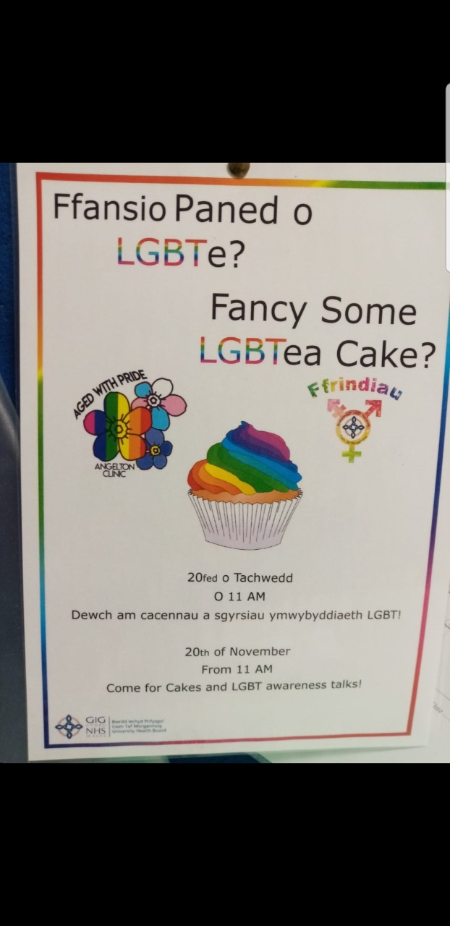

Appendix 2



