SUSTAINABLE HOSPITALITY & TOURISM MANAGEMENT

Destination Management

Name: Ana Cimpoes
Student ID: 2120104
Module code: BMIH5006
Lecturer: Ruth Taylor-Davies

Table of Contents
Introduction 3
The relevance of Milton Friedman’s theory in today’s world 4
Stability in finance alongside social stability 5
Businesses responsible for being environmentally sound 6
Future recommendations 7
Environmental aspect within hospitality industry 9
Significant towards sustainability economics or ecological trait 10
Tourism industry UK 11
Conclusion 12
References 13

Introduction
The restaurant and hospitality industry, which encompasses dining, accommodation, and tourist attractions, has a substantial impact on the global economy. However, it is also well-known for its detrimental environmental impact, which raises questions about sustainability and social responsibility (CSR). The paper in question explores the relationship between sustainability and revenues in the hotel business. Milton Friedman, a mathematician, stated in the early 1950s that the principal job of Liverpool hotel sector is to maximise profitability (Muldoon et al., 2023). This research reconsiders Friedman's position in present times when conservation and ethical behaviour are still important.
This research concentrates on Liverpool CSR ideals in terms of financial and social benefits. The study looks at economic considerations as well as the impact of consumer preferences to see if environmental and financial goals can be met in the hotel sector at Liverpool. It makes recommendations for a more environmentally friendly tomorrow. The historical context, economic considerations, consumer impact, and recommendations are all detailed, with drawings and numbers from the firm to back them up.

The relevance of Milton Friedman’s theory in today’s world
The economist, Milton Friedman has claimed that the business’s Primary duty should be improvise the revenue during the in the mid of 20th century (Musiał and Lubszczyk, 2022). For a long time, such a perspective, determined by a profit-first tactics, had a significant impact on business practises, notably those operating in the hospitality industry at Liverpool. The conventional notion existed considered a company's primary commitment was to it’s the shareholders, which resulted in a complete disregard for environmental and socioeconomic ramifications. Nonetheless, as the world faces mounting ecological concerns such as shifting temperatures and resource scarcity, the cultural backdrop must be reconsidered.
Finances and Communal Responsibility in the Contemporary Age
The landscape has shifted dramatically in the 21st century. Companies are growing more conscious of the significance of taking an environmental alongside socially responsible strategy (Musia and Lubszczyk, 2022). This transition is illustrated by John Elkington's Tripled Bottom Lines. It advocates the idea that success should be measured not only by money, but also by the benefits it delivers to people and the natural world. Observing the implementation of corporate social responsibility principles within the hospitality industry boosts traveller tastes, which have proven profitable commercially alongside ethically.
Elkington's model with the three-layered bottom lines
Elkington's concept introduces three bottom lines: earnings, people, alongside the natural world (Zaharia and Zaharia, 2021). Income is concerned with traditional financial evaluations, whereas People alongside Nature are concerned with the consequences on people and the surroundings. This broad viewpoint is used to examine the continued existence and the greater context for the travel industry. The next sections look at how these elements interacts and when, in modern times, wealth and responsible company practises can coexist. Adopting the Elkington architecture within the instance of Liverpool, involves finances, individuals, alongside the natural world, after adopting CSR at the point of interest.

Stability in finance alongside social stability
The pursuit of financial robustness together with financial viability was an important factor in the modern hotel business at Liverpool. Despite the power of Friedman's optimising profit perspective within the past, companies in that industry now recognise the need for economic stability as well as adaptation (Mayer et al., 2020). Developing strategies that ensure the long-term health of the Liverpool’s lodging industry while also producing income is a requirement for financial sustainability. Monetary resiliency is critical in an industry that is marked by volatile macroeconomic conditions, altering client expectations, and growing competition. It focuses on strategies that enable the Liverpool hotel business weather recessions and adapt to changing market conditions.
Example- manipulating environment beside revenues
An examination of various cases from the tourism business reveals an adjustment to the natural world while maintaining profit. To reduce operational expenses while also attracting eco-conscious travellers, lodging firms such as Hilton Liverpool and Marriott Hotels have implemented green programmes (Sanvitale, 2020). This demonstrates how ethical behaviour and economic feasibility may coexist. Furthermore, local resorts that value real and unique experiences over attractions for tourists are good instances of the financial benefits of servicing particular demographics while also assisting others.
Irridex concept of doxey for tourism sustainability
Doxey's Irridex idea is a great tool for achieving ecologically conscientious travel. This paradigm assesses whether visitors think individuals affect the environment, emphasising the importance of striking a balance between financial benefits and sustainability concerns (Cheung and Li, 2019). This assists businesses in detecting the narrow line that divides misuse of resources from profit margins. By employing the Irridex technique, the tourism industry can better its fiscal targets while also ensuring long-term environmental alongside financial viability.

Businesses responsible for being environmentally sound
Aspiration from customers to environmental practises
Customer interests have evolved significantly in the hospitality business at Liverpool over the last generation. Increasingly, customers and visitors are on the lookout for organisations that embrace ecological alongside ethical company adhere to (Han, 2021). This expanding requirement displays a higher concern for the natural world than simply being focused on ecological practises. Customers anticipate the incorporation of green efforts into the daily operations of hotel places, restaurants, and other tourism enterprises. The shift in expectations implies that sustainable methods have moved from a secondary factor to a vital factor in customer choices.
Sectorial determinations on response with ever-changing consumer benefits
In response to increased customer demands for environmentally conscious procedures, the lodging industry at Liverpool went through a drastic transformation. Hotels, restaurants, and the tourism industry in Liverpool have all implemented green efforts, such as garbage-reduction strategies, conservation of energy measures, and accountable procurement of supplies (Kuokkanen and Sun, 2020). The realisation that organisations must evolve in order to meet the needs of their customers is what drives the execution of such initiatives. likewise, a wide range of eco-certifications and regulations have been developed to guide and evaluate an entity's ecologically conscious actions, making it easier for consumers find and choose responsible options.
A purpose towards living together.
Given the changing character for the ecological difficulty, it may be more suitable to reinterpret the traditional concept of employer versus client devotion as an example of cohabitation (Guix and Petry, 2023). Businesses in the lodging sector at Liverpool have a possibility to balance increasing customer demand for sustainability with profit-driven goals. This coexistence is a win-win situation for everybody; by providing environmentally friendly services, hotel alongside restaurants attract ethical customers while also lowering costs over time by employing the best possible use of their finances.

Future recommendations
Methods for increasing sustainability-based revenue
Moving forward, it is apparent that the merging between economic viability and sustainability in the accommodation sections of Liverpool represents not simply an occasional trend; instead, it constitutes a persistent reality. Organisations must focus on a few important techniques to increase profits through green procedures (Lee et al., 2023).
- Make investments in technology- Adopt technology that automate sustainability procedures, reduce garbage, while improving the utilisation of energy. Maintenance expenses can be significantly lowered by utilising waste reduction apps, ecologically friendly illumination, and smart building administration systems.
- Environment promotion- Implementing sustainability programming in marketing can help attract consumers who are conscious of the environment. The Liverpool hospitality industry can distinguish itself from competitors by stressing moral behaviour throughout sales material along with online venues.
Sustainable over the continuing within travel and hospitality
To remain sustainable, the lodging industry must be passionate, flexible, and forward-thinking. To ensure continuous success, businesses should consider the subsequent advice (Madanaguli et al., 2023).
- Continuous improvement- The concept of sustainability is fluid and evolves over time. By analysing and upgrading efforts on a regular basis, you can keep sustainability initiatives up to date and ensure compliance with the most recent environmental legislation and customer needs.
- The oversight obedience- Keep current on regulations which are evolving in terms of protecting the environment and sustainable. Compliance, besides to being needed under legislation, demonstrates an enterprise's dedication to responsible business practise.
- Environmental accountability and Participation in local environmental efforts can build business's connections with other parties while also fostering trust.
Worthwhile activities to businesses
Businesses throughout the hospitality industry at Liverpool can implement the subsequent actionable steps to maintain sustainability and generating income.
• Define particular goals, such as rubbish decrease, lowering emissions of carbon, and energy and water saving programmes, in order to ensure long-term survival. Such goals provide a path to financial prosperity (Xu et al., 2022).
• Making investments in tools and systems that aid in measuring and evaluating the consequences of our actions on the environment. Statistics and statistics are essential for making choices that are well-informed.
• Offer regular instruction to each of the levels of personnel to ensure that everyone maintains supported of environmental initiatives.

Environmental aspect within hospitality industry
Consequence of industry upon the natural world
Due to the enormous quantity of fluids, power, and waste generated, the hotel industry has historically had a substantial adverse effect on the environment (Achmad et al., 2022). Given the industry's scale and extent, its environmental impact continues a cause of concern. Considering the rising attention on ecological throughout the world nowadays, this offers a huge challenge. Though the sector has gotten better, and there's still work to be done to reduce the adverse environmental consequences.
Alterations inside technologies besides invention
Recent changes, particularly creative ideas, are paving the way over the lodging industry around Liverpool to become more ecologically sustainable. Resort have been built and operated in new ways as a result of advanced power management techniques, IoT (internet of Things) technology that enable intelligent operations, alongside sustainable construction resources (Kansakar et al., 2019). Whenever reductions in the future are considered, such changes afford a chance for achieving a balance amongst profitability alongside sustainable.
The approach Hilton ecological developments by means of a visual illustration.
The Hilton Liverpool Carlton hotel near Liverpool, the world's biggest supplier of introductions, is an exemplary example of an organisation that is aggressively addressing the potential and challenges of a more sustainable future. The Travelling alongside Purpose" effort, which focuses on problems such as child opportunities, community resiliency, and fairness to everybody, seeks to help individuals across all generations. The possibility for environmentally friendly growth is proven by Hilton's commitment to reducing water consumption, waste, and carbon dioxide emissions through its partnership with the Worldwide Wildlife Foundation. Their efforts demonstrate when an important marketplace giant can set the way for a more ecologically responsible future.

Significant towards sustainability economics or ecological trait
The impact of financial security on sustainable practises
The financial resilience is critical to establishing sustainability in the dining establishments and hotel sectors at Liverpool. A corporation with good financial health is more willing to invest in environmentally conscious procedures. The Liverpool hotel sector's likelihood of promoting sustainability is mainly influenced by its financial wellness that would be achieved by investing in environmentally friendly equipment, implementing waste-reduction measures, or funding philanthropic endeavours.
An analytical structure for sustainable
The environmental movement is an investment that will pay out in the long run, rather than a one-time cost. Companies must take a proactive stance, understanding that revenue and sustainable development can coexist. An effectively carried out environment strategy can result in company distinction, increased brand recognition, and cost savings. The Triple Bottom Line approach, that considers economic, ecological, and cultural factors and demonstrates how responsible development can boost liquidity in the economy, can help steer this strategy.
Using the Butler's life course approach in the tourism sector
Butler's Life Course Method is often used within the field of tourism, and it is also useful in the hospitality sector at Liverpool. It recognises that tourist locations such as Liverpool, and hence accommodations in Liverpool, move through stages of exploration, participation, expansion, and emphasis. Companies can use this structure to assess their success on their green journey inside the greater context of sustainability. It highlights the importance of modifying equitable growth activities in alignment with their lifespan for the purpose to make the best possible use of accessible funding.
To ensure long-term sustainability in the field of tourism, financial resilience must be included as a key component of the wider sustainable development strategy. It establishes the foundation for capital expenditures within environmentally friendly technology, as well as societal efforts such as consumer-driven sustainability adaption. Hotels will be more ready to meet successful and ethical future whenever they implement approaches that establish a compromise among sustainability alongside financial goals.

Tourism industry UK
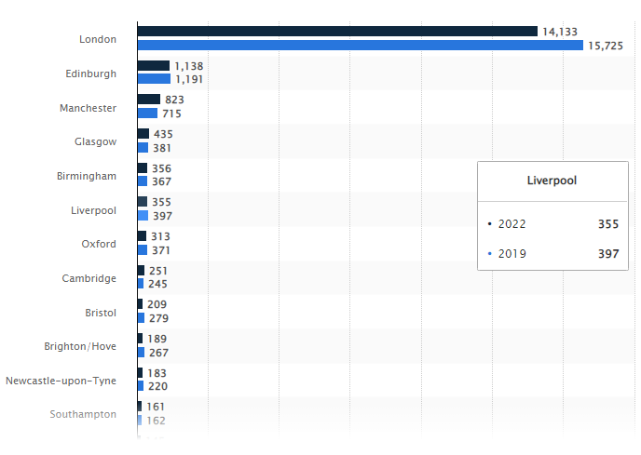
Figure 1 Most visited cities of UK in 2019 to 2022
(Source: Statista, 2023)

Based on statistics from 2019 to 2022, the most frequently travelled to city within the United Kingdom are London. Then with 355 million traveller the Liverpool is become 5th lagers visited city in UK after the London (Statista, 2023).
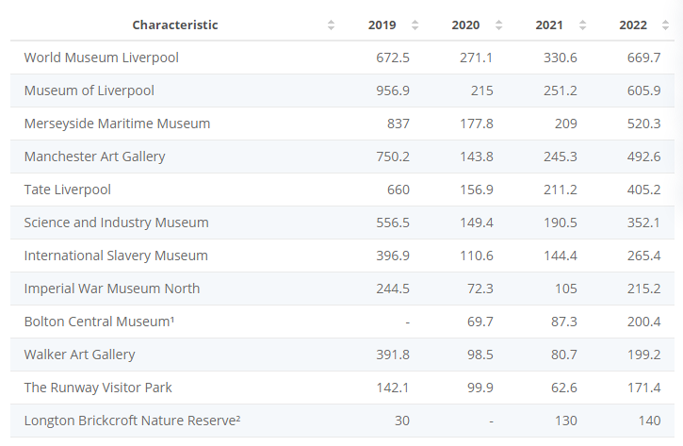
Figure 2 most visited attraction in the North West England
(Source: Statista, 2023)
The most visited attraction in 2022 of Northwest England is Liverpool based the World Museum; That approximately 669.7 thousand visitors are visited in the year of 2022 (Statista, 2023).

Conclusion
Evaluating the findings leads to the conclusion that the CSR practises advocated through Milton Friedman in the 1950s may be implemented effectively in the 21st century with higher earnings and durability. Analysing the monetary components of this hypothesis leads to the conclusion that the tourist pursues a balance among money and environmentally responsible tourism by employing Doxey's Irridex idea. Analysing the instance of Marriott and Hilton at the Liverpool hotel may bring to the conclusion that they did successfully promote the greenest programme.
The next suggestions to adopt CSR including sustainable development in the hotel industry through the use of advanced technologies and marketing campaigns engaging staff can aid in CSR implementation. Improvements in innovation and technological advancement could assist to continue the company's growth while adhering to CSR duties.

References
Achmad, W. and Yulianah, Y., (2022) Corporate social responsibility of the hospitality industry in realizing sustainable tourism development. Enrichment: Journal of Management, 12(2), pp.1610-1616.
Benner, M. (2020). The decline of tourist destinations: An evolutionary perspective on overtourism. Sustainability, 12(9), 3653.
Cheung, K.S. and Li, L.H. (2019) Understanding visitor–resident relations in overtourism: Developing resilience for sustainable tourism. Journal of Sustainable Tourism, 27(8), pp.1197-1216.
DOXEY, S. Moore, MA (2015). An essay on Doxey’s (1975) Irridex; Ap’s (1992) Social Exchange Process; and Gursoy and Rurhterford’s (2004) Determinants of Community Support theories. Mphil document, University of Cape Coast, Ghana.
Guix, M. and Petry, T. (2023) CSR managers as hybrid professionals: managing at the intersection of coexisting logics. Journal of Sustainable Tourism, pp.1-23.
Han, H. (2021) Consumer behavior and environmental sustainability in tourism and hospitality: A review of theories, concepts, and latest research. Journal of Sustainable Tourism, 29(7), pp.1021-1042.
Kansakar, P., Munir, A. and Shabani, N. (2019) Technology in the hospitality industry: Prospects and challenges. IEEE Consumer Electronics Magazine, 8(3), pp.60-65.
Kuokkanen, H. and Sun, W. (2020) Companies, meet ethical consumers: Strategic CSR management to impact consumer choice. Journal of Business Ethics, 166, pp.403-423.
Lee, S., Yeon, J. and Song, H.J. (2023) Current status and future perspective of the link of corporate social responsibility–corporate financial performance in the tourism and hospitality industry. Tourism Economics, 29(7), pp.1703-1735.
Madanaguli, A., Srivastava, S., Ferraris, A. and Dhir, A. (2022) Corporate social responsibility and sustainability in the tourism sector: A systematic literature review and future outlook. Sustainable Development, 30(3), pp.447-461.
Mayer, C., Strine Jr, L.E. and Winter, J. (2020) 50 years later, Milton Friedman’s shareholder doctrine is dead. Fortune Magazine.
Meikassandra, P., Prabawa, I. W. S. W., and Mertha, I. W. (2020). Wellness Tourism In Ubud.“A Qualitative Approach To Study The Aspects Of Wellness Tourism Development”. Journal of Business on Hospitality and Tourism, 6(1), 79-93.
Muldoon, J., Gould, A.M. and Yonai, D.K. (2023) Conjuring-up a bad guy: The academy’s straw-manning of Milton Friedman’s perspective of corporate social responsibility and its consequences. The Economist, 68(2), pp.171-188.
Musiał, H.G. and Lubszczyk, M.M. (2022) The Issue of Corporate Social Responsibility in the Light of Milton Friedman's Views and Their Further Development.
Sanvitale, A.L. (2020) Corporate Social Responsibility in the Hotel Industry: A Study of Marriott International and Odyssey Hotel Group.
Statista (2023) Most visited free attractions in North West England from 2019 to 2022 [online] https://www.statista.com/statistics/515746/most-visited-free-attractions-in-north-west-england/. (Accessed at: 8-11-2023)
Statista (2023). Leading UK city destinations 2018. [online] Statista. Available at: https://www.statista.com/statistics/289010/top-50-uk-tourism-destinations/ (Accessed at: 8-11-2023)
Wang, S., and Mirehie, M. (2022). Community perceptions of tourism impacts. Handbook of Tourism Impacts, 60-74.
Xu, L., Mohammad, S.J., Nawaz, N., Samad, S., Ahmad, N. and Comite, U. (2022) The role of CSR for de-carbonization of hospitality sector through employees: A leadership perspective. Sustainability, 14(9), p.5365.
Zaharia, R.M. and Zaharia, R. (2021) Triple bottom line. The Palgrave Handbook of Corporate Social Responsibility, pp.75-101.

