Name: Sohail Ali
Id: 2209702

Task-2: Create a reflective piece that outlines how you came up with your idea and how it adds value, based on the concepts introduced in Unit Two of the module:

During Covid-19 we all found out how hard it was to manage medicines and doctors. A lot of people died due to the lack of medicines and doctors. Affordability, cited by 40% of respondents, was patients’ biggest obstacle to obtaining primary care, the PCC and Green Center found in a survey fielded May 22 through May 25 (Rubin, 2020). Lot of people needed to spend lakhs to find oxygen cylinders or covid medicines. So, it is very important to have a solution which will help the needy in finding emergency medicines in a cost effective way. That is why the solution I provided is to create a website and app which will work as a middle man between doctors, medicines, and patients. Patients can buy medicines at cost effective way from the website and we will also have a buy now pay later system for the patients which do not have the money to pay. Moreover, the system will also help the patients to book doctors immediately from around the world and the patients can get treatment from online.

The project will create value to the society by providing cost effective medicines to the patients and they can get medicines when they are very much in need of it instead of looking for medicines here and there. They can buy and get treatment from the doctors from their home without being worried about where they will get the medicines from. This way the society will benefit a lot from this project and everyone who do not have the money to get the treatment can easily get a lot of benefits from that and they will not need to worry about the money immediately and can focus more on the treatment.

If implemented properly, this solution can be spread into the whole world and can be a change maker in the healthcare industry. More than first world countries, the third world countries can get a lot of benefit from that and as this is completely remote, it can be easily managed from anywhere in the world. And this can lead to a great health benefit for the underdeveloped countries and people from there can be benefitted a lot.

Create an A3 digital conference poster or Powerpoint showcasing your project.

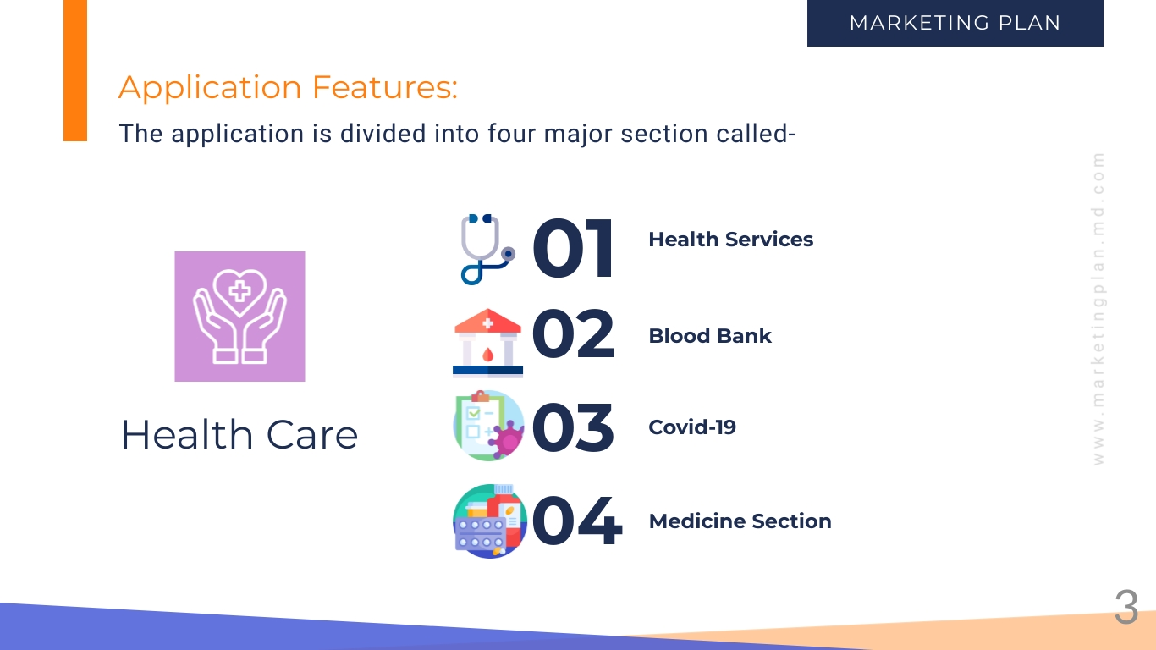

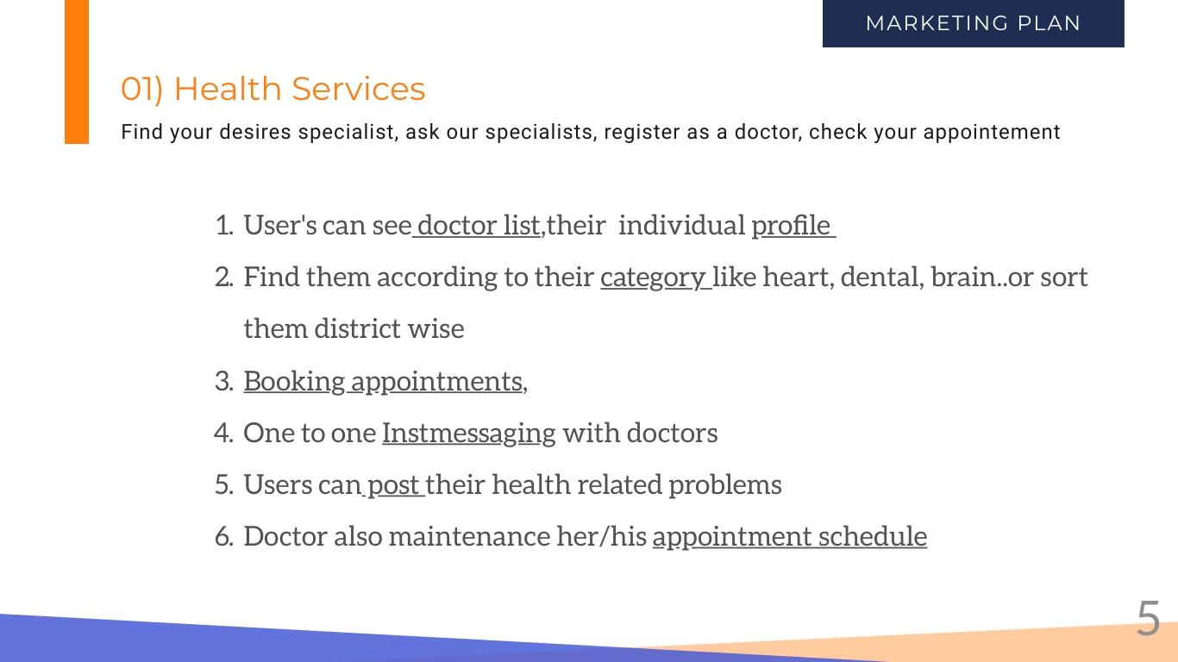

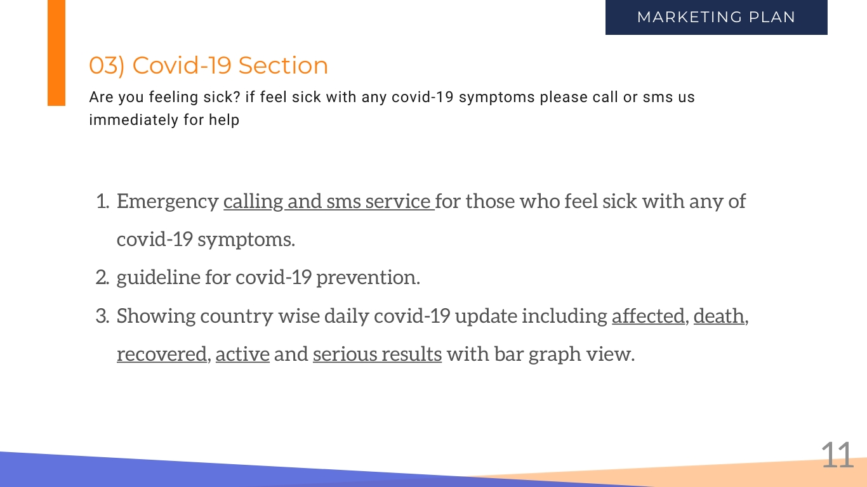

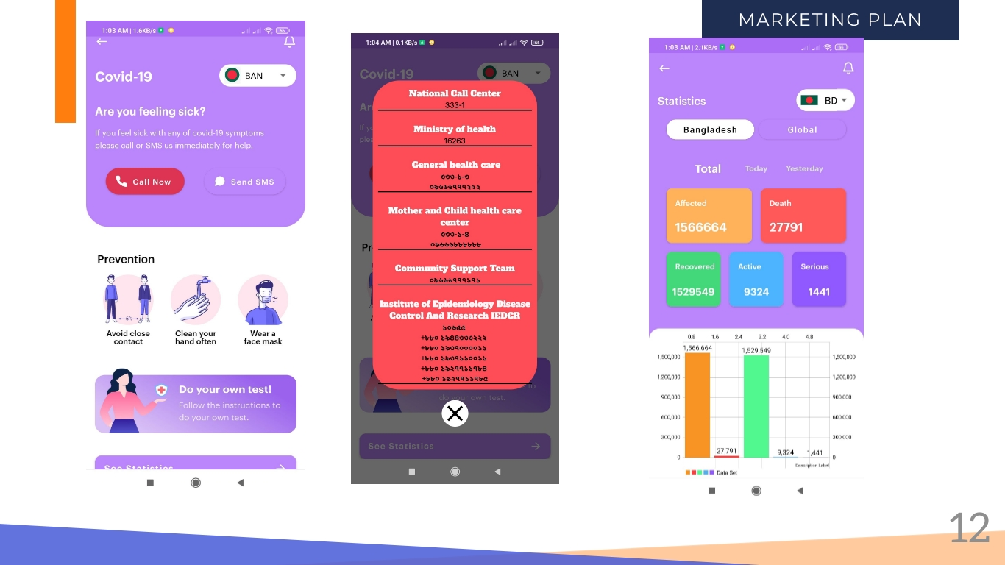

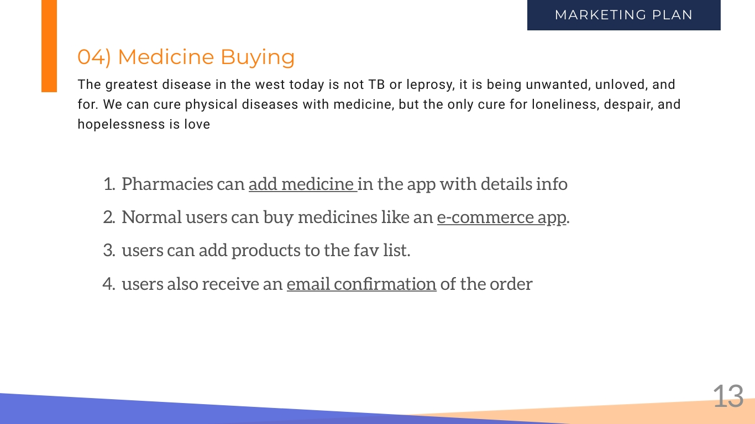

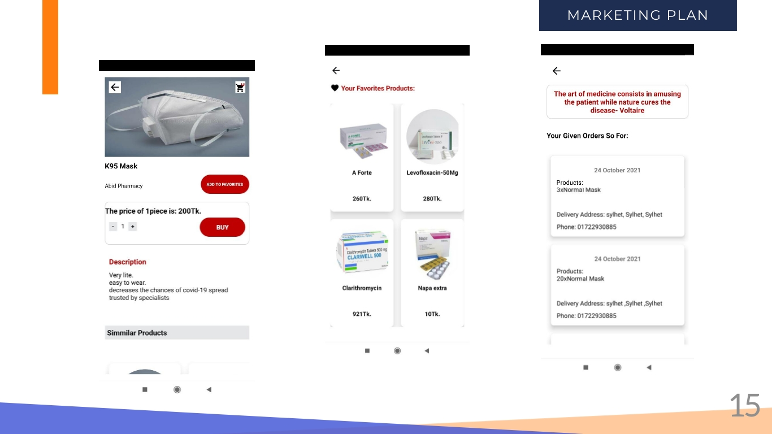

References:
Rita Rubin, MA, 2020, COVID-19’s Crushing Effects on Medical Practices, Some of Which Might Not Survive

