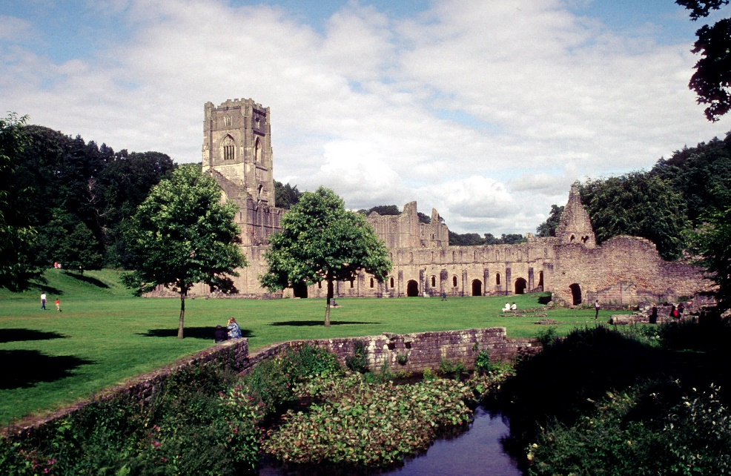

Fountains Abbey, seen from the southwest as depicted in the image, offers a striking visual summary of the contrasts between early Cistercian architectural principles and the aspirations of later medieval monasticism. Established in 1132 by visionary monks dedicated to the Cistercian revival of Benedictine purity, the abbey was meticulously crafted to adhere to the Order's rigorous architectural principles: simplicity, humility, and functionality. Early twelfth-century Cistercian documents stated that churches were to avoid elaborate decorations, stained glass, sculptural adornments, and particularly grand towers. St. Bernard criticised excessive ornamentation for diverting attention from true devotion, labelling intricate structures as something to ‘catch the worshipper's eye and dry up his devotion.’ Their churches featured square east ends, minimalist interiors, and low wooden lanterns instead of ornate stone spires or bell towers.

This, however, did not prevent a bell tower from being constructed in the Fountains Abbey. In the image, standing out prominently, is Huby’s Tower. A structure built between 1494 and 1526 under the guidance of Abbot Marmaduke Huby. Rising 180 feet, this structure defies early Cistercian prohibitions on such verticality. It was not part of the abbey's original 12th-century design, which would have been much more modest in its verticality and external display. The presence of this tower, richly carved and visibly marked with inscriptions and emblems, represents a dramatic shift from early austerity to late-medieval expressions of piety and status. Huby’s Tower showcases the stylistic evolution of the abbey. The tower's verticality and Gothic tracery stand in stark contrast to the rounded arches and substantial massing of earlier Romanesque forms, heralding an innovative relationship with light, space, and splendour. The visual presence commands attention within the surrounding monastic complex. While it proudly displays the devout motto “Soli Deo Honour et Gloria,” the tower's impressive scale and intricate ornamentation suggest a declaration of institutional prestige alongside its divine significance.

The scale of these ruins testifies to the expansion of the monastic community, which by the 14th century required buildings far larger than those envisioned in the order's early years. Yet, despite their size, many of these structures preserved the Cistercian preference for bare stone, simple pointed arches, and architectural rhythm over decorative detail. Inside, the repetition of arches and restrained ornamentation would have guided monks from the exterior world into a focused spiritual space. Light, admitted through plain glass, illuminated stone in a way that reinforced humility rather than spectacle.

The landscape that surrounds the abbey, visible in the image beyond the abbey walls, was a deliberate selection, reflecting the careful considerations of its builders. The Order expressed a preference for secluded locations, seeking to minimise worldly distractions and to dwell in proximity to an ideal of Edenic simplicity. The valley's isolation, sculpted by the meandering River Skell, facilitated the emergence of Fountains as a self-sufficient enclave, reflecting the spiritual solitude sought by the Cistercian monks. The act of physical removal was paralleled by the establishment of spiritual boundaries. In the early traditions of the Cistercian order, the presence of secular courts and feasts within the confines of monastic precincts was strictly forbidden. As recorded in the Exordium Parvum, communities such as Cîteaux endeavoured to safeguard their enclosure from external lay influences. Fountains, devoid of guest halls or noble chapels, serves as an affirmation to the initial desire to protect poverty, simplicity and the pure space from the influences of the outside world. Yet the ruinous condition visible today also speaks to historical rupture.

The abbey faced multiple cases of economic turmoil: forward selling of its wool crop, a higher demand of tax in the 14th century due to Scottish invasion, the black death of 1348–1349, and then the Papal Schism of 1378-1409, English Cistercian houses like Fountains Abbey were told to stop communicating to the mother house of Citeaux because it backed a different pope. In response to this, the abbots made their own chapter to run the order in England. Fountains Abbey met its dissolution as part of Henry VIII's broader campaign against monastic institutions. The monks faced expulsion, resulting in the abandonment of the buildings, which were either left to deteriorate or dismantled for their materials. The ruins observable today, grand walls exposed, with nature gradually enveloping the stone, serve as evidence to the abrupt end of monastic tradition and the fragility inherent in even the most resilient establishments.

Furthermore, the ruins are a historical witness. The towering remnants strike awe for their size and for the lost culture of regular prayer, liturgical rhythm, and spiritual striving. Fountains, transferred to Studley Royal Park in the 18th century and maintained by the National Trust, enables us to examine medieval monasticism's goals and contradictions. Therefore, the image exhibits continuity and complexity. The abbey's position, scale, and many architectural characteristics conform to early Cistercian precepts, but its towering verticality and subsequent decorations show the community's changing response to prosperity, dedication, and permanency. It depicts theological architecture characterised by silence, confinement, and humility but not immune to time, ambition, and change.

Bibliography

Primary

- Bernard of Clairvsux: Apology, translated by David Burr (Paul Hasall, 1996)
- The Exordium Parvum

Secondary

- Burton, Janet. The Cistercians in the Middle Ages. (Boydell Press, 2011)
- Carter, Michael. "The Tower of Abbot Marmaduke Huby of Fountains Abbey: Hubris or Piety?". (Yorkshire Archaeological Journal. 2010)
- Marsden, Alan. “Huby’s Tower | Salem Chapel, Martin Top.” (2024) https://www.martintop.org.uk/blog/hubys-tower.
- Knowles, David. Religious Orders Vol 1. Cambridge University press, 1979)

Barnard of Clairvsux: Apology
Marsden, Alan. Huby’s Tower
Carter, Michael. "The Tower of Abbot Marmaduke Huby of Fountains Abbey: Hubris or Piety?". 269–286.
Ibid
Exordium Parvum, Chapter 15
Ibid
Knowles, David, Religious Orders Vol 1. 68–9
Burton, Janet. The Cistercians in the Middle Ages. 99–100, 176.

