Short film or TV Production essay

This essay will demonstrate how I intend to create a film for Paranormal Wales and how I will market my own film successfully to the horror genre. Also in this essay, I will be looking at the short film Blackwood, to compare different elements of the horror genre. This essay will look closely at the code and conventions of the horror film, so that it will relate to my own practice and create a realistic horror film.

“ The Horror Story is an allegory for the horrific world we presently or could soon inhabit. It serves as a prescriptive or cautionary tale about how to best metabolize our darkest fears and survive. The power gap between the monster and the victim is immense, and thus the victim who raises the courage to confront the force with all of their inner genius to their last breath, inspires us to do the same. To win is to survive.” (Story Grid, 2019)

When exploring the horror genre, horror is a myth for people’s nightmares. We can tell if the film is a horror film by having a group protagonist sitting around a campfire telling ghost stories. This is why sometimes when we watch a television series or film, that the opening scene begins by telling a story at night. For example, in the film The Frog directed by John Carpenter, 1997 the audience are aware that something is about to happen in the film, or television series, because it will be the first signal that they are greeted with.

The internet has changed the way that filmmakers see the use of marketing films in many ways. This isn’t due to the fact that it is cheaper than advertising on television platforms, but various types of distributors and companies can send their content to a specific target audience, and if film companies and distributors use social media, then it can really attract a wider audience. This marketing strategy is less expensive for the average consumer and more time consuming. For example, Blackwood is a short horror film based on a YouTube channel called Alter. By Blackwood being released on Alters YouTube channel, it will only target the horror fan base.

When it comes to marketing in film, consideration needs to be given on how much is going to be spent on the marketing phase. When investing money into marketing, it normally costs half to a quarter of the actual budget. For example, for my short film in block 2 called She, we had a budget of £5,000 to make the film, and in total we spent £5,313. If the film was to be marketed, £3,500 would have been spent on marketing.

Paid streaming services like Amazon Prime, Netflix, and Hulu don’t only just stream big movie titles or mini series, but they also distribute independent films or television series to these platforms. These companies know the target audience the best, they even know what to recommend to a specific audience.

Codes and conventions help the filmmaker when it comes to filmmaking because it gives the filmmaker a guide to the genre on what the director wants to make. Every genre, has codes and conventions in its generation. With the Horror genre, Horror is defined to be a static genre because of particular basic elements, while some genres develop over time to a wider background and because of the target audience, than the horror genre. Codes and conventions also help the audience, with the audience knowing the codes and conventions of a certain genre, they can expect what is going to be in every film.

Blackwood is a short horror film that is based on a YouTube channel called Alter. Alter is a dedicated horror based short film YouTube channel that has 788K subscribers (when writing the essay). Blackwood is about a sound recordist picking up a strange sound while filming in the woods. Then when she comes across a strange encounter, she wakes up confused in her own home. Her only evidence of the incident is her sound recorder.

When picking a location for a horror film, a horror film is normally in a location that is in a less crowded area. This is due to the fact that the main protagonist in the film can be harmed without anything in its path. This is why you see a lot of horror films in the horror genre to use abandoned houses or forests. For example, in the short film Blackwood (Image 1), it shows that the protagonist is walking around exploring an empty forest, with nothing in her path. But if this was viewed in a crowded location, then the film would be focused around specific people. For example, The Purge 2 is set on the street because people are locked in their houses.
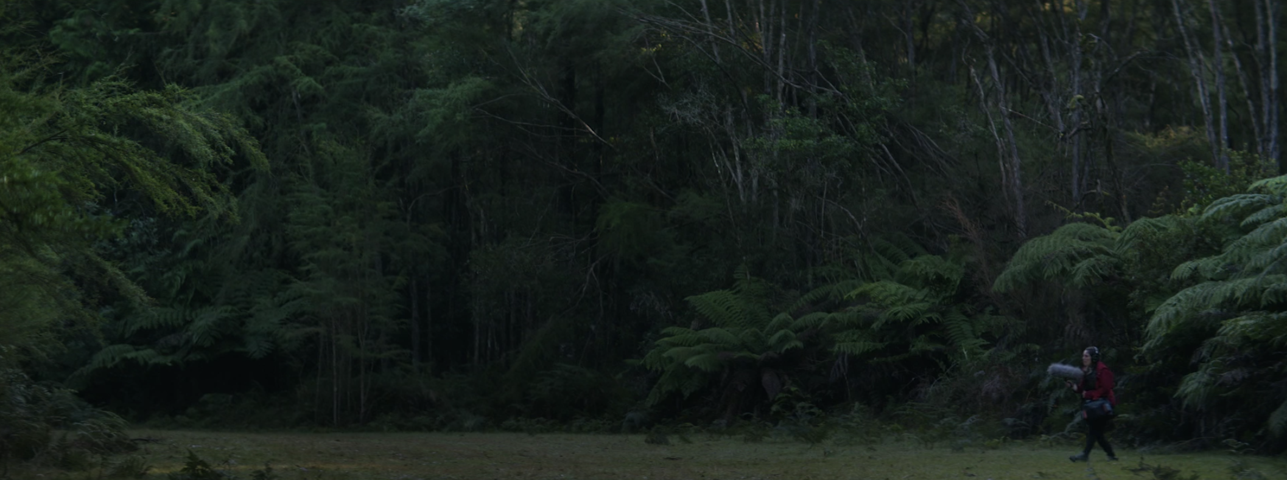

Image 1: Protagonist walking around an empty forest

In the short film Blackwood they use certain cinematography techniques that are used in the horror genre. Blackwood mainly uses handheld footage for thin film because by using handheld footage, it creates tension and suspense for the audience so they know that the protagonist is in danger. Image 1 shows the protagonist exploring the forest, it is cut to handheld footage to show the danger of the protagonist. Also establishing shots are seen when it comes to the horror genre, establishing shots are used because it is to establish where the main protagonist is in the world that they are exploring. For example, in Image 1, an establishing shot of the forest is seen, so that the viewers know that the main protagonist is in the forest and that they know where the film is set.

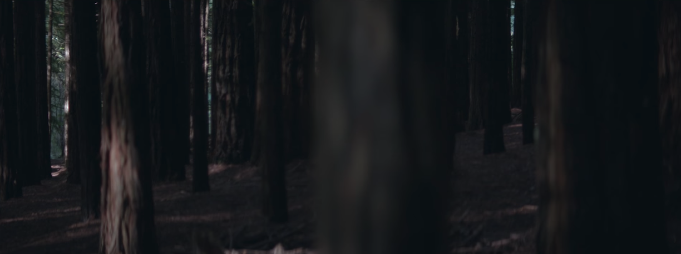

Image 2: Protagonist exploring the woods

In image 2, the protagonist exploring the woods can be seen. This is also a common cinematography technique by the camera panning and then following the main character in the film.

Fear is also a common factor when it comes to the codes and conventions of the horror genre. Nightmares, alienation, vulnerability, death, fear of the unknown, and the loss of the identity all relate to some sort of fear. However, this will only be focussed on the main character of the film, mainly the background or the main characters persona. For an example, in the film Blackwood (Image 3) the main protagonist shows the fear of death as she is being attacked by an unknown creature.

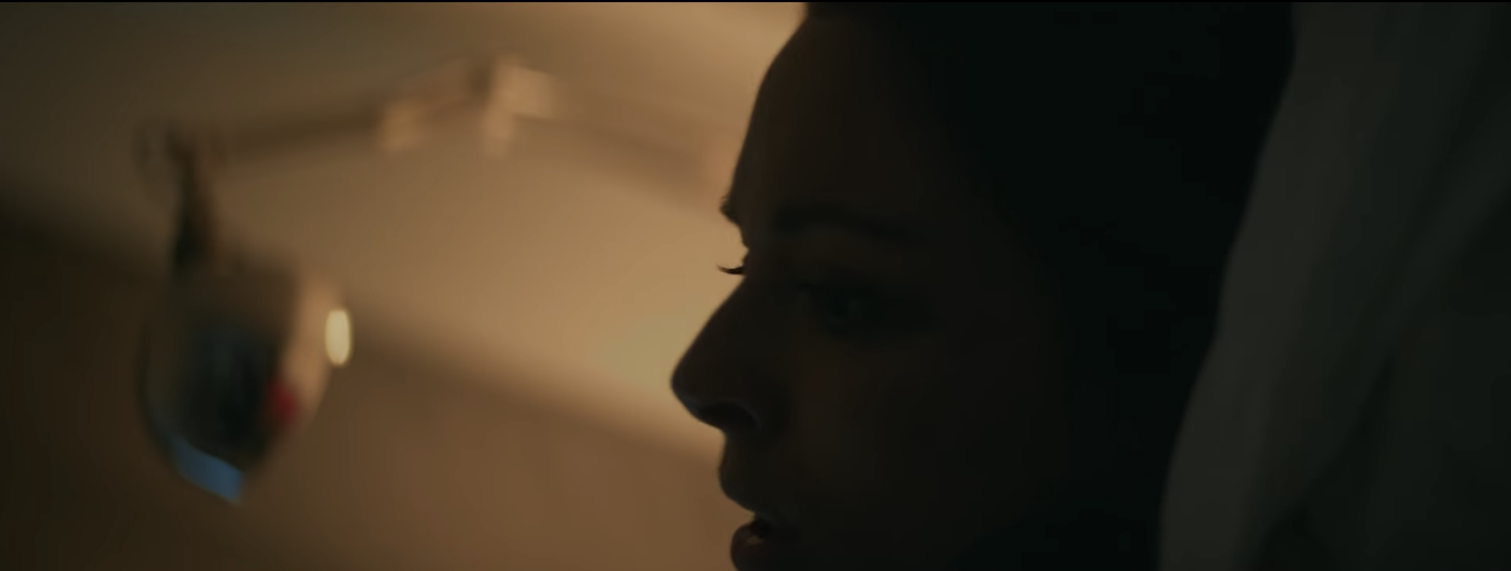

Image 3: The main protagonist showing fear of death

When it comes to sound design or even music within the horror genre, horror films will generally use dramatic music because of current actions that are in the film. Using the right music in the film can make or break the film. If non dramatic music our sound effects are used, it can give a different meaning to the audience. For an example, in the film Blackwood, they mainly use suspense music to create tension for the action is about to unfold.

Bibliography

Websites

Codes And Conventions Of A Horror Film by kay-lee ... - Prezi. Retrieved November 23rd, 2019, from https://prezi.com/8m6mpn9vmcoq/codes-and-conventions-of-a-horror-film/

Secrets of the Horror Genre | Story Grid. Retrieved November 22nd, 2019, from https://storygrid.com/secrets-of-the-horror-genre/

Videos

Blackwood. (2019). Directed by A. Montague. Alter. Accessed November 23rd 2019, from https://www.youtube.com/watch?v=6mjpXaWApCc&t=73s

Marketing: Crash Course Film Production #13. (2017). Directed by C. Coures. CrashCoures. Accessed, November 23rd 2019, from https://www.youtube.com/watch?v=04C3B1Ztwf0

Moodle Reading List

https://moodle.uwtsd.ac.uk/pluginfile.php/315580/mod_resource/content/1/CASE%20STUDY%203%20THE%20HORROR%20GENRE.pdf

