A comparison of the marketing methods of two international hotels
BMIH4005
Moryom Begom Qureshi (2238616)
Marketing essential | Gayathri Mudiyanselage | word count 1500

This essay is introducing the subject of marketing, especially comparing the market methods and strategy of two multinational hotel brands.
I will examine two hotel brands six sense and Holiday Inn. Comparing the brands marketing strategies also will be identifying similarities and differences in respective marketing strategies.

Six Sense Hotel is an international hotel spa with 22 Hotels Resort across the world.
Six Sense was founded in 1995 with a mission to promote responsible practices in top tier hospitality (Wikipedia.com) From exotics resorts and spas to private clubs and luxurious residences six senses is a luxury five-star hotel, resort and spa are synonymous with a unique style authentic, personal and sustainable. Six senses are a business that significantly reduce their environmental impact through green best practices in maintenance, services, logistics, products and supplies (sixsenses.com) The core elements revolve around reducing waste, saving energy and cutting down on water usage. This is one of six senses STRENGH (appendix 5) where business use the SWOT analysis to help their businesses, so by being a sustainable hotel shows quality that separates them from their competitors. SWOT analysis stands for STRENGTH, WEAKNESSES, OPPERTUNITIES, THREATS. It is away for assessing your business, it also helps you recognise what your business is good at and helps you for a better future for your company.

The resort chain highly emphasizes the importance of clientele like families and millennial group on their business. (Refer to appendix 1 graph of age). Six senses adopt for couples, as they design perfect romantic atmosphere and serenity couple choose the resort to celebrate anniversaries wedding and other significant events. The top five countries consumers reside to are the UK, USA, Canada, India and Thailand. (Appendix graph geographic), also the PESTLE strategy impacts on hotel and tourism (Appendix 7) PESTLE which stands for Politics, social, legal, economics, technological, legal, environmental. (Brigitte 2015)
The biggest impact that has affected Six Senses and Holiday Inn is the political side to it when Russia and Ukraine had a war, this had huge effect on tourism where customers have been restricted to travel on air also because of low tourism it has made fuel price and food price go up that has affected travellers to disposable income (Nikolova 2022)

So overall Six Sense targets young millennial who are highly attracted to sustainability, and new intellectual development. Families and couple have similarities behaviour, generally both are looking for a calm, quiet place for relaxation. With luxury spa facilities for couple activities for kids, and a relaxing dining experience. (Appendix 6) is a perceptual map that shows that six sense falls in the high-quality high price (Wikipedia). Whereas Holiday Inn is an American chain of hotel based in Atlanta, Georgia and brand of IHG Hotels and Resorts. The chain was founded in 1952 by kemmons Wilson, who opened the first location in Memphis, Tennessee that year. The chain was a division of bass brewery from 1988-2000, six continents from 2000-03 and IHG hotels and resorts since 2003, it operates hotel under the names Holiday inn, holiday express, holiday inn club vacations and Holiday inn Resorts. as of 2018, holiday inn operates more than 1,100 locations. Holiday inn has air conditions room restaurants, pools, television, direct dial telephone services, piped music and radio, wall to wall carpeting and cocktail lounges, holiday inn location tends in basic areas like next to train station or bus station or supermarkets.so on the perceptual map they fall under basic location and low price. (Appendix 6.)

Holiday inn marketing strategic is mainly emphasized on the variable under the control of the firm that the marketing manager manipulates in order to achieve tactical marketing objective.
Holiday Inn found that the four features that are of most significance to business travellers are providing free high-speed internet access comfortable in room workspaces, full service, meeting facilities and robust loyalty program. Broadcasting advertising is essential in Holiday Inn they look at business travellers and last-minute booking, traditionally at men aged 35-54. See (Appendix 3) Companies like Holiday Inn must do Marketing in order to attract customer and sell their products in order to make profits. Marketing department is an important part of organisation, responsible for up selling of organisation, responsible for selling of company products by different ways like advertising, providing seasonal or promotional offers giving discounts, hiring celebrities for the advertisement of their products. (Appendix 5) this shows Holiday Inn have used OPERTUNITIES to improve their business in the SWOT analysis. Both companies use the marketing mix plan or the 4P’s, product, price, placement, promotion. The 4p’s work in conjunction with one another, main purpose is to generate higher sales. (McCarthy 1960) (Neil Patel 2023)

To position six senses and Holiday Inn in the BOWMAN strategy which is a clock that shows the available options are for businesses or its managers in terms of positioning strategies in terms of price perceived added value. (Appendix 4) so six senses will be 5 focused differentiation, and Holiday Inn 3 Hybrid (google)

Reference list:
International Hotels Groups. (March 31,2009.) Retrieved (June 6, 2009.)
Niklova Milana (August 22.2022.)
Similarweb LTD (2009-2023)
Feys Brigette Pestle analysis (2015)
Will, Kenton (March 27.2003)
McCarthy, Basic marketing A managerial approach (1960)
Neil Patel available at: https://neilpatel.com/blog/4-ps-of-marketing/ ( Accessed 17 May 2023)
Six senses spa hotel available at: https://en.wikipedia.org>wiki>sonu_shivdasani Accessed: 17 May 2003)
Six senses available at: https://sixsenses.com (Accessed 17 May 2023)
Holiday inn available at: https://holidayinn.com (Accessed 15 May 2023)
Holiday Inn available at: https://en.wikipedia.org>wiki>Holidayinn (Accessed 15 May 2023)
Niklova Milano (August 22.2022)
Google bowman clock available at: https://thinkinsight.net>stratergy (Accessed 15 May 2023)
Wikipedia perceptual marketing available at: https://en.wikipedia.org/wiki/Perceptual_mapping
(Accessed 14 May 2023)

Appendix:1-2
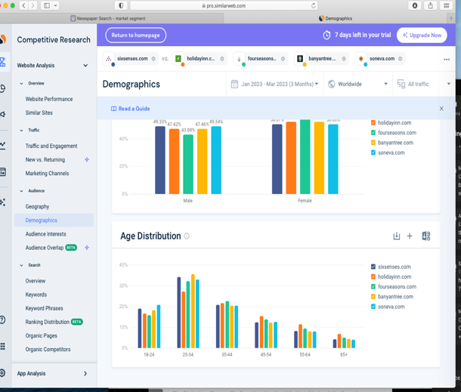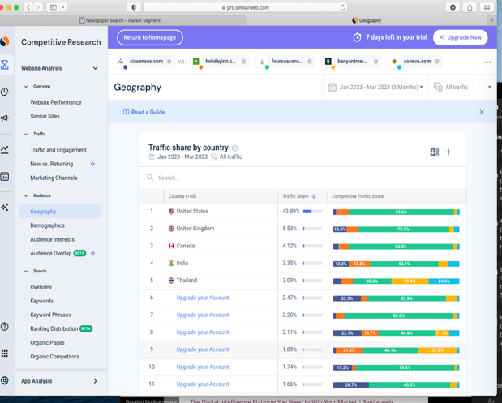
Appendix 3-4
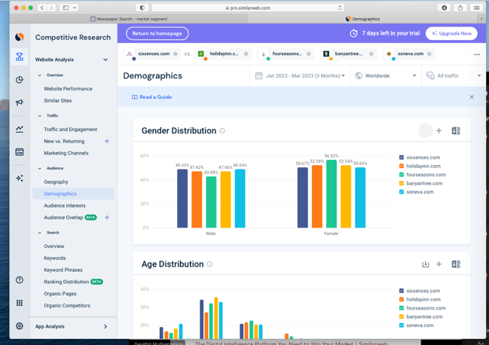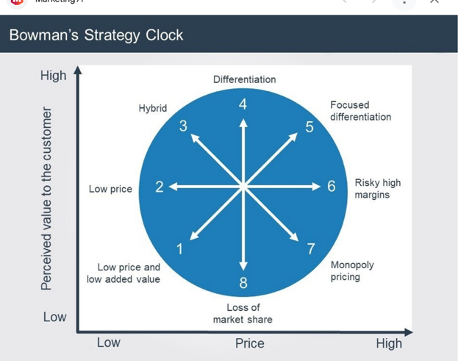

Appendix 4

- Low price and low added value: not a competitive position for a business customer perceives very little value and low price.
- Low-cost leader such as Poundland
- Hybrid, Good value and reasonable price Holiday Inn
- Differentiation, Highest level of perceived added value Starbucks
- Focused differentiation, Highest price level, high perceived value, luxury brand. Lois Vuitton, Six Senses spa hotel.
- Risky high margin, High risk high prices without offering anything extra in terms of perceived value. Gyms
- Monopoly pricing is only one business offering the products, tightly regulated. Royal mail
- Loss of market share, middle range of standard price for a product with low perceived value. Tesco

Appendix 5
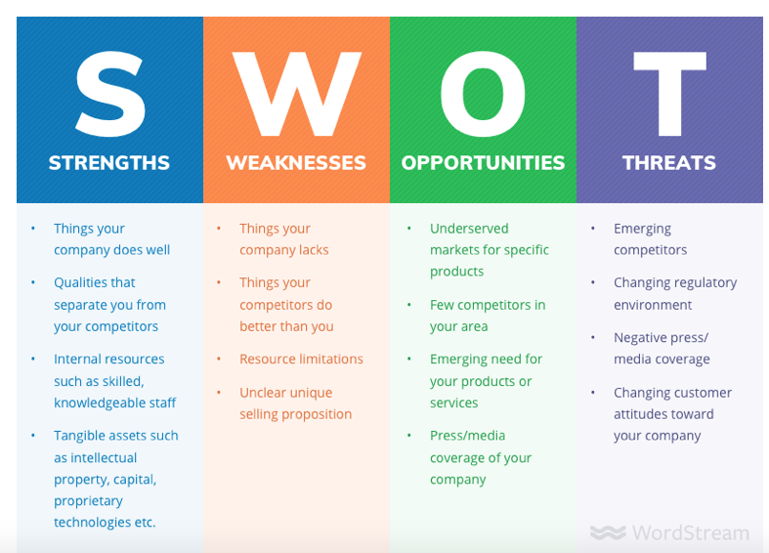 Appendix 6
High price
Low
price
Basic location
HOLIDAY INN
Luxury location
SIX SENSES

