Module Title: Design Thinking and Innovation
Module Code: LCLM6002
Assessment Type: Written Portfolio

Title: Applying Design Thinking to Reimagine Customer Journeys: A Strategic Innovation Portfolio for Premier Inn (Whitbread PLC)

Chosen Organisation: Whitbread PLC – Premier Inn (UK

Student Name:
Student ID:

Word Counts: 4371

Table of Contents
1. Introduction 2
2. Key Consumer and Industry Trends Affecting Premier Inn 4
3. Part 1 – Analysis of Premier Inn’s Approach to Innovation 6
3.1 Application of the Innovation Ambition Matrix 6
3.2 Current Customer Journey Mapping 7
4. Part 2 – Proposed Digital Transformation Initiative: Premier Inn SmartStay 11
4.1 Description of the “Premier Inn SmartStay” initiative 11
4.2 Improved Customer Journey Map with SmartStay 12
4.3 Organisational impact, desirability–viability–feasibility and KPIs 13
5. Conclusion 16
References 17

1. Introduction
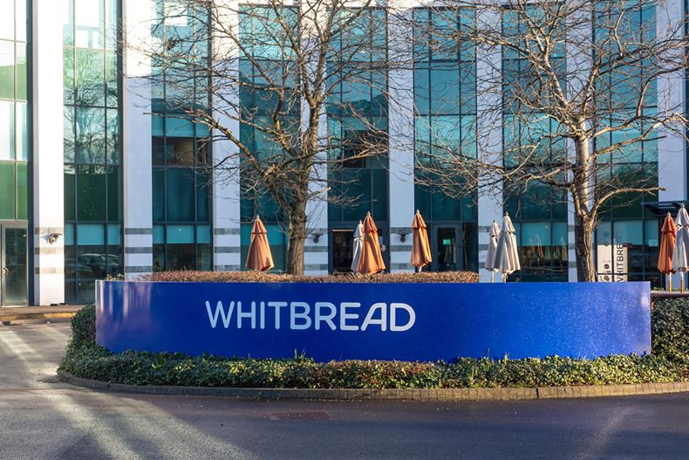
Figure 1: WHITEBREAD PLC (McGagh, 2021)
Whitbread PLC is a UK-based hospitality group operating hotels and restaurants in the country and in a few international markets, with Premier Inn being its flagship hotel brand (Whitbread PLC, 2025). It is a brand specialising in offering low-cost accommodation of high quality to business and leisure travellers, which has an extensive asset base that offers guests uniformity and location versatility (Whitbread PLC, 2024). Whitbread has, in recent years, focused its resources on its UK portfolio, active management of growth in Germany, and further investing in customer experience as a driver of long-term value creation (Whitbread PLC, 2025). In addition to these priorities, the group also emphasises its strategy of sustainability of the Force of Good and a growing dependence on digital distribution, service delivery and interaction with guests (Whitbread PLC, 2025). These trends render Premier Inn a suitable place to learn about design thinking and innovation within a real-world hospitality environment that is real-world.
This portfolio is designed to use design thinking and innovation frameworks to examine and redesign the customer journey at Premier Inn in a manner that will enhance the value given to the guests and Whitbread as a company. Design thinking is a human-centric, iterative and experimental-based innovation that is complementary to more traditional forms of analytic strategic planning, and it proposes innovation as a process originating from concerns and experiences of the customers, as opposed to being constrained by internal factors (Brown, 2008). In this approach, the customer experience turns into a pivotal artefact to comprehend how the guests experience the brand across the touchpoints and where the frictions or unsatisfied opportunities emerge (Lemon and Verhoef, 2016). The portfolio is hence aimed at relating strategic innovation options to specific experience design.
The work is divided into three major sections. The following review will examine some consumer and industry trends that influence the environment in which the enterprise operates, especially focusing on the digital transformation of hospitality (Peng et al., 2024). In part 1, the Innovation Ambition Matrix and the customer journey mapping are used to evaluate the current innovation portfolio and the guest experience of the organisation. Part 2 then suggests a new digital transformation project and a reimagined customer journey, and the conclusion considers the implications of both to Premier Inn and Whitbread more generally. This way, the portfolio facilitates the learning outcomes of this module.

2. Key Consumer and Industry Trends Affecting Premier Inn
Premier Inn is subject to larger forces in the UK hotel industry, which influence its competitive environment. It is predicted that trading is challenging with the growth slowing down, not being able to afford the cost of living and an imbalanced business and international travel recovery (PwC, 2025). However, there continues to be structural demand for cheap short-stay accommodation, particularly in regional cities and transport hubs where low-cost and midscale brands are competing intensely on price and consistency (PwC, 2025). The operators in this setting need to control costs, maximise occupancy and differentiate based on service quality, location and brand strength, as opposed to price. In the case of Whitbread, this is a set of circumstances that necessitate exploring the benefits of its size, operational effectiveness and digitalising alongside addressing expectations of stakeholders toward lucrative development, elevated guest contentment, and careful business conduct (Whitbread PLC, 2024; 2025).
Area | Key Trend | Implication for Premier Inn
UK hotel market | Slower growth, cost-of-living pressure, and intense price competition | Must protect value positioning and drive efficiency in operations and pricing.
Demand pattern | Ongoing need for short-stay, value hotels in cities and travel hubs | Opportunity to leverage a nationwide network and a consistent product.
Digital behaviour | Guests expect seamless online and mobile booking, self-service and contactless options | Requires continual improvement of website, app and check-in/check-out journeys.
Customer expectations | Focus on end-to-end experience, transparency and flexibility | Need to manage the whole journey, not just the room, and offer clearer information and flexible options.
Sustainability awareness | Growing interest in environmentally responsible brands | Must communicate Force for Good and low-carbon hotel initiatives clearly to guests.
Table: Premier Inn: Key Market and Consumer Trends (Lemon and Verhoef, 2016)
Hospitality studies emphasise that digital technologies have been put at the centre of hotel operation, guest relations, and value creation (Buhalis and Leung, 2018). Mobile systems, data analytics and platform models have made it possible to conduct more personalised and efficient services throughout the customer lifecycle (Peng et al., 2024). Research also indicates that digital transformation entails robust organisational capacity and favourable environmental factors, other than technology investments (Nikopoulou et al., 2023). These forces imply that Premier Inn has to consistently upgrade its systems and processes to remain relevant and strong, and become more of a combination of front-stage guest interfaces with back-stage platforms, including property-management and revenue-management systems (Buhalis and Leung, 2018).
Premier Inn is also directly involved in shifts in consumer behaviour. It is no longer experienced at isolated touchpoints but instead across the journey-based on the search to the post-stay review (Lemon and Verhoef, 2016). Customers are increasingly demanding smooth online experiences, where they can search, book, check in, and manage their stay via connected channels (Buhalis and Leung, 2018). Price transparency, flexible booking policy and trustworthy information have turned into crucial factors of decision (PwC, 2025). They differ in preferences: business guests are focused on speed and connectivity, whereas leisure guests are focused on comfort, assurance and tailor-made (Lemon and Verhoef, 2016). Increasing sustainability pressures also affect accommodation options, increasing the topicality of the Force for Good promises of Whitbread (Whitbread PLC, 2025).
Such trends render design thinking more relevant to the innovativeness of Premier Inn. The competitive forces and changing expectations are such that, systematically revealing the areas of pain, generating ideas and testing them, people have to be part of the work (Liedtka, 2018). With the digital technologies transforming service delivery, innovation should aim at recreating the journeys and touchpoints, but not just include physical facilities (Stickdorn et al., 2018). This enables Premier Inn to capitalise on its brand and size and redefine how customers browse, book, and experience any of the stays on the channel.

3. Part 1 – Analysis of Premier Inn’s Approach to Innovation

3.1 Application of the Innovation Ambition Matrix
The Innovation Ambition Matrix is a viable model of analysing the manner in which organisations strike a balance between core, adjacent and transformational innovation (Nagji and Tuff, 2012). Core innovation enhances existing services to its current clients, adjacent innovation can bring its capabilities into new segments or products, and transformational innovation is the business model or market review. In the case of hotel brands, employing this portfolio lens will allow leadership to continue to deliver short-term performance and renewal in the longer term.
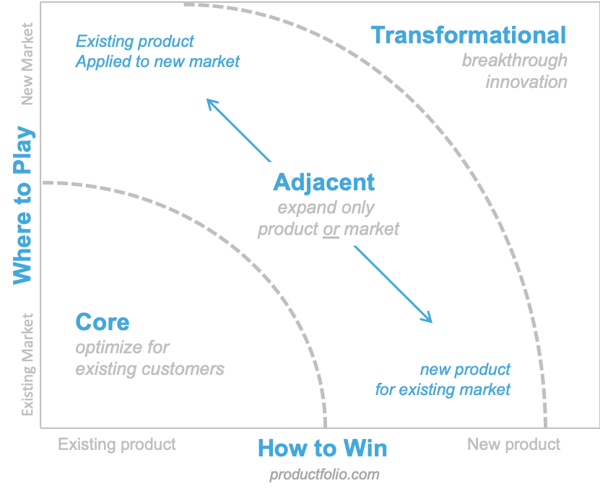
Figure 1: Innovation Ambition Matrix (Anon, 2020)
Design thinking is a complement to this perspective because it orients user empathy, rigorous testing and functional experimentation at the core of the innovation endeavours (Brown, 2008). Design thinking does not start with organisational constraints but first with a profound understanding of guest needs and goes on through the cycles of ideation, prototyping and refinement (Liedtka, 2018). It is especially critical within the customer journey of hospitality, with a range of channels and where digital efforts are commonly hard to predict (Peng et al., 2024). With reference to the case of the Premier Inn, the combination of Innovation Ambition Matrix and design-based thinking aids in having a systematic perspective of the portfolio, with human experience being at the heart of the decision-making process.
The majority of the innovations that have taken place in the recent past at Premier Inn follow core innovation. Optimising the standard room offer is another component of the value proposition, comfort, cleanliness and reliability, and has remained the mainstay of the brand (Whitbread PLC, 2024). Whitbread has also invested in digital booking and distribution systems, which means that customers can access the site and easily compare and reserve rooms at the convenience of their website and mobile app (Premier Inn, 2025). These channels enable easy rate management, dates and confirmations. Self-service kiosks and online cheque-in in the hotel industry lessen the workload on reception staff without sacrificing optional human assistance (Whitbread PLC, 2025). There are also the core initiatives, such as continuous betterment of pricing, processes in operations and their services that maintain margins in the UK value-segment market (PwC, 2025).
Adjacent innovation is evident in Whitbread continuing to expand to Germany, where it finds new locations and customer types, adapting its successful UK business model in addition to taking advantage of shared systems (Whitbread PLC, 2025). Another example of an introduction of a hub in the UK by Premier Inn, which provides rooms of small sizes equipped with technology for guests in the city (Whitbread PLC, 2024). Combining the hotel and restaurant business facilitates the development of existing opportunities even further, which allows the group to reclaim on-site revenues.
Whitbread has elements of the sustainability agenda that make it a transformational innovation. The Force for Good programme focuses on building hotels that are more energy-saving and less carbon-intensive, such as all-electric new constructions or properties renovated to be made so (Whitbread PLC, 2025). These efforts demand design, technology and supply chain changes and are an indicator of a more fundamental reconsideration of the hotel operations going forward. The experiments with new environmental standards and reporting also extend the frontier of the innovation of the organisation.
On the whole, the portfolio of innovations at Premier Inn is heavily biased towards core enhancement, but some adjacent and transformative innovations are made selectively. The balance safeguards short-term income, but could restrict the possibilities of more radical designs of guest-centric digital experiences that might be revealed through design thinking (Martin, 2009).

3.2 Current Customer Journey Mapping
Customer journey mapping is a graphic representation of how customers experience a service during the phases and touchpoints where teams can determine any pain points, feelings and focus areas of improvement (Kalbach, 2020). This is consistent with the hospitality literature that considers customer experience cumulative instead of transactional (Lemon and Verhoef, 2016). For Premier Inn, the typical UK guest journey can be understood through key stages: Awareness, Search and Comparison, Booking, Pre-arrival, Arrival and Check-in, Stay and Check-out/Post-stay.
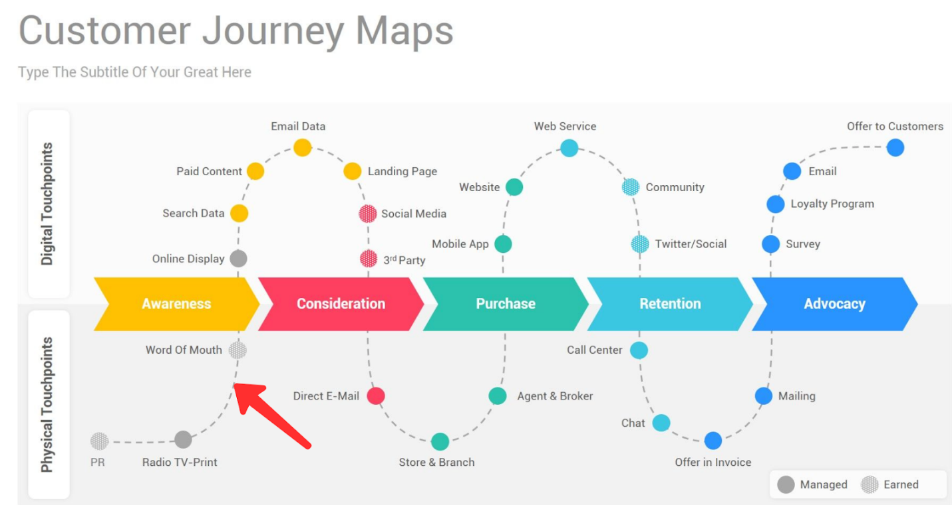
Figure 2: Customer Journey Map (Mann, 2023)
This journey consists of a combination of digital and physical touch on the part of guests. During Awareness and Search, many begin on general search engines or comparison sites before navigating to the Premier Inn website to explore locations, room formats and pricing (Premier Inn, 2025). The website and application enable travellers to choose their dates, kinds of rates and add-ons like breakfast and receive immediate email confirmations in the Booking stage (Premier Inn, 2025). Pre-arrival engagement includes booking-management features, reminders and online check-in prompts (Whitbread PLC, 2024).
Arrival and Check-in combine physical spaces--signage, reception areas, kiosks, lifts--with interpersonal interactions (Whitbread PLC, 2025). The core experience is defined by the stay in the room and on-site restaurant/bar, along with the support of the interaction with the staff in case of necessity (Whitbread PLC, 2024). Check-out and Post-stay involve reception desks, key return points, digital receipts, satisfaction surveys and loyalty communications sent via email or app notifications (Whitbread PLC, 2025).
Through all these levels, Premier Inn provides sufficiently worthwhile gain points and identifiable pain points which restrict the quality of experience.
Awareness and Search
The strengths encompass high brand awareness, value positioning and a massive presence in the UK as well, which makes it less risky to customers when they need to book (Whitbread PLC, 2024). Search filters allow easy comparison between hotels and even dates through the search filters of websites (Premier Inn, 2025). Mobile users face pain points related to being unable to compare or find differences between the nearby hotels or comprehend the differences between room types and rate specifics (Buhalis and Leung, 2018).
Booking
The benefits of gain comprise the transparent pricing, expedient transaction and a straightforward decision on adaptable and non-adaptable rates (PwC, 2025). Examples of pain points are perplexity about conditions of entry into and exit out of a given cancellation agreement, occasional payment-related problems and inaccessibility-related customisation, which can be eroded to undermine user trust (Lemon and Verhoef, 2016).
Pre-arrival
Visitors enjoy convenient access to their reservation information and changes. Nonetheless, it is characterised by a tendency towards standardisation instead of trip-purpose personalisation, which limits possibilities of pre-trip customisation (Nikopoulou et al., 2023).
Arrival and Check-in
This gives a sense of efficiency and predictability due to the combination of familiar layouts and self-service kiosks (Whitbread PLC, 2025). The points of pain are the failure of kiosks to work, making queues or getting lost on the way. Lack of coverage of the staff during busy periods can also bring about frustration (Lemon and Verhoeff, 2016).
Stay
The typical room product tends to be satisfactory in the areas of silence, comfort and cleanliness, which are the keystones of the value offering of Park Hyatt Premier Inn (Whitbread PLC, 2024). However, the stay is still limited with regard to digital integration. Guests tend to use telephone or face-to-face interactions to provide information and requests, and this becomes less convenient and less beneficial when it comes to live service recovery or in-the-moment personalisation (Peng et al., 2024).
Check-out and Post-stay
The payment procedure is smooth as a rule, and it is backed by electronic documents and feedback demands. Nevertheless, Premier Inn is not leveraging post-stay behavioural data; therefore, it sends general follow-up messages instead of offers or personalised loyalty-creating policies (Lemon and Verhoef, 2016).
Priority Opportunities for Digital Innovation
An integrated contribution of the journey map and innovation portfolio indicates that a number of strategic opportunities in Premier Inn exist. First, trip-purpose tags or simple preference profiles would make it possible to streamline search results, e-mails and offers and enhance the sense of relevance (Nikopoulou et al., 2023). Second, more complete cross-channel development—website, app, kiosks, reception, etc.--would make the movement between touchpoints smoother, spending less time entering the same information (Buhalis and Leung, 2018). Lastly, developing more in-stay information tools like requesting and feedback services would enable faster issue response and create more insightful information to help service design (Kalbach, 2020). Enhancing these aspects would make the experience of the guests in the Premier Inn in line with the modern demands and go hand in hand with the innovation drive of Whitbread.

4. Part 2 – Proposed Digital Transformation Initiative: Premier Inn SmartStay

4.1 Description of the “Premier Inn SmartStay” initiative
Evaluation of the current innovation portfolio and customer journey of the Premier Inn brand indicates that the brand is providing its loyal core product but has not exercised opportunities to provide digital personalisation and an integrated, data-driven service throughout the stay. SmartStay is suggested to be an AI-powered digital concierge integrated within the current Premier Inn application and web ecosystem that coordinates interactions from booking to post-stay interaction. The project will transform the app, which is mainly a transactional tool, into a multifunctional regular companion that provides guests with additional information during their stay and creates more valuable insights at Whitbread (Peng et al., 2024).
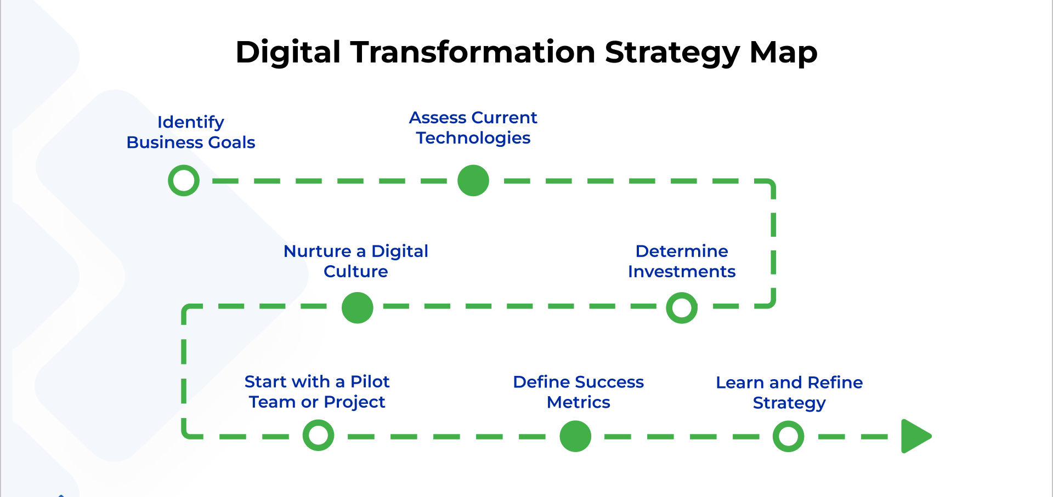
Figure 3: Digital Transformation Strategy Map (Tsonev, 2205)
SmartStay would also increase the search and booking experience because preference profiles and past behaviour would be used to customise hotel suggestions, room and add-ons to specific guests. It may also provide extras that are contextually relevant during the booking process (i.e. breakfast, parking or late check-out) with obvious and respectful prompts without being pushy with upselling (Nikopoulou et al., 2023). These characteristics enhance existing online platforms at Premier Inn but redefine them in accordance with the purposes of guests instead of directly rating kinds and availability (Premier Inn, 2025).
In the pre-arrival stage, SmartStay would replace generic confirmation messages with personalised itineraries and recommendations based on the purpose of the trip, drawing on local information and hotel facilities. Customers would be able to verify the expected time of arrival, add special requests and get reminders to check in online, which would minimise uncertainty and facilitate the functioning of the hotel (Whitbread PLC, 2024). SmartStay would also be used as a digital concierge during the stay: guests will be able to order additional items, change their housekeeping preferences, receive information about facilities and get immediate feedback without calling the reception or visiting the desk (Stickdorn et al., 2018). Post-checkout, digital receipts would be enabled at the same interface, and immediate feedback and feedback loops would be prioritised, as well as loyalty offers that would be offered after a certain amount of time, based on the observed travel patterns (Lemon and Verhoef, 2016).
The concept of SmartStay is based on design thinking principles. The project is based on the understanding of the annoyances and the unmet needs of the guests by studying the journey mapping, e.g., waiting at reception, in-stay generic communication, and lack of digital support (Kalbach, 2020). It would be developed in iterative cycles of prototype and testing with representative guest segments and hotel teams, integrating quantitative information with qualitative insights to improve the features (Liedtka, 2018). This strategy maintains the emphasis on the desired guest experience, workable staff experience in line with Whitbread's goals (Martin, 2009).

4.2 Improved Customer Journey Map with SmartStay
The SmartStay introduction transforms the Premier Inn customer experience through the introduction of new digital touchpoints and reinforcing the relationships between the old ones. In the Awareness and Search stages, the app and website become more proactive, greeting logged-in users with tailored suggestions based on previous stays and saved preferences rather than a generic location search (Premier Inn, 2025). In Booking, the interface presents the appropriate combinations of room and rate prices to each profile and the optional add-ons with clear prices, while still retaining the capability of sectioning the defaults (Nikopoulou et al., 2023). This minimises the cognitive effort and elevates perceived relevance at a critical decision point (Lemon and Verhoef, 2016).
In the Pre-arrival stage, SmartStay adds a personalised preparation layer. Guests are offered brief information about what to expect during their stay, including the check-in possibilities, directions, location, and other useful details (Whitbread PLC, 2025). The application reminds the visitors to provide check-in times and special requests, which are channelled to the hotel staff to facilitate workforce and room assignments (Buhalis and Leung, 2018). On Arrival and Check-in, integration between SmartStay and kiosk systems allows guests who have completed online check-in to generate keys quickly, while those preferring traditional reception can still be supported by staff who have access to the same preference data (Whitbread PLC, 2024).
The room and these facilities in the hotel are enhanced with the digital concierge capabilities of SmartStay and are available during the Stay. Visitors can read the details about the facilities, order products or report maintenance services via minimal in-app service flows, which are loaded to the corresponding crews and feedback sent to the customer (Stickdorn et al., 2018). This decreases friction on the side of the guests and the staff since it formalises communication that would otherwise be chaotic and divided between calls and visits (Buhalis and Leung, 2018). By entering the app at Cheque-out, guests will have an opportunity to evaluate bills, pay and rate their satisfaction in a few words, reducing queues at the reception and receiving a timely response (Peng et al., 2024). SmartStay helps to do more targeted follow-up, including thank you messages, requesting reviews, offering future improvement to booking with a discount, though not generic, depending on the observed preferences in the Post-stay stage (Lemon and Verhoef, 2016).
Journey Stage | SmartStay Enhancement | Main Benefit for Guests and Premier Inn
Awareness & Search | Tailored hotel suggestions based on past stays and saved preferences | More relevant options and faster decisions
Booking | Profile-based room/rate combinations and clear add-on offers | Reduced cognitive effort and clearer value at booking
Pre-arrival | Personalised pre-stay information plus arrival-time and request capture | Better expectations and smoother room/staff planning
Arrival & Check-in | App–kiosk integration for fast key collection and shared guest profile | Shorter queues and a more consistent welcome experience
Stay | In-app digital concierge for information, service requests and issues | Less friction, quicker responses and more structured staff workflows
Check-out | In-app bill review, payment and quick feedback | Faster departure and timely feedback capture
Post-stay & Loyalty | Targeted thank-you messages, review prompts and tailored future offers | Stronger loyalty and more relevant rebooking incentives
Table: Improved Customer Journey with SmartStay
The improved journey map may be represented as a layered diagram where SmartStay touchpoints run parallel to the current site, kiosk and face-to-face interactions, and their handovers are obvious. This depiction assists Whitbread teams in visualising data flowing down the path, positioning of tasks and functions in the workload distribution and the workload density shifts of various roles with new feature additions (Kalbach, 2020). The map may be perfected as a living artefact since pilots can create new knowledge, assisting in maintaining a cycle of design thinking instead of a single transformation (Stickdorn et al., 2018).

4.3 Organisational impact, desirability–viability–feasibility and KPIs
It is desirable, and SmartStay can enhance the experience of customers in the Premier Inn since this can make it more responsive, convenient and personalised without compromising the premise of Simplicity and value by the brand. Customer journey research proposes that friction reduction in the major processes and providing appropriate support may help enhance satisfaction and loyalty, especially by ensuring the uniformity, that is, similarity of experience across channels (Lemon and Verhoef, 2016). SmartStay pays attention to various tastes and contact and control preferences, allowing guests to do more with their own gadgets, and this approach is significant where the attitude to interaction differs (Buhalis and Leung, 2018). In the case of Whitbread, creating a cloudless, more individualised experience can cement the place of Premier Inn as a reliable but up-to-date brand in the budget, as well as the midscale markets (Whitbread PLC, 2025).
The viability of the initiative is also viable, provided that it is implemented carefully. Other sources of revenue are more successful cross-selling of the relevant add-ons and enhancing loyalty, increasing the rate of bookings and decreasing the costs of acquisition (PwC, 2025). Operation efficiencies involve less pressure on the front-desk personnel during peaks, the improved match between the staffing and demand, and the management of the service requests in a more organised way that may restrict service failures and rework (Whitbread PLC, 2024). Even though the creation of the app would need investment in the app development, its connection with the back-end systems and personnel training, it is possible to introduce expenses in stages, using pilots and a focused roll-out of SmartStay and match the cost with the projected advantages (Peng et al., 2024). The project is also aligned with the digital and sustainability strategy of Whitbread, which is that increasing digital interactions will lower the paper usage, and more wisdom in the management of resources like energy and housekeeping (Whitbread PLC, 2025).
Whitbread's current capabilities can help the organisation to build a strong foundation when it comes to organisational and environmental conditions, which seem to be favourable due to the technological conditions. Another point is that the company already has strong digital channels, which are centralised, have systems and standard processes in its estate, which can be expanded instead of substituted (Whitbread PLC, 2024). Nonetheless, studies of digital transformation in the hospitality sector caution the risk of failure of technological projects in case organisational preparedness, employee engagement, and change management are overlooked (Nikopoulou et al., 2023). The Practices of design thinking can be used to address these threats by engaging the workforce of the hotel and visitors in co-design experiences, conducting mini-experiments and constant improvement of features and processes (Liedtka, 2018). Other regulatory factors, including data privacy and safety, should be taken care of by having proper governance and disclosure of how the data of guests is utilised (Peng et al., 2024).
In order to measure impact and provide a path to ongoing improvement, a set of key performance indicators should be outlined even at the very first stage. Measures of interest are the percentage of the bookings that are completed by an authenticated SmartStay user, adoption of online cheque-in, cheque-out time and cheque-in and cheque-out averageness, number of requests to the in-app service service and corresponding resolution time, and the satisfaction score of the digital experience components as indicated by guests (Kalbach, 2020). On the business level, Whitbread will be able to monitor the variation in the rates of repeat booking, ancillary revenue per stay and cost to serve at hotels where SmartStay is rolled out and control sites (PwC, 2025). These quantitative indicators need to be complemented with qualitative feedback from guests and staff to make sure that the design thinking is still present in the development of the initiative (Stickdorn et al., 2018).

5. Conclusion
This analysis conducted in the context of this portfolio has revealed that Premier Inn has an established core offer and a set of continuous innovations, yet its customer experience consists of friction and untapped touchpoints. The Innovation Ambition Matrix has identified a portfolio predominantly in core improvements, with the adjacent and transformational programmes having been in the geographic expansion, new formats and sustainability-based property strategies (Nagji and Tuff, 2012). The analysis of the existing path showed that, besides strong product and digital booking portals used by Premier Inn, there were weaknesses, notably a lack of customisation, disjointed in-stay feedback, and inconsistent arrival and departure experiences (Lemon and Verhoef, 2016).
This project, SmartStay, is based on these findings, and it tries to reposition the app and other systems in Premier Inn as an all-in-one digital concierge that can be used by customers throughout their journey. The concept, which is based on design thinking, will aim at making the guest experience more desirable, operationally viable to hotel employees and strategically viable to Whitbread in a competitive world (Brown, 2008). With SmartStay, Premier Inn can continuously innovate through visualisation and refinement of the improved journey to the extent of continuous innovation. In a broader perspective, the article demonstrates the use of design thinking and customer journey mapping to assist hospitality organisations in transforming the ambitions related to innovation into tangible, testable alterations to the guest experience, which can help hospitality organisations create value (Stickdorn et al., 2018).

References
Anon (2019). Innovation Ambition Matrix. [online] Productfolio. Available at: https://productfolio.com/innovation-ambition-matrix/ [Accessed 20 Nov. 2025].
Brown, T. (2008) ‘Design thinking’, Harvard Business Review, 86(6), pp. 84–92.
Buhalis, D. and Leung, R. (2018) ‘Smart hospitality – interconnectivity and interoperability towards an ecosystem’, International Journal of Hospitality Management, 71, pp. 41–50.
Kalbach, J. (2020) Mapping Experiences: A Complete Guide to Creating Value through Journeys, Blueprints and Diagrams. 2nd edn. Sebastopol, CA: O’Reilly Media.
Lemon, K.N. and Verhoef, P.C. (2016) ‘Understanding customer experience throughout the customer journey’, Journal of Marketing, 80(6), pp. 69–96.
Liedtka, J. (2018) ‘Why design thinking works’, Harvard Business Review, 96(5), pp. 72–79.
Mann, N. (2023). How to Create a Customer Journey Map: A Step-By-Step Breakdown. [online] Woopra. Available at: https://www.woopra.com/blog/customer-journey-map [Accessed 21 Nov. 2025].
Martin, R.L. (2009). The Design of Business: Why Design Thinking Is the Next Competitive Advantage. Boston, MA: Harvard Business Press.
McGagh, M. (2021). Broker tips: Whitbread, Asos and Grafton. [online] Wealth Manager. Available at: https://citywire.com/wealth-manager/news/broker-tips-whitbread-asos-and-grafton/a1449816 [Accessed 17 Nov. 2025].
Nagji, B. and Tuff, G. (2012) ‘Managing your innovation portfolio’, Harvard Business Review, 90(5), pp. 66–74.
Nikopoulou, M., Kourouthanassis, P., Chasapi, G., Pateli, A. and Mylonas, N. (2023) ‘Determinants of digital transformation in the hospitality industry: technological, organisational, and environmental drivers’, Sustainability, 15(3), 2736.
Peng, B., Hu, B., Cheng, M. and Jiang, Y. (2024) ‘Digital transformation in the hospitality industry: a bibliometric review from 2000 to 2023’, International Journal of Hospitality Management, 123, 103558.
Premier Inn (2025) ‘Book a hotel’, Premier Inn [online]. Available at: https://www.premierinn.com/gb/en/book-a-hotel.html (Accessed: 21 November 2025).
Premier Inn (2025) ‘Force for Good’, Premier Inn [online]. Available at: https://www.premierinn.com/gb/en/why/force-for-good.html (Accessed: 21 November 2025).
Premier Inn (2025) ‘Premier Inn hotels | Book direct’, Premier Inn [online]. Available at: https://www.premierinn.com/gb/en/home.html (Accessed: 21 November 2025).
PwC (2025) ‘Hotels Forecast 2025–2026: Selective resilience’, PwC UK [online]. Available at: https://www.pwc.co.uk/industries/hospitality-leisure/insights/uk-hotels-forecast.html (Accessed: 21 November 2025).
Stickdorn, M., Hormess, M.E., Lawrence, A. and Schneider, J. (2018). This Is Service Design Doing: Applying Service Design Thinking in the Real World. Sebastopol, CA: O’Reilly Media.
Tsonev, N. (2025). 7 Key Steps to a Successful Digital Transformation Strategy. [online] Kanban Software for Agile Project Management. Available at: https://businessmap.io/digital-transformation/strategy [Accessed 21 Nov. 2025].
Whitbread PLC (2024) Annual Report and Accounts 2023/24. Dunstable: Whitbread PLC. Available at: https://cdn.whitbread.co.uk/media/2024/05/Whitbread-PLC-Annual-Report-and-Accounts-2023_Single_pages-1.pdf (Accessed: 21 November 2025).
Whitbread PLC (2025) ‘Force for Good’, Whitbread plc [online]. Available at: https://www.whitbread.co.uk/sustainability/ (Accessed: 21 November 2025).
Whitbread PLC (2025) Annual Report and Accounts 2024/25. Dunstable: Whitbread PLC. Available at: https://cdn.whitbread.co.uk/media/2025/05/Whitbread-PLC-Annual-Report-and-Accounts-2024-25.pdf (Accessed: 21 November 2025).
Whitbread PLC (2025) Environmental, Social and Governance Report 2024/25. Dunstable: Whitbread PLC. Available at: https://cdn.whitbread.co.uk/media/2025/05/Whitbread-PLC-Environmental-Social-and-Governance-Report-2024-25.pdf (Accessed: 21 November 2025).

