Management Communication (BMSK4013) Heather Coates - 2116386

Table of Contents

The Relevance of the Communication Cycle for Effective Communication in Management

The Importance of Selecting an Appropriate Tone, Language and Level of Formality in Management Communication

Assess the Effectiveness of a Range of Verbal and Written Communication Methods Within the Area of Your Organisation

Evaluating Theories of Motivation within my Workplace

Evaluate the Principal Factors that May Effect Performance and Motivation in the Workplace

Select a theory of Motivation and apply to Your Workplace and Evaluate the Impact

Develop Appropriate Criteria to Evaluate Own Ability to Communicate Effectively

The Relevance of the Communication Cycle for Effective Communication in Management

The relevance of the communication cycle for effective communication in management is to accomplish goals and objectives so that certain roles and responsibilities for the progression and development to succeed.
There are numerous models and theories which analyse the communication process.
I have chosen to focus on one of the best-known models: The Shannon-Weaver model.
This model was first published in 1948, and it has been adapted, modified, and developed in many ways since. Claude Shannon was a mathematician and Warren Weaver was a scientist. They were primarily interested in “machine translation”, and how early computers, radios and televisions transmit information. However, the theory equally applies to human communication, and it remains hugely influential in modern social sciences. It is the foundation of most current communication theories, and for this reason, it is sometimes referred to as “the mother of all models”.

The Shannon-Weaver model introduces 5 key stages to the communication process:

The Sender
The sender is the information source with an idea.

The Encoder
The encoder then transmits the idea into relevant symbols in form of words, pictures, or gestures.

The Channel
The channel which could be in the form of non-verbal communication, email, teams, WhatsApp and verbal communication, telephone, or face to face.

The decoder
The decoder who is the reverse transmitter changes this back into a message which is precisely understood by the sender.

The Receiver
The receiver is defined as the destination of the message from the sender.
As shown in the diagram below

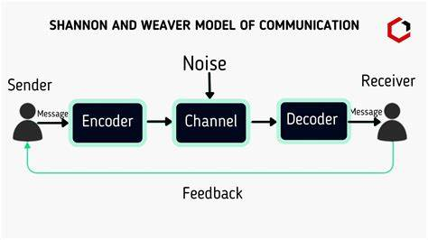

The communication cycle does not always work effectively as some protentional problems may occur along the way. Therefore, this would be referred to the sender in the form of feedback.

Disadvantages of the Shannon and Weaver Model of Communication

It is based more on social communication rather than group communication.

The Receiver plays the inactive part in the communication process as the sender plays the primary role that sends messages.

Feedback is taken as less important in comparison to the messages sent by the sender.

The model is taken by some critics as a “misleading misrepresentation of the nature of human communication” as human communication is not mathematical in nature. www.businesstopia.net

There are various other methods for us to communicate such as: verbal, non-verbal, visual and written all of which are used within my workplace in order to communicate effectively.
(www.communicationtheory.org)

The Importance of Selecting an Appropriate Tone, Language and Level of Formality in Management Communication
Effective communication is imperative within any organisation as it generates a mutually understanding environment between the management and the employees. This in turn helps in increasing the employee’s productivity.
As a manager, when communicating with the staff, tone of voice, language and level of formality used should always be courteous and professional and convey confidence in order that the staff are more inclined to acknowledge and/or accept the message being conveyed. It is also important to ensure that you covey the message clearly and concisely in a way in which the staff members are able to understand.
However, you must not be seen to be overconfident or arrogant in order that your employees feel at ease and connected to you. Managers should also ensure that they use appropriate language within the workplace. It is important to refrain from using slang, bad grammar, or sloppy and discriminatory or derogatory language.
This can be seen in the following examples:

Tone
The tone of the message can change how it is received and perceived by the person receiving it. A friendly tone can aid with building trust among the work colleagues, whilst a more formal tone may be appropriate in certain situations. An example of this is, when giving directions an amicable and soft tone can help to motivate rather than intimidate the team.

Language and level of formality
Using the appropriate language within the context of the situation is of great importance. For example, it is far more important to use basic language rather than complicated terms, especially when you could be dealing with staff members of different ethnicity and cultures. Also, you can use a more informal tone with employees as opposed to a more formal tone when dealing with outside agencies such as potential suppliers and stakeholders.

Assess the Effectiveness of a Range of Verbal and Written Communication Methods Within the Area of Your Organisation

There are two types of channels, these being verbal and non-verbal communication.
Verbal communication is spoken messages that we share with others such as team meetings, handover at the beginning of a new shift, allocation of tasks to be carried out by individual members of staff.
This is beneficial to the members of staff that are on shift at that particular moment in time. As the communications are only relevant to these particular staff members.

Non-verbal communication is conveyed via a workplace related social media apps (WhatsApp), e-mail, e-rostering and on-line wage applications.
These are a way to communicate with the whole team as all members of staff are placed onto the e-systems on commencement of employment.

Evaluating Theories of Motivation within my Workplace

A.H. Maslow developed a conceptual framework for understanding human motivation which has been widely acclaimed. Maslow proposed that human needs can be arranged in a particular order from the lower to the higher.

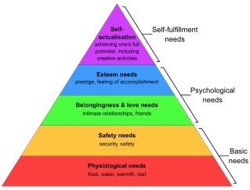

(www.psychologydiscussion.net)
Basic Physiological Needs – The needs that are taken as the starting point for motivation theory are the so-called physiological needs. These needs relate to the survival and maintenance of human life. Within my workplace this is applied in the form of free meals and beverages at the end of each shift, paid regular breaks, discounts on Hotel stays, food and drinks within the entire chain of businesses.
Safety and Security Needs – After satisfying the physiological needs, people want the assurance of maintaining a given economic level. This is provided in the form of higher than average wages, optional pension scheme, contract of employment etc.
Social Needs – this is accomplished in my workplace via social gatherings, team building exercises, free menu testing evenings.
Esteem and Status Needs – These needs embrace such things as self-confidence, independence, achievement, competence, knowledge, and success. These are provided in the form of on-going training, staff bonuses, employee of the month awards.
Self-fulfilment Needs – The final step under the need priority model is the need for self- fulfilment or the need to fulfil what a person considers to be his mission in life. The management encourage staff to grow within the company by encouraging them reach their full potential within their specific role and by nurturing their individual talents.

Maslow's hierarchy of needs has two key disadvantages:
Maslow’s theory ignores humans’ different cultural and social backgrounds - Therefore, priorities can differ from person to person. For example, some people may value socialising with friends and family more than safety. As well as people may prioritise being respected by society than safety. For example, the family may buy expensive cars and houses to show off to society and gain respect from others than buying insurance safety plans for the family.

Fails to take into account that individuals may be motivated by intrinsic rewards -Maslow’s theory fails to acknowledge that humans may be motivated by intrinsic rewards such as reaching monetary accomplishments rather than self-actualisation. www.studysmarter.co.uk/

Evaluate the Principal Factors that May Effect Performance and Motivation in the Workplace

Workplace Incentives
There can be a misconception that the only incentive for employees is monetary rewards.
However, many employees have the drive to and motivation to and can thrive on recognition from their employer in many other forms. Non-monetary rewards such as a simple ‘thank you’ can go a long way to inspire staff to produce high standards of work.

Relationship Between Co-workers
A good relationship between staff is important for the smooth day to day running of the organisation. When you have a staff group that have a good relationship with each other and show each other mutual respect and an understanding of each others roles it makes it easier to resolve any conflicts that may arise. A good working relationship between employees and a relaxed working environment can aid in reducing stress levels also.

Personal Development
Ongoing personal development and training is an essential tool within the workplace. By encouraging employees to learn and improve their skill set it benefits both the employee and the organisation. The employee can benefit by offering progression from within and this in turn benefits the organisation through staff retention.

Leadership
Good leadership can be a major tool to motivate employees. A manager that shows respect and understanding for their employees and holds an ‘open-door’ policy is more likely to gain the trust and respect of their employees which in turn aid with motivation and staff performance.
Bad leadership on the other hand can lead to a culture of disrespect, conflict and de-motivated staff.

Select a theory of Motivation and apply to Your Workplace and Evaluate the Impact

I have chosen to use McGregors’ Theory X and Y.

Social psychologist Douglas McGregor developed two contrasting theories that explained how managers' beliefs about what motivates their people can affect their management style. He labelled these Theory X and Theory Y.

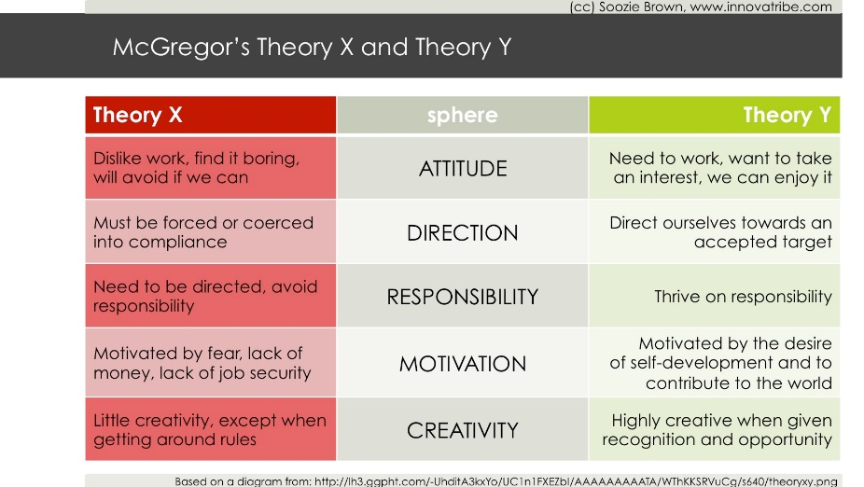
https://chrisperleyblog.com/

Theory X and Theory Y refer to two different styles of management:

Theory X – Authoritarian
Theory X managers tend to take a negative view of their employees and assume that they are naturally unmotivated and dislike their work. The employee is often closely monitored, and their work scrutinised at every point. This can be very de-motivating and lead to unhappy, stressed and employees feeling under-valued.
These days this is more likely to be found within larger organisations where there are several layers of management.
The employees tend to be unhappy in their job, dislike taking responsibility, have little or no motivation to improve themselves unless there is something in for themselves rather than the organisation as a whole. They need to be closely monitored and their work checked constantly.

Theory Y – Participative
Theory Y managers take a positive attitude towards their employees, and they use a more team-based management style, encouraging employees the chance to have input in decision making. This encourages more of a trusting relationship between the managers and their employees, thus making them feel valued and encouraging motivation.
Under this type of management employees are self-motivated and enjoy the work that they do. Management are inclined to involve them in the decision making process and value their input and ideas.

Within my workplace the management style falls firmly under the Theory Y style.
The staff are made to feel valued and are rewarded without pressure.
The management are open to suggestions from staff without criticism and operate an open-door policy and are accessible to all employees at any time.
They encourage all employees to be the best they can at work, and offer ways to improve themselves and their skills with varied but appropriate training.

This style of management makes the employees feel valued and have a sense of independence and empowerment within their role. They feel as if they matter within the organisation no matter what their ranking is.

However, both theories can have their disadvantages:

Theory X can instil a sense of inferiority in the employee as they are so closely scrutinised and their opinions can be undervalued. This is turn can create a negative environment and lead to stressed and unhappy staff. It can lead to de-motivation and discourage them from wanting to improve themselves.

Theory Y – not all employees have the confidence to work off their own initiative and can need more guidance than others. It can lead to management becoming complacent as the onus for decision making is placed more onto the employee rather than the manager.

Develop Appropriate Criteria to Evaluate Own Ability to Communicate Effectively
In order to assess my communication skills I completed two questionnaires. Through completing these, I was able to see which communication style matched to me. The results revealed that I am an assertive communicator that communicates effectively.
Assertive communication is a form of communication in which an individual expresses their feelings and personal needs in a direct but respectful manner. Researchers have linked assertiveness in communication to improved outcomes. https://www.coursera.org/
Being an assertive communicator means that I can establish a basis on which to build relationships by communicating my needs directly.
This method of communication is more direct, clear and concise, and minimises the chances of misunderstanding and errors.
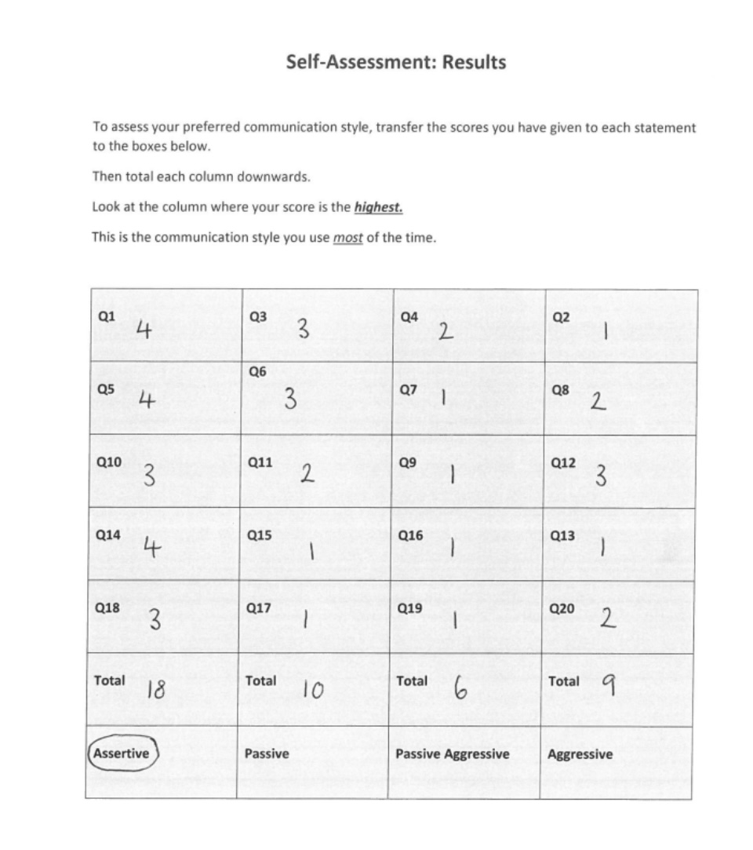

I have identified areas of strengths and weakness from feedback from my work colleagues and managers.

STRENGTHS | WEAKNESSES
- Taking Criticism  - Verbal communication  - Clear and concise  - Connect well with listeners  - Good time keeping  - Confidence  - Accepting Guidance | - Over-confident on times  - On-line training  - Too talkative on times in certain situations  - Holding presentations  - Nervousness

On reflection of the above, I have set myself a personal development plan to build on my weaknesses and to have more confidence in myself when it comes to on-line training and to rein in my talkativeness where appropriate.

Personal Development Plan
What do I want to learn? | What do I have to do? | What support and resources will I need? | How will I measure success? | Target Date for Review
To learn to be less talkative in certain situations | Practice having more reined in conversations. Develop my skills. | Support from friends, family and colleagues | Feedback from others. | 3 months
How to carry out my on-line training without the support of others | Prepare better, Spend time practising | Support from tutor, support from friends and family and work colleagues and managers | Feedback from colleagues and management | 6 months
Deliver my presentations with more confidence and without hesitating and tripping over my words and to overcome my nervousness | Practice in front of family and friends, to be more confident | Support from friends, family, and tutors and management | Feedback from tutor and work appraisals | 6 months

Short-Term Goals (within 6 months)
My short-term goal is to complete my University course I am currently studying.
To complete all work based on-line training to my best ability.
To complete my probationary period with the positive outcome of securing a permanent position with my current workplace.
To complete in-house training to allow me to expand my current role.
Medium Term Goals (within 1-2 years)
I would like to progress within my role to gain a promotion.
To apply my current study into practice.

Long Term Goals (2-3 years)
To secure a place within the management team.

References

www.communicationtheory.org/shannon-and-weaver-model-of-communication

Shannon and Weaver Model Of Communication - Businesstopia

www.psychologydiscussion.net/theory/theories-of-motivation

Maslow, A. H. (1970a). Motivation and personality. Harper & Row

https://learning-theories.com/maslows-hierarchy-of-needs.html

Maslow's Theory: Explanation, Hierarchy & Needs | StudySmarter

Theory X and Theory Y - Understanding People's Motivations (mindtools.com)

theory-x-and-theory-y1.jpg (1679×944) (chrisperleyblog.com)

Assertive Communication: Definition, Examples, and Tips | Coursera

