

Programme: BSc (Hons) Health and Social Care University: University of Wales Trinity Saint David
Current professional role: Key Worker in Health and Social Care Future career direction: Counselling Practitioner.

Student Name: Adriana Ilona Rana-Ryng.
Student Number: 2430426.
Module Code: BMHP5015_LON.
Module Title: Changemakers: Building your Personal Brand for Sustainable Employment.
Programme: BSc (Hons) Health and Social Care.
Lecturer’s Name: G1: Christiana Melam.
Assignment Title: Component 1:

Online Portfolio – Reflective Practice and Personal Branding.

Table of content :
Introduction. 3
Reflection on Unit 1: Brand You. 3
Statement for my Personal Brand and proof of future success. 4
Reflection on Unit 2: It’s a Small World. 7
Reflection on Uni 3: Opportunity Knocks. 9
This reflection is about the gig economy and flexible employment. 9
Reflection on Unit 4: The Pursuit of Happiness. 12
SMART Personal Development Plan. 16
Conclusion. 17
References. 18

Introduction.

I learned a lot from the module “Changemakers: Building Your Brand for Sustainable Employment” with valuable knowledge on professional development, career resilience and strategy identity work in social and health care The study program in a systematic way explored four important thematic areas: personal branding and self-awareness (Unit 1), global connectivity and cultural competence (Unit 2), career opportunities, networking, and assessment (Unit 3) and professional wellbeing and resilience (Unit 4). We link theoretical frameworks with online Moodle activities, this portfolio critically appraises my current professional practice as a Key Worker, whilst studying at Level 5 academic standards, mapping a structured pathway to my future goal of becoming a Counselling Practitioner. The main argument of this work is that sustainable employability needs evidence-based competence, realistic self-assessment and understanding of organisational structures instead of relying on self-assessed confidence alone.

- Reflection on Unit: Brand You.

In Unit 1 I delved into personal branding, self-awareness, and emotional intelligence across health and social care. To know who I am as a practitioner means assessing my primary strengths against my growth boundaries. Dacre Pool and Sewell's (2007) Career EDGE model emphasises that self-awareness and emotional intelligence link generic skills directly to professional self-efficacy. Salovey and Mayer (1990) and Goleman (1995) show emotional intelligence (EI) as essential to perceive, effectively managing and utilising emotions in professional practice. Rooting this in Schön (1983) emphasises the importance of reflection-in-action for reflective practice developing professional self-knowledge.

Statement for my Personal Brand and proof of future success.

To establish my baseline, I took the IHHP( n.d.) Emotional Intelligence Quiz online twice, and achieved "Excellent EQ" on both attempts.

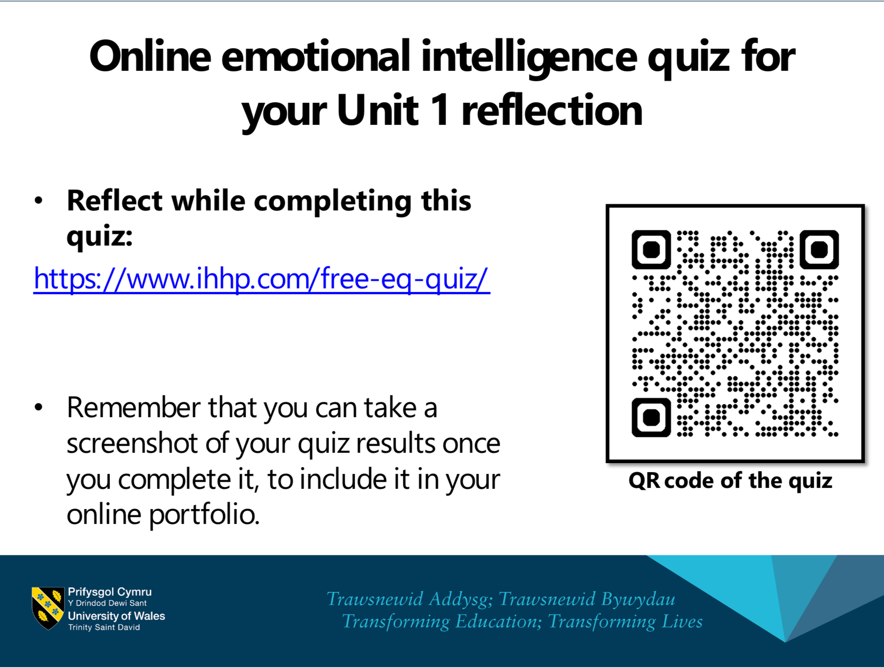
Screenshot 1.1: Confirmation of Completion of the Online IHHP ( n.d.). Emotional Intelligence assessment (module 2).

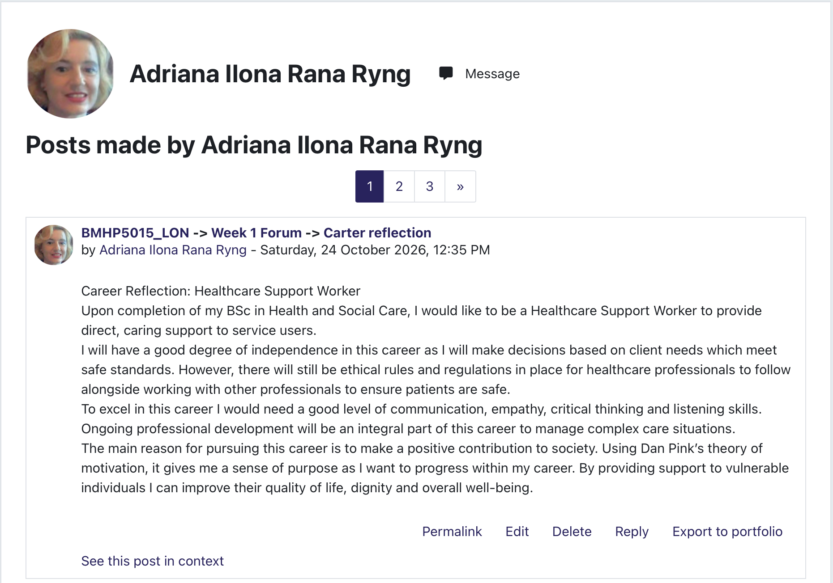
Screenshot 1.2: Reflection on future carrier.
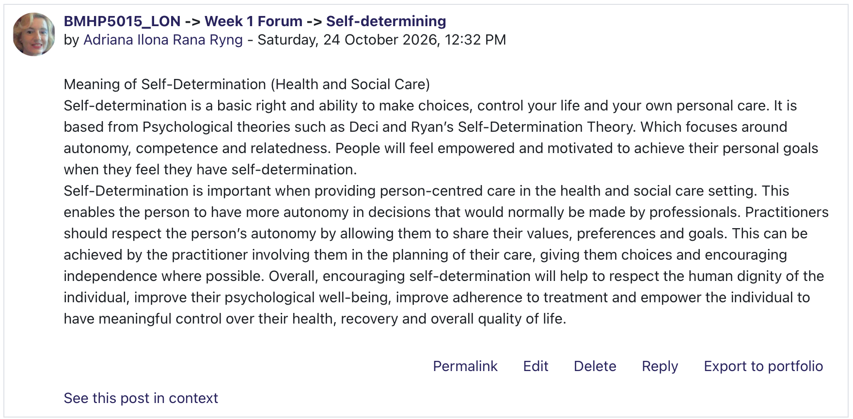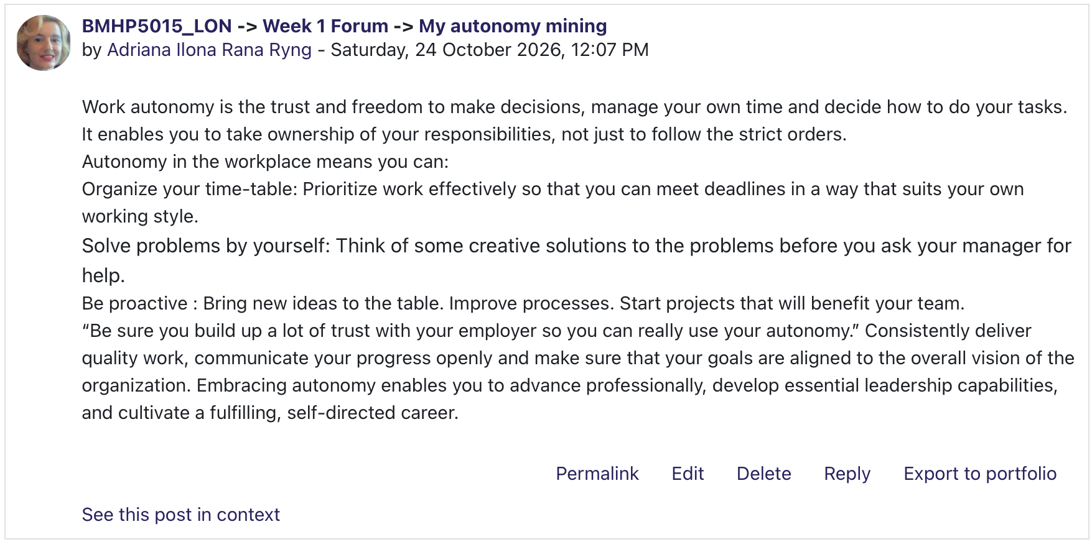
Screenshot 1.3: My Moodle forum contributions on self-determination, autonomy and reflection in professional development.
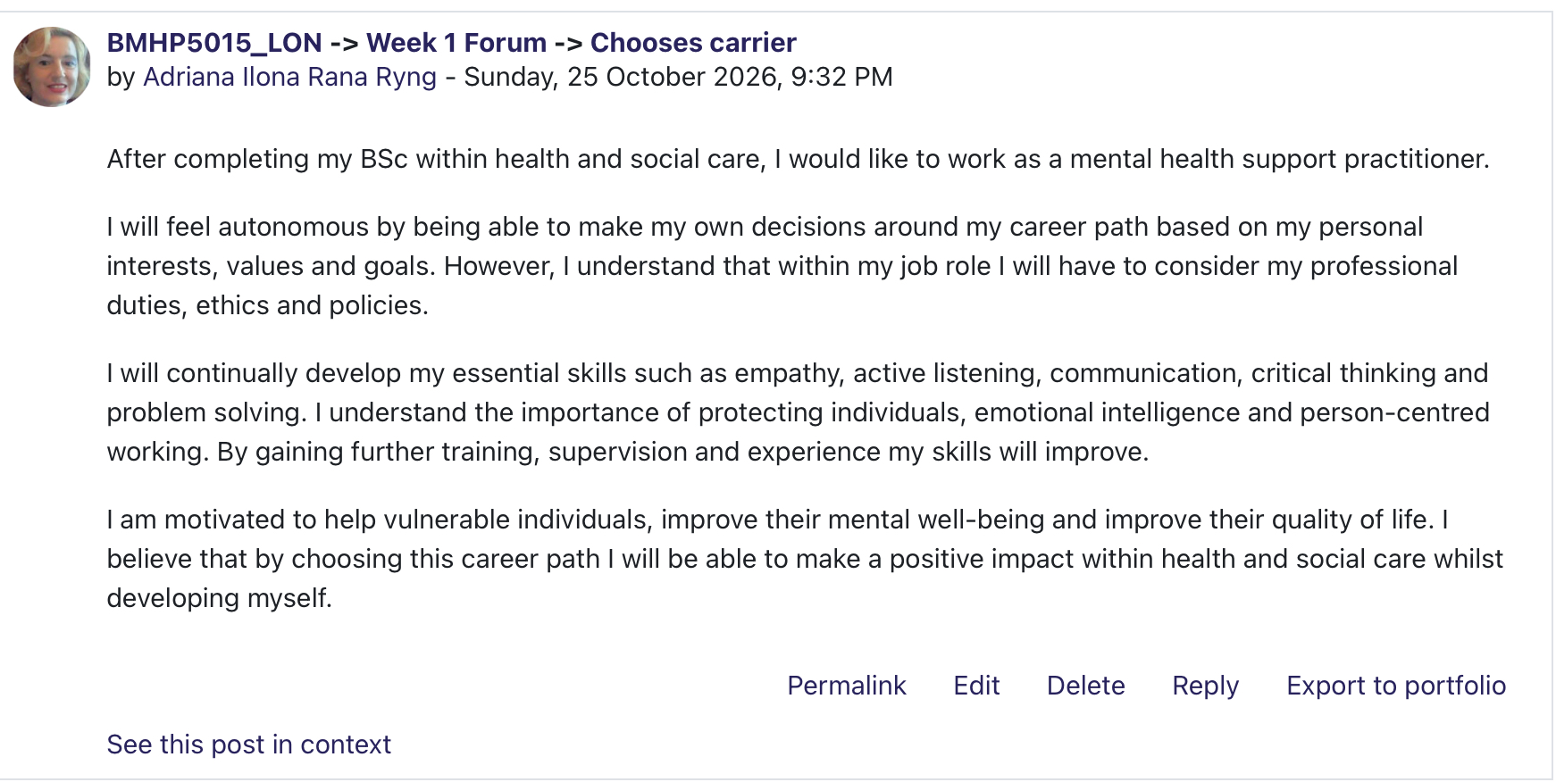
Screenshot 1.4: My Moodle reflection on career aspirations and future goals in health and social care.
I am currently a Key Worker in health and social care, and have gained vital core skills through front line experience, receiving essential safety training, and contributing to the planning of service users' care plans. My professional values are driven by compassion, listening and advocating for others. In the future, I choose to become an accredited Counselling Practitioner mention in forum discussion:

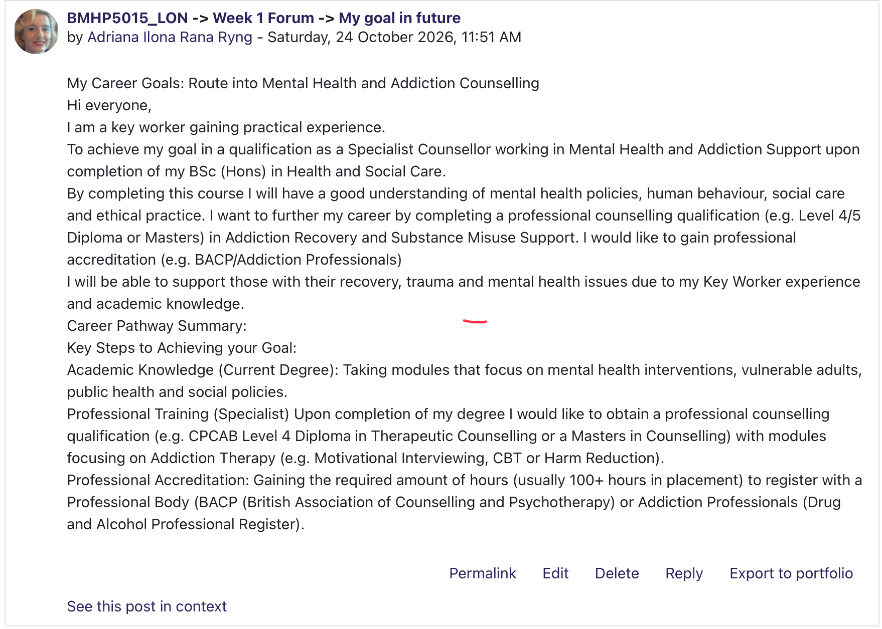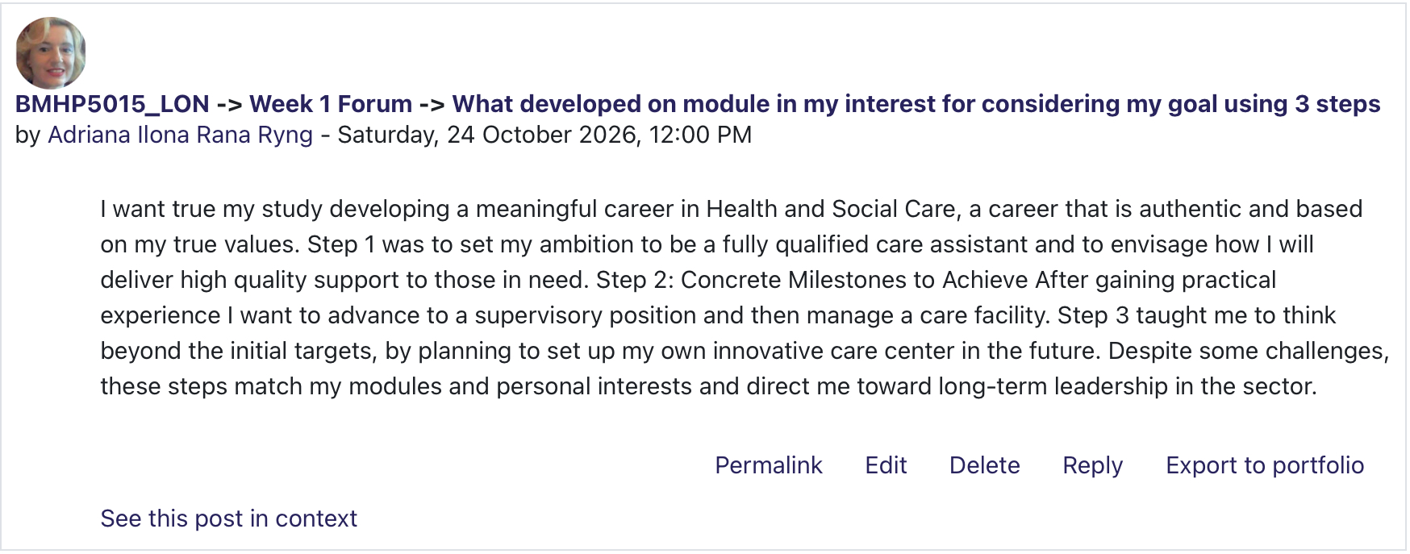
Screenshot 1.5: My Moodle contributions on mental-health career aspirations and the steps needed to achieve my future goals.

In critically assessing these findings I realise that a high self-reported EQ score reflects self-image rather than documented clinical skill. This experience was a great personal insight into my tendency to jump too quickly from active listening to problem-solving mode or trying to solve the service user’s immediate problems. Positive-driven, while intentions, this behaviour can inadvertently disempower people. Seeing that emotional distress needs containment and emotional regulation rather than premature solutions is critical. So, building a true personal brand as an aspiring counsellor needs to be supplemented with accredited therapeutic training that is in line to professional standards (BACP, n.d.).

- Reflection on Unit: It’s a Small World.

I looked at global connectivity, cultural competence and diversity in contemporary health and social care.
In a connected sector practitioners have to deal with different cultural backgrounds, different health beliefs and systemic inequalities (Great Britain, 2022). By being culturally aware, moving beyond simply tolerating to actively adapting communication to better understand the different heritages and sensory needs with personal values of your service users. This links to Hofstede’s (2011) Cultural Dimensions framework and how different cultural expectations of authority, individualism and family involvement influence service user engagement. In this unit I have been discussing global challenges in health care, anti-discriminatory practice and cultural awareness.

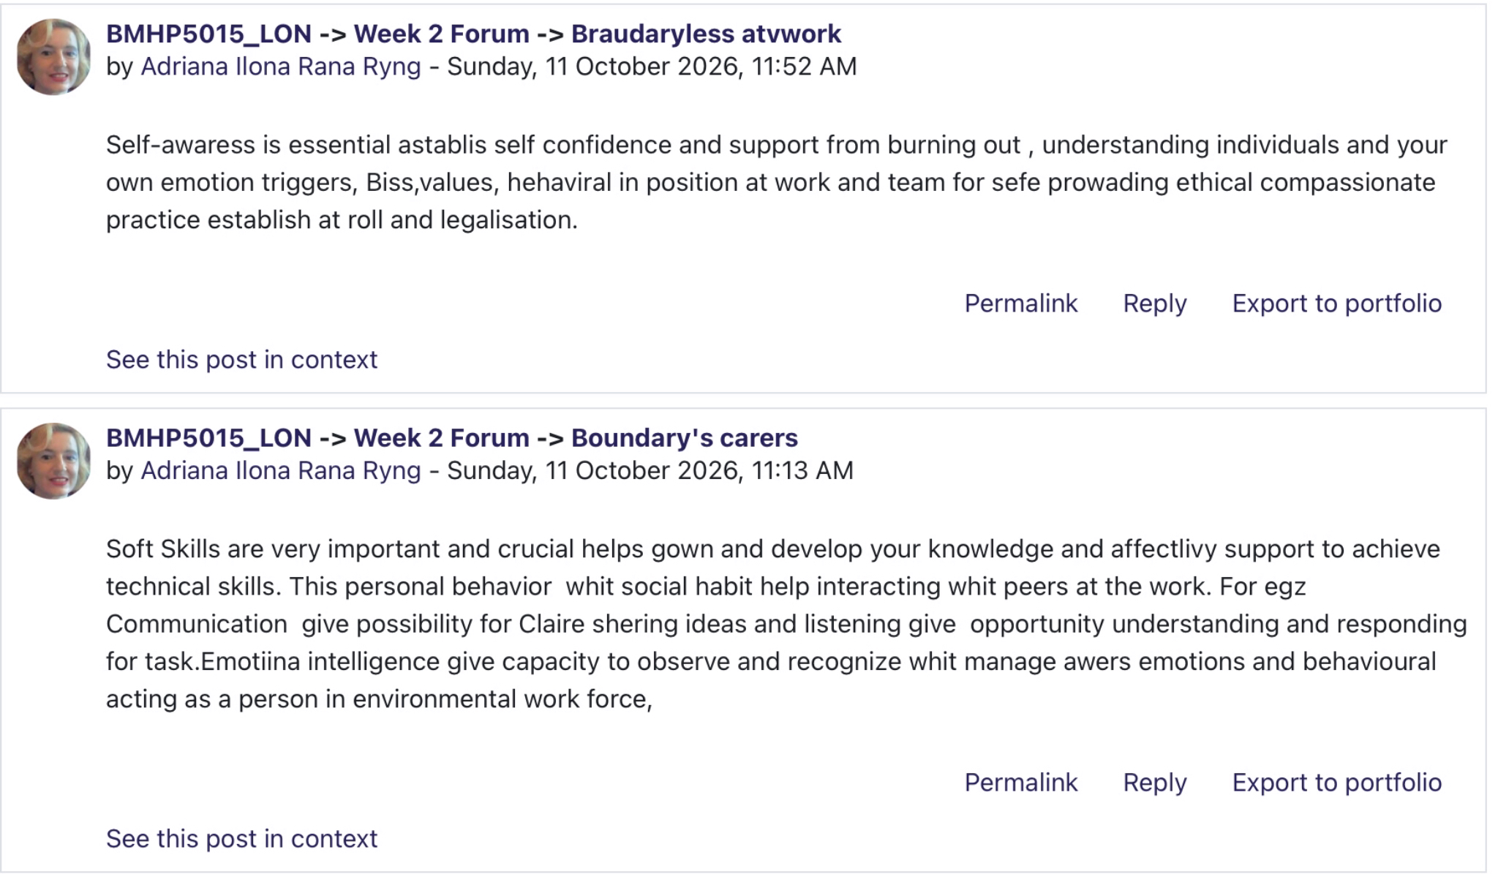
Screenshot 2.1: My Moodle forum contributions on self-awareness, soft skills and professional boundaries.
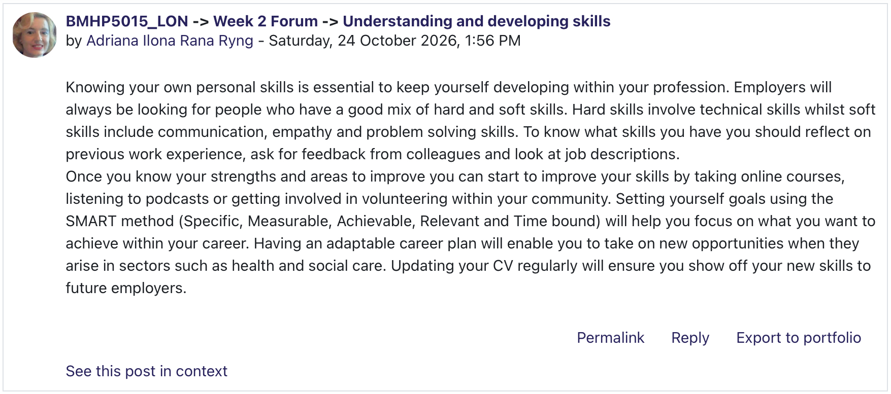
Screenshot 2.2: My Moodle forum contribution on developing professional skills.

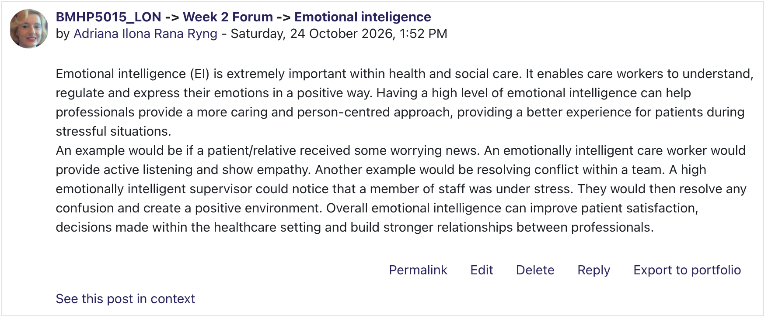
Screenshot 2.3: My Moodle forum contribution on emotional intelligence and understanding emotions at work.

Reflecting on these activities has broadened my knowledge to better provide my role of person-centred support. I presumed that good intentions were sufficient to ensure respectful care, but critical reflection shows that unexamined personal assumptions can inadvertently maintain exclusion.
Good is here used as for example, care workers who are subjected to harassment from third parties or discriminatory behaviour need to distinguish between protections for staff in the workplace (ACAS, 2026) and procedures for safeguarding vulnerable adults (SCIE, 2015). As I move into counselling, it is important that I build cultural competence so that I do not impose my own biases on clients from minority backgrounds.

- Reflection on Uni: Opportunity Knocks.

Unit 3 was about determining career opportunities, goal setting, professional networking and evaluation methods in modern health care. When you look into recruitment, you find that a standard CV alone is a rather ineffective sales tool, as potential employers do not really know what you can do from what is written down. Instead, winning trust, using professionals to avoid blind luck, trust-building, using professional advocates and active networking are essential. Furthermore, career advancement requires a serendipity mindset – the ability to recognise and respond to unexpected career opportunities (Heinström and Sormunen, 2020).

This reflection is about the gig economy - technologi, flexible employment and networking.

In the context of today's digital world, artificial intelligence will be an essential tool for any company. It should be noted, that those businesses which implement the abovementioned technologies tend to see great improvements in their functioning. In addition, it is possible to optimize the range of processes and cut costs through the application of automated systems. Still, despite technological advantages, it is necessary to understand that progress can only be achieved if the right environment is created. The company should invest in the education of its employees and motivate them to obtain the best results by using new equipment.
In Unit 3, I covered three types of evaluation to assess the effectiveness of these professional networks and career plans: goal-based evaluations (assessing if particular SMART goals are
met), process-based assessments (analysing strengths of the network and communication dynamics) and outcome-based evaluations (looking at general impacts and the 'greater good' gained from partnerships).

I'd mapped my career using the "sweet spot" framework (skills, interest, and market demand) via Moodle activities and assessed networking strategies.
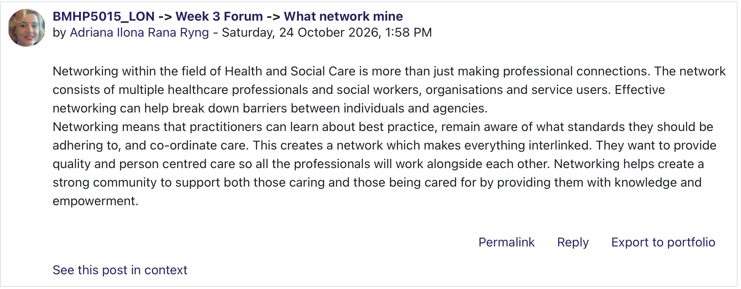
Screenshot 3.1: My Moodle forum contribution defining the importance of professional networks in health and social care

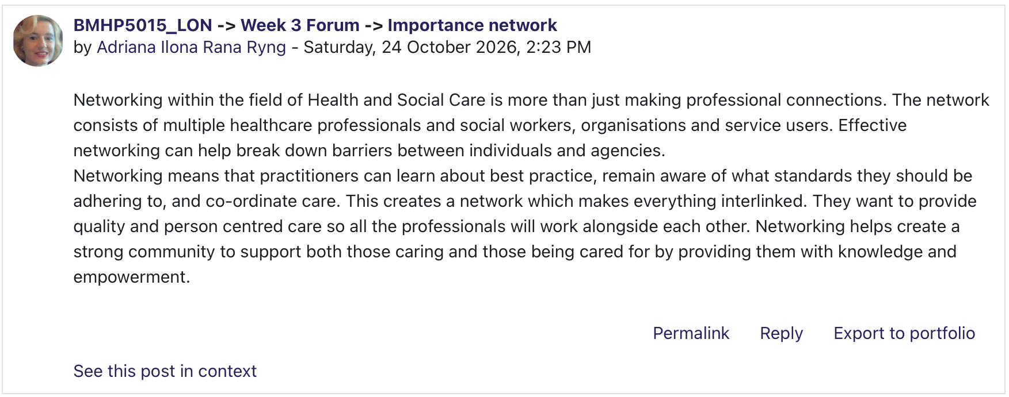
Screenshot 3.2: My Moodle forum post on the importance of professional networking.

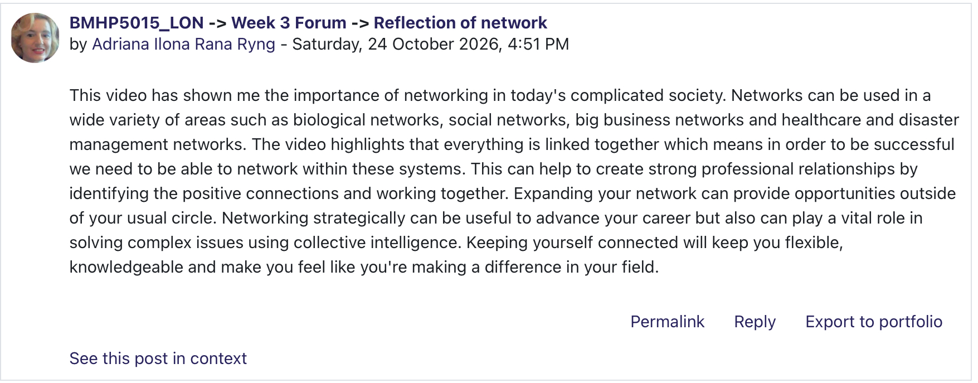
Screenshot 3.3: My Moodle reflection on the role of professional networks.
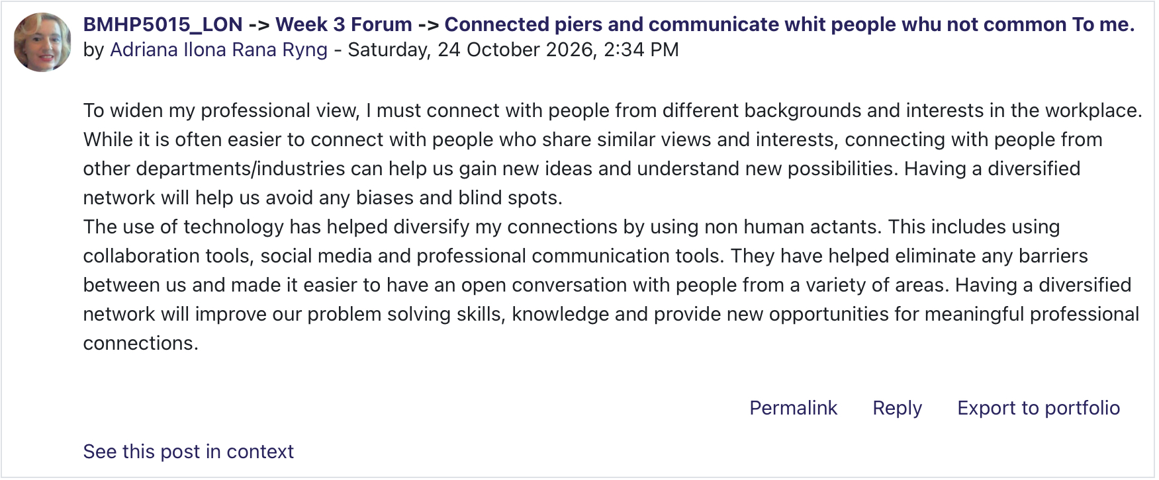
Screenshot 3.4: My Moodle contribution on connecting with professionals outside my immediate network.

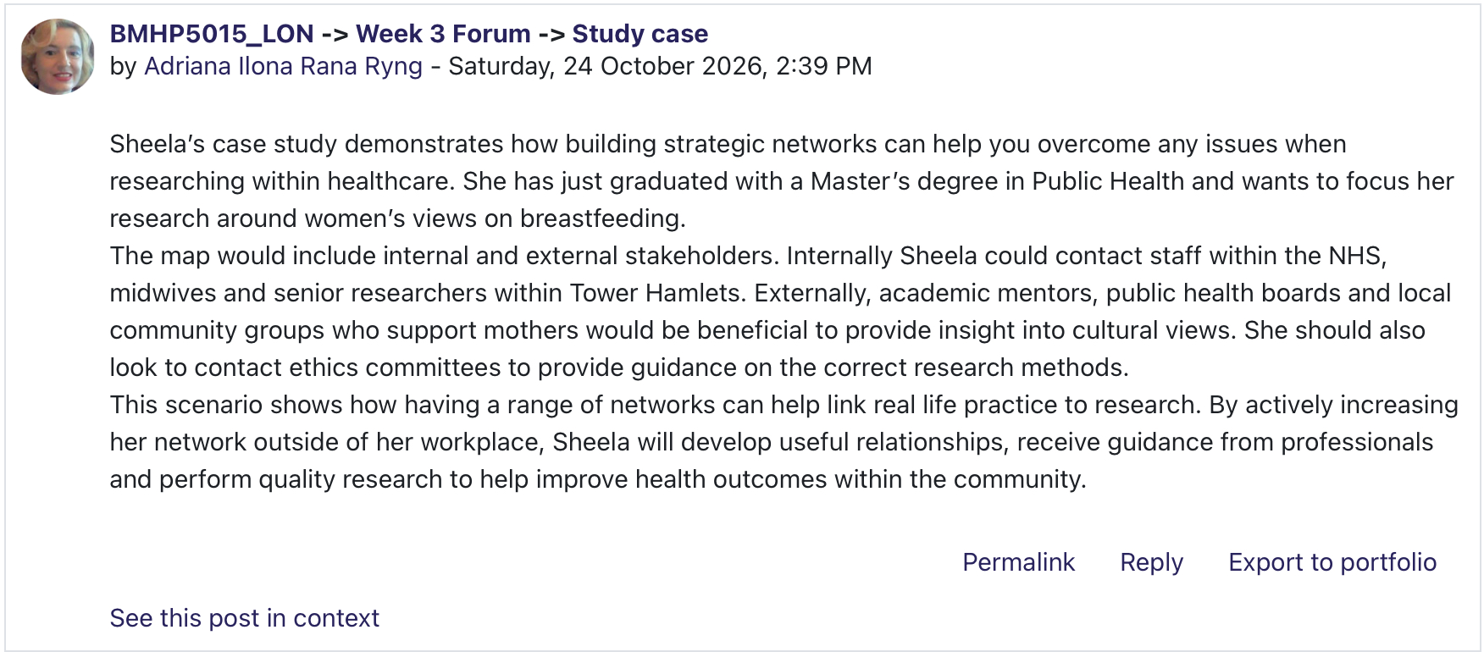
Screenshot 3.5: My Moodle study-case response on building and using a strategic professional network.

Discussion on the application of evaluation methods to set ambitious stretch goals (Pina e Cunha et al., 2017) while balancing flexible employment versus clinical continuity critical examination of these frameworks indicates a need to balance informal networking and aspirations and real professional barriers. Moving from key worker to counselling practitioner presents huge structural challenges: lots of money for training, time pressures, and the need to juggle full-time work with a higher academic level 5
study and completion of intensive clinical supervision and placement hours. Applying Tomlinson’s (2017) Graduate Capital model, alongside the boundaryless and protean career perspectives of Arthur and Rousseau (1996) and Hall (2004), I recognise that career transition depends not only on individual motivation and networking but also on acquiring formal graduate capital and navigating institutional constraints.
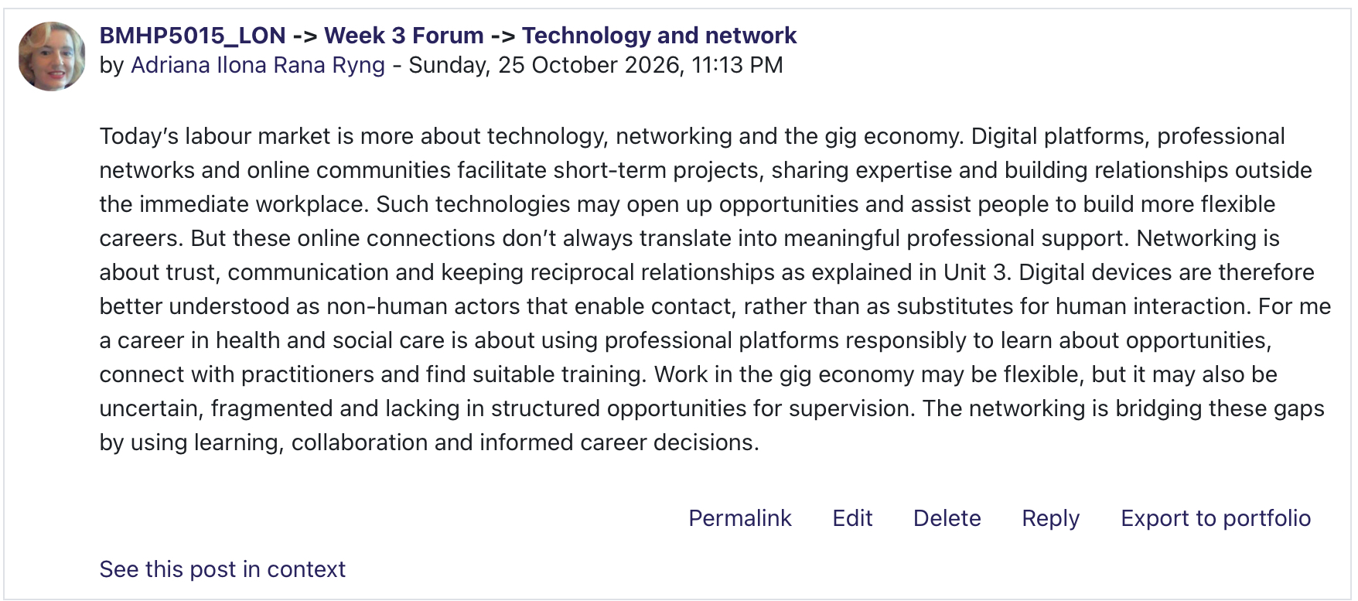
Screenshot 3.6: Reflection about technology in a small world and network.

Professional networking is an important aspect of career development in health and social care. As discussed in my Unit 3 Moodle contributions, networks connect practitioners, organisations and service users, allowing the sharing of knowledge, collaboration and co-ordinated care. Building relationships with professionals from different backgrounds can also help me to have a better understanding of career opportunities and develop the skills needed to transition from my current role as a Key Worker to counselling practice. However networking needs to be purposeful and consistent, making connections is only a first step, maintaining professional relationships and using them to learn and collaborate is also important. Thinking about the Moodle activities helped me to understand that good networks can help with my professional development and with better outcomes for service users.

- Reflection on Unit: The Pursuit of Happiness

In Unit 4, we must look at the workers' wellbeing with emotional resilience. The work-life balance in health and social care is visual as well. At risk are frontline workers because of chronic stress and burnout from high workload demands, emotional labour and staff shortages. Inside of the sector, the Health and Safety Executive (2024) and Skills for Care (n.d.) note that the wellbeing of staff directly impacts the quality of services and the safety of patients. Seligman’s (2011) PERMA model proposes that sustainable
Wellbeing is about positive emotion, engagement, relationships, meaning and achievement.
This unit involved Moodle activities on resilience strategies, workload management and professional boundaries.

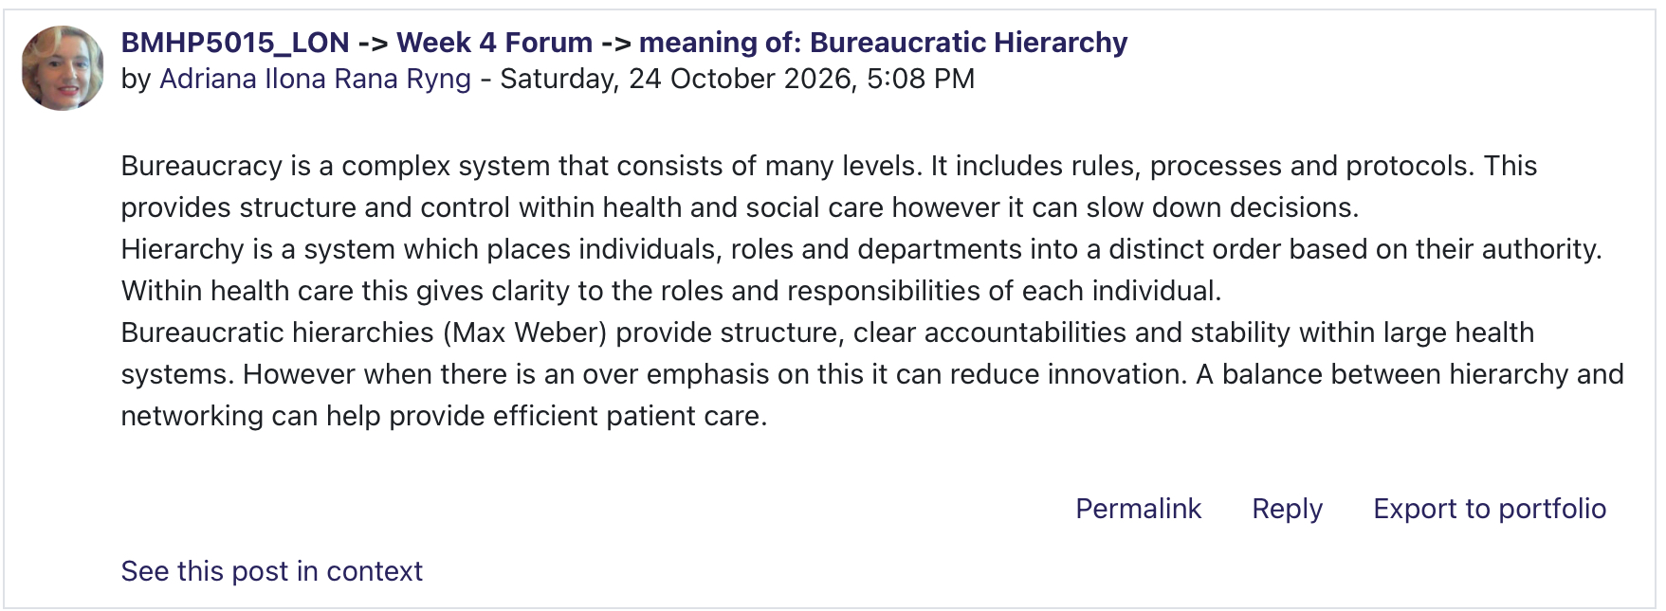
Screenshot 4.1: My Moodle contribution on bureaucratic hierarchy in health and social care.

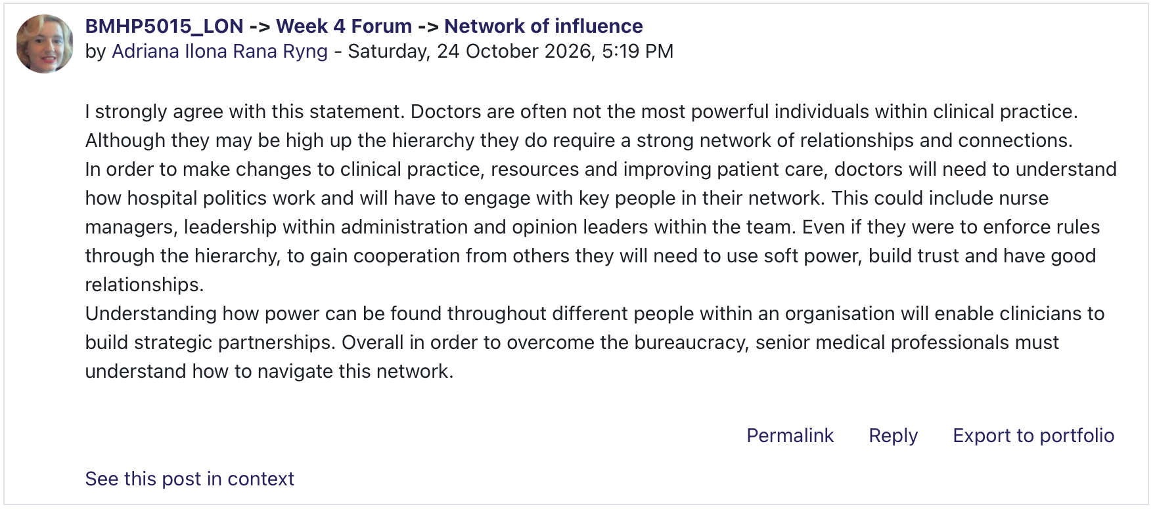
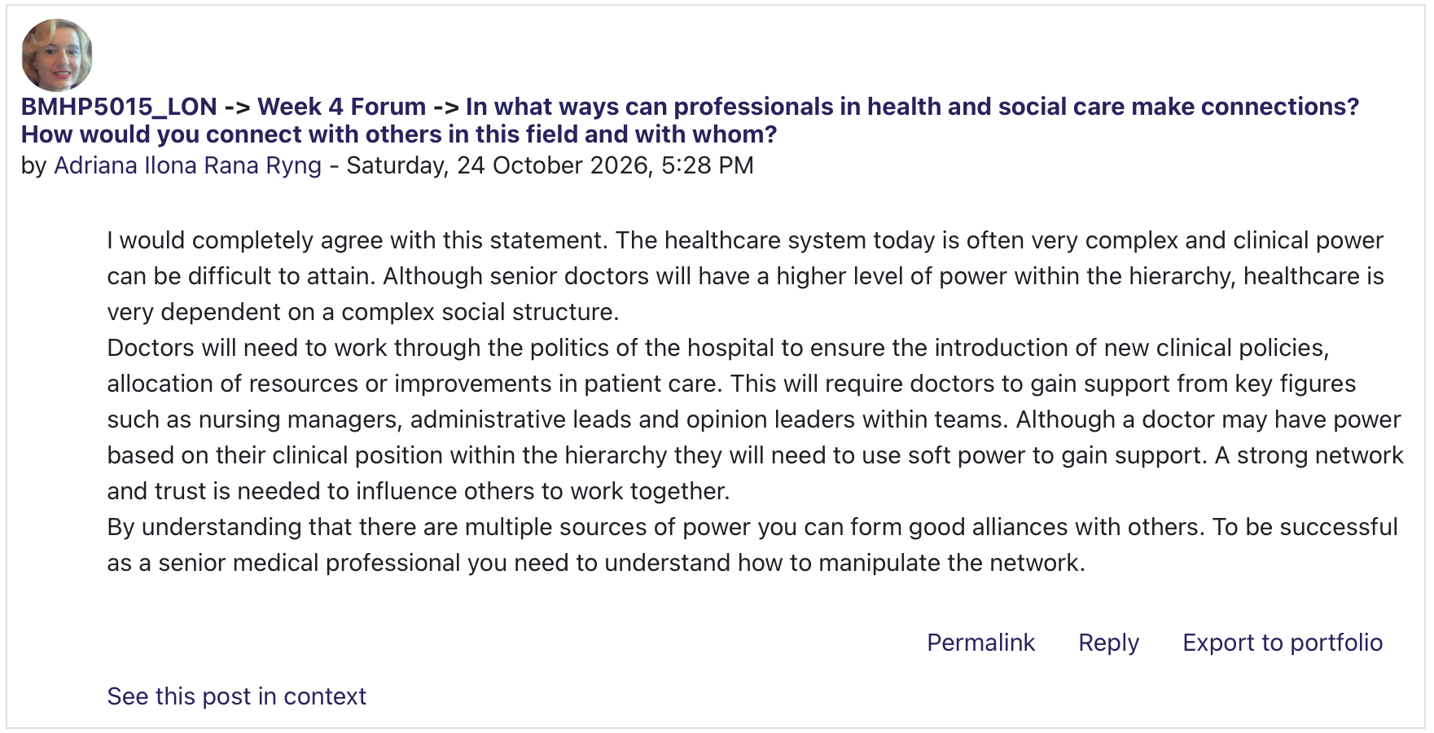
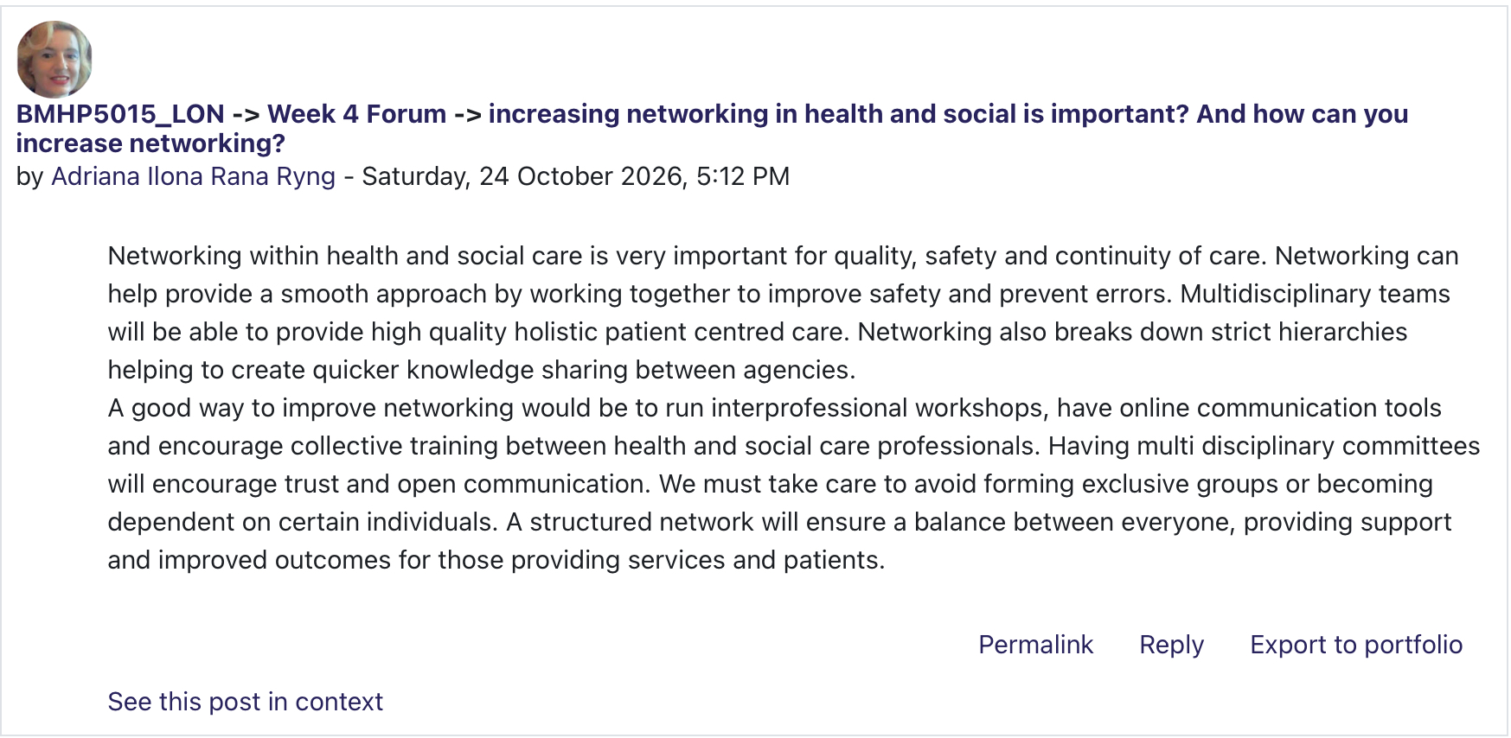
Screenshot 4.2: My Moodle contributions on professional influence, hierarchy and networking quality in health care.

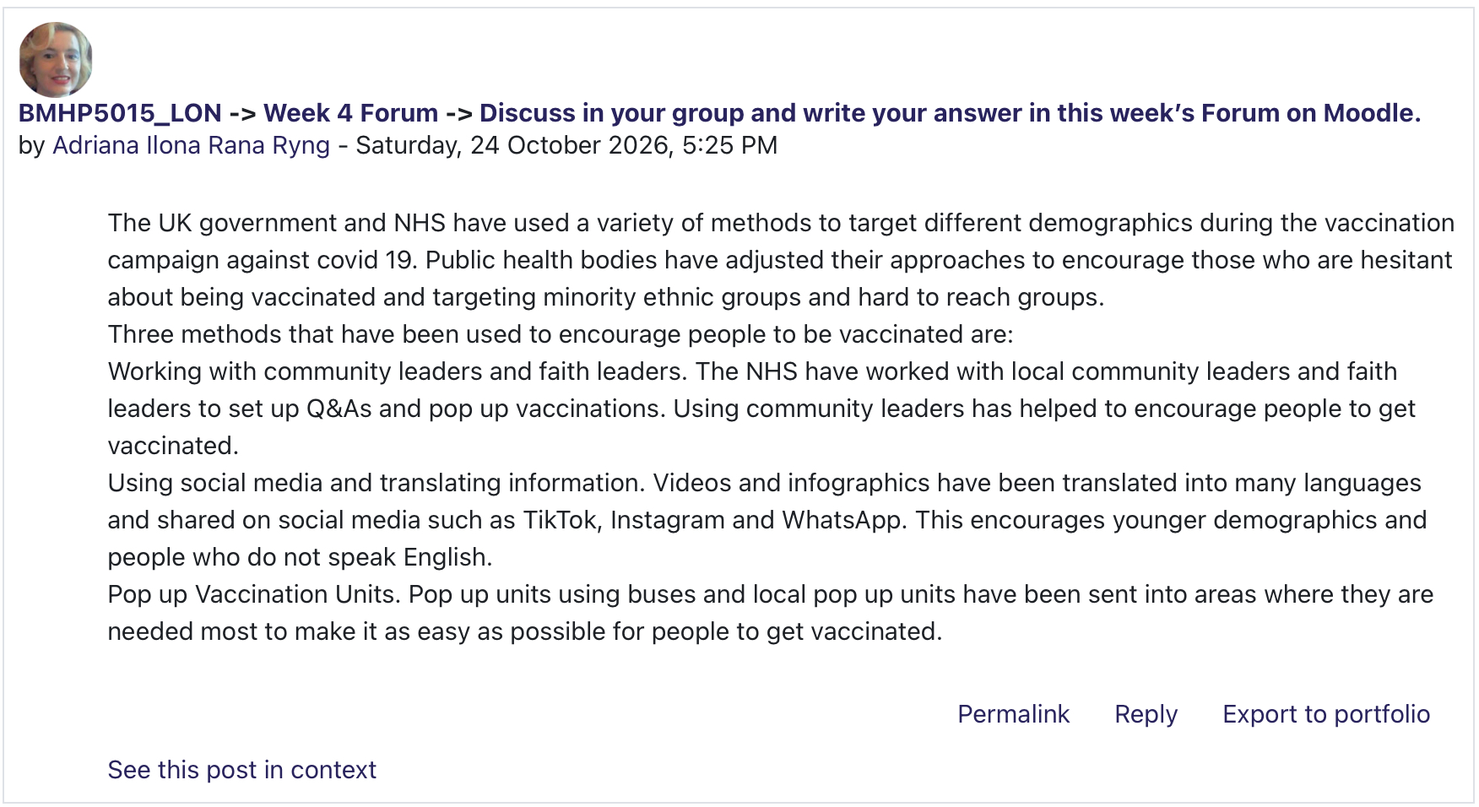Screenshot 4.3: My Moodle practical exercise on community outreach and increasing vaccination uptake. Connection piers, public Health for monitoring differently environmentally.
My critical reflection in this unit draws attention to an important distinction: that individual resilience cannot make up for systemic organisational failures. Practitioners are supposed to handle
inappropriately shifting the burden to personal mindfulness or emotional awareness to meet excessive demands. Reflect on the timing of structural support regarding work and timing, highlighting how these factors are influenced by the profession. Accessible reflective supervision is essential for achieving sustainable employment. Counsellors need to differentiate between internal management support within the workplace and external, specialised clinical supervision to prevent professionals from secondary traumatic stress and to maintain safe and ethical practices.
Personal development plan and critical reflection Using Kolb’s (1984) Experiential Learning Cycle (Concrete Experience \rightarrow &gt; Reflective Observation \rightarrow Conceptualisation Active Abstract I have experimented throughout all four units to synthesise my learning and develop a targeted action plan.

Concrete Experience: Moodle quizzes, forums, key worker practice]
│
▼
[Reflective Observation: Shifting from problem-solving to emotional containment]
│
▼
[Abstract Conceptualisation: Resilience requires organisational support + rigid boundaries]
│
▼
[Active Experimentation: Implementation of SMART PDP Goals below]

SMART Personal Development Plan

Target / Priority Area. | Specific Action and Justification. | Deadline and Review Method. | Success Measure / Outcome.
1. Therapeutic  Communication and  Active Listening. | Complete an  accredited  advanced active  listening workshop  to shift from quick  problem-solving to  reflective client  containment. | Within 3 Months  Reflective review  with line manager. | Non-judgement solution after reflective reviewing problem/task during demonstrating professional skills and responsibilities.
2. Professional  Training Pathway. | Research accredited  postgraduate or  professional  counselling  pathways suitable to  pursue upon  completing my Level 5 studies, mapping  required clinical  placement hours  and financial  requirements. | Within 6 Months  Formal consultation  with academic  advisor. | Identification of  suitable accredited  training programmes  and mapping of  required clinical  placement hours.
3. Information  Governance and  Digital Literacy. | Complete advanced  training on  GDPR-compliant  electronic record  keeping relevant to  clinical case  management. | Within 4 Months  Demonstration of  task to senior lead. | High standard of  compliance and  accuracy in  anonymised,  objective clinical  record-keeping.
4. Professional  Boundaries and  Supervision. | Establish structured  workplace  operational  supervision while  actively researching  external clinical  supervision  structures required  for future  therapeutic work. | Within 3 Months  Ongoing quarterly  review. | Important regular structures supervision with engagement for establishing and evaluating maintenance professional boundaries.

Conclusion

This portfolio has helped me evaluate my personal strengths; professional values and current experience support my employability, personal brand and professional transition from key worker to counselling practitioner. The theoretical perspectives with Moodle from units I learned activities that I showed online and portfolio.
Overviewing with a critical insight from Unit 1 emphasised the need for learners to have validated self-reported emotional intelligence in relation to real practice, particularly the importance of moving beyond premature problem-solving. Given confidence and a high self-reported emotional-intelligence score do not, on their own, demonstrate counselling competence; these need to be supported by reflective practice, training and evidence from practice. Units 2 highlighted cultural competence, shifting perspectives and equity as core pillars of person-centred care. Unit 3 reminded me that for us to benefit from a serendipity mindset, sweet-spot analysis and networking, we need to navigate real-world career barriers, understand employment trends such as the gig economy and acquire formal graduate capital. Has helped me recognise that career development requires more than motivation and networking, because financial, academic and placement requirements can constrain progression.
At last, Unit 4 showed that I must build sustainable professional wellbeing; one must establish both personal boundaries and supportive organisational structures. And have also shown that person-centred care depends not only on individual cultural awareness and resilience but also on organisations addressing discrimination, workload pressures and access to appropriate supervision. My SMART development plan therefore focuses on practical and measurable next steps while recognising that safe, ethical progress towards counselling practice depends on both my own development and appropriate organisational and professional support.

References

Acas (2026) Harassment - Discrimination at work. Available at: https://www.acas.org.uk/discrimination-and-the-law/harassment (Accessed: 18 October 2026).

Arthur, M.B. and Rousseau, D.M. (eds.) (1996) The boundaryless career: a new employment principle for a new organisational era. New York: Oxford University Press.

British Association for Counselling and Psychotherapy (n.d.) Training to become a therapist. Available at: https://www.bacp.co.uk/careers/counselling-and-therapy-as-a-career/training-to-become-a-therapist/ (Accessed: 18 October 2026).

Dacre Pool, L. and Sewell, P. (2007) ‘The key to employability: developing a practical model of graduate employability’, Education + Training, 49(4), pp. 277–289. doi: 10.1108/00400910710754435.

Goleman, D. (1995) Emotional intelligence: why it can matter more than IQ. New York: Bantam Books.

Great Britain (2022) Health and Care Act 2022. London: HMSO.

Hall, D.T. (2004) ‘The protean career: A quarter-century journey’, Journal of Vocational Behavior, 65(1), pp. 1–13. doi: 10.1016/j.jvb.2003.10.006.

Health and Safety Executive (2024) Work-related stress and how to manage it. Available at: https://www.hse.gov.uk/stress/overview.htm (Accessed: 18 October 2026).

Heinström, J. and Sormunen, E. (2020) ‘Serendipity as chaos or discovery – exploring the role of personality and sense of coherence’, Information Research, 25(4), article isic2001. doi: 10.47989/irisic2001.

Hofstede, G. (2011) ‘Dimensionalizing cultures: The Hofstede model in context’, Online Readings in Psychology and Culture, 2(1), pp. 1–26. doi: 10.9707/2307-0919.1014.

IHHP (n.d.) Test your emotional intelligence with our free EQ quiz. Available at: https://ihhp.com/free-eq-quiz/ (Accessed: 18 October 2026).

Kolb, D.A. (1984) Experiential learning: experience as the source of learning and development. Englewood Cliffs, NJ: Prentice-Hall.

Pina e Cunha, M., Giustiniano, L., Rego, A. and Clegg, S. (2017) ‘Mission impossible? The paradoxes of stretch goal setting’, Management Learning, 48(2), pp. 140–157. doi: 10.1177/1350507616664289.

Salovey, P. and Mayer, J.D. (1990) ‘Emotional intelligence’, Imagination, Cognition and Personality, 9(3), pp. 185–211. doi: 10.2190/DUGG-P24E-52WK-6CDG.

Schön, D.A. (1983) The reflective practitioner: how professionals think in action. New York: Basic Books.

Seligman, M.E.P. (2011) Flourish: a visionary new understanding of happiness and well-being. New York: Free Press.

Skills for Care (n.d.) Wellbeing. Available at: https://www.skillsforcare.org.uk/Support-for-leaders-and-managers/Managing-people/Wellbeing/Wellbeing.aspx (Accessed: 18 October 2026).

Social Care Institute for Excellence (2015) Types and indicators of abuse. (Last reviewed December 2020). Available at: https://www.scie.org.uk/safeguarding/adults/introduction/types-and-indicators-of-abuse/ (Accessed: 18 October 2026).

Tomlinson, M. (2017) ‘Forms of graduate capital and their relationship to graduate employability’, Education + Training, 59(4), pp. 338–352. doi: 10.1108/ET-05-2016-0090.

