Electronics 1 Assignment
Traffic Light System

Contents

Introduction 3
Background Research 3
Circuit Design 3
Traffic Light Pseudo English 5
Component Pricing 6
Details of Testing & Simulation 7
Conclusions 8
References 9
Appendix 10

Introduction
The task for this assignment was to produce a working traffic light system to control the flow of traffic on a cross road. As well as controlling traffic flow, the system would have to in-cooperate pedestrian crossing across all four lanes of traffic. To have a competent system, sensors such as Passive Infrared (PIR) or ultrasound would have to be used determine whether there was traffic waiting at a particular light and allow that traffic to flow if there was no traffic at any other part of the crossroad.
However, Proteus [1]; the simulation software that was being used did not have a working PIR sensor. Instead, a potentiometer was used as a PIR is a variable resistor with its variance being adjusted by infrared instead of manual adjustments. This change seemed the best compromise in order to demonstrate the use of analogue digital conversion (ADC) being used in the code. The pedestrian call would be done using a button press as seen on most pedestrian crossings in the UK.
Furthermore, routines are sped up in the code (such as delays in traffic signals) so it easier and quicker to cycle through routines and call other routines e.g. the pedestrian crossing routine.
Screenshots of the code can be accessed in the appendix of these report.

Background Research
In order to ensure that the system was legal, the Highway code was consulted specifically to check that the traffic lights changed colours in the correct manner. For example: when the light is changing from red to green, amber displays along with red not by itself, unlike it is when changing from green to red [2].
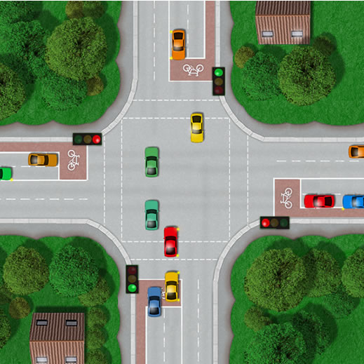
Figure1: Shows a crossroad layout only difference this is double lane [3].
Furthermore, on a crossroad when attempting to turn right the oncoming traffic has the right of way [3]. This means that lanes heading in opposite directions can be paired up as any cars attempt to turn right will have to wait for a gap in the oncoming traffic. Another benefit of pairing up traffic is that traffic will flow quicker as now two lanes can flow simultaneously instead of one at a time. This also simplifies the code as instead of four separate signals, traffic lights can be paired so there is the equivalent of 2 different signals in the crossroad (i.e. vertical traffic flow and horizontal traffic flow).

Circuit Design
This traffic light system was designed around one microcontroller (PIC18F452) [4] which would control all the different components of the system. The system itself was designed to carry out bi-directional traffic flow where traffic lights would be paired up in the north/south (vertical) direction and the east/west (horizontal) direction. Reasons for this was to improve traffic flow as all roads are single carriage so cars that attempting to turn right (cross a lane of traffic) only would have to cross one lane of traffic and would have to adhere to the highway code and wait until the lane was clear to cross [3]. If one lane would only be allowed to flow at a time, cars would be waiting for longer periods of time unnecessarily for adjacent traffic flow and for the light changes. Another reason for this choice would that it would enable the code to be simpler and more efficient.
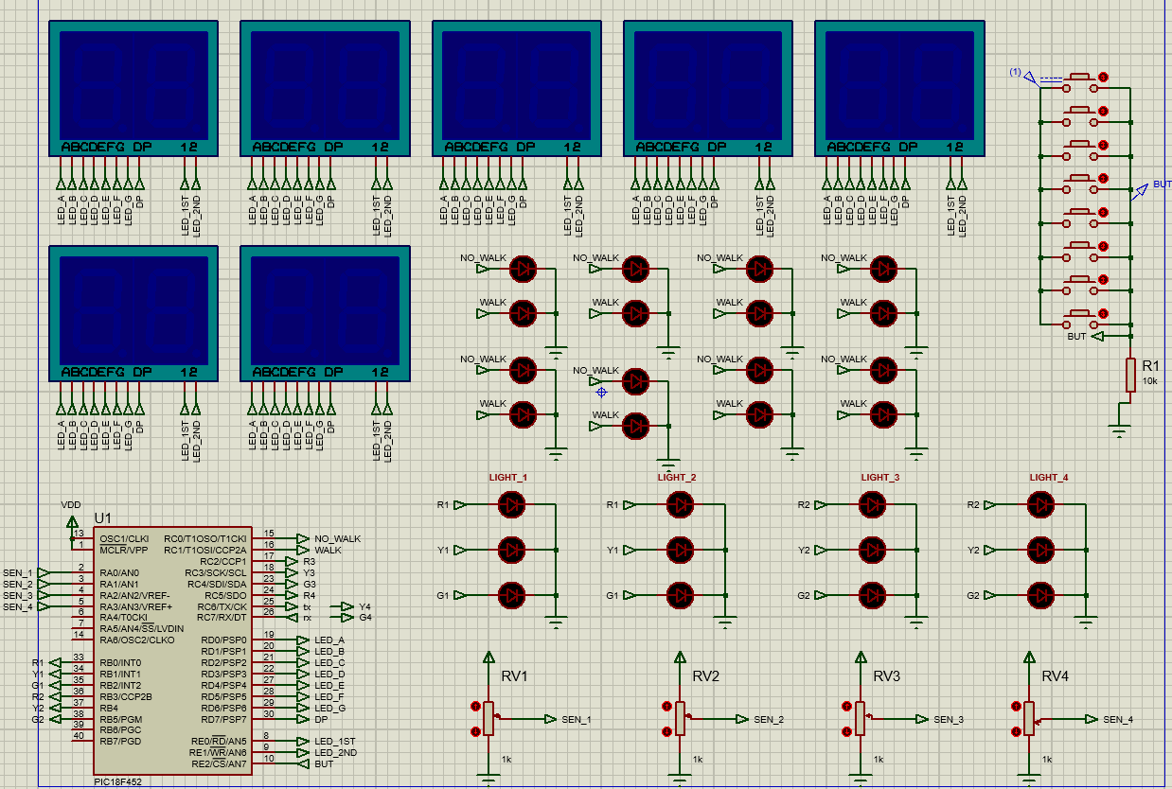
Figure 2: Shows the layout of the circuit in Proteus. Lights 1&2 are paired as are 3&4 [1].

Because a lot of the signals such as the 7-segement countdown and the pedestrian ‘walk and ‘no walk’ Light Emitting Diodes (LEDs) would have to be synchronised, all the separate countdowns could run off the same signals (i.e. the same pins) saving space on the microcontroller for other tasks.
In order to allow safe crossing for pedestrians, all the traffic lights would have to display red. Therefore, the pedestrian button press would consist of 8 buttons, one for each combination of crossing routes, all connected to the same input pin. This pin then could hold a state in the code (high or low) to indicate if a pedestrian was waiting to cross. The pedestrian would then be signaled to cross when the traffic lights would next all be red.
As already stated PIR sensors would be used to detect traffic but for simulation purposes this was done via a potentiometer. There would be four potentiometers in total (for each lane of traffic) which would be connected to the analogue pins.
Initially, each pin was paired up with a LED traffic light, totaling 12 pins to just control the light signals. However, once it was realised that traffic lights could be paired up it meant only 6 pins were needed to be used (3 for vertical and 3 for horizontal directions). This in turn meant that all these pins could be on the same port which enabled simplification of the code as hexadecimal characters could be outputted onto that port which corresponded to traffic light states.

Traffic Light Pseudo English
- Include the main.h header file.
- Define arrays for displaying values on 7-segment and traffic lights.
- Define variables.
- Define functions.
- Timer Interrupt function:
  - Check to see if the pedestrian crossing button has been pressed.
  - If pedestrian button has been pressed and the traffic lights are all red call the pedestrian crossing countdown routine. Once this is completed reset button and traffic lights states to their default and show the red ‘No Walk’ pedestrian light.
  - Run through both sensor functions to check whether cars are waiting at the traffic lights.
- Main Function:
  - Set up analogue ports and the analogue timer settings.
  - enable the timer interrupt.
  - Main WHILE Loop:
    - Set pedestrian lights to show red ‘No Walk’.
    - IF there is no traffic detected by the sensors the traffic lights will run through a default routine outlined in ‘traffic’ function.
    - ELSE IF there is traffic Nth or Sth but not Est or Wst show the hex-decimal values from the array in location to allow turn lights green (nth & sth) and return back to red when traffic has passed, traffic is detected in the other direction or the long delay has elapsed.
    - ELSE IF there is traffic Est or Wst but not Nth or Sth show the hex-decimal values from the array in location to allow turn lights green (Est & Wst) and return back to red when traffic has passed, traffic is detected in the other direction or the long delay has elapsed.
    - ELSE if there is traffic waiting in both directions run the default traffic routine.
- Pedestrian countdown function:
  - Turns all traffic lights red to ensure that no traffic will be moving whilst pedestrians are crossing.
  - Change pedestrian walk lights to green ‘Walk’.
  - First WHILE loop displays the number 10 on the 7-segment for roughly 1 second.
  - Second WHILE loop countdowns from 9 to zero of the 7-segement with a delay of a second between each number.
  - Once loops are complete 7-segments are turned off and pedestrian light is changed back to red ‘No Walk’. Change the variables used to increment through arrays to show the 7-segement values back to their default ready for when the function is called next.
- Traffic function runs the default routine based on timings:
  - Show the values in the array location to display red lights on the traffic lights initially. As the array is incremented the values of light positions changes and cycles through stop and go positions for both directions.
  - IF the value of the variable (location) is greater than the array size its value is converted back to its default (zero).
  - IF the variable (location) is zero pedestrian button press is reset as is the variable ‘state’ which indicates if the traffic lights are in a light position that permits safe pedestrian crossing. Zero means it is not.
  - IF location variable holds the value 3, the light green for nth & sth and a delay is initialised to allow traffic to flow in these directions.
  - ELSE IF variable holds value 7, lights a green est & wst and a delay is initialized to allow traffic to flow in these directions.
- Sensor 1 function:
  - Read both analogue ports for sensor s1 & s2 and which ever has the lowest value is assigned is sensor 1.
  - The value is printed onto a virtual terminal for the user to understand values of the pots.
- Sensor 1 function:
  - Read both analogue ports for sensor s1 & s2 and which ever has the lowest value is assigned is sensor 1.
  - The value is printed onto a virtual terminal for the user to understand values of the pots.

Component Pricing
The majority of the components below were priced using ‘RS Components’, an online store for electronic components [5]. On this website there was a wide array of choices for each component each being similarly priced. Where it was possible the same device was chosen to the one that was used in Proteus [1]. However, when these components were unavailable, like with the 7-segment display, a similar product was chosen.
- PIC18f452 - £7.52 x1 [4]
- PIR – £1.75 x4 = £7 [6]
- Button - £0.122 x8 = £0.98 [7]
- LEDs G/Y- £0.166. Gx12 Yx4 = £2.66 [8]
- LEDs Red - £0.366 x12 = 4.40 [8]
- 7-Segment display - £4.002 x8 = £32.02 [9]
- Total = £54.58
The above calculation is for the minimum number of components needed to run the system as designed however, it is good practice to order more components than required in case some are faulty or some break during the building stage.

Details of Testing & Simulation
Testing of the circuit was done using Proteus circuit simulation software [1] as it enabled real time simulation of the of circuit with the current code. This way changes could be made easily both in software and hardware with minimal cost. Once the prototype was completed in simulation, the next would be testing with the physical components. Physical testing is helpful as it allows for any faults in the simulation software found and corrected. However, due to time constraints it was not possible to build the circuit in real-life.
The design and testing methodology adopted for this task was ‘End to End’ [10] based which aims at testing the functionality of the entire code in a real-life scenario in which it will be interacted with by users (i.e. pedestrians and drivers). This method was adopted as Proteus allowed the interfacing with the components at any stage of the process to simulate how users would interact with the system. This in-turn made it very helpful to see any short-comings in the code at that stage in the process and being able to try ideas that could solve problems through ‘trial and error’ until a solution was found. An example of this procedure was when the pedestrian crossing routine was being called to ensure that the routine would not be executed until the traffic lights were all red. As the code developed more routines were introduced and the code was tested end-to-end again to ensure every additional code worked correctly with the rest.
Moreover, Proteus offers good user interfacing (UI) when accessing data to find at any moment in time what values variables hold making the process of debugging easier.
Initially, the pedestrian countdown function was written as it was a relatively simplistic task and standalone not requiring any other interaction with other functions other than when it was to be called. Once called it would run and then reset before returning to the main function. The biggest challenge facing this task was to get the number ’10’ displayed correctly on the display before the countdown started. Because the number was to be displayed on a double-digit 7-segment display neither digit (1 or 0) could be displayed at the same time and so a suitable frequency had to be obtained in which the display would flick between the two digits quickly to appear constant to the eye. Once this was managed the display would cycle through an array hex values (corresponding to numbers 1 to 9), using a while loop. This task proved straightforward with very few problems being faced.
The next task was to implement a default traffic signal routine in which the signals would change based on a timer for when there was no traffic around so that lights would not get stuck green in one direction. The first attempt used a range of functions which would all hold a traffic light state for the junction which would be called by the traffic function in the correct order. However, this method proved to complicate the code and made it difficult to understand how to in-cooperate the button press for the pedestrian crossing. Therefore, the decision was taken to adopt a similar method to the countdown timer by cycling through an array of hex values corresponding to traffic light states. This helped with implementing the button press as it is known at which point in the array the lights would be red and so at this point if the button had been pressed previously, the countdown routine could be run.
The biggest challenge faced was implementing the routines that would stop the default routine and start a different one when traffic is detected by the PIR sensor. The major difficulty with is was to ensure that the routines would switch at a safe point and that when the routine ended (i.e. if the traffic had passed or traffic was detected at the other set of lights) that when transferring to the other routine it carried on fluidly. For example: when the PIR had gone from detecting traffic to not detecting but no other traffic had been detected the routine would change back to the default timed one. However, the new routine often repeated the previous traffic arrangement before switching to the other set of lights. This was rectified by saving the state of the lights of the default routine in a variable called ‘location’. As a sensor routine ended and the default traffic function was going to be called. Upon exiting routine, the code would assign the value of location to make sure the routine started changing the lights on the adjacent set of traffic lights.
Because this code had been designed around a default traffic light routine based on timings whenever a button was pressed or a sensor detected a car; this routine had to be interrupted. Hence, the decision was taken to use interrupts; more specifically a timing interrupt. The timing interrupt would interrupt the main code every 50us to check the sensors and the pedestrian button press. The advantage of using a timing interrupt was that it prevented the need to write multiple check points within the main function to check the state of the inputs. This simplified the code hugely and was lot more easily implemented into the existing code.

Conclusions
I believe this task went well and I was able to design a working traffic light system that was safe and that allowed fluid traffic flow. Another credible point was that I was able to implement the correct traffic light sequence followed legal lighting procedure as outlined by the DVLA [2].
Purely focusing on programming skills, this task was the first time I had used interrupts and the use of them I found very helpful as I was able to interrupt routines without putting in a check point each time. However, that being said due to the nature of how I set up the routines I did need to put some of these check points in to ensure that the interrupt didn’t activate a function out of sequence with the lights (e.g. the variable ‘state’).
Next time I think an area to improve is more background research in traffic light crossroad layouts before deciding on a route to code up the system. My system has 2 sets of traffic lights paired up allowing for simplifications in the code and simpler traffic flow where any car turning right would have to wait till it was clear to cross the adjacent lane. In real life however, I have found very little evidence for this system being operated. Instead, what later research found was that the simplest system operated for a crossroad in the UK was where one set of lanes were paired up (i.e. the main road) with the two adjacent lanes having sperate traffic signals. This method seems to address any potential jam that may occur when opposite traffic from the minor lanes want to turn right. With this additional research earlier, I could have coded up a system that was more truthful to real-life.

References
[1] Proteus 8 Professional, version 1.85, [Software], Grassington, Labcenter Electronics, 2023
[2] British Government, ’The Highway Code: Light Signals Controlling Traffic’ 27th July 2022. [Online]. Available at: https://uwtsd.ac.uk/media/uwtsd-website/content-assets/documents/library-and-learning-resources/infoskills/IEEE-eng_v.1.2.pdf . [Accessed on: 10th April 2023].
[3] DVLA, ‘The Highway Code’, 2023. [Online]. Available at: https://www.highwaycodeuk.co.uk/road-junctions.html .[Accessed on: 10th April 2023].
[4] Microchip, ‘PIC18F452’ 2023. [Online]. Available at: https://www.microchip.com/en-us/product/PIC18F452#purchase-from-store . Accessed on: 12th April 2023.
[5] RS Components, ‘RS Components’, 2023. [Online] Available at: https://uk.rs-online.com/web/ . Accessed on: 12th April 2023.
[6] CPC, ‘PIR Sensor’ 2023. [Online]. Available at: https://cpc.farnell.com/murata/ira-s210st01/pyroelectric-infrared-sensor-2vdc/dp/SN36935?mckv=s_dc|pcrid|490691434481|kword||match||plid||slid||product|SN36935|pgrid|47130025876|ptaid|pla-1952127140113|&CMP=KNC-GUK-CPC-SHOPPING-946695261-47130025876-SN36935&s_kwcid=AL!5616!3!490691434481!!!network}!1952127140113!&gclid=EAIaIQobChMIxKv91bGk_gIVY4BQBh0uAgOCEAQYDyABEgIA4PD_BwE . Accessed on: 12th April 2023
[7] RS Components, ‘Black Button Tactile Switch’. [Online]. Available at: https://uk.rs-online.com/web/p/tactile-switches/4791413p?cm_mmc=UK-PLA-DS3A-_-google-_-CSS_UK_EN_Switches_Whoop-_-Tactile+Switches_Whoop+(2)-_-4791413P&matchtype=&pla-869542756077&cq_src=google_ads&cq_cmp=9771206593&cq_term=&cq_plac=&cq_net=g&cq_plt=gp&gclid=EAIaIQobChMI5Y-LvLKk_gIVAf3jBx15KgVTEAQYASABEgITZ_D_BwE&gclsrc=aw.ds . Accessed on: 12th April 2023.
[8] RS Components, ‘LEDs’. [Online]. Available at: https://uk.rs-online.com/web/c/displays-optoelectronics/leds-light-emitting-diodes/leds/?cm_mmc=UK-PPC-DS3A-_-google-_-1_UK_EN_AE_Displays+%26+Optoelectronics-Category_lv_4-_-LEDs-_-leds&matchtype=e&kwd-21711786&cq_src=google_ads&cq_cmp=16061319809&cq_term=leds&cq_plac=&cq_net=g&cq_plt=gp&gclid=EAIaIQobChMIpMOD3bKk_gIVhfftCh0NvgrVEAAYASAAEgJx-vD_BwE&gclsrc=aw.ds . Accessed on: 12th April 2023.

[9] RS Components, ‘KCDC03-123 Kingbright 2 Digit 7-Segment LED Display, CC Green 12 mcd RH DP 7.6mm’. [Online]. Available at: https://uk.rs-online.com/web/p/led-displays/8770791 . Accessed on: 12th April 2023.

[10] Research Gate, ,End-to-End Testing Integration Design’. [online] Available at: https://www.researchgate.net/publication/221028427_End-To-End_Integration_Testing_Design . Accessed on: 17th April 2023.

Appendix
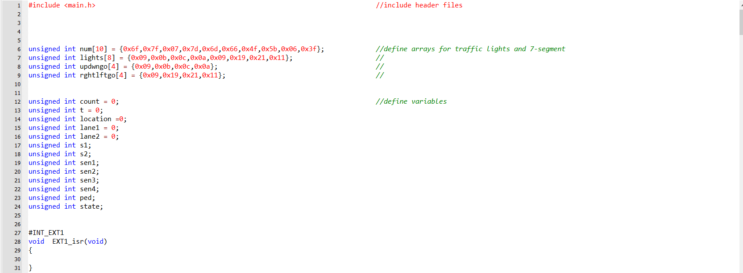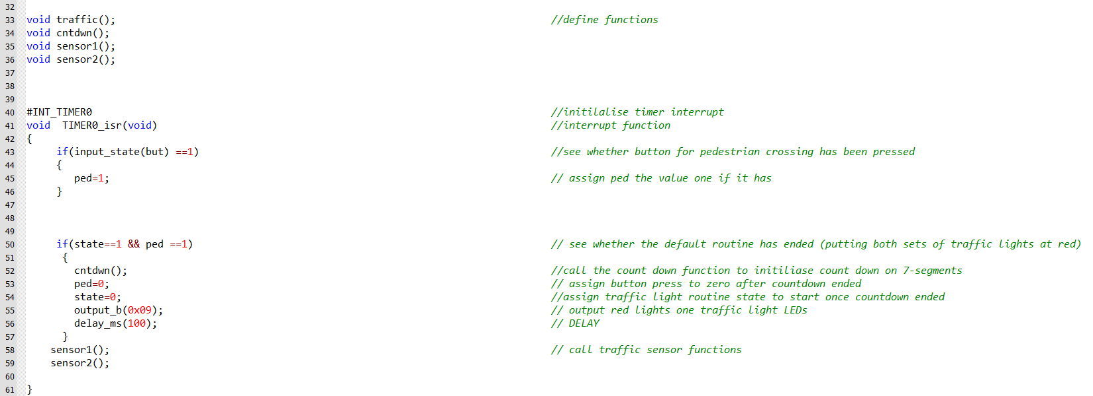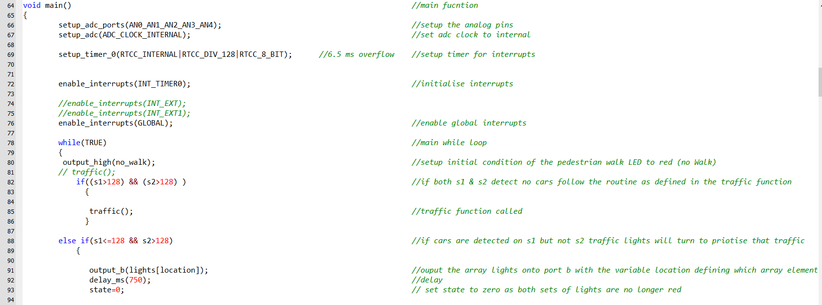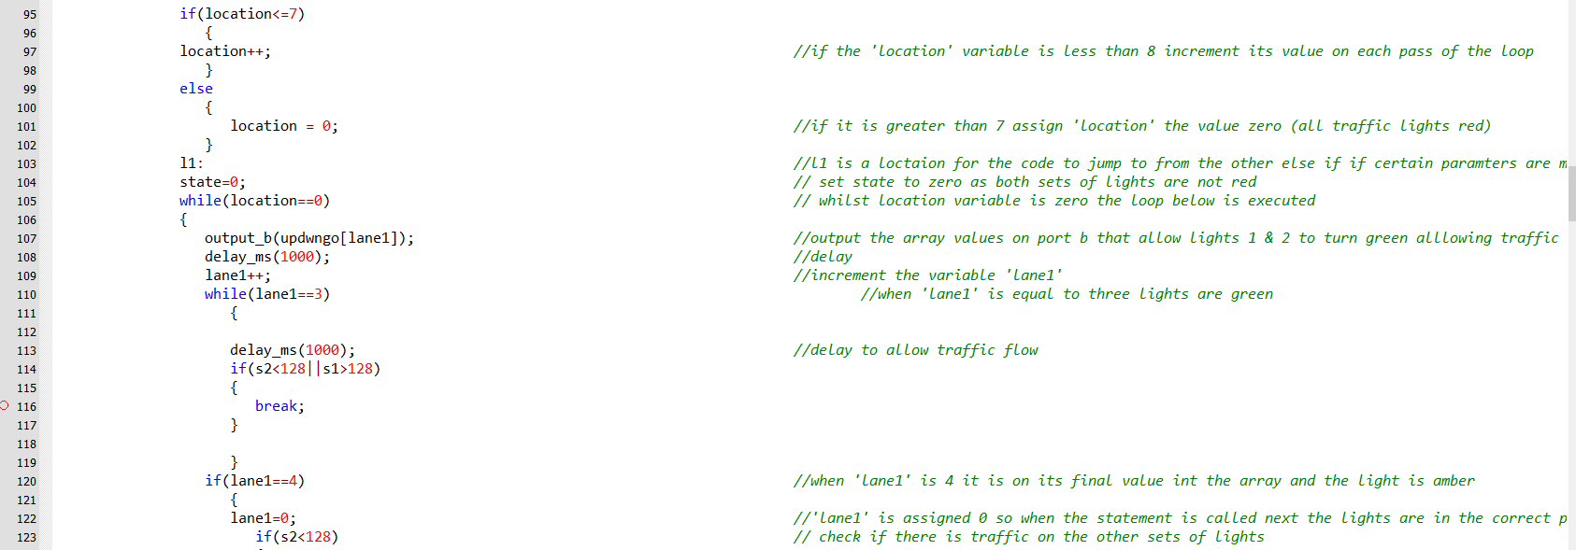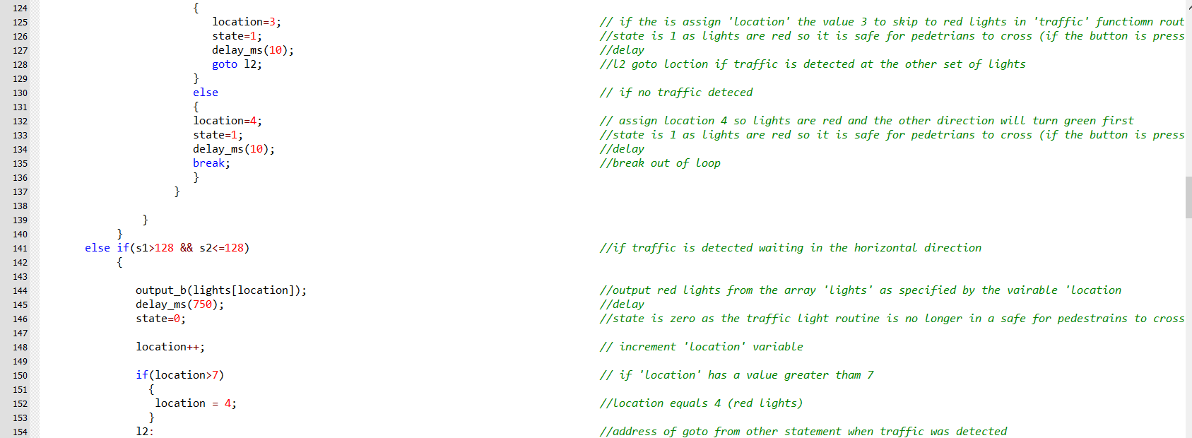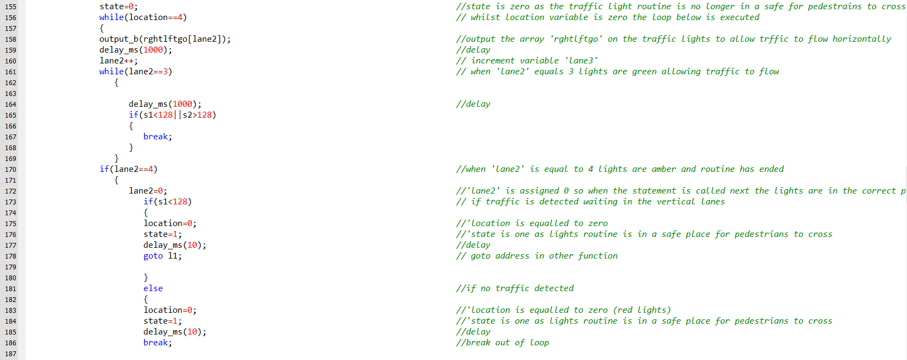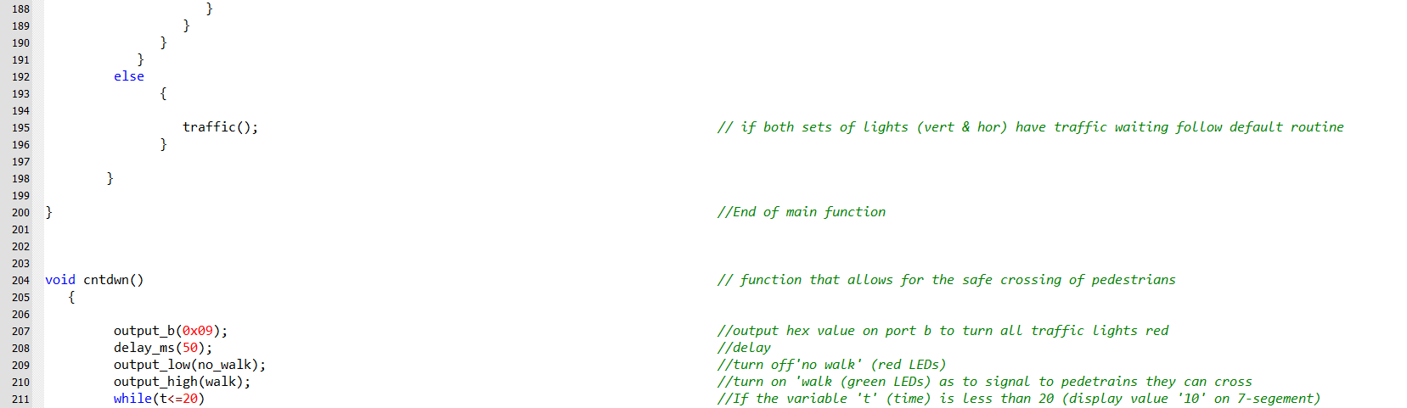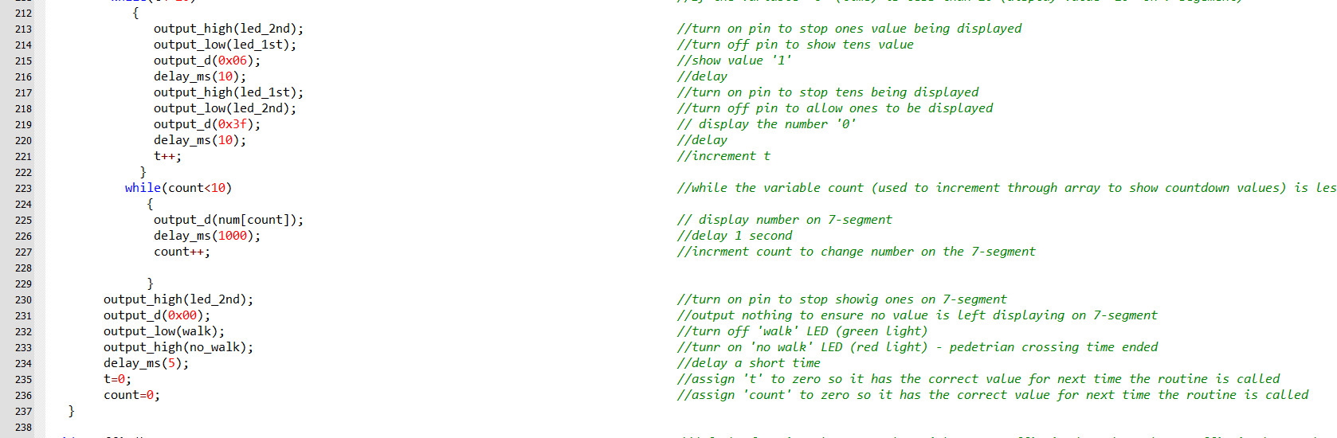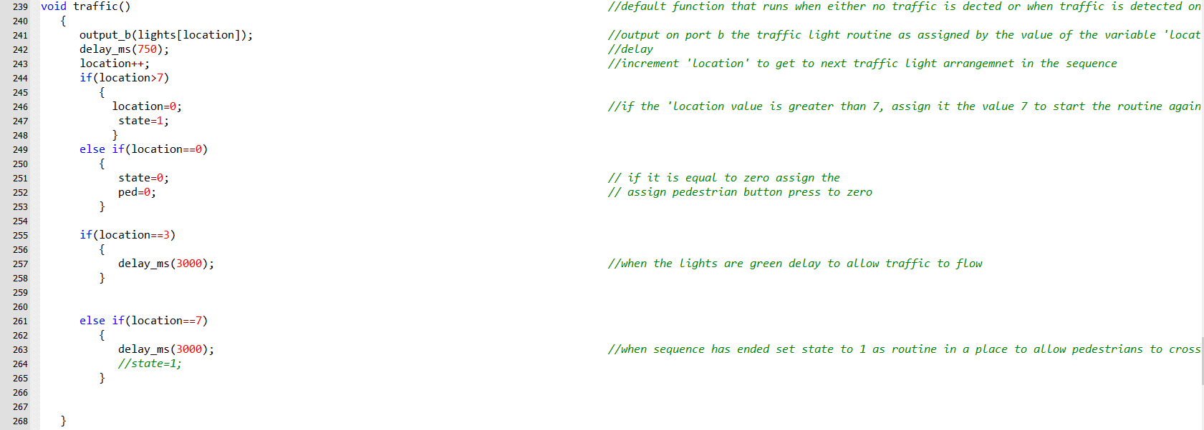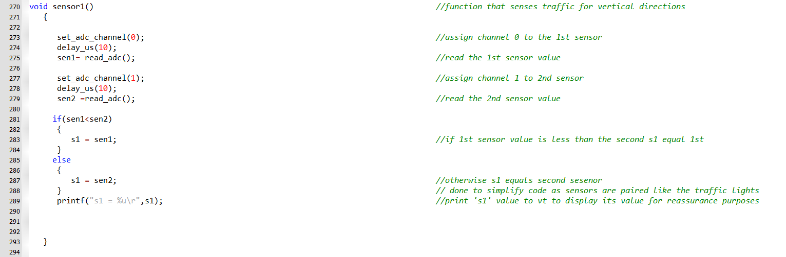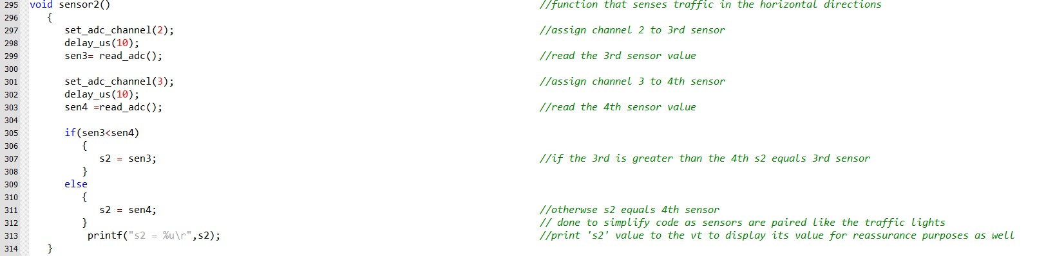
Note there should be 8 7-segments however, there are only 7 as a I could not fit all in.

