

DISSERTATION

SUBMITTED AS PART OF REQUIREMENTS TOWARDS THE AWARDS OF:

MASTER OF SCIENCE IN LOGISTICS

DATED: MAY 2019

NAME: RICHARD DANSO

STUDENT NUMBER: P120255

Appendix 1: DECLARATION

I, Richard Danso declare that I am the sole author of this study; that all references cited have been consulted; that I have conducted all work of which this is a record, and that the finished work lies within the prescribed word limits.
This has not previously been accepted as part of any other submission.

Signed: .......................................................................

Date: ...........................................................................

Appendix 2: FORM OF CONSENT
I, Richard Danso hereby consent that my study, submitted in candidature for the Master of Science in Logistics if successful, may be made available for inter-library loan or photocopying (subject to the law of copyright) and that the title and abstract may be made available to outside organisations.

Signed: ............................................................................

Date: ................................................................................

TITLE:

“Change Management: A Change is Best Optimised When the Change Management Process is Effective”

A Review of the Implementation of Management of the Joint Deployed Inventory (MJDI) in Army Supply Chain

ABSTRACT
For any organisation to experience growth, change is inevitable. The change can either be a minor or major change; however, regardless of how big or small the change is, it is very important to get the change management processes right to reduce the quantum of burden involved in the change (Drucker, 1999). Organisations must always recognise that human nature will always finds it very difficult to switch or change once they become comfortable and used to existing processes (Reiss, M. (2012). Resistance to change can be very painful for any change process and are liable to delay and financial loss (Harvey & Broyles, 2010). This project looks at how the change management processes affected the embracement of the implementation of the Management of Joint Deployed Inventory (MJDI) across the Army.

This project reviews various literatures including; AKDAR theory of change, Kurt Lewin Change Management Model and Kubler- Ross Roller Coaster Change (Grief Cycle). Following the literature review, the project uses survey questionnaire to gather data from existing MJDI users who have experienced MJDI implementation roll out. The information gathered was then analysed to draw conclusions. The data was analysed using EXCEL and SPSS Chi-square Test to test the hypothesis below:
The Null Hypothesis to be tested by this project is:
Hₒ: The MJDI implementation (roll out) could not have been best optimised with effective change management process.
The Alternate Hypothesis to be tested by this project is:
Hₒₐ: The MJDI implementation (roll out) could have been best optimised with effective change management processes.

In the Recommendation, the project proposed that before any change is implemented; there must be a clearly defined reason why change must take place. It also highlights the important for a pilot project before any major change in order to identify any problems that may arise to draw remedies and contingency plans to combat such problems. Finally, although certain problems may be hidden and inevitable, it is recommended to use a feedback approach to measure performance during and after any change implementation.
TABLE OF CONTENTS
Serial | Content | Page (s)
 | Declaration | 1
 | Consent | 2
 | Title | 3
 | Abstract | 4
 | Content | 5
 | List of Tables, Figures and Appendixes | 6
1.0 | Introduction | 7
1.1 | Background | 7
1.2 | What is MJDI? | 8
1.3 | The Change | 9
1.4 | After the Change | 10
1.5 | Aim | 11
1.6 | Research Hypothesis | 11
1.7 | Research Objective | 12
1.8 | Methodology Approach | 13
1.9 | Study Benefit | 12
1.10 | Research Structure | 13-14
2.0 | Literature Review | 15
2.1 | Introduction | 15
2.2 | Kurt Lewin Change Management Model | 15
2.2.1 | Unfreeze | 15
2.2.2 | The Change (Transition) | 16
2.2.3 | Freezing (Refreezing) | 15
2.3 | ADKAR Model | 16
2.3.1 | Awareness of the Need for a Change | 17
2.3.2 | Desire to Participate in and Support the Change | 17
2.3.3 | Knowledge on How to Change | 17
2.3.4 | Ability to Implement Required Skills and Behaviour | 18
2.3.5 | Reinforcement to Sustain the Change | 18
2.4 | Kubler- Ross Roller Coaster Change (Grief Cycle) | 18-19
2.5 | Beckhard Change Equation | 20-22
2.6 | Why Is Effective Change Management Important? | 23
2.7 | Project Management Relation to Change | 24-25
2.8 | Project Management Processes | 25-27
3.0 | Methodology | 28
3.1 | Introduction | 28
3.2 | The Research Approach | 29-30
3.3 | Data Collection | 31-33
3.4 | Questionnaire Design | 34
3.5 | Pilot Study | 34-35
4.0 | Analysis | 36
4.1 | Introduction | 36
4.2 | Excel Analysis (Percentages) | 37-46
4.3 | SPSS Analysis | 47-61
5.0 | Summary and Recommendation | 62
5.1 | Summary | 59-66
5.2 | Conclusion | 67-68
5.3 | Recommendation | 69-70
 | References | 71-73
 | Appendices | 74-76
LIST OF TABLES
Table No. | Description | Page (s)
Table 2.1 | The ADKAR model of change management | 17
Table 2.2 | Effective and Non-Effective Change management results | 23
Table 3.1 | Targeted population for research | 32
Table 4.1 | Statistics of Age Group of users surveyed | 38
Table 4.2 | Statistics of Trade Experience of the surveyed population | 39
Table 4.3 | Statistics of systems previously used by users before changeover | 40
Table 4.4 | Statistics of duration with previous systems | 41
Table 4.5 | Statistics of the level of adequacy of training received | 41
Table 4.6 | Statistics showing how long users got informed | 42
Table 4.7 | Statistics of multiple question 7A to 7H | 43
Table 4.8 | Statistics of user who agree or disagree transition was well managed | 43
Table 4.9 | Statistics on whether the MJDI roll out was a burden or not. | 44
Table 4.10 | Statistics of age rank range of the population surveyed. | 45
Table 4.11 | Statistics of current MJDI competency of users. | 45

LIST OF FIGURES

Figure No. | Description | Page (s)
Figure 2.1 | Lewin’s Change Model | 15
Figure 2.2 | The Roller Coaster of Change | 18
Figure 2.3 | Beckhard’s Change Equation | 20
Figure 3.1 | Methodology Diagram | 29

CHAPTER ONE

INTRODUCTION
1.1 BACKGROUND
Implementing change in an organisation can be very challenging and frustrating especially if not managed effectively. (Drucker, 1999). For an organisation to be dynamic and optimal; change is inevitable and, in some cases, un-avoidable. However, implementing unnecessary change can be more painful and the financial loss can be relatively high. According to Drucker, the change process within an organisation can be implemented at different pace based on the degree or necessity for change.

Irrespective of the degree or necessity for change, it is very imperative to have a good change management process in place to reduce the “burden” already involved in change. Pressure and criticism on organisations due to poor performance can cause a panic implementation of change which could rather cause more problems if good thoughts and management procedures are not put in place. (Cameron and Green, 2009)

After the end of Operation GRANBY (First Gulf War) in 1991 (Tucker, 2010), there was a lot of critics on how the Ministry of Defence (MOD) handled the flow of inventory in and out of theatre (Iraq). It was highlighted that a lot of consignment were either missing in transit or in theatre, which affected Regimental and Operational capability due to the lack of materiel expected in certain areas of operations and the lack of visibility of goods. Following on, the MOD did not learn a lesson from this short fall but repeated the same incident during Operation Telic in 2003 (Second Gulf War), (Ripley, 2016). This time around, there were large number of repetitive ordering of the same goods, excessive orders quantities and overstocking due to the lack of confidence in the Supply Chain and the inability to gain visibility of goods in transit.

Recommendations from a Public account select committee suggested that the MOD supply chain had to be globalised. (Selected committee on Public Accounts Thirty-Ninth Report, 2004). As result of the increase pressure and the public’s increasing interest in how the MoD handle taxpayers’ money, the MOD started investing in various Information Technology (IT) systems to enhance visibility, control, maintain and manage equipment within the MOD, in peace and operational area. Some of the systems adapted include Management of Materiel in Transit (MMit), Visibility in Transit Asset Logging (VITAL), Management of the Joint Deployed Inventory (MJDI) and Joint Asset Management and Engineering Solutions (JAMES). This project limits its study on MJDI, focusing on the implementation and change management processes.

1.2 WHAT IS MJDI?
MJDI is the future military logistics Information System (IS) acquired by MOD to replace the Tri-Service (Army, Airforce and Navy) current divergent logistics systems. The MOD saw MJDI as a single IS capability which will significantly improve Supply Chain Management, visibility and accounting for materiel utilising common operating procedures. This means that MJDI will address the core issues of visibility, excessive stockholding, poor forecasting, which will then reduce bottlenecks and provide cost and process optimisation. This capability delivery was contracted to a company called Sopra Steria, whilst Defence Equipment Support (DES) and the MJDI Project team (selected from the Tri-Services) coordinates the management and implementation of the new capability. (Sopra Steria, 2006).

The pilot phase of the rollout was started with 90 static and deployed aviation units within the MOD and was completed by December 2007. This was aimed at controlling over 2,400 stockholding sites and in excess of 62,000 individual accounts for in-use equipment. The pilot continued for over 4 years within Airforce and Navy before it was finally rolled out to the Army in May 2011. It was anticipated that the MJDI IS will have over 18,000 users by the time it will be fully implemented across the Tri-Service, which will constitute circa 8000 Army users. Just like any good project or programme, a clear mission statement was issued for the implementation of MJDI. (Sopra Steria, 2006).
The mission statement for MJDI was clearly stated as:
“Management of the Joint Inventory IS will give the MOD a firmer and sustainable control over its supply chain which will result in an optimised logistics footprint, improved visibility by operational commanders and will contribute to increased effectiveness and efficiency in the end-to-end supply chain”. (DE&S, 2006)
The main objective behind this mission was that the MOD will use a centralised single tool to manage, forecast and plan the flow of inventory across the Tri-Service, by eliminating bad processes and transaction. However, after many years of the implementation of MJDI, it is vivid that the bottlenecks identified before the roll-out still exist. A lot of this has been blamed on the way the implementation was carried out. This situation has been concluded by many critics that a failure to the mission of the MJDI implementation. This project will review how the roll-out was carried out within the Army environment as part of the Tri-Service roll-out.

1.3 THE CHANGE
Part of the key drivers for the introduction MJDI as an effective Enterprise Resource Planning (ERP) tool was the frustration as a result of pressure and scrutiny from the National Audit Office (NAO). MJDI as an ERP system was acquired to alleviate bottlenecks due to existing systems such as Global, UNICOM and USAS which were highly stove pipe concept. In that regards, the MOD saw the need to integrate an ERP which will link the Tri-Service supply chain network together for wider optimisation and improve through life support of equipment capability. (DE&S, 2006).

One of the key changes MJDI brought to the MOD is the Management Information System (MIS) repository, which is available for inventory managers to exploit for supply chain optimisation. The MIS repository is an ORACLE base application called ORACLE Discoverer (OD). The MJDI OD can be used to extract data from unit MJDI accounts for further analysis to inform management decisions.
OD provides an integrated business intelligence solution that comprises intuitive ad-hoc query, reporting, analysis, and Web-publishing functionality. These tools enable non-technical users to gain immediate access to information from data marts, data warehouses, multidimensional data sources, and online transaction processing systems. Discoverer integrates seamlessly with Oracle Portal, Oracle WebCenter Portal, and Oracle WebLogic Portal enabling rapid deployment of Discoverer workbooks and worksheets to Web portals. (ORACLE, 2012).

In the long-term, this change was intended to optimise MOD inventory across the armed forces by providing:
- Asset availability on the first, second and third line
- In use, in transit and in repair materiel
- Improve supply chain performance, with the ability to realise financial benefits through:
- Enhance provisioning system for Land managed items at unit level which operates on a “pull” basis for replenishment from the base inventory system.
- Reduced equipment loss.
- Reduce transport and operating costs.
- Faster repair loop times.
- Reduced Logistics support requirement in theatre (operations).

1.4 AFTER THE CHANGE
MJDI has been implemented in the Airforce since December 2007 and subsequently in the Army in May 2011. After nearly 8 years of MJDI roll-out to the Army, there are still negative comments and bottlenecks within the Army supply chain. This has also been seen in logistics inspection reports. These negative comments and reports have been attributed to the way the MJDI was rolled out.

In 2013, MOD suspended a £92.5m investment plan to implement new Base Inventory Warehouse Management systems (BIWMS) in order to re-assess the needs of its users and also saw the need to review the investment already made on MJDI. BIWMS was intended to replace legacy systems used to oversee the MOD supply and support chain as part of a move away from siloed systems to improve pan-ministerial system interoperability. (MOD, 2013).

According to a National Audit Office (NAO) report of the MoD’s 2013 to 2014 accounts, the ministry already rolled out a deployed warehouse management system across a "significant proportion" of deployed units to improve the visibility of its inventory holdings. However, implementation of BIWMS has been suspended pending a review of user requirements. According to the audit report, the project was to be a significant part of MoD efforts to enhance its inventory management.
The NAO’s findings did note "significant improvement" in the last few years over how the ministry managed its inventory. Nonetheless, the auditor concluded there remained ongoing challenges to ensure better management and accounting of UK defence assets. (MOD, 2013).

1.5 AIM
The aim of this project is to analyse and review the implementation of MJDI across the Army. The project will further investigate how the change management process affected the effectiveness of the roll-out of MJDI:
a. Evaluating whether effective change management can influence the effectiveness of a change process (Kneer, 2006).

1.6 RESEARCH HYPOTHESIS

The Null Hypothesis to be tested by this research is:
Hₒ: The MJDI implementation (roll-out) could not have been optimised with effective change management process.

The Alternate Hypothesis to be tested by this research is:
Hₒₐ: The MJDI implementation (roll-out) could have been optimised with effective change management processes.

1.7 RESEARCH OBJECTIVES
A project objective underpins the rationale behind any study, which means that the objective drives the hypothesis of the project. It is very important for any project object to apply to the concept of SMART model. It means that the objectives must be; Specific, Measurable, Achievable, Realistic and Timebound. (Scott, 2014). The following objective underpins this project:
- To find out if the Management of Joint Deployed Inventory (MJDI) implementation as an ERP system was well managed; with regards the change management process.
- To establish findings and use the results; in line with the literature review to suggest holistic recommendations for any future MOD implementations.
- To provide a documented change process guide to optimise the cost and efficiency of future implementations across the MOD.

1.8 METHODLOGY APPROACH
The project gathered data by utilising questionnaire to target MJDI users who were affected by change. The qualitative data collected was then converted into quantitative measurable data for comprehensive analysis to test user behaviours, performance measurement and feedback against the change management processes. Part of the analysis will also measure the effect of the implementation of MJDI by performance metric.

1.9 STUDY BENEFITS
This paper gathers real data from MJDI users for analysis and therefore information gained will be very useful for immediate, medium and long-term exploitation by the MOD for future optimisation projects. This research will not just help tackle issues related to MJDI implementation but will serve as an effective reference point for any future change process within the MOD and civilian establishments to facilitate any minor or major implementation.

1.10 RESEARCH STRUCTURE
The rest of the project outline is stipulated below:
Literature Review
The following topics are discussed;
- Kurt Lewin’s- Change management model
- ADKAR- Change model
- Kubler Ross - Change roller coaster
- Kotter- 8 Guiding Principles for Change management
- Beckhard- The change equation

The aim of this chapter is to provide an in-depth knowledge of the subject for discussion and analysis. The Literature Review will also highlight how important an effective change management can help to reduce pain and risk involved in an organisational change.

Methodology
This discusses the methodology approach, especially the data collection process and method for the project will be presented. This is to enhance the readers’ understanding of the hypothesis of this project and how best to present recommendations without making the error of concluding with an opinion but conclusive on holistic evidence base.
Research Questions
The research questions for the project are influenced by previous and current reports about MJDI implementation and also the literature review which encompasses the practicality of change management. Therefore, the initial research questions which will be expanded further are as follows:

RQ1: Was there awareness of the need for change?
- What was the duration of awareness before the change?
- How was the change communicated to users?

RQ2: Was there a desire to support and participate in the change?
- Did users have the desire to change their existing process?
- Were people ready to support the change?

RQ3: Did people have enough knowledge required for change?
- What was the level of education given to users about the change?
- How useful was the information given for the change process?

RQ4: What was the level of ability to implement the change?
- How prepared were the units for the change? (including required resources and infrastructure)

RQ5: Was there any provision for reinforcement to sustain the change?
- Was there any support during the transition period and after the change?

Analysis
This chapter presents and describes the analysis of the data collected. Discussions are presented by comparing the results (see Chapter 4 – Analysis) to informed academic theories. The analysis chapter also shows the statistical approach for the research.

Conclusion
This chapter presents a summary of the findings discussed in the analysis. The chapter also focuses on answering the questions raised by the hypothesis and recommendation based on the results attained at the end of the analysis.
It further presents a critique of the approach and method used for the research, including any problems that were discovered and how the problems were overcome. Finally, a comprehensive recommendation for future implementations and further work in this area of study were presented.

CHAPTER TWO
LITERATURE REVIEW
2.1 INTRODUCTION
Kotter (1997) defines change management as how one takes an organisation from position A to B by applying a set of guiding principles, in fulfilment or implementation of a vision. This chapter looks at the various theories of change management and how effectively they can be applied. Theories discussed in this paper include:
- Kurt Lewin’s- Change management model
- ADKAR- Change model
- Kubler Ross - Change roller coaster
- Kotter- 8 Guiding Principles for Change management
- Beckhard- The change equation

2.2 KURT LEWINS CHANGE MANAGEMENT MODEL
Lewin’s (1943) model also cited by Green (2007), is more interested in the effect of change on personalities involved in any change within an organisation. Lewin grouped the stages of change management into stages termed as Unfreeze, Change and Freeze. The model is illustrated in figure 2.1 below:

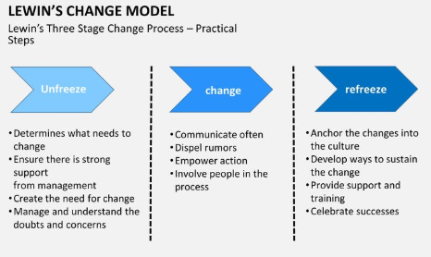
Figure 2.1 – Lewin’s Change Model (Lewin K, 1943)
2.2.1 UNFREEZE
The unfreeze stage of Lewin’s model is the process of making people aware of the need for change. It involves making people understand the reason, how and what could be achieved at the end of the change. The vision and process must be laid out clearly and good enough to motivate people involved in the change process. The more people are motivated the easier the implementation.
This process also involves weighing the advantages and a disadvantage of the outcome of the change. This could be achieved using methods such as SWOT analysis. SWOT analysis is a study undertaken by an organisation or individual to measure its internal strength and weakness as well as its external opportunities and threats (Fine, 2009). Lewin defined this stage as the of weighing of pros and cons in his model; Force Field analysis. The pros and cons are weighed to determine if there is need for change. This first stage is where a department or the whole organisation is moved towards motivation for a better change. (Cummings et al, 2016)

2.2.2 THE CHANGE (TRANSITION)
The second stage in Lewin’s model is the actual change process. In fact, he called this stage the transition. This means he considered this stage more of a process rather than an event. During this stage, people start moving towards new way of doing things. It is said to be the hardest stage of change management as people do not know what to expect and are unaware of what is at the end of the tunnel. There are obviously new things to learn during this stage and more time will be spent on coaching and mentoring with an expectation of mistakes which cannot be avoided. A successful change could be achieved if management consider this stage very important and manage it properly.

2.2.3 FREEZING (REFRREEZING)
The freezing stage of Lewin’s model comes into play once the change or transition is in process and people are adjusting to the new way of doing things or familiarise with new equipment and processes. This stage is more to do with stabilizing the change. It is very important to make sure people are used to the change and the change is helping to achieve the aims and objectives of the organisation.
It is also very important to find out how the change is helping the organisation through feedbacks and performance measurement. According to Lewin, if a stable and comfort change is not achieved, it is always easy for people to go back to the former ways of doing things, against the organisation’s intentions.

2.3 ADKAR MODEL
The ADKAR model is a modern change management tool compared to Lewin’s model. This is seen as a practical approach to effective change management for individuals and organisations. This model was built on a practical approach by conducting research in more than 900 organisations. First published by Prosci in 1998, Haitt (2006) threw more light on ADKAR model, highlighting the fact that a successful change would be achieved if each person in the organisation fully understands why and how to transform into the new or proposed era. The model is outlined in Table 2.1 below:
A | Awareness of the need for change
D | Desire to support and participate in the change
K | Knowledge of how to change
A | Ability to implement the change
R | Reinforcement to sustain the change
Table 2.1: The ADKAR model of change management

The ADKAR model consists of five sequential steps for actions:
2.3.1 AWARENESS OF THE NEED FOR A CHANGE
It is very important that, individuals are aware and do understand why the need for change within an organisation. Clear and concise communication is very important at this point and will help individuals fully understand why change is necessary.

2.3.2 DESIRE TO PARTICIPATE IN AND SUPPORT THE CHANGE
The desire for people to participate in and support change is achieved after individuals have fully been briefed and have understood the need for change.
It is usually achieved by letting people know the benefits and incentives involved in a change process. Motivation is very key in this process because people are usually comfortable with existing processes and can only be inspired by higher and promising outcomes to fully embrace change.

2.3.3 KNOWLEDGE ON HOW TO CHANGE
This stage is very important but can only be achieved through good management of change. Many changes within organisations failed due to top managers themselves having little or no knowledge of how a change will be carried out. In some cases, a plan is designed on paper, but the practical demonstration and the technical knowhow is lacking during the implementation. The process of achieving this stage successfully can be achieved through; training, coaching, forums, seminars, mentoring and modern methods including videos, computer-based training (CBT) and interactive or other simulations.

2.3.4 ABILITY TO IMPLEMENT REQUIRED SKILLS AND BEHAVOUIR
Once a theoretical approach or briefing has been implemented, one needs to practice for perfection. Although theoretical approach is good, one cannot eliminate the practical approach and continues rehearsals where possible to build confidence during the change process especially during the early stages. After confidence has been installed, individuals within the organisation will develop a strong will to demonstrate the new ways of doing things.

2.3.5 REINFORCEMENT TO SUSTAIN THE CHANGE
This final stage of ADKAR model is aimed at sustaining the change that has been implemented. This stage employs processes to ensure the change is stable and effective. The process is also aimed at making sure people do not revert to the former way of doing things. This could be achieved through feedbacks, rewards, recognition, performance measurement, responding to feedback and constructive criticism.

2.4 KUBLER- ROSS ROLLER COASTER CHANGE (GRIEF CYCLE)
Kubler-Ross (2005) was known as the mother of hospice as result of her seminal work on the grief process when people are faced with change. Although Kubler-Ross’s study is considered as a very old concept, majority of businesses in recent times have realised that people go through similar responses when faced with changes in their working and personal lives. The Kubler-Ross’ study identified five stages of responses that people go through during a change as follows:

2.4.1 THE DENIAL: This stage is the early stages of change where people are uncertain whether the change is real. At this stage people seems not to believe what is going on and the feeling is more like a dream.

2.4.2 ANGER: At this point, people have realised that what is going on is real and can no longer deny the change causing grief and anger. Most people feel uncomfortable at this stage and wish it was a dream.

2.4.3 BARGAINING: This stage is where people hoped that they can somehow postpone or delay the inevitable. At this stage there is the realisation that, this change is coming to stay and must therefore be embraced.

2.4.4 DEPRESSION: During this fourth stage, the person begins to understand the certainty of what is going to happen. However, people do not see the point of the change.

2.4.5 ACCEPTANCE: This final stage is where people begin to accept the change in peace and start embracing with the hope that things are going to be better. There will still be some existences of doubt at this stage, but the future relies on hope. The major significance of this model is that; it maps the emotional responses that people are likely to experience if or when a major step-change is announced and especially if this is likely to contain bad news. Figure 2.2 (The Roller Coaster of Change) below shows the process involved when a change is announced versus the time (present and future) up until the realistic expectations:
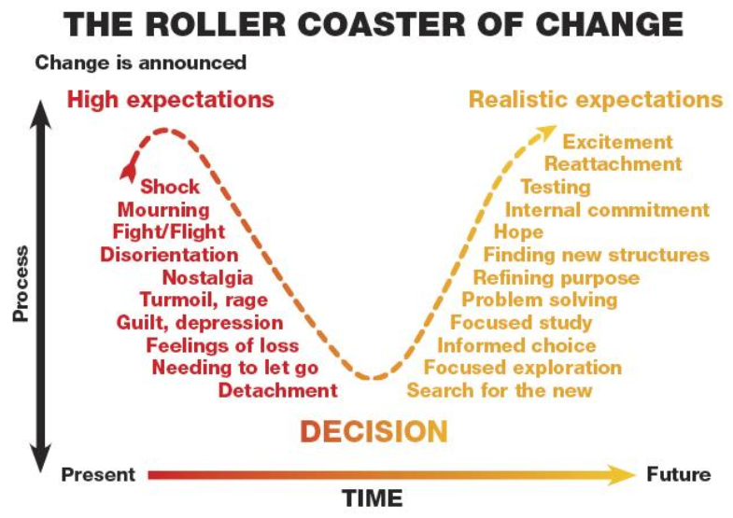
Figure 2.2 (The Roller Coaster of Change) - Elizabeth Kubler-Ross (1975)

More often, the experiences outlined in the roller coaster are ignored by planners and managers when implementing change or transition process within an organisation. From Kubler-Ross’s reasoning, major underlying cause of the 70% failure rate of all major change initiatives is attributed to the impact on the people involved in the change.

2.5 BECKHARD CHANGE EQUATION
The Beckhard change equation is a backbone of an organisational development in the sense that; the model takes into consideration the role and importance of employee involvement in change. The key approach to this model is that; there are more concentration on the role and responses of the people involved rather than the command and control of the senior management. Beckhard (1987), created an organisational framework that has been employed for organisational development especially in major or large changes. This generic framework for change comes in four main parts:

2. 5.1 DETERMAIING THE NEED FOR CHANGE: At this stage, people must understand why the need for change. There should be a firm justification why it is unacceptable and undesirable to conduct business in the same way or why they should switch from existing processes. If the people are not dissatisfied with the current processes and management cannot justify why they need changing, then there is no motivation to change.

2.5.2 ARTICULATING A DESIRED FUTURE: The worst thing to do is to effect a change in an organisation where the people involved do not know or understand where they stand within the change. This stage looks at ensuring that employees fully understand and can picture their future as part of a changed organisation and can see their place in the new organisation.

2.5.3 ASSESSING THE PRESENT AND WHAT NEEDS TO BE CHANGED IN ORDER TO MOVE TO THE DESIRED FUTURE: At this stage, all employees are fully aware of what they need to know or do to prepare themselves for the change and what steps they require to take in order for the change to be successful.

2.5.4 GETTING TO THE DESIRED FUTURE BY MANAGING THE TRANSITION:
At this stage, the change is already in place and people are getting used to the new procedures. However, to sustain the change, a good management process must be installed. The engagement of external specialist and appropriate process is very helpful. Although Beckhard Change model is one of the simplest, it is very powerful in the sense that it tackles all the major issues involved when planning a change. More importantly, the model takes into consideration the role of all employees within the team affected by the change.

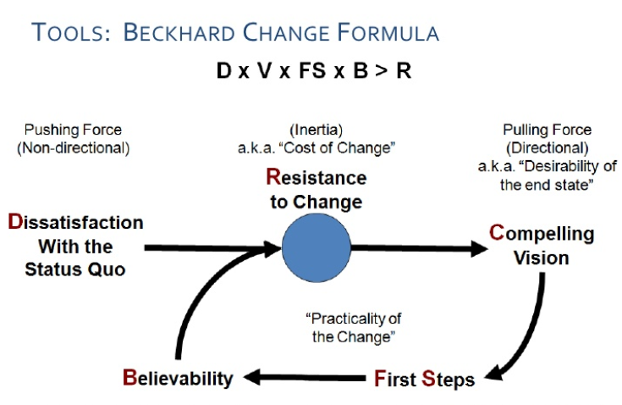
Figure 2.3 (Beckhard’s Change Equation) - Beckhard (1987)

Figure 2.2 above explains Beckhard’s Equation as: VxDxFSxB>R. The key message from Backhard change equation is that; for change to work properly D, V, B and FS must be greater than R.
Where:
D: Dissatisfaction with the status quo
V: Vision of what is possible
F: First, Concrete steps that can be taken towards the vision
R: Resistance (If any of these factors are missing or weak, then you are going to get resistance)
The model has two very practical applications:
- Before the change: When planning a major change, planning or project team must make sure all the first three elements are built into their plans.
- During the change: This is use by managers as a trouble-shooting tool for figuring out why people are resisting the change.

2.6 WHY IS EFFECTIVE CHANGE MANAGEMENT IMPORTANT?
Table 2.2 below; outlines some of the most common implications of effective and ineffective change management. These come from study participants, client experiences and input from hundreds of training participants conducted by Change Management Learning Centre at The United States of America in 2007:
What can happen if change is NOT managed? | What can happen if change is EFFECTIVELY managed?
- Productivity declines as people become more consumed with the change being introduced.  - Passive resistance festers.  - Active resistance emerges and sabotages the change.  - Valued employees leave the organization, a very costly proposition in terms of the lost contribution and the cost to replace them.  - Employees become disinterested in the current state and the future state.  - Employees begin arguing about change and the direction of the company.  - People are left to wonder why the change is happening.  - More people begin taking sick days or not showing up for work.  - People find work-around to avoid implementing the new way of doing things.  - Employees revert to the old way of doing things.  - Changes are not fully implemented.  - Changes are scrapped and cancelled due to the lack of support throughout the organization.  - Divides are created in the organization between 'us' and 'them'.  - The organization builds a history of failed and painful changes.  - Many types of risk are created - risk to the project, to the organization, to the employees involved and to the individuals supporting or chartering the change. | - Employees have a solid understanding of why change is happening.  - Employees engage in both the solution and the change.  - Training is used to build knowledge after employees have made the personal decision to support the change.  - Resistance is identified and dealt with early in the process.  - Senior leaders demonstrate their own and the organization's commitment to the change.  - Communications are segmented and customized for different audiences, answering the questions that they care about.  - Momentum is built throughout different areas and levels within the organization.  - Changes are less painful to the organization and to the employees.  - A coalition of support among senior leaders and managers creates momentum throughout the organization.  - Probability of meeting project objectives is increased.  - The organization begins to build a history of successful change, creating a better 'backdrop' for the next change initiative.
Table 2.2 (Effective and Non-Effective Change management results): www.changemanagemet.com (2007)
2.7 PROJECT MANAGEMENT RELATION TO CHANGE
2.7.1 PROJECT
This part of the chapter looks at project management as part change management and how it can influence a change. According to Graham (1993), a project is a set of people and other resources, temporarily assembled to reach a specific objective, normally with a budget and a fixed period. A project is unique venture with beginning and an end, conducted by people to meet established goals within parameters of cost, schedule and quality. Boddy & Buchanan (1992)

The key words used by Graham and Buchanan were cost, time and quality. Whenever time, cost and quality are mentioned, there are always factors that can hinder against such targets. Any project taken on by a team has a potential risk involved. To manage and control any risk associated with a project, a good project management tool or technique is very imperative.

2.7.2 PROJECT MANAGEMENT
Project management is the planning, co-ordination and control of project from conception to completion (including commissioning) on behalf of a client requiring the identification of the client’s objectives in terms of utility, function, quality, time and cost and the establishment of relationships between resources, integrating, monitoring, and controlling the contributors to the project and their output, evaluating and selecting alternatives in pursuit of the client’s satisfaction with the project outcome. (Walker ,2002).

2.7.3 ELEMENTS OF CHAGE MANAGEMENT
According to Walker any project consists of the following elements:
- Objective – Every project has a definable and measurable result, which is defined in terms of final purpose, cost, quality and timing of delivery. This simply means the project has a start point and a desirable or expected end or state.
- Complexity – This arises as many different tasks are required to be achieved in a project and the relationship between these must be understood. The task involved determines the rate of complexity.

- Constraints – Each project has a definable measurable end. The measurable limit could be cost, size, time and many more.
- Uniqueness – A project is usually a one-off, produced to the requirement of a specific customer or for our own organisation. Developing a project for your own organisation make your organisation the customer. The project type and specification could be a repetition of an existing project.
- Uncertainty – While projects are planned, there is inevitably element of risk that can affect objectives to be achieved or not. There are various factors that can affect the objectives of a project both positively and negatively. Impact of factors such as political, weather, environmental, technological constraints can cause uncertainty during a project cycle.
- Temporary Nature – Projects have a defined beginning and end, so the resources allocated to a particular project are allocated on a temporary basis for completion and management of the project. However, certain project resources may be carried across operations management after the project is commissioned.
- Life cycle – Projects are planned to follow a predicted path. The control of projects requires that it is necessary to divide up the life cycle of a project into phases.

2.8 PROJECT MANAGEMENT PROCESS
According to the Project Management Institute (2008), project management is the application of knowledge, skills, tools and techniques to project activities to meet the project requirement. Project Management Institute (2008) explains that; Project Management is accomplished through the application and integration of the project management process which includes initiating, planning, executing, monitoring, controlling and closing.

2.8.1 INITIATING
Initiating is the formal start of a project and will usually be triggered by the issue of a Project Mandate which briefly describes the purpose of the project and gives authority to spend money on initiating the project. The initiation stage is where work is carried out to assess what needs to be done and how best to do it with whatever resources available.
2.8.2 PLANNING
After the high-level planning has been done during initiation, a more detailed phase of planning and development usually occurs. The result should be a clear specification for what needs to be done, who by, and when. The main focus should be on ensuring that time, cost and resources are sensibly managed, available and committed to the project. This enables to create a project plan and schedule, which are key stages of the process.
Risk and resources for resolving unforeseen issues, as well as progress checkpoints, should also be factored into the plan at this stage. Once this has been done, management can start spending the main part of the project budget. You should gain formal approval to begin the work, if necessary, now that a better idea of how much it will all cost is known. (Project Management Institute, 2008)

2.8.3 EXECUTING
The production and implementation stage are when the project plan is put into action by implementing the processes outlined in the previous stages. At this point any deliverables are produced (where applicable) as defined by the project plan. For example, if the project is to produce a new promotional pack for a trade show, early deliverables might be to complete all your product photography and gather product information and prices. At this stage, it is important to ensure that the project remains focused on its objectives and that any factors which could affect the execution of the project are closely monitored.

2.8.4 MONITORING AND CONTROL
Throughout the production and implementation stage the ongoing progress of the project must be monitored. Progress must be controlled and any issues which arise because of the day-to-day work must be dealt with. Project performance should be regularly observed and measured against the predicted expectations of the project plan and any quality measurement mechanisms in place.

2.8.5 CLOSING
Closing is the last phase of any project and is when the work done is formally accepted and the project is dissolved. Closure does not necessarily mean success, but simply the final point of the project. Even when failed projects are cancelled, for instance, they should also be closed. Commonly, closure involves the finalisation of all activities across the project and a switching over to business as usual if this applies. This should be accompanied by a project review or 'lessons learned' exercise and the archiving of any relevant project documents, which can be used to feed into and improve any future projects and plans. (Project Management Institute ,2008).

2.8.6 CONCLUSION:
Project management and change management process are usually incorporated although it usually not known by many. The following processes are mostly found in a project and change management process which clearly confirms how these two processes are identical:
- Identify requirements
- Establishing clear and achievable objectives
- Balancing the competing demands for quality, scope, time and cost.
- Adapting the specifications, plans, and approach to the different concerns and expectations of the various stakeholders.

For a change to be affectively managed, each stage of the process involved in the change must be considered as a project to be managed effectively for people to embrace. This includes managing people, resources, cost, etc. to achieve target.

CHAPTER THREE
RESEARCH METHODOLOGY
3.1 INTRODUCTION
This Chapter describes how the project was designed and the processes involved in achieving the aim of the research, indicating the step by step approach to this project. The chapter also highlights any problem encountered whilst preparing this project and how they were dealt with. At the initial stages, the plan was to undertake a case study approach or Delphi survey to answer the hypothesis. However, after a critical evaluation, it was determined that; a case study was not appropriate for the hypothesis been measured and although a Delphi survey was appropriate, it was far complex to get the data required from the stakeholders involved. The complexity of the Delphi survey was due the fact that; the experts involved were feeling reluctant to sit on the panel for personal reasons. Therefore, a primary research approach was used instead to increase efficiency and reduce unnecessary errors.

3.2 THE RESEARCH APPROACH
Data for any research project can be collected in various forms depending on suitable and availability of the data required. Data can either be in a primary or secondary; in a quantitative or qualitative format. (Treiman, 2009). The difference between primary and secondary data is that a primary data is collected directly by the researcher for a specific project whiles secondary data is data collected by a third party. The type of data that was collected for this project is a primary data (Thomas ,2009).
This project uses primary data gathered through a survey for holistic analysis to test the proposed hypothesis. The research paradigm adopted is a post-positivist which will require the development of hypothesis to statistically test the population results (Grix, 2004). The methodology used is shown in figure 4 below:

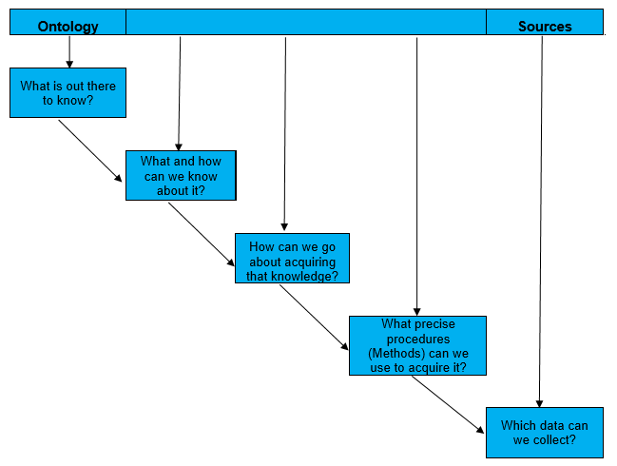
Figure 3.1: Methodology Diagram (Inspired by: Grix, 2004)

3.2.1 TYPES OF DATA
Primary data is data collected by the researcher from direct source using methods such as; direct observation, surveys, interviews, and information recorded from a specific activity (for example; how long it takes a group of people to complete a specific distance). Direct observations allow the researcher to focus on detailed information important to the researcher. Surveys also helps to gather considerable detailed data; however, the researcher will have to rely and trust the honesty and integrity of the population surveyed. Some of the remedies that some be utilised to reduce the risk of dishonesty is by building in self-verifying questions. Different answers may indicate the surveyed person is being inconsistent, dishonest or inattentive. Although self -verification questions are very useful, it can be time consuming and unattractive to the population if not considered carefully. Thomas (2009).
Interviews are also good source of gathering information for research but could be slow, expensive and they take people away from their regular jobs, but they allow in-depth questioning and follow-up questions. One of the key problems with interviews is that people might say what they think the interviewer wants to hear, they might avoid being honest, critical and meticulous, especially if their jobs or reputations are likely to be affected in the process.

Logs such as fault logs, error logs, complaint logs, and transaction logs, if used well are good objective data source. They can yield lots of valuable data about system performance over time under different conditions. Data collection can be difficult if the method of collection is poorly designed. A poorly designed questionnaire may well lead to the respondent becoming confused or annoyed and could result in unresponsiveness. A pilot study is very important element of good study design. However, conducting a pilot study does not necessarily guarantee success in the main study, but it does increase the chances of success. However, a pilot study must not use as the approach to identify errors but must be treated as the best and final approach with an expectation of minimum errors as possible. (Van Teijlingen and Hundley, 2001)

Secondary Data is collected from external source such as; television, radio, internet, magazines, newspapers, reviews, research articles, and stories told by people. There are more secondary data available than primary data and also cheaper to obtain compared to primary data. The problem with secondary data is that, reliability, accuracy and integrity of the data is uncertain. This project discusses how effective Change Management can help in a change process, specifically focused on how change was managed whilst Implementing MJDI.
The questions raised in the questionnaire were designed to find out how MJDI Users felt during implementation of MJDI with regards to Change Management.

3.3 DATA COLLECTION
Looking at the study at hand, the use of questionnaire was appropriate method as the data required was mainly opinions which was then converted from qualitative into quantitative data to support further analysis. Questionnaires are also relatively cheaper way of ensuring a large amount of information is gathered, and depending on the types of questions asked, statistical analysis can reveal correlations between demographics and other results.
Questionnaires can be distributed by various forms including; by post (normal mail or by hand), electronic email, online applications and by interviews. Posting either by mail or email was not considered because it was not suitable for the targeted population. Emails might also filter into junk mail folder and was therefore not considered. Considering the targeted population, who are mainly MJDI Users across a session of the Army. The method selected for questionnaire distribution was to travel with Ordnance Warrant Officers for the various formations during inspection within a selected Regiments within the Army and get as many MJDI users to fill out the questionnaires.

To ensure that people were available to complete the questionnaire, a calendar appointment was agreed with head of departments prior to the visit. This method was selected because it gives instant responses to the questionnaire. The method was practised few times to gain the average time it takes to complete the questionnaire. The average time achieved during the practise was ten minutes. It was very important to achieve the timing right in order to give responders the right time for completion to prevent any embarrassments and time wasting.

3.3.1 TARGETED POPULATION
When selecting a research population, one needs to be very careful because it can be very costly or in some case insufficient data may cause the research objective may be defeated. To survey all MJDI users within the MOD was unrealistic goal. Therefore, the size of the population was limited to ten main Regiments within selected Army units.

The criterion for selecting the Regiments is intended to cover all Divisions and Brigades across the Army. To ensure a fair and appropriate representation of population is covered the following units from various Divisions were selected. Table 3.1 below shows details of targeted units selected across different Divisions. The figure 820 was the initial rough estimate before using sample size calculator to determine the size based on 5% confidence interval. (Dattalo, 2008).

Division | Unit Name | Target Population
1 Division | 1 Regiment RLC | 60
1 Division | 6 Regiment RLC | 60
1 Division | 3 Regiment RLC | 60
1 Division | 4 Riffles Regiment | 20
1 Division | 2 YORKS Regiment | 20
3 Division | 4 Battalion REME RLC Stores Section | 40
3 Division | 4 Regiment RLC | 40
3 Division | 10 Queens Own Ghurkha Logistics Regiment | 40
3 Division | 27 Regiment RLC | 40
3 Division | 6 Battalion REME RLC Stores Section | 40
Force Troop Command | 17 Port & Maritime Regiment RLC | 30
Force Troop Command | 9 Regiment RLC | 40
Force Troop Command | 29 RLC Regiment | 30
Force Troop Command | 3 Signal Regiment | 20
Force Troop Command | 32 Royal Artillery Regiment | 20
Regional Command | HQ Catterick Garrison | 20
Regional Command | Andover Support Unit | 20
Regional Command | Stafford Support Unit | 20
Regional Command | Upavon Support Unit | 30
Regional Command | Donnington Support Unit | 30
Joint Helicopter Command | 123 Aviation Squadron, RLC Stores Section | 30
Joint Helicopter Command | RAF Odiham | 20
Joint Helicopter Command | 5 Regiment Army Air Corps | 30
Joint Helicopter Command | RAF Benson | 30
Joint Helicopter Command | HQ Wattisham Station | 30
Total |  | 820
Table 3.1: Pre-Selected Sample Size for research

3.3.2 SAMPLE SELECTION
There are two main types of sampling: probability and non-probability sampling. The difference between the two types is whether the sampling selection involves randomisation or not. Randomisation occurs when all candidates of the sampling frame have an equal opportunity of being selected for the study.
Following is a discussion of probability and non-probability sampling and the different types of each. (Bryman, A., & Cramer, D, 1994) & Creswell, J. W. (2013).
Probability Sampling – Uses randomisation and takes steps to ensure all candidates of a population have equal chance of being selected (Robson, C. (2002). There are several variations on this type of sampling and the following is a list of ways probability sampling may occur:
- Random sampling – every candidate has an equal chance of being selected.
- Stratified sampling – population divided into subgroups (strata) and candidates are randomly selected from each group.
- Systematic sampling – uses a specific system to select candidates such as every 2nd person in a row.
- Cluster random sampling – divides the population into clusters, clusters are randomly selected, and all candidates of the cluster selected are further sampled.
- Multi-stage random sampling – a combination of one or more of the above methods.
Non-probability Sampling – Does not rely on the use of randomisation techniques to select members. This is typically done in studies where randomisation is not possible in order to obtain a representative sample. Bias is more of a concern with this type of sampling. The different types of non-probability sampling are as follows:
- Convenience or accidental sampling – members or units are selected based on availability and convenience.
- Purposive sampling – members of a particular group are purposefully sought after for specific reasons.
- Modal instance sampling – members or units are the most common within a defined group and therefore targeted for a purpose.
- Expert sampling – members considered to be of high quality are chosen for participation due to their experience and expertise.
- Proportional and non-proportional quota sampling – members are sampled until exact proportions of certain types of data are obtained or until enough data in different categories is collected.
- Diversity sampling – members are selected intentionally across the possible types of responses to capture all possibilities without dilution.
- Snowball sampling – members are sampled and then asked to help identify other members to sample and this process continues until enough samples are collected.
    - SAMPLE SIZE
It is sometimes impossible to conduct a survey on a large population, for example the whole of the United Kingdom. In order to get a fair and unbiased representation, it is important to select a sample size of the population to test the hypothesis. When conducting quantitative research, it is very important to determine the sample size for your study (Ryan,2013). The sample size selected must represent the target population intended to measure. To select any sample size, a calculation should be done before collecting any of data.
Although is generally good to select a large sample size it is not always feasible due to reasons including; cost, convenience, time, and accessibility. To calculate the sample size, it is important to select the margin of error (e) and the Confidence Interval (CI). The “CI” and “e” used for calculating the sample size for this research are 95% and 5% respectively, with a standard deviation (d) of 0.5. The formula used for calculating is shown below:
Formula:
This calculator uses the following formula for the sample size n:
Sample size (n) = N*X / (X + N – 1),
WHERE,
Sample population adjusted (X) = Z_{d/2}² *p*(1-p) / e²,

AND
Z_{d/2} is the critical value of the Normal distribution at d/2 (e.g. for a confidence level of 95%, d is 0.05 and the critical value is 1.96), e is the margin of error, p is the sample proportion, and N is the population size. Note that a Finite Population Correction has been applied to the sample size formula. (Daniel, 1999).

Confidence level - Cl | Z_{α/2} - Value
90% | 1.645
95% | 1.96
99% | 2.58
Using a CI of 95%, e of 5% and a population of 8000

X = Z_{d/2}² *p*(1-p) / e²

X = 1.96² *0.5*(1-0.5) / (0.05)²

X = 384

n = N*X / (X + N – 1),
n = 8000*384 / (384+8000 – 1)
n = 367
Based on n value of 367 and X value of 384, which gives a confidence level of 95% and 5% margin of error, 387 people were surveyed for this research. The 387 were the population available for the survey which was perfect for the research because is almost close to the 384 attained from the sample size calculation.
3.4 QUESTIONNAIRE DESIGN
Based on the literature review in Chapter 2 and the project objectives, a comprehensive questionnaire was designed to gather primary data. The data gathered was then thoroughly analysed to draw conclusions and recommendations for future exploitation by both the Army units and MOD civilian establishments. The purpose of this questionnaire was to investigate how users of the MJDI rates the implementation of IS system, with regards to change management processes. Further evaluations were carried out to draw findings in order to come up with possible recommendations for future enhancement of change programme.
The purpose of the questionnaire was to gather primary data from MJDI users, analyse the data in order to achieve the aims and objectives of this project as stated in chapter 1. The questions asked in the project were mainly influenced by the theories and principles of change management outlined in the literature review. For example, questions like; (How long did you know you were changing your old system to MJDI?); was aimed at identifying if people involved in the change were fully briefed in time before the change. The questionnaire consists of eleven questions with question 7 having sub questions from 7a-7h. (See Appendix 1)

3.5 PILOT STUDY
After the initial questionnaire was designed, a pilot study was carried out. A pilot study is usually a survey performed prior to a main study with the intention to test the survey. A pilot study is normally conducted on a small scale to prevent huge losses especially when major adjustment is required at the end. Reflecting on the formal points stated above, a pilot study was performed to ascertain whether the layout, flow and design of the questions asked are suitable to test the hypothesis at hand.
It is imperative to conduct a pilot study because it may discover in advance any possible failure in the major task at hand. Hallgrimsson (2012)
During the pilot study, fifteen people were sampled randomly to complete the initial questionnaire and comment on the layout, style and wording of the questions. During this process, several errors were identified and pointed out by the correspondents. The main points raised by the correspondents were grammatical errors, omission and design errors. The main points identified are listed below:
- A question mark was also omitted at the end of question 2.
- Question 3 was re-designed to give respondents choice of answers.
- Question 4 had to be re-worded because respondents could not understand it straight away.
- The final change was to put questions 7-15 together and make it 7a-7h.
As highlighted above, pilot studies are normally small in comparison with the main research project and therefore can provide only limited information based on the sources and variation of the sample test. It is unlikely, for example, that a pilot study alone can provide adequate data on variability for a power analysis to estimate the number of animals to include in a well-designed experiment. A good and comprehensive review of the literature or even a single article is a more appropriate source of information on variability. The pilot study may, however, provide vital information on the severity of proposed procedures or treatments. Ruxton & Colegrave (2006)
3. 6 ANALYSIS
The next stage in this Chapter was the analysis stage where the data gathered was critically analysed to draw conclusions and further recommendations. Analysis can be conducted using various statistical methods such as SPSS, Excel, Power BI, SAS and others. This paper uses Excel and SPSS Chi-Square Test to measure the hypothesis.
3.7 RECOMMENDATIONS AND CONCLUSION:
After the analysis, conclusions were derived from the results; after comparing them with the literature review. To alleviate the possibility of been bias in concluding the hypothesis, the project will only make conclusions and recommendations based on the results of the analysis in line with the literature review for the benefit of future implementations.

CHAPTER FOUR
ANALYSIS
4.1 INTRODUCTION
This chapter presents analysis and results obtained from the questionnaires used to ascertain information regarding how MJDI users felt during the transition from their previous systems to MJDI; with particularly attention to change management process. A total of 387 questionnaires distributed for the survey. Out of the 387 questionnaires 387 were completed, which represents hundred percent completion. The hundred percent response was possible because an arrangement was made with each Unit and the questionnaires were completed in a forum of MJDI users. In the analysis, a simple Excel calculation was used to present percentages obtained in the responses for all questions and a further Chi-square Test to determine if the hypothesis should be accepted or rejected.

4.2 EXCEL ANALYSIS (PERCENTAGES)

Question.1 What is your age group?

Response 1
Age Group (Years) | Number | Percentage (%)
18-22 | 111 | 29
23-29 | 87 | 22
30-34 | 76 | 20
35-39 | 54 | 14
40-44 | 41 | 11
45-49 | 18 | 5
Total | 387 | 100
Figure 4.1 – Statistics of age group of the population surveyed.

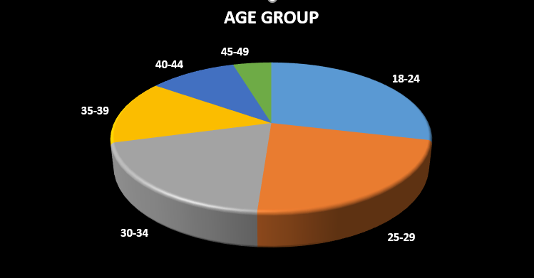

Q.2. How long have you been doing your current trade?

Trade Experience (Years) | Number | Percentage (%)
0-4 | 121 | 31.3
5-8 | 96 | 24.8
9-12 | 76 | 19.6
13-16 | 56 | 14.5
17-20 | 24 | 6.2
21-24 | 14 | 3.6
Total | 387 | 100
Figure 4.2 – Statistics of trade experience of the population surveyed.

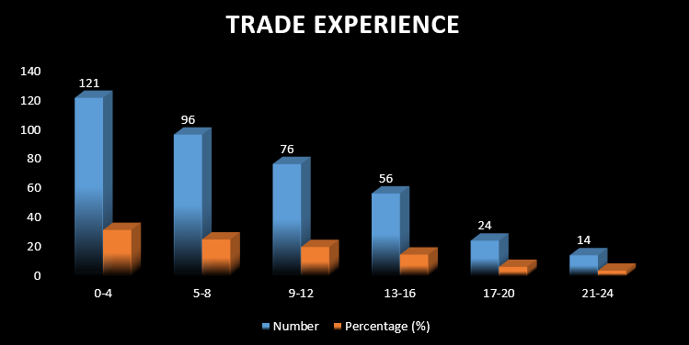

Q.3. What system(s) were you using before switching to MJDI?

Previous System/ MIS | Number | Percentage (%)
USAS | 43 | 11.1
UNICOM | 156 | 40.3
BACMS | 11 | 2.8
MERLIN | 14 | 3.6
GLOBAL | 132 | 34.1
MANUAL | 31 | 8.0
Total | 387 | 100
Figure 4.3 – Statistics of previous system used by of the population surveyed.

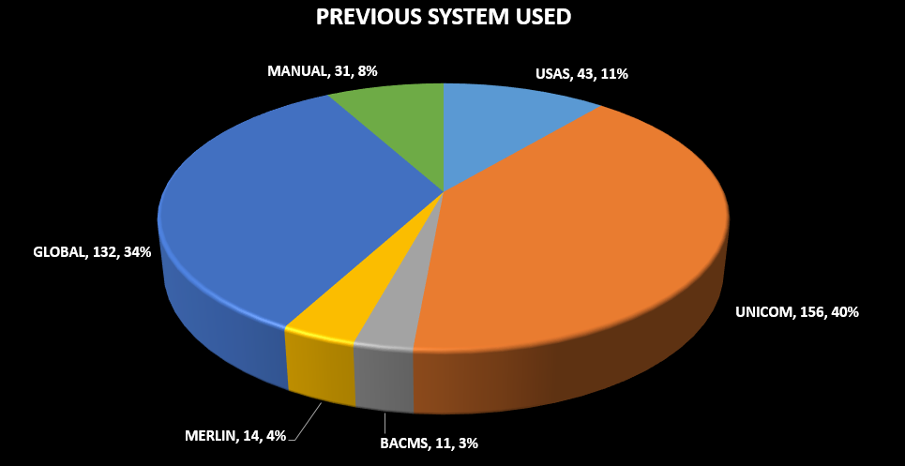

Q.4. How long did you use your previous system before switching to MJDI?
Durations with Previous System | Number | Percentage (%)
0-2 | 53 | 13.7
3-4 | 59 | 15.2
5-6 | 56 | 14.5
7-8 | 66 | 17.1
9-10 | 87 | 22.5
11-12 | 66 | 17.1
Total | 387 | 100

Figure 4.4 – Statistics of duration with previous system used by the population surveyed.

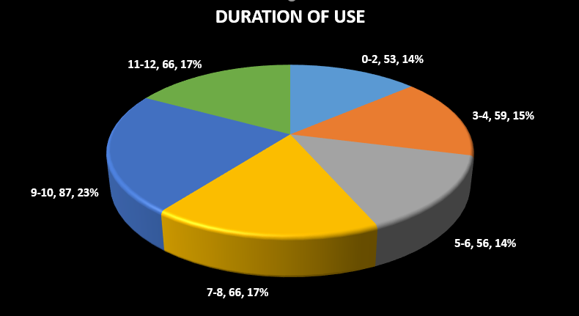

Q.5 Do you feel you had adequate training before switching to MJDI?

Adequate Training | Number | Percentage (%)
Yes | 158 | 40.8
No | 229 | 59.2
Total | 387 | 100
Figure 4.5 – Statistics of how the users rate the level of training adequacy before switching to MJDI.

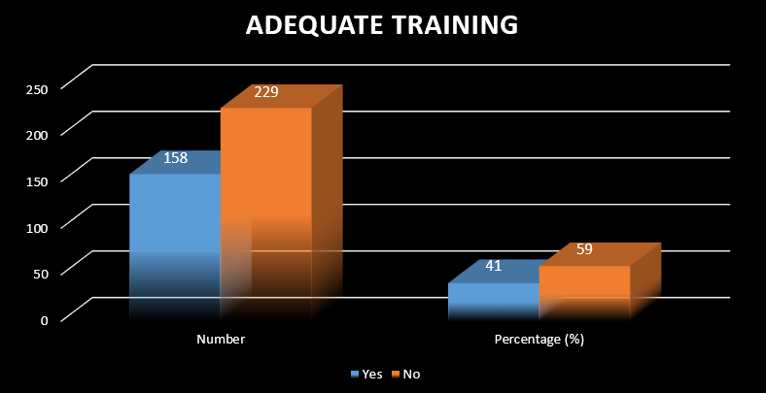

Q.6. How much notice did you received before switching to MJDI?

Informed Duration (Months) | Number | Percentage (%)
0-4 | 114 | 29.5
5-9 | 89 | 23.0
10-14 | 77 | 19.9
15-19 | 56 | 14.5
20-24 | 37 | 9.6
25-29 | 14 | 3.6
Total | 387 | 100
Figure 4.6 – Statistics of the notice received by users before switching to MJDI.

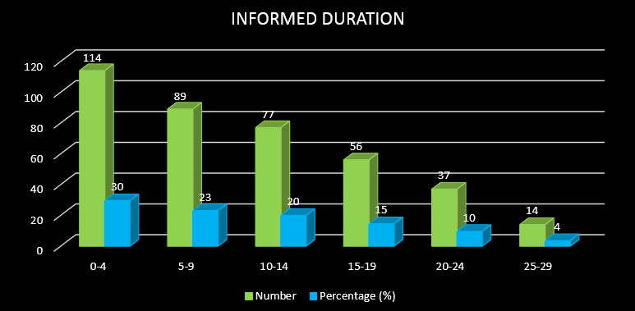

Q.7. How well do you agree with the following statements (1= Strongly Disagree to 5= Strongly Agree)?

How well do you agree with the following statements (1= Strongly Disagree to 5= Strongly Agree)? |  | 1 | 2 | 3 | 4 | 5 | Total
A | I was well informed about the new MJDI prior to the changeover | 46 | 56 | 101 | 98 | 86 | 387
 | Percentages | 11.9 | 14.5 | 26.1 | 25.3 | 22.2 | 100
B | The training I received on MJDI transition allowed me to use it right away | 124 | 101 | 77 | 57 | 28 | 387
 | Percentages | 32.0 | 26.1 | 19.9 | 14.7 | 7.2 | 100
C | There was almost no gap between my MJDI training and its full activation in my unit | 45 | 71 | 77 | 92 | 102 | 387
 | Percentages | 11.9 | 14.5 | 26.1 | 25.3 | 22.2 | 100
D | The MJDI is an improvement on my previous IS system | 43 | 59 | 67 | 97 | 121 | 387
 | Percentages | 11.1 | 15.2 | 17.3 | 25.1 | 31.3 | 100
E | I would return to the old system or tool if given the chance | 127 | 78 | 65 | 59 | 58 | 387
 | Percentages | 32.8 | 20.2 | 16.8 | 15.2 | 15.0 | 100
F | The MJDI project team who rolled MJDI in my unit were competent and knew what they were doing | 164 | 105 | 67 | 34 | 17 | 387
 | Percentages | 42.4 | 27.1 | 17.3 | 8.8 | 4.4 | 100
G | I was very confident to use MJDI after my MJDI roll out | 167 | 83 | 58 | 45 | 34 | 387
 | Percentages | 43.2 | 21.4 | 15.0 | 11.6 | 8.8 | 100
H | I had adequate support from the MJDI team after the roll out | 45 | 67 | 69 | 78 | 128 | 387
 | Percentages | 11.6 | 17 | 17.83 | 20.2 | 33.1 | 100
Figure 4.7 – Statistics of Q7A to 7H – These are multiple questions of agree or disagree.

Q.8. Do you agree that the MJDI implementation was managed properly?

Managed Properly | Number | Percentage (%)
Yes | 209 | 54
No | 178 | 46
Total | 387 | 100
Figure 4.8 – Statistics on whether the implementation was managed properly or not.

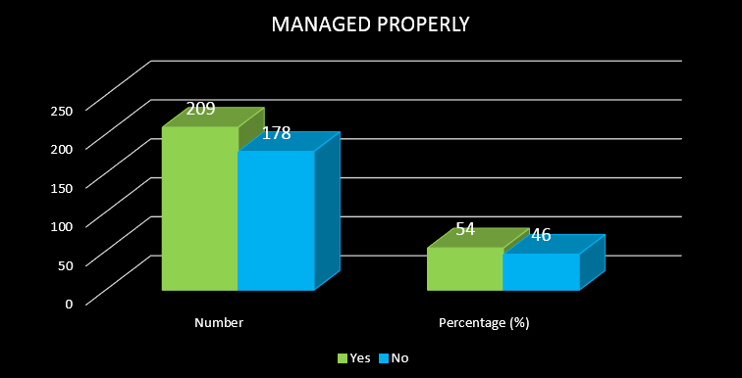

Q.9. Did you see the MJDI roll out as a burden?

Did you see the MJDI roll out as a burden? | Number | Percentage (%)
Yes | 186 | 48
No | 201 | 52
Total | 387 | 100
Figure 4.9 – Statistics on whether the MJDI roll out was a burden or not.

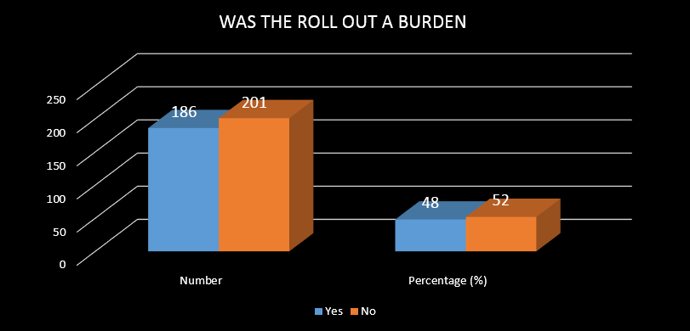

Q.10. What is your current rank?

Rank Range | Number | Percentage (%)
Pte | 62 | 16
LCpl | 71 | 18
Cpl | 101 | 26
Sgt | 62 | 16
SSgt | 44 | 11
WO | 47 | 12
Total | 387 | 100
Figure 4.10 – Statistics of age rank range of the population surveyed.

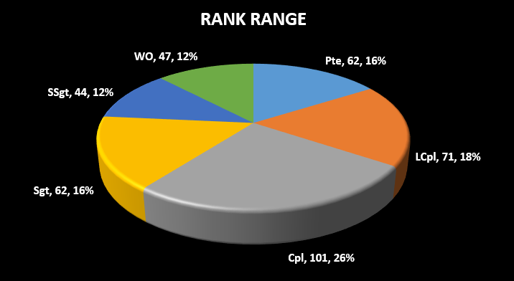

Q.11. I feel very confident to use MJDI at present? (1= Strongly Disagree to 5= Strongly Agree)

Current Competency | Number | Percentage (%)
Strongly Disagree | 31 | 8.0
Disagree | 43 | 11.1
Slightly Disagree | 69 | 17.8
Agree | 111 | 28.7
Strongly Agree | 133 | 34.4
Total | 387 | 100
Figure 4.11 – Statistics of current MJDI competency of users.

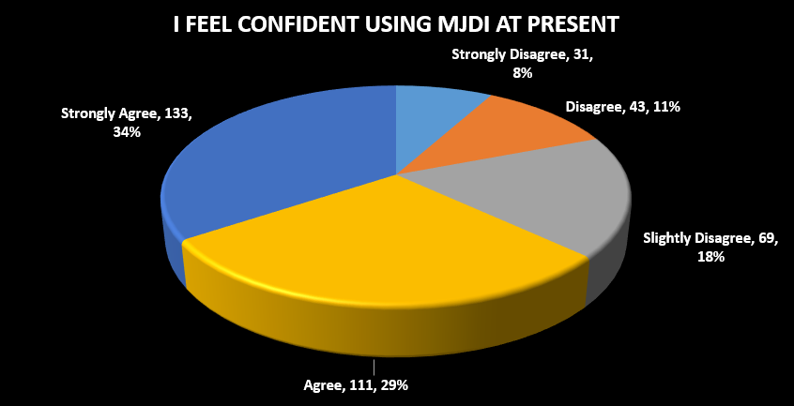

4.3 SPSS ANALYSIS

Results of the Frequency Test (Age Range)
 |  | Age Group | Experience in Trade
N | Valid | 387 | 387
N | Missing | 0 | 0
Mean |  | 2.69 | 2.50
Median |  | 2.00 | 2.00
Mode |  | 1 | 1
Sum |  | 1042 | 969

Age Group
 |  | Frequency | Percent | Valid Percent | Cumulative Percent
Valid | 18-24 | 111 | 28.7 | 28.7 | 28.7
Valid | 25-29 | 87 | 22.5 | 22.5 | 51.2
Valid | 30-34 | 76 | 19.6 | 19.6 | 70.8
Valid | 35-39 | 54 | 14.0 | 14.0 | 84.8
Valid | 40-44 | 41 | 10.6 | 10.6 | 95.3
Valid | 45-49 | 18 | 4.7 | 4.7 | 100.0
Valid | Total | 387 | 100.0 | 100.0

Narrative (Age Range)

The result shows population of 18-24 years of age is 111 which is 28.7 percent as the highest population percent against population of 45-49 years at 18 with 4.7 percent as the lowest population. Although there is significant difference, it is a realistic representation of the population measured as it is likely to have more young soldiers in the Army compared to older personnel.

Results of the Frequency Test (Experience in Trade)
Experience in Trade
 |  | Frequency | Percent | Valid Percent | Cumulative Percent
Valid | 0-4 | 121 | 31.3 | 31.3 | 31.3
Valid | 5-8 | 96 | 24.8 | 24.8 | 56.1
Valid | 9-12 | 76 | 19.6 | 19.6 | 75.7
Valid | 13-16 | 56 | 14.5 | 14.5 | 90.2
Valid | 17-20 | 24 | 6.2 | 6.2 | 96.4
Valid | 21-24 | 14 | 3.6 | 3.6 | 100.0
Valid | Total | 387 | 100.0 | 100.0

Narrative (Trade Experience)

The result shows population of 0-4 years’ experience are 121 which is 31.3 percent as the highest population percent against population of 22-24 years at 14 with 3.6 percent as the lowest population. Although there is significant difference, it is a realistic representation of the population measured as is likely to have less experience people in the Army as the compared to young soldiers.

Chi-Square Test
Key Point for analysis: if p-value is greater than 0.05, we will accept Null Hypothesis and vice versa if is less than 0.05.
Results of Chi-Square Test for Trade Experience and Previous System

Case Processing Summary
 | Cases
 | Valid |  | Missing |  | Total
 | N | Percent | N | Percent | N | Percent
Experience in Trade * Previous System Used | 387 | 100.0% | 0 | 0.0% | 387 | 100.0%

Experience in Trade * Previous System Used Crosstabulation
Count
 |  | Previous System Used |  |  |  |  |  | Total
 |  | USAS | UNICOM | BACMS | MERLIN | GLOBAL | MANUAL | Total
Experience in Trade | 0-4 | 43 | 1 | 0 | 0 | 77 | 0 | 121
Experience in Trade | 5-8 | 0 | 84 | 0 | 1 | 2 | 9 | 96
Experience in Trade | 9-12 | 0 | 54 | 11 | 0 | 11 | 0 | 76
Experience in Trade | 13-16 | 0 | 16 | 0 | 13 | 18 | 9 | 56
Experience in Trade | 17-20 | 0 | 0 | 0 | 0 | 24 | 0 | 24
Experience in Trade | 21-24 | 0 | 1 | 0 | 0 | 0 | 13 | 14
Total |  | 43 | 156 | 11 | 14 | 132 | 31 | 387

Chi-Square Tests
 |  | Value |  | df |  | Asymptotic Significance (2-sided)
Pearson Chi-Square |  | 594.374ª |  | 25 |  | .000
Likelihood Ratio |  | 545.378 |  | 25 |  | .000
Linear-by-Linear Association |  | 29.057 |  | 1 |  | .000
N of Valid Cases |  | 387
a. 18 cells (50.0%) have expected count less than 5. The minimum expected count is .40.
Symmetric Measures
 |  |  | Value |  | Approximate Significance
Nominal by Nominal | Phi |  | 1.239 |  | 0.000
Nominal by Nominal | Cramer's V |  | 0.554 |  | 0.000
N of Valid Cases |  |  | 387

H1: There is no difference between trade experience and the sort of system previously used before MJDI migration.

H1a: There is difference between trade experience and the sort of system previously used before MJDI migration.

The result of Pearson Chi-Square shows (x=594.374ª, p=0.000, df=25), which is not statistically significant as the P-Value is less than 0.05, which indicates that the Null Hypothesis must be rejected. This also indicates that; there is difference between trade experience and the sort of system previously used before MJDI migration and therefore accept the alternative. This is an evidence that the previous system used can be dependent on the length of experience of the person, as the probability value is less than 0.05.

Results of Chi-Square Test for Previous System and Duration of Using Previous System
Case Processing Summary
 | Cases
 | Valid |  | Missing |  | Total
 | N | Percent | N | Percent | N | Percent
Previous System Used * Duration of Previous System | 387 | 100.0% | 0 | 0.0% | 387 | 100.0%

Previous System Used * Duration of Previous System Crosstabulation
Count
 |  |  | Duration of Previous System |  |  |  |  |  |  |  | Total
 |  |  | 0-2 | 3-4 |  | 5-6 |  | 7-8 | 9-10 | 11-12 | Total
Previous System Used | USAS |  | 41 | 0 |  | 0 |  | 0 | 2 | 0 | 43
Previous System Used | UNICOM |  | 12 | 52 |  | 38 |  | 5 | 34 | 15 | 156
Previous System Used | BACMS |  | 0 | 0 |  | 11 |  | 0 | 0 | 0 | 11
Previous System Used | MERLIN |  | 0 | 0 |  | 0 |  | 13 | 0 | 1 | 14
Previous System Used | GLOBAL |  | 0 | 7 |  | 7 |  | 48 | 51 | 19 | 132
Previous System Used | MANUAL |  | 0 | 0 |  | 0 |  | 0 | 0 | 31 | 31
Total |  |  | 53 | 59 |  | 56 |  | 66 | 87 | 66 | 387
Chi-Square Tests
 |  | Value |  |  | df |  | Asymptotic Significance (2-sided)
Pearson Chi-Square |  | 665.657ª |  |  | 25 |  | 0.000
Likelihood Ratio |  | 511.054 |  |  | 25 |  | 0.000
Linear-by-Linear Association |  | 165.609 |  |  | 1 |  | 0.000
N of Valid Cases |  | 387
a. 15 cells (41.7%) have expected count less than 5. The minimum expected count is 1.51.

Symmetric Measures
 |  | Value | Asymptotic Standard Errorª | Approximate T^{b} | Approximate Significance
Interval by Interval | Pearson's R | 0.655 | 0.034 | 17.009 | 0.000^{c}
Ordinal by Ordinal | Spearman Correlation | 0.666 | 0.036 | 17.509 | 0.000^{c}
N of Valid Cases |  | 387
a. Not assuming the null hypothesis.
b. Using the asymptotic standard error assuming the null hypothesis.
c. Based on normal approximation.

H2: There is no difference between previous system used and the duration of using that previous before MJDI migration.

H2a: There is difference between previous system used and the duration of using that previous before MJDI migration.

The result of Pearson Chi-Square shows (x=665.657ª, p=0.000, df=25), which is not statistically significant as the P-Value is less than 0.05, which indicates that the Null Hypothesis must be rejected. This also indicates that; there is difference between previous system used and the duration of used before MJDI migration and therefore accept the alternative. This is an evidence that the length of used can be dependent on the type of system used, as the probability value is less than 0.05.

Results of Chi-Square Test for the adequacy of training received and the confidence after activation.

Case Processing Summary
 | Cases
 | Valid |  | Missing |  | Total
 | N | Percent | N | Percent | N | Percent
Was the training adequate * Confident after activation | 387 | 100.0% | 0 | 0.0% | 387 | 100.0%

Was the training adequate * Confident after activation Crosstabulation
Count
 |  | Confident after activation |  |  |  |  | Total
 |  | Strongly Disagree | Disagree | Slightly Disagree | Agree | Strongly Agree | Total
Was the training adequate | Yes | 78 | 26 | 22 | 21 | 11 | 158
Was the training adequate | No | 89 | 57 | 36 | 24 | 23 | 229
Total |  | 167 | 83 | 58 | 45 | 34 | 387

Chi-Square Tests
 | Value | df | Asymptotic Significance (2-sided)
Pearson Chi-Square | 7.339ª | 4 | 0.119
Likelihood Ratio | 7.430 | 4 | 0.115
Linear-by-Linear Association | 1.320 | 1 | 0.251
N of Valid Cases | 387
a. 0 cells (0.0%) have expected count less than 5. The minimum expected count is 13.88.

Symmetric Measures
 |  | Value | Asymptotic Standard Errorª | Approximate T^{b} | Approximate Significance
Interval by Interval | Pearson's R | 0.058 | 0.051 | 1.149 | 0.251^{c}
Ordinal by Ordinal | Spearman Correlation | 0.074 | 0.051 | 1.451 | 0.148^{c}
N of Valid Cases |  | 387
a. Not assuming the null hypothesis.
b. Using the asymptotic standard error assuming the null hypothesis.
c. Based on normal approximation.

H3: There is no difference between adequacy of training received and the competent to use MJDI after activation.

H3a: There no difference between adequacy of training received and the competent to use MJDI after activation.

The result of Pearson Chi-Square shows (x=7.339ª, p=0.119, df=4), which is statistically significant as the P-Value is more than 0.05, which indicates that the Null Hypothesis must be accepted. This also indicates that; there is no difference between the adequacy of training and the competency after the activation and therefore reject the alternative. This is an evidence that the level of training received did not affect the competency of the user after activation, as the probability value is more than 0.05.
Results of Chi-Square Test for the Adequacy of training received and the improvement process.

Case Processing Summary
 | Cases
 | Valid |  | Missing |  | Total
 | N | Percent | N | Percent | N | Percent
Adequacy of training * Improvement from MJDI | 387 | 100.0% | 0 | 0.0% | 387 | 100.0%

Adequacy of training * Improvement from MJDI Crosstabulation
Count
 |  | Improvement from MJDI |  |  |  |  | Total
 |  | Strongly Disagree | Disagree | Slightly Disagree | Agree | Strongly Agree | Total
Adequacy of training | Strongly Disagree | 43 | 6 | 2 | 3 | 70 | 124
Adequacy of training | Disagree | 0 | 53 | 15 | 15 | 18 | 101
Adequacy of training | Slightly Disagree | 0 | 0 | 50 | 24 | 3 | 77
Adequacy of training | Agree | 0 | 0 | 0 | 53 | 4 | 57
Adequacy of training | Strongly Agree | 0 | 0 | 0 | 2 | 26 | 28
Total |  | 43 | 59 | 67 | 97 | 121 | 387

Chi-Square Tests
 | Value | df | Asymptotic Significance (2-sided)
Pearson Chi-Square | 583.466ª | 16 | .000
Likelihood Ratio | 542.543 | 16 | .000
Linear-by-Linear Association | 30.457 | 1 | .000
N of Valid Cases | 387
a. 3 cells (12.0%) have expected count less than 5. The minimum expected count is 3.11.

Symmetric Measures
 |  | Value | Asymptotic Standard Errorª | Approximate T^{b} | Approximate Significance
Interval by Interval | Pearson's R | .281 | .047 | 5.743 | .000^{c}
Ordinal by Ordinal | Spearman Correlation | .149 | .061 | 2.958 | .003^{c}
N of Valid Cases |  | 387
a. Not assuming the null hypothesis.
b. Using the asymptotic standard error assuming the null hypothesis.
c. Based on normal approximation.

H4: There is no difference between adequacy of training received and the improvement in processes after activation.

H4a: There no difference between adequacy of training received and the improvement in processes after activation.

The result of Pearson Chi-Square shows (x=583.466ª, p=0.000, df=16), which is statistically significant as the P-Value is less than 0.05, which indicates that the Null Hypothesis must be rejected. This also indicates that; there is difference between the adequacy of training and the improvement in process after the activation and therefore accept the alternative. This is an evidence that the level of training received did affect the improvement in processes after activation, as the probability value is less than 0.05.

Results of Chi-Square Test for the Adequacy of training received and the improvement process.

Case Processing Summary
 | Cases
 | Valid |  | Missing |  | Total
 | N | Percent | N | Percent | N | Percent
Gap before activation * Confident after activation | 387 | 100.0% | 0 | 0.0% | 387 | 100.0%

Gap before activation * Confident after activation Crosstabulation
Count
 |  | Confident after activation |  |  |  |  | Total
 |  | Strongly Disagree | Disagree | Slightly Disagree | Agree | Strongly Agree | Total
Gap before activation | Strongly Disagree | 44 | 1 | 0 | 0 | 0 | 45
Gap before activation | Disagree | 11 | 49 | 2 | 2 | 7 | 71
Gap before activation | Slightly Disagree | 12 | 6 | 46 | 7 | 6 | 77
Gap before activation | Agree | 22 | 18 | 10 | 36 | 6 | 92
Gap before activation | Strongly Agree | 78 | 9 | 0 | 0 | 15 | 102
Total |  | 167 | 83 | 58 | 45 | 34 | 387

Chi-Square Tests
 | Value | df | Asymptotic Significance (2-sided)
Pearson Chi-Square | 412.314ª | 16 | 0.000
Likelihood Ratio | 371.260 | 16 | 0.000
Linear-by-Linear Association | 2.397 | 1 | 0.122
N of Valid Cases | 387
a. 1 cells (4.0%) have expected count less than 5. The minimum expected count is 3.95.

Symmetric Measures
 |  | Value | Asymptotic Standard Errorª | Approximate T^{b} | Approximate Significance
Nominal by Nominal | Phi | 1.032 |  |  | .000
Nominal by Nominal | Cramer's V | .516 |  |  | .000
Interval by Interval | Pearson's R | .079 | .049 | 1.551 | .122^{c}
Ordinal by Ordinal | Spearman Correlation | -.024 | .057 | -.472 | .637^{c}
N of Valid Cases |  | 387
a. Not assuming the null hypothesis.
b. Using the asymptotic standard error assuming the null hypothesis.
c. Based on normal approximation.

H5: There is no difference between the gap after training and the confident to use the system after activation.

H5a: There is difference between the gap after training and the confident to use the system after activation

The result of Pearson Chi-Square shows (x=412.314ª, p=0.000, df=16), which is statistically significant as the P-Value is less than 0.05, which indicates that the Null Hypothesis must be rejected. This also indicates that; there is difference between the gap after training and confident after the activation and therefore accept the alternative. This is an evidence that the gap between the time of training and the actual date of activation affected the confident to use MJDI, as the probability value is less than 0.05.

Results of Chi-Square Test for improvement in processes and switching to old system if given the choice.

Case Processing Summary
 | Cases
 | Valid |  | Missing |  | Total
 | N | Percent | N | Percent | N | Percent
Improvement from MJDI * Switching to Previous System | 387 | 100.0% | 0 | 0.0% | 387 | 100.0%

Improvement from MJDI * Switching to Previous System Crosstabulation
Count
 |  | Switching to Previous System |  |  |  |  | Total
 |  | Strongly Disagree | Disagree | Slightly Disagree | Agree | Strongly Agree | Total
Improvement from MJDI | Strongly Disagree | 43 | 0 | 0 | 0 | 0 | 43
Improvement from MJDI | Disagree | 7 | 52 | 0 | 0 | 0 | 59
Improvement from MJDI | Slightly Disagree | 4 | 12 | 51 | 0 | 0 | 67
Improvement from MJDI | Agree | 3 | 5 | 10 | 55 | 24 | 97
Improvement from MJDI | Strongly Agree | 70 | 9 | 4 | 4 | 34 | 121
Total |  | 127 | 78 | 65 | 59 | 58 | 387

Chi-Square Tests
 | Value | df | Asymptotic Significance (2-sided)
Pearson Chi-Square | 660.478ª | 16 | 0.000
Likelihood Ratio | 582.616 | 16 | 0.000
Linear-by-Linear Association | 43.077 | 1 | 0.000
N of Valid Cases | 387
a. 0 cells (0.0%) have expected count less than 5. The minimum expected count is 6.44.

Symmetric Measures
 |  | Value | Asymptotic Standard Errorª | Approximate T^{b} | Approximate Significance
Nominal by Nominal | Phi | 1.306 |  |  | 0.000
Nominal by Nominal | Cramer's V | 0.653 |  |  | 0.000
Interval by Interval | Pearson's R | 0.334 | .046 | 6.954 | 0.000^{c}
Ordinal by Ordinal | Spearman Correlation | 0.214 | .060 | 4.302 | 0.000^{c}
N of Valid Cases |  | 387
a. Not assuming the null hypothesis.
b. Using the asymptotic standard error assuming the null hypothesis.
c. Based on normal approximation.
H6: There is no difference between the improvement of processes and switching back to old system if given the opportunity.

H6a: There is difference between the improvement of processes and switching back to old system if given the opportunity.

The result of Pearson Chi-Square shows (x=660.478a, p=0.000, df=16), which is statistically significant as the P-Value is less than 0.05, which indicates that the Null Hypothesis must be rejected. This also indicates that; there is difference between the improvement of processes and switching back to old system if given the opportunity and therefore accept the alternative. This is an evidence that people are likely to revert to old ways if they do not see any improvement in a new system, as the probability value is less than 0.05.

Results of Chi-Square Test for competency of the roll out team and whether the roll out was a burden.
Case Processing Summary
 | Cases
 | Valid |  | Missing |  | Total
 | N | Percent | N | Percent | N | Percent
Competency of Roll Out Team * Did you feel burdened | 387 | 100.0% | 0 | 0.0% | 387 | 100.0%

Competency of Roll Out Team * Did you feel burdened Crosstabulation
 |  |  |  |  |  | Did you feel burdened |  | Total
 |  |  |  |  |  | Yes | No | Total
Competency of Roll Out Team | Strongly Disagree |  |  | Count |  | 66 | 98 | 164
Competency of Roll Out Team |  |  |  | Expected Count |  | 78.8 | 85.2 | 164.0
Competency of Roll Out Team | Disagree |  |  | Count |  | 61 | 44 | 105
Competency of Roll Out Team |  |  |  | Expected Count |  | 50.5 | 54.5 | 105.0
Competency of Roll Out Team | Slightly Disagree |  |  | Count |  | 42 | 25 | 67
Competency of Roll Out Team |  |  |  | Expected Count |  | 32.2 | 34.8 | 67.0
Competency of Roll Out Team | Agree |  |  | Count |  | 11 | 23 | 34
Competency of Roll Out Team |  |  |  | Expected Count |  | 16.3 | 17.7 | 34.0
Competency of Roll Out Team | Strongly Agree |  |  | Count |  | 6 | 11 | 17
Competency of Roll Out Team |  |  |  | Expected Count |  | 8.2 | 8.8 | 17.0
Total |  |  |  | Count |  | 186 | 201 | 387
 |  |  |  | Expected Count |  | 186.0 | 201.0 | 387.0
Chi-Square Tests
 |  | Value | df |  | Asymptotic Significance (2-sided)
Pearson Chi-Square |  | 18.462ª | 4 |  | 0.001
Likelihood Ratio |  | 18.649 | 4 |  | 0.001
Linear-by-Linear Association |  | 0.227 | 1 |  | 0.634
N of Valid Cases |  | 387
a. 0 cells (0.0%) have expected count less than 5. The minimum expected count is 8.17.

Symmetric Measures
 |  | Value | Asymptotic Standard Errorª | Approximate T^{b} | Approximate Significance
Nominal by Nominal | Phi | 0.218 |  |  | 0.001
Nominal by Nominal | Cramer's V | 0.218 |  |  | 0.001
Interval by Interval | Pearson's R | -0.024 | 0.051 | -0.476 | 0.635^{c}
Ordinal by Ordinal | Spearman Correlation | -0.073 | 0.051 | -1.429 | 0.154^{c}
N of Valid Cases |  | 387
a. Not assuming the null hypothesis.
b. Using the asymptotic standard error assuming the null hypothesis.
c. Based on normal approximation.

H7: There is no difference between the competency of the roll out team and how did the unit felt burdened during roll out.

H7a: There is difference between the competency of the roll out team and how did the unit felt burdened during roll out.

The result of Pearson Chi-Square shows (x=18.462ª, p=0.001, df=4), which is statistically significant as the P-Value is less than 0.05, which indicates that the Null Hypothesis must be rejected. This also indicates that; there is difference between the competency of the roll out team and how the unit felt burdened during roll out and therefore accept the alternative. This is an evidence that the competency of the activation team makes the roll out easier, as the probability value is less than 0.05.

Results of Chi-Square Test for how the Implementation was managed and the current competency of MJDI users.

Case Processing Summary
 | Cases
 | Valid |  | Missing |  | Total
 | N | Percent | N | Percent | N | Percent
Implementation Managed Properly * Current Competency | 387 | 100.0% | 0 | 0.0% | 387 | 100.0%

Implementation Managed Properly * Current Competency Crosstabulation
 |  |  | Current Competency |  |  |  |  | Total
 |  |  | Strongly Disagree | Disagree | Slightly Disagree | Agree | Strongly Agree | Total
Implementation Managed Properly | Yes | Count | 17 | 11 | 31 | 63 | 87 | 209
Implementation Managed Properly | Yes | Expected Count | 16.7 | 23.2 | 37.3 | 59.9 | 71.8 | 209.0
Implementation Managed Properly | No | Count | 14 | 32 | 38 | 48 | 46 | 178
Implementation Managed Properly | No | Expected Count | 14.3 | 19.8 | 31.7 | 51.1 | 61.2 | 178.0
Total |  | Count | 31 | 43 | 69 | 111 | 133 | 387
 |  | Expected Count | 31.0 | 43.0 | 69.0 | 111.0 | 133.0 | 387.0

Chi-Square Tests
 |  | Value | df |  | Asymptotic Significance (2-sided)
Pearson Chi-Square |  | 23.591ª | 4 |  | 0.000
Likelihood Ratio |  | 24.105 | 4 |  | 0.000
Linear-by-Linear Association |  | 13.202 | 1 |  | 0.000
N of Valid Cases |  | 387
a. 0 cells (0.0%) have expected count less than 5. The minimum expected count is 14.26.
Symmetric Measures
 |  |  |  | Value |  | Asymptotic Standard Errorª | Approximate T^{b} | Approximate Significance
Nominal by Nominal | Phi |  |  | 0.247 |  |  |  | 0.000
Nominal by Nominal | Cramer's V |  |  | 0.247 |  |  |  | 0.000
Interval by Interval | Pearson's R |  |  | -0.185 |  | 0.050 | -3.692 | 0.000^{c}
Ordinal by Ordinal | Spearman Correlation |  |  | -0.200 |  | 0.050 | -4.005 | 0.000^{c}
N of Valid Cases |  |  |  | 387
a. Not assuming the null hypothesis.
b. Using the asymptotic standard error assuming the null hypothesis.
c. Based on normal approximation.

H8: There is no difference between the current competency of the MJDI users and how the implementation was managed.

H8a: There is difference between the current competency of the MJDI users and how the implantation was managed.

The result of Pearson Chi-Square shows (x=23.591ª, p=0.000, df=4), which is statistically significant as the P-Value is less than 0.05, which indicates that the Null Hypothesis must be rejected. This also indicates that; there is difference between the current competency of MJDI users and how the implementation was managed and therefore accept the alternative. This is an evidence that the current competency of the MJDI users is dependent on the how the implementation was managed, as the probability value is less than 0.05.

Results of Chi-Square Test the effect of post activation support and the improvement from the MJDI.
Case Processing Summary
 | Cases
 | Valid |  | Missing |  | Total
 | N | Percent | N | Percent | N | Percent
Post Activation Support * Improvement from MJDI | 387 | 100.0% | 0 | 0.0% | 387 | 100.0%

Post Activation Support * Improvement from MJDI Crosstabulation
 |  |  | Improvement from MJDI |  |  |  |  | Total
 |  |  | Strongly Disagree | Disagree | Slightly Disagree | Agree | Strongly Agree | Total
Post Activation Support | Strongly Disagree | Count | 29 | 0 | 5 | 11 | 0 | 45
Post Activation Support | Strongly Disagree | Expected Count | 5.0 | 6.9 | 7.8 | 11.3 | 14.1 | 45.0
Post Activation Support | Disagree | Count | 12 | 54 | 1 | 0 | 0 | 67
Post Activation Support | Disagree | Expected Count | 7.4 | 10.2 | 11.6 | 16.8 | 20.9 | 67.0
Post Activation Support | Slightly Disagree | Count | 0 | 0 | 59 | 4 | 6 | 69
Post Activation Support | Slightly Disagree | Expected Count | 7.7 | 10.5 | 11.9 | 17.3 | 21.6 | 69.0
Post Activation Support | Agree | Count | 0 | 0 | 0 | 78 | 0 | 78
Post Activation Support | Agree | Expected Count | 8.7 | 11.9 | 13.5 | 19.6 | 24.4 | 78.0
Post Activation Support | Strongly Disagree | Count | 2 | 5 | 2 | 4 | 115 | 128
Post Activation Support | Strongly Disagree | Expected Count | 14.2 | 19.5 | 22.2 | 32.1 | 40.0 | 128.0
Total |  | Count | 43 | 59 | 67 | 97 | 121 | 387
 |  | Expected Count | 43.0 | 59.0 | 67.0 | 97.0 | 121.0 | 387.0

Chi-Square Tests
 | Value | df | Asymptotic Significance (2-sided)
Pearson Chi-Square | 1037.930ª | 16 | 0.000
Likelihood Ratio | 855.654 | 16 | 0.000
Linear-by-Linear Association | 266.903 | 1 | 0.000
N of Valid Cases | 387
a. 0 cells (0.0%) have expected count less than 5. The minimum expected count is 5.00.

Symmetric Measures
 |  | Value | Asymptotic Standard Errorª | Approximate T^{b} | Approximate Significance
Nominal by Nominal | Phi | 1.638 |  |  | .000
Nominal by Nominal | Cramer's V | .819 |  |  | .000
Interval by Interval | Pearson's R | .832 | .029 | 29.374 | .000^{c}
Ordinal by Ordinal | Spearman Correlation | .851 | .027 | 31.759 | .000^{c}
N of Valid Cases |  | 387
a. Not assuming the null hypothesis.
b. Using the asymptotic standard error assuming the null hypothesis.
c. Based on normal approximation.

H9: There is no difference between the effect on improvement of processes and the post activation support from the MJDI team.

H9a: There is difference between the effect on improvement of processes and the post activation support from the MJDI team.

The result of Pearson Chi-Square shows (x=1037.930a, p=0.000, df=16), which is statistically significant as the P-Value is less than 0.05, which indicates that the Null Hypothesis must be rejected. This also indicates that; there is difference between the improvement of process is affected by the post activation support received from the MJDI team and therefore accept the alternative. This is an evidence that the post activation support from the team makes things easier for MJDI users, as the probability value is less than 0.05.

CHAPTER FIVE
RECOMMENDATION AND CONCLUSIONS
5.1 Summary of Analysis
5.1.1 Summary of Frequency Analysis
The results indicate that majority of MJDI users falls within the 18-24 age group which is 111 out of 387 users surveyed representing 28.7% (See Table 4.1). This supports the fact that most people join the Army around the age of 18-24 and are expected to complete their trade training within 6 months of joining. It is anticipated that, the soldier will be posted to field Army and start using MJDI within a maximum of 1 year of completing basic training if no injuries are sustained.
The analysis also shows that the highest number of the population surveyed have been in their current trade for a period between 0-4 years with the least belonging to 22-24 years, representing 31.3% and 3.6% respectively (See Table 4.2). This significant number for 0-4 years reflects the Army population which is very bottom heavy in a pyramid hierarchy structure. As seen in the age range analysis above, there are more junior rank soldiers within the Army. In a typical RLC Supply Squadron, the composite will always be a mixture of low rank - high population, medium rank – medium population and high rank – low population.
Higher number of personnel used UNICOM previously before switching to MJDI, representing 156 and 40.3% in numbers and percentage respectively (See Table 4.3). Although various systems have been around for quite a long time for people to manage their equipment, the research reveals a fairly significant number of people still using manual processes before switching to MJDI. Figures showing a high number of 31 or 8%, who were still using manual processes. This significant figure raises a lot of questions because many of these users had access to systems such as UNICOM, GLOBAL and the rest of the systems available before MJDI. The common excuse was that; “transactions are quicker and easy using manual processes or have no or poor network connectivity to use such systems”.
The results also show that majority of users have been using their previous system for period between 9 -10 years (at 87 / 22.5%) and second highest is between 7- 8 years (66 / 17.1%) and 11-12 years (66 / 17.1%). (See Table 4.4).
These figures mean that many people have been with their previous systems for a very long time and have become comfortable and mastered it very well. Switching from such a system becomes very difficult and challenging for people to accept. However, majority of people wanted some sort of upgrade or refinement in their existing systems. Typical example was the ability to be able to see stock levels across different units to aid the ordering of materiel among units. On the other hand, some people were happy to tolerate with the lapses associated with their previous systems and did not see the necessity for change.
High significant number of users admitted that they were informed in good time before the changeover, with 98 out of 387 users representing 25.3% of those who agree they were informed in good time and 86 representing 22.2% who strongly agreed they were happy with the time of informed before changeover to MJDI (See Table 4.6). It was identified that this group of users were mainly the population who were using UNICOM and GLOBAL within main RLC logistic Regiments based in United. The number of users who claimed they were informed in less than 6 months were quite not happy about the significant short notice. However, further investigations revealed that this group are mainly junior rank population who did not get the information cascaded to them from their chain of command. It is always important for line managers to disseminate important information to their subordinate to make any change process less painful.
On the other hand, majority of users strongly disagree that the training they received before the changeover allowed them to use MJDI right away. With figures showing 124 strongly disagree and 28 strongly agree representing 32% and 7.2% respectively (See Table 4.7). The results also indicate that majority of users strongly disagree that there was almost no gap between training and the full activation. Counting 102 users strongly disagree in that respect representing 22.2% (See Table 4.8). The idea of training people early enough is a good idea; however, some users were concerned because significant number of users admitted skill fade before getting opportunity to use the system at their unit.
The analysis also shows a high number of people who strongly agreed that MJDI has brought some sort of improvement to their work processes.
The number of who strongly agree they have seen some improvement is 121 out of the 387, representing 31.3% of the population surveyed. Although this is a good number of users have seen improvement, there are also 45 (11.9%) and 59 (14.5%) disagree and strongly disagree of any improvement from the change respectively. Further investigation revealed that those who did not agree of any improvement are those who are still struggling or are yet to master the full potential of MJDI. (See Table 4.9).
Further questioning indicates that although some people have fully embraced the system, there is still significant number of users who will revert to old systems when given the option. Out of the 387 surveyed, 58 (15%) strongly agree that they will go back to their old systems when given the opportunity. This is very alarming for a system that was brought in to improve processes and optimise efficiencies. It can be argued that users are still getting used to MJDI but not a convincing statement for a system that was rolled out to the Army in May 2011.
Also, results show that; majority of users disagreed that the MJDI roll-out team who came to activate them to MJDI were competent enough, with a significant number of 164 representing 42.4% stating that they did not think the team were competent enough during the roll-out. Further investigation revealed that most of the MJDI roll-out team personnel did not have supply chain background or understood the supply chain process and therefore, whilst they can operate MJDI, they were lacking the knowledge to explain in detail the functionality of certain key algorism behind the application. When questions were asked, this was blamed on the lack of adequate manpower and funding to recruit personnel with suitable Knowledge, Skills and Experience (KSE). However, in every change process it is important to get people with the right KSE to lead in the area of expertise.
Although, majority of the users strongly disagree that they had the confidence to use MJDI straight after the activation (167 representing 43.2%) disagreed, a high number of them believed they had the right support from the team after the roll-out. 128 people representing 33.1% strongly agree that the support was adequate.

The research also revealed that high significant number of users believed that; the MJDI implementation process could have been managed better than it was managed resulting in high number of users further believing the roll-out become a burden to them. Although, 209 (54%) thought the implementation was manged well, 178 (46%) thought it could be better. Further analysis also shows that 186 (48%) think the roll-out was a burden, compared to 201 (52%) who think it was not a burden. The percentage of people who thinks the roll out was not managed properly and as a burden in this research is significantly high. This situation can be argued as some of the key negative impact on the MJDI implementation process.

5.1.2 SUMMARY OF THE SPSS CHI-SQUARE TEST
The Chi-square Test provides accurate correlation and significance relationship between variables such as; age and rank, trade experience and rank, training received and competency. To summarise the Chi-Square results; the most significance results will be discussed further to articulate the findings from the analysis.
The results from the analysis shows that the level of training did not really affect the confidence of using MJDI after activation; however, the training level did affect the level of improvement of the population surveyed. This shows that although majority of users believed they had the confidence to use MJDI after the activation, most did not actually experienced improvement in their existing processes, because they have still not discovered and mastered the full capability of the MJDI application. Furthermore, the gap between training and activation affected the confidence of users as they experienced skill fade due the gap between training and activation. It is always important to plan training at the right time in order to avoid significant gap between training and the introduction of any new process or application.

Also, the results revealed that the lack of confidence and improvement in the processes as expected from MJDI has a significant impact on the number of people who are likely to revert to their old systems or application if given the opportunity. More importantly, the competency of the activation team had a significant effect on the activation process; which made them felt as if they were burdened by the roll-out. It was also identified that; the current competency of MJDI users is significantly affected by how the implementation was managed.

5.2 CONCLUSIONS
This project has clearly identified the important of installing a robust change management procedure in every change process; irrespective of how small or big it is. The depth of information gathered makes it interesting but still difficult to easily draw conclusions to either accept or reject the hypothesises that;
The Null Hypothesis to be tested by this research is:
Hₒ: The MJDI implementation (roll-out) could not have been optimised with effective change management process.
The Alternate Hypothesis to be tested by this research is:
Hₒₐ: The MJDI implementation (roll-out) could have been optimised with effective change management processes.
Results from the analysis of this project indicates that; high significant number of MJDI users believed they were not informed early enough prior to the changeover. Also, majority of them felt they did not receive adequate training, which affected their confidence in using the new system. Although majority of users believe MJDI has brought some improvement to their work processes, it is also believed that the results would have being much greater if more effort and investment were applied to the change management process.
Furthermore, regardless of the improvements that has been achieved from the introduction of MJDI as admitted by some users; it was very disappointing to identify that a significant percentage of user admitted they will revert to former systems if given the opportunity. However, further investigation shows that; users are lacking the ability to exploit MJDI to its full capability due the lack of competence of some of the MJDI teams who executed the training and roll-out to some of the users. On the positive note; most of the users testify that the support they received from the MJDI team after the activation is very encouraging.
Looking at the figures from the analysis and the significance of users who intend to revert to their old system, those who felt the roll-out was a burden and those who felt the implementation could have been better managed. This project concludes from the findings by rejecting the null hypothesis in favour of the alternative hypothesis that;
“People will embrace the MJDI if the change management processes were effectively managed”.
It can also be confirmed that the project objectives have fully been met. The project has been able to identify:
1) How the MJDI implementation process was managed, the verdict of people affected by the change and what could have been done to increase success
2) Results for recommendation derived from the survey and analysis.
3) The project will serve as a reference document for future implementations.

5.3 RECOMMENDATIONS
5.3.1 PILOT PROJECT
This project recommends that in any future project, a pilot project must be run to test the success of any major implementation. This can be achieved by focusing on selected elements within a targeted or segregated session of the entire project in order to ascertain any challenges, cost savings and any opportunities that can be exploit for better optimisation to reduce the burden associated with change. From the research, it was identified that; most of the problems that took place during the MJDI implementation were new to the project team so there was no immediate contingency plan to combat such bottlenecks.
Pilot projects serves as the test bench or simulation to prevent wasting large sums of resources on giant projects. Any mistakes can be corrected during the test phase in order to prevent bigger financial loss. During the pilot project, feedbacks collated can be used to help how things can be improved.
5.3.2 TRAINING
The project reveals that; the time allocated for training for some of the units was inadequate and the level of competence of the trainers was lower than expected. This project recommends that in any future implementation where training is involved; adequate time and resources must be allocated to facilitate the training of personnel. In many instances, a computer-based training with enough assessment scenarios is good for reducing the cost of training. However, it is important to have the skill and knowledge of qualified persons to facilitate such training.
In situations where computer-based training cannot be avoided, the system could be designed to test user ability and a further system generated training based on initial performance during the assessment. This can help reduce situations where people may be over trained or under trained. Finally, irrespective of the medium of training; it is importance to carry out a review to confirm and verify if the training is fit for purpose. All limitations identified at this stage, can be rectified to improve future training.

5.3.3 IMPLEMENTION (THE CHANGE)
For any change to be implemented successfully, the need for change must overcome the constraints against change. Furthermore, any substitution for existing system must proof better than the old for change to be welcomed. This project recommends that; when implementing any other change, the MoD must acquire a product that will overcome existing problems and improve on it. Introducing a new system which cannot perform better than an existing system will not be accepted as positive change and hence will affect the support for change. This recommendation is motivated from the fact that many of the users admitted they will revert to their old systems when given the option.
5.3.4 FURTHER WORK
This project recommends that; further work should be undertaken on looking at the MJDI project team perspective on how the team think MJDI roll-out was managed and their measurement of success or failure. This will create an opportunity to determine how the project team rate their success of implementation and access any feedback they have receive throughout the MJDI activation process, highlighting on areas the team believe requires improvement. This further work will also look the level of support, training and resources given to the MJDI team during the implementation to see if that can be optimised for any future projects.

REFERENCES
Beckhard, R & Harris R, T (1987): Organizational Transitions: Managing Complex Change. London, England
Boddy, D & Buchanan, D (1992): Take the Lead- Interpersonal Skills for Project Managers. Prentice Hall, New York, USA
Cameron, E & Green, M (2009): Making Sense Change Management-A complete Guide to the model, tool & Techniques of organisational Change 2nd Edition. London, England
Change Management Learning Centre (2007): Website- http://www.changemanagement.com . Accessed on 23rd October 2012 at 13:45hrs
Cummings, S, Bridgman, T & Brown, K, G (2016). Unfreezing Change as three Steps: Rethinking Kurt Lewin’s legacy for Change Management. Sage Journal, Human Relations Vol 69 (Part1), Pages 33-60, 2016.
Daniel W, W (1999). Biostatistics: A Foundation for Analysis in the Health Sciences. 7th edition. New York: John Wiley & Sons.
Dattalo, P. (2008). Determining Sample Size: Balancing Power, Precision, and Practicality (Pocket Guide to Social Work Research Methods). Oxford University Press, Oxford, England.
DE&S (2006). Ministry of Defence Annual Report and Account 2006-07: Fifth Report of Session 2007-08. Accessed online at

https://books.google.co.uk/books?isbn=0215038339 on 12 July 2018 at 1845hrs.

DE&S (2010): Whole Fleet Management Programme Management Office. Website download: https://www.gov.uk/whole-fleet-management-programme-management-office. Accessed on 23rd August 2012 at 14:23hrs
Fine, L, G (2009). The SWOT Analysis: Using your Strength to overcome Weakness, Using Opportunities to overcome Threats. CreateSpace Independent Publishing Platform, England.
Drucker, P.F (1999): Management Challenges for the 21st Century. Elsevier, Oxford, England
Graham, N (2011): Project Management for Dummies. John Wiley & Sons, Wessex, England
Green, M (2007): Change Management Master Class- A step by Step Guide to Successful Change Management. London, England
Grix, J. (2004): The foundations of research, Houndmills, Palgrave Macmillan.
Haitt, J, M (2006): ADKAR- A Model for Change in Business, Government and Our Community. Loveland, Coralado, USA
Hallgrimsson, B (2012): Prototyping and Model making for Product Design. Lawrence King, London, England
Harvey, T, R & Broyles E, A (2010). Resistance to Change: A Guide to Harnessing Its Positive Power. Rowman & Littlefield Education.
Kneer, C. (2006), Change management enhance the ability to survive: Books on demand, GmbH, Norderstedt, Germany.
Kubler-Ross, E & Kessler D (2005): On Grief and Grieving: Finding the Meaning of Grief through the Five Stages of Loss. Kent, UK
Kotter P, J (2011): Managing organisational Change and Design. - What Leaders Really Do? Harvard, USA
ORACLE (2012). ORACLE Business Intelligent. Accessed at https://docs.oracle.com/cd/E28389_01/bi.1111/b40107/overview.htm. on 23 November 2018 at 15:45hrs.
Project Management Institute Report (2008): Website-http://www.strategicstandards.com/files/2008/ProjectManagement08.pdf. Accessed on 12th December 2012 at 11:45hrs
Project Management Institute (2008): A Guide to the Project Management Body of Knowledge, Fourth Edition. Project Management Institute Inc, USA.
Reiss, M. (2012), Change management: A balance and blended approach, Books on demand, Norderstedt.
Ryan, T.P. (2013), Sample size and determination: John Wiley & sons Inc. New Jersey.
Ripley, T (2016). Operation Telic: British Army Campaign in Iraq 2003 - 2009, Lancaster, England
Ruxton, G, D & Colgrrave (2006), N: Experimental Design for the Life Sciences. Oxford, England
Scott, S, J (2014). S.M.A.R.T. Goals Made Simple: 10 Steps to Master Your Personal and Career. Archangel Ink Publishing
Selected committee on Public Accounts Thirty-Ninth Report (2004): Website download; http://www.archive2.official-documents.co.uk/document/cm63/6355/6355.pdf. Accessed on 16th August 2012 at 18:56hrs
Sopra Steria (2006). Management of the Joint Deployed Inventory: Accessed at https://www.soprasteria.co.uk/docs/librariesprovider41/Solution-Overview/sopra-steria-mjdi.pdf?sfvrsn=2 on 17 Oct 2018 at 2215hrs.

Teijlingen van, E., Hundley, V. (2001): The importance of conducting and reporting pilot studies: the example of the Scottish Births Survey, Journal of Advanced Nursing 34
Treiman, D.J. (2009), Quantitative data analysis: Doing social research to test ideas, John Wiley & sons Inc. San Francisco, CA.
Tucker, S, C (2010). The Encyclopaedia of Middle East Wars: The United States in the Persian Gulf, Afghanistan, and Iraq Conflicts, ABC CLIO LLC, California, USA
Thomas, G (2009): How to do Your Research Project- A Guide for Students in Education and Applied Social Sciences. SAGE, Birmingham, England
Walker, I & Wilkie, R (2002): Commercial Management in Construction. Blackwell, Oxford, England

APPENDIX 1 TO DISSERTATION
QUESTIONNNAIRE

I am WO2 Richard Danso, and I am studying a MSc. Logistics and Supply Chain Management with University of Wales Trinity Saint David. This survey is to analyse and evaluate the MJDI MIS implementation project regarding change management. Your assistance in completing this questionnaire would be greatly appreciated.
Please insert (X) where applicable

Question.1 What is your age group?

A.1
Age Range  (Years) | 18-24 | 25-29 | 30-34 | 35-39 | 40-44 | 45-49

Q.2. How long have you been doing your current trade?

A.2
Trade Experience  (Years) | 0-4 | 5-8 | 9-12 | 12-16 | 17-20 | 21-24

Q.3. What system(s) were you using before switching to MJDI?

A.3
What system | USAS | UNICOM | BACMS | MERLIN | GLOBAL | Manual

Q.4. How long did you use your previous system before switching to MJDI?

Answer.4
Previous System  (Years) | 0-2 | 3-4 | 4-6 | 7-8 | 9-10 | 11-12

Q.5 Do you feel you had adequate training before switching to MJDI?

A.5
MJDI Training | Yes | No

Q.6. How much notice did you received before switching to MJDI?

A.6
How Long  (Months) | 0-4 | 5-9 | 10-14 | 15-19 | 20-24 | 25-29

Q.7. How well do you agree with the following statements (1= Strongly Disagree to 5= Strongly Agree)?

A.7
 |  | 1 | 2 | 3 | 4 | 5
A | I was well informed about the new MJDI prior to the changeover
B | The training I received on MJDI transition allowed me to use it right away
C | There was almost no gap between my MJDI training and its full activation in my unit
D | The MJDI is an improvement on my previous IS system
E | I would return to the old system or tool if given the chance
F | The MJDI project team who rolled MJDI in my unit were competent and knew what they were doing
G | I was very confident to use MJDI after my MJDI roll out
H | I had adequate support from the MJDI team after the roll out
Q.8. Do you agree that the MJDI implementation was managed properly?
A.8
Managed properly | Yes | No

Q.9. Did you see the MJDI roll out as a burden?
A.9
Embraced of the system | Yes | No

Q.10. What is your current rank?

A.10
Rank Range | Pte | LCpl | Cpl | Sgt | SSgt | WO

Q.11. I feel very confident to use MJDI at present? (1= Strongly Disagree to 5= Strongly Agree)
A.11
Current Competency | 1 | 2 | 3 | 4 | 5
I felt very confident to use MJDI at present?
(1= Strongly Disagree to 5= Strongly Agree)

