

Programme: BA (Hons) Leadership and Management Skills for the Workplace
Module: Managing Business Information
Module code: LCLM 5004
Lecturer: Dr. Amer Kareem & Dr Oluwaseun Adegbite
Assignment Title: Component 2- Individual report- Information Systems Improvements

Student Name: George Lupsa
Word Count: 2035

Table of Contents
1. Introduction 3
1.1 Overview of the business case 3
1.2 Identification of key challenges faced by the organisation 3
2. Evaluation of Existing Systems 3
2.1 Analysis of the current information systems in place 3
2.2 Identification of inefficiencies and gaps 4
2.2.1 Inventory Issues 4
2.2.2 Disconnected CRM (customer relationship management) 5
2.2.3 Security and regulatory compliance 5
2.2.4 Poor integration of systems 5
2.2.5 Reporting delays and data quality problems 5
3. Recommended Solution 5
3.1 Proposal of a suitable new or upgraded information system 5
3.2 Justification for the recommendation based on business needs, efficiency, cost and scalability 6
3.3 Explanation of how the system will improve operations, data management and decision-making 7
4. Implementation Plan 8
4.1 Steps for implementing the new system 8
4.2 Consideration of training, integration with existing infrastructure, and potential challenges 9
5. Conclusion 9
5.1 Key takeaways 9
5.2 Expected benefits 10
References 11

1. Introduction

1.1 Overview of the business case
Kalori Ltd. is a consumer electronics company that is experiencing strong growth in the market and undergoing continuous expansion. The firm is operating business across 30 stores as well as an ecommerce platform. Kalori Ltd. has achieved strong sales rates due to high demand in the market and strategic approach but internal information systems fail to address the rapid growth. Due to such operational inefficiencies, the performance outcomes of the business are down followed by poor customer satisfaction and regulatory issues. Currently, Kalori Ltd. is dependent upon manual systems for operating inventory, sales management and customer data that are not connected to one another. As per Saghiri and Mirzabeiki (2021), omnichannel operations and high-volume transactions would demand real-time visibility and strong communication systems to facilitate engagement and cannot be maintained through legacy systems. As a result, the legacy systems are affecting communication between different functional areas, causing risks and potential barriers to the growing business.

1.2 Identification of key challenges faced by the organisation
The key challenges faced by Kalori Ltd. includes manual inventory tracking systems leading to discrepancies between online and physical stores. Consequently, lack of stock levels have caused order cancellations and delayed services resulting in customer dissatisfaction. Secondly, fragmented customer relationship management (CRM) has caused inefficiency as customer data stored in diverse systems is not properly linked and used to analyse purchase history. Likewise, this has poorly affected Kalori Ltd. to establish proper marketing, indicating lack of personalisation. The sales reporting is done manually using spreadsheets that have outdated data and errors, leading to ineffective performance evaluation and lack of responsiveness (Samineni, 2023). It is evident that poor data governance and control has led the firm to face potential breaches and non-compliance regulatory issues. This is why it has been found that Kalori Ltd. significantly faces the integration challenge, and ineffective use of software systems that can address its growing expansion.

2. Evaluation of Existing Systems

2.1 Analysis of the current information systems in place
To evaluate the current information systems, Kalori Ltd.’s IT environment has been critically considered. In this section, the DeLone and McLean IS Success Model will be utilised for analysing the current information systems used by Kalori Ltd. This framework includes six stages for evaluating the performance of information systems including system, information and service quality, usability, user satisfaction and key benefits (Çelik and Ayaz, 2022). The manual systems and use of spreadsheets filled by workers for sales reporting affects inventory processes due to potential errors and lack of efficiency. Low quality systems and information quality issues are evident from the ineffective data updates that can cause imbalance in maintaining stock levels, leading to stockouts, delay in services and often order cancellations. Moreover, the current information systems implemented within physical stores and online platforms are separate, lack connection and data integration which has further caused discrepancies in inventory management (Pamisetty, 2023). This clearly indicates service quality issues and lack of proper systems use such as automation, IoT and big data. Along with this, disconnected customer data systems are affecting the firms to manage and draw information on the loyal customers and use personalisation to improve engagement. This helps in analysing the poor user satisfaction and negative outcomes through the potential risks of regulatory breaches as the company has failed to implement proper systems.
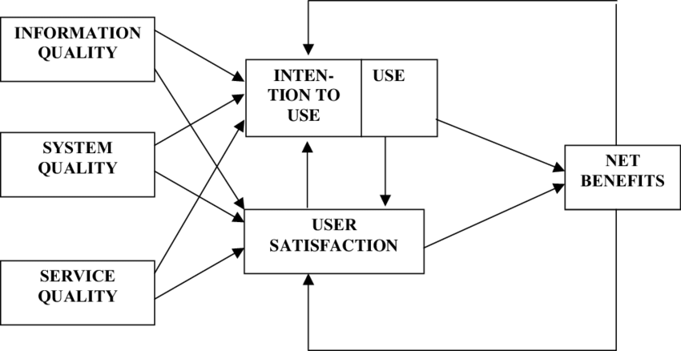
Figure 1: DeLone and McLean IS Success Model
(Source: Adapted from Çelik and Ayaz, 2022)

2.2 Identification of inefficiencies and gaps
Multifaceted gaps and efficiencies have been identified that are currently slowing down Kalori Ltd.

2.2.1 Inventory Issues
Since the systems are not interconnected and synchronised, inventory systems lack real-time updates which can cause lack of stocked goods and inaccuracy in forecasting. Customers have been unable to place orders and replenishment has been delayed due to the lack of interconnection between physical stores and online platforms.

2.2.2 Disconnected CRM (customer relationship management)
Due to fragmented customer data, a unified assessment of customers has not been possible for Kalori Ltd. Moreover, marketing limitations have occurred due to lack of tailored impacts on customers as there is limited access to purchase history and customer insights (Theodorakopoulos and Theodoropoulou, 2024). Kalori Ltd. has been unable to build proper engagement with the customers and enhance loyalty.

2.2.3 Security and regulatory compliance
The lack of centralised governance control has led to ineffective management of audit trails and exposed the business to potential security breaches and external threats. It is viewed that the firm may suffer from GDPR (General data protection regulation) compliance issues as audits, reports and customer data must be secured properly.

2.2.4 Poor integration of systems
Integration of systems is not present in Kalori Ltd. which has led to manual use and transfer of sales data to finance departments, creating scope for errors and discrepancies. Furthermore, the inventory updates lack proper information sharing in real time due to communication barriers and poor service outcomes affecting business performance.

2.2.5 Reporting delays and data quality problems
The manual data entry and spreadsheets used in sales have caused delayed services and errors in data affected the inventory management and stock levels. Kalori Ltd. has suffered sales discrepancies because of the inadequate stock levels and replenishment delays due to outdated information kept in spreadsheets.

3. Recommended Solution

3.1 Proposal of a suitable new or upgraded information system
Kelori Ltd. is suggested to integrate a cloud-based ERP system with CRM and business intelligence (BI) capabilities. The operational challenges can be addressed with the help of this solution effectively. The enterprise resource planning (ERP) system will be integrated with inventory management module, ecommerce integration, financial tactics, BI and CRM tools. Since the ERP system is cloud-based, it can facilitate real-time accessibility of data, improve visibility and enhance communication systems (Khokrale, 2024). Kalori Ltd. is offered with multiple platforms through which the ERP system can be acquired and implemented. These platform suggestions include SAP (SAP Business One), Oracle and Microsoft (Dynamics 365). Kalori Ltd., being a fast-growing electronic consumer company, can leverage the Oracle NetSuite because it is effective for businesses undergoing scalability. Oracle NetSuite is a comprehensive cloud-based platform integrating HR, CRM and ecommerce functionalities into a single suite allowing business to transform and enhance real-time visibility (NetSuite, n.d.). It can facilitate strong retail integration and help with cloud deployment through a user-friendly interface.

Figure 2: NetSuite Logo
(Source: NetSuite, n.d.)

3.2 Justification for the recommendation based on business needs, efficiency, cost and scalability
Aligning systems implementation to business needs: With an integrated ERP system, Kalori Ltd. can leverage the unified platform for operating multifaceted functionalities of the business. This can help the business to minimise inventory issues, data inaccuracies, establish digitalised reporting structures and remove departmental silos.
Improving efficiency: By automating the inventory, the stock levels management can be improved and replenishment can be achieved on time to improve sales rates (Daniel and Archie, 2024). This can facilitate customer satisfaction through effective stocking initiatives. The ERP systems and automated alerts can inform on stock requirements and eliminate redundancies. CRM integration can automate personalised campaigns followed by accurate financial reports.
Minimising cost: While upfront costs for implementing a cloud-based ERP system can be high, it will reduce cost of operations in the long term (Gooda et al., 2025). Kalori Ltd. will benefit from high sales rates due to proper stock levels, higher customer satisfaction, eliminating unskilled workers can save costs through automation and minimised compliance risks.
Scalability considerations: Since Kalori Ltd. is undergoing expansion and is likely to open more stores across other regions, the suggested cloud ERP can help in scaling up the business. The solution ERP system can add more users, integrate newer sales channels and help the managers to operate multiple inventories.

3.3 Explanation of how the system will improve operations, data management and decision-making
The solution systems will effectively improve operations, facilitate high accessibility in real-time and data management so that proper decisions can be taken. To elaborate, the key benefits and improvements that can be introduced through the suggested initiatives will enhance competitive advantage of the business. By integrating Porter’s Value Chain Model, the integration of the ERP system will be critically analysed to detect the positive outcomes. The value chain model by Porter shows how organisations can develop competitive edge through digital solutions and coordination achieving efficiency between primary and support activities (Al-Shammari, 2023). It is viewed that the ERP system strengthens the primary operations through the enhancement of inbound logistics, marketing and sales, strong services and high productivity. As per the views of Jude (2025), using automated inventory operations, cloud-based platforms to improve real-time visibility and accuracy in forecasts will accurately help in stock replenishment. Similarly, the CRM integration will help in tracking down customer perceptions and needs, thus improving overall customer services for Kalori Ltd. likewise, the interconnected support activities will undergo improvement due to this ERP system as firm and technology infrastructure becomes strong to improve compliance with regulations.
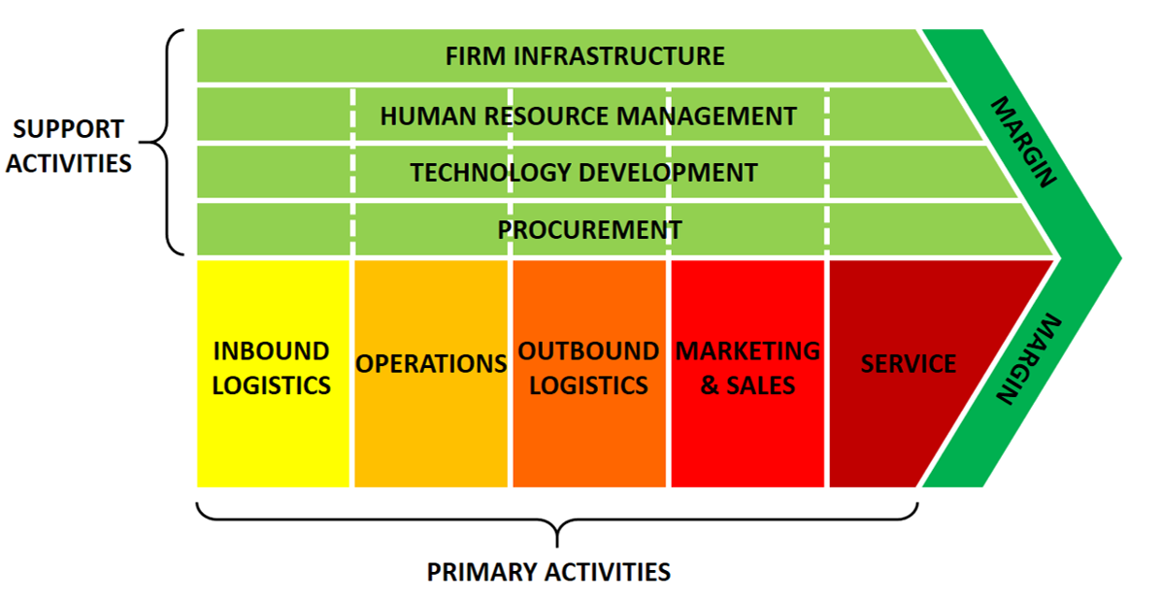
Figure 3: Porter’s Value Chain Model
(Source: Inspired from Al-Shammari, 2023)

4. Implementation Plan

4.1 Steps for implementing the new system
The table below offers an in-depth understanding of a structured implementation plan for the integration of the ERP system. Each stage includes multiple activities to achieve the key initiatives which can address the end goal of the project.
Stages | Key initiative | Actions | Time required
Phase 1 | Analysing Requirements | Conducting stakeholder meeting | 2 months
Phase 1 | Analysing Requirements | Identifying existing business goals | 2 months
Phase 1 | Analysing Requirements | Detecting customisation requirements | 2 months
Phase 2 | System identification and vendor selection | Evaluating ERP vendors | 1 month
Phase 2 | System identification and vendor selection | Assessing cost, scalability and integration impacts | 1 month
Phase 2 | System identification and vendor selection | Finalising vendor and contractual terms | 1 month
Phase 3 | Designing systems and configuration | Configuring requirements and modules | 3 months
Phase 3 | Designing systems and configuration | Addressing user roles | 3 months
Phase 3 | Designing systems and configuration | Implementing firewalls | 3 months
Phase 3 | Designing systems and configuration | Reporting dashboard setup | 3 months
Phase 4 | Data integration | Existing data should be removed | 2 months
Phase 4 | Data integration | Filter through duplicates | 2 months
Phase 4 | Data integration | Historical data migration | 2 months
Phase 5 | Testing and implementation | Unit tests and staff assessments | 1 month
Phase 5 | Testing and implementation | On-the-job training | 1 month
Phase 5 | Testing and implementation | User acceptance monitoring and evaluation | 1 month
Phase 5 | Testing and implementation | Compliance measurements | 1 month
Table 1: Implementation Plan for the ERP system at Kalori Ltd.

4.2 Consideration of training, integration with existing infrastructure, and potential challenges
Multifaceted challenges may be faced by Kalori Ltd. while integrating the ERP systems into the business. This is likely to happen because of the sudden changes and transformation of the legacy systems which may require time and adjustment among staff. The anticipated challenges during digital transformation have been elaborated along with mitigation strategies.
Employee resistance to change: The proposed solutions of changing the legacy systems into dynamic and advanced cloud-ERP systems can affect their responses and create resistance to change. It is important for companies undergoing digital transformation to engage with the staff, implement digital training programmes and enhance skill sets (Alieva and Powell, 2023).
Errors during data migration: During data transfer from old systems into the cloud platforms, errors may occur which demands effective data cleansing and tests run across parallel systems.
Transitional system downtime: Another risk for the business is the system downtime which is common if the transition takes place during a high sales period. This means Kalori Ltd. should ensure that the implementation takes place in a low-sales period.
Overruns in budget: To navigate the challenges of exceeding budget, project scope should be clearly addressed with phase-based deployment to avoid unnecessary expenditure.

5. Conclusion

5.1 Key takeaways
The report concludes that Kalori Ltd. should undertake the proposed solution of cloud-based ERP system to overcome the current issues of inventory management and poor IT systems. For tackling the accuracy problems and data errors, the integrated ERP system with CRM and BI dashboards can improve overall reporting structures and strengthen communication. Furthermore, the implementation plan has been added along with potential challenges that may affect Kalori Ltd. the mitigation strategies have been mentioned along indicating that training of staff and data cleansing are vital strategies to eliminate risks during ERP integration.

5.2 Expected benefits
The implementation of the ERP system will be beneficial for the firm due to enhanced business intelligence capabilities, enhanced visibility of the inventory processes in real time and minimised stock discrepancies. Furthermore, the integrated CRM systems will facilitate the company to make personalised marketing tactics and drive higher sales. Furthermore, automated reporting systems and better compliance can offer security and long-term competitive edge to the firm.

References
Alieva, J. and Powell, D.J., (2023) ‘The significance of employee behaviours and soft management practices to avoid digital waste during a digital transformation’, International Journal of Lean Six Sigma, 14(1), pp.1-32.
Al-Shammari, M.M., (2023) ‘Production value chain model for sustainable competitive advantage’, Management Systems in Production Engineering, (1 (31), pp.27-32.
Çelik, K. and Ayaz, A., (2022) ‘Validation of the Delone and McLean information systems success model: a study on student information system’, Education and Information Technologies, 27(4), pp.4709-4727.
Daniel, M. and Archie, O., (2024) ‘Optimizing SME inventory operations: IoT and automation for cost-effective stock management’, Journal of Supply Chain Innovation and Technology, 12(4), pp.55-70.
Gooda, S.K., Mohanraj, P., Veni, J., Ashish, A., Kannadhasan, S. and Thamizhkani, B., (2025) ‘Cloud-Based Solutions for Scalable Enterprise Resource Planning Systems Benefits and Implementation Strategies’, In ITM Web of Conferences (Vol. 76, p. 05002). EDP Sciences.
Jude, T., (2025) ‘How Cloud-Based Solutions Improve Inventory Management in Retail’, Sci. Direct J. Supply Chain Innov, 18(1), pp.88-99.
Khokrale, R.K., (2024) ‘Using Cloud-Based ERP Solutions for Real-Time Supply Chain Visibility and Decision-Making’, International Journal of Research Publications in Engineering, Technology and Management (IJRPETM), 7(2), pp.9811-9830.
NetSuite (n.d.) NetSuite Enterprise Resource Planning (ERP) System. Available at: https://www.netsuite.com/portal/products/erp.shtml (Accessed 28 February 2026)
Pamisetty, A., (2023) ‘Intelligent Infrastructure for Real-Time Inventory and Logistics in Retail Supply Chains’, Available at SSRN 5267332.
Saghiri, S. and Mirzabeiki, V., (2021) ‘Omni-channel integration: the matter of information and digital technology’, International journal of operations & production management, 41(11), pp.1660-1710.
Samineni, N.C., (2023) ‘High-Volume Data Reconciliation for Daily Retail Sales and Inventory Reporting’, In Modern Economics & Management Forum (Vol. 6, No. 5).
Theodorakopoulos, L. and Theodoropoulou, A., (2024) ‘Leveraging big data analytics for understanding consumer behavior in digital marketing: A systematic review’, Human Behavior and Emerging Technologies, 2024(1), p.3641502.

