Student Name: Maria-Victoria Lazar  Student ID: 2235531  Module Title: Foreign Languages & Cultural Awareness  Module code: BMIH5003  Lecturer: Heidi Prosser  Date: 09.02.2024 | 
ASSIGNMENT 1: PORTFOLIO
(4 Components)

Component 1: Professional Reflection (500 words +/- 10%)

Weighting: 25%
I am an F&B employee at Radisson hotel where I have been working for the last three years. This place is quite famous which is why many tourists involve this place as a tour destination (Gao and Su, 2023). My initial days of employment in the hotel are very tough and quite disturbing for me. I have a careless nature, and because of this I continuously make little mistakes that highlight my bad performance at the workplace (Moneva and Leukfeldt, 2023). I can never forget a very panicked and funny case which was created by my misunderstanding and also some because of the guest misinterpretation, about the requirement. I almost remember that it was a rainy evening when I was busy taking orders and serving food to the national and international guests at the restaurant. At that time we had a couple from Germany as tourist guests and also a lady from India who can be counted as a senior citizen of her community. According to my memory, The German couple ordered "We want drei (is a German word that means three) hamburger and a bottle of wine" but I take it as a "dry hamburger and a bottle of wine" (Anon, 2020). On the contrary, the Indian lady ordered "Please bring me that" by pointing her finger at the menu card, in the specialty column. This behavior of the old Indian lady demonstrates that she may or may not know the English language.
When the orders are arrived at the table both the international guests are very disappointed as they wait very long for the desired food and still the results are not accordingly. While the Indian lady is shouting because she is religiously strictly vegetarian. However most of the confusion was created by the guest side, but I was also scolded by the manager because I should confirm the order at least one more time. This confusion not only hurt the guest but also harmed the brand image of the restaurant because of the guest's appropriate behavior including shouting and yelling at me as a reaction to confusion (Stokburger-Sauer and Hofmann, 2023). After that, we abruptly provided the German couple the required but were unable to do so for the lady because she instantly ran out of the restaurant (Kostova, 2023).
After this panic confusion, I suggest the manager print the menu cards in many different languages as this place is very famous for tourism. The Manager said it would be very costly and take many places. Because it is not possible to add every language to the card, even if it is done there is still a 30-40% chance of confusion. So I suggest why not adopting digital technology for placing orders, to avoid confusion. My suggestion impresses the manager and he discusses it with his boss and on that day no more such situation is happening. , we successfully launched a free app through which the guests can have details of the food in their language, along with a picture, on their mobile phones. Now the manager is planning to arrange a self-service kiosk for the customers, with which they can easily add food from the menu to their order and also pay the charges (Vongsumedh, 2023).
References:
Anon, (2020). German Numbers - Counting in German to 999,999 | Learn German Easily. [online] Available at: https://learn-german-easily.com/counting-in-german [Accessed 30 Jan. 2024].
Gao, Y. and Su, W., 2023. The long-run tourism effect of historical celebrities: Evidence from one of the most influential literatus in China. Tourism Economics, 29(6), pp.1461-1483.
Kostova, K.B., 2023. TEACHING SOFT SKILLS IN THE BUSINESS ENGLISH FOREIGN LANGUAGE CLASS IN BULGARIA. Endless light in science, (март), pp.178-186.
Moneva, A. and Leukfeldt, R., 2023. Insider threats among Dutch SMEs: Nature and extent of incidents, and cyber security measures. Journal of Criminology, 56(4), pp.416-440.
‌Stokburger-Sauer, N.E. and Hofmann, V., 2023. Can a smile help heal service failures? The interplay of employee emotions, guest emotions, and justice perceptions for successful service recoveries in the hospitality industry. Journal of Hospitality and Tourism Management, 55, pp.261-276.
Vongsumedh, P., 2023. E-Café: An Innovation for Providing Safe Services in a Dine-in Restaurant during the New and the Next Normal. Journal of Roi Kaensarn Academi, 8(3), pp.361-373.
Component 2: Training Plan (500 words +/- 10%)

Weighting: 25%

Recent events at Radisson hotel have made it clear that it is important to train the staff better. This way of doing things will make sure that all workers are ready to handle a wide range of situations that might come up at work. The main goals are to improve the skills of the staff, keep up the high standards that the unique company is known for, and make the whole tourist experience better. The first important thing is to do is make a detailed training plan for the team that fits the needs of the business. The training program that is being developed is called “Diversity Training”. It is clear that staff members need to keep learning and growing when they acknowledge the ideas and experiences they already have.
The first step in the process is to find and label important situations so that can be deal with the many problems the team faces. Taking care of angry customers, reacting to emergencies, or fixing problems with the service are all examples of this. The ability to spot and understand the specific problems is what makes it possible to make training courses that work The training program will be tailored to each specific situation.
Modules on things like case studies, role-playing games, and how to communicate clearly are common in these types of classes. An emergency response module could have both a virtual and a real workout module at the same time (Trinidad, 2020). Along with improving technical skills, these classes stress "soft skills" like tolerance and cultural knowledge.
Sessions that try to improve the general tourist experience are an important part of the training plan. This means sharing what to know about figuring out what visitors will want, giving them personalised service, and solving problems before they happen (Christou and Chatzigeorgiou, 2019). Success stories and cases from real life will be used to show how great service can make tourists' trips more enjoyable. I think it should push cross-functional training for the staff if there is a need to fully understand how the hotel works. By promoting teamwork and collaboration, this makes sure that all employees are informed of the problems their coworkers in different jobs are facing (Dhevabanchachai and Wattanacharoensil, 2017).
One of the goals is to commit to continued career growth. At this point, employees has been sent to the classes and workshops regularly to make sure they are up to date on the latest developments in the hotel business (Trinidad, 2020). To find out how well the training programme is working, there is a requirement to set up a strong method for review and feedback. Evaluations, polls, and comments from field workers will be looked at from time to time. With the new information, training programmes will be made better and more up-to-date, so they can meet new obstacles and get better over time.
References:
Christou, E. and Chatzigeorgiou, C., 2019. Industrial placement in hospitality management education. Students' experiences and development of skills. In ICOMEU conference proceedings. 2nd international congress on management of educational units, 29th November-1st December 2019, Thessaloniki, Greece (pp. 157-164).
Dhevabanchachai, N.T. and Wattanacharoensil, W., 2017. Students’ expectations, experiences, and career direction after in-house internship: the pedagogical role of the hotel training center in Thailand. Journal of Teaching in Travel & Tourism, 17(2), pp.118-134.
Trinidad, C.O., 2020. Implementation of the student internship program in the Philippines: The BSc in Hospitality Management Program of host training establishments in the National Capital Region. African Journal of Hospitality, Tourism and Leisure, 9(2), pp.1-16.
Component 3: Student Self-Reflection (500 words +/- 10%)

Weighting: 25%
Since I started working in the hotel business, my view on how important it is to know about other cultures has changed. The stages of the Gibbs Reflective Cycle description, feelings, evaluation, analysis, conclusion, and action will help me think critically about how I have grown my cultural understanding.
Description
I had a very basic idea of cultural awareness when I first started working in the hotel business. It was limited to noticing and enjoying the different cultures of the guests. I learned how important cultural understanding is, though, as I worked in the field and saw how it worked in real life.
Feeling
Because I work with a wide range of people and coworkers, my feelings have gone from being happy to occasionally feeling uneasy. Despite some problems at first, the task of getting used to new cultural norms led to career and personal growth.
Evaluation
When I think back on my trips, I realise how important it is to be sensitive to other cultures. Beyond simple talks, it takes the ability to understand subtleties, predict different needs, and create an environment where everyone feels welcome (Bavik¸ 2016). When I learned that knowing other cultures is not only a matter of courtesy in the service industry, it changed my first thoughts.

Analysis
My way of thinking about ideas changed because of real-life events. Some people at an international event did not have as much fun because they did not understand other cultures (Dzhandzhugazova et al., 2016). As soon as I came to this decision, I started reading a lot of scholarly writing on the topic. This helped me develop my formal knowledge of cultural awareness.
Conclusion
After considerable consideration, I have decided that everyone working in the hospitality industry has to have a solid awareness of cultural differences. The company's income and image also go up, and so do the customers' happiness (Hayes et al., 2021). Honouring and recognising people from different ethnic groups not only improves service performance but also makes everyone feel welcome.
Action Plan
I would like to keep learning about cultural awareness and use what I learn in the future. I want to get even better at what I do by going to more training classes and workshops. In addition, I want to help my team become more culturally aware by sharing what I know and what I have done.
My personal development journey has led to a greater understanding of the need of cultural sensitivity in the hospitality industry, which has completely changed my life. I have realised how crucial cultural sensitivity is to provide the visitors a really unique experience by fusing classroom learning with real-world application. As I progress in the hospitality sector, I understand that I will need to continuously improve and use my abilities in cultural awareness; doing so will support both my professional and personal growth.

References:
Bavik, A., 2016. Developing a new hospitality industry organizational culture scale. International Journal of Hospitality Management, 58, pp.44-55.
Dzhandzhugazova, E.A., Blinova, E.A., Orlova, L.N. and Romanova, M.M., 2016. Innovations in hospitality industry. International Journal of Environmental and Science Education, 11(17), pp.10387-10400.
Hayes, D.K., Hayes, J.D. and Hayes, P.A., 2021. Revenue management for the hospitality industry. John Wiley & Sons.
Component 4: Training Presentation (6 Slides)

Weighting: 25%
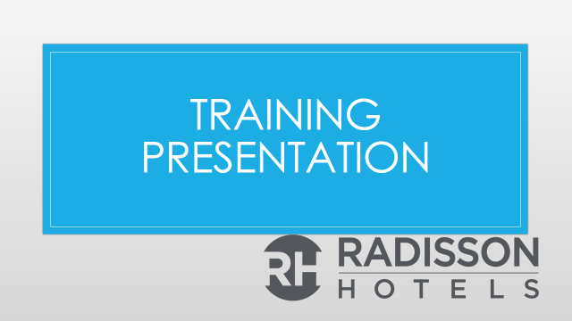
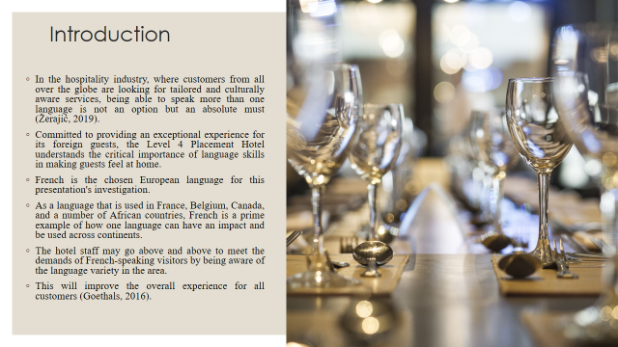
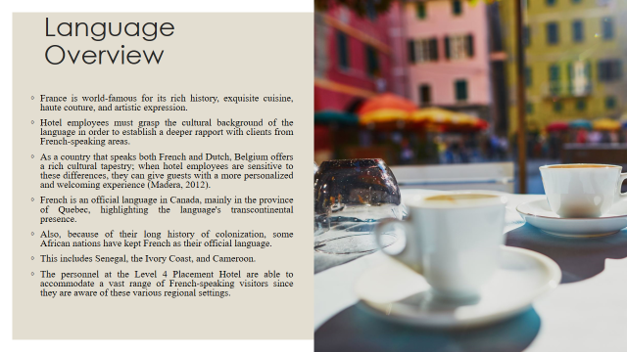
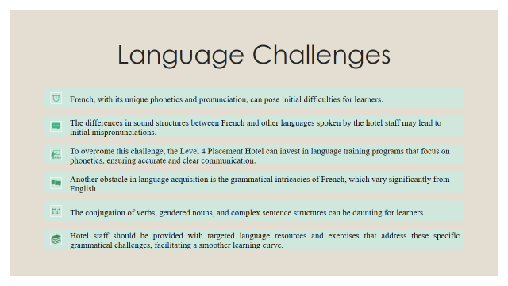
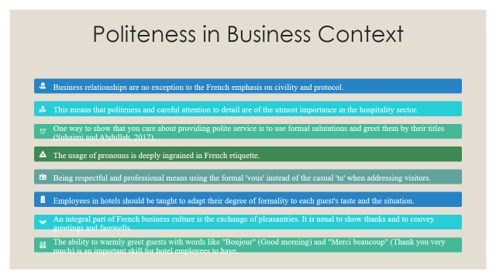
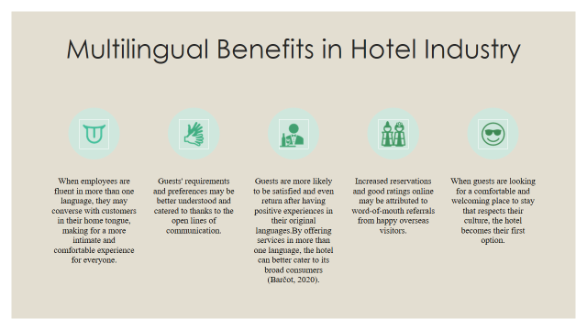
References (no screenshots):
Barčot, K., 2020. THE EFFECT OF MULTILINGUALISM ON PERSONALITY (Doctoral dissertation, RIT Croatia).
Suhaimi, N.I.B. and Abdullah, A.B., 2017. The Role of Multilingualism in Enhancing Tourism Sector in Malaysia. International Journal of Academic Research in Business and Social Sciences, 7(7), pp.2222-6990.
Madera, J.M., Dawson, M. and Neal, J.A., 2012. The effect of knowing a second language and experience working with non-English speakers on job performance. International Journal of Hospitality Management, 31(4), pp.1083-1089.
Goethals, P., 2016. Multilingualism and international tourism: a content-and discourse-based approach to language-related judgments in web 2.0 hotel reviews. language and Intercultural communication, 16(2), pp.235-253.
Žerajić, A., 2019, June. Intercultural management and the importance of foreign languages in modern hotel industry. In Tourism International Scientific Conference Vrnjačka Banja-TISC (Vol. 4, No. 1, pp. 360-377).

