Academic report on reflective learning experiences

By
Omolara Lawal-Akintola
1906883
Lecuturer : Shao-Lan Yuen

INTRODUCTION
Academic and Employability skills is a module designed to equip individuals with academic and transferable skills that can be applied to the workplace. These skills provide individuals with various job opportunities in both the private and public sectors of the economy. The aim of the module is to groom individuals to be confident and competent in a range of employability skills which will make these individuals be craved by employers and standout among their equals in the employment market.
There are various skills that are required to be employable, but before you are considered, you need to be noticed on paper, that is presenting an amazing Curriculum Vitae (C.V), which is attached to an interesting Cover Letter. Presentation Skills are also a stepping stone towards gaining ones desired job. After being noticed on paper via ones C.V and Covering Letter, one could be called for interview for further selection where some Presentation skills will be demonstrated. Time Management skills is also key in the workplace, time must be managed effectively (Morgan, 2017).
In this academic report Kolb’s Reflective Model will be used to give a reflective report on my learning experiences both inside and outside the classroom environment in the following skills, C.V’s, Covering Letters, Presentation skills and Time Management.

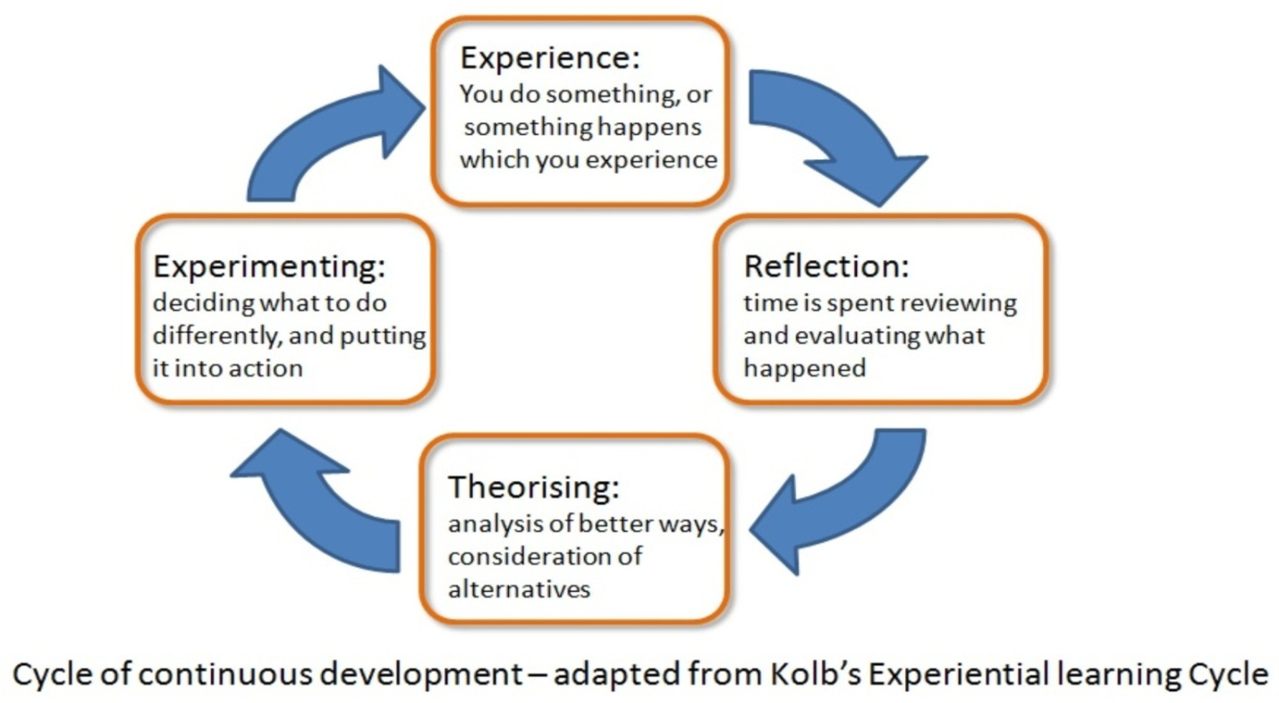(1984). Source: Google Images
I arrived in the United Kingdom with a Bachelors’ degree in Business Education and previously worked as an accountant. The educational orientation I received in my country was entirely different, it was purely academic. There was nothing like reflecting on our experiences and applying it to our workplace. At the moment I am transitioning from being an accountant to becoming Care personnel. It is an entirely new experience to me.
CURRICULUM VITAE (C.V)
Previously, I had a conservative view about writing C.V.’s; I thought that they were monotonous. I had the view that it was all about me, I never liked drafting one, this why I have hardly changed jobs. I used to write all the good things about myself concerning my educational and work experience, always thinking such information would get me shortlisted for an interview. Alas, from my various

lectures in this module as well as academic literature, I have learnt that I am totally wrong. I assume this is why I was not able to get the job I wanted easily. My C.V. must have been sorted to the “No list”, it did not find itself in the “May be” list, talk less of the “Yes list”. Now I have an idea of what a C.V is really all about. A C.V. can be defined as a concisely written document, highlighting who an individual is, the person’s educational and professional qualifications, a person’s capabilities as well as the individual’s job experience that will convince an employer to offer the individual a job, or give the person the opportunity to move to the next level in the process of job selection (Morgan, 2017). I have learnt from this module that C.V’s are about the employer and not me. It shows how I can help the employer. It establishes trust and a connection by understanding what the employer wants by providing the appropriate information about myself that fits the job description and shows that I can help the employer achieve its aim and objectives. Maund (2017) supports the view that Functional C.V’s provide information on “what you can do for them (employer), that is, how I can help the employer. Furthermore, I learnt that I have to research into the organization that I am seeking employment with. I need to know everything that needs to be known, both Maund (2017 p.285) and Morgan (2017 p.340) supported this view which I agree with, as I have learnt that this will enable me to know what the employer wants which will in turn enable me to understand the employer better and be able to provide the required help they would need. Having read and learnt about C.V’s, I now realize that they are all about the employer and my understanding about C.V’s has improved.

COVERING LETTER
A Cover Letter in my opinion is a document that accompanies or is attached to a C.V., which was more or less, to me had the same information that was contained in a C.V. I did not even think it was necessary, once the C.V was drafted, I thought that was enough to get me employed. I also thought it was all about me, but having the opportunity to come back to the university and pass through a course in academic and employability skills has proved me wrong. It has made me realize that for a cover letter to be interesting, it needs to be about the employer, it needs to indicate that I understand the employer and how I can help it achieve its mission or vision.
From my lectures in this module I have learnt that cover letters are about the future while C.V’s are about the past. A Cover Letter has to give an interesting impression to catch the attention of the person who is likely to read it. So the person’s name can be used at the beginning, to make it a little bit less formal. The aim of a cover letter is to attract the attention of the intending employer to look at my C.V (Maund, Schriek, & Tinkle, 2017). It should definitely not be a replicate of the C.V. Morgan (2017) supports the latter view and I agree with him. Furthermore, the most relevant and significant idea to me that I have learnt is from Bounds (2007), “Afters Concept,” which emphasizes the “cause” or the impact of what I do, that is the after effect of my cover letter on the individual that reads it. A Cover Letter has to give an interesting impression to catch the attention of the person reading it, so where it is possible one should find out the name of the person who is likely to read it. I should indicate how I am going to add value to the organization, is it by being economical, adding to the profit margin, observing effective time management or prompting its goodwill? I also learnt that I should pick a clue from the organisation’s mission statement or vision and align it with my skills to suit the job position in question.

PRESENTATION SKILLS
Doing presentations is something that I have always dreaded for a very long time. Am an introvert and shy, I feel anxious and nervous of the thought of it. Even the one we did recently, despite the fact that my camera was off and I was not physically facing an audience, I still felt nervous. I had to summon up courage to do it. It was even one of my class mates that encouraged me. May be this happening because I think the presentation is about me and wondering what people’s comments will be.
Presentation is conveying information of specific goals (Morgan, 2017). Presentation skills are one of my major weaknesses; this might be due to my stage fright. I am in dire need to improve this skill which I view as being highly important as it exhibits how I can effectively communicate verbally. The latter is an important skill when selected for interview. According to Bounds (2007), who specified 5 rules that one can implement for communication to stick, which are (1) Make sure the context is known to the audience, (2) think from the perspective of the audience, (3) being thorough is key, (4) Collect extra information and (5) provided required information only. I will try and practice these rules in future to see whether it will improve my presentation skills. While I learnt from my lecturer, in this module, that a presentation is all about the audience, and not about me, it is how I can help them. Bounds (2007) is also in support of the latter idea, that the audience just wants to know if one can help them. Sometimes and more often than not, communication is not effective where the presenter and the audience have conflicting focus (Bounds, 2007). I quiet agree with this school of thought, as if my perception differs from the audience, effective communication will not take place. A presentation is rewarding only when you get what you want afterwards (Bounds, 2007). This is what Bounds (2007) refers to as “afters”, which are the benefits which normally occur at a future date.

However, I have not sufficiently developed my skills in presentations. I am not yet confident about presenting but will put in more effort in future to overcome my present nervousness.
TIME MANAGEMENT
Before I had the opportunity to return to the University procrastination was the order of the day for me. I constantly postponed several daily routine activities. I also found it difficult to say ‘no’ to do things for other people when I had so many things that I had to do myself. This is also coupled with the fact that I have a Nigerian background where time is not valued so much. If a function is suppose to start at 10.00a.m people will not start arriving until 12.00p.m., this is what we call “Nigerian time”, my people are not time conscious at all. When I arrived in the United Kingdom I discovered that time is money and they a very time conscious, which is a totally different setting for me, I just had to adjust. Furthermore, in this module I discovered that there is a whole topic that dealt with time management, so I wondered at the time, what is there to learn about managing ones time?
I learnt that Time Management is our capability to utilize our time productively (Morgan, 2017). Furthermore, Morgan (2017) stated that good time management is the potentiality to influence the usefulness of our time in such way that we are capable of planning and managing what we do without excessive pressure. To be able to manage my time and let procrastination be a thing of the past in my personal life and career, I needed to set my goals using SMART that is, my goals needed to be specific, measureable, attainable, relevant and time bound. I now do things differently by agreeing with (Morgan, 2017)’s school of thought, focusing and prioritizing my goals and tasks, as well as adopting the “Time Management Matrix” which involves two features, ‘urgency’ and ‘importance’ of the goal or task to be achieved. Furthermore, I now keep a diary to list out my to-do-list in order of urgency and importance. I have also gradually developed the habit of being able to say “no” and being a bit more assertive in my approach (Cottrell, 2015), when I have several tasks of my own to do.

CONCLUSION
This report has been able to use Kolb’s Experiential Learning Cycle to reflect on my previous and present learning experiences. My learning and experience of the topics discussed has totally changed my perspective, as per the C.V. and Covering Letters I have now realized that they are all about the employers, reflecting an understanding of the employer as well as indicating how my skills can help the employer achieve their objectives. I have an improved understanding of Presentations, which is all about the audience and seeing things from their own point of view as well as how I can help them do things or reason differently. However, I have not sufficiently developed my skills in presentations. I am not yet confident about presenting, but will put in additional effort to overcome my stage fright. My perspective on how I manage my time has definitely changed, my time is much more organized and planned, which has helped my personal and workplace tasks. While I am still jittery about presentations, I will definitely do things differently and pick a clue from my learning experiences from this course (Academic and Employability Skills), both inside and outside the classroom. This will make me more attractive to prospective employers.

REFERENCES
Bounds, A. (2007). The Jelly Effect: How to Make Your Communication Stick. England: Capstone Publising Ltd.
Cottrell, S. (2015). Successful Self Management. In Skills for Success Personal Development and Employability (pp. 97-105). London: Palgrave Macmillan Publishers Limited.
Maund, A., Schriek, M., & Tinkle, P. k. (2017). Resumes, Interviews and Negotiation. In K. M. Quintanilla, & S. T. Wahl, Cerficate in Higher Education: Skills for the Workplace Student Yearbook (pp. 281-310). London: SAGE Publications Ltd.
Morgan, P. (2017). Time Management. In P. Morgan, The Business Student's Guide to Study and Employability (pp. 49-67). London: SAGE Publications Ltd.

