

ACCA 7002
DATABASE SYSTEMS
Assignment 1

Submitted by: Shubhi Pushkarna
Student ID: 2230035
Course: Msc data science and Analytics

Abstract
In order to promote effective management of artists, works, customers and transactions, this assignment provides the foundation for the implementation of a robust and scalable database system for the Art Emporium. The ERD allows for a more detailed understanding of relationships and dependencies among different entities within the system, which is visually represented by the database structure.
The purpose of the Art Emporium Database Administration System (DBMS) is to offer complete and effective administration for an online art marketplace. SQL is used by the system to manipulate and retrieve data from a relational database. The construction of an Entity-Relationship Diagram (ERD) to illustrate the links between important entities is one of the tasks in this assignment's conceptual and logical design components for the database.
Artists, Artworks, Categories, Customers, Orders, ArtworkOrders, and Transactions are some of the entities that are present in the system. The ERD captures the complex interactions involved in an art emporium's operations by illuminating the relationships and interdependence between these organisations. Artists produce works of art that fall under several categories. Orders are placed by customers that include several Artworks. For financial monitoring purposes, each Order is linked to a Transaction.
The database is made to handle basic functions including order processing, financial transactions, artwork and category administration, user and artist management, and more. Additionally, it supports elements that improve the overall user experience, such as customer reviews and feedback.
The database administrator's job is to create Stored Procedures for transactional operations using Rollback and Commit as needed to guarantee data security and integrity. Triggers and Functions are also used to audit Insert, Update, and Delete operations on important tables, such the Customer and Artist tables.

Table of contents

- Introduction……………………………………………………………………..4
- Entity Relationship diagram……………………………………………...……..5
- Performance Tuning ……………………………………………………..……..8
- Transaction Questions …………………………………………………………10
- Code Executed …………………………………………………………………12
- Conclusion………………………………………………………………………17

- Introduction

Structured Query Language (SQL) is a cornerstone in the dynamic field of data management, enabling enterprises to effectively store, retrieve, and process enormous volumes of data. This assignment seeks to explain the nuances of SQL, the language that powers relational database administration, as we go deeper into the world of databases.

This assignment will walk you through the fundamentals of SQL, covering everything from simple data manipulation and queries to more complex subjects like joins, subqueries , triggers, indexing, functions, transactions and stored procedure. As we move further , we’ll have a thorough grasp of how SQL facilitates user interaction with databases using Entity Relationship diagram , allowing for effective data administration and the extraction of insightful information.

In this task, we will make a database schema prototype using an appropriate Entity Relationship Diagram after analysing Swansea Art Emporium's needs and data collection . To help Swansea Art Emporium handle artist and client needs, we will use PostgreSQL database using SQL queries and commands.

The report will also delve further into the

- SQL code that was used to establish each table structure, as well as the SQL code that was used to develop the database performance optimisation upgrades, referential integrity constraints, check constraints, and check constraints.
- SQL code that adds believable sample data to every table
- SQL code that provides proof of the tests done to confirm the restrictions
- SQL code to show proof of transaction commit and rollback actions
- SQL code for triggering and function implementation and testing.

- ENTITY – RELATIONSHIP DIAGRAM FOR SWANSEA ART EMPORIUM

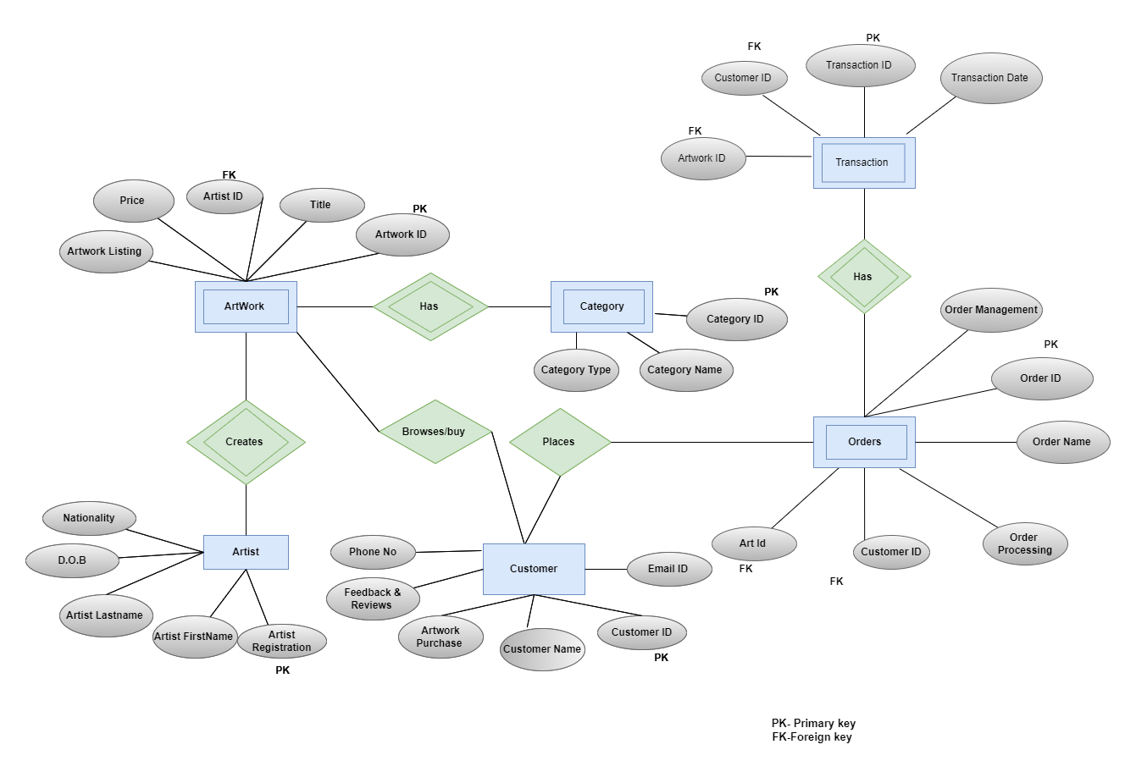
Figure 1. ERD for Swansea art emporium

The entities, relationships, and characteristics found in a database system are represented visually in an entity-relationship diagram, or ERD. Relational databases are frequently modelled and designed using it. The above ERD that is —a company that offers a variety of art for sale.
In the above Representation
- Rectangles are used to symbolise different entities.
- The symbol (PK) denotes the primary keys.
- (FK) stands for foreign keys.

Entity relationships are represented by lines joining the connected entities; the cardinality is shown at both ends of these lines.

Entities:
- Artist: Attributes: Artist Registration (Primary Key), Artist FirstName, Artist LastName, DOB, Nationality.
Represents the artists associated with the art emporium. Each artist has a unique identifier (Artist Registration) and additional attributes such as name, birthdate, nationality.
- Artwork: Attributes: Artwork ID (Primary key), Artist ID/Registration (FK) , title, price, artwork listing.
Represents the various works of art that are up for grabs. A unique identity (Artwork) and many properties, such as , price, title, and Artwork listing, are assigned to every artwork. It is associated with the Artist entity by means of the ArtistID, designating the artist responsible for the artwork. Artwork is a dependent entity on the artist entity as artwork could only exists if there is an artist creating it . Thus, it has been shown in the double rectangle.
- Category: Attributes: Category ID (Primary Key), Category name, Category Type.
Depicts different and various kinds of artwork category, it is a WEAK entity(dependent) on the artwork.
- Orders: Attributes: Order ID (Primary Key), Order Management, Order Name, Order Processing, Customer ID(Foreign key), Artwork ID(Foreign key).
The Order entity is a dependent entity on the customer entity, It is connected with the customer entity with relationship of buying or placing the order
- Customers: Attributes: Customer ID (primary key), Email ID, Phone no, feedback and reviews, artwork purchase.
- Transaction: Attributes: Transaction ID, transaction date , Customer ID, artwork ID. One to one relationship , as one order can have only one transaction.
This ERD includes a Transaction entity to capture financial information related to each order.

Let us examine the relationship among the entities in the art emporium's Entity Relationship Diagram (ERD):

Artist and Artwork
Relationship: One-to-Many (1:N)
Justification: Although an artist is capable of producing several pieces of art, each piece is the product of a single artist. The relationship between the Artist and the Artwork entities, which uses the ArtistID as a foreign key in the Artwork entity, serves as a representation of this.
Artwork and category
Relationship: Many-to-Many(N:N)
Justification: An artwork can belong to multiple categories, and a category can include multiple artworks. To represent this many-to-many relationship, an associative entity called ArtworkCategory is introduced.
The category entity contains information about different categories for artworks, and it may include attributes like CategoryID and CategoryName.
Artwork and Customer
The relationship between the Artwork and Customer entities in an Entity-Relationship Diagram (ERD) typically represents the interaction between customers and the artworks they have purchased or are interested in.
Relationship: Many to Many (M:N)
Justification: An artwork can be of interest to multiple customers, and a customer can be interested in or purchase multiple artworks. To represent this many-to-many relationship.
- The ‘Artwork’ entity contains the information about each artworks , such as ArtworkID, Artist ID, Artwork listing, title and price.
- The ‘Customer’ entity includes the information regarding the customer details , including Customer ID, Name, email, Phone no, Feedback and reviews, Artwork Purchase.
The tracking of client interactions with artworks, such as showing interest or making purchases, is made possible by this design. It offers a means of connecting certain pieces of art to certain clients and vice versa.
Customer and Orders
Relationship: One to many (1:N) or Many to one (N:1)
Justification: A single client can be linked to several orders, but only one customer places each order. Usually, to express this, a foreign key that points to the main key of the Customer entity is included in the Order entity.
The CustomerID foreign key in the Order object, which identifies which client placed the order, establishes the link. This reflects the situation in which a client may place many orders over time in real life by enabling the linkage of multiple orders with a single customer.

- Performance Tuning
Question - Data queries are database transactions used to query the database for information. Think of data query requirements that are going to be important and/or frequently executed in the database and identify three secondary indexes that can be added to improve the performance of such data queries. You should also indicate why you have chosen to index the column(s).
Answer- A database for an artwork emporium may have a number of crucial and regularly carried out data query needs. By adding the proper secondary indexes, database performance may be optimised by identifying these needs. To increase performance, the following three typical data query needs and matching secondary indexes are provided.
Data Query Requirements
- Retrieve Artworks by Category:
Query: Get every piece of art that falls within a certain category.
Index: In the ArtworkCategory table, create an index on the CategoryID column.
Justification: This index makes it easier to explore or search for artworks within a certain category by facilitating the effective retrieval of artworks linked with that category.

- Locate Customer Transactions Between Selected Dates:
Query: Get a list of client transactions from a given time frame.
Index: In the Transaction table, create an index on the Date column.
Justification: By indexing the transaction date, reporting and analytics based on transaction dates work better since rapid access to transactions within a certain time period is made possible.
- Look up artwork by the name of the artist:
Query: Look up artwork by name.
Index: In the Artist table, create a full-text index on the Name column.
Explanation: Finding artworks by artist name is made faster by an efficient full-text index on the artist's name. This is especially helpful in situations when people wish to find artwork by looking up the names of their favourite artists.
SECONDARY INDEX JUSTIFICATIONS
- Categoryid Index
Rationale: Classifications offer an orderly method of arranging artworks. Category-based queries run more quickly when the CategoryID field in the Category database is indexed. This facilitates features like category-based artwork viewing.
- Index of Transaction Dates:
Rationale: Date range queries are frequently used to query transactions, particularly in analytical applications. Retrieving transactions within specified time frames is made more efficient by indexing the Date column in the Transaction table.
- Full-Text Artist Index:
Rationale: The names of the artists are important search parameters for users. In order to improve user experience while searching for certain artists, a full-text index on the Name field in the Artist table expedites searches for artworks by artist name.
With the goal of maximising query performance and response times, these secondary indexes are selected in accordance with the particular query needs and the columns included in these queries.

- Transaction
Question
Briefly explain how the transaction you have implemented for Task 1, to address the situation at Swansea Art Emporium.
Answer - The Art Emporium database employs transactions to ensure data integrity during intricate processes that call for several SQL statements. A collection of one or more SQL statements that are performed as a single unit of work is called an exchange. Keeping the database constant even in the event that one or more statements are executed incorrectly is the primary goal of utilising transactions.
It is possible to run different SQL statements inside the transaction block. Adding new records, altering old ones, or removing data are a few examples. There may be more than one table in these sentences.
A transaction starts with the BEGIN; statement. Until a transaction is specifically committed or turned back, all future SQL statements are treated as part of the same transaction after it has started.
Executing SQL Statements :
Various SQL statements can be run within the transaction block. For example, adding new records, updating current ones, or deleting data. These claims may contain a large number of tables.
adding a new client and the relevant transaction
INSERT INTO Customers (Shubhi, pushkarna, spushkarna26@gmail.com) VALUES ('Shubhi', 'Pushkarna', 'spushkarna26@gmail.com');
INSERT INTO Transactions VALUES (1, 101, '2024-01-07', 500.00) (CustomerID, ArtworkID, TransactionDate, AmountPaid);
Putting a Transaction in Motion:
The advancements achieved throughout the exchange are applied permanently with the use of the COMMIT; statement. All modifications are stored to the data set, and the exchange is complete, assuming nothing goes wrong.

Rolling Back a Transaction:
The ROLLBACK; statement is used to undo changes made since the start of the transaction in the event that an error occurs or if it is necessary to discard the modifications made.
Rolling back the transaction due to an error
BEGIN;
SQL statements
ROLLBACK;

- CODE EXECUTED

Create database art emporium
CREATE TABLE Artists (
ArtistID SERIAL PRIMARY KEY,
FirstName VARCHAR(50) NOT NULL,
LastName VARCHAR(50) NOT NULL,
CONSTRAINT UQ_Artists_Name UNIQUE (FirstName, LastName)
);

CREATE TABLE Artwork (
artwork_id INT PRIMARY KEY,
artwork_name VARCHAR(100),
artist_id INT,
category_id INT,
price DECIMAL(10, 2),
CONSTRAINT fk_artist FOREIGN KEY (artist_id) REFERENCES Artist (artist_id),
CONSTRAINT fk_category FOREIGN KEY (category_id) REFERENCES Category (category_id)
);

CREATE TABLE Category (
category_id INT PRIMARY KEY,
category_name VARCHAR(100)
);

CREATE TABLE Customer (
customer_id INT PRIMARY KEY,
customer_name VARCHAR(100),
customer_email VARCHAR(100),
customer_phone VARCHAR(20),
Customer_FeedbackReviews VARCHAR(50),
);

CREATE TABLE Order(
order_id INT PRIMARY KEY,
customer_id INT,
order_date DATE,
total_amount DECIMAL(10, 2),
CONSTRAINT fk_customer FOREIGN KEY (customer_id) REFERENCES Customer (customer_id)
);

CREATE TABLE Processes (
process_id INT PRIMARY KEY,
process_name VARCHAR(100)
);

CREATE TABLE Artist_Registration (
artist_id INT,
process_id INT,
registration_date DATE,
CONSTRAINT fk_artist_reg_artist FOREIGN KEY (artist_id) REFERENCES Artist (artist_id),
CONSTRAINT fk_artist_reg_process FOREIGN KEY (process_id) REFERENCES Processes (process_id)
);

CREATE TABLE Artwork_Listing (
artwork_id INT,
process_id INT,
listing_date DATE,
CONSTRAINT fk_artwork_listing_artwork FOREIGN KEY (artwork_id) REFERENCES Artwork (artwork_id),
CONSTRAINT fk_artwork_listing_process FOREIGN KEY (process_id) REFERENCES Processes (process_id)
);

CREATE TABLE Customer_Registration (
customer_id INT,
process_id INT,
registration_date DATE,
CONSTRAINT fk_customer_reg_customer FOREIGN KEY (customer_id) REFERENCES Customer (customer_id),
CONSTRAINT fk_customer_reg_process FOREIGN KEY (process_id) REFERENCES Processes (process_id)
);

CREATE TABLE Artwork_Purchase (
purchase_id INT PRIMARY KEY,
artwork_id INT,
customer_id INT,
purchase_date DATE,
CONSTRAINT fk_purchase_artwork FOREIGN KEY (artwork_id) REFERENCES Artwork (artwork_id),
CONSTRAINT fk_purchase_customer FOREIGN KEY (customer_id) REFERENCES Customer (customer_id)
);

CREATE TABLE Order_Processing (
order_id INT,
process_id INT,
processing_date DATE,
CONSTRAINT fk_order_processing_order FOREIGN KEY (order_id) REFERENCES [Order] (order_id),
CONSTRAINT fk_order_processing_process FOREIGN KEY (process_id) REFERENCES Processes (process_id)
);

ALTER TABLE Artist
ADD CONSTRAINT chk_artist_phone CHECK (LEN(artist_phone) <= 20);

ALTER TABLE Customer
ADD CONSTRAINT chk_customer_phone CHECK (LEN(customer_phone) <= 20);

-- Sample data for Artist table
INSERT INTO Artist (artist_id, artist_FirstName,artist_LastName)
VALUES (1, 'Chris','Dignam',);

-- Sample data for Category table
INSERT INTO Category (category_id, category_name)
VALUES (1, 'Painting'), (2, 'Sculpture'), (3, 'Photography');

-- Sample data for Artwork table
INSERT INTO Artwork (artwork_id, artwork_name, artist_id, category_id, price)
VALUES (1, 'beach Painting', 1, 1, 150.00),
(2, 'ancient Sculpture', 1, 2, 300.00);

-- Sample data for Customer table
INSERT INTO Customer (customer_id, customer_name, customer_email, customer_phone,customer_FeedbackReview)
VALUES (1, 'Jane Doe', 'janedoe@example.com', '9876543210', 'Very good');

-- Sample data for Order table
INSERT INTO Order (order_id, customer_id, order_date, total_amount)
VALUES (1, 1, '2022-09-01', 500.00);

-- Sample data for Processes table
INSERT INTO Processes (process_id, process_name)
VALUES (1, 'Registration'), (2, 'Listing'), (3, 'Purchase');

-- Sample data for Artist_Registration table
INSERT INTO Artist_Registration (artist_id, process_id, registration_date)
VALUES (1, 1, '2022-05-01');

-- Sample data for Artwork_Listing table
INSERT INTO Artwork_Listing (artwork_id, process_id, listing_date)
VALUES (1, 2, '2022-081-07');

-- Sample data for Customer_Registration table
INSERT INTO Customer_Registration (customer_id, process_id, registration_date)
VALUES (1, 1, '2022-01-01');

-- Sample data for Artwork_Purchase table
INSERT INTO Artwork_Purchase (purchase_id, artwork_id, customer_id, purchase_date)
VALUES (1, 1, 1, '2022-01-03');

-- Sample data for Order_Processing table
INSERT INTO Order_Processing (order_id, process_id, processing_date)
VALUES (1, 4, '2022-01-04');

-- Testing constraints

-- Transaction rollback example
BEGIN TRANSACTION;
INSERT INTO Artist (artist_id, artist_FirstName,artist_LastName)
VALUES (1, 'Adele, Nozedar);
INSERT INTO Artist(artist_id, artist_FirstName,artist_LastName)
VALUES (1, 'Angela','Graham');
COMMIT;

-- Transaction commit example
BEGIN TRANSACTION;
INSERT INTO Artist (artist_id, artist_FirstName, artist_LastName)
VALUES (2, 'Angela','Graham');
COMMIT;
- CONCLUSION
To conclude, Art Emporium has benefited greatly from the implementation of a well-thought-out database system. The large collection of artworks, artists, clients, and transactions may all be managed centrally and effectively with the help of the database. A structured and well-organized data storage system that makes information retrieval and modification easy has been accomplished via the usage of a relational database paradigm.
By minimising redundancy and guaranteeing data integrity, the database structure efficiently depicts the connections between various entities. By removing data abnormalities, normalisation approaches have produced a system that is more reliable and scalable. Clarity in table relationships is established by the use of main and foreign keys, which enhances accuracy and consistency in data visualisation.
SQL instructions provide for the easy entry, retrieval, and management of data. Security procedures like user identification and access limitations ensure that sensitive data is safeguarded and privacy regulations are obeyed. It is now simpler to access a specific piece of data or entry thanks to indexes.
All things considered, Art Emporium's database solution and the ERD satisfies the organization's requirements for effective data administration and analysis. In addition to streamlining day-to-day operations, the SQL code creates the groundwork for future scalability and adaptability to changing company needs. Art Emporium may expand on this strong database basis as technology develops to remain competitive in the dynamic art industry."

- REFERENCES
- Artist and Makers Emporium. (n.d.). Artist and Makers Emporium. [online] Available at: https://artistandmakersemporium.uk/.
- Petrovic, B. (2018). SQL index overview and strategy. [online] SQL Shack - articles about database auditing, server performance, data recovery, and more. Available at: https://www.sqlshack.com/sql-index-overview-and-strategy/
- Linode Guides & Tutorials. (n.d.). A Primer on SQL Transactions. [online] Available at: https://www.linode.com/docs/guides/a-primer-on-sql-transactions/.
- Sandoval, J. (2023). Understanding Entity-Relationship Diagrams (ERDs) and Their Applications in Database Design. [online] Vertabelo Data Modeler. Available at: https://vertabelo.com/blog/what-does-erd-stand-for/.
- SQLServerCentral. (n.d.). Database Normalization in SQL with Examples. [online] Available at: https://www.sqlservercentral.com/articles/database-normalization-in-sql-with-examples.
- GeeksforGeeks. (2023). Secondary Indexing in Databases. [online] Available at: https://www.geeksforgeeks.org/secondary-indexing-in-databases/#:~:text=The%20primary%20index%20is%20typically.

