



Search

Artificial Intelligence and Machine Learning (ACCA6011)

William Baker – 1703131
Software Engineering
Gordon Dickers

Table of Contents

Table of Figures 2
1. Introduction 2
2. Task 1 – AI Maze Search 2
2.1. Node Class 3
2.2. Maze Class 3
2.3. Maze AI Class 3
3. Task 2 – Hill Climbing and Eight-Tiles Puzzle 5
3.1. Hill Climbing 5
3.2. An Illustration of Hill Climbing 5
3.3. Hill Climbing Programming 6
Bibliography 9

Table of Figures
Figure 1 - The DFS Function 4
Figure 2 - The DFS function printing to console 4
Figure 3 - The calculateH function 7
Figure 4 - The 'isSolved' function 7
Figure 5 - The 'solve' function 8

Introduction

This report contains details into a artificial intelligence development task. It will cover the basic details of the required tasks and the solutions to the problems. It covers an AI Maze solver using DFS (Depth First Search), and an illustration and development of the Hill Climbing algorithm used on the Eight-Tiles problem.

Task 1 – AI Maze Search

The first task was to develop an AI (Artifical Intelligence) agent that could systematically search a given maze for one or more objects. The program developed used DFS (Depth First Search) to find a given object within the maze.

Node Class

The next class was the Node class, this was a very basic container class, used to store the data for each position in the maze. This included the row and column it’s positioned in, the char is represents, and a Boolean to say if it has been visited by the DFS algorithm. The constructor of this class would set the ‘visited’ Boolean to False to ensure that it was set correctly.

Maze Class

The developed program used two main classes. The first of these was the Maze class, it was responsible for holding all of the function relating to the maze itself. It contained a multitude of functions, such as loading the maze from a file, printing the maze to the console, getting certain nodes in the maze.
Within the Maze class, the actual maze was stored in a 2-Dimensional vector containing each Node within the maze. The nodes were loaded into the vector when the ‘loadMaze’ function was run.

Maze AI Class

The final class was the ‘MazeAI’ class, it was mainly used for carrying out the DFS, it took a reference to the maze in the constructor and had one Boolean method called ‘DFS’ which would carry out the search, returning true if it found the given char in the maze. The ‘MazeAI’ class also contained two ints, ‘foundRow’ and ‘foundCol’, which were set if and when the DFS function found the object, it would set the to the location it found them at.
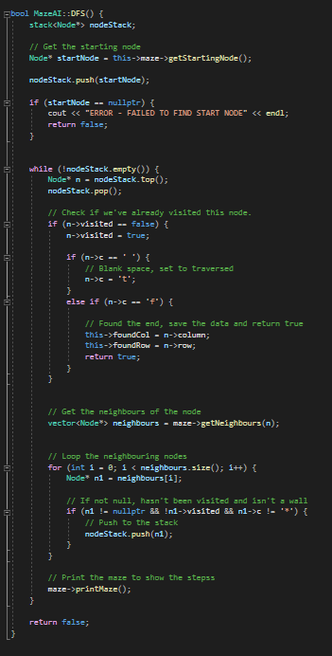
Figure 1 - The DFS Function

The DFS function used a stack to store each node it found, starting the starting node ‘s’, and then pushing each neighbouring node to the stack. The node was then popped off the stack and checked if it had already been visited, if so it would continue in the loop, if it hadn’t, it was checked if the Node was blank or the given object. If the node was blank it would get set to ‘t’ to show a visual representation or where was being visited. If it was the given object, it would set the ‘foundCol’ and ‘foundRow’ values to the current Node position, and return true in the function. The code for this function can be found to the right, in Figure 1. [1]
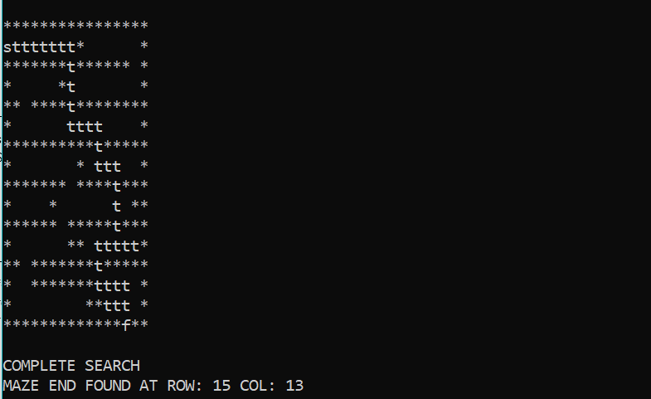
The result of the DFS function was printed in the console. This can be seen below in Figure 2. You can see the Completed maze and the location coordiantes of the maze end.
Figure 2 - The DFS function printing to console

Task 2 – Hill Climbing and Eight-Tiles Puzzle

Hill Climbing

Hill Climbing is a very basic local search algorithm. It effectively chooses the next best/cheapest move in a puzzle, in an attempt to find a solution to the problem. Hill climbing uses what is known as the ‘Greedy approach’, which means it moves in the direction uses the least cost. It also doesn’t have any backtracking, meaning it never goes back on itself after making a move, which can also cause a big problem if it get stucks in a position where it’s surrounded be moves with a higher cost. [2]

An Illustration of Hill Climbing

Hill climbing can be used to effectively solve the eight-tiles problem. It can do this by calculating the next best move in the puzzle and carrying out that move till the puzzle is solved. A random, solvable eight-tiles puzzle was assigned, and below is an illustration of how it could be completed with the algorithm.

Current:
h=5
Next positions:
h=6,4

3 | 1 | 2
6 | 4
7 | 8 | 5

3 | 1 | 2
6 | 4 | 5
7 | 8
Current:
h=4
Next positions:
h=3,5

3 | 1 | 2
6 | 4 | 5
7 |  | 8
Current:
h=3
Next positions:
h=4,5,2

Current:
h=2
Next positions:
h=3,1

3 | 1 | 2
6 | 4 | 5
 | 7 | 8

Current:
h=0
Next positions:
-

 | 1 | 2
3 | 4 | 5
6 | 7 | 8

Hill Climbing Programming

As part of the task, it was requied that a program that used hill climbing to automatically solve the eight tiles problem. To do this, a few functions were needed.
The first was the ‘calculateH’ function would calculate the current heuristic value of the puzzle (the number of tiles that are out of place). This function worked by looping the tiles in the current puzzle and comparing them to the solution puzzle, if they didn’t match it incrememted the ‘h’ value. The code for this function can be seen below in Figure 3.
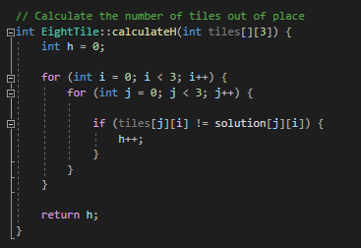
Figure 3 - The calculateH function

The next function that was implemented was the ‘isSolved’ function, this was made to check if the puzzle had been solved. This was very easy to implement as it just checked if the ‘calculateH’ function returned 0 tiles out of place. The code for this can be seen in Figure 4.
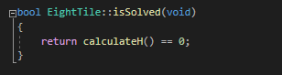
Figure 4 - The 'isSolved' function

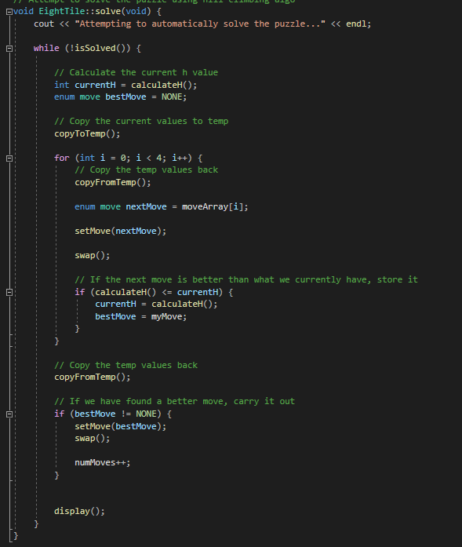
The next function was the actual hill climbing function itself, it was named ‘solve’. This function would store the curreny ‘h’ value and then check if there was a better option based on any of the possible movements. It would then choose the next best movement and continue looping till it either got stuck or finished the puzzle. Due to the limitations of the hill climbing algorithm, it could often get stucked if it moved to a position where it was surrounded by moves that have a ‘h’ value higher than the current ‘h’ value. This function also made use of two other functio n ‘copyToTemp’ and ‘copyFromTemp’. These were used to copy the current tiles and position to and from temporary variables, it did this to carry out moves and calculate the ‘h’ value before reverting back, then eventually doing the best found move. The code for this function can be seen in Figure 5.
Figure 5 - The 'solve' function

Bibliography

[1] | V. Joshi, "Deep Dive Through A Graph: DFS Traversal," Medium, 25 September 2017. [Online]. Available: https://medium.com/basecs/deep-dive-through-a-graph-dfs-traversal-8177df5d0f13. [Accessed 26 February 2020].
[2] | Upasana, "An Introduction to Hill Climbing Algorithm," Edureka, 10 December 2019. [Online]. Available: https://www.edureka.co/blog/hill-climbing-algorithm-ai/. [Accessed 26 February 2020].

